Software Requirements Specification

for

MyHealthCare

Version 1.0 approved

2021. 12. 01

Table of Contents

Table of Contents ii

Revision History ii

1. Introduction 1

1.1 Purpose 1

1.2 Document Conventions 1

1.3 Intended Audience and Reading Suggestions 1

1.4 Product Scope 1

1.5 References 1

2. Overall Description 2

2.1 Product Perspective 2

2.2 Product Functions 2

2.3 User Classes and Characteristics 2

2.4 Operating Environment 2

2.5 Design and Implementation Constraints 2

2.6 User Documentation 2

2.7 Assumptions and Dependencies 3

3. External Interface Requirements 3

3.1 User Interfaces 3

3.2 Hardware Interfaces 3

3.3 Software Interfaces 3

3.4 Communications Interfaces 3

4. System Features 4

4.1 System Feature 1 4

4.2 System Feature 2 (and so on) 4

5. Other Nonfunctional Requirements 4

5.1 Performance Requirements 4

5.2 Safety Requirements 5

5.3 Security Requirements 5

5.4 Software Quality Attributes 5

5.5 Business Rules 5

6. Other Requirements 5

Appendix A: Glossary 5

Appendix B: Analysis Models 5

Appendix C: To Be Determined List 6

# Introduction

## Purpose

*The product, called “MyHealthCare” is a well-structured platform for the health industry. The scope of this software is that facilitates the interaction and communication between the client and the employees of this industry.*

## Document Conventions

|  |  |
| --- | --- |
| **Term** | **Definition** |
| User | Someone who interacts with the mobile phone application |
| Admin/Administrator | System administrator who is given specific permission for managing and controlling the system |
| Employee of health indusrty | Someone who working in the health industry |
| DESC | Description |
| RAT | Rational |
| DEP | Dependency |

## Intended Audience and Reading Suggestions

*This project is a prototype for the health industry management system. This has been implemented under the guidance of a college professor. This project is useful for the employees of health industry and as well as to the clients.*

## Product Scope

*The purpose of the online health management system is to ease health management and to create a convenient and easy-to-use application for clients, trying to make appointments. The system is based on a relational database with its healt management and reservation functions. We will have a database server supporting many major hospitals around the world as well as many medical employees in various departments. Above all, we hope to provide a comfortable user experience along with the best service available.*

## References

List any other documents or Web addresses to which this SRS refers:

* <https://krazytech.com/projects>

# Overall Description

## Product Perspective

*WWWWWWWWWWWWWWWWWWWWWWWWWWWWWWWWWWWWWWWWWW*

*This system will consist of two parts: one mobile application and one backend service. The mobile application will be used to find the proper service and view information about them while the web portal will be used for managing the information about the appointments and the system as a whole.*

*A distributed airline database system stores the following information.*

* *Client description - It includes client code, name, address and email. This information may be used for keeping the records of the customer for any emergency or for any other kind of information.*
* *Appointment description – It includes the client details, the location of the appointment, the resident medic, and the date of the appointment.*
* *Hospital description – It includes hospital name, address, phone number and coordinates.*

## Product Functions

*WWWWWWWWWWWWWWWWWWWWWWWWWWWWWWWWWWWWWWWWWW*

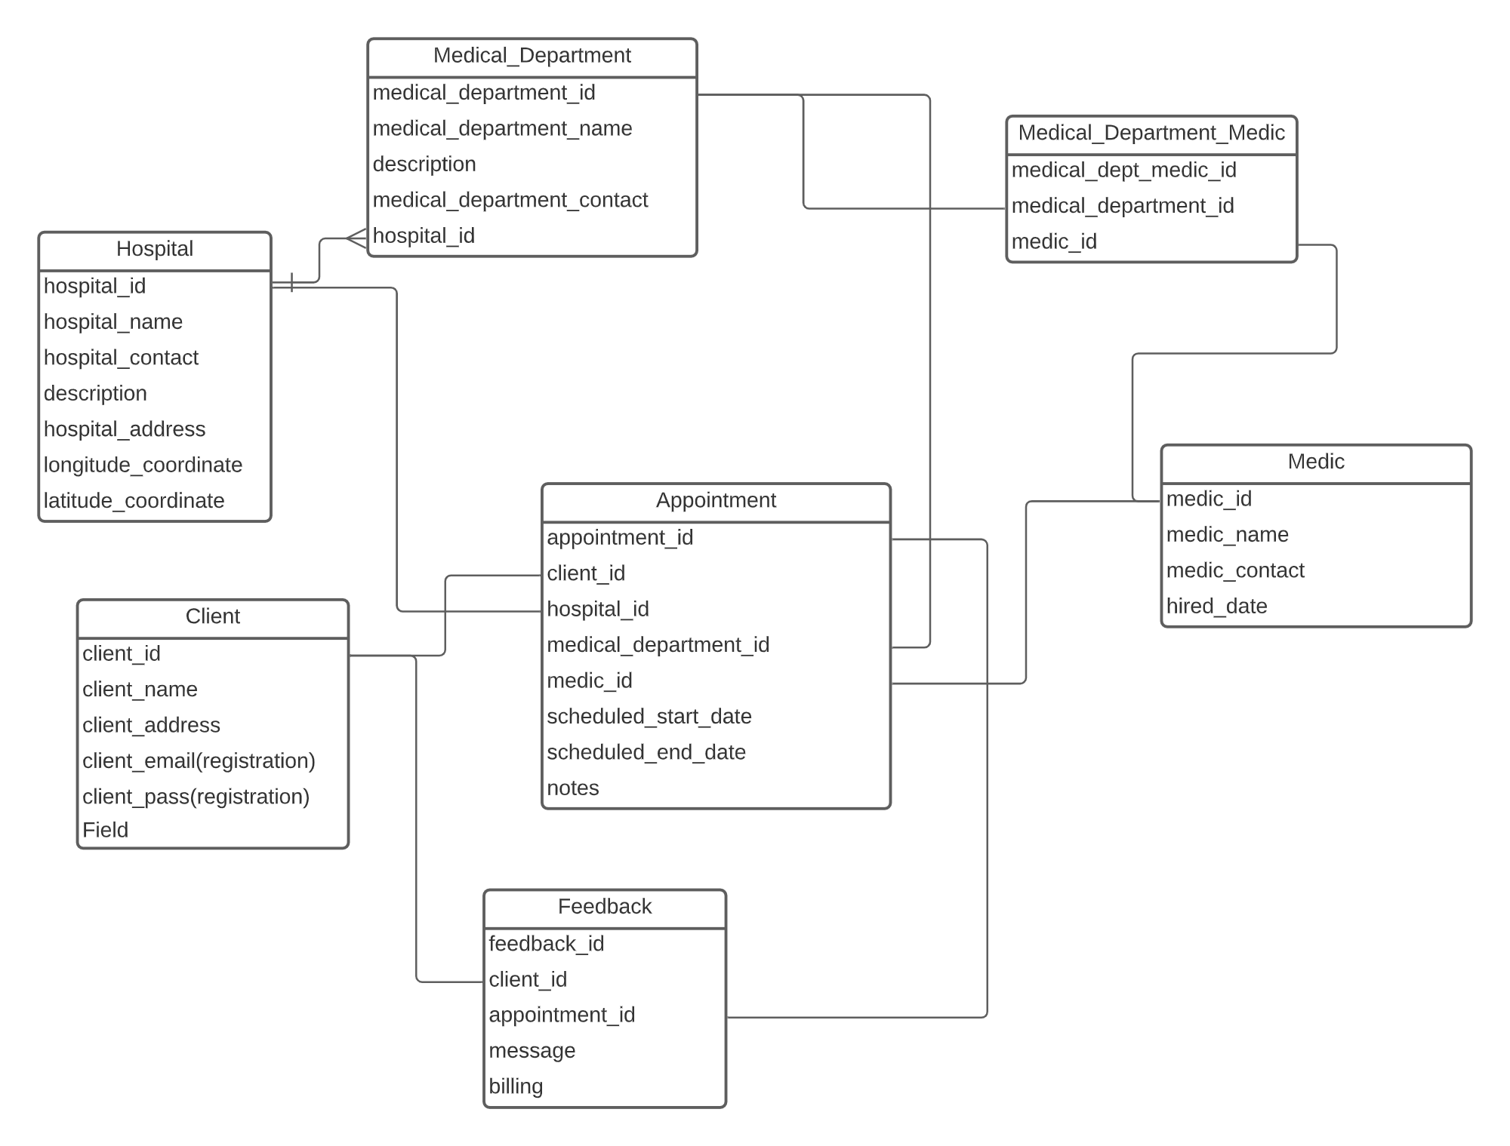

## User Classes and Characteristics

There are three types of users that interact with the system: clients, employees of the health industry and administrators. Each of these three types of users has different use of the system so each of them has their own requirements.

The clients can only use the application to find a restaurant. This means that the user has to be able to search for the suitable treatment, choose a hospital, a medical department, and after that a medic from that search and then navigate to it.

The employees of the health industry will use the mobile application too. There they will get notified about their appointments, they get information like the client's data, the day and the hour of the appointment.

The administrators don’t have an interface to interact with. That type of interface will be our software next step.

## Operating Environment

*Operating environment for the MyHealthCare system is as listed below.*

* *Operating system: Android*
* *Database: MySQL database*
* *Platform: Kotlin*
* *Backend: PHP*

# External Interface Requirements

## User Interfaces

A first-time user of the mobile application should see the log-in page when he/she opens the application, see Figure 1.

If the user is not a first-time user, he/she should be able to see the search page directly when the application is opened, see Figure 2. Here the user can scroll on the list of hospitals or he/she can search for them by name.

Every user should have a profile page where they can see their full name, e-mail address, personal code and the registration date, see Figure 3.

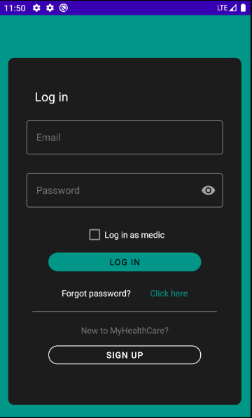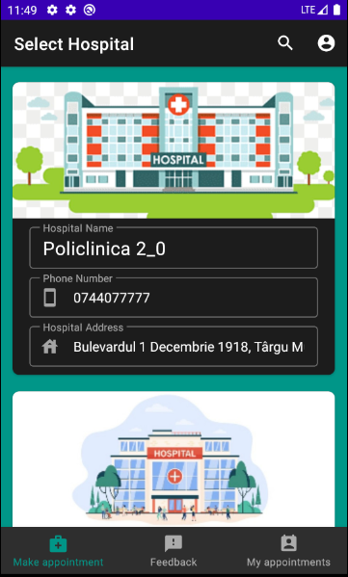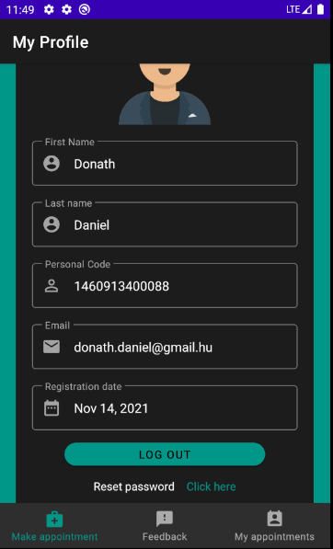

*Figure 1 - Login page* Figure 2 – Search page Figure 3 – Profile page

*The user of the mobile application has to do the following movements for making an appointment:*

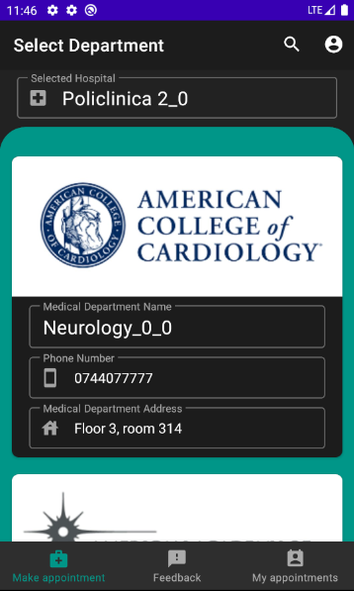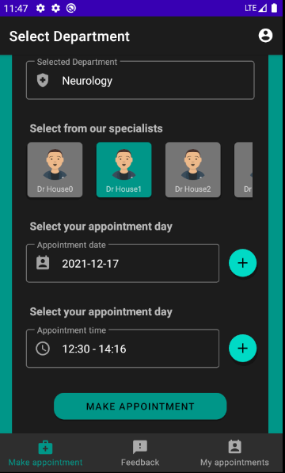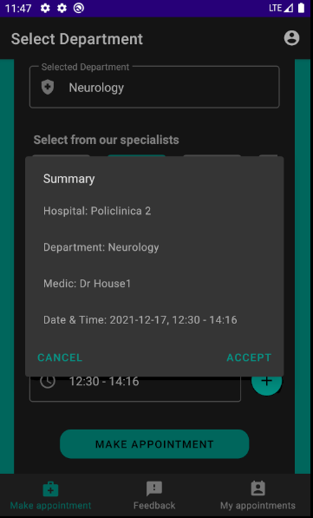

*Figure 3 – Department page Figure 4 – Appointment page* Figure 5 – Accept appointment

## Hardware Interfaces

The system requires a device which has Android 5.0 (Lollipop) operating system or above.

## Software Interfaces

<Describe the connections between this product and other specific software components (name and version), including databases, operating systems, tools, libraries, and integrated commercial components. Identify the data items or messages coming into the system and going out and describe the purpose of each. Describe the services needed and the nature of communications. Refer to documents that describe detailed application programming interface protocols. Identify data that will be shared across software components. If the data sharing mechanism must be implemented in a specific way (for example, use of a global data area in a multitasking operating system), specify this as an implementation constraint.>

*WWWWWWWWWWWWWWWWWWWWWWWWWWWWWWWWWWWWWWWWWW*

## Communications Interfaces

<Describe the requirements associated with any communications functions required by this product, including e-mail, web browser, network server communications protocols, electronic forms, and so on. Define any pertinent message formatting. Identify any communication standards that will be used, such as FTP or HTTP. Specify any communication security or encryption issues, data transfer rates, and synchronization mechanisms.>

The communication between the different parts of the system is important since they depend on each other.

*WWWWWWWWWWWWWWWWWWWWWWWWWWWWWWWWWWWWWWWWWW*

# System Features

## System Feature 1

ID: SF1

TITLE: User registration - Mobile application

DESC: The mobile application is downloaded, then the user should be able to register through the mobile application. The user must provide his/her full name, password, e-mail address and personal code. The user can choose to provide a regularly used phone number.

RAT: In order for a user to register on the mobile application.

DEP: None

## System Feature 2

ID: SF2

TITLE: User log-in - Mobile application

DESC: Given that a user has registered, then the user should be able to log in to the mobile application. The log-in information will be stored on the phone and in the future the user should be logged in automatically.

RAT: In order for a user to log-in on the mobile application.

DEP: SF1

## System Feature 3

ID: SF3

TITLE: User reset password - Mobile application

DESC: Given that a user has registered, then the user should be able to reset his/her password. The user should get an email with the new password in it.

RAT: In order for a user to reset his/her password on the mobile application.

DEP: SF1

## System Feature 4

ID: SF4

TITLE: Mobile application - Search for a hospitals

DESC: Given that a user is logged in to the mobile application, then the first page that is shown should be the list of hospitals page. The user should be able to search for a hospital by name.

RAT: In order for a user to search for a hospital.

DEP: SF2

## System Feature 5

ID: SF5

TITLE: Mobile application - Search for a medical department

DESC: Given that a user selected a hospital, then the next page that is shown should be the list of medical departments (which are in the selected hospital) page. The user should be able to search for a medical department by name.

RAT: In order for a user to search for a medical department

DEP: SF4

## System Feature 6

ID: SF6

TITLE: Mobile application – Make appointment

DESC: Given that a user selected a medical department, then the user should be able to select a medic, a date and an hour for making the appointment.

RAT: In order for a user to make an appointment

DEP: SF5

## System Feature 7

ID: SF7

TITLE: Mobile application - Profile page

DESC: On the mobile application, a user should have a profile page. On the profile page a user can check his/her information, which includes his/her full name, e-mail address, personal code and registration date.

RAT: In order for a user to have a profile page on the mobile application.

DEP: SF2

## System Feature 8

ID: SF8

TITLE: Mobile application - "My appointments" page

DESC: On the mobile application, a user should have a "My appointments" page. On this page a user can check information about his/her future appointments, like the name of the medic, the chosen hospital, medical department and date.

RAT: In order for a user to have a "My appointments" s page on the mobile application.

DEP: SF2

## System Feature 9

ID: SF9

TITLE: Mobile application - "Feedbacks" page

DESC: On the mobile application, a user should have a "Feedbacks" page. On this page a user can check information about his/her past appointments, like the name of the medic, the chosen hospital, medical department, date and the message report about that appointment.

RAT: In order for a user to have a "Feedbacks" page on the mobile application.

DEP: SF2

## System Feature 10

ID: SF10

TITLE: Mobile application - "Feedbacks" page

DESC: On the mobile application, a user should have a "Feedbacks" page. On this page a user can check information about his/her past appointments, like the name of the medic, the chosen hospital, medical department, date and the message report about that appointment.

RAT: In order for a user to have a "Feedbacks" page on the mobile application.

DEP: None

# Other Nonfunctional Requirements

## Performance Requirements

<If there are performance requirements for the product under various circumstances, state them here and explain their rationale, to help the developers understand the intent and make suitable design choices. Specify the timing relationships for real time systems. Make such requirements as specific as possible. You may need to state performance requirements for individual functional requirements or features.>

## Safety Requirements

<Specify those requirements that are concerned with possible loss, damage, or harm that could result from the use of the product. Define any safeguards or actions that must be taken, as well as actions that must be prevented. Refer to any external policies or regulations that state safety issues that affect the product’s design or use. Define any safety certifications that must be satisfied.>

## Security Requirements

<Specify any requirements regarding security or privacy issues surrounding use of the product or protection of the data used or created by the product. Define any user identity authentication requirements. Refer to any external policies or regulations containing security issues that affect the product. Define any security or privacy certifications that must be satisfied.>

## Software Quality Attributes

<Specify any additional quality characteristics for the product that will be important to either the customers or the developers. Some to consider are: adaptability, availability, correctness, flexibility, interoperability, maintainability, portability, reliability, reusability, robustness, testability, and usability. Write these to be specific, quantitative, and verifiable when possible. At the least, clarify the relative preferences for various attributes, such as ease of use over ease of learning.>

## Business Rules

<List any operating principles about the product, such as which individuals or roles can perform which functions under specific circumstances. These are not functional requirements in themselves, but they may imply certain functional requirements to enforce the rules.>

# Other Requirements

<Define any other requirements not covered elsewhere in the SRS. This might include database requirements, internationalization requirements, legal requirements, reuse objectives for the project, and so on. Add any new sections that are pertinent to the project.>

Appendix A: Glossary

<Define all the terms necessary to properly interpret the SRS, including acronyms and abbreviations. You may wish to build a separate glossary that spans multiple projects or the entire organization, and just include terms specific to a single project in each SRS.>

Appendix B: Analysis Models

<Optionally, include any pertinent analysis models, such as data flow diagrams, class diagrams, state-transition diagrams, or entity-relationship diagrams.>

Appendix C: To Be Determined List

<Collect a numbered list of the TBD (to be determined) references that remain in the SRS so they can be tracked to closure.>