

Comp4310 – Mobile Software Development
Push Notifications Using Firebase Cloud Messaging (FCM)

Group 4

Team member :
Ghydaa Mallah 1230620
Baraa Darraj 1230667

Table of Contents

2.1 Problem Statement
3. Technical Framework
3.1 Overview of Firebase Cloud Messaging (FCM)
3.2 FCM Architecture and Message Flow
3.3 Types of FCM Messages
3.3.1 Notification Messages
3.3.2 Data Messages
3.3.3 Combined Messages
3.3.4 System vs. Application Processing
3.4 Device Registration and FCM Token
3.5 Notification Delivery in Android (Foreground / Background / Killed State)
3.5.1 Foreground State
3.5.2 Background State
3.5.3 Killed State
3.5.4 System vs. Application Processing
3.6 Notification Channels and System Tray Display (Android 8+)
4.1 System Architecture
4.1.1 Architecture and Design Pattern
4.2 User Interface Design
4.3 Notification Implementation
4.4 Testing and Results
Test 1: Firebase Connection
Test 2: Token Retrieval
Test 3: Notification Delivery
Test 4: Application State Testing
Actual Testing Results
5. Discussion and Conclusion
5.1 Discussion
5.2 Conclusion
5.3 Lessons Learned
5.4 Team Contributions

1. Executive Summary
This report presents the development of a simple Flutter mobile application that uses Firebase Cloud Messaging (FCM) to support push notifications. The main goal of the project is to show how a Flutter application can connect to Firebase, register a user's device, and generate a unique FCM token for each device.
The application was developed as a Notification Tester App to demonstrate the basic setup of push notifications. This step is important because it confirms that the connection between the application and Firebase is working correctly and prepares the application to receive notifications in future stages.

2. Background
Push notifications are an important feature in modern mobile applications. They allow applications to send updates, reminders, and alerts directly to users without requiring them to open the application. This helps improve user engagement and ensures that important information is delivered quickly.
In the past, many applications used a method called polling, where the application repeatedly checked the server for new information. This approach can increase network usage and consume more battery power. To solve this problem, cloud messaging services were introduced, allowing notifications to be sent directly through a centralized platform.
Firebase Cloud Messaging (FCM) is one of the most popular notification services because it is reliable, easy to use, and works well with Flutter applications. It helps developers send notifications efficiently and provides a simple way to manage communication between the application and users.

2.1 Problem Statement
Many mobile applications rely on users manually opening the application to check for updates, which reduces user engagement and delays information delivery. This project addresses the challenge of implementing reliable real-time communication in Flutter applications by integrating Firebase Cloud Messaging (FCM) to enable push notification support and device registration.
2.2 Scope of Research
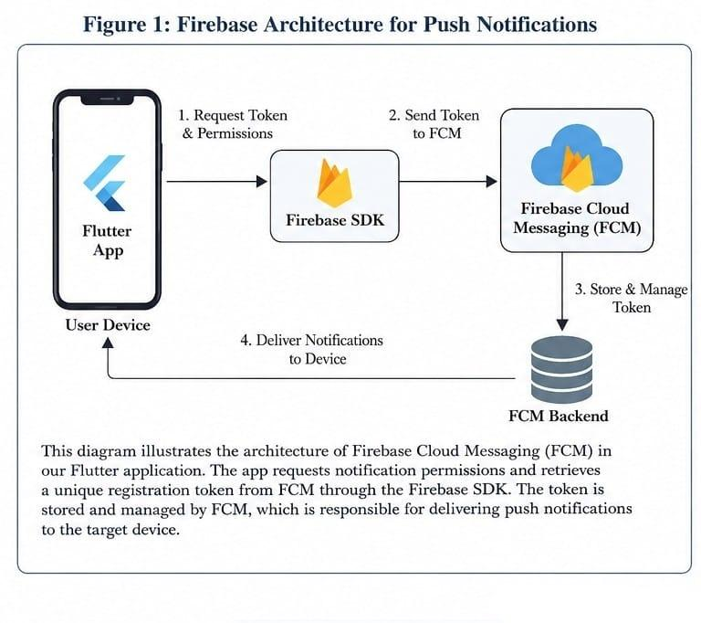
This project focuses on developing an Android-based Flutter prototype that demonstrates Firebase Cloud Messaging integration, device registration, FCM token retrieval, and local notification display. The project does not include iOS testing, topic-based messaging, automated server-side notification sending, or backend database integration.

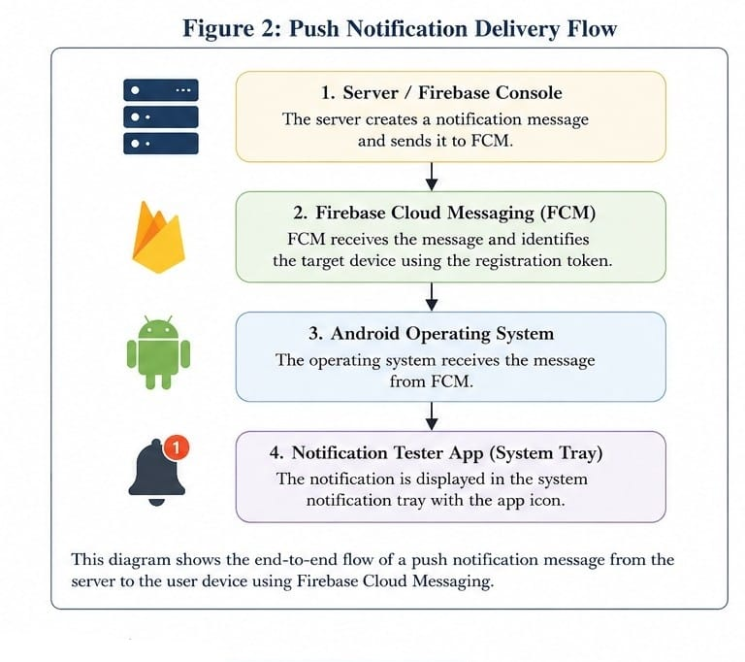

3. Technical Framework

3.1 Overview of Firebase Cloud Messaging (FCM)
Firebase Cloud Messaging (FCM) is a service provided by Google that allows developers to send push notifications and messages to mobile applications. It supports multiple platforms, including Android, iOS, and Flutter, making it one of the most popular solutions for mobile notifications.
Instead of requiring applications to continuously check for updates, FCM sends notifications directly to user devices whenever new information becomes available. This reduces network usage, improves battery efficiency, and provides a faster and better user experience.
FCM supports different types of messages, including notification messages and data messages. It also allows notifications to be sent to a single device, a group of devices, or users subscribed to a specific topic.
Because of its reliability, scalability, and easy integration with Firebase services, FCM has become an essential tool in modern mobile application development.

3.2 FCM Architecture and Message Flow
Firebase Cloud Messaging uses a cloud-based architecture that enables reliable communication between application servers and user devices. The architecture consists of four main components:
- Message Sender – The server or system responsible for creating and sending notification requests.
- FCM Server – Receives, processes, and manages message delivery.
- Transport Layer – Delivers messages to devices using platform-specific services.
- Client Application – The mobile application installed on the user's device that receives and processes messages.
The communication process begins when the application registers with FCM and receives a unique registration token. When a notification is sent, the application server forwards the request to FCM. FCM then processes the request and routes the message to the target device. Finally, the notification is displayed by the Android system or processed by the application, depending on the message type and application state.

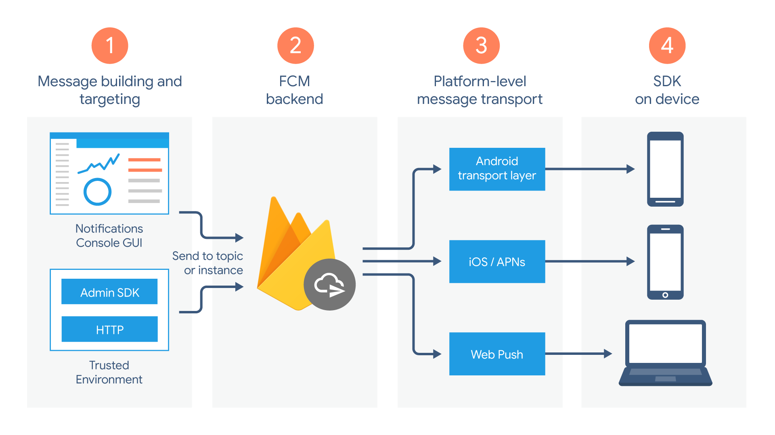

3.3 Types of FCM Messages
Firebase Cloud Messaging supports different message types to meet various communication requirements. Understanding these message types helps developers choose the most suitable method for delivering information to users.

3.3.1 Notification Messages
Notification messages contain predefined fields such as a title and message body. These messages are mainly used to display information directly to users.
When the application is running in the background, Android automatically displays the notification in the system notification bar. If the application is in the foreground, developers can decide how the notification should be presented.
Notification messages are commonly used for alerts, reminders, announcements, and user engagement.

3.3.2 Data Messages
Data messages contain custom information defined by the developer in the form of key-value pairs.
Unlike notification messages, Android does not automatically display data messages. Instead, the application receives and processes the data using its own logic.
These messages are useful for background synchronization, chat applications, updating content, and performing custom actions within the application.

3.3.3 Combined Messages
Combined messages include both notification content and additional data in a single message.
This allows a notification to be displayed to the user while also sending extra information that the application can process internally.
Combined messages are commonly used in messaging and social media applications where both user interaction and background processing are required.

3.3.4 System vs. Application Processing
One of the main differences between FCM message types is how they are processed.
Notification messages can be handled automatically by Android, especially when the application is in the background.
Data messages, however, are always processed by the application itself, giving developers greater flexibility and control over application behavior.

3.4 Device Registration and FCM Token
When a mobile application is launched for the first time, Firebase automatically registers the application with Firebase Cloud Messaging (FCM) and generates a unique registration token. This token acts as an identifier for a specific application installed on a specific device.
The FCM token is important because it allows notification messages to be sent directly to the correct device. Without this token, Firebase cannot determine where a notification should be delivered.
Applications can obtain the current token using the Firebase Messaging API. In Flutter applications, the token is commonly retrieved through the Firebase Messaging package and can then be stored for future notification delivery.
It is important to note that FCM tokens may change over time. For example, a new token may be generated if the application is reinstalled, application data is cleared, or the user moves to a new device. Therefore, applications should always be prepared to handle token updates and keep the latest token synchronized with the backend system.
In summary, the FCM token is a key component of the notification process because it uniquely identifies application instances and enables accurate notification delivery.

3.5 Notification Delivery in Android (Foreground / Background / Killed State)
The behavior of Firebase Cloud Messaging notifications depends on the current state of the Android application. Android handles incoming messages differently when the application is running in the foreground, running in the background, or completely closed.

3.5.1 Foreground State
The foreground state occurs when the user is actively using the application and it is visible on the screen.
In this state, incoming FCM messages are delivered directly to the application through the message handler. Android does not automatically display notification messages while the application is open. Therefore, developers must create and display notifications manually if they want users to see them.
This approach provides greater flexibility because the application can decide how to process and present the information.

3.5.2 Background State
The background state occurs when the application is running but is not currently visible to the user.
For notification messages, Android automatically displays the notification in the system notification bar. When the user taps the notification, the application opens automatically.
For data messages, the application receives the message and can process it in the background according to its logic.

3.5.3 Killed State
The killed state occurs when the application is completely closed or removed from memory by the operating system.
Even in this state, notification messages can still be delivered successfully through Firebase Cloud Messaging. Android displays the notification directly in the notification bar, allowing users to receive important information even when the application is not running.
When the user opens the notification, the application starts and can process any additional data associated with the message.

3.5.4 System vs. Application Processing
One of the main differences between FCM message types is how they are processed.
Notification messages are usually handled automatically by the Android operating system, especially when the application is in the background or closed.
Data messages, on the other hand, are always processed by the application itself. This gives developers more control over how information is handled and displayed.

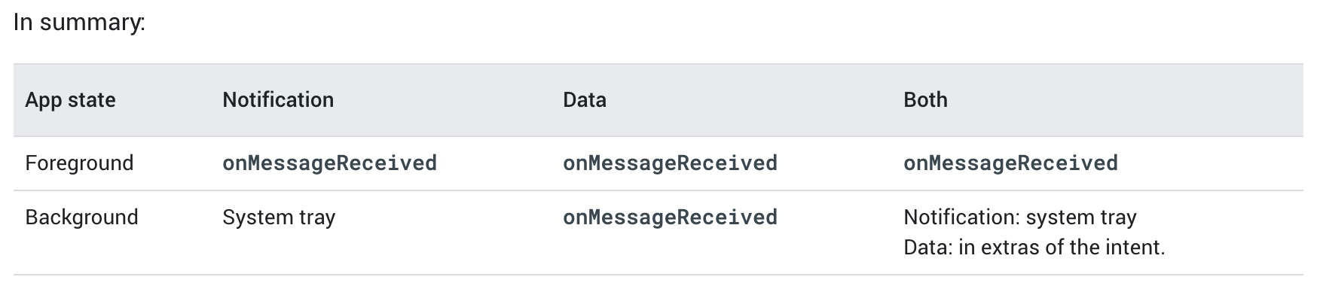

3.6 Notification Channels and System Tray Display (Android 8+)
Starting from Android 8.0 (API Level 26), Android introduced Notification Channels to provide users with more control over application notifications.
Every notification must belong to a notification channel; otherwise, it will not appear on devices running Android 8.0 or later.
A notification channel defines how a group of notifications behaves. Developers can configure settings such as notification importance, sound, vibration, and visual alerts.
Notification channels improve the user experience because users can manage notification settings separately for different types of notifications. For example, users can disable promotional notifications while still receiving important alerts.
One of the most important channel settings is the importance level. Android provides several importance levels ranging from low priority notifications to high priority notifications.
High-priority channels are typically used for urgent alerts that require immediate user attention, while lower-priority channels are used for informational messages that do not interrupt the user.
To create a notification channel, developers assign a unique channel ID, a channel name, and an importance level. The channel is then registered with the Android notification system and can be used whenever notifications are sent.
Overall, notification channels help organize notifications, improve user control, and provide a more consistent notification experience across Android applications.

4. Prototype Implementation

4.1 System Architecture
The developed system consists of a Flutter mobile application integrated with Firebase Cloud Messaging (FCM) and local notification services.
The main components of the system are:
- Flutter Application: Responsible for the user interface and notification management.
- Firebase Cloud Messaging (FCM): Handles message delivery between Firebase and user devices.
- Firebase Console: Used to send test notifications to registered devices.
- Android Device: Receives and displays notifications.
The communication process begins when the application connects to Firebase and obtains a unique FCM token. This token identifies the device and allows Firebase to deliver notifications to the correct destination. When a notification is sent through Firebase Console, FCM routes the message to the target device, where it is displayed to the user.
This architecture provides a simple and reliable solution for implementing push notifications in mobile applications.

4.1.1 Architecture and Design Pattern
Due to the small scope of the application and the presence of a single main screen, a full architectural pattern such as MVVM or Clean Architecture was not implemented. Instead, the project follows a simple structure where the notification-related functionality is separated into a dedicated service file (notifications_service.dart), while the user interface logic remains within the main UI class.
The application integrates Firebase Cloud Messaging (FCM) with Flutter Local Notifications to handle push notifications in both foreground and background states. Notification initialization and display logic are encapsulated within reusable functions (initializeNotifications and showNotification), improving code organization and readability.
The state management in the application is handled using Flutter’s built-in setState, which is sufficient for this small-scale prototype. The app consists of a single main screen that displays the FCM token and allows the user to copy it for testing purposes.
For larger and more complex applications, adopting structured state management solutions such as Provider, Riverpod, or BLoC, along with a layered architecture, would be recommended to improve scalability and maintainability.

4.2 User Interface Design
The application was designed with a simple and user-friendly interface to demonstrate notification functionality.
The main screen contains:
- A section that displays the generated FCM token.
- A button that allows the user to copy the token to the clipboard.
- Status messages that provide feedback when actions are performed successfully.
The interface follows a minimal design approach, making it easy for users and developers to test notification functionality without unnecessary complexity.
The design focuses on usability and provides quick access to the information required for notification testing.

4.3 Notification Implementation
Push notification functionality was implemented using Firebase Cloud Messaging (FCM) together with local notification services.
The implementation process includes:
- Connecting the application to Firebase.
- Requesting notification permissions from the user.
- Generating and retrieving a unique FCM token.
- Receiving notification messages from Firebase.
- Displaying notifications on the device through the Android notification system.
The application supports notification delivery in different application states, including:
- Foreground State
- Background State
- Killed State
This ensures that users can receive notifications regardless of whether the application is currently open or running in the background.
Local notifications were used to ensure that incoming messages are displayed properly and provide a consistent user experience.

4.4 Testing and Results
Several tests were performed to verify the functionality of the notification system.

Test 1: Firebase Connection
The application was launched and successfully connected to Firebase services. The FCM token was generated and displayed on the screen, confirming successful registration.

Test 2: Token Retrieval
The generated token was copied and used as the target device identifier. The token retrieval process worked correctly without errors.

Test 3: Notification Delivery
Test notifications were sent through Firebase Console using the generated token. Notifications were successfully delivered and displayed on the target device.

Test 4: Application State Testing
Notification delivery was tested under different application states:

Application State | Result
Foreground | Notification received successfully
Background | Notification received successfully
Killed State | Notification received successfully

Actual Testing Results
Test Case | Result
Firebase Initialization | Passed
Token Retrieval | Passed
Copy Token Function | Passed
Foreground Notification | Passed
Background Notification | Passed
Notification Tap | Passed

5. Discussion and Conclusion

5.1 Discussion
The project successfully demonstrated the integration of Firebase Cloud Messaging within a Flutter application. It highlighted the importance of several key aspects, including notification permissions management, handling the FCM device token, and configuring Android notification channels to ensure proper delivery of notifications.

5.2 Conclusion
This prototype achieved its primary objective, which was to demonstrate the implementation of push notifications using Firebase Cloud Messaging. The application successfully initialized Firebase services, retrieved the device registration token, and displayed notifications using Flutter Local Notifications through properly configured notification channels.

5.3 Lessons Learned
- Understanding the correct initialization requirements for Firebase before using its services.
- Managing notification permissions on modern Android versions (Android 13 and above).
- Handling background messages using background message handlers.
- Proper configuration of notification channels to ensure reliable notification delivery.
- Displaying foreground notifications using Flutter Local Notifications.

5.4 Team Contributions
Member | Contribution
Ghydaa Mallah | Firebase setup, FCM integration, token retrieval, report writing
Baraa Darraj | UI implementation, notification handling, diagrams, and testing

References :
https://firebase.google.com/docs/cloud-messaging/concept-options

https://firebase.google.com/docs/cloud-messaging/android/receive

https://developer.android.com/develop/ui/compose/notifications/create-notification

https://firebase.google.com/docs/cloud-messaging/android/receive-messages

chrome-extension://efaidnbmnnnibpcajpcglclefindmkaj/https://pdfs.semanticscholar.org/889a/d3a19ab1160a571931611376bd84367a7800.pdf

