How To Tutorials

How to run H2 console: First install H2 console. Then run it and fill those details: 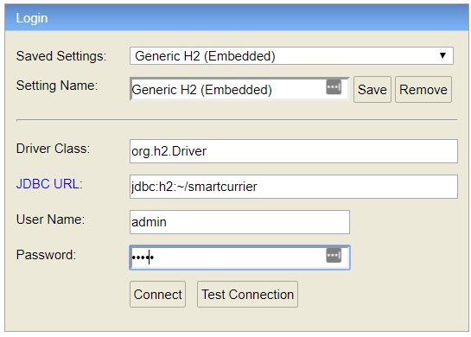

Password is admin.