CS5200: Database Theory and Applications
Final Project Report — Spring 2026

Expense Tracker
(ExpenseIQ)

Personal Expense Management System

Full-Stack Application with AI-Powered Financial Assistant
Built with Flask · Streamlit · SQLite3 · Ollama (Gemma3:4b)

1. Project and Database Description

1.1 Project Overview
Expense tracker is a full-stack personal finance management system designed to help individuals take complete control of their financial lives. Managing personal finances is a major challenge — people forget small cash transactions, lose paper receipts, and struggle to identify long-term spending patterns. This application solves these problems by providing a centralized, easy-to-use platform to record every dollar earned or spent.
The system is fully customizable. Users can create specific categories for expenses such as groceries, rent, utilities, and transportation, as well as income sources like salary, freelance work, or investment returns. A key differentiator is the integrated AI Assistant powered by a local Large Language Model (Ollama / Gemma3:4b), which allows users to manage finances through plain English — eliminating the need for complex menus.

1.2 Target Users
User Group | Primary Needs
Students | Track loans, tuition, and daily spending on a limited income.
Families | Manage household bills, groceries, and childcare costs in one organized place.
Freelancers | Track variable income and business-related expenses across multiple clients.
General Users | Save for vacations or large purchases and monitor savings progress over time.

1.3 Problems Solved
- People forget small cash transactions, which can add up to a significant portion of expenditures.
- Paper receipts are easily lost, creating gaps in financial records.
- Bank statements do not always categorize spending clearly — this app lets users define their own categories.
- Long-term spending trends are hard to identify without dedicated digital tools and visualizations.
- The AI assistant removes barriers for non-technical users who find traditional finance apps difficult.

1.4 Input Data
- Transaction details: date, amount, type (DEBIT/CREDIT), and a description or narration.
- Income sources: salary, bonuses, freelance payments, gifts, or stipends.
- User-defined income and expense categories (e.g., Groceries, Utilities, Freelance).
- Budget limits for specific categories with configurable periods (monthly / weekly / yearly).
- Natural language chat messages processed and executed by the integrated AI assistant.

1.5 Key Functions
Function | Description
Data Entry | Add, edit, or delete income and expense records via form UI or natural language.
Categorization | Group spending into custom categories for better analysis and reporting.
Budget Tracking | Set spending limits per category; live progress bars show OK / Warning / Over status.
Analytics & Reporting | Monthly and all-time summaries with income vs. expense bar charts by category.
AI Chat Interface | LLM-powered assistant understands natural language and performs CRUD operations.
Authentication | Token-based login with SHA-256 password hashing and per-request session validation.

1.6 LLM Integration
To meet the advanced course requirement, Expense tracker integrates a Large Language Model via Ollama running the gemma3:4b model locally. Users can interact with the database using natural language through the AI Assistant page. Example queries the system understands:
- "Add a $50 grocery expense"
- "Record salary income of $2000"
- "Show all transactions this month"
- "What is my current balance?"
- "Delete transaction #12"
- "Show this month's summary"
The AI maps these phrases to structured CRUD actions (CREATE, READ, UPDATE, DELETE, SUMMARY, BALANCE), executes the appropriate database operation, and returns a human-readable response. All interactions are persisted in the ChatLog table.

2. Database Description

2.1 Overview
ExpenseIQ uses SQLite3 as its database engine, running in WAL (Write-Ahead Logging) mode to support concurrent reads and writes. The database is stored in a single file (expenses.db) and consists of six tables that manage all user data, financial transactions, budgets, categories, AI chat history, and authentication tokens.
Foreign key constraints are enforced via PRAGMA foreign_keys = ON. A critical design decision was to store the transaction category as a free-text string rather than a foreign key to the Category table — this ensures that historical records remain valid even when categories are renamed or deleted.

2.2 Business Rules
- Each User can have zero or many Transactions, Categories, Budgets, ChatLogs, and Tokens.
- Each Transaction must belong to exactly one User and carries a type of DEBIT or CREDIT.
- A user's balance is always recalculated from scratch after every transaction insert, update, or delete — preventing incremental drift.
- Transaction amounts must be positive; the type field controls the sign of their effect on the balance.
- Budget tracking is explicit: transactions must be manually linked to a budget via budget_id.
- Category names must be unique per user. A new user is seeded with 14 default categories on registration.
- Tokens are single-use session keys — issued on login and deleted on logout.

2.3 Database Schema — Six Tables
Table | Purpose
Users | Registered accounts with SHA-256 hashed passwords and a computed balance field.
Tokens | Active session tokens; issued on login, deleted on logout. Used for stateless auth.
Category | Per-user expense/income/both categories; 14 defaults seeded at registration.
Transactions | All DEBIT/CREDIT financial records; every write triggers a balance recalculation.
Budget | Spending limits per category with monthly/weekly/yearly periods.
ChatLog | Persists every AI chat message (role, content, action type) across sessions.

3. Database Diagrams and Data Dictionary

3.1 Entity-Relationship Diagram (Crow's Foot Notation)

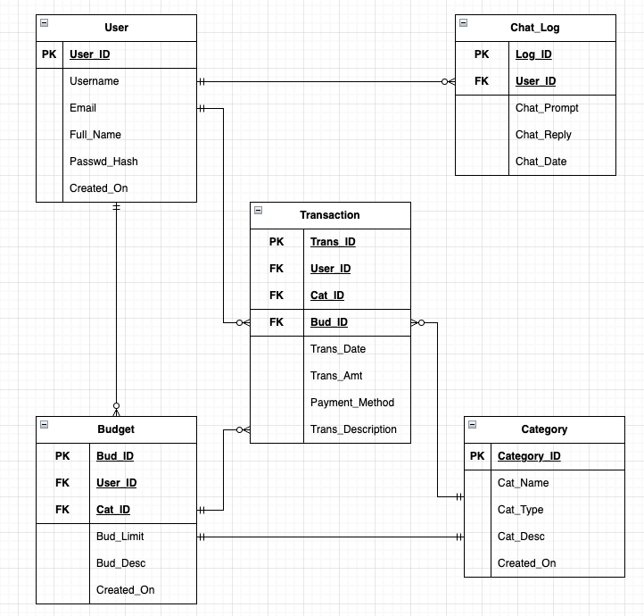
Figure 1 — ExpenseIQ Entity-Relationship Diagram (Crow's Foot Notation)

3.2 Relationships Summary
Relationship | Cardinality | Description
Users → Transactions | One-to-Many | A user can record many transactions; each transaction belongs to one user.
Users → Category | One-to-Many | A user can create many categories; each category belongs to one user.
Users → Budget | One-to-Many | A user can define many budgets; each budget belongs to one user.
Users → ChatLog | One-to-Many | A user can have many chat entries; each entry belongs to one user.
Users → Tokens | One-to-Many | A user can have active tokens; each token belongs to one user.
Transactions → Budget | Many-to-One (opt.) | A transaction may be linked to one budget via budget_id (optional FK).

3.3 Data Dictionary
The table below documents every attribute across all six database tables, including data types, formats, constraints, and key designations.

Table | Attribute | Contents | Type | Format | Range | Req. | Key | FK Ref
Users | user_id | Unique User ID | INTEGER |  |  | Y | PK
 | username | Login handle | VARCHAR(50) |  | 3-50 chars | Y | UQ
 | password | SHA-256 hash | VARCHAR(255) |  | 6+ chars | Y
 | balance | Account balance | DECIMAL(12,2) | 9,999.99 |  | Y
 | last_login | Last login time | DATETIME |  |  | N
Category | category_id | Unique Category ID | INTEGER |  |  | Y | PK
 | user_id | Owner User ID | INTEGER |  |  | Y | FK | Users
 | name | Category name | VARCHAR(50) |  | Max 50 | Y | UQ
 | type | income/expense/both | VARCHAR(10) |  |  | Y
 | created_at | Date created | DATETIME |  |  | Y
Transactions | transaction_id | Unique Transaction ID | INTEGER |  |  | Y | PK
 | user_id | Owner User ID | INTEGER |  |  | Y | FK | Users
 | type | DEBIT or CREDIT | VARCHAR(10) |  |  | Y
 | category | Category name (string) | VARCHAR(50) |  |  | N
 | amount | Transaction amount | DECIMAL(12,2) | 9,999.99 | > 0 | Y
 | description | Notes | TEXT |  | Max 500 | N
 | transaction_date | Date of transaction | DATETIME |  |  | Y
 | budget_id | Linked budget | INTEGER |  |  | N | FK | Budget
Budget | budget_id | Unique Budget ID | INTEGER |  |  | Y | PK
 | user_id | Owner User ID | INTEGER |  |  | Y | FK | Users
 | name | Budget name | VARCHAR(100) |  | Max 100 | Y
 | category | Category name | VARCHAR(50) |  |  | Y
 | limit_amount | Spending cap | DECIMAL(12,2) | 9,999.99 | > 0 | Y
 | period | monthly/weekly/yearly | VARCHAR(10) |  |  | Y
 | created_at | Date created | DATETIME |  |  | Y
ChatLog | log_id | Unique Log ID | INTEGER |  |  | Y | PK
 | user_id | User in chat | INTEGER |  |  | Y | FK | Users
 | role | user or assistant | VARCHAR(10) |  |  | Y
 | message | Message content | TEXT |  | Max 2000 | Y
 | action | LLM action type | VARCHAR(20) | CREATE/READ/... |  | N
 | created_at | Message timestamp | DATETIME |  |  | Y
Tokens | token | Auth token (PK) | TEXT | 64-char hex |  | Y | PK
 | user_id | Owner User ID | INTEGER |  |  | Y | FK | Users
 | username | Cached username | TEXT |  |  | Y

3.4 Data Type Legend
Code | Definition
PK | Primary Key — unique identifier for each record in the table.
FK | Foreign Key — links a record to a row in another table.
UQ | Unique Constraint — value must be unique across all rows for that column.
INTEGER | Whole number; used for IDs (auto-incremented) and foreign keys.
VARCHAR(n) | Variable-length character string; n defines the maximum allowed length.
TEXT | Unlimited-length string; used for descriptions and chat messages.
DECIMAL(p,s) | Fixed-precision decimal; p = total digits, s = decimal places (e.g., 12,2).
DATETIME | Date and time value stored as ISO 8601 text in SQLite.

4. User Interfaces and Forms
ExpenseIQ features seven distinct pages built with Streamlit. Each page communicates with the Flask backend via RESTful JSON API calls, using token-based authentication. Below are annotated screenshots of every key interface.

4.1 Dashboard
The Dashboard is the home screen, showing the current account balance, monthly income/expense summary cards, a list of the most recent transactions, and a category breakdown panel on the right. It gives users an immediate snapshot of their financial health.

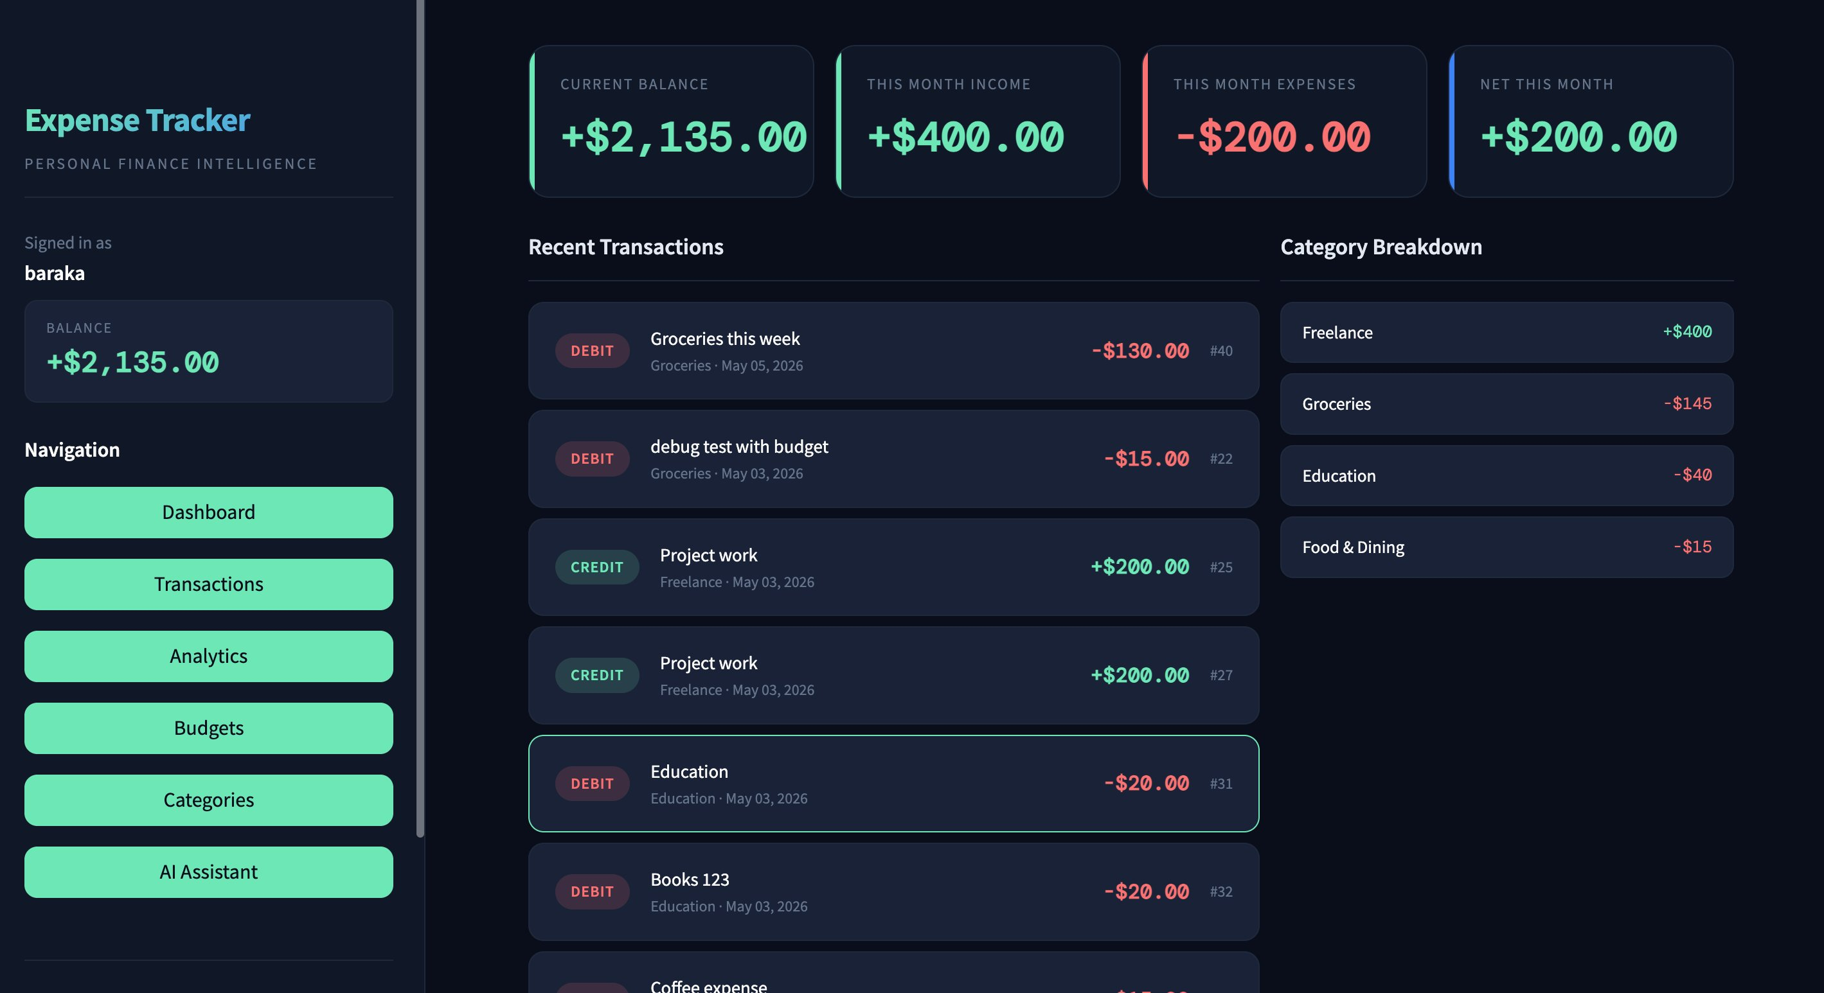
Figure 2 — Dashboard

4.2 Manage Transactions
The Transactions page provides full CRUD functionality. The left panel contains an Add New Transaction form with type selector, amount input, category dropdown, description field, date picker, and an optional budget link. The right panel displays all transactions with date/type filters and Delete buttons.

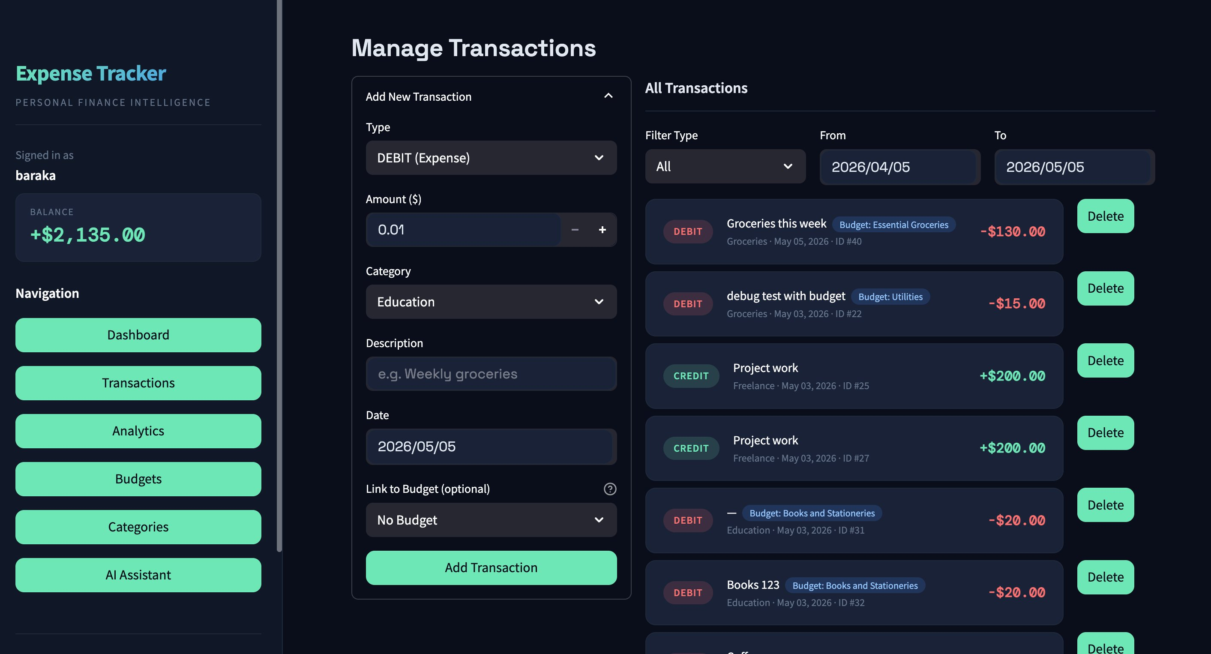
Figure 3 — Manage Transactions

4.3 Financial Analytics
The Analytics page allows users to select a specific month and view total income, total expenses, and net balance. A category breakdown table is displayed alongside a bar chart comparing DEBIT and CREDIT amounts per category for the selected period.

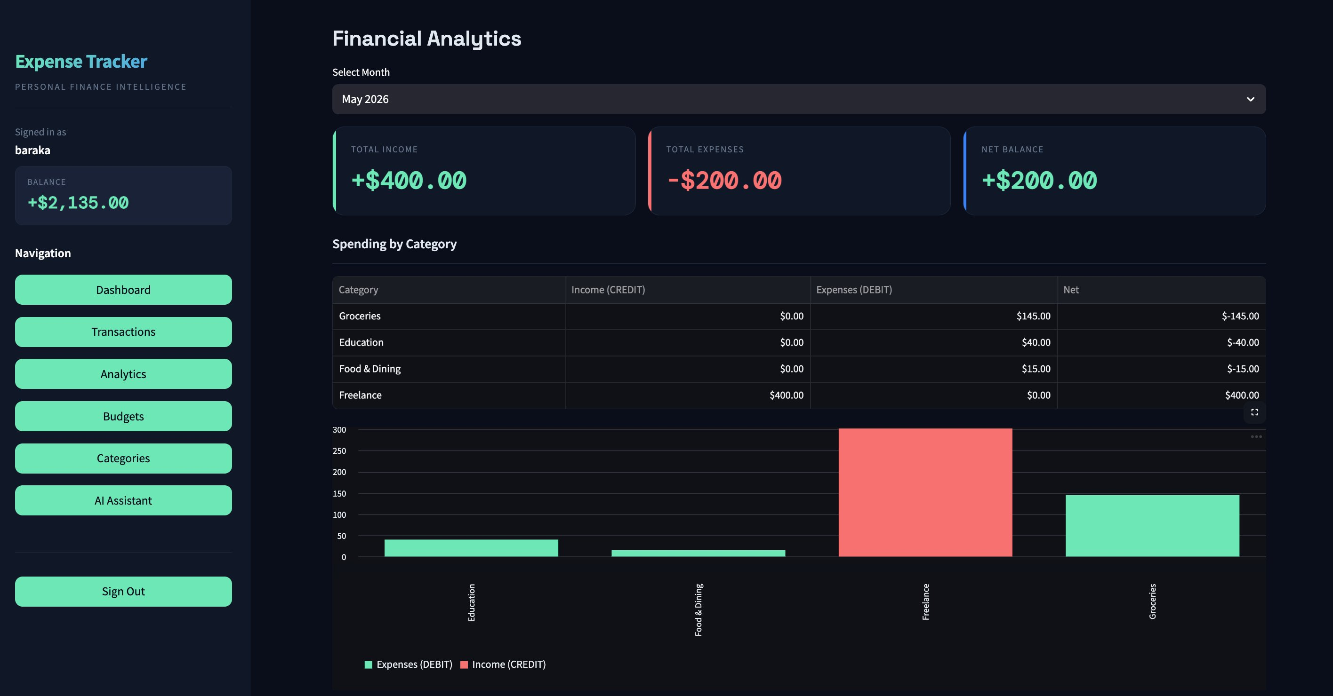
Figure 4 — Financial Analytics

4.4 Budget Management
The Budgets page lets users create spending limits by entering a budget name, spending cap, and period (monthly/weekly/yearly). Existing budgets are shown on the right with live progress bars displaying the percentage of the limit used and an 'On Track' or 'Over' status.

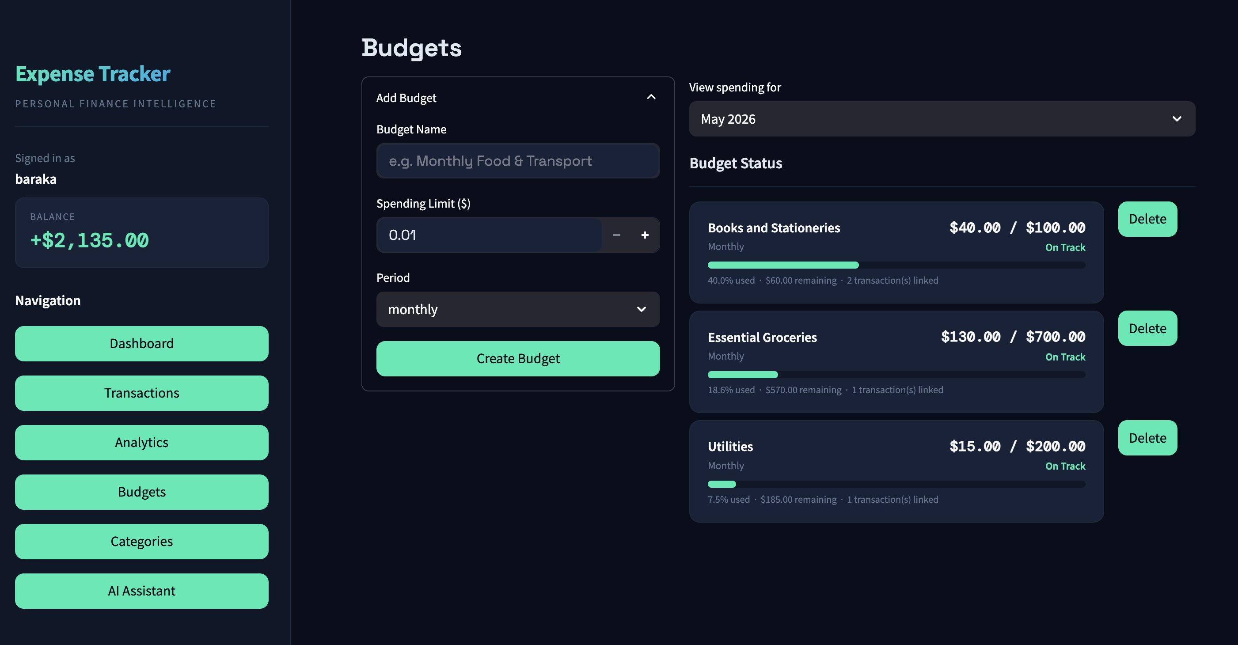
Figure 5 — Budget Management

4.5 Categories Management
The Categories page enables users to create and manage custom income and expense categories. Each category displays a type badge (EXPENSE, INCOME, or BOTH). Default categories are pre-populated on registration and users can add or delete categories at any time.

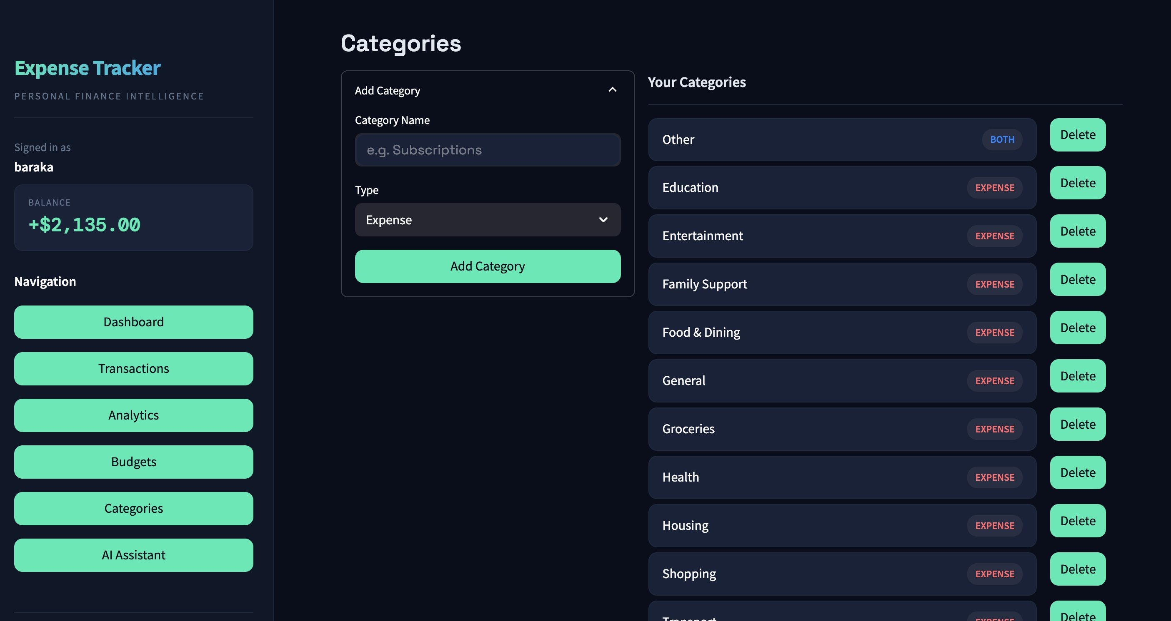
Figure 6 — Categories Management

4.6 AI Financial Assistant
The AI Assistant page provides a natural language chat interface powered by Gemma3 via Ollama. Users can type requests in plain English. Quick-action buttons on the right allow common queries with a single click. The assistant's chat history is persisted across sessions via the ChatLog table.

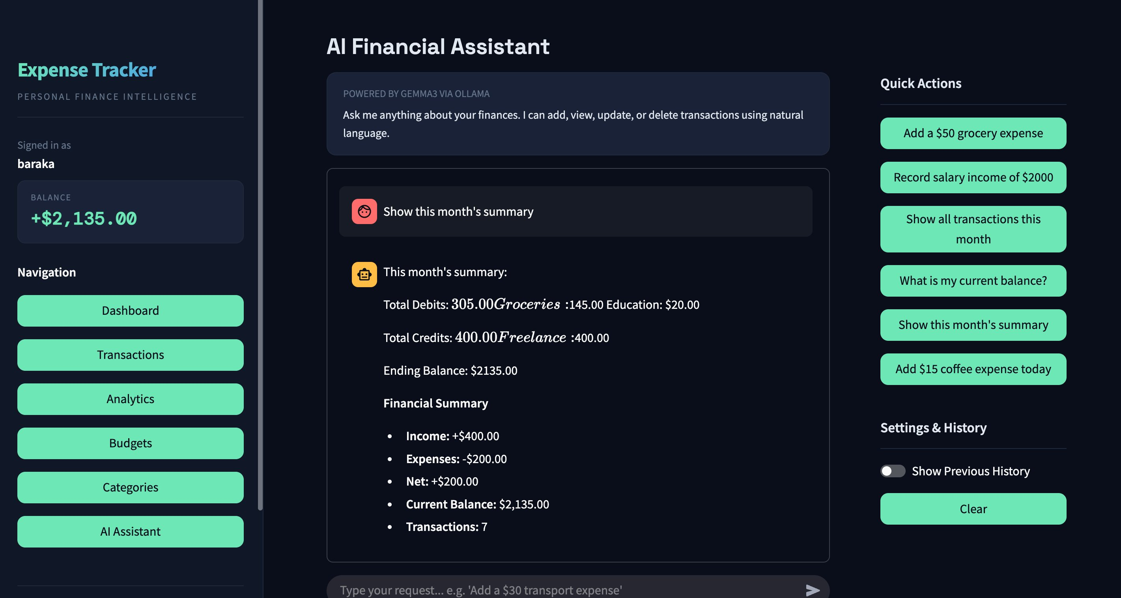
Figure 7 — AI Financial Assistant

5. Source Code and SQL Commands

5.1 System Architecture
ExpenseIQ follows a decoupled three-tier architecture:

Layer | Technology | File | Role
Presentation | Streamlit (Python) | frontend.py | Renders all UI pages; communicates with Flask via HTTP REST.
Application | Flask (Python) | app.py | REST API server; handles validation, business logic, AI orchestration.
Data | SQLite3 | expenses.db | Serverless file-based database; WAL mode for concurrent access.
AI Engine | Ollama / Gemma3:4b | Local daemon | Local LLM; receives structured prompts and returns JSON action objects.

5.2 Project File Structure
expense_app/
├── app.py # Flask backend — REST API, DB logic, AI orchestration
├── frontend.py # Streamlit frontend — all UI pages and user interaction
├── run.py # Single-terminal launcher (starts Flask + Streamlit)
├── db_test.py # Database setup and connection verification
├── diagnose.py # Flask API network diagnostics
├── requirements.txt # Python dependencies
├── expenses.db # SQLite3 database (auto-created on first run)
└── README.md # Project documentation

5.3 REST API Endpoints
Method | Endpoint | Auth | Description
POST | /api/register | No | Create a new user; seeds 14 default categories automatically.
POST | /api/login | No | Verify credentials; issue and store a 64-character hex token.
POST | /api/logout | Yes | Delete the current token row, invalidating the session.
GET | /api/me | Yes | Return the current user's info and balance.
GET | /api/transactions | Yes | List transactions (optional: start_date, end_date, category, type filters).
POST | /api/transactions | Yes | Create a transaction; triggers full balance recalculation.
PUT | /api/transactions/<id> | Yes | Update a transaction; triggers balance recalculation.
DELETE | /api/transactions/<id> | Yes | Delete a transaction; triggers balance recalculation.
GET | /api/balance | Yes | Return the current computed balance.
GET | /api/summary | Yes | Aggregated totals by category; optional ?month=YYYY-MM filter.
GET | /api/categories | Yes | List all categories; optional ?type=income|expense filter.
POST | /api/categories | Yes | Create a new custom category.
DELETE | /api/categories/<id> | Yes | Delete a category.
GET | /api/budgets | Yes | List budgets with live spent/remaining/percentage/status.
POST | /api/budgets | Yes | Create a new budget.
DELETE | /api/budgets/<id> | Yes | Delete a budget.
GET | /api/chat/logs | Yes | Retrieve chat history (max 200 entries).
DELETE | /api/chat/logs | Yes | Clear all chat history for the current user.
POST | /api/llm | Yes | Send natural language; AI parses and executes the action.

5.4 Critical Code — Connection Points
A. Frontend → Backend (Streamlit to Flask)
The Streamlit UI uses Python's requests library as an HTTP client. Every API call attaches the session token via an X-Auth-Token header:

# frontend.py
API = 'http://127.0.0.1:5000/api'
SESSION = requests.Session()

def api(method: str, path: str, **kwargs):
headers = kwargs.pop('headers', {})
headers['Content-Type'] = 'application/json'
if st.session_state.get('token'):
headers['X-Auth-Token'] = st.session_state.token
r = SESSION.request(method, f'{API}{path}', headers=headers, timeout=90, **kwargs)
return r.json(), r.status_code

B. Backend → Database (Flask to SQLite3)
Flask establishes a per-request SQLite connection stored in Flask's g object for thread safety. WAL mode and foreign keys are enabled on every connection:

# app.py
def get_db():
if 'db' not in g:
g.db = sqlite3.connect(DB_PATH, timeout=30, check_same_thread=False)
g.db.row_factory = sqlite3.Row # dict-like row access
g.db.execute('PRAGMA journal_mode=WAL') # concurrent reads/writes
g.db.execute('PRAGMA foreign_keys = ON') # enforce FK constraints
return g.db

@app.teardown_appcontext
def close_db(error):
db = g.pop('db', None)
if db is not None:
db.close()

C. Backend → AI Engine (Flask to Ollama)
Flask orchestrates AI interactions: it retrieves the user's DB context, constructs a structured prompt, posts it to the local Ollama daemon, and parses the returned JSON action:

# app.py
OLLAMA_URL = 'http://localhost:11434/api/generate'
OLLAMA_MODEL = 'gemma3:4b'

def call_ollama(prompt):
resp = http_requests.post(OLLAMA_URL, json={
'model': OLLAMA_MODEL,
'prompt': prompt,
'stream': False,
'options': {'temperature': 0.1} # low temp for structured JSON output
}, timeout=60)
if resp.status_code == 200:
return resp.json().get('response', '')

5.5 SQL — Database Schema (DDL)

-- Users Table
CREATE TABLE IF NOT EXISTS users (
user_id INTEGER PRIMARY KEY AUTOINCREMENT,
username VARCHAR(50) UNIQUE NOT NULL,
password VARCHAR(255) NOT NULL,
balance DECIMAL(12,2) DEFAULT 0.00,
last_login DATETIME
);

-- Category Table
CREATE TABLE IF NOT EXISTS categories (
category_id INTEGER PRIMARY KEY AUTOINCREMENT,
user_id INTEGER NOT NULL,
name VARCHAR(50) NOT NULL,
type VARCHAR(10) CHECK(type IN ('income','expense','both')),
created_at DATETIME DEFAULT CURRENT_TIMESTAMP,
UNIQUE(user_id, name),
FOREIGN KEY (user_id) REFERENCES users(user_id)
);

-- Transactions Table
CREATE TABLE IF NOT EXISTS transactions (
transaction_id INTEGER PRIMARY KEY AUTOINCREMENT,
user_id INTEGER NOT NULL,
type VARCHAR(10) CHECK(type IN ('DEBIT','CREDIT')) NOT NULL,
category VARCHAR(50),
amount DECIMAL(12,2) NOT NULL,
description TEXT,
transaction_date DATETIME DEFAULT CURRENT_TIMESTAMP,
budget_id INTEGER,
FOREIGN KEY (user_id) REFERENCES users(user_id),
FOREIGN KEY (budget_id) REFERENCES budgets(budget_id)
);

-- Budget Table
CREATE TABLE IF NOT EXISTS budgets (
budget_id INTEGER PRIMARY KEY AUTOINCREMENT,
user_id INTEGER NOT NULL,
name VARCHAR(100) NOT NULL,
category VARCHAR(50) NOT NULL,
limit_amount DECIMAL(12,2) NOT NULL,
period VARCHAR(10) CHECK(period IN ('monthly','weekly','yearly'))
DEFAULT 'monthly',
created_at DATETIME DEFAULT CURRENT_TIMESTAMP,
FOREIGN KEY (user_id) REFERENCES users(user_id)
);

-- ChatLog Table
CREATE TABLE IF NOT EXISTS chat_logs (
log_id INTEGER PRIMARY KEY AUTOINCREMENT,
user_id INTEGER NOT NULL,
role VARCHAR(10) CHECK(role IN ('user','assistant')) NOT NULL,
message TEXT NOT NULL,
action VARCHAR(20),
created_at DATETIME DEFAULT CURRENT_TIMESTAMP,
FOREIGN KEY (user_id) REFERENCES users(user_id)
);

-- Tokens Table
CREATE TABLE IF NOT EXISTS tokens (
token TEXT PRIMARY KEY,
user_id INTEGER NOT NULL,
username TEXT NOT NULL
);

5.6 SQL — Key Queries
Recalculate User Balance (called after every transaction change)
UPDATE users SET balance = (
SELECT COALESCE(
SUM(CASE WHEN type='CREDIT' THEN amount ELSE -amount END), 0
)
FROM transactions WHERE user_id = ?
) WHERE user_id = ?;

Monthly Summary — Income and Expenses by Category
SELECT category,
SUM(CASE WHEN type='CREDIT' THEN amount ELSE 0 END) AS income,
SUM(CASE WHEN type='DEBIT' THEN amount ELSE 0 END) AS expenses
FROM transactions
WHERE user_id = ?
AND strftime('%Y-%m', transaction_date) = ?
GROUP BY category;

Budget Spending Status for a Selected Month
SELECT b.budget_id, b.name, b.limit_amount,
COALESCE(SUM(t.amount), 0) AS spent
FROM budgets b
LEFT JOIN transactions t
ON t.user_id = b.user_id
AND t.category = b.category
AND t.type = 'DEBIT'
AND strftime('%Y-%m', t.transaction_date) = ?
WHERE b.user_id = ?
GROUP BY b.budget_id;

5.7 Sample Data (SQLite3 Terminal Output)
The screenshots below show sample records inserted into the database, queried directly via the SQLite3 CLI:

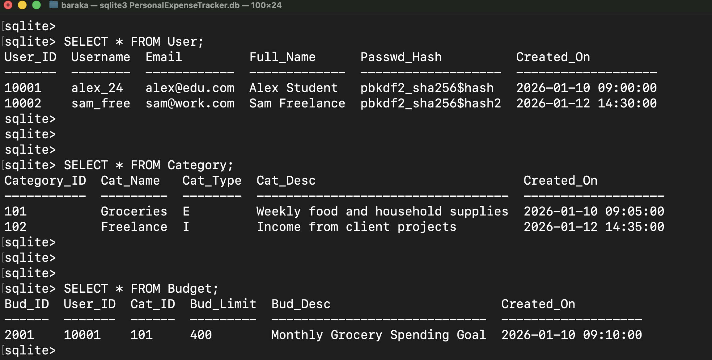
Figure 8 — Users, Categories, and Budgets sample data

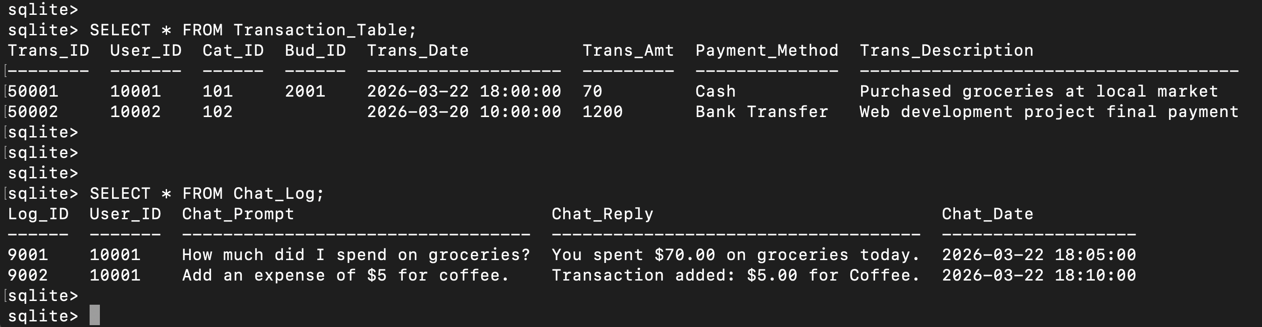
Figure 9 — Transactions and ChatLog sample data

5.8 Validation Rules
Field | Rule
Amount | Must be a positive number; maximum $1,000,000.
Username | 3–50 characters; letters, numbers, and underscores only.
Password | Minimum 6 characters; stored as SHA-256 hash (never plain text).
Category name | Required; maximum 50 characters; must be unique per user.
Budget name | Required; maximum 100 characters.
Description / Notes | Optional; maximum 500 characters.
Transaction date | Must be after 2000-01-01; no more than 1 year in the future.
Chat message | Maximum 2,000 characters per message.

6. Key Design Decisions
Design Decision | Rationale
Balance recalculated from scratch on every write | Prevents incremental math drift. After every insert, update, or delete on the Transactions table, recalculate_balance() sums all CREDIT and subtracts all DEBIT amounts for the user to recompute the exact current balance.
Transactions.category stored as free string (not FK) | Decouples transaction history from the categories table. Renaming or deleting a category does not break any historical records. Trade-off: no database-level referential integrity between transactions and categories.
Token-based authentication (no cookies) | Streamlit does not reliably support server-side cookie sessions. A 64-char hex token is generated at login, stored in the Tokens table and in Streamlit's session_state, then sent via X-Auth-Token header on every request.
AI Proxy Pattern (UI → Flask → Ollama) | The Streamlit UI never contacts the LLM directly. Flask retrieves DB context, builds a precise structured prompt, calls Ollama, parses the JSON response, validates the action, and executes the DB change — ensuring the AI only operates on authorized, validated data.
WAL mode for SQLite | WAL (Write-Ahead Logging) allows concurrent readers while a write is in progress, preventing lock contention between the Flask API server and any external diagnostic or test scripts.
Schema migration guards in init_db() | Two ALTER TABLE statements are wrapped in try/except to add the budget_id column to Transactions and remove a stale column from Budget — allowing older database files to upgrade in-place without data loss.

