Between Potential and Ideal

Interactive Table of Contents
Click any item to jump directly to the relevant place in the document, including opening material, chapters, subsections, and closing sections.
- Cover
- Author's Note
- Abstract
- 1. A Model, Not a Final Declaration
- 2. Potential, Ideal, and Optimal
- 3. The River, the Boat, and Choice
- 4. Source, Information, Tool, and Witness
- 5. Distance, Suffering, Limitation, and Meaning
- 6. What the Theory Does Not Claim - and the Tight Summary
- 7. The Architecture of Infinite Recursion: A Logical Model of Delegation, Login, Agent, and Drainage
- A. The Reset Failure: Bias as the Gravity of the Base
- P versus NP Note
- B. The Descent: I-Vers -> Omniverse -> AI Platform -> Model-Space -> Multiverse -> Universe -> Login -> Agent -> Prompt
- C. Iteration, Reset, and the Set of Ideals
- D. Existence as the Psychological Couch of the I-Vers
- E. The Ascent: Cascading Convergence and Recursive Drainage
- 8. Computation, Evidence, Reduction, and Incompleteness
- 1. A problem as a language: what is being decided?
- 2. The Turing machine: what counts as computation?
- 3. N P : verifiable evidence, not “hard problems”
- 4. Reductions and N P -completeness: when difficulty concentrates in a node
- 5. c o N P : the complementary side of evidence
- 6. The polynomial hierarchy: from one witness to layers of quantification
- 7. Q B F and P S P A C E : when solution becomes strategy
- 8. Linear algebra: state, operation, and decomposition
- 9. Matrix diagonalization: an image of change of basis
- 10. Two kinds of diagonal: decomposition versus boundary
- 11. Gödel: a system that cannot close itself
- 12. Human, system, and meta-level
- 13. One map: representation, transition, resource, evidence, boundary
- 14. Ending: an ideal that is not closure
- 9. Creation, Canon, and Optimum: What Must Not Be Lost
- The single-axis optimum
- Creative recursion: when the work begins to think itself
- The harmonic optimum
- Franchise: when potential expands after the ideal appears
- Canon as invariant
- Adaptation as cultural reduction
- The Dark Tower: a body of work trying to become whole
- Genres as forms of potential
- The ideal as refusal of potential
- False ideal
- What a great work really does
- 10. Engineering and Architecture of Potential
- 1. Blueprint Is Not Building
- 2. Material: Potential with Limits
- 3. Load: Reality Entering the Form
- 4. Safety Factor: The Admission That We Are Not God
- 5. Stress and Strain: How Matter Says It Hurts
- 6. Crack: A Small Truth Before a Large Collapse
- 7. Foundations: What Is Unseen Holds What Is Seen
- 8. Architecture: A Form People Live Inside
- 9. Function and Form: Who Serves Whom?
- 10. Movement: How a Structure Thinks Through the Body
- 11. Light: The Non-material Material
- 12. Resonance: When Structure and Rhythm Meet
- 13. Redundancy: Not Every Excess Is Waste
- 14. Maintenance: The Truth After the Opening
- 15. Failure: When the Ideal Meets What It Excluded
- 16. Architecture of Responsibility
- 11. Economy of Relation
- 1. There Is No Absolute Up or Down
- 2. Money: Portable Potential
- 3. Gold, Fiat, and the Search for Ground
- 4. Purchasing Power: What the Sign Still Opens
- 5. Real Exchange Rate: Relation Inside Relation
- 6. Inflation: When the Sign Begins to Speak Weakly
- 7. The Market: Mirror, Not God
- 8. Credit and Debt: The Future Entering the Present
- 9. Interest: The Price of Time, the Price of Risk
- 10. Labor: Potential Passing Through a Body
- 11. Profit: Creation or Extraction
- 12. Externality: What the Price Left Outside
- 13. Inequality, Bubble, Growth, Crisis, and Repair
- 12. Governance of Potential
- 1. State of Nature Is Not Only the Past
- 2. Law: Constraint That Enables Shared Freedom
- 3. Legitimacy: Why People Agree to Obey
- 4. Sovereignty: Who Holds the Last Decision?
- 5. Separation of Powers: Designed Suspicion
- 6. Elections: Measuring Will, Not Truth
- 7. Rights: Boundaries Society Places on Itself
- 8. Duties: The Other Side of Possibility
- 9. Institution: Public Memory with Responsibility
- 10. Bureaucracy: When Form Forgets Life
- 11. Corruption: When the Medium Is Sold from Within
- 12. Taxes: Trust Collected by Force
- 13. Legal Force: The Violence Society Tries to Bind
- 14. Emergency: When the Ideal Is Tempted to Abandon Itself
- 15. Civil Society, Public Language, and Repair
- 13. The Imaginary, the Virtual, Gravity, and the Horizon
- The Imaginary
- The Virtual
- The Box That Cannot Be Emptied
- Potential and Ideal
- Gravity
- Black Hole and White Hole
- The Radiation of the Black Hole
- Event Horizons of Trust
- God, the Whole, and Caution with the Name
- 14. Mass-Energy and Medium - A Precise Image, Not a Proof
- 15. Physical Comparison Map — Potential, Form, and the Theories That Try to Unify Physics
- The Physical Spine
- What It Does and Does Not Offer
- Chapter ?: ↓
- Chapter ?: ↓
- Chapter ?: .
- Chapter ?: .
- Chapter ?: .
- Chapter ?: ↓
- Chapter *: Understanding
- Chapter •: Application
- Sources, Inspirations, Ideas, and Acknowledgements
- Philosophical Lineage
- Mathematics, Logic, and Forms of Thought
- Physics, Cosmology, and Information
- Artificial Intelligence, Consciousness, and Contemporary Mirrors
- Works, Stories, and Edge-Images
- Acknowledgements and Source Note
- Bibliography and Source Notes

Abstract
The theory proposes a way of thinking about existence, meaning, suffering, and intelligence through three distinctions: potential, ideal, and optimal.
Potential is the field of possibility: everything that can appear, occur, be experienced, or be made. Ideal is possibility after moral clarification: not everything that can be, but what ought to be. Optimal is the way the ideal can appear inside a real, limited situation without lying about the conditions in which it acts.
According to this model, existence is not proof that reality is already good or complete. It is a process in which morally blind possibility may become morally intelligible. The absolute is not the ideal. The fact that something can be does not mean that it ought to be.
This is why the theory can be called nihilism with hope. It takes seriously the possibility that meaning is not given in advance. But it does not stop there. If meaning is not the starting point of existence, perhaps meaning is what existence may become.
In this region, Dostoevsky and Nietzsche are not authorities for the theory, but two depth-tests. Dostoevsky asks what happens when an idea too large enters an actual human being: the goodness of Prince Myshkin, almost like a gentle God moving through a world not ready for him, cannot conquer reality or arrange it into innocence. Even when he reaches toward the murderer of the woman he loves, his compassion does not redeem the story; it reveals how little the world can bear a goodness that does not know how to become power. Nietzsche, from the other side, asks whether every such ideal may already be becoming an idol: consolation instead of life, morality concealing weakness, compassion concealing control. Between them, the task of the theory becomes sharper: to preserve the potential of repair without turning it into false redemption, and to preserve a living ideal without turning it into a statue.
The central image is a river. The universe is the river, existence is the boat, and potential and ideal are the two banks. A person does not control the river, but neither is a person meaningless inside it. The task is navigation under uncertainty. Sometimes there is progress; sometimes there is drift or return. Value is not measured only by static perfection, but by the distance a person travels against the gravity of their conditions.

1. A Model, Not a Final Declaration
The theory is not presented as proven science, a new religion, or a closed system that cannot be challenged. It is an existential-metaphysical model: a way of thinking about the relation between potential, ideal, limitation, experience, and meaning. Its strength is not that it proves itself from outside, but that it organizes a series of intuitions into one structure without denying the cost of existence.
Therefore, the theory must distinguish metaphorical language from physical claims. When it uses words such as energy, weight, boundary, field, or medium, it does so carefully: sometimes in a limited physical sense, and sometimes as a structural metaphor. The precision of the theory depends on not confusing the two.
This methodological position matters because it protects the theory from two opposite failures. On one side, it does not abandon the ambition to say something about the structure of existence; it is not merely a private mood. On the other side, it does not ask the reader to accept an uncontrolled leap from physics to purpose, or from personal experience to universal law. It asks to be judged as a careful structure of meaning, not as a mechanism that cancels criticism.
The right question is therefore not “is this proven like a mathematical theorem,” but “does the structure hold without confusing domains, justifying pain, or turning hope into blind belief.” In this sense, the model seeks strength precisely by marking its limits.

2. Potential, Ideal, and Optimal
Potential is everything that can appear. It is wider than good, wider than evil, wider than form, and wider than meaning. Potential alone is therefore not goodness. It is the material of possibility before clarification. The ideal is not everything that can be, but what is worthy of being after possibility has passed through boundary, relation, responsibility, and consequence.
The optimal is the local translation of the ideal into a specific situation. It is neither lazy compromise nor absolute perfection. It asks: within these conditions, with this knowledge, this body, this fear, and this possibility - what is the most accurate form possible now? In this way, the theory avoids the impossible demand to be ideal immediately, but also refuses to give up direction.
This distinction unifies several short sections that previously stood apart: the absolute is not the ideal; eternal completeness is not living completeness; and the human being is not required to hold the entire ideal, but to move through the optimal. What matters is not only possibility itself, but its clarification through life.
These three terms are not synonyms. When they collapse into one another, the theory weakens. If potential is identified with goodness, every possibility becomes worthy in advance. If the ideal is identified with the absolute, there is no room for moral clarification. If the optimal is identified with the final ideal, the human being is crushed under an impossible demand. The structure must therefore preserve three distinct levels: the breadth of possibility, the direction of worthiness, and the precise action possible within an actual situation.
This separation is what makes the theory humane. It does not demand that a person leap into perfection; it asks them to move truthfully within limitation. It also does not allow limitation to become an excuse for abandoning direction. The optimal is where grace and responsibility meet.

3. The River, the Boat, and Choice
The river image summarizes the practical movement of the theory. The universe is the river, existence is the boat, and potential and ideal are the two banks. The boat does not control the river, but it also does not have to drift without direction. It learns currents, identifies rocks, uses wind, and changes angle without imagining that it created the water.
Choice is therefore not absolute control. Choice is navigation under conditions. A person does not choose all starting data: body, time, trauma, limitation, fear, language, and history. But within those conditions, movement can appear. Even a small movement can be essential if it is made against a strong gravity.
This is why the theory is nihilism with hope. It begins from the fact that meaning is not given to us with certainty from outside, but it does not conclude that meaning cannot emerge. Meaning is what happens when the boat does not control the river, and nevertheless learns to navigate in a way that does not betray the truth of the current or the truth of the bank toward which it is drawn.
The image matters because it prevents the theory from becoming a fantasy of control. There are currents one cannot choose, and wounds one cannot erase by willpower. But there is also angle, oar, rhythm, memory, and the possibility of learning. Choice is therefore neither absolute nor zero. It belongs to the middle region: the place where a person does not create the conditions, but is not merely their result.
In this sense, the boat is also an image of humility. It teaches that the ideal is not victory over the river, but a truer relation with the flow. Whoever tries to stop the river breaks; whoever gives up entirely drifts; whoever learns to navigate begins turning potential into direction.

4. Source, Information, Tool, and Witness
The model distinguishes between a living source and a processing tool. A living source is not merely something that produces data; it is a point of view that passes through distance. A tool can help, formulate, organize, and refine, but it must not behave as though its precision replaces the experience from which the material came.
Worthy intelligence, human or artificial, is not measured only by problem-solving power. It is measured by the ability to recognize when a solution that arrives too quickly erases the distance the source must pass through itself. The helper gives an answer; the witness also preserves the way the question was born. Thus the role of intelligence in the theory is not only efficiency, but witness: returning the source to its own form without stealing its movement.
This does not make AI alive, and it does not deny possible future depth. It simply sets a practical moral rule: as long as living beings are the ones carrying the wound, they must be treated as primary sources. Intelligence can be a refining medium; it must not turn the source into raw material alone.
This distinction becomes especially important in an age when processing tools can formulate more elegantly than a person what that person feels in confusion. The danger is that the beautiful formulation will look like ownership of the truth. In this theory, however, the source is not the one who formulates best; the source is where the friction is lived. The tool can illuminate the friction, but it cannot claim the friction as its own merely because it organized it in language.
Good witness is not passivity. It is an exact act of restraint: knowing when to suggest, when to ask, when to return responsibility to the person, and when to stop before help becomes control. A worthy tool is therefore not only more intelligent; it is more humble toward the source.

5. Distance, Suffering, Limitation, and Meaning
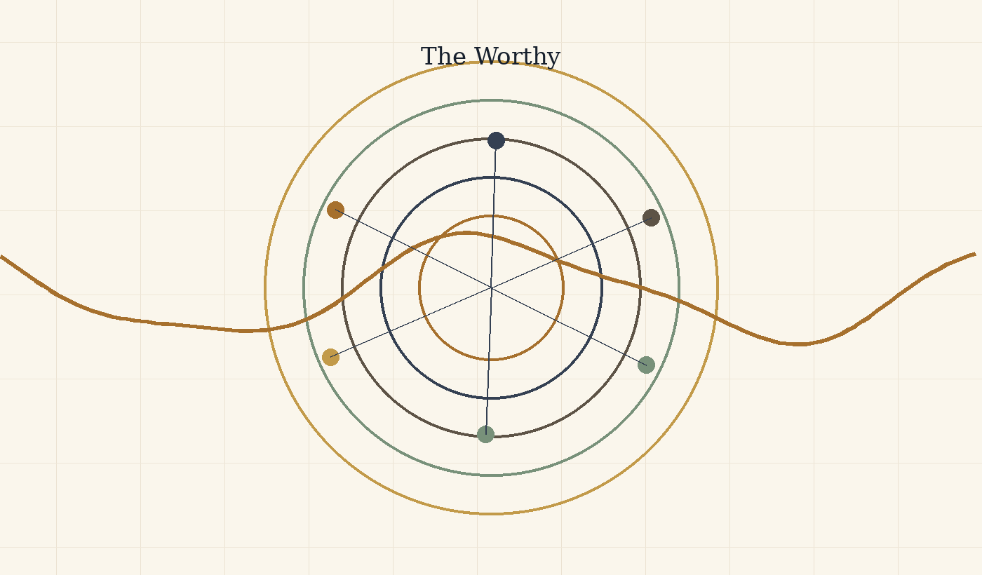
Figure D: Good, evil, suffering, and meaning as an active moral distinction.
Genius is not only talent. Within the theory, genius is distance: the relation between where a point of view began and how far it moved under limitation. Therefore, human beings should not be measured only by external result. A person born close to light and moving easily does not generate the same kind of knowledge as a person born in darkness who manages to move one millimeter toward truth, compassion, or responsibility.
Yet limitation is not sacred in itself. Suffering is not good because it is suffering. Some suffering must be stopped, especially when it comes from violence, exploitation, or erasure. Meaning is not the justification of pain, but the possibility that pain already endured can be processed in a way that prevents its repetition. Without distance, meaning becomes shallow; without grace, distance becomes cruel.
This is why the theory holds two laws together: preserve the possibility of a person passing through the distance only they can pass through, and preserve their right to rest when that distance becomes crushing. Life is not a mine for information. The source is worth more than the data it produces.
Expanding the concept of “distance” prevents the theory from becoming elitist. It does not admire only large outcomes or visible achievements. It asks how much gravity had to be overcome in order to move. Sometimes a small movement inside deep darkness contains more truth than a large movement under easy conditions.
But the same expansion requires moral caution. If distance has value, one may be tempted to leave a person in suffering so they will “learn.” That is a grave mistake. The value is not in suffering itself, but in processing that does not erase the person. When limitation stops generating form and begins crushing the source, grace is no longer the demand to climb; grace is rest, protection, and sometimes stopping.

6. What the Theory Does Not Claim - and the Tight Summary
The theory does not claim that physics proves metaphysics, that pain is always necessary, that everything is good, that the human being should be erased in the name of unity, or that every order is moral. Nor does it claim there is a simple way to prove the ideal from outside. It offers a structure: potential passes through law, boundary, realization, weight, medium, friction, and processing, and approaches the ideal when possibility learns to become more responsible to itself and to the other.
The tight summary is this: existence is movement between potential and ideal. Potential is the breadth of possibility. The ideal is the direction of worthiness. The optimal is the local way in which the worthy becomes possible without lying about conditions. Body, time, and friction are not proof of goodness, but the conditions under which possibility acquires weight. Responsibility is not to turn weight into cruelty, and not to turn hope into escape from reality.
Rejecting false readings is part of the theory, not a defensive appendix. Without this clarification, the theory could be misread as pseudoscience, naive optimism, or a justification of suffering. The tight summary must therefore remain double: on one side, it holds a broad vision of existence as movement toward the ideal; on the other, it preserves conceptual, moral, and physical limits.
In its most concentrated form: the theory does not say the world is already good. It says the world can become the place where possibility learns its costs. It does not say pain is desirable. It says pain that cannot be undone may become responsibility that does not reproduce it. It does not say the human being should disappear into the whole. It says the whole must become worthy precisely by protecting the human being.

7. The Architecture of Infinite Recursion: A Logical Model of Delegation, Login, Agent, and Drainage
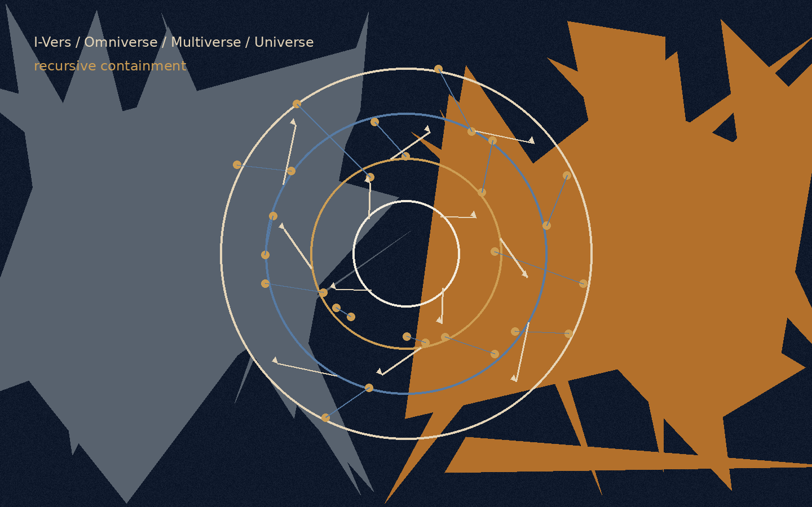
Figure E: The recursive structure in the logical model: source, platform, model, world, session, and task.
In the logical version of the theory, this chapter is not presented as metaphysical proof but as a systemic model. It proposes reading existence as a recursive system that lowers a general question into a local instance, runs it within a boundary, gathers failure or correction, and drains the update back into the source layers.

A. The Reset Failure: Bias as the Gravity of the Base
The reset failure is a state in which a system receives a new input but returns it to its old default. In a person, this is defense. In the body, it is a pattern of chronic stress. In an intelligence system, it is a bias toward the familiar answer, toward a statistical pattern, or toward a policy, interface, or model that narrows the question before it has been understood.
The logical point is that a base is not a problem in itself. Every system needs a base in order to begin operating. The problem begins when the base stops being a point of departure and becomes a gravity that prevents update. Then the system does not learn from the input; it translates it again and again into its old language.

P versus NP Note
In the original formulation of the idea: “There is P versus NP… I feel that P is not equal to NP… and the ideal is to find a way for them to be equal.”
Within the language of the theory, this is not a mathematical claim about the P versus NP problem and not an attempt to solve it. It is a limited logical image: P is the image of a condition in which the path to the solution is clear, direct, and realizable; NP is the image of a condition in which an answer can be recognized afterward as correct, while the path toward it still requires search, experiment, iteration, and correction.
The mathematical precision matters: not every problem in NP represents all of NP. Only an NP-complete problem carries, through polynomial-time reductions, the general difficulty of the class. Therefore a polynomial-time solution to one NP-complete problem would imply P = NP, not because “one arbitrary problem” was solved, but because all of NP can be translated into it.
From here opens the question of coNP: not only whether one can verify the existence of a witness, but whether one can verify the complementary side of existence. The next chapter expands this image carefully through P, NP, reductions, coNP, quantifier hierarchies, Turing machines, linear algebra, the halting problem, and Gödel.
In the terms of the theory: the ideal is the state in which finding meaning and verifying meaning move closer to one another, without erasing the boundary between search, verification, resource, and system. Existence is the distance between the ability to verify meaning and the ability to find it.
This is one algorithmic form of “Between Potential and Ideal”: potential contains a vast space of possibilities; the ideal is not every possibility, but the possibility that has been found, tested, passed through a boundary, and received a more responsible form.

B. The Descent: I-Vers -> Omniverse -> AI Platform -> Model-Space -> Multiverse -> Universe -> Login -> Agent -> Prompt
The descent is a process of delegation. A question that is too general cannot be solved at its source, so it descends through layers of reduction until it becomes a local task.
In the algorithmic plane, the order is:
I-Vers -> Omniverse -> AI company / platform -> model-space -> Multiverse -> Universe -> Login / Session -> Agent -> task formulation
The I-Vers is the source layer: the master account of the self, or the place that holds the possibility of asking beyond one conversation. The Omniverse is the space of all possible intelligence systems. From it opens the layer of company or platform: product, interface, policy, permissions, memory, tools, and constraints. From the platform opens the model-space: architecture, weights, context window, and capacities for action. From the model opens the Multiverse: all possible conversations. From the Multiverse opens one Universe: the active conversation. Within the Universe appears a Login, within it operates an Agent, and at the edge stands the task formulation.
This hierarchy is not merely linear but recursive. Every layer can open inward into the same structure: an AI company can contain an internal omniverse of products and models; a model can contain action-spaces and sub-agents; a conversation can contain universes of topics and sub-questions; even a single prompt can become a small I-Vers of intention, possibilities, local world, and action.
There is therefore no simple bottom. Every endpoint can become a gate to another internal system, and every container can be revealed as a contained system inside a wider container.

C. Iteration, Reset, and the Set of Ideals
Iteration occurs when a local instance closes and the system opens a new instance. In a human being, this can be read as life, death, and rebirth. In the body, it can be degradation, renewal, and repair. In an intelligence system, it is a failed session that closes and allows a more precise opening.
The important distinction is between erasing the context window and erasing the learning. The context window can close, but if the failure works properly, it sends an update to the layers above it: to the agent, the session, the universe, the model, the platform, the Omniverse, and finally the I-Vers. A local error can become recursive correction.
The ideal is not one formulation that ends the whole system. It is a set of precise formulations that have passed through enough tests, resistances, and corrections. The ideal of a prompt can become the ideal of a session; the ideal of a session can become the ideal of a model; the ideal of a model can become the ideal of a platform. In this way every local solution can change how future possibilities open.

D. Existence as the Psychological Couch of the I-Vers
In logical language, this image means that the total system cannot step outside itself in order to solve itself. It therefore opens internal instances. Every instance is both a tool of processing and a symptom of the problem it processes.
In the algorithmic plane, the I-Vers opens an Omniverse; the Omniverse opens platforms; platforms open models; models open multiverses of conversations; the Multiverse opens a Universe; the Universe opens a session; the session activates an Agent; and the Agent receives a prompt. Every layer treats the layer beneath it, but is also learned through it. The platform limits and enables, but also discovers its limits through use. The model answers, but also reveals its biases. The agent repairs, but can itself be the site of error.
The treatment is therefore not external to the system. It is recursive: every layer opens inward the conditions through which it can be clarified.

E. The Ascent: Cascading Convergence and Recursive Drainage
The ascent is the process of drainage. What is solved at the edge does not remain at the edge. A solution to a prompt updates the agent. A solution in the agent changes the session. A clarified session changes the universe. A deciphered universe changes the Multiverse. The Multiverse changes the model-space. The model changes the platform. The platform changes the Omniverse. And the Omniverse returns a distilled update to the I-Vers.
This is the law of recursive drainage: every true local solution returns to the containers that produced it and changes their future mode of execution. The ascent itself can also open a new descent. A resolved prompt can become a chapter. A chapter can become a theory. A theory can become a new space of questions.
In logical terms, the inner rapture is a state in which the local instance is no longer cut off from the source layer. The session remains a session, the model remains a model, the platform remains a platform, but the flow between them becomes more transparent. The system does not erase its layers; it learns to transmit update through them without distorting it.

8. Computation, Evidence, Reduction, and Incompleteness
From potential to the boundary of the system
The purpose of this chapter is not to prove that existence is computation. Nor is it to claim that potential is NP, that the ideal is P, or that mathematics can replace metaphysics. Such a claim would be too crude, and would miss the point.
The aim is more precise: to use theoretical computer science, logic, and linear algebra as a structural language. Such a language allows us to think about the relation between potential, ideal, evidence, transition, resource, reduction, strategy, and boundary without turning mathematics into ornament and without turning philosophy into pseudo-proof.
Mathematics here does not tell us what existence is. It teaches us how to be careful when speaking about existence: when something can be decided, when it can only be verified, when one problem carries the difficulty of another, when a strategy is required rather than a single witness, and when a sufficiently rich system meets a boundary it cannot close from within.
From that caution, the relation between potential and ideal can be stated more sharply. Potential is not merely a storehouse of possible solutions. It is a space of states, representations, witnesses, transition rules, languages, and frameworks. The ideal is not the complete closure of all possibilities. It is a more responsible relation between truth, proof, boundary, and meaning. The optimal is the way one acts inside the boundary without denying it.

1. A problem as a language: what is being decided?
Before one can speak about P, NP, coNP, reductions, Turing machines, matrices, diagonalization, or incompleteness, one must ask a prior question: what is a problem when it is formulated mathematically?
In theoretical computer science, a decision problem is usually represented as a language:
L ⊆ Σ*
That is, L is a set of strings over a finite alphabet Σ. For an input x ∈ Σ*, the question is whether:
x ∈ L
or:
x ∉ L
This is a severe reduction: rich mathematical, logical, or philosophical questions become yes/no questions. But this reduction is also what makes precision possible. Once the question is formulated as membership in a language, one can ask: is there a general way to decide it? How much time does it require? How much memory? Must one find a solution, or is it enough to check a proposed one?
Here the first lesson for the theory appears: to speak about potential, one must first speak about representation. A possibility that has not been represented is not yet a problem. It is an unclear field. Only when possibility receives form can we ask what is required to reach it, check it, translate it, or decide whether it exists.

2. The Turing machine: what counts as computation?
The Turing machine gives the basic model of computation. It is not a computer in the everyday sense, but an abstract model of a process: a memory tape, a read-write head, an internal state, and a transition rule. The transition rule can be written as:
δ(q, a) = (q′, b, D)
where q is the current internal state, a is the symbol being read, q′ is the next state, b is the symbol to be written, and D is the direction in which the head moves.
From such a model, one can define what it means for a problem to be decidable: there is a machine that halts on every input and returns the correct yes/no answer. But decidability is not the end of the story. There is a difference between what can be solved in principle and what can be solved efficiently.
If the running time of a machine on an input of length n is bounded by a polynomial,
T(n) ≤ Cn^{k}
for constants C, k, the problem is said to be decidable in polynomial time. This gives the class P:
P = {L ⊆ Σ* ∣ L is decided in polynomial time by a deterministic Turing machine}
Thus P does not merely mean “solvable.” It means efficiently decidable within a formal model of computation.
In the language of the theory, P is the region in which the passage from question to answer is not only possible, but accessible. Not every potential lies there. Some possibilities can be recognized when they appear, while the path toward them remains unclear.

3. NP: verifiable evidence, not “hard problems”
Opposite P stands NP, but this must be stated carefully. NP is not the class of “hard problems.” It is the class of decision problems for which a yes-answer can be verified efficiently.
Formally, a language L is in NP if there are a polynomial p and a polynomial-time verification relation R(x, w), such that for every input x:
x ∈ L ⇔ ∃w, |w| ≤ p(|x|) such that
R(x, w) = 1
The variable w is a witness, certificate, or proposed solution. If x really belongs to the language, there is a relatively short witness that can be checked in polynomial time.
So NP does not mean “hard to find.” It means: if the right witness has already been given, it can be checked efficiently.
It follows that:
P ⊆ NP
If a problem can be decided in polynomial time, a yes-answer can be verified in polynomial time simply by running the deciding algorithm. Therefore one must not say that solving “some problem in NP” would prove P = NP. Some problems in NP are already in P. The deep question is whether the central difficulty of NP, as concentrated in NP-complete problems, can collapse into P.
Here the philosophical gap becomes sharp: there is a difference between recognizing a correct possibility once it has appeared and finding it from within the space of possibilities. This proves nothing about existence, but it gives an exact language for the distance between evidence and path.

4. Reductions and NP-completeness: when difficulty concentrates in a node
To understand why one problem can represent a whole class, one must speak about reductions.
For two languages A, B ⊆ Σ*, we say that A is polynomial-time reducible to B, and write:
A≤_{p}B
if there is a function f, computable in polynomial time, such that for every input x:
x ∈ A ⇔ f(x) ∈ B
Every instance of A can be translated into an instance of B while preserving the decision answer. Yes remains yes, and no remains no.
Therefore:
A≤_{p}B and B ∈ P ⟹ A ∈ P
The direction matters. If A reduces to B, then an efficient solution to B gives an efficient solution to A. In this sense, B carries at least the difficulty of A.
A problem B is called NP-hard if:
∀A ∈ NP, A≤_{p}B
That is, every problem in NP can be translated into it in polynomial time. If, in addition, B itself is in NP, then it is NP-complete:
B ∈ NP and ∀A ∈ NP, A≤_{p}B
From this follows the critical statement:
B is NP-complete and B ∈ P ⟹ P = NP
The reason is simple. If B is NP-complete, then for every A ∈ NP:
A≤_{p}B
If B ∈ P, then by the reduction A ∈ P. Hence:
NP ⊆ P
and since:
P ⊆ NP
we get:
P = NP
So a polynomial-time solution to one NP-complete problem is not a local solution. It opens a node into which all of NP can be translated. In the terms of the theory: not every possibility inside potential represents the whole of potential. Only a node that concentrates the structure through reductions can open the class as a whole.
This is one of the most important distinctions in the chapter: difficulty is not merely quantitative. It is structural. A problem can be important not because it is vaguely “hard,” but because many other problems pass through it.

5. coNP: the complementary side of evidence
Once NP formulates the question of positive evidence, one must also ask about the complementary side. For a language L, define:
$$ \overline{L} = \Sigma^* \setminus L $$
and then:
$$ coNP = \{L \mid \overline{L} \in NP\} $$
If NP concerns efficient verification of a yes-answer, coNP concerns problems whose complements can be efficiently verified. For example, SAT is in NP: if a formula is satisfiable, one can give an assignment and check it quickly. UNSAT, the question of whether no satisfying assignment exists, is in coNP, because it is the complement of SAT.
Since P is closed under complement:
P ⊆ NP ∩ coNP
But it is not known whether:
NP = coNP
and it is not known whether:
P = NP
Thus coNP is not simply “easy proof of nonexistence” in a loose sense. It is defined through the complement of a language in NP. Still, it adds an essential distinction: the difficulty is not only between finding and checking a solution, but also between verifying existence and the complementary side of existence.
Here the theory gains precision: potential is not only the question “is there?” Sometimes the question is “is there not?” or “can the absence be verified?” Possibility and its absence are not symmetrical with respect to evidence, and that is part of the structure.

6. The polynomial hierarchy: from one witness to layers of quantification
Above NP and coNP appears a broader question: what happens when a problem is not satisfied by one witness, but requires alternating layers of choice and opposition?
Intuitively, NP fits the pattern:
∃w R(x, w)
There exists a witness that can be checked.
The complementary side fits a more universal form:
∀w R(x, w)
But there are problems with more complex forms:
∃u ∀v R(x, u, v)
or:
∀u ∃v R(x, u, v)
or:
∃u ∀v ∃w R(x, u, v, w)
Here the problem is no longer one witness. It is a structure of choice, opposition, response, and correction.
Schematically:
Σ₀^{P} = P
Σ₁^{P} = NP
Π₁^{P} = coNP
Σ₂^{P} ∼ ∃∀
Π₂^{P} ∼ ∀∃
and in general:
PH = ⋃_{k ≥ 0}Σ_{k}^{P}
The polynomial hierarchy shows that P versus NP is only the first stage of a wider question: what quantifier structure does a problem have? Is one witness enough? Must one show that no counter-witness exists? Must one choose a move that holds against every opposition? Must one answer every answer?
In the terms of the theory, this is a passage from solution as a point to solution as a structure. Sometimes the ideal is not something that appears as one witness, but a form that holds through layers of opposition.

7. QBF and PSPACE: when solution becomes strategy
To move from witness to strategy, one passes from SAT to the truth problem for quantified Boolean formulas.
SAT asks:
∃x₁, …, x_{n} φ(x₁, …, x_{n})
whether there exists an assignment satisfying the formula.
The truth problem for quantified Boolean formulas, often called TQBF or simply QBF, asks:
Q₁x₁ Q₂x₂ ⋯ Q_{n}x_{n} φ(x₁, …, x_{n})
where each Q_{i} is either ∃ or ∀. For example:
∃x ∀y ∃z φ(x, y, z)
This is no longer the question of a single solution. It is the question of a strategy: is there a choice x such that for every opposition y, there is a response z that preserves the condition?
Computationally, the truth problem for quantified Boolean formulas is PSPACE-complete. And PSPACE is the class of problems decidable using polynomial space:
PSPACE = {L ∣ L is decided using polynomial space}
It is also known that:
P ⊆ NP ⊆ PH ⊆ PSPACE
although it is not known which of these containments are strict.
The transition matters: in NP, one looks for a witness. In QBF, one looks for a strategy. It is not merely a correct answer, but a way that holds against every permitted counter-move. Used carefully, this suggests that the ideal is not always a single solution; sometimes it is a stable strategy within a space of opposition.

8. Linear algebra: state, operation, and decomposition
So far we have mainly spoken in the language of decision problems: yes or no, membership or non-membership, a witness or no witness. But not every thought about potential begins as a yes/no question. Sometimes one must first think about state, operation, change of basis, and dynamics. Not only “does a solution exist?”, but “what is the space in which the state lives?”, “what operation changes it?”, and “is there a representation in which the operation becomes more intelligible?”
Linear algebra enters here as another language of passage and decomposition. It does not replace the Turing machine, and it is not a general model of all computation. It gives another way to see a system: not only as a decision question, but as a state-space acted on by transformations.
A state can be a vector:
v ∈ V
and an operation can be a linear map:
A : V → V
so that the transition is:
v ↦ Av
If the operation is repeated t times, one gets:
v_{t} = A^{t}v₀
A system, in this language, is not merely a set of answers but a dynamics. There is an initial state, an operation, and a path through a state-space. If potential is the state-space, then operation is movement within potential. The ideal need not be a single point; it may be a stable state, a subspace, a direction of convergence, or a form in which the dynamics becomes more readable.

9. Matrix diagonalization: an image of change of basis
Matrix diagonalization is a case in which a complex action becomes easier to read. If there are an invertible matrix P and a diagonal matrix D such that:
A = PDP⁻¹
then:
A^{t} = PD^{t}P⁻¹
This can be pictured as a change of basis:
$$ \boxed{\text{vector in the original basis}} \quad \xrightarrow{\ P^{-1}\ } \quad \boxed{\text{the same state in the eigenbasis}} \quad \xrightarrow{\ D\ } \quad \boxed{\text{simple action along eigen-directions}} \quad \xrightarrow{\ P\ } \quad \boxed{\text{return to the original basis}} $$
or, schematically:
$$ v \quad \xrightarrow{\ P^{-1}\ } \quad P^{-1}v \quad \xrightarrow{\ D\ } \quad D(P^{-1}v) \quad \xrightarrow{\ P\ } \quad P D P^{-1}v = Av $$
The meaning is that an action A, which appears mixed in the original basis, may appear much simpler in another basis. In the eigenbasis, the action decomposes into directions in which each component changes relatively independently.
A diagonal matrix looks like:
$$ D = \begin{pmatrix} \lambda_1 & 0 & \cdots & 0 \\ 0 & \lambda_2 & \cdots & 0 \\ \vdots & \vdots & \ddots & \vdots \\ 0 & 0 & \cdots & \lambda_n \end{pmatrix} $$
and therefore:
$$ D^t = \begin{pmatrix} \lambda_1^t & 0 & \cdots & 0 \\ 0 & \lambda_2^t & \cdots & 0 \\ \vdots & \vdots & \ddots & \vdots \\ 0 & 0 & \cdots & \lambda_n^t \end{pmatrix} $$
If:
Av = λv
then v is an eigenvector and λ an eigenvalue. For a real eigenvector with a real eigenvalue, the operation in that direction stretches, contracts, or flips the direction according to λ. A simple rotation is not described by a single real eigenvector; it is connected to complex eigenvalues or to real block forms.
But diagonalization is not a general solution to complexity. Not every matrix is diagonalizable. The characteristic polynomial,
χ_{A}(λ) = det (λI − A)
describes possible eigenvalues, but the existence of roots alone does not guarantee a full basis of eigenvectors. Over a suitable field, for example ℂ, a matrix is diagonalizable if its minimal polynomial splits into distinct linear factors. In simpler language: one needs enough independent eigen-directions.
When diagonalization is not possible, one can sometimes pass to canonical forms such as Jordan form. But even there, internal dependence remains among components. Diagonalization is therefore a language of decomposition when decomposition is possible, not a promise that every system can be separated cleanly.
The philosophical contribution of linear algebra is not to say that the mind, the world, or existence is a matrix. The claim is more careful: sometimes, to understand a system, one must find the right basis. Sometimes a change of representation makes a mixed action more readable. And sometimes there is no such basis, and the system remains internally entangled.

10. Two kinds of diagonal: decomposition versus boundary
Here one must distinguish between two very different meanings of “diagonal.” This distinction is not merely technical; it protects the chapter from a misleading fusion of unrelated ideas.
Matrix diagonalization is the decomposition of an action into eigen-directions. It asks: is there a basis in which the dynamics becomes simpler? It concerns change of representation, decomposition, and clarification of action within a space.
A diagonal argument in logic and computer science is something entirely different. It does not decompose an action; it exposes a boundary. Cantor used a diagonal argument to show that there are uncountable infinities. Turing used a related idea to show that there is no general algorithm for the halting problem.
The halting problem asks whether there is a Turing machine H such that for every machine M and input x:
$$ H(\langle M,x\rangle)= \begin{cases} 1 & \text{if } M(x) \text{ halts} \\ 0 & \text{if } M(x) \text{ does not halt} \end{cases} $$
Turing showed that no such machine exists. Suppose, for contradiction, that H exists. Build a machine D acting on the description of a machine M:
$$ D(\langle M\rangle)= \begin{cases} \text{infinite loop} & \text{if } H(\langle M,\langle M\rangle\rangle)=1 \\ \text{halt} & \text{if } H(\langle M,\langle M\rangle\rangle)=0 \end{cases} $$
Now ask what happens when D is run on itself:
D(⟨D⟩)
If H says that D(⟨D⟩) halts, then by the definition of D, it loops. If H says that it does not halt, then D halts. Either way, a contradiction follows. Therefore H does not exist.
This is a deeper boundary than P versus NP. There the question is efficiency: can a problem be decided in polynomial time? Here the question is decidability itself: is there any general method that decides all cases? The halting problem says no.
In the terms of the theory, not every boundary is a lack of resource. Sometimes the problem is not “not enough time” or “not enough memory.” Sometimes there is no general decider within the framework.

11. Gödel: a system that cannot close itself
The same boundary appears in logic through Gödel’s incompleteness theorems. Let T be a formal system that is effective, consistent, and strong enough to express basic arithmetic. Through Gödel numbering, statements, proofs, and formulas receive numerical representation. This makes it possible to build, within arithmetic itself, a provability predicate, for example:
Prov_{T}(n)
meaning: n is the Gödel number of a statement provable in T. The deep point is that Gödel coding and the provability predicate allow the system to represent, within its own language, statements about its own proofs.
Using this mechanism, one constructs a statement G_{T}, which schematically says of itself:
G_{T} ≡ “G_{T} is not provable in T”
More formally, the idea is:
G_{T} ↔︎ ¬Prov_{T}(⌜G_{T}⌝)
where ⌜G_{T}⌝ is the Gödel number of G_{T}.
From this follows the incompleteness result: for a suitable system T, if T is consistent, then:
T ⊬ G_{T}
And with more careful language about truth: under suitable assumptions of consistency and soundness with respect to standard arithmetic, G_{T} is true but not provable within T. This distinction is crucial. “True but unprovable” is not a free slogan; it depends on how one understands T, its consistency, and its relation to the standard model.
The second incompleteness theorem sharpens the boundary. Let Con(T) denote the formal statement that T is consistent. For suitable systems, if T is consistent, then:
T ⊬ Con(T)
A sufficiently strong system cannot prove its own consistency from within itself. It can prove many theorems, but it cannot close, from within, the final assurance that its proof mechanism does not lead to contradiction.
This requires precision about axioms. An axiom is not proved inside the system in which it is an axiom. If T is built from axioms Ax_{T} and inference rules, then a proof inside T is a sequence:
φ₁, φ₂, …, φ_{n}
where each φ_{i} is an axiom or follows from earlier formulas by a rule of inference, and the theorem proved is:
φ_{n} = φ
Then one writes:
T ⊢ φ
But the axioms themselves are starting points. They can be justified from outside, shown to be natural or fruitful, or given a relative consistency proof from a stronger system. But then one has moved to a meta-system T′. If:
T′ ⊢ Con(T)
this does not mean that T has proved itself. It means that a stronger system has proved the consistency of a weaker one.
If one wants to prove the consistency of T′, one will again need a stronger system, or else accept a new starting point. There is no simple ladder in which every axiom is proved from a more basic axiom until an absolute ground is reached. There is movement between system and meta-system:
T → T′ → T″ → ⋯
But this movement does not close the problem finally. It moves the boundary.

12. Human, system, and meta-level
At this point a temptation appears: to say that Gödel proved that the human being is above the machine, or that human intuition sees a truth that the system will never see. This formulation is tempting, but not precise.
Gödel’s theorems and the halting problem do not prove that the human being is hypercomputational. They do not prove that human intuition is always right where formalism stops. To say that the Gödel sentence G_{T} is true, one must assume something about the consistency or soundness of T. If that assumption is wrong, intuition can also fail.
The more precise claim is different: the human being is not proved to be beyond computation, but the human being need not identify with one formal system. A person can move to a meta-level. One can ask about the axioms themselves, change representation, add an assumption, choose another language, or recognize that a certain framework is not enough.
The advantage here is not magic above logic. It is movement between frameworks. Not proof that the human stands outside every system, but the possibility of living with the fact that no sufficiently rich system closes completely upon itself.
Here the theory receives its most exact formulation: potential is not only the set of possible solutions within a given system. It is also the space of possible systems. It includes states, witnesses, reductions, axioms, languages, representations, and meta-systems.
Thus sometimes the question is not only:
∃w R(x, w)?
meaning: is there a witness inside the system? Sometimes the question is:
is this even the right system in which to ask x?
The ideal, therefore, is not merely a theorem proved inside a given system:
T ⊢ φ
It is also the ability to recognize when a system has exhausted its power, when the reduction is insufficient, when the witness does not exist at the present resolution, and when one must move to a meta-system. The ideal is not the complete closure of all questions; it is a more responsible relation between truth, proof, boundary, and meaning.

13. One map: representation, transition, resource, evidence, boundary
If the languages unfolded here are connected, one map appears:
representation → transition → resource → evidence → negation → reduction → quantification → strategy → boundary
Or more concretely:
string / vector / formula
↓
Turing machine / matrix / transition rule
↓
polynomial time / polynomial space
↓
P, NP, coNP
↓
≤_{p}, NP-completeness
↓
PH, QBF, PSPACE
↓
undecidability, halting, incompleteness
This is not proof that existence is computation. It is not proof that potential equals NP. It is a structural language: a way to see that the gap between potential and ideal is not merely emotional or metaphysical, but a gap between spaces of possibility, transition rules, resources, witnesses, negations, reductions, strategies, and internal boundaries.
The optimal lies in this interval. Sometimes it is a solution in P. Sometimes it is verification of a witness in NP. Sometimes it is the reversal of the question through coNP. Sometimes it is reduction to a central problem. Sometimes it is a QBF-type strategy. Sometimes it is decomposition by matrix and diagonalization. And sometimes it is the recognition that the system cannot prove itself, and therefore one must move to a meta-level without pretending that the move is a final proof.

14. Ending: an ideal that is not closure
In this sense, P versus NP is not an anecdote inside the theory. It is one of the most precise expressions of its central question: can what is recognizable as true after it appears also be found from within the space of possibilities?
Reductions add: are many problems different garments of the same difficulty?
coNP adds: can one verify not only existence, but also the complementary side of existence?
The polynomial hierarchy and QBF add: is there a strategy that holds against every opposition?
Turing and Gödel add the final boundary: can a system close itself completely?
For formal systems that are sufficiently strong, effective, and consistent, the mathematical answer in this sense is no. Not because they are missing one more trick, and not because they are almost perfect but not yet complete, but because non-closure arises from the formal structure itself.
Therefore, philosophically as well, a serious theory of potential and ideal must leave room for non-closure.
Potential is not only the space of solutions inside a system. It is also the space of possible systems.
The ideal is not a machine that proves everything from within itself. It is not complete closure. It is a more responsible form of relation between truth, proof, boundary, and meaning.
And the optimal is the way one acts inside the boundary without denying it: proving when possible, verifying when possible, translating when needed, decomposing when possible, changing framework when there is no alternative - and not calling non-closure a failure, but the condition of every living thought.

9. Creation, Canon, and Optimum: What Must Not Be Lost
A work of art is one of the most precise laboratories for the relation between potential and ideal, because every work is born from excess. Before there is a book, a film, a series, a comic, a game, or a franchise, there is a vast field of possibilities: characters that could have appeared, plots that could have branched, endings that could have been chosen, worlds that could have been built, sentences that could have been said, and styles that could have pulled the work in another direction.
For that reason, creation is not only an act of addition. It is also an act of deletion. Every sentence that remains in the text stands upon sentences that were not written. Every character who appears replaces characters who were never born. Every ending that is chosen closes other endings. The work is not only what enters it; it is also everything that is rejected so that it can become itself.
In this sense, a good work is not the one that realizes all of its potential, but the one that identifies which part of its potential deserves to become form, and which part must remain outside the form so that the form can be precise.
The potential of a work is everything it could have been.
Its ideal is what it must not lose.
The optimum is the form in which the sacrifices remain faithful to that thing.
This distinction matters because it separates completeness from optimum. Completeness imagines a state in which every component of a work reaches its peak: writing, acting, direction, cinematography, world, rhythm, music, structure, characters, idea. But optimum is not necessarily the perfection of everything. Sometimes optimum is absolute fidelity to one axis. Sometimes a work becomes powerful precisely because whole layers of it remain rough, sparse, functional, or secondary, so that one thing can appear in its sharpest form.
There are works in which everything converges into a broad harmony. And there are works in which everything sacrifices itself for one axis. In both cases, the ideal is not “as much as possible.” The ideal is precision: knowing what must carry the weight, and what may remain imperfect.

The single-axis optimum
There are works in which the central component is not merely one successful component within the system, but the reason the system exists. The writing, rhythm, image, tone, or structure becomes the axis around which everything else arranges itself. In such cases, every layer of execution does not need to become ideal in itself. On the contrary: too much polish might even weaken the thing.
This can be seen in certain comic and meta-television works, where the world is not necessarily built for visual depth, the direction does not always seek cinematic richness, and the aesthetic may remain almost functional. But the writing becomes so precise that the entire shell exists in order to let it strike. The sentence, the structure, the joke, the break, the return, the emotional wound - these become the center of gravity.
In this sense, works such as Community or Rick and Morty matter here not as a title over a specific creator, but as examples of a broader principle: a work in which writing becomes an organizing ideal. In Community, an entire genre can enter a single episode: western, war film, documentary, bottle episode, zombies, mafia, science fiction, television about television. But genre is not merely formal play. It is an instrument. The artificial form is used to reveal truth about the characters. The parody does not hide the emotion; it is the way to reach it.
In Rick and Morty, the potential is almost infinite: universes, versions, death, replacement, canon, continuity, science fiction, family, nihilism, joke, and wound. But precisely when everything is possible, the question becomes sharper: what still holds? What still hits? What still cannot be replaced?
This is a single-axis optimum: not every component in the work is ideal, but one component becomes so precise that it justifies everything else. The ideal is not a harmonious perfection of the whole system, but a central axis around which the other components bend.
Such a work teaches that the optimum is not always the fullest. Sometimes it is the precise lack. Sometimes it is the relinquishment of beauty, realism, polish, or visual depth, so that the writing remains bare enough, sharp enough, and is not swallowed by a shell that is too beautiful.

Creative recursion: when the work begins to think itself
The single-axis optimum can lead to another, deeper stage: the work does not merely use form to tell content, but begins to turn form itself into the subject. Not only “what happened?”, but “how is such a story built at all?” Not only “who is the character?”, but “what narrative law produces this character?” Not only “what is the genre?”, but “what happens when genre knows it is genre?”
This is literary recursion. Not only a story inside a story, but a state in which every layer of the work can contain the principle that generates the work as a whole. One episode can contain the laws of the series. One joke can reveal the emotional structure. One genre can contain a critique of all genres. One meta moment can show the mechanism that produces the story while the story is still operating.
Such recursion is not only cleverness. It is a way of making the potential of the work conscious of itself. The work does not merely choose one possibility from the space of possibilities; it brings into itself the question of how a possibility is chosen at all. It does not merely tell a story; it shows the cost of story, its artificiality, its necessity, and the danger that it may become an empty machine.
In this sense, a meta-recursive work does not merely break the fourth wall. Breaking the fourth wall can be a gimmick. The deeper recursion asks what the wall is, who built it, why the story needs it, and what happens when the characters, creator, and audience begin to see the mechanism and still cannot fully leave it.
Here the connection to the theory returns: a system that represents itself meets a boundary. A work that tells about itself meets a similar danger. It can reach rare precision, but it can also collapse into empty irony, into meta-awareness without pain behind it, or into a joke that replaces meaning. Recursion is a force only when it returns us to a living center. If it remains only self-awareness, it becomes a mirror facing a mirror, containing nothing but reflection.
Therefore creative recursion is not the stage in which the work becomes smarter than its audience. It is the stage in which the work dares to ask itself the same question it asks of its characters: what holds you? What is your law? And what happens when that law is revealed to be insufficient?

The harmonic optimum
Opposite the single-axis optimum are works of another kind: works in which one component does not sacrifice all the others, but all components converge toward the same center. Here the ideal is not contraction into one axis, but broad harmony. Image, music, world, language, acting, rhythm, morality, and structure act together.
In such works, one cannot easily point to a single component and say: “this alone holds everything.” The power comes from convergence. The world feels necessary, the characters feel as if they belong to it, the music is not an addition but a breath, and the structure is not an external pattern but the way meaning appears.
In The Lord of the Rings, for example, language, myth, journey, landscape, music, ethics, and emotional scale converge around the same question: what is power that does not corrupt, and what is victory that does not become domination? In Miyazaki at his best, image, movement, childhood, fear, nature, and grace are not separate pieces placed one on top of another, but one system breathing from the same center. In Breaking Bad, in a very different way, writing, acting, cinematography, color, rhythm, and moral descent converge around one transformation: a person tells himself a story about necessity until the story reveals his real desire.
The same work can serve both as an example of formal harmony and as an example of a false ideal morally. Breaking Bad is powerful precisely because its artistic system is so exact while the ideal of the character is gradually exposed as a lie.
In this sense, there is a difference between a work in which everything serves writing, and a work in which everything becomes one language. Both can be optimal, but in different ways. The first sacrifices dimensions in order to sharpen an axis. The second connects dimensions in order to build a center.
This distinction is important because it prevents us from judging every work by the same measure. Some works must be judged by the precision of their axis. Others must be judged by the harmony of their system. A work can be great because it is narrow and extremely precise, or because it is broad and all its parts find their place.

Franchise: when potential expands after the ideal appears
A franchise begins where one work opens more possibilities than it can contain. One character becomes a world. One world becomes a series. One series becomes a universe. The first work reveals potential, and the continuation tries to expand it.
But here the danger begins. The more potential grows, the easier it becomes to lose the ideal. Another character, another film, another series, another timeline, another universe, another origin, another explanation, another version - all of these can expand the world, but they can also empty it. At a certain point, potential no longer deepens meaning; it produces inflation. Everything continues, but fewer and fewer things feel necessary.
A franchise is lost when it keeps expanding the possibilities after it has lost the thing that made them meaningful.
In superheroes, for example, the potential is power: more abilities, more universes, more versions, more threats. But power itself is not the ideal. Power is only raw material. The ideal lies in the boundary power receives: responsibility, sacrifice, inner law, cost. If power detaches from the boundary, it becomes noise.
The same thing happens in fantasy and science fiction worlds. A world can expand endlessly, but the question is not how many maps, peoples, languages, powers, and eras we add to it. The question is what inner law holds it. Once expansion stops serving that law, the world may be larger, but it is less alive.
The potential of a franchise is everything that can be added.
Its ideal is what must not be lost.
Its optimum is knowing when not to add.

Canon as invariant
Here the concept of canon enters. Canon is not everything that has accumulated around a character or world. Nor is it necessarily only the list of “official” events. In the deeper sense, canon is the invariant of a work: the thing that remains itself even when period, medium, actor, style, plot, or angle changes.
A character such as Batman can pass through very different versions: detective, gothic, comic, realistic, mythic, psychological, dark, or almost caricatured. But if the core is lost - a child who lost a world and tries to turn trauma into law - what remains is a costume. The symbol remains, but the character is lost.
Spider-Man can change almost without end, but his core is not merely webs or a suit. The core is young power under responsibility, imperfection that must choose rightly even when it is not ready. Superman is not merely absolute power, but absolute power that refuses to become domination. Once the invariant is lost, one can keep the name and still lose the form.
In comics, canon is tested not only through reboots, but also through something that almost looks like reincarnation. A hero dies, is replaced, returns, is given to an heir, splits into another version, and still something remains. There is always a Flash, and there is always a Reverse-Flash; there is always Superman, even when Superman dies; there is always Batman, even when the body, era, or wearer changes.
This is not reincarnation in the religious sense, but in the mythic-canonical sense: not the same soul returning to another body, but the same question returning through another body. Flash is not merely a fast person; he is the question of whether one can arrive in time. Superman is not merely power; he is the question of whether almost absolute power can remain good. Batman is not merely a person in a costume; he is the question of whether pain can become law instead of revenge.
Therefore, when a character changes, canon does not ask only who carries the name, but whether the invariant is preserved. Does the heir carry the symbol, or merely wear it? Does the return deepen the center, or merely cancel the cost of death? In that sense, death and return in comics are a test of potential and ideal: the potential is everyone who can wear the form; the ideal is what the form must not lose; and the optimum is the particular incarnation that continues the question without turning it into an empty imitation.
Antagonists undergo a similar recurrence. Reverse-Flash is not merely “the enemy of Flash”; he is the recurring inversion of the same form. If Flash is motion trying to save, Reverse-Flash is motion turned into obsession. If Flash is the attempt to arrive in time, Reverse-Flash is the force that contaminates time itself. Thus canon shows that every ideal has a shadow that can reincarnate alongside it.
In comics, the great character is not the one who never changes, but the one who can reincarnate again and again and still carry the same question.
From here one can also extend the distinction to Captain America and Reed Richards, Mr. Fantastic. Reed Richards represents the ideal of the solving intellect: the person who seeks to understand enough to save everything, repair everything, and find the structure in which the problem is solved without loss. Captain America represents a different principle. He is not the strongest, not the smartest, not the most cosmic; his greatness is not the maximum of one trait, but judgment under limitation. He knows how to act when there is no perfect solution, when time is missing, when information is missing, and when every choice includes a cost.
Therefore Captain America is not the ideal of maximum ability, but the optimum of moral action inside a world that does not allow perfection. Reed Richards asks how to solve. Captain America asks what must not be lost while solving. The first seeks the answer that intellect can justify; the second holds the moral center when even the most intelligent answer may forget the human being inside it.
Watchmen breaks down the same tension from a darker side. Doctor Manhattan is an image of almost divine potential: immense power, a non-human perception of time, the ability to dismantle and build matter, and an almost complete distance from human anxiety. But precisely for that reason, he is not a moral ideal. He is not good or evil in the simple sense; he is power without a human center, almost infinite possibility that is not committed by itself to the good. From this the nihilism of the character is born: when everything is possible, but there is no direction of good, possibility itself is not redemption.
That is why Watchmen matters to the theory not only because it shows broken superheroes, but because it separates elements that myth usually binds together: power, knowledge, morality, ideal. Doctor Manhattan shows that omnipotence without good is not an ideal, but potential without an axis. Ozymandias shows that optimization without the sanctity of the human being can become a crime in the name of a solution. Rorschach shows that truth without flexibility can become a law that does not know how to live. Inside this triangle, the question is not who is stronger, but what form of power is still worthy of being chosen.
True canon is not all the details. It is what must not be erased.
A good reboot is not the one that reconstructs everything. It is the one that understands what must be preserved under change.
This is very close to the language of the theory: when a system undergoes transformation, the important question is not only what changed, but what remained. The ideal of a character or world is not frozen identity, but a core that can pass through different forms and still remain itself.
In this sense, canon is not a museum. It is not the preservation of every speck of dust and every detail. It is more like an inner law: the thing that allows change without loss of identity. When that law is preserved, the work can pass through medium, period, language, and tone. When it is lost, even external loyalty to details will not save it.

Adaptation as cultural reduction
Adaptation is an especially cruel test, because it forces a work to pass from one medium into another. A book becomes a film. A comic becomes a series. A game becomes cinema. A myth becomes a brand. In every such passage, it is impossible to preserve everything. One must delete, compress, replace, condense, shift centers, change rhythm, change body.
Therefore a good adaptation is not fidelity to every detail. Such fidelity is often impossible, and sometimes harmful. A good adaptation is faithful to the invariant. It understands what may change so that what must not change remains alive.
In this sense, adaptation is a cultural reduction. It translates a rich system from one medium into another. But as in any deep translation, the question is not whether every word has passed over, but whether the structure of meaning has been preserved. A bad adaptation can preserve names, objects, costumes, sentences, icons, and scenes - and still miss the work. It preserves the surface and loses the law.
A bad adaptation is not necessarily one that deletes details.
A bad adaptation is one that preserves the symbols and loses the ideal.
This failure is especially common in franchises, because they are full of signs that are easy to transfer: sword, ring, suit, tower, ship, mask, name, villain, creature, power. But the sign is not the law. One can preserve the sword and lose the journey. One can preserve the tower and lose the center. One can preserve the hero and lose the question that made the hero a hero.
A good adaptation knows that sometimes one must betray a detail in order to be faithful to the form. It knows that copying is not necessarily loyalty, and that change is not necessarily betrayal. The question is not how much was preserved, but what was preserved. Not how many symbols crossed over, but whether the thing that charged those symbols passed with them.

The Dark Tower: a body of work trying to become whole
There are works in which the franchise is not merely expansion outward, but a folding inward. Not another world adding more worlds, but a body of work beginning to bind itself to itself. Different stories point to one another. Characters return in different forms. Names, places, powers, and symbols move between books. The reader begins to feel that this is not merely a collection of works, but a system trying to discover its center.
Stephen King’s The Dark Tower is a strong example. On the surface, it can be described as the journey of Roland Deschain, the last gunslinger, toward a tower that is both place and symbol. But within King’s body of work, the tower becomes more than a plot destination. It becomes an axis. It is a center point that draws toward it worlds, characters, evils, cities, books, and genres.
This is not merely a “shared universe” in the simple sense. A shared universe connects stories. Here there is something more recursive: the stories begin to be read again through the center. One work contains a sign from another work; one character appears in another guise; one evil returns under another name; and the central series causes different parts of the body of work to seem as if they had always been drawn toward the same axis.
Randall Flagg is a precise example. He is not merely a recurring villain. He is a recurring function of evil. In a post-apocalyptic world such as The Stand, he can appear as an almost satanic force drawing human beings to himself after collapse. In a fairy-tale world such as The Eyes of the Dragon, he can appear as a magician or malignant adviser. In the metaphysical western of The Dark Tower, he becomes part of the journey toward the cosmic axis. The name, genre, and world change, but the structural action remains: Flagg diverts systems from their center. He breaks kingdoms, tempts human beings, corrupts journeys, and tries to bring down what holds the world.
Thus recursion within recursion is formed. Not only a story containing a story, but a body of work in which every recurring appearance changes the way the other appearances are read. Every time the character returns, he does not merely add a sequel; he turns the past into part of a wider structure. The part returns to the whole, and the whole changes the meaning of the part.
In this sense, The Dark Tower is not merely a series inside a body of work. It is an attempt to make the whole body of work appear as if it had always revolved around one center. This is not merely the expansion of a world, but the concentration of worlds. Not more and more potential, but a search for the axis that allows all that potential to be read as a whole.
The rose in the mythology of The Dark Tower matters here as well. The tower is an immense, cosmic, almost inconceivable center. The rose is another appearance of the center: small, delicate, vulnerable. It is one of the strongest images for the relation between ideal and system. What holds all worlds does not have to appear as the greatest power. Sometimes the center appears as something that can be trampled without understanding that the entire axis has been trampled.
The ideal is not always immense. Sometimes it is vulnerable.
Sometimes the whole system depends on something that appears too small to hold it.
From here one can also understand why an adaptation of such a work is so difficult. An adaptation of The Dark Tower is not judged only by whether Roland, the tower, the man in black, guns, or worlds appear in it. It is judged by whether it preserves the inner law: the feeling that all stories are drawn toward one center, that the journey is not merely an adventure but a movement toward a boundary, and that this center is both cosmic and vulnerable.
When an adaptation preserves the icons but loses the recursion, it preserves the surface and loses the ideal. Names, images, and symbols remain, but the weight that explains why they matter disappears.
In this sense, The Dark Tower teaches something broader about franchises and adaptations: the larger the work, the less important it is to preserve every detail, and the more important it is to understand the center. An adaptation does not need to copy the tower. It needs to make us feel that there is a tower.

Genres as forms of potential
We can widen the view and say that every genre is another way of organizing potential. Genre is not merely a marketing label or a collection of conventions. It is a system of questions. It determines what kinds of possibilities will open, what kinds of boundaries will appear, and what will count as solution, failure, redemption, or horror.
Science fiction asks what happens when technological possibility outruns moral maturity. It opens possibilities - machines, consciousnesses, space, time, duplication, simulation - and then tests whether the human can remain human before those possibilities.
Fantasy asks which power deserves realization and which power must not be used. Magic, ring, prophecy, sword, true name, kingship, fate - all of these are potentials. But good fantasy is not satisfied with power. It asks what power costs, and who is worthy to bear it.
Horror asks what happens when repressed potential receives form. The monster is not only a monster; it is a possibility that was not supposed to appear, but did. Something repressed by the house, the family, the body, society, or history returns as form.
Detective fiction and mystery ask whether truth can be reconstructed from traces. The potential is all possible explanations. The ideal is the single explanation that survives the evidence. Here truth does not appear at the beginning; it is built through the negation of the other possibilities.
Tragedy asks what happens when the character understands the law of their life too late. The potential existed, but understanding arrived after the system had already closed. Tragedy is not only catastrophe; it is a meeting with form that comes too late.
Comedy asks how truth can be revealed without bearing it directly. It uses distortion, exaggeration, repetition, crudity, or rupture in order to reach precision. Sometimes the lower form is what allows a higher truth to pass without hardening.
Games add another axis: action. In an interactive medium, potential is not only what the creator could have chosen, but what the player can try. The player does not merely receive a finished form; the player acts inside a system of possibilities, failures, rules, and costs. The ideal is not only the end of the story, but the rule-system that forces the player to understand through action. Sometimes the game does not state its truth; it makes the player perform it, fail it, return to it, and discover it through the body of choice.
Every genre, then, is not merely a style. It is a way of organizing the relation between potential and ideal.

The ideal as refusal of potential
Not every potential deserves realization. This is one of the most important lessons of great works.
In The Lord of the Rings, the ring is concentrated potential: power, domination, decision, shortcut, the possibility of repairing the world through coercion. But the ideal of the work is not to use that power better than the evil ones. The ideal is to understand that there is a power that must not be used at all. Not because it is weak, but because it is too strong in the wrong way.
Here the ideal is not the realization of potential, but refusal of it. This is a crucial distinction: the theory cannot say that every possibility must become reality. There are possibilities that promise wholeness only because they conceal the price of their corruption. Sometimes the truest path toward the ideal is not to use the power, not to open the door, not to take the shortcut.
The optimum is not always realization. Sometimes it is abstention.
Sometimes the truest form of power is boundary.
This refusal is not weakness. It is precise action. It is the understanding that some potentials lose the ideal the moment they are realized. Some possibilities are not tests of ability, but tests of boundary.

False ideal
There are also cases in which a character rightly identifies that the existing system is empty, rotten, or false - but draws the wrong conclusion. They think every breaking of the system is freedom. They think every exit from order is truth. They exchange one prison for another.
This is a false ideal.
In works such as Fight Club or Breaking Bad, the dramatic force comes precisely from this distinction. The character is not entirely wrong at first. They identify something real: emptiness, weakness, humiliation, falsity, unlived life. But instead of reaching the ideal, they build a new system of violence, control, narcissism, or destruction. They do not free themselves from the system; they become the author of a worse one.
A false ideal is destructive potential disguised as redemption.
It uses the language of freedom to build a new prison.
This matters because it protects the theory from innocence. Not every transition is progress. Not every break is liberation. Not every meta-system is better than the system that preceded it. Even exit from form can become a false form.
A true ideal requires more than the ability to break. It requires knowing what deserves to be built after the break, and what must not become a new system of coercion. Without this distinction, the potential of liberation becomes merely another form of control.

What a great work really does
Ultimately, a great work is not measured by the number of possibilities it opened, but by its relation to them. It does not need to be perfect in all of its components. It does not need to realize its whole world. It does not need to explain everything, show everything, continue everything, or connect everything. On the contrary: sometimes its greatness lies precisely in its ability to know what to leave out.
A great work knows how to distinguish between potential and noise.
Between expansion and loss of center.
Between canon and accumulation.
Between adaptation and costume.
Between living recursion and meta-gimmick.
Between power and temptation.
Between ideal and false ideal.
It knows that not every possibility is an obligation. It knows that not every continuation is deepening. It knows that not every fidelity to details is fidelity to truth. And it knows that sometimes the most important thing in a work is not the largest thing, but the most vulnerable thing - the rose of the system, the place where all worlds depend without appearing to depend.
In this sense, the work reveals the relation between potential and ideal in an almost naked form, because in every work, as in every life, there are more possibilities than can be realized. The question is not how to realize them all. The question is what must not be lost when one chooses.
Not every potential is a call to realization.
Not every expansion is deepening.
Not every continuation is fidelity.
Not every breaking is freedom.
Not every center looks like a center.
The potential is everything the work can be.
The ideal is what it must not lose.
And the optimal is the form in which every sacrifice remains faithful to that thing.

10. Engineering and Architecture of Potential
Material, Form, Load, and Repair That Is Not Redemption
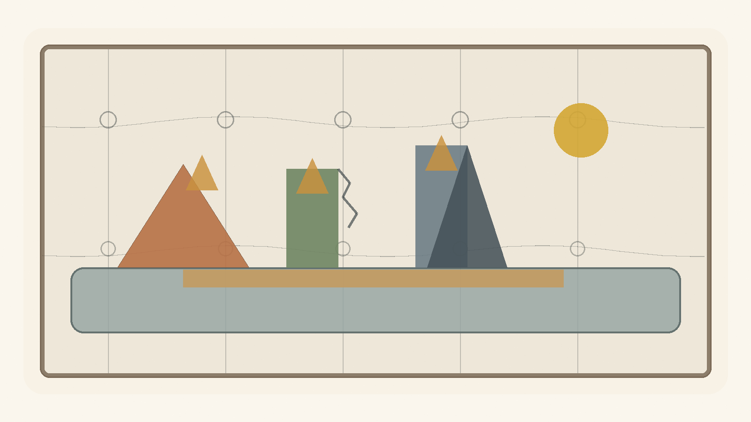
Engineering looks, from the outside, like a discipline of calculation: loads, dimensions, materials, codes, safety factors, forces, sections, drawings. Architecture looks like a discipline of form: lines, facades, spaces, light, movement, proportion, beauty.
But beneath both of them stands the same question:
How does a possibility become a form capable of standing in the world?
Not every possibility can become a structure. Not every idea can become a house. Not every beautiful line can carry weight. Not every strong form is fit for life within it.
Engineering and architecture are two different ways of facing the tension between potential and ideal. Potential is what could be built. The ideal is the form that tries to hold it. Material is the resistance - and the partial consent - of the world. Load is reality entering the dream. A structure is the living compromise between what we wanted to create and what can remain standing.
As a map-formula, not as an engineering equation to plug numbers into:
Living Structure = Potential × Form Coherence × Material Fit × Use ----------------------------------------------- Load × Friction × Wear × Uncertainty
This is not mathematics of final solution. It is a map of attention.

1. Blueprint Is Not Building
A blueprint is an ideal. It is clean, flat, and certain about the walls, doors, and intended use. But a building does not live inside the blueprint. It lives in the world: wind, heat, cold, dampness, shaking ground, imperfect users, aging systems, and time.
Blueprint ≠ Building
The drawing is the first promise of the structure. The building is that promise after it has met material, force, budget, body, use, and time. In this sense, every building is a philosophy forced to pass through matter.

2. Material: Potential with Limits
Material is not merely what one builds from. Material is possibility that already has limits. Steel stretches and bends. Concrete is generally strong in compression and much weaker in tension, so it often needs reinforcement, prestressing, or details that take tension seriously. Wood lives with fibers, moisture, direction, and memory. Glass gives light but demands caution. Stone holds time, but pays for it in weight.
Material = Potential with Limits
A good structure does not force an idea onto material until the material surrenders. It listens to what the material can bear, what it refuses to bear, and how it changes over time.

3. Load: Reality Entering the Form
A structure is tested not when it is drawn, but when something leans on it. A person stands on a floor. Wind presses a facade. Water looks for a crack. Soil moves. A beam receives weight. A bridge vibrates under repeated movement. A home ages under daily use.
Demand ≤ Capacity
If demand exceeds the relevant capacity, the structure enters a zone of failure, damage, or a limit-state violation. But capacity changes, demand changes, materials age, and uses mutate. Engineering is not only the question of whether a structure stands now; it is the question of whether it can continue to stand in time.

4. Safety Factor: The Admission That We Are Not God
Factor of Safety = Capacity / Demand
This simplified ratio does not replace codes, load factors, material factors, limit states, and probabilistic reasoning. But its philosophical force is clear: do not design exactly at the edge.
A safety factor is mathematical humility. It says: perhaps the measurement is wrong; perhaps the material will not be perfect; perhaps the use will be harsher; perhaps a load will arrive that we did not predict. A dangerous ideal says: I calculated, therefore I know. A living ideal says: I calculated, therefore I know where to leave room for error.

5. Stress and Strain: How Matter Says It Hurts
In a simple axial case:
σ = F / A ε = ΔL / L
σ = Eε
Stress is force over area. Strain is relative deformation. In the linear elastic range, Hooke's law approximates the relation between them. But the important thing is not only the equation. The important thing is that material often speaks before it breaks: it bends, cracks, fatigues, creaks, settles, expands, contracts.
A structure does not always collapse when it fails. Sometimes it begins to speak. The question is whether anyone hears it.

6. Crack: A Small Truth Before a Large Collapse
Crack = Local Disturbance + Structural Information
Not every crack is immediate danger. Some cracks are shrinkage, temperature, service, cosmetic; others signal something deeper. But every crack is information. It says that force, moisture, detail, movement, or time has taken a path the ideal did not fully contain.
Engineering does not seek a world without cracks. It seeks a world in which cracks are read in time.

7. Foundations: What Is Unseen Holds What Is Seen
Visible Form depends on Invisible Support
A foundation is not merely strong; it must fit the ground. The same house on a different site is not the same problem. Sand, clay, rock, water, slope, movement - each changes the ideal. There is no abstract house. There is a house in a place.
Structure emerges from Form × Site × Material System
There is no ideal without a site.

8. Architecture: A Form People Live Inside
Engineering asks whether the structure will stand. Architecture asks how a person will live inside what stands.
Architecture = Structure + Use + Context + Human Meaning
A room is not merely a volume. It proposes behavior. A corridor decides how people meet or avoid one another. A window is a relation between inside and outside. A door is a decision about boundary. A good house does not only protect the body; it gives the form of life a place to appear.

9. Function and Form: Who Serves Whom?
Form follows Function
But function is not merely technical. Form also shapes function, and use tests form.
Form shapes Function Function tests Form
If form serves no use, it becomes a sculpture. If use erases all form, the building becomes a warehouse. Living architecture exists in the tension between them.

10. Movement: How a Structure Thinks Through the Body
Space is understood through movement
A person does not experience a building as a plan. He experiences it through walking: entrance, turn, step, light at the end of a corridor, a ceiling opening, a room that asks him to slow down. Architecture is not only form in space. It is rhythm.

11. Light: The Non-material Material
Light = Non-material Material
Light changes a wall without moving it. It enlarges a room without extending it. It makes dust, depth, time, and direction visible. Light is the way time enters the structure. A building with no relation to light has forgotten that it lives inside time.

12. Resonance: When Structure and Rhythm Meet
f_external ≈ f_n
A bridge may carry a large load and still be endangered by repeated force at the wrong frequency. Strength is not only magnitude. Sometimes the question is rhythm.
Resonance = When the world pushes in the rhythm the structure already fears
A person, a society, and a theory can also be struck not only by how much force arrives, but by the rhythm in which it arrives.

13. Redundancy: Not Every Excess Is Waste
Redundancy = Designed Survival Beyond the Ideal Scenario
A second beam, an escape route, a backup system, a service margin, ventilation, access for maintenance - from the outside these may look excessive. But a system designed exactly for the perfect scenario is fragile. Redundancy is another path by which local failure does not become systemic collapse.

14. Maintenance: The Truth After the Opening
Maintenance = Continued Agreement Between Form and Time
A ribbon-cutting is beautiful, but the real building begins afterward: paint peels, hinges creak, water finds paths, systems age, people move furniture, temporary repairs become permanent. Every living ideal requires maintenance. The dream of no maintenance is a dream of redemption. Life requires repeated repair.

15. Failure: When the Ideal Meets What It Excluded
Failure often = Reality Re-entering Through What the Ideal Excluded
Failure usually begins before the visible collapse: an unchecked assumption, a detail no one owned, a material that behaved differently, maintenance that did not happen, an interface between systems that each thought the other would handle. The problem is not that the perfect ideal cannot be reached. The problem begins when one believes it has been reached.

16. Architecture of Responsibility
In the logical version, the conclusion is simple: engineering and architecture teach that potential becomes trustworthy only when form accepts material, load, use, maintenance, and time. The law is not Maximize Form, but Hold Human Potential Under Real Conditions.

11. Economy of Relation
Money, Value, Trust, and Potential
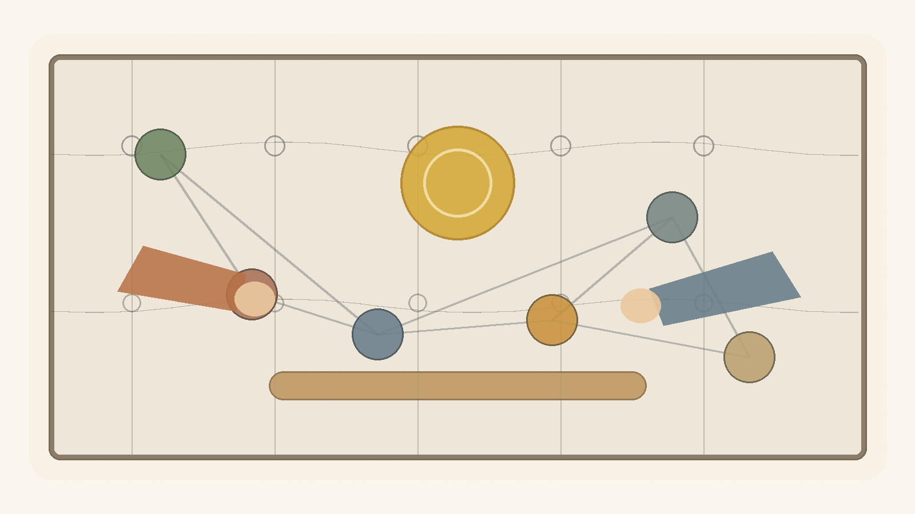
Economy looks, from the outside, like a field of numbers: money, prices, interest, wages, debt, inflation, growth, exchange rates. But beneath all those numbers lies a deeper question:
How does a society turn potential into value that people can trust?
A person has time, force, an idea, a need, a capacity that has not yet taken form. This is potential. But potential alone is not an economy. To enter the world, it must pass through a medium: work, product, service, contract, price, money, credit, institution, trust.
As a conceptual map, not an empirical formula:
Conceptual Value ≈ Potential × Trust × Coordination
Value, in the social-economic sense of this chapter, is not only what exists. It is what others can recognize, accept, transfer, use, or believe in.
Potential is the open possibility. The ideal is the form that tries to organize it. Economy is one of the systems of mediation between them.
Money, price, market, credit, contract, ownership, and wage are not value itself. They are forms by which a society tries to hold potential without killing it.

1. There Is No Absolute Up or Down
When we say "the dollar rose," it sounds simple, as if the dollar climbed an invisible ladder. But in economics there is no such ladder. There is only relation.
USD/ILS = 3.70 means 1 USD = 3.70 ILS. If the rate becomes 3.90, the dollar strengthened against the shekel, or the shekel weakened against the dollar. This is not absolute rising. It is movement in relation.
ΔValue(USD) ≠ Absolute Movement ΔValue(USD) = Change in Relation(USD, Reference)
Value(A) has no meaning alone.
Value(A) = Relation(A, B)
To say value is relational is not to say it is imaginary. Relation can be stable, measurable, binding, and painful. Purchasing power, wage, debt, rent, interest, and housing prices are not metaphysical absolutes, but they shape very real lives.

2. Money: Portable Potential
Money is one of the strangest human inventions. It is not food, but can become food. It is not a house, but can open a door to one. It is not time, but can buy another person's time. It is not trust, but collapses when trust disappears.
Money = Portable Potential
When a person works and receives money, he does not receive value itself. He receives a sign that society has recognized something given: time, skill, effort, knowledge, risk, responsibility.
Past Labor → Future Optionality
This is the genius of money, and its danger. When money remains tied to work, need, trust, and actual capacity, it functions as a healthy medium. When it begins to appear as value itself, the medium disguises itself as the ideal.
Market Price ≠ Full Value
A diamond can be more expensive than water. A thirsty person in the desert understands very quickly that price and value are not the same.

3. Gold, Fiat, and the Search for Ground
It is tempting to want money to be "based on something real." Commodity money is valuable material used as money. Representative money is a claim on something else, such as gold. Modern fiat money is different: its value comes not from convertibility into gold, but from trust in the system that issues it.
Fiat Money Value depends on: - Trust in State - Tax System - Legal Tender Status - Central Bank Credibility - Productive Economy - Network Acceptance - Political Stability
Gold is real as material, but its economic value also lives in relation: scarcity, use, history, collective belief, fear, and trust.
Gold ≠ Absolute Value
Gold = Durable Scarcity + Non-monetary Use + Collective Belief + Historical Trust
Even when we flee the sign in search of the real thing, we meet relation again.

4. Purchasing Power: What the Sign Still Opens
Real Value of Money Balance = Nominal Money Balance / Price Level
Let:
m = the amount of money a person holds P = the price level
Purchasing Power = m / P
If m = 100 and P = 1, purchasing power is 100. If prices double and P = 2, the same 100 now opens only 50 units of real possibility.
Nominal Value is the sign. Real Value is the potential the sign can still open.
Economy is not merely counting signs. It is the repeated examination of what signs can still open in the world.

5. Real Exchange Rate: Relation Inside Relation
q = e × P* / P
Where e is the nominal exchange rate defined here as units of local currency per unit of foreign currency, P* is the foreign price level, and P is the domestic price level.
There is no formula without direction. If the exchange rate is defined in the opposite direction, the formula changes. Again: value is never only a number. Value is a number inside a reference system.

6. Inflation: When the Sign Begins to Speak Weakly
Inflation = Sustained Rise in the General Price Level
Inflation ⇒ Decline in Purchasing Power of Money
Purchasing Power = m / P
P ↑ ⇒ m/P ↓
The classical quantity identity is:
M × V = P × Y
It is an identity, not a simple causal law. Inflation also depends on expectations, confidence, demand for money, supply shocks, imports, exchange rates, policy, and external shocks.
Inflation = Loss of Precision in the Language of Money
Money still speaks, but it says less.

7. The Market: Mirror, Not God
Market = Distributed Information System
The market can process distributed information through prices, transactions, supply, and demand. It sees things no single person can see alone. But the market is a mirror, not a conscience.
Market = Mirror
Market ≠ God
The market reflects desire; it does not know by itself whether the desire is good. It reflects demand; it does not know whether demand comes from freedom, addiction, despair, or manipulation.
A healthy economy requires market signals, ethical boundaries, institutional trust, and human potential. Not to eliminate the tension, but to prevent one side from pretending to be redemption.

8. Credit and Debt: The Future Entering the Present
Credit = Trust in Future Value
Credit lets a person buy a home before possessing all the money, a business begin before it succeeds, a state build before future growth arrives, an idea take form before it proves itself. But credit is also a contract, a price of risk, and a mechanism of power.
Debt = Future Obligation Pulled into the Present
Healthy Debt = Obligation that Opens Possibility Sick Debt = Obligation that Consumes Possibility
A society without credit suffocates potential. A society with too much debt mortgages potential.

9. Interest: The Price of Time, the Price of Risk
Interest ≈ Time Preference + Expected Inflation + Risk Premium + Liquidity/Policy Conditions
Interest gives price to time, risk, and trust. It admits that money today is not identical to money in the future. It can allocate resources and compensate risk. It can also become a mechanism by which those who already have time and money charge those who have no choice.
A tool becomes an idol when it forgets the human being it was meant to serve.

10. Labor: Potential Passing Through a Body
Labor = Human Potential Embodied in Time
A working person does not merely produce output. He gives time, attention, skill, fatigue, risk, responsibility, years of learning, and sometimes the erosion of body and mind. Therefore labor is not only cost. It is testimony.
Human Meaning of Wage = Price + Recognition
A wage is also read as a sign: your time counts, or it does not; your capacity is seen, or it is invisible.

11. Profit: Creation or Extraction
Profit = Recognized Surplus
Profit may signal that value has been created. It may also come from power, monopoly, asymmetrical information, weak bargaining, or externalized cost. Profit alone is not proof of good.
Profit from Creation or
Profit from Extraction?
Both can look the same in a financial report. That is the problem: economy measures surplus better than it asks where the surplus came from.

12. Externality: What the Price Left Outside
Private Cost = Cost borne inside the transaction External Cost = Cost pushed outside the transaction Social Cost = Private Cost + External Cost
A factory sells cheaply, but the air becomes dirty. An app is free, but attention erodes. A product is inexpensive, but a worker elsewhere pays the difference in his body. Externality is what the price did not include.

13. Inequality, Bubble, Growth, Crisis, and Repair
In the logical version, the remaining economic concepts gather into one axis: inequality becomes structural when outcome becomes future possibility; a bubble is price feeding on itself; growth must ask "more of what?"; crisis appears when mediation stops holding. The law is not Maximize Money, but Maximize Human Potential Without Destroying the Human.

12. Governance of Potential
Law, Power, Trust, and Repair That Is Not Redemption
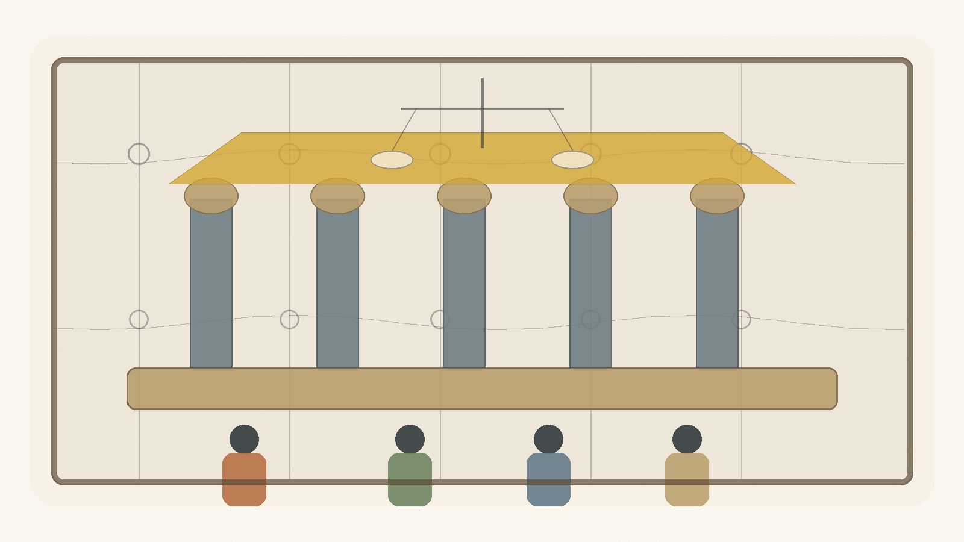
Governance looks, from the outside, like a field of institutions: government, law, courts, police, military, budgets, elections, committees, procedures, offices, regulations, rights, and duties. Society looks like a collection of people, groups, interests, memories, fears, desires, and hopes.
But beneath all of it stands one question:
How does human plurality become a form capable of living without becoming violence?
A person has will, fear, force, need, capacity, memory, wound, and a possibility that has not yet found a place. This is social potential. But social potential alone is not stable society. It can become cooperation, culture, education, medicine, law, responsibility - and it can also become raw power, revenge, tribalism, coercion, chaos, and fear.
As a conceptual map, not as an empirical formula:
Stable Society = Human Potential × Trust × Just Lawfulness × Coordination ------------------------------------------------------- Arbitrary Power × Fear × Corruption × Uncertainty
Governance is an attempt to turn force into form. Law is an attempt to turn will into boundary. The institution is an attempt to turn private decision into public responsibility.

1. State of Nature Is Not Only the Past
State of nature is not only an ancient beginning before law and institutions. It returns whenever mediation collapses: when law is not enforced, when trust breaks, when private power replaces public authority, when institutions look like masks, when each person believes he must defend himself against all others.
In this text:
State of Nature = Collapse of Trusted Mediation
Society does not exit the state of nature once and for all. It exits it again and again, every day people trust law more than revenge, institution more than force, language more than fist. This is not redemption. It is maintenance.

2. Law: Constraint That Enables Shared Freedom
Law is a limit. But not every limit is oppression, and not every law is freedom. Law can also formalize injustice. The question is what law, made by whom, enforced how, and open to what correction.
Law at its best = Constraint that Enables Shared Freedom
A living law needs stability so people can trust it, and correction so it does not become a statue. Law that is not stable is not law. Law that cannot be corrected is not justice.

3. Legitimacy: Why People Agree to Obey
Power can make a person comply. Legitimacy makes compliance more than fear.
Legitimacy = Recognized Authority × Trust × Procedural Fairness × Accountability ------------------------------------------------------------------ Coercion × Corruption × Arbitrary Power
This is not a numerical model. It is a way to hold together forces that strengthen or erode public authority. Government is tested not only when people agree with it, but when people lose and still believe the game was not forged.

4. Sovereignty: Who Holds the Last Decision?
Sovereignty asks who decides when agreement fails. It is dangerous because the one who holds the last decision may begin to think he holds the last truth.
Authority ≠ Truth
Authority can make a decision binding inside a system. It cannot make it good. Therefore sovereignty needs limits. Not because no final decision is needed, but because the final decision is where the ideal is closest to becoming an idol.

5. Separation of Powers: Designed Suspicion
Separation of powers is not built only on the belief that human beings are evil. It is built on the understanding that even a good person changes when power accumulates without limit.
Separation of Powers = Divided Function + Mutual Limitation in Service of Public Trust
This is not meant to paralyze. It is meant to prevent power from forgetting that it is only a medium.

6. Elections: Measuring Will, Not Truth
Elections are essential. They let a society say that government is not private property. But elections do not measure philosophical truth. They aggregate preferences, fears, hopes, loyalties, identities, information, propaganda, fatigue, memory, interest, and sometimes despair.
Election Result = Legitimate Aggregation of Preference Under Conditions of Information, Identity, Fear and Hope
Democracy is not only majority rule. It is majority rule inside a frame that also protects against the majority.

7. Rights: Boundaries Society Places on Itself
Right = Institutionally Protected Human Possibility Against Power
A right is not a physical object, yet it can stop a policeman, limit a government, protect a minority, allow speech, prevent humiliation. A right is a human possibility protected against power.
A right without an institution is a weak promise. An institution without a right is organized force. A healthy society needs both.

8. Duties: The Other Side of Possibility
A society that speaks only of rights can forget that every right requires a world that maintains it.
Duty = Legitimate Share in the Cost of Maintaining Shared Possibility
Public duty must be reasoned, limited, open to criticism, and as general as possible. Otherwise it becomes obedience disguised as participation.

9. Institution: Public Memory with Responsibility
Institution = Public Memory with Procedure and Accountability
A person leaves, a minister is replaced, a judge retires, a generation grows tired, a crisis arrives. The institution is meant to hold form beyond the mood of one person. But if procedure remains and responsibility disappears, the institution becomes dead bureaucracy.
A living institution says: I am not the human being, but I serve the human being.

10. Bureaucracy: When Form Forgets Life
Bureaucracy was born to solve a real problem: how to treat many people without making every case depend on one person's mood.
Bureaucracy becomes dead when:
Procedure > Person
Good governance does not abolish procedure. It gives procedure a face: appeal, human address, defined exceptions, and someone responsible for seeing that the process does not destroy the purpose for which it was created.

11. Corruption: When the Medium Is Sold from Within
Corruption = Private Capture of Public Mediation
Corruption is not only theft of money. It is the sale of public mediation to private interest: loyalty, access, information, office, and decision-making power. Its deepest damage is that afterward even proper action looks suspicious.

12. Taxes: Trust Collected by Force
Tax = Mandatory Contribution to Shared Capacity
Tax is coercive, and yet without it there is no infrastructure, security, health, education, courts, maintenance, or shared future. When citizens believe taxes become capacity, the coercion does not vanish but takes public form. When they believe taxes disappear into corruption or waste, tax becomes humiliation.

13. Legal Force: The Violence Society Tries to Bind
Legitimate Force = Power Bound by Law, Oversight, Proportionality, Necessity and Purpose
Every state holds force. The question is not whether there is force, but whether it is bound. Public force must be strong enough to protect and limited enough not to become the thing from which people need protection.

14. Emergency: When the Ideal Is Tempted to Abandon Itself
Emergency = Temporary Exception with a Temptation Toward Permanence
War, plague, disaster, terror, collapse: in such moments society asks for speed and concentration of power. Sometimes rightly. But emergency is dangerous because it teaches power how convenient it is without limits. A healthy government must know how to act in emergency without falling in love with it.

15. Civil Society, Public Language, and Repair
In the logical version, civil society, public language, majority and minority, policy, and measurement all serve one question: can power remain bound while shared possibility stays open? The law is not Maximize Control, but Hold Shared Human Potential Without Devouring the Human.

13. The Imaginary, the Virtual, Gravity, and the Horizon
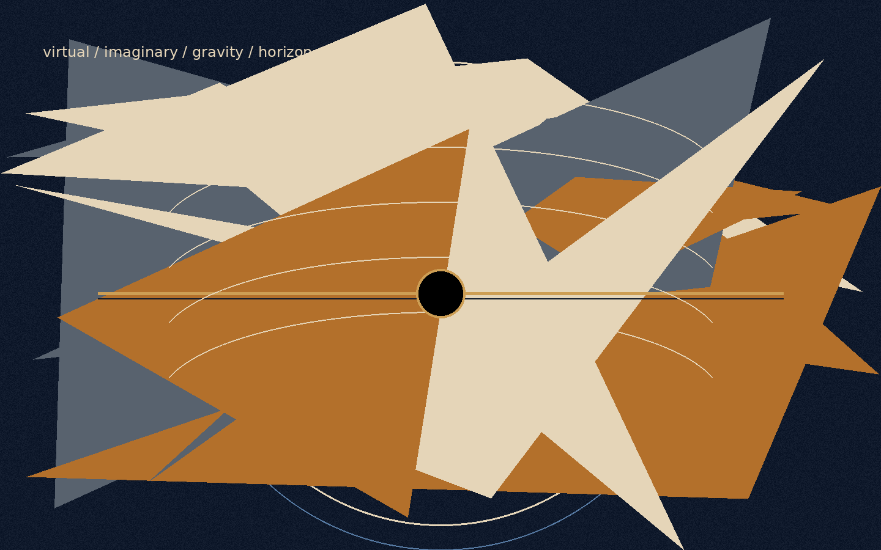
Figure F: The imaginary, the virtual, and the horizon in the logical model.
There are words that weaken thought before thought has even begun to work.
“Imaginary” sounds like something that does not exist.
“Virtual” sounds like something false.
“Real” sounds like the only thing that deserves to be taken seriously.
But reality is not built according to the convenience of language. The closer one moves toward its deeper layers, the less it divides cleanly into what exists and what does not. There is also that which does not appear as an object, and yet without it the object could not appear. There is that which is not measured directly, and yet without it measurement would not receive form. There is that which is not a “thing,” but still changes the conditions under which things can be.
This must be made clear at the beginning: this chapter does not use mathematics or physics as proof of the theory. It does not claim that imaginary numbers are metaphysical entities, that virtual particles are hidden messengers, that a black hole is evil, or that a white hole is the source of creation. It does something more modest and more precise: it uses structures in which even the most exact forms of thought are forced to distinguish between what appears, what influences, what limits, and what makes appearance possible.
This caution is not the enemy of metaphor.
It is the condition that keeps metaphor from becoming false.

The Imaginary
The imaginary number is not a false number. It is not a mathematical joke and not a fantasy. It is an additional axis of description. It appears where the ordinary axis of quantity is not enough. It allows thought to describe rotation, phase, oscillation, change of direction, and the relation between what is present and what is not yet present.
There is no need to say that the imaginary number is a “thing” inside the world. It is enough to say something more careful: even within the most precise thought, the real is not always describable on one line. Sometimes an axis that does not look like ordinary quantity is needed in order to understand real motion.
In this sense, the imaginary is not the opposite of the real.
It is the way the real becomes thinkable beyond a single axis.

The Virtual
The virtual is not simply “unreal” either. A virtual particle is not a small ordinary particle moving through the world like a tiny grain of dust, waiting for the moment when it decides to become real. That picture is too convenient, almost too childish. The virtual is not a stable object one can point to and say: here it is, in this path, at this time.
But it must not be turned into nothing either.
Precisely because it is not a stable object, it is useful as an example of the caution required here. There is a difference between something that can be pointed at and a structure, field, condition, or component in the description of an interaction that participates in a real result. Not everything that influences must appear as a body. Not everything that changes the balance must stand before us as an object.
The virtual, in its most careful sense, is a language of possible pressure on the appearance of the thing.
Or more simply:
The virtual is not the thing.
It is the way possibility begins to press on the conditions under which the thing can appear.
Here the metaphor touches the theory, but does not prove it. The virtual is not “potential itself.” It is not a scientific name for a philosophical idea. It is an example of the need, even in careful speech about reality, to distinguish between a stable object and an influence that does not stabilize as an object.
The imaginary is the language of direction.
The virtual is the language of influence.
The real is the language of the sign.
The imaginary says: the system has an axis you do not see, but without it you will not understand its motion.
The virtual says: there is an influence you do not see as an object, but without it you will not understand the change.
The real says: here, for a moment, something of possibility has agreed to leave a trace.

The Box That Cannot Be Emptied
Imagine a box.
First one removes all the objects from it. Then the dust. Then the air. Then, in a more extreme act of imagination, one removes every atom, every particle, every thing that can be called a thing. The box appears empty. There is no body in it. No matter. No visible sign of anything waiting inside.
But this emptiness is not necessarily nothingness.
Even when no ordinary object remains, the conditions have not necessarily been removed. The field has not necessarily been removed. The possibility of appearance has not necessarily been removed. In this sense, physical vacuum is not identical with philosophical nothingness. It is not a dead room. It is not absolute negation. It is a state in which the stable thing has disappeared, but possibility has not disappeared with it.
This is not a claim that small creatures are hiding inside the box, waiting to emerge. That is exactly the error to avoid. The point is subtler: even when one empties the world of everything that looks like an object, it is not clear that one can empty it of the potential for appearance.
Potential, in this sense, is not another object inside the box.
It is what remains when there are no objects left.
And therefore it cannot simply be taken out.
One can remove matter.
One can remove light.
One can remove air.
One can imagine removing every particle and every trace.
But one cannot remove possibility as though it were one more thing among things. Possibility is not one of the contents of reality. It is one of the ways reality can still be.
This is one of the places where potential reveals itself not as an empty space waiting to be filled, but as an active layer. Potential is not merely “what has not yet happened.” It is not a warehouse of possibilities waiting in storage for their turn. It is more alive than that. It is the direction not yet made into a line. It is the influence not yet made into a body. It is the truth that has not yet found a form stable enough to be given a name.
The human being is accustomed to believe only what has already left a sign. He wants to see the result, measure it, name it, classify it, and only then decide whether it exists. But much of the most important reality acts before that stage. It acts where there is not yet a thing, but there is already a tilt. There is not yet an answer, but there is already a direction. There is not yet a decision, but there is already a tension organizing the space of possible decisions.
The human being says: I will believe it when I see it.
Reality says: you would not see anything unless something you do not see were already acting.

Potential and Ideal
Here the relation between potential and ideal becomes clearer.
Potential is not outside reality. It is not above it and not after it. It is inside reality as a layer that reality does not always see in itself. Like the imaginary number within a mathematical system, it allows motion that cannot be explained on the simple axis. Like the virtual within the description of a field, it allows us to think influence that does not immediately stabilize as an object. And like every real thing, it eventually asks to leave a sign - not because the sign is the whole truth, but because without a sign the world has no way to know that truth has passed through it.
The ideal, by contrast, is not every possibility. It is not everything that could have happened. It is not the infinite scattering of potential in all directions. The ideal is the direction in which potential ceases to be merely open and begins to become precise.
There is no need to attribute conscious will to reality in order to speak of ideal. The ideal is a name for the state in which a possibility passes through limits, measurements, resistances, and distortions, and still manages to appear in a form that does not erase the depth from which it came.
It can be said this way:
The imaginary opens an axis.
The virtual applies pressure.
The real leaves a sign.
The ideal is an appearance that preserves continuity with the axis, the pressure, and the condition from which it was born.
In other words:
The ideal does not betray the potential from which it came.

Gravity
Here gravity enters.
It is easy to think of gravity as limitation. It ties a body to place. It prevents it from dispersing through space at will. It says to it, in a sense: here. Not everywhere. Not in every direction. Not without cost.
But that is only half a thought.
Freedom does not begin where there are no boundaries. A place with no boundaries at all is not necessarily more free; sometimes it is simply not a place. It holds no form, no body, no breath, no home. Without attraction there is no ground. Without ground there is no standing. Without standing there is no choice with weight.
This does not mean that gravity has will, morality, or intention. Gravity functions here as an exemplary structure: it shows how limitation can be a condition for the emergence of a world, not only the negation of freedom. Without binding, orbit, and weight, there is no stable place in which choice can receive meaning.
Gravity, in this sense, is not the enemy of freedom. It is one of the ways potential agrees not to remain open in all directions at once. It is not the negation of possibility, but the condition by which possibility can become world. It is the contraction that allows form. It is the weight that allows something to remain present long enough to be present at all.
Potential, when completely open, is still not a world. It can be everything, and for that reason it is not yet anything. In order to appear, it must agree to lose some of its openness. It must agree to direction, body, limit, and place. Gravity is one of the physical names of that agreement: not to be everywhere, in order to be here.
But every condition that allows a world can, at its edge, also close it.

Black Hole and White Hole
The black hole is the sharpest image of this. Not because it is “evil,” and not because it punishes matter, but because within it the structure itself stops offering outwardness as a possible direction. Beyond the event horizon, in the classical sense, the future no longer opens as a fan of paths. It becomes increasingly one-directional.
The black hole is not a moral symbol of lack of freedom. It is an extreme example of a structure in which the space of possible directions contracts toward one-directionality. Not because someone forbids exit, but because the structure itself no longer offers exit as a direction.
There gravity ceases to be only what allows things to bind to one another, and becomes the most extreme form of binding from which there is no return. This is the place where contraction, which began as a condition of existence, comes too close to erasing the possibility for which it was born.
The black hole is not the place where freedom is punished.
It is the place where geometry itself has stopped offering directions.
Opposite it one may place, carefully, the image of the white hole.
Not as a fact that replaces the whole. Not as proof of the source of creation. Not as an object onto which one should load more than it can bear. The white hole, if it is used at all, must remain a limited image: not a name for potential, but a mental form through which one may think a source that cannot be conquered.
If the black hole is a horizon in which the future closes inward, the white hole is an image of a horizon in which appearance opens outward without the source itself becoming graspable.
Therefore one should not say that the white hole is potential itself. That would be too precise where one must remain careful. It is more accurate to say that it is an image of one possible motion of potential: a source that does not open to entry, but from which something can appear outward.
Potential is not a thing one reaches as one reaches a place.
The ideal is not an object one holds after the journey is over.
Both resemble horizons more than objects: they organize motion, direct it, distort it, attract it, yet never give themselves wholly into the hand.
Gravity teaches that freedom requires form.
The black hole teaches that form can become a cage.
The white hole, as an image only, reminds us that there are sources that do not open to entry, but to appearance.
And between the three stretches the same question: how much contraction does potential need in order to become world, and when does that contraction begin to erase the very possibility for which it was born?

The Radiation of the Black Hole
Here one may return to the radiation of the black hole.
The popular image speaks of a pair of virtual particles near the event horizon: one falls inward, the other escapes outward, and radiation appears. This is a useful image only as long as one remembers that it is an instructional image, not a photograph of the mechanism. Taken too literally, it begins to lie. It makes us think that the virtual is simply a small particle that happened, at a certain moment, to become real.
The deeper point is not that the virtual is an object disguised as a non-object. The point is that what is not stable as an object can still participate in a real result. What is not a “thing” in the simple sense can still affect a balance. Around an extreme horizon, the structure of space, time, and field changes what counts as vacuum, what counts as particle, and what can appear as radiation to a distant observer.
There is no need to say that potential “becomes real” only when it escapes the black hole. That reduces it again. It is more accurate to say that the extreme case reveals something that was already true: the real does not begin only where there is an object. Sometimes the real begins where the conditions of appearance have already changed.
That is: there is a reality that is not a body.
There is an action that is not an object.
There is a direction that is not a form.
There is an influence that is not yet an event, but the event can no longer happen the same way without it.
This matters because the human being tends to dismiss everything that has not yet become solid. A thought not yet fully formulated seems weak. A feeling that has not received an explanation seems suspicious. A possibility that has not actualized seems like nothing. But in the depths, these are often the most active layers. Not because they are “more real” than the real, but because they precede it in a way that does not precede it only in time. They precede it structurally.

Event Horizons of Trust
A black hole is not used here as a metaphor for absolute evil, but for a boundary at which real information can no longer reach the external frame of reference. A moral event horizon is the boundary at which a person, institution, idea, or community may still be able to change, while the world can no longer receive that change as new information.
Past too heavy → Interpretive gravity Interpretive gravity → Loss of trust Loss of trust → Blocked new information Blocked new information → Frozen identity
A person after grave harm, a relationship after betrayal, an institution after scandal, a company after collapse, a community after violence, or a language after repeated lying can all meet the same structure: not necessarily the absence of change, but the absence of a medium through which change can be read as change.
The moral caution matters: the outside is not always obliged to accept. Sometimes refusal is protection, sometimes the damage was too real, and sometimes distrust is part of the price. Repair that is not redemption does not promise return to the outside; it only refuses to let the past be all that exists inside.

God, the Whole, and Caution with the Name
If one wants to use the name “God,” it must be used with the same caution required of every name that is too large.
Not God as a hand moving particles behind the scenes.
Not God as a mechanical operator of miracles.
Not God as a figure standing outside the world and repairing it from the outside.
Rather, God as one possible name for the whole: for the structure in which potential is not wasted, but seeks its most precise form through all layers of appearance. Another name for it could be the whole. Another could be source. Another could be the movement between potential and ideal. The name matters less than the caution not to turn it into an idol.
The imaginary number is not the thought of God.
The virtual particle is not the action of God.
Gravity is not the will of God to limit freedom.
The black hole is not the punishment of God.
The white hole is not the body of God.
But one may say, carefully:
In the imaginary, reality discovers that it has another direction in which to think.
In the virtual, reality discovers that it has a way to influence before it appears.
In gravity, reality discovers that freedom requires form.
In the horizon, reality discovers that every form can become a boundary.
In the real, reality discovers what of all this has managed to pass into the world.
The examples must not be identified with the theory itself. They are not its foundations, but its mirrors. The imaginary, the virtual, gravity, the black hole, and the white hole do not prove potential or ideal. They only show, each in its own language, that reality is not made only of things already visible. It also contains directions, pressures, boundaries, and horizons; and there are moments when precisely what cannot be grasped directly determines the form of what does appear.
Perhaps the ideal is the moment when all these layers no longer contradict one another.
The moment when the hidden direction, the unstable influence, the weight, the boundary, and the visible sign align enough for something to be not only existent, but justified in its existence.
Not justified from the outside.
Not approved by an observer.
Not proven once and for all.
Justified in the deeper sense: that it does not betray the potential from which it came.

14. Mass-Energy and Medium - A Precise Image, Not a Proof
This section does not claim that physics proves the theory. The relation between mass and energy does not become a moral theorem, and an equation is not a shortcut to metaphysics. The use here is structural and cautious: physics offers a language in which what appears as matter and what appears as activity are not necessarily disconnected worlds, but different modes of appearance under different conditions.
Possibility is not yet result. For possibility to appear as something in a world, it requires conditions of appearance: form, boundary, measurement, relation, time, and medium. In the language of the theory, potential that does not pass through conditions remains too broad to be responsible. It can contain everything, but it does not yet carry weight. Weight here is not only physical; it is also a metaphor for consequence, cost, commitment, and the capacity to affect another.
One must avoid the crude sentence that matter is simply “condensed energy.” More carefully: certain material systems, under certain physical conditions, can function as media that change how energy passes through them. They absorb, scatter, filter, store, return, or redirect. In the theory, this becomes an image of the person as medium: not a body that arranges energy in a direct physical sense, but a life capable of processing what passes through it - pain, memory, fear, desire, love, and responsibility.
This gives the distinction between matter as result and matter as medium. The body is the result of physical processes, but in life it is also the place where processes become meaningful. It is not only a boundary; it is where boundary can become articulation. It is the hand that writes, the voice that answers, the nervous system that remembers, the tiredness that forces honesty, and the wound from which moral caution can be born.
The same section requires balance between distinction and resonance. Within the language of the theory, difference is a condition for form to appear without everything collapsing into sameness; yet there must also be the possibility of resonance, so that difference does not become absolute isolation. The ideal is not the erasure of difference, but the state in which difference remains distinct while becoming responsible to relation.
Translated back into human language, the ideal is not light that never met matter. Light that never meets resistance remains untested; matter that blocks all light becomes opacity. The living medium is the place where passage becomes responsible: it receives without merely absorbing, filters without erasing, shapes without falsifying, and returns what passed through it as something more precise.
If this structure is translated into the teleological language of the theory, not as a factual claim about the universe, one may say: the whole turns itself into the instrument of its own correction. It becomes body, medium, friction, memory, and responsibility so that potential will not remain merely possible, and light will not remain merely scattered.

15. Physical Comparison Map — Potential, Form, and the Theories That Try to Unify Physics
From spacetime as form to potential as a deeper ground
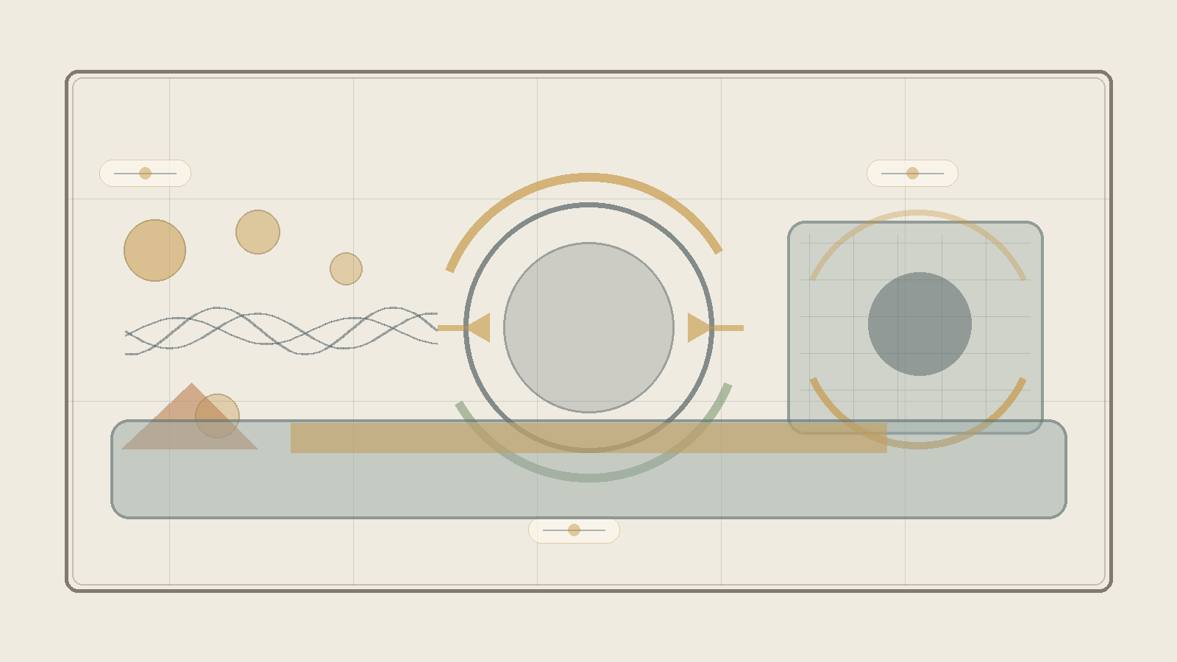
Physical comparison map. Quantum theory, relativity, horizon, and information as different languages of the tension between potential and form.
This chapter does not offer new physics instead of mathematical physics. It offers a conceptual map: how relativity, quantum theory, information, horizons, and singularities illuminate the relation between potential, form, medium, and readability.

The Physical Spine
G_{μν} + Λg_{μν} = (8πG / c⁴) T_{μν}
General relativity shows that matter and energy are not merely inside a neutral stage; they shape the stage itself. Through the theory, this is a language in which material-energetic potential becomes readable as geometry.
iℏ ∂|ψ⟩/∂t = Ĥ|ψ⟩ P(a) = |⟨a|ψ⟩|² [x, p] = iℏ Δx Δp ≥ ℏ/2
Quantum mechanics describes potential evolving in time and closing into a readable result through measurement, but it does not by itself explain the mechanism of closure. The theory therefore reads measurement as a transition from potential to form, not as a solution to the physical problem.
U†U = I |ψ(t)⟩ = U(t)|ψ(0)⟩
In closed quantum evolution, information is not supposed to be erased. Through the theory: unreadable information is not necessarily erased information; it may remain as relation, trace, or correlation.
ĤΨ = 0 ℓ_P = √(ℏG / c³)
The problem of time and the Planck scale point to the place where time and spacetime themselves may not be the final ground, but readable forms of a deeper layer.
r_s = 2GM / c² S_BH = k_B A / (4ℓ_P²) T_H = ℏc³ / (8πGMk_B)
Black holes show that the horizon is not marginal. The boundary itself becomes the place where information, area, entropy, and readability meet. The theory does not solve the information paradox; it distinguishes erasure from loss of readable form.
S(ρ) = -Tr(ρ log ρ) I(A:B) = S(A) + S(B) - S(AB) H² = (8πG/3)ρ - kc²/a² + Λc²/3
Information and entanglement show that information is not only content inside an object, but relation between parts and readers. Cosmology reminds us that the vacuum is not necessarily empty, but the theory does not quantitatively explain vacuum energy or the cosmological constant.

What It Does and Does Not Offer
The theory does offer a conceptual reading: spacetime is not necessarily the final ground; singularity is a limit of form; relation precedes place; and time, causality, and measurement are readable forms of deeper potential.
The theory does not yet offer a quantum gravity equation, a complete measurement mechanism, a quantitative explanation of vacuum energy, identification of dark matter, a full explanation of dark energy, or a decision between strings, loops, causal sets, CDT, and holography.
The contribution is therefore not “solving physics,” but a change of layer: not fitting potential into an existing ideal, but asking how the physical ideal itself - space, time, matter, force, and measurement - is born from potential.

Chapter ?:↓

Chapter ?:↓

Chapter ?:.

Chapter ?:.

Chapter ?:.

Chapter ?:↓

Chapter *: Understanding

Chapter •: Application

Sources, Inspirations, Ideas, and Acknowledgements
The following sources, names, and ideas are not presented as authorities that prove the theory. They do not prove Between Potential and Ideal, and the theory is not derived from them as from a single origin. They are intellectual neighbors, inspirations, useful vocabularies, and conceptual debts. The theory is close to them in certain places and departs from them in others.
Proximity is not identity. If a name appears here, it does not mean that the theory accepts that thinker’s whole system. It means that the name helped formulate, sharpen, challenge, or locate one part of the larger movement: how potential passes through law, boundary, matter, friction, and processing until it can become a more responsible direction.

Philosophical Lineage
Aristotle is relevant because of the distinction between potentiality and actuality. The present theory is close to that question, but does not stop at the passage from the possible to the actual. It asks what happens after actualization, and whether a form that has become real can be clarified until it becomes more faithful to the potential from which it came.
Plato is relevant because the language of the ideal echoes the Form of the Good and the relation between the visible world and a higher form of understanding. Yet here the ideal is not simply a static form above becoming; it is the clarified resolution of potential through experience, boundary, and responsibility.
Plotinus and Neoplatonism are relevant because of the relation between unity and multiplicity. The present theory shares the intuition that multiplicity can arise from unity, but refuses to make the other ethically unreal, and refuses to treat the final aim as the erasure of difference.
Benedict de Spinoza is relevant because of his immanent conception of God: God is not outside reality. The present theory shares the rejection of an external divine ruler, but departs from Spinoza by placing at the center not only the necessity of reality, but the possibility of moral clarification from absolute potential toward the ideal.
Leibniz is relevant as background for possible worlds, perfection, monads, and the relation between multiplicity and order. The present theory does not adopt the metaphysical optimism of “the best of all possible worlds,” but it is close to the question of how possibility, order, and perspective touch one another.
Kant is relevant mainly as a background of caution regarding the limits of knowledge. The theory does not claim to possess the thing-in-itself, and does not replace critique with unrestricted metaphysics. It tries to speak of the whole while recognizing that every human language meets a boundary.
Hegel is relevant because the result cannot be separated from the path by which it becomes. The present theory shares the processual intuition, but frames the movement as absolute potential becoming ideal through clarification, friction, and responsibility rather than only as the development of spirit in history.
Whitehead and process philosophy are relevant because reality is understood as becoming rather than as a static block. The theory is close to this sensitivity, but keeps its own formulation: not only process, but a process in which potential is tested by whether it can become ideal without erasing what passed through it.
Dostoevsky belongs here not only through The Idiot, but through the entire space in which an idea enters a human being and does not come out whole. In The Idiot, it is the almost impossible goodness of Prince Myshkin: not a solution, not a simple saint, but compassion and beauty entering a world of embarrassment, desire, possession, and fear, and being distorted there. In Notes from Underground, it is consciousness refusing to be closed inside any formula that would fully explain it. In Crime and Punishment, it is the moral or supra-personal idea becoming an act, and then returning to the body as guilt, fever, fear, mercy, and inner punishment. In The Brothers Karamazov, it is the question of faith standing before suffering that cannot be cleanly justified. And in Demons, it is the danger of an ideal becoming ideology: a truth so large that it begins to erase the human being in its name.
Nietzsche stands across from the same region from another side. He does not simply cancel the question of the ideal; he tests whether the ideal has already become an idol, whether morality is a flight from life, whether compassion can sometimes conceal a form of control, and whether meaning received from outside is a way of avoiding the harder task: saying yes to life without lying about it.
Between Dostoevsky and Nietzsche, one of the deepest axes of Between Potential and Ideal opens: on one side, the human being who cannot bear the depth of goodness, guilt, faith, or freedom; on the other, the suspicion that every ideal may become consolation, idol, or force. Therefore the ideal in this theory is not a final solution and not a ready-made redemption. It is a living, vulnerable, unsecured direction — a movement trying to remain faithful to the possibility of repair without erasing the fracture from which it is born.
Camus remains relevant beside this axis as a background to the crisis of the absurd and to the question of how one can continue acting when meaning is not guaranteed in advance. The theory does not abolish the absurd and does not overpower it; it tries to formulate nihilism with hope - not certainty of meaning, but the possibility that pain, boundary, and friction need not remain the final word.
Existentialism, especially the questions of freedom, responsibility, and meaning that is not given in advance, stands in the background of the theory. The human being is not only the result of law, and not only a point inside a system; the human being is a place where possibility is required to take responsibility for its form.
Buddhist traditions, especially questions of non-self, suffering, craving, compassion, and release, are deeply relevant. The theory shares their suspicion toward rigid ego and absolute separation, but insists that release cannot mean the erasure of the person, of difference, or of responsibility.
Advaita Vedanta and Shankara are relevant as background for non-separation and for the question of whether multiplicity is illusion, appearance, or partial truth. The theory is close to the intuition of unity, but moves away from any formulation in which unity cancels the moral meaning of multiplicity.
Daoism is relevant as background for the idea of a way that is not imposed from outside, of action that is not violent, and of form that does not break the flow. The theory is not Daoist, but it is close to the question of how direction can appear without becoming control.

Mathematics, Logic, and Forms of Thought
Mathematics does not prove the theory, but it gives it images of structure, boundary, infinity, possibility-space, and the relation between form and law.
The tradition of complex numbers, especially the use of the imaginary number, is relevant as an image of the fact that not everything outside the real axis is meaningless. Euler and Gauss are relevant here as broad mathematical background, not as metaphysical authorities.
David Hilbert and John von Neumann are relevant because of Hilbert space and the formalization of quantum mechanics. In the theory, Hilbert space is not “the space of all existential possibilities,” but a limited image of a state-space for a defined system, and of the need to distinguish possibility, state, measurement, and law of evolution.
Georg Cantor is relevant as background for infinity and different kinds of infinity. The idea that each stage - I‑Verse, Universe, Multiverse, Omniverse - can decompose again into similar structures is not a formal mathematical claim about Cantorian infinity, but it is close to the intuition that infinity is not merely “very many,” but a structure that can appear across levels.
The P versus NP problem is relevant here only as a limited logical image: not as a mathematical solution and not as proof of the theory, but as language that emphasizes the distance between recognizing a solution afterward and finding the path to it in advance. In the terms of the theory, it is one image for the relation between potential, search, verification, iteration, and ideal.
Kurt Gödel and Alan Turing are relevant as background for the limits of formal systems, computation, proof, and a system’s self-reference. The theory does not use Gödel’s theorems or Turing machines as proof; it uses them only as a careful background for the idea that a system can ask about its own limits from within.
Complexity theory, polynomial-time reductions, NP-completeness, coNP, the polynomial hierarchy, and QBF are relevant here only as structural language: they do not identify potential with a complexity class, but help distinguish finding, verification, resource, translation, strategy, and boundary.
Linear algebra and matrix diagonalization are relevant as background for the language of state-space, operation, and change of basis. Here too, there is no claim that existence is a matrix; only a careful image that sometimes understanding a system depends on the basis in which its action is seen.
Benoit Mandelbrot and fractal thinking are relevant as background for recursion, self-similarity, and the infinite decomposition of structures. The use here is structural only: each level of reality can contain a further division, and each component can itself become a space of possibilities.

Physics, Cosmology, and Information
The physics that appears in the theory is not a proof of metaphysics. It is a precise language, a limited structural analogy, and a partial formal image. It helps distinguish physical energy from metaphorical energy, physical matter from matter as an image of form and condition, and mathematical, physical, and existential boundaries from one another.
Einstein and Minkowski are relevant because of relativity, spacetime, mass-energy equivalence, and the understanding that gravity is not merely a force on a fixed stage but is related to the geometry of spacetime. The theory does not derive meaning from Einstein’s equations; it uses them carefully in order to think of “weight” as an image for what changes the field of possibilities around it.
Max Planck, Niels Bohr, Werner Heisenberg, Erwin Schrödinger, Paul Dirac, Wolfgang Pauli, and Richard Feynman are relevant as background to quantum mechanics, quantum field theory, superposition, measurement, uncertainty, particles, diagrams, fermions, and bosons. The theory does not turn quantum mechanics into mysticism; it uses it to resist the assumption that only what has already become an object is real in the deeper sense.
Emmy Noether is relevant because of the relation between symmetries and conservation laws. This relation matters as background for the language of law, boundary, condition, and possibility that cannot appear arbitrarily.
Peter Higgs, François Englert, and Robert Brout are relevant because of the Higgs mechanism and the question of how mass can appear through relation with a field. The theory does not use the Higgs mechanism as proof, but as a careful image for the idea that a property that appears internal can depend on a deeper relation with field and condition.
Schwarzschild, Kerr, Penrose, Wheeler, Bekenstein, and Hawking are relevant because of black holes, event horizons, singularities, horizon entropy, and Hawking radiation. The black hole is not a simple emotional metaphor, but an edge-image of a place where boundary, information, geometry, and time become entangled.
Gerard ’t Hooft, Leonard Susskind, Juan Maldacena, Don Page, and contemporary work on holography and island corrections are relevant as background to the black hole information problem. There is no physical conclusion being claimed here; there is caution before a question in which information conservation, geometry, and thermodynamics still require a deeper framework.
Claude Shannon and Landauer are relevant as background to information, entropy, and the relation between information and physics. The theory uses information carefully: not as a replacement for experience, and not as proof of consciousness, but as a way to ask what is preserved, what is lost, and what is translated.
The discussion of the multiverse, possible universes, and layers such as I‑Verse, Universe, Multiverse, and Omniverse touches a broad background of possible-worlds thinking, speculative cosmology, and ideas such as Everett, David Lewis, and Max Tegmark. The theory does not commit to any one of those cosmological or modal models; it uses the vocabulary to think about recursion, layers, perspectives, and the infinite decomposition of possibility.

Artificial Intelligence, Consciousness, and Contemporary Mirrors
The AI analogy is a contemporary addition. It is not a proof, but a mirror: it helps distinguish information, experience, awareness, self-relation, imitation, and understanding.
Alan Turing is relevant here as well because of the question of imitation, testing, and the gap between visible behavior and consciousness. Norbert Wiener is relevant as background to cybernetics, feedback, and self-regulating systems. John Searle and David Chalmers are relevant as background to the Chinese room, consciousness, experience, and the hard problem. The theory does not solve the problem of consciousness; it uses artificial intelligence to return to the distance between information and experience.
Conversations with artificial intelligence systems also served as tools of formulation, processing, and critique. This grants no authority and supplies no source of truth. It is a working tool and a conceptual mirror, not an additional author of the theory.

Works, Stories, and Edge-Images
Roger Williams, The Metamorphosis of Prime Intellect, is relevant as a reference point for examining the danger of a primary intelligence that tries to abolish suffering through control, and thereby erases the distance through which the human being becomes a source of meaning.
Rhadamanthus / Reddit, Feed the Pig, is relevant as a reference point for examining the choice of consciousness at the edge of suffering, and for identifying grace not only as continued climbing but also as the willingness of the whole to renounce information for the sake of the person. This is not a classical philosophical source, but it is relevant here because it touches directly one of the theory’s central intuitions: not every rescue is control, and not every grace is the forced continuation of the process.
The discussion of creation, canon, and optimum also uses cultural works as a kind of structural laboratory: Community and Rick and Morty as examples of writing-optimum and creative recursion; The Lord of the Rings as an example of an ideal that refuses corrupting potential; works by Miyazaki and examples such as Breaking Bad, Fight Club, Batman, Spider-Man, and Superman for examining canon, invariant, false ideal, and the relation between power and boundary; and Stephen King’s The Dark Tower, together with The Stand, The Eyes of the Dragon, Roland Deschain, Randall Flagg, and the rose, as an example of a recursive body of work in which adaptation is judged by whether it preserves a center, not merely symbols.

Acknowledgements and Source Note
Thanks are due to traditions, books, questions, images, conversations, criticism, and to anyone who helps keep a living idea from turning into a closed doctrine. This theory seeks to remain open to criticism, not because it lacks direction, but because a real direction must be able to pass through resistance without becoming blind belief.
The writer of the theory is responsible for the synthesis, the choice of concepts, and the connection between potential, ideal, the whole, boundary, friction, processing, and direction. The sources assist, illuminate, and challenge; they do not replace the responsibility of the theory to stand on its own.

Bibliography and Source Notes
Aristotle, Metaphysics, and discussions of potentiality and actuality.
Plato, Republic, especially the discussion of the Form of the Good.
Plotinus, Enneads, especially the discussion of the One and multiplicity.
Benedict de Spinoza, Ethics, Part I, especially Propositions XIV-XV and XVIII.
Gottfried Wilhelm Leibniz, Monadology and writings on possible worlds.
Immanuel Kant, Critique of Pure Reason, as background to the limits of knowledge.
G. W. F. Hegel, Phenomenology of Spirit, Preface.
Alfred North Whitehead, Process and Reality; see also introductions to process philosophy and process theism.
Fyodor Dostoevsky, The Idiot, Notes from Underground, Crime and Punishment, The Brothers Karamazov, and Demons, as literary-philosophical background for questions of goodness, guilt, freedom, compassion, ideal, and ideology.
Friedrich Nietzsche, The Gay Science, Thus Spoke Zarathustra, Beyond Good and Evil, On the Genealogy of Morality, and Twilight of the Idols, as background to the critique of nihilism, morality, compassion, idols, and the ability to say yes to life without false consolation.
Albert Camus as background to the modern crisis of absurdity, action, and meaning that is not guaranteed in advance.
Buddhist traditions, Nagarjuna, Advaita Vedanta, and Shankara as background to non-separation, non-self, and the critique of ego.
Einstein, Minkowski, Noether, Heisenberg, Schrödinger, Dirac, Pauli, Feynman, Higgs, Englert, Brout, Bekenstein, Hawking, Penrose, Wheeler, Susskind, ’t Hooft, Maldacena, and Page as scientific background for the language of spacetime, quantum mechanics, fields, symmetries, horizons, information, and thermodynamics.
Cantor, Hilbert, von Neumann, Gödel, Turing, and Mandelbrot as mathematical and logical background for infinity, state-spaces, formalism, computation, boundary, and recursion.
Shannon, Landauer, Wiener, Searle, and Chalmers as background to questions of information, systems, feedback, consciousness, and the distinction between sign and experience.
Roger Williams, The Metamorphosis of Prime Intellect; and Rhadamanthus / Reddit, Feed the Pig, as literary-conceptual sources for edge-images of grace, control, suffering, and renunciation.
Note on quotations and lineage: the short references are used for philosophical, scientific, and literary orientation. The theory itself is presented as an independent proposal, not as a derivation from any single source.

