Boundary Horizons and the Shape of the Universe
Information, visibility, curvature, and what does not return
Between Potential and Ideal
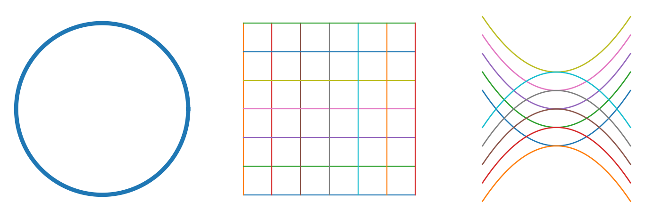
Updated distribution · May 2026

Table of Contents
Horizons of Boundary
Addition: The Shape of the Universe, Infinity, and Curvature
Curvature, infinity, boundary, and horizon
Why this belongs to the theory
The visible symptom
Three geometries as three shapes of possibility
The theory’s deeper diagnosis
Relational map: the shape of possibility
How it changes the core
Three applications
What must not be inferred
Contribution back to the theory
Sources and notes

Horizons of Boundary
Boundary Horizons
Information, visibility, and what does not return.
Why horizons belong to the theory
A horizon is not a beautiful edge; it is a boundary of access. It distinguishes what exists from what can reach us, truth from what can be carried as evidence, potential from accessible potential. Boundary horizons belong in the theory only where they sharpen questions of knowledge, source, return, and responsibility.
A black-hole event horizon is not an ordinary wall. In general relativity, it is a boundary from which even light cannot escape to an outside observer. NASA emphasizes that the event horizon is not a surface like Earth’s, but a boundary. Source: NASA Black Hole Basics.
A cosmic event horizon is not the same as a black hole. It concerns cosmic expansion and which signals can ever reach us in the future. It must not be confused with the observable universe, particle horizon, or Hubble sphere.The holographic principle, carefully
If mentioned here, the holographic principle is not proof of the theory. It is a careful structure of thought: sometimes the boundary of a system can carry information about what does not appear fully inside. This does not imply that consciousness, morality, or the ideal is written on the boundary of the universe.
Allowed use: thinking about boundary, trace, information, archive, canon, source, and witness. Forbidden use: turning the concept into mysticism, simulation claims, destiny, or physical proof of meaning.Boundary horizon map
AI: source horizon — the output is visible, while data, weights, and path are opaque.
Law: evidentiary horizon — truth may exist beyond what a system can prove.
Healthcare: clinical horizon — a treatment window may close even while knowledge remains.
Education: horizon of understanding — good teaching does not throw the learner beyond the horizon; it moves the horizon.
Art and music: horizon of interpretation — boundary, silence, or frame preserves a trace of a whole not fully given.
Meaningful accessibility = truth/event × traces × readable boundary × time × trustworthy medium / closed horizon × loss of source × noise × concealment × metaphoric overreach.

Addition: The Shape of the Universe, Infinity, and Curvature

Curvature, infinity, boundary, and horizon


Why this belongs to the theory
The shape of the universe is not a decorative scientific metaphor. It belongs here only because it teaches a precise distinction: not every infinity is the same infinity, not every boundary is an edge, and not every open space is shapeless.
The theory speaks of potential as a field of possibilities. Cosmology adds a discipline to that phrase: a field of possibilities is not only a list of what may happen; it also has a geometry. A space may be finite without an edge, open but curved, or so close to flat that its curvature is not measurable within our observational horizon.
This does not prove the theory. It gives the theory a language: possibility never appears in a neutral void. It appears within a geometry of boundary, horizon, curvature, and accessibility.

The visible symptom
People usually ask: is the universe flat, closed, or open? Is it infinite? Does it have an edge? Is it saddle-shaped, curved, or flat?
These are not the same question.
- Curvature concerns the large-scale geometry of space: positive, zero, or negative.
- Topology concerns how space is connected to itself: finite or infinite, looped or unlooped, bounded or unbounded.
- The observable universe concerns what light has had time to reach us from, not necessarily all that exists.
- A cosmic event horizon concerns what can ever affect us in the future, given expansion.
The philosophical error begins when “we have not seen an edge” becomes “there is no boundary,” or when “the universe appears flat” becomes “we know the whole with absolute certainty.”

Three geometries as three shapes of possibility
In simplified cosmological models there are three broad geometric families:
1. **Closed / positively curved** — like the surface of a sphere: finite but without an edge.
2. **Flat** — zero curvature in the simplified model. Current measurements are consistent with a flat or nearly flat universe, but “consistent with” is not “metaphysically certain.”
3. **Open / negatively curved**, often illustrated by a saddle — not closed, and not adequately captured by a simple drawing.
The crucial precision is this: flat does not mean empty, closed does not mean walled, and open does not mean without form.

The theory’s deeper diagnosis
The human mistake is to imagine that infinity always means “everything is open.” But there are infinities with form, and there are finite spaces without edges. The theory therefore gains a new distinction:
**Potential is not only the quantity of possibilities. Potential is also the geometry of possibilities.**
If space is curved, paths that seem to depart may return. If space is open, paths that seem near may diverge. If space is flat, the relation between distance, direction, and scale may look stable — but only within the horizon of measurement.
In the theory’s language:
- Closed potential is not necessarily blocked; it may be finite without an edge.
- Open potential is not necessarily free; it may be curved in ways that make paths diverge.
- Flat potential is not necessarily proven; it may be what appears within our observational horizon.

Relational map: the shape of possibility
Shape of Possibility =
Possible Space × Curvature × Topology × Observational Horizon × Boundary Conditions
-----------------------------------------------------------------------------------
Simplistic Infinity × Forced Metaphor × Confusing Accessibility with Existence × Overcertainty
This is not a physical formula. It is a relational map. To understand possibility, one must ask not only what can happen, but what kind of space the possibilities inhabit, what its boundaries are, and what is accessible from within it.

How it changes the core
The theory already says that potential is a field of possibilities. This chapter adds: a field is not only a collection; a field has shape.
The ideal cannot be “all possibilities.” It must clarify not only which possibilities exist, but which are accessible, which return, which diverge, and which appear open only because we do not yet see the larger curvature.
The optimal is action inside partial geometry. We act within a horizon. Responsible action is therefore not action from certainty about the whole, but action that knows its map may be locally flat only at a limited scale.

Three applications
**Education:** A learner may understand one exercise without understanding the shape of the field. Local understanding may appear flat while the domain as a whole curves back, branches, or demands a change of scale.
**AI:** A single output appears like a flat answer. Behind it is a curved space of data, weights, assumptions, biases, and infrastructures. The user sees a surface; the system operates within a hidden topology.
**Governance and economy:** A price, grade, rating, or KPI looks like a clear point. But it sits within a geometry of supply chains, labor, power, finance, and infrastructure. The question is not only what the number is, but within what social geometry it was produced.

What must not be inferred
Do not infer that the universe proves the theory.
Do not infer that cosmic flatness is a moral ideal.
Do not infer that black holes, cosmic horizons, or holography explain consciousness or meaning.
Do not say that the universe is flat with absolute certainty. A responsible formulation is: the best measurements are consistent with a flat or very nearly flat universe, within the limits of the model and observational horizon.

Contribution back to the theory
This chapter sharpens the idea of potential:
Potential is not only openness. It is a shape of openness.
Infinity is not only freedom. Sometimes it is geometry.
Boundary is not only an end. Sometimes it is the only way to know what can be seen.
The theory must now ask in every domain: are we describing possibilities, or the shape of the space in which possibilities behave?

Sources and notes
- NASA StarChild, “What is the shape of the universe?” — accessible explanation of positive, zero, and negative curvature.
- Efstathiou & Gratton, “The evidence for a spatially flat Universe” — research discussion of evidence for spatial flatness with precision but not metaphysical certainty.
- Planck 2018 cosmological parameters — curvature constraints consistent with a flat universe when combined with other measurements.

