≈Designed and implemented by Barakman (barakman@yahoo.com)≈

Virtual Fly-Through

1. General Description

2. Physical Structure

3. Logical Structure

4. Manual Instructions

5. External Dependencies

1. General Description

1.1. Application

The application simulates a flight through a virtual scene.

The scene attributes include:
- A set of 3-dimensional objects.
- Ambient-light / point-light ratio.

The flight parameters include:
- Motion thrust and rotation angle.
- Motion and rotation decrease rates.

The simulation is event-oriented:
- Synchronous (system-triggered) events:
  - Rendering the scene.
  - Translating the scene.
- Asynchronous (user-triggered) events:
  - Moving or turning within the scene.
  - Changing any of the attributes or parameters.

The structure of an input file:
{
<Number of Polyhedrons>
For each Polyhedron
{
<Name> <Number of Points> <Number of Polygons>
For each Point
{
<X-Coordinate> <Y-Coordinate> <Z-Coordinate>
}
For each Polygon
{
<Color> <Number of Points>
For each Point
{
<Index>
}
}
}
}

Restrictions on the contents of an input file (no run-time check is made):
- The points of each polygon (at least 3 indices) must be given in cyclic order.
- The name of each polyhedron (at most 99 characters) must be a single word.
1.2. Implementation

The software architecture is based on a single generic library.
The library is compatible and adjustable for any specific platform.
It connects a graphic device, which must implement a few operations.
Any API that provides suitable operations can be used (e.g., Win32 API).
This application implements the graphic device using OpenGL for Windows.

The composition of the scene:
- A list of polygons.
- A list of polyhedrons.

The management of the scene:
- Rendering – applied over the polygons.
- Translation – applied over the polyhedrons.

Updating the scene (by adding a file):
- Each new polyhedron is initialized with points (listed in the file itself).
- Each new polygon is initialized with pointers to points (of its polyhedron).

Rendering the scene:
- The following lists are maintained:
  - For each scanline, a list of the polygons that begin at it.
  - A list of the polygons that intersect the current scanline.
- The scene is rendered (each scanline) as follows:
  - The list of the polygons that begin at the scanline is appended to the list of the polygons that intersect it.
  - Each polygon in the list is first called to render the scanline and update its depth, and then removed from the list if it ends at the scanline:
    - Each of the pixels between each pair of adjacent intersections (with the polygon edges) is rendered.
    - If the pixel has already been rendered by a polygon which is closer at that position, then it is skipped.
    - The brightness of each pixel is a function of its color, its position, and the ambient-light / point-light ratio.
  - Any polygon that is either partly behind the viewing plane of the viewer or situated perpendicularly to it, is skipped.

Translating the scene:
- The following arrays are maintained:
  - The current motion of the user at each axis.
  - The current rotation of the user at each axis.
- The scene is translated as follows:
  - A motion vector and a rotation matrix (in the opposite direction of the user's), are calculated.
  - Each polyhedron is called to translate and to project itself:
    - Each of the points is translated respectively (according to the motion vector and the rotation matrix).
    - Each of the points is projected (regardless of the motion vector or the rotation matrix).
2. Physical Structure

● VirtualFlyThrough.dsp
● VirtualFlyThrough.dsw

LibUser
GraphicHandlers
Library
VirtualFlyThrough
GenericClasses
GraphicElements
GraphicManagers
GenericUtilities
GraphicInputFiles

● VirtualFlyThrough.h
● VirtualFlyThrough.cpp
● MainInterface.h
● MainInterface.cpp

●●
●●
●●
●●
●●●●●●
●●●●●●
●
●
●●●●●
●●●●●
●●
●●

Device.h
Device.cpp
List.h
List.cpp
IndexList.h
IndexList.cpp
InterList.h
InterList.cpp
Point.h
Point.cpp
Polygon.h
Polygon.cpp
Polyhedron.h
Polyhedron.cpp
RenderMngr.h
RenderMngr.cpp
TranslateMngr.h
TranslateMngr.cpp
Directory.h
Directory.cpp
GluiMenu.h
GluiMenu.cpp
GlutDevice.h
GlutDevice.cpp
…
…
…
…
…
…
…
…
…
…
…
…

3. Logical Structure

3.1. Glossary

X
X
X
X
1
*

Y
Y
Y
Y

X is a base-type of Y
X is the template of Y
X has a single Y
X has several Ys

3.2. Client

1
1

MainInterface

1

GluiMenu

Device

1

GlutDevice

Directory

VirtualFlyThrough

3.3. Server

VirtualFlyThrough
1
1

1
1

RenderMngr

TranslateMngr
List

List<Polygon>

List<Polyhedron>

*
*

1
1
*

Polyhedron

Point

*

Polygon
List

IndexList

InterList

Inter

4. Manual Instructions

4.1. Main Menu

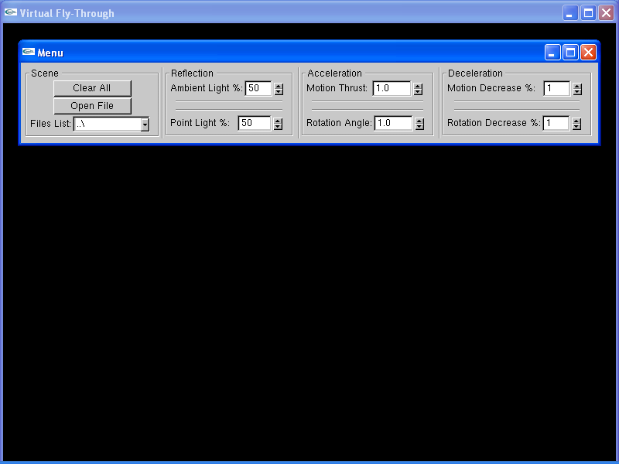

Hide Menu

Show Menu



4.2. Motion Control

Home

↑

PgUp

←

○

→

End

↓

PgDn

Del

Ins

Move Up

Move Forward

Move Left
Move Right

Move Backwards

Move Down

Cease Motion

4.3. Rotation Control

Q

W

E

A

S

D

Z

X

C

Alt

Space Bar
Turn Up
Turn Right
Turn Down
Turn Left

Turn Right-Wise
Turn Left-Wise

Cease Rotation

5. External Dependencies

5.1. Building Requirements

 | Compilation | Static Linkage
Library | math.h  string.h | double Point::m_fDistance
Project | io.h  string.h  direct.h  GL\glui.h  GL\glut.h | glu32.lib  glui32.lib  glut32.lib  opengl32.lib  -Ignore libcd.lib

Notes:
- All header files should be placed in the default header path.
- All library files should be placed in the default library path.
- The static member variable 'double Point::m_fDistance' should be:
  - Globally declared.
  - Set to the distance of the viewer from the viewport.

5.2. Run-Time Requirements

 | Platform | Dynamic Linkage
Library | Any | None
Project | Pentium + Windows | glut32.dll

Notes:
- This project was developed and tested with Visual C++ 2010 (over Windows).
- All external dependencies are standard MSVC libraries, with the exception of:
  - GLUI library / version 2.2 (by Paul Rademacher).
  - GLUT library / version 3.7.6 (by Nate Robins).
- The GLUI library can be found at www.cs.unc.edu/~rademach/glui.
- The GLUT library can be found at www.pobox.com/~nate/glut.html.

≈Designed and implemented by Barakman (barakman@yahoo.com)≈

