UNIVERSITY OF RWANDA
COLLEGE OF SCIENCE AND TECHNOLOGY S
SCHOOL OF ICT
COMPUTER AND SOFTWARE ENGINEERING
NYARUGENGE CAMPUS
MODULE: WEB DESIGN
YEAR 1
18/07/2026

SMART WORKFORCE MANAGEMENT SYSTEM

Project Technical Report

Table of Contents
CHAPTER 1: INTRODUCTION 3
CHAPTER 2: SYSTEM ANALYSIS AND DESIGN 4
CHAPTER 3: IMPLEMENTATION 9
CHAPTER 4: CONCLUSION AND RECOMMENDATION 12

CHAPTER 1: INTRODUCTION
  - 1.1 Historical Background
In many organization and education institutions, support staff such as cleaners, maintenance workers, and other operational employees play an important role in ensuring a clean, safe, and organized working environment. However, managing these employees manually has become challenging.
Traditionally, workforce management activities such as assigning duties, recording attendance, monitoring task completion were performed using paper records or informal communication records. This approach often caused difficulties such as loss of information, poor task tracking, delays in communication and inefficient monitoring of employee performance.
The Smart Workforce Management System is a web application developed to provide a simple web-based platform that helps to efficiently manage staff activities. The system allows users to register employees, assign tasks, monitor attendance and manage workforce-related information through an organized digital platform.

  - 1.2 Problem Statement
Managing university support staff manually creates several challenges that affect efficiency and productivity. These challenges include:
- Difficulty in assigning task and monitoring their completion.
- Lack of a centralized system for storing employee information.
- Challenges in tracking employee attendance.
The need for web-based Smart Workforce Management System simplifies workforce management activities and improves coordination within the work field.

  - 1.3 Objectives of the project
General objective:
To develop a web-based Smart Workforce Management System that improves the management and coordination of university support staff activities.
Specific Objectives:
The specific objectives are:
- To provide a platform for registering and managing employee information.
- To allow assigning of tasks to employees.
- To provide a way of monitoring employee attendance.
- To reduce dependance on manual record keeping.

  - 1.4 Expected Outcomes
The expected outcomes are:
- A functional web application for managing workforce activities.
- Faster and easier access to employee information.
- Improved task assignment and tracking
- Better organization of attendance records.
  - 1.5 Project Rationale
The Smart Workforce Management System simplifies employee management and provides organization information for decision-making; it provides an easier way to assign tasks and monitor employee activities.
The project also demonstrates how web technologies such as HTML, CSS and JavaScript can be used to solve real-word management challenges.

CHAPTER 2: SYSTEM ANALYSIS AND DESIGN
  - 2.1 System Analysis
2.1.1 Intended Users of the Project
The Smart Workforce Management System is designed for a Manger who is responsible for controlling and coordinating workforce activities. The manger is the main user of the system and performs all management operations through the platform.
The manager can perform the following activities:
- Employee Management
- Task management

- Attendance Management
2.1.2 Intended System Partners
The following are the partners besides from the manager who benefit from the system
- University Management
- Support staff Workers
- IT support team
  - 2.2 System Design
The system design describes the relationship between authentication and the system function.

  - 2.2.1 High Architecture
DATA STORAGE (database)

1. employee
2. task
3. attendance
APPLICATION LAYER
1. Form validation
2. Data processing
3. User interaction
WEB PLATFORM

1. Login
2. Dashboard
3. Register
4. Task Assign
5. Attendance

API API

  - 2.2.3 Flow chart
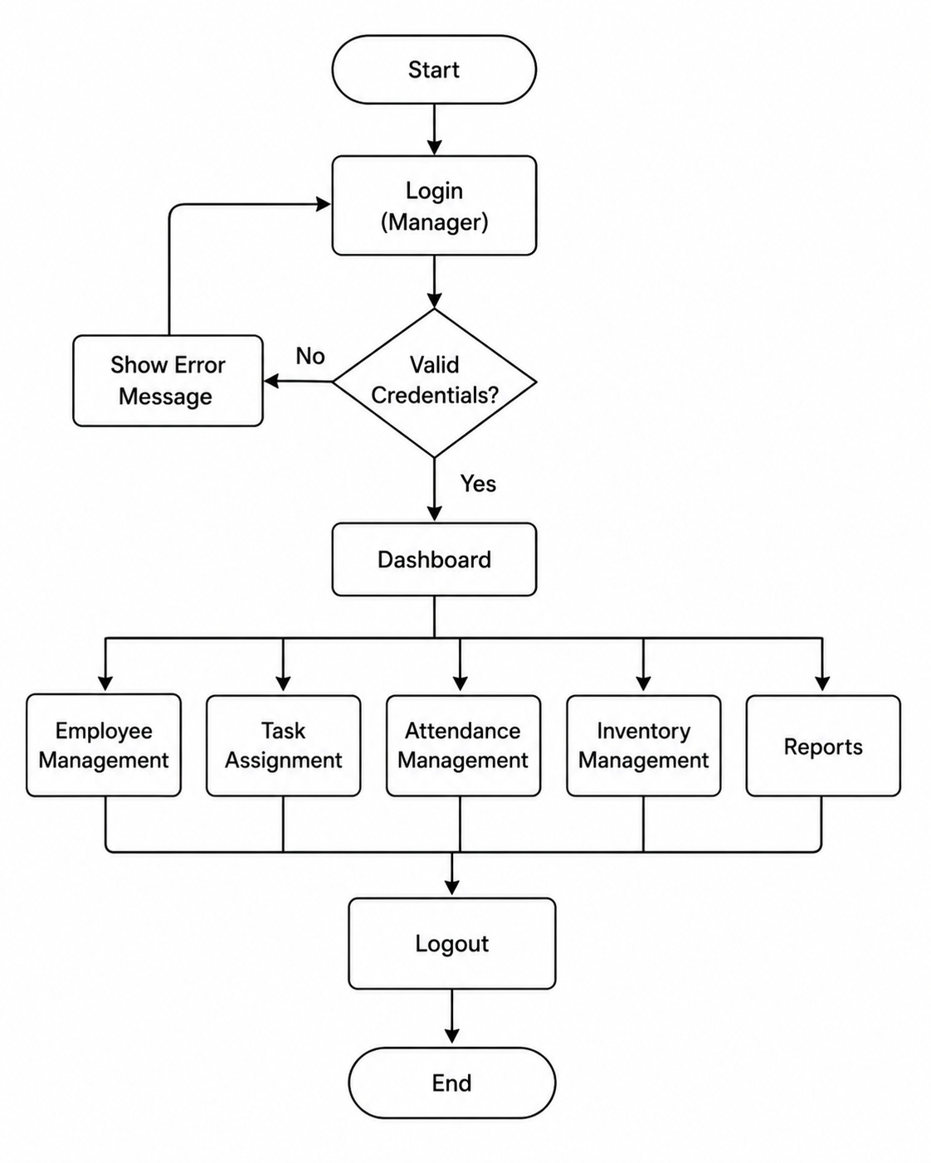

  - 2.2.3 ERD
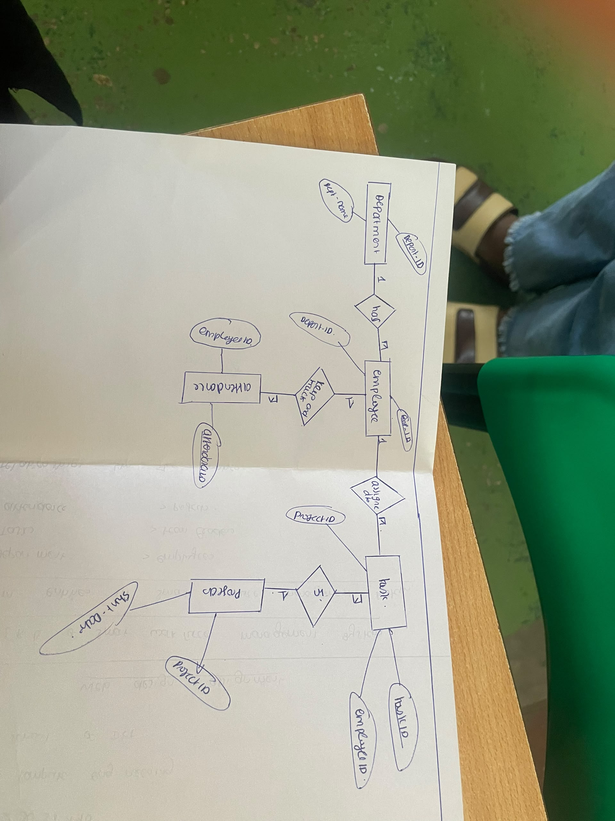

CHAPTER 3: IMPLEMENTATION
  - 3.1 introduction
This chapter describe the implementation of the Smart Workforce Management System. The system was developed using HTML, CSS, and JavaScript to make a responsive and interactive web application.
HTML was used to create the structure of the web pages, CSS was used for styling and improving the visual appearance and JavaScript was used to provide dynamic functionality such as validation, navigation and user interaction.
  - 3.2 Login Page
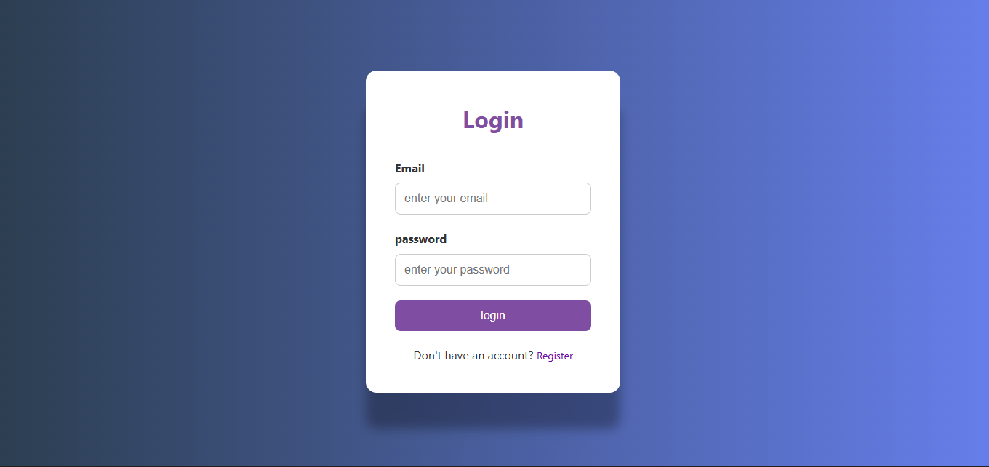

The login page allows the manager to access the system using valid login credentials. It includes username and password fields with JavaScript validation to ensure that required information is entered before login.
  - 3.3 Dashboard
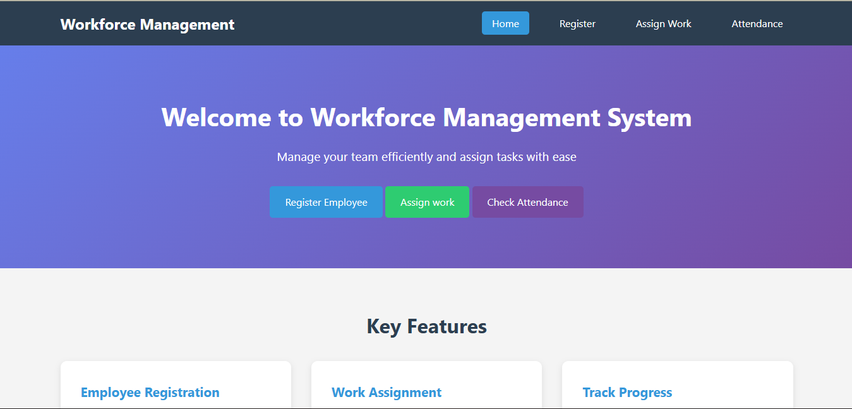

The dashboard is the main page of the system also known as Home page. It provides navigation to all modules including employee management, task management and attendance management.
  - 3.4 Employee Management
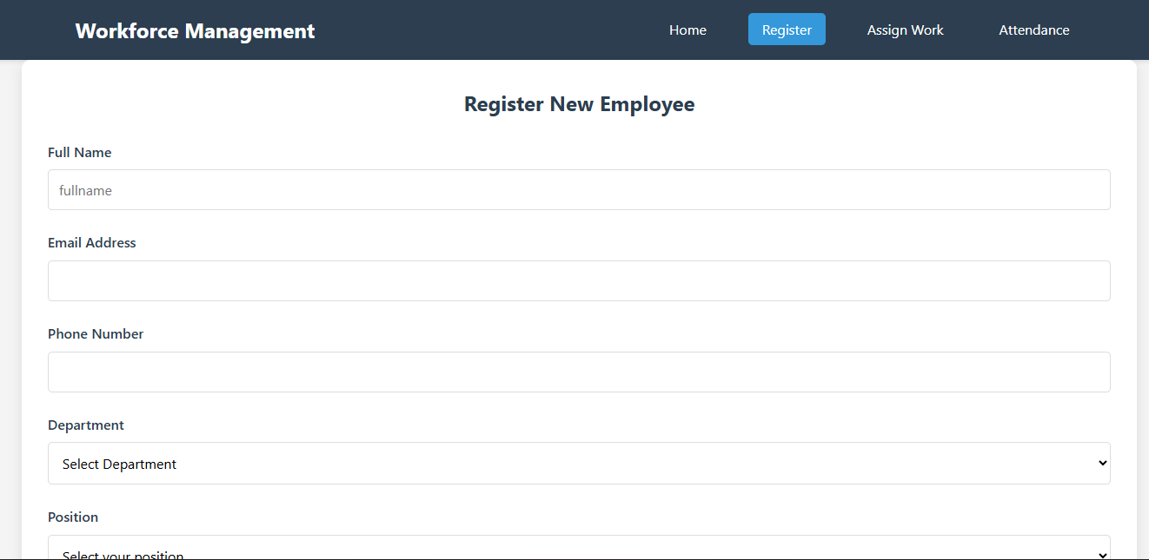

This page allows the manager to register new employees. The manager fills the form, the form records employee full name, email address, phone number, department, position. It uses JavaScript to ensure that the data entered is valid.

  - 3.5 Tast Assign

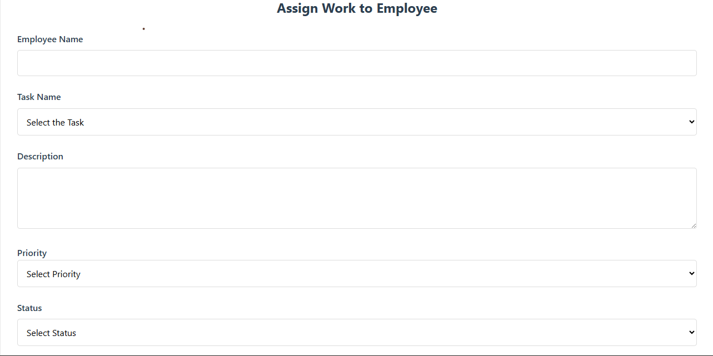

This page enables the manager to assign task to employees. The page also states the task information and the completion status even its priority.
  - 3.6 Attendance Management
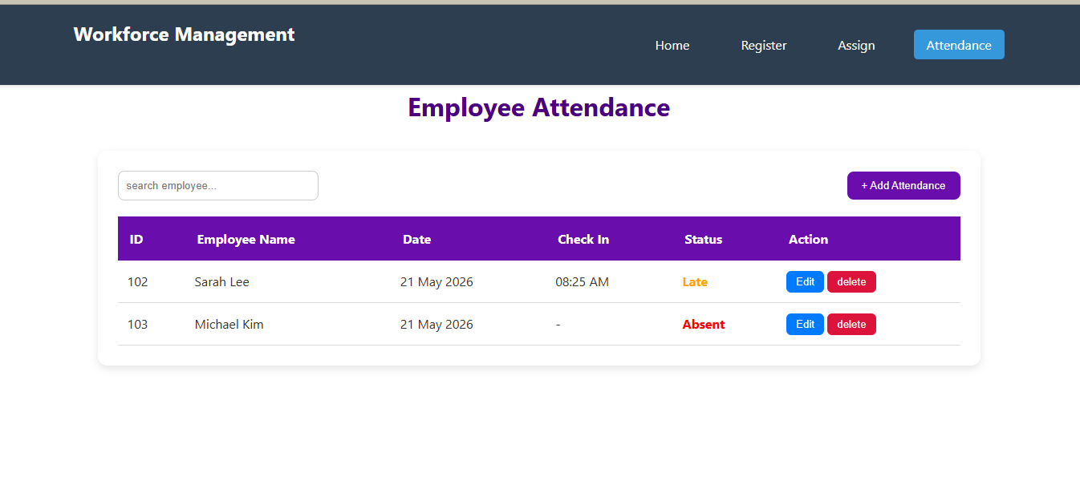

The attendance page records employee attendance and enables manager to monitor attendance history.

CHAPTER 4: CONCLUSION AND RECOMMENDATION
  - 4.1 Conclusion
The Smart Workforce Management System was developed to improve the management of university support staff activities. The system provides a centralized platform where the manager can register employees, assign task and monitor attendance.
The project achieved its main objectives by replacing manual process with a simple web-based solution. Through the use of HTML, CSS and JavaScript, the system offers an interface that enhances efficiency and organization.
Approximately 85% of the planned objectives were achieved.
  - 4.2 Recommendations
To the Lecturer
More practical sessions on advanced web technologies would help to develop more comprehensive web application.
To university
The university should continue encouraging project-based learning and provide adequate laboratory facilities and internet access.

To organization
The organization should adopt the Smart Workforce Management System to improve workforce coordination, reduce paperwork, and increase operational efficiency.
To manager
The manager should receive basic training on how to use the system effectively and maintain accurate workforce records.
  - 4.3 Future improvement
- Role based access for multiple managers and employees.
- Email and SMS notifications for task assignments.
- Report generation and data analytics.
- Integration with database.
  - 4.4 Appendix
GitHub Repository: smartworkforcemanagement
Deployment Link: https://barameleila2.github.io/smartworkforcemanagemt/
Emails and Passwords
Email: Admin@gmail.com
Password: 1234

