But the Drought Came Back?

The Very Next Year!
  - Harvard University | CS171 |Final Project Process Book
  - Ben Steineman & Shiuh-Wuu (Victor) Liu

Overview and Motivation
Earlier this month, California Governor, Jerry Brown, issued new directives which aim to reduce water consumption which includes an unprecedented mandatory 25% cut in urban water use. These measures are intended to address the growing concerns and threats of the sustained drought over the last couple of years.
As proud Californians working for a renewable energy technology company, we are deeply concerned with sustainable living practices which will impact our friends and family as well as our posterity. As a result, we are very passionate about gathering insights into this topic which may lead to some innovative solutions that could help address this problem.

Related Work
The following resources have inspired us and helped us drive forward a meaningful visualization for the purposes of conveying important insights into how the drought has affected California in the last few years.
- ▶ MIT Residential Footprint - YouTube. (n.d.). Retrieved April 11, 2015, from https://www.youtube.com/watch?v=9-vI6AJ32fg

- ▶ The Cat Came Back - Camp Songs - Kids Songs - Children’s Songs by The Learning Station - YouTube. (n.d.). Retrieved April 11, 2015, from https://www.youtube.com/watch?v=LjMffHG1V_Q
  - This song from our childhood helped inspired the title for our project.

- California Drought Information | USGS California Water Science Center. (n.d.). Retrieved April 11, 2015, from http://ca.water.usgs.gov/data/drought/

- California Land & Water Use. (n.d.). Retrieved April 11, 2015, from http://www.water.ca.gov/landwateruse/surveys.cfm

- CDFA > STATISTICS. (n.d.). Retrieved April 11, 2015, from http://www.cdfa.ca.gov/statistics/

- cida.usgs.gov/ca_drought/. (n.d.). Retrieved April 11, 2015, from http://cida.usgs.gov/ca_drought/

- CIDA-Viz/ca_reservoirs.json at master · USGS-CIDA/CIDA-Viz · GitHub. (n.d.). Retrieved April 11, 2015, from https://github.com/USGS-CIDA/CIDA-Viz/blob/master/ca_reservoirs/Data/ca_reservoirs.json

- Crop_Coeffients.pdf. (n.d.). Retrieved from http://www.cimis.water.ca.gov/Content/PDF/Crop_Coeffients.pdf

- How to Estimate Water Useage Required for an Irrigation System. (n.d.). Retrieved April 11, 2015, from http://www.irrigationtutorials.com/how-to-estimate-water-useage-required-for-an-irrigation-system/

- Mapping the Spread of Drought Across the U.S. - NYTimes.com. (n.d.). Retrieved April 11, 2015, from http://www.nytimes.com/interactive/2014/upshot/mapping-the-spread-of-drought-across-the-us.html

- Microsoft PowerPoint - Blaine-Hanson Water Forum complete.ppt - blaine-hanson_water_forum_complete.pdf. (n.d.). Retrieved from http://www.pge.com/includes/docs/pdfs/shared/edusafety/training/pec/water/blaine-hanson_water_forum_complete.pdf

- Streaming through 1Channel.ch. (n.d.). Retrieved April 11, 2015, from https://add2ac80562d5288b8b87115bba350a041fd1663.googledrive.com/host/0B2kv7wOF5KquclBsZXlUR1hCNms/index.html

- USGS Release: Data-driven Insights on the California Drought (12/8/2014 8:33:13 AM). (n.d.). Retrieved April 11, 2015, from http://www.usgs.gov/newsroom/article.asp?ID=4069#.VSmUZZPK5aZ

- Virtual Water - Discover how much WATER we EAT everyday. (n.d.). Retrieved April 11, 2015, from http://www.angelamorelli.com/water/

- waterfootprint.org. (n.d.). Retrieved April 11, 2015, from http://waterfootprint.org/en/

- Start Using Landsat on AWS | AWS Official Blog. (n.d.). Retrieved April 11, 2015, from https://aws.amazon.com/blogs/aws/start-using-landsat-on-aws/

Questions

Data
Data that comes from USGS have already been formatted in CSV and JSON which means that they will require minimal processing as they are structured.
For the purposes of achieving Objective #1, we would need to create two tables from raw files which are ‘Daily Reservoir Utilization’ and ‘Reservoir Meta’. The fields required for ‘Daily Reservoir Utilization’ include <Reservoir ID>, <Storage Level>, <Date Recorded>. The fields required for ‘Reservoir Meta’ include <Reservoir ID>, <Storage Capacity>, <Longitude>, <Latitude>, and <Reservoir Name>. The tables will be aggregated on by <Year-Month> using the <Date Recorded> field. The <Average Storage> and <Capacity %> fields will be aggregated by <Year-Month>. The two tables will be joined on <Reservoir ID> as the key. Any reservoir outside of the top 10 capacity reservoirs will be grouped into an Others category. The raw files that enable the above operations are:
- storage.json – Fields: 3, Records: 437,881
- reservoir.json – Fields: 10, Records: 91
For the purposes of achieving Objective #2, we would need to create a ‘2010 CA Water Withdrawal Data’ table. The fields that we would use are <Year>, <Usage>, <Ground or Surface>, <Saline or Fresh>,<Daily Volume>. The raw files that enable the above operations are:
- usco2010.xlsx – Fields: 117, Records: 3,225

Sankey Chart
We choose to use the Sankey chart to visualize the flow of water withdrawals in the state of California. This allows us to visualize what will be affected the most by the drought.
The data structure for a Sankey Chart consists of Sources, Targets, Values and Nodes.
Sources, Targets and Values define where the water is coming from, where it's going and what quantity of water. Water travels through different categories and levels.
1. Water Source:
A. Surface Water (Reservoirs, Rivers, Creeks, Streams and Lakes)
B. Ground Water (Pumps and Aquifers)

2. Water Type:
A. Fresh (Water with a low concentration of dissolved salt and solids, potable water and water that's not from the sea)
B. Saline (Water containing salt, not potable)

3. Water Use:
A. Public Supply
B. Domestic
C. Industrial
E. Irrigation
F. Irrigation Crop
G. Irrigation Golf
H. Livestock
I. Aquaculture
J. Mining
K. Thermoelectric
L. Thermoelectric once-through
M. Thermoelectric recirculation

The quantity of water is measured in Millions of Gallons per Day (Mgal/d). By determining how many millions of gallons each reservoir holds you can easily calculate how much water each every category is using.

Links are defined as the segments between the nodes, the width of each link is determined by the Value (Mgal/d). Attributes of a link are: Source, Target, and Value.

Nodes are defined as the labeled blocks that are connected by the links. The height of each node is determined by the sum of all the values linking to the node. Attributes of a node are: Name.

An example of data layout for Sankey Chart:

{"links": [
{"source":"Surface Water","target":"Fresh","value":"20"},
{"source":"Fresh","target":"Irrigation","value":"4"},
] ,
"nodes": [
{"name":"Surface Water"},
{"name":"Fresh"},
] }

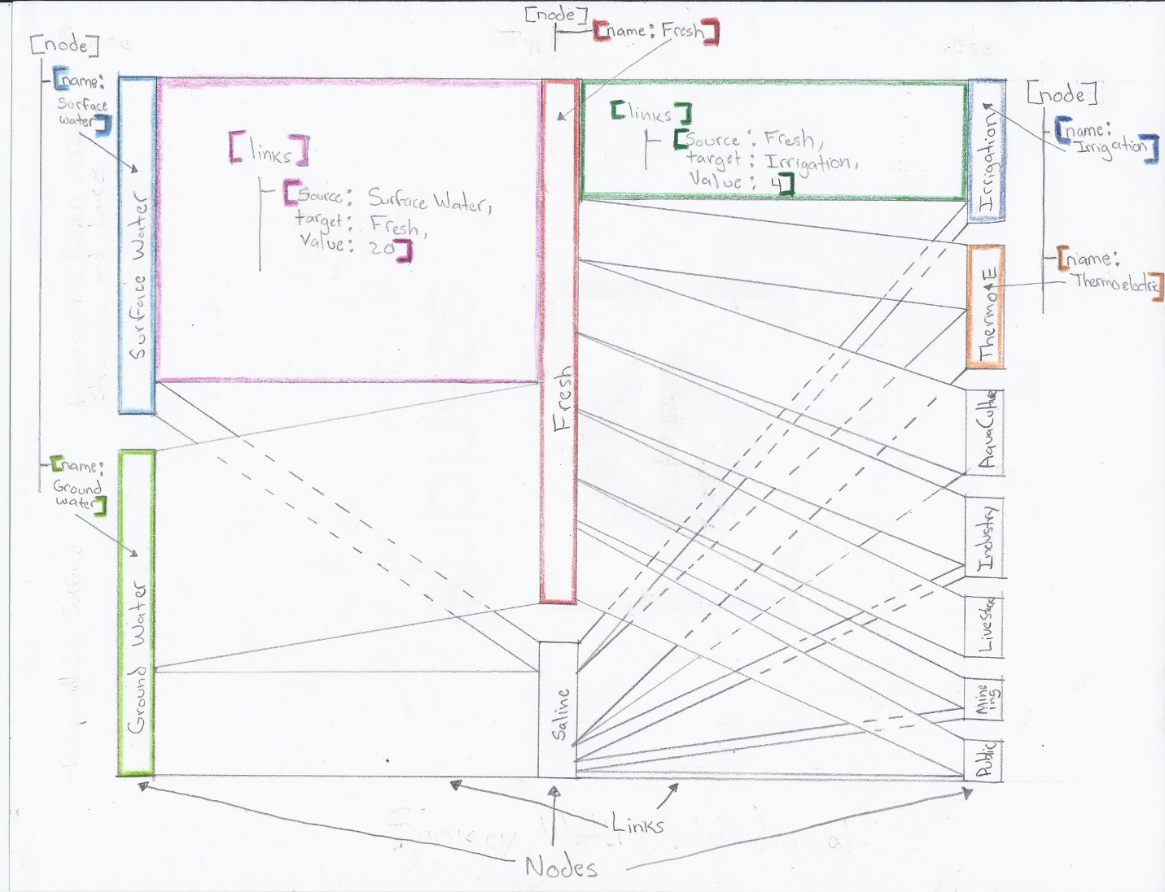

Exploratory Data Analysis
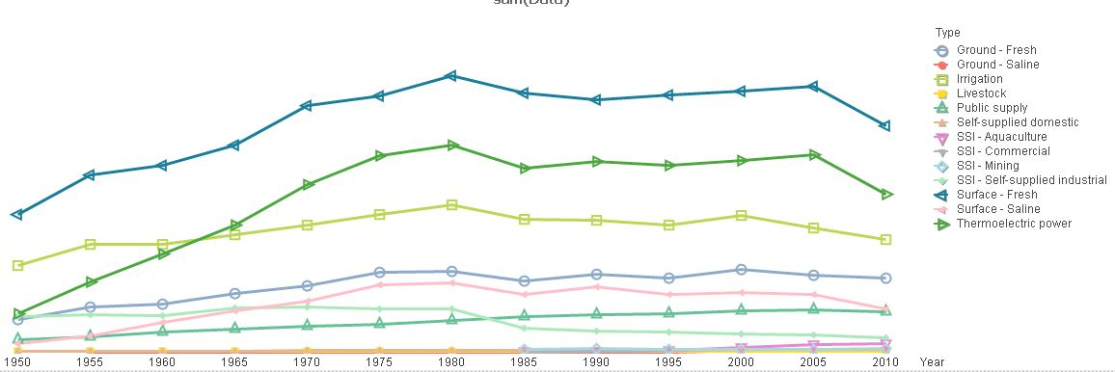
Figure 1

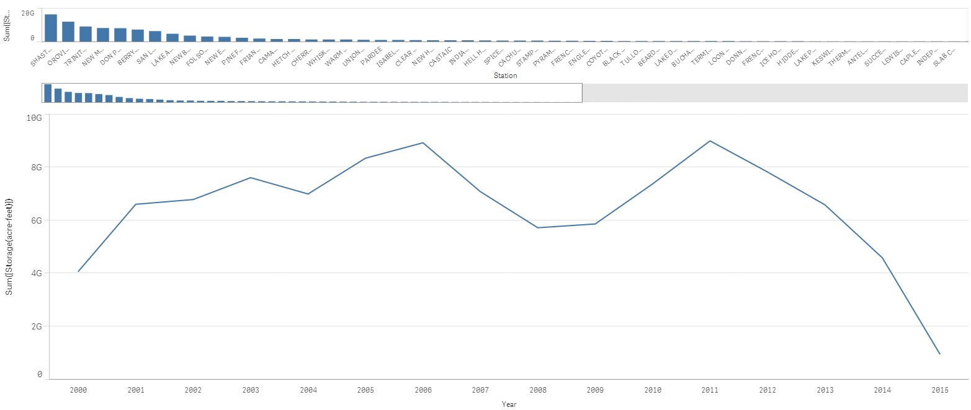
Figure 2

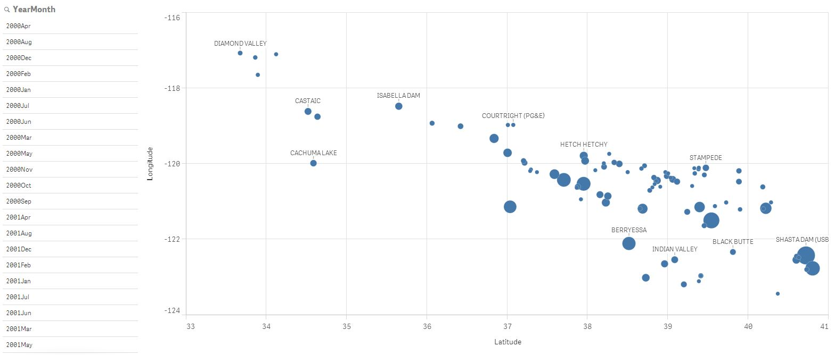
Figure 3

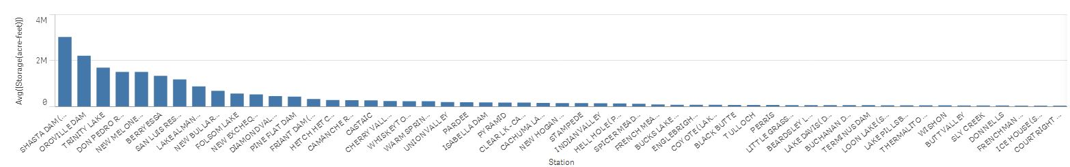
Figure 4

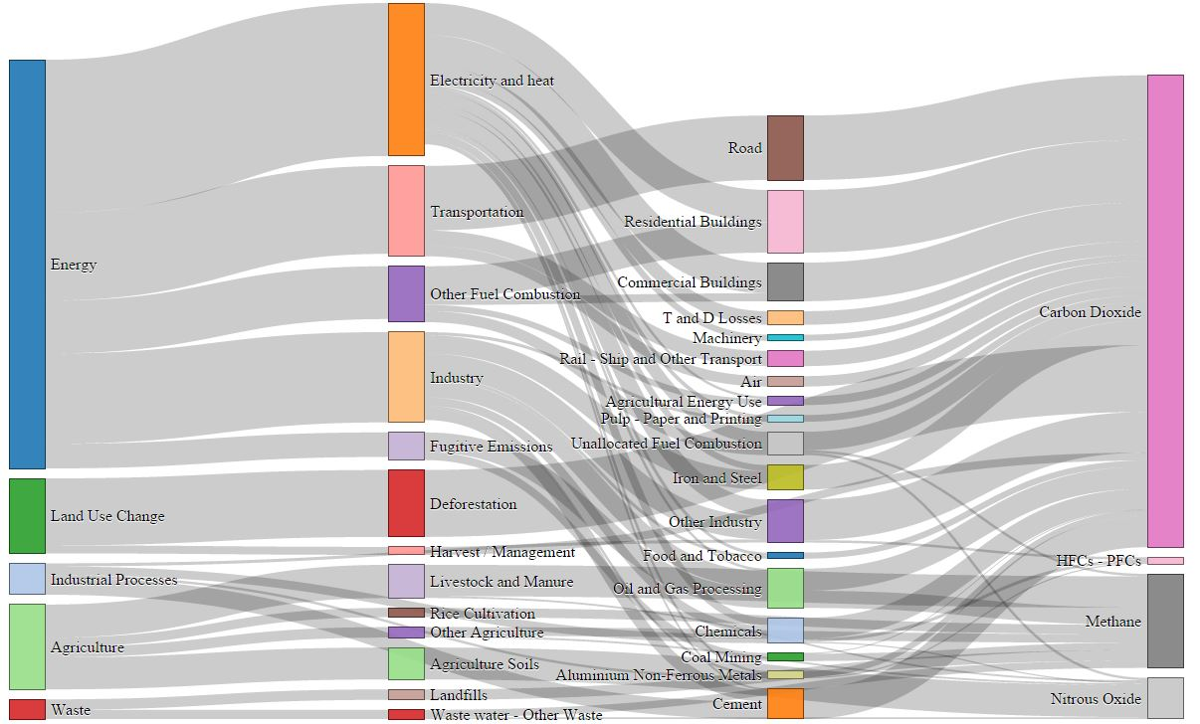
Figure 5

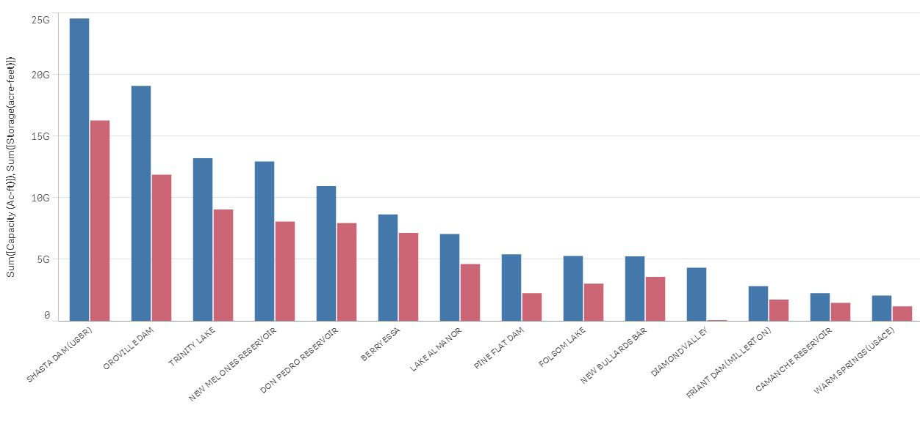
Figure 6
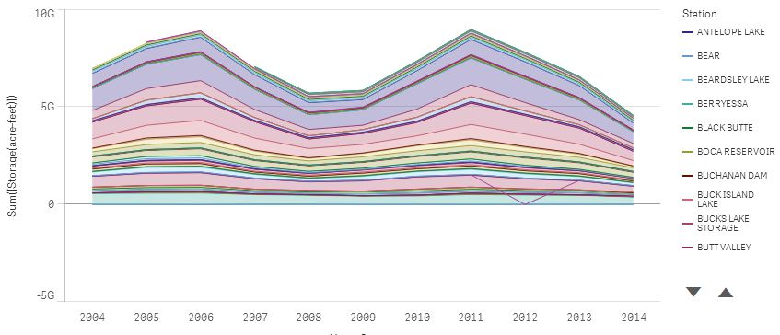
Figure 7

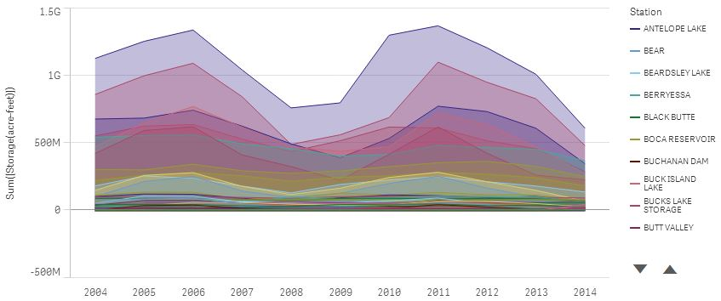
Figure 8
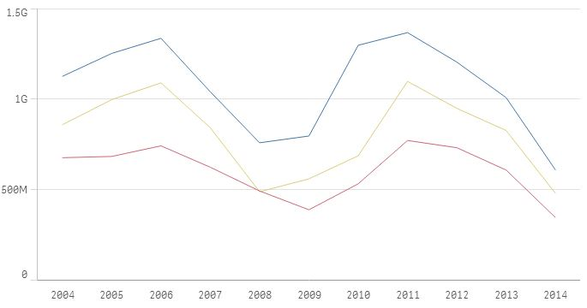
Figure 9

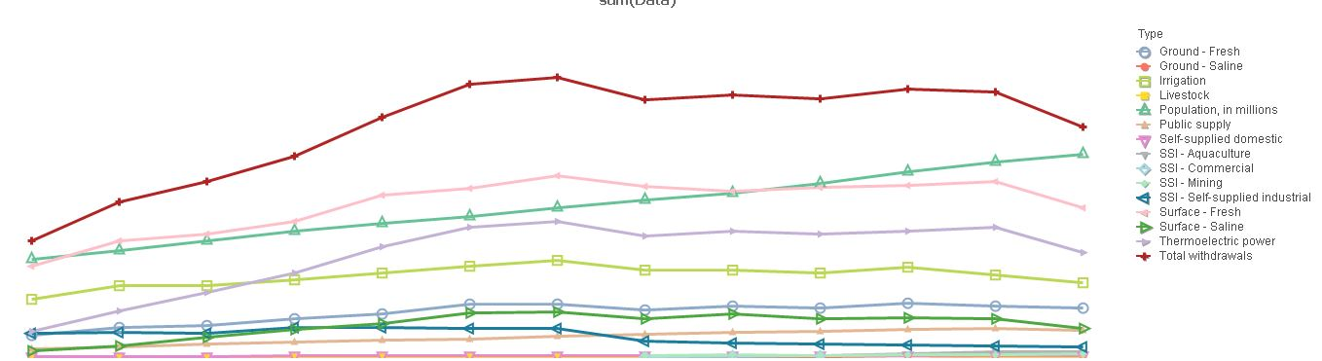
Figure 10

Design Evolution

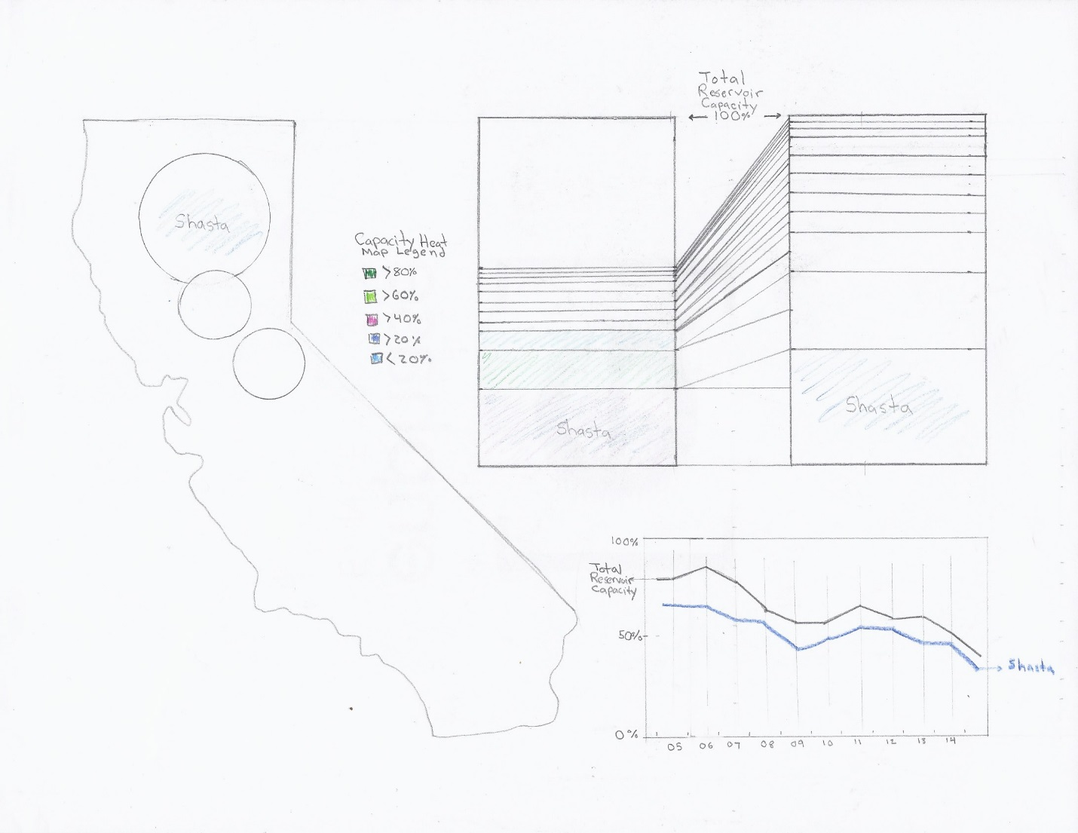
Figure 1

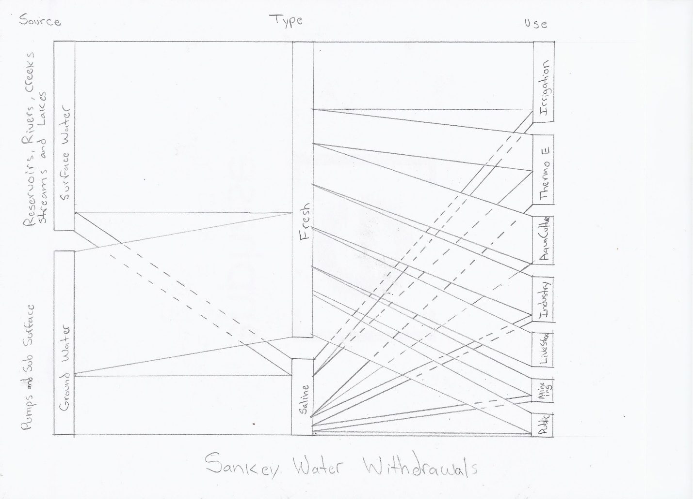
Figure 2
- Map of California displays mapped reservoir longitude and latitude locations and selection of reservoirs. The reservoirs are displayed on the map using concentric circles that indicate current utilization and capacity. See Figure 1.
- Line Chart that displays reservoir capacity utilization over time. See Figure 1.
- Stacked Bar Charts shows reservoir utilization with heatmap on stacked bar chart that indicates ‘% of capacity utilization’ for each reservoir. See Figure 1. The two stacked bar charts are also linked by lines which help indicate percentage utilization. The color-coded heatmap is a double encoding.
- Sankey Chart shows the fields, <Ground or Surface>, <Saline or Fresh>, and <Water Usage>. Hovering on Sankey Chart that will show a ‘Details Table’ for each category. See Figure 2.

Implementation

Evaluation

Overview and Motivation: Provide an overview of the project goals and the motivation for it. Consider that this will be read by people who did not see your project proposal.
Related Work: Anything that inspired you, such as a paper, a web site, visualizations we discussed in class, etc.
Questions: What questions are you trying to answer? How did these questions evolve over the course of the project? What new questions did you consider in the course of your analysis?
Data: Source, scraping method, cleanup, etc.
Exploratory Data Analysis: What visualizations did you use to initially look at your data? What insights did you gain? How did these insights inform your design?
Design Evolution: What are the different visualizations you considered? Justify the design decisions you made using the perceptual and design principles you learned in the course.
Implementation: Describe the intent and functionality of the interactive visualizations you implemented. Provide clear and well-referenced images showing the key design and interaction elements.
Evaluation: What did you learn about the data by using your visualizations? How did you answer your questions? How well does your visualization work, and how could you further improve it?

