Xamarin

Adv

1. Backend Code reusability otherwise we have to use Objective C for IOS, Java for Android and C# for Windows phones.

Disadv

1. UI needs to built on its own platform to be able to access native features but there is still lot of code reusability from Business logic. This makes sense. Forms can be used to increase UI code reusability,
2. Learning curve
3. Price of s/w for commercial use

Use Xamarin XPIs in Xamarin Android

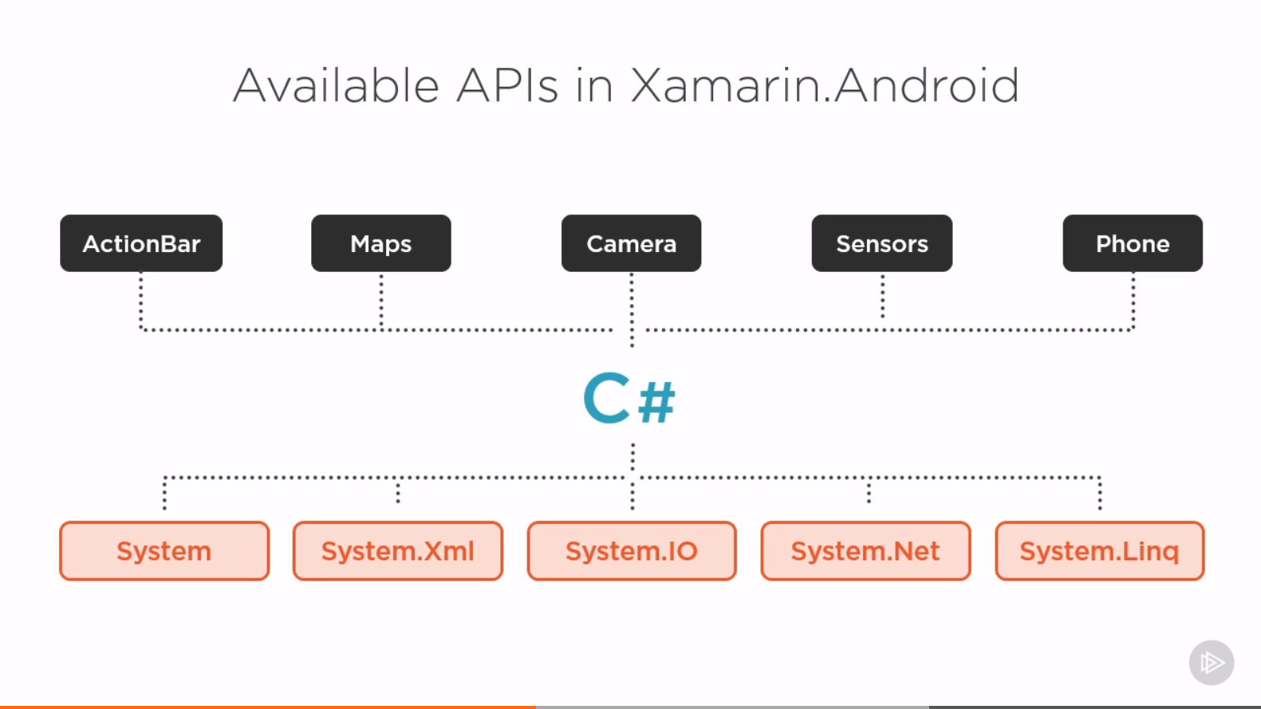

Distribute the app thru the playstore in the form of apk

In Xamarin, we write code for each platform in C#. We get 60-70% reusability. With Xamarin apps, we get 100% reusability across all platforms because UI is written in XAML.