**Full Name:** Baran Öden

**Title:** Front End Web Developer

**About me:** Currently I am interested in Front End Web development. My code writing skills at HTML is pretty ordered which makes the work easier also precise. I really enjoy writing HTML and CSS, finishing touches on a work really makes my day and makes me happy as well. I can create Responsive websites easily.

I am studying HTML, CSS and JavaScript for 1 year, at 2015 I took Basic Web Design courses and graduated from a random course who made me love Web Development. But I was also interested in Teaching English. So, I went to English Literature department to make my English and its culture perfect. And started to work as an English Teacher. On the other hand, I didn’t leave my interest on web development behind. I kept working as a freelancer as well which I was creating WordPress-based websites for customers through online.

**At 2020, I quit being a teacher and started to study HTML, CSS and JavaScript. Now I am trying to push very forward on Coding Front End.**

**I also took Search Engine Optimization Courses and practiced a lot while making WP-Based web sites.**

**Links:**

* [**https://github.com/baranoden**](https://github.com/baranoden)
* [**https://linkedin.com/in/baranoden**](https://linkedin.com/in/baranoden)
* [**https://instagram.com/baranodenn**](https://instagram.com/baranodenn)

**Code Skills:**

* HTML 5 (Advanced)
* CSS3 (Advanced)
* JavaScript (Intermediate)
* Bootstrap (Advanced)
* ReactJS (Beginner)

**Programs/Applications:**

* **Visual Studio (Advanced++)**
* Adobe Dreamweaver (Beginner)
* Adobe Premiere Pro (Advanced)
* Adobe Photoshop (intermediate)
* Microsoft Word/Pp/excel (intermediate)
* Camtasia (Advanced)
* Discord/Skype/Ventrilo/Raid/TeamSpeak/Zoom
* WordPress (Advanced++)
* Git (Advanced)

**Education**

2015 - Graduated from High School of Accounting. (Graduated)

2015 - Web design and SEO certificate (Graduated)

2017-2021 -- Doğuş University: Associate of Arts: English Language and Literature (Graduated)

Work History ->> Currently Student at Patika.dev Frontend Bootcamp

* **2016-01** English Tutor, Private Lessons, İstanbul Ümraniye

I am still giving private lessons, and worked with students in classrooms, small study areas or home environments to provide educational support.

-------------------------------------------------------------------------------------------------------------------------------------

* **2019-07** English Teacher, Just English, İstanbul Kadıköy

I worked as an English Teacher at Just English for half year. I experienced almost every type of student. I am really good at understanding people's problems and what they are having struggle with. I developed my own teaching style. Students are facing with a fully experienced teacher instead of shy or newbie teacher.

-------------------------------------------------------------------------------------------------------------------------------------

* **2014-08** Web designer & SEO (Currently and still working as Freelance but not fulltime, only when I got a job order.)

Creating cheap but professional any-kind websites for customers.

-------------------------------------------------------------------------------------------------------------------------------------

**Personal Information/Notes**

* I can create/edit videos with Adobe Premier Pro or edit photos and maybe design basic logos.
* Advanced level of English at writing and reading. (I can give some academic subjects as well)
* Non-stop worker. Never gets exhausted, never delays his work.
* Team player.
* Adaptive.
* Problem solver (always)

**Example Works of mine:**

**Example detail page from a project-based job of mine.**

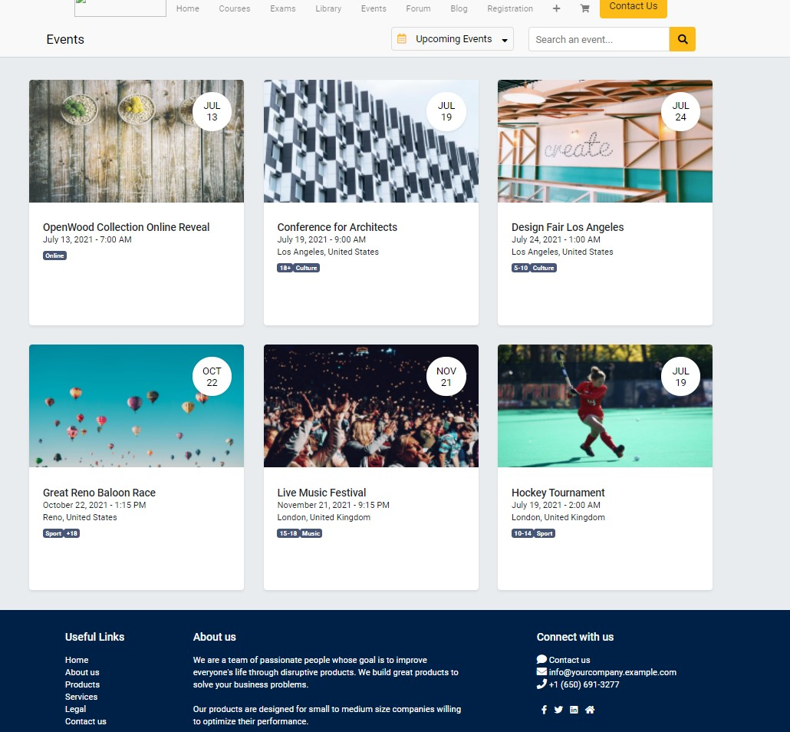

**Example div container from page above.**

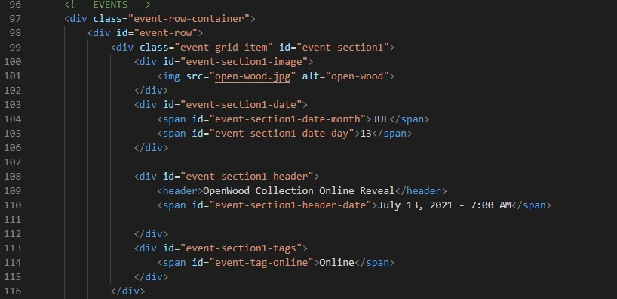

**Example CSS Codes from same page.**

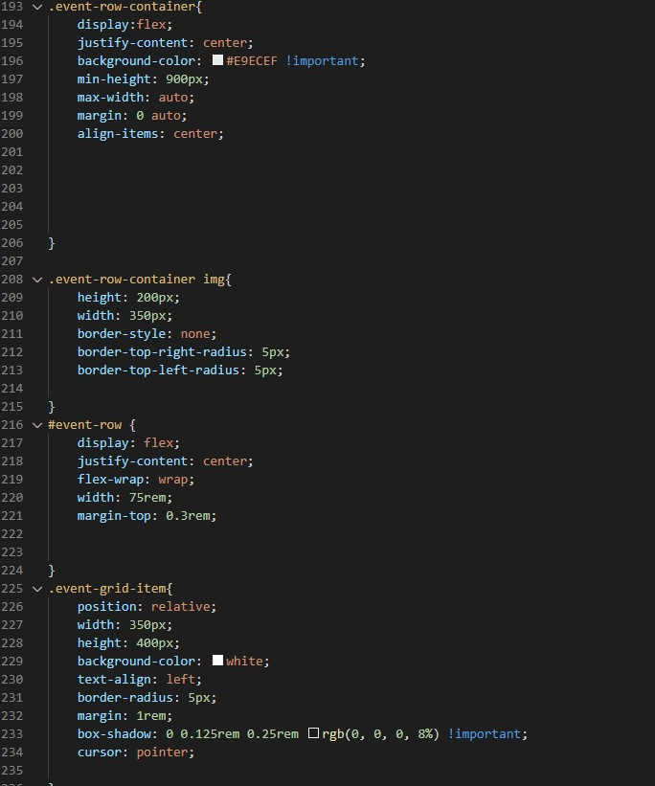

**Example JS navigation bar from same page.**

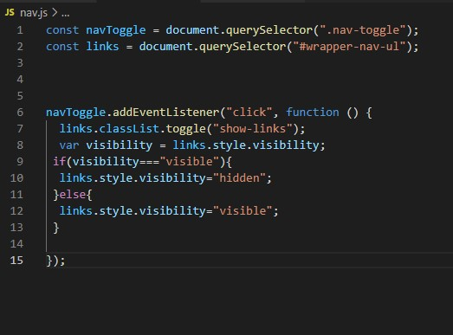

**Contact:**

[Baranoden@gmail.com](mailto:Baranoden@gmail.com)

+90 539 705 1894

Whatsapp / Phone Calls / SMSs