ToGather   
Brief Use-Cases

1. **Introduction**

In this document, use cases are introduced briefly for the Inception. Primary actors and use cases are identified.

1. **Overview**

ToGather Next generation Calendar App is a scheduling program which helps people to be more effective and stay connected to their friends. The main purpose of this application is to make its user more organized while enjoying their personal life, increase effectiveness of their time management skill and decrease chaos among the multitude of their tasks. ToGather App is an opportunity cost savior for its users.

ToGather App requires that the users have a stable internet connection and a device to use the app.

1. **Use-Case Diagram**

The figure below shows the use-case diagram for the ToGather App.

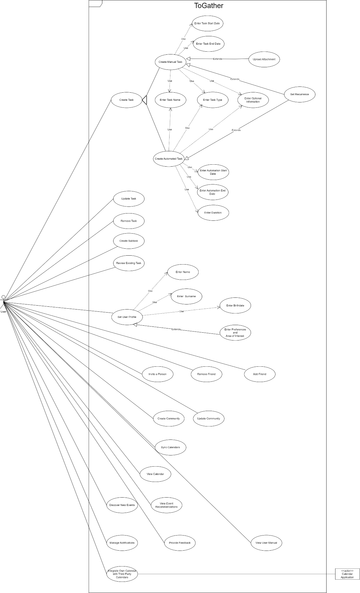

1. **Actors**

### Professionals

### This actor represents a person who wants to use the app to bring balance between their personal and professional life.

### University Students

### This actor represents a person who wants to use the app to bring balance between their personal and university life.

### Calendar Applications

### This actor represents third-party entity which provides synchronization data based on integration request.

### Use Cases

* 1. **Create a Task**

The use case describes how the users create a task on calendar application.

* 1. **Update the Task**

The use case describes how the users update the existing task to get updated schedule.

* 1. **Remove the Task**

The use case describes how the users remove the existing task from the calendar.

* 1. **Create Subtask**

The use case describes how the users create subtasks to the existing tasks.

* 1. **Review Existing Task**

The use case describes how the user reviews detailed information of an existing task.

* 1. **Set User Profile**

The use case describes how the user set their personal information and preferences.

* 1. **Add Friend**

The use case describes how the user starts a connection with another user.

* 1. **Remove Friend**

The use case describes how the user ends connection with another user.

* 1. **Invite a Person**

The use case describes how the users can invite other potential user to the application.

* 1. **Create Community**

The use case describes how the users create special communities to get recommendation based on the preferences which are tuned while creating communities.

* 1. **Update Community**

The use case describes how the user adds/removes other users to the community and edits community specific information.

* 1. **Sync the Calendars**

The use case describes how the users are syncing each other’s calendar.

* 1. **View Calendar**

The use case describes how the user views his/her own or friends’ calendars.

* 1. **Discover New Events**

The use case describes how users discover new events based on their interests, location, and social connections.

* 1. **View Event Recommendations**

The use case describes how users view recommended events based on users' past interests, activities, and social circles.

* 1. **Integrate Own Calendar with Third Party Calendars**

The use case describes how the users integrate ToGather app with other existing calendars.

* 1. **Manage Notifications**

The use case describes how the users open/close notifications/email notifications.

* 1. **Provide Feedback**

The use case describes how users give feedback to the application through online surveys.

* 1. **View User Manual**

The use case describes how users access all the necessary information through the online supplied user manual.