_{Appendix} C: IEEE 830 Template
Software Requirements Specification
for
Academic Scheduler – Personal Timetable and Task Management System

Version 5.0
Prepared by Kaja Barańska
Lodz University of Technology
13.04.2026

Table of Contents
_{Appendix} C: IEEE 830 Template 1
Revision History 2
1. Introduction 3
1.1. Purpose 3
1.2. Document Conventions 3
1.3. Intended Audience and Reading Suggestions 3
1.4. Product Scope 3
1.5. References 3
2. Overall Description 3
2.1. Product Perspective 3
2.1.1 Use case diagram 3
2.1.2 Class diagram 4
2.1.3 Activity diagram 4
2.2. Product Features 4
2.3. User Classes and Characteristics 5
2.4. Operating Environment 5
2.5. Design and Implementation Constraints 5
2.6. User Documentation 5
2.7. Assumptions and Dependencies 5
3. System Features 5
3.1. Checking Timetables 5
3.2 Adding Personalised Reminders 5
3.3 Adding To-Do Lists 5
4. External Interface Requirements 5
4.1. User Interfaces Overview 5
4.2. Hardware Interfaces 6
4.3. Software Interfaces 6
5. System Features/Modules 6
5.1. Timetable Viewing 6
5.1.1 Description and Priority 6
5.1.2 Stimulus/Response Sequences 6
5.1.3 Functional Requirements 6
5.2. Personalised Reminders 7
5.2.1 Description and Priority 7
5.2.2 Stimulus/Response Sequences 7
5.2.3 Functional Requirements 7
5.3. To-Do Lists 7
5.3.1 Description and Priority 7
5.3.2 Stimulus/Response Sequences 7
5.3.3 Functional Requirements 7
5.4. Source Code Repository 7
6. Nonfunctional Requirements 7
6.1. Performance 7
6.2. Security 7
6.3. Usability 8

Revision History
Name | Date | Reason for Changes | Version
Kaja Barańska | 03.03.2026 | Initial Version | V1.0
Kaja Barańska | 10.03.2026 | Use Case Diagram | V2.0
Kaja Barańska | 17.03.2026 | Class Diagram | V3.0
Kaja Barańska | 24.03.2026 | Activity Diagram | V4.0
Kaja Barańska | 13.04.2026 | Github and Git | V5.0

1. Introduction

1.1. Purpose
The purpose of the system is to allow users to check their timetable and also add their individual tasks and notes.

1.2. Document Conventions
In order to write tis document I used the IEEE 830 structure. To describe any requirements I used the word ,,shall”.

1.3. Intended Audience and Reading Suggestions
This document is written for developers and project supervisors. In the further part I explain the concept of the system, as well as the features and requirements

1.4. Product Scope
The purpose of the software is to make keeping up with everyday tasks and lessons more convenient, with daily reminders of deadlines and to-do lists which each user can personalise. Keeping every feature in one place allows user to organise better and see every task and plan clearly.

1.5. References
This document is based on the IEEE 830 Software Requirements Specification template and the assignment description provided in the Software Engineering course.

2. Overall Description

2.1. Product Perspective
The system shall be connected to the IFE timetables website, and allow the user to log in and gain more features.

2.1.1 Use case diagram
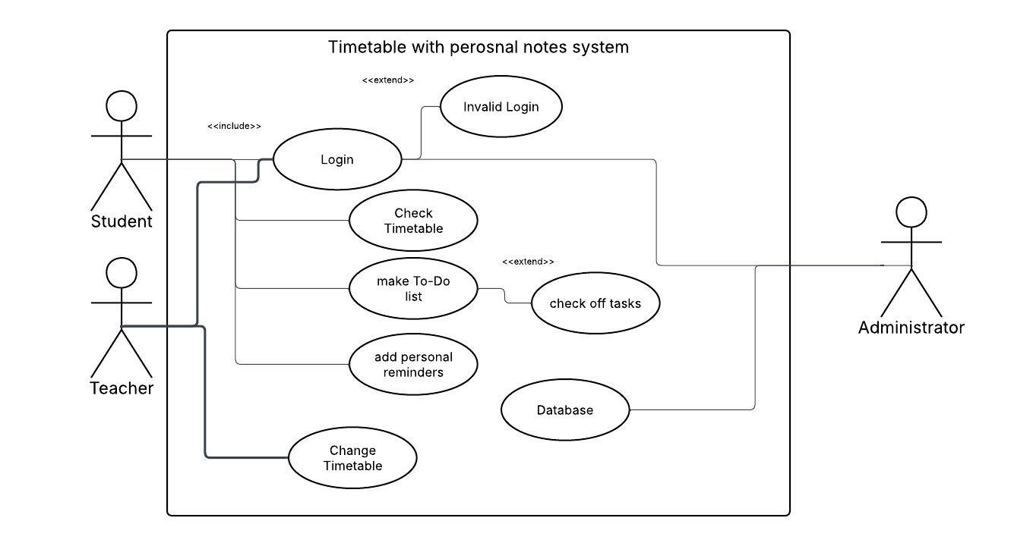
Figure 1This use case diagram illustrates the role-based interactions within a "Timetable with personal notes system," detailing how students and teachers can log in to view schedules and manage tasks or reminders, while teachers have the added ability to modify

2.1.2 Class diagram
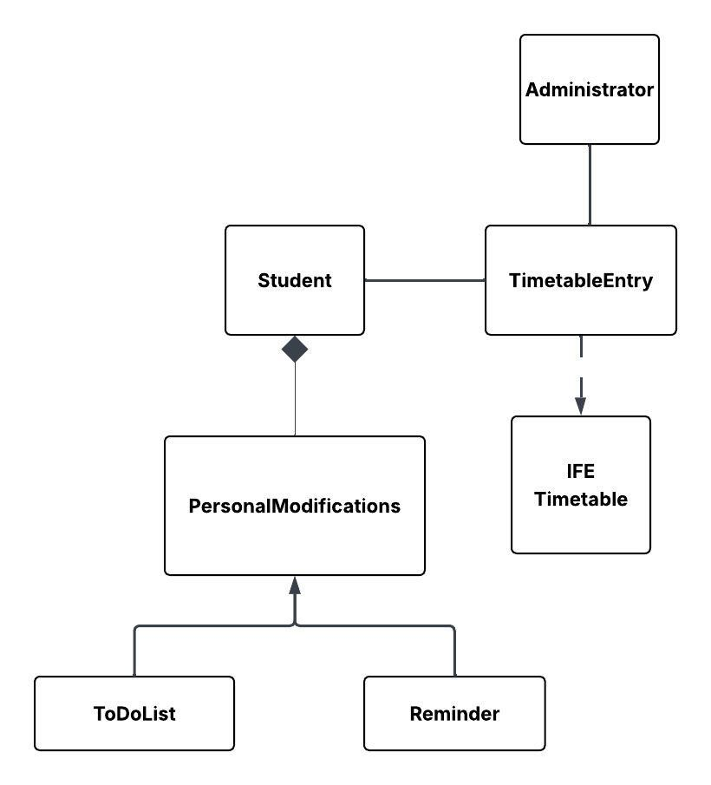
Figure 2 This class diagram outlines the structural relationships of the system, illustrating how administrators and students interact with timetable entries, while students exclusively own personal modifications that are specifically categorized into to-do lists and reminders.

2.1.3 Activity diagram
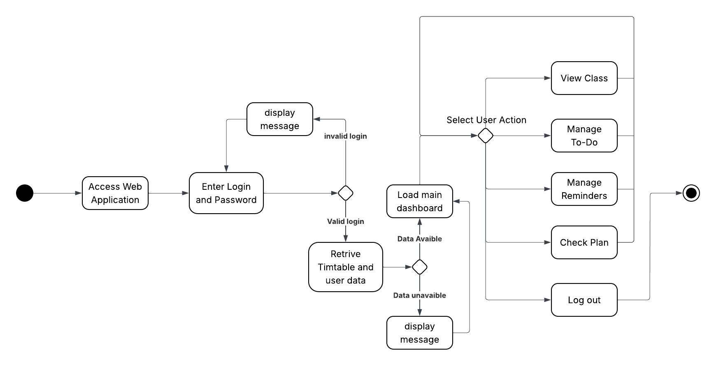
Figure 3 This activity diagram illustrates the user workflow for a web application, detailing the step-by-step process from initial login and data retrieval to navigating a central dashboard where they can manage classes, to-do lists, and reminders before final

2.2. Product Features
- Checking timetable
- Adding personalised reminders
- Adding to-do lists

2.3. User Classes and Characteristics
The product is design for IFE students with an active student account in the Technical University of Lodz, with the idea of everyday use.

2.4. Operating Environment
The system will operate as a web application that can be accessed through a web browser on a computer or mobile device with an internet connection.

2.5. Design and Implementation Constraints
The system must connect to the existing IFE timetable website and be developed using standard web technologies such as HTML, CSS and JavaScript

2.6. User Documentation
At the beginning the software will display a basic tutorial, presenting all new features, where to find them and how to use them.

2.7. Assumptions and Dependencies
The system will be dependent on the IFE timetables website, so it is crucial that it will remain active, also the student has to have an active student account at Wikamp.

3. System Features

3.1. Checking Timetables
The main function of the software shall be the ability to freely check the timetable of the user course of study, same as on the IFE page, with the advantage of remembering the choice and having a personal account with login and password

3.2 Adding Personalised Reminders
The software shall be able to allow the user to add reminders of upcoming deadlines and tests.

3.3 Adding To-Do Lists
The software shall be able to allow the user to add their own tasks and do-to lists which they will be able to check and keep track on.

4. External Interface Requirements

4.1. User Interfaces Overview
The system shall provide a graphical user interface (GUI) accessible through a web browser. The main screens include: a Login Screen, where the user enters their student credentials; a Dashboard, displaying the current week’s timetable along with upcoming reminders and to-do items; a Timetable View, where the user can browse different weeks and days; a Reminders Screen, where the user can create, edit, and delete deadline reminders; and a To-Do List Screen, where the user can manage personal tasks. Each action shall provide immediate visual feedback, such as confirmation messages on successful save or error messages when an operation fails.
The interface shall follow a clean, responsive design compatible with modern web browsers (Chrome, Firefox, Edge) on both desktop and mobile. Navigation shall be provided through a top menu bar present on every screen. All forms shall include input validation with clear error messages displayed inline. A “Help” button shall be accessible on every screen, opening a brief usage guide. Keyboard navigation shall be supported for all interactive elements.

4.2. Hardware Interfaces
The application does not require any dedicated hardware. It shall run on any device equipped with a modern web browser and an active internet connection, including desktop computers, laptops, tablets, and smartphones. No direct communication with hardware peripherals is required beyond standard input devices (keyboard, mouse, or touchscreen).

4.3. Software Interfaces
The system shall interface with the IFE timetable website to retrieve course schedule data via HTTP requests. The front-end shall be built using HTML5, CSS3, and JavaScript. User account authentication shall rely on the existing Wikamp (LDAP/SSO) student login system. All data exchange between the client and server shall use the HTTP/HTTPS protocol, with data formatted as JSON. A relational database (e.g., MySQL or PostgreSQL) shall store user-specific data such as reminders and to-do lists.

5. System Features/Modules
This section describes the functional requirements of the Academic Scheduler system, organized by its three main features: timetable viewing, reminders, and to-do lists.

5.1. Timetable Viewing

5.1.1 Description and Priority
The system shall allow users to view the timetable for their course of study, retrieved from the IFE website. This is the core feature of the application and has the highest priority.

5.1.2 Stimulus/Response Sequences
Stimulus: The user logs in and navigates to the timetable view.: The user has successfully logged in with valid student credentials.
Response: The system retrieves and displays the timetable for the user’s course of study, showing the current week by default.
Stimulus: The user selects a different day or week.
Response: The system updates the timetable view accordingly.

5.1.3 Functional Requirements
REQ-1.1: Upon user login, the system shall display the timetable of the selected course of study.
REQ-1.2: Upon selecting a different day or week, the system shall update and display the corresponding timetable information.
REQ-1.3: The system shall allow the user to view timetable details such as subject name, time and classroom.
REQ-1.4: If the timetable data cannot be retrieved, the system shall display an error message informing the user that the timetable is unavailable.
REQ-1.5: If the user enters incorrect login information, the system shall display a message informing the user that the login or password is incorrect.
REQ-1.6: The system shall remember the user’s selected timetable and notes after successful login.

5.2. Personalised Reminders

5.2.1 Description and Priority
The system shall allow users to create reminders for upcoming deadlines and tests. This feature has medium-high priority.

5.2.2 Stimulus/Response Sequences
Stimulus: The user opens the Reminders screen and fills in the reminder form. Response: The system saves the reminder and displays it in the upcoming reminders list.

5.2.3 Functional Requirements
REQ-2.1: The system shall allow the user to create a reminder with a title and an optional due date.
REQ-2.2: The system shall allow the user to edit or delete existing reminders.
REQ-2.3: The system shall display upcoming reminders on the dashboard, sorted by due date.

5.3. To-Do Lists

5.3.1 Description and Priority
The system shall allow users to create and manage personal to-do lists with individual tasks that can be marked as complete. This feature has medium priority.

5.3.2 Stimulus/Response Sequences
Stimulus: The user adds a new task. Response: The system saves and displays it. Stimulus: The user checks off a task. Response: The system marks it as completed.

5.3.3 Functional Requirements
REQ-3.1: The system shall allow the user to create a to-do list and add individual task items to it.
REQ-3.2: The system shall allow the user to mark individual tasks as complete or incomplete.
REQ-3.3: The system shall allow the user to delete tasks and entire to-do lists.

5.4. Source Code Repository
The complete source code for this project is publicly available on GitHub for review and version tracking. The repository contains all project files, full commit history corresponding to each development phase, and supporting documentation. The project can be accessed at: PASTE THE LINK TO GITHUB

6. Nonfunctional Requirements

6.1. Performance
NF-1.1: The system shall load the timetable view within 3 seconds under normal network conditions.
NF-1.2: The system shall support at least 100 simultaneous users without degradation in performance.

6.2. Security
NF-2.1: All user data shall be transmitted over HTTPS to ensure encrypted communication.
NF-2.2: User passwords shall be stored using a secure hashing algorithm (e.g., bcrypt) and never stored in plain text.

6.3. Usability
NF-3.1: The system shall be accessible on modern web browsers (Chrome, Firefox, Edge) on both desktop and mobile devices.
NF-3.2: The user interface shall follow a consistent design, with all core features reachable within two navigation steps from the dashboard.

