Data Technician Workbook
Week 3: Databases & SQL

Name:
Course Date:
Table of contents
Day 1: Task 1 3
Day 1: Task 2 3
Day 3: Task 1 4
Day 4: Task 1: Written 6
Day 4: Task 2: PostgreSQL Practical 9
Course Notes 19
Additional Information 19

Day 1: Task 1

Place/paste your ERD image here:

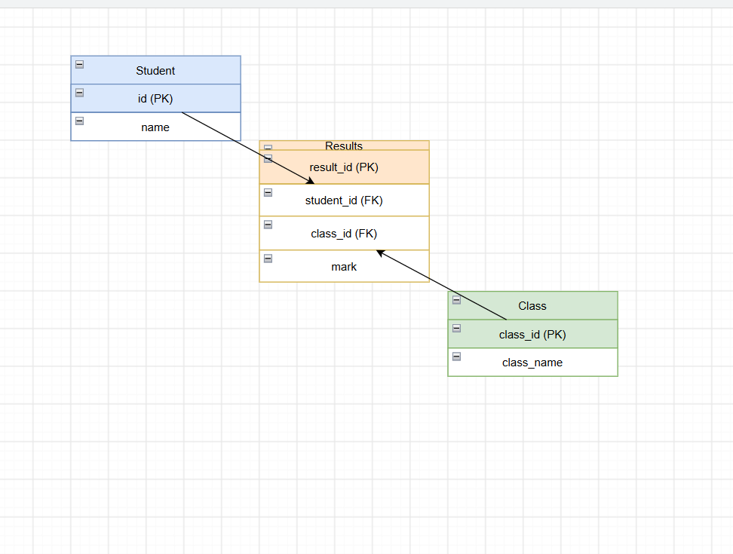

Next,

Please research and complete the questions below relating to key concepts of databases.

What is a primary key? | A primary key is a unique identifier which is assigned to each record within a database table. It can be attribute or a set of attributes that can uniquely identifies each record in the table. cannot contain NULL values. It ensures that two records cannot be same. Consider an example of the table EMPLOYEE Relation unique EMP_ID can acts as a primary key. Some more common example would be vehicle registration plates, driving license numbers, telephone numbers.  Primary Key in DBMS - GeeksforGeeks
How does this differ from a secondary key? | Getting Knowledge of primary and secondary keys is important when working with relational databases. A secondary key is called alternate key. Unlike primary key it is not the main identifier and not always be unique. A table can have multiple secondary keys. Secondary keys can contain NULL values. It also helps to find the records faster when you search using information such as customer name or email address.  Primary Keys and Secondary Keys
How are primary and foreign keys related? | We know a primary key is a unique identifier for each and every record in the current database table and foreign key is an identifier which is used to refer the primary key of a record in different table. You can say the table with primary key is the parent table where the table with the foreign key will be the child table. This relationship keeps the data organised and also ensures that the related data are linked correctly. Without primary key and foreign key, it will be harder to manage the complex data and will be difficult to retrieve related information accurately.  https://www.reddit.com/r/AskComputerScience/comments/lfmkpi/can_someone_explain_foreign_and_primary_keys_in/
Provide a real-world example of a one-to-one relationship | A one-to-one relationship is when one record in one table is connected to only one record to another table. This connection should work in both the ways. Each side should have a unique match — no sharing, no duplicates. You can find one-to-one (or 1:1) relationships everywhere in real world for example: we can say that each student has one backpack, and that each backpack belongs to one student. We also can say one person has one ID number, and the ID number is unique to one person.  https://www.yourdictionary.com/articles/examples-one-to-one-relationships
Provide a real-world example of a one-to-many relationship | In one-to-many relationship we can say that one item in the first table is linked to many items in second table but each item in second table only connects back to one item in the first table. This is a most common relationships you will use in real applications. For example, think like parent and child relationship one parent is linked with several children but each child is linked with only one mother(biological). Another good example of real world can be a customer and their orders one customer can place many orders.
Provide a real-world example of a many-to-many relationship | A many-to-many relationship means when a single record in one table is linked to multiple records in another table, same way when a single record of second table is connected with multiple records of first table. Many-to-many relationship is represented in a schema by third table which is also called junction table. This junction table contains foreign keys which are referencing to the primary keys to original tables, which break the relationships from many-to-many into one-to-many.  A real time example:  A product can belong to multiple categories and each category can contain many products(E-commerce).  User can join many groups and many groups can contain many users (Social platforms).  A patient can be prescribed multiple medications, and each medication can be prescribed to many patients (Healthcare).  https://innosufiyan.hashnode.dev/one-to-one-and-many-to-many-relationships-with-real-world-examples

Day 1: Task 2

Please research and complete the questions below relating to key concepts of databases.

What is the difference between a relational and non-relational database? | A relational database organizes data into separate tables, using a structured format that helps to define rows and columns within a schema. That makes relation clear and consistent. It also follows strict rules to keep data accurate and reliable. In a relational database you can give each table a primary key which can be used to establish the relation between two or more tables. Once tables are connected you can use SQL to interact database.  Non-relational database is used to store data in flexible formats such as documents, key-value pairs, or graphs, it does not use fixed table structures. Which makes it useful to handle large amount of unstructured data. We can say nonrelational database is used for flexible and rapid change data.  https://aws.amazon.com/compare/the-difference-between-relational-and-non-relational-databases/#:~:text=You%20can%20link%20the%20tables,for%20accessing%20and%20managing%20data.  https://www.coursera.org/gb/articles/relational-vs-non-relational-database
What type of data would benefit off the non-relational model?  Why? | Since we know that non-relational databases are used for large data, unstructured data, that change frequently, such as social media posts, customer activity, online shopping data. Non-relational database is used to store information in flexible structures like documents or key-value pairs. Since they can handle large unstructured and semi structured data quickly that allows developers to change data formats without redesigning entire tables. It allows data to be stored in different formats without needing a strict structure, it updates data quickly It is used by modern applications because it can handle fast changes and large volumes of information efficiently.

Day 3: Task 1

Please research the types of 'JOIN ' below, explain what they are and provide an example of the types of data they would be used on.

Self-join | A self-join is a regular join, where the table is joined with itself. It is often used to compare rows within the same table, or you can say It helps in find a relationship between records in a single table by treating table as two separate instances.  Syntax:  SELECT columns  FROM table as a  JOIN table as b  ON a.col_name = b.col_name;  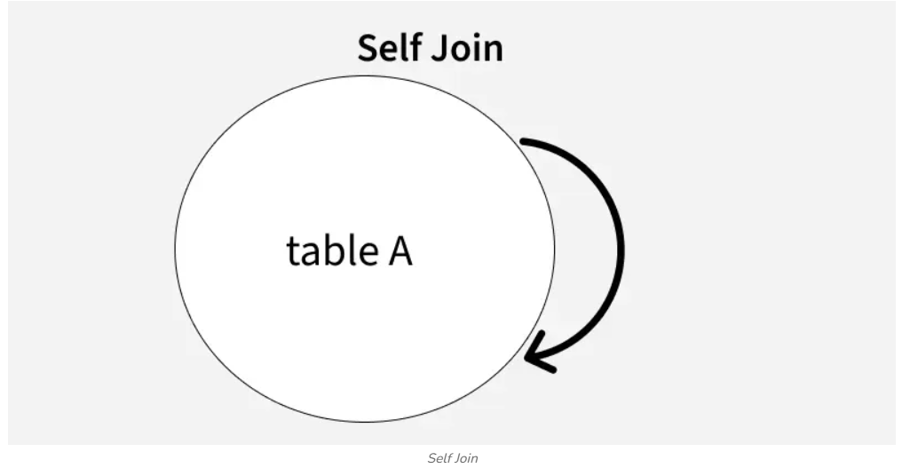
Right join | Right join is also called the right outer join, is used to combine rows from two tables based on a related column. It returns all records from the right table and only the matching records from left table. If there is no match in the left table the result will show null values from the left tables column.  Syntax:  SELECT columns  FROM tableA  RIGHT JOIN tableB  ON tableA.col_name = tableB.col_name;  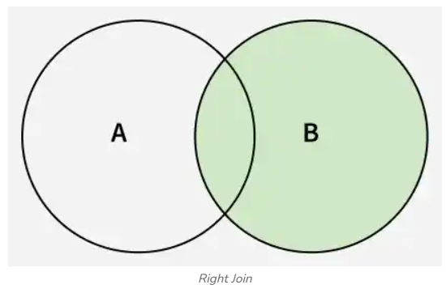  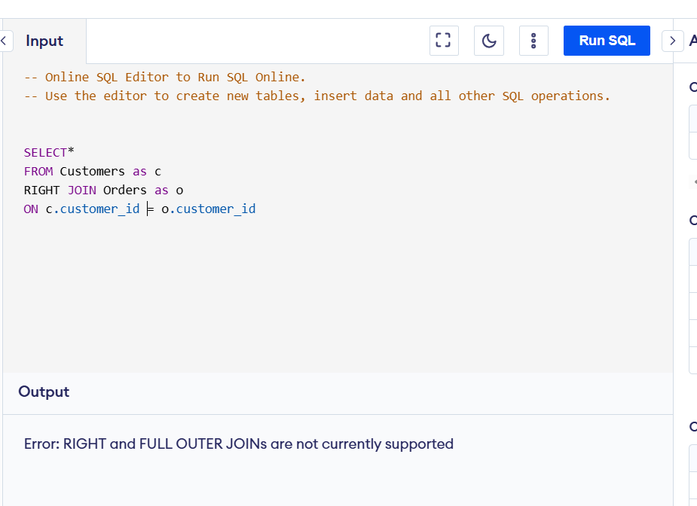
Full join | The full join or Full outer join returns all the rows from both the tables, that combines all the matched rows and unmatched rows. If there is no matched rows the missing columns are filled with NULL values. You can say it is the combination of Left Join and Right Join. It reveals all gaps in both tables in one query.  Syntax:  SELECT columns  FROM table1  FULL JOIN table2  ON table1.column = table2.column;  OR  SELECT columns  FROM table1  LEFT JOIN table2  ON table1.column = table2.column;  UNION  SELECT columns  FROM table1  RIGHT JOIN table2  ON table1.column = table2.column;  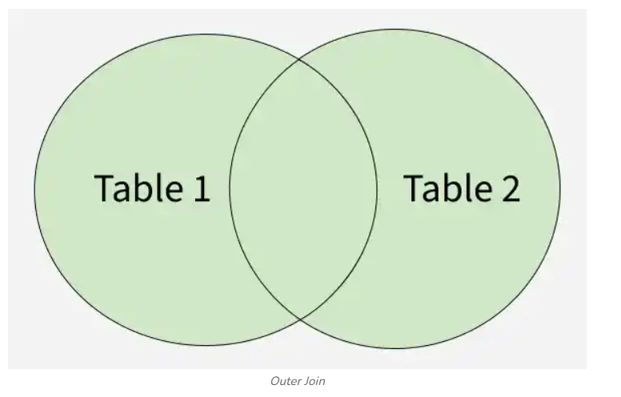
Inner join | INNER JOIN is used to combine records from two or more tables based on the related column. It returns only the records who has matching values in all the tables, filtering out non matching records. It is commonly used to link related data, such as customers and their orders, so that only matching records are displayed. This will help the user to view connected information accurately and will avoid to show unrelated records.  Syntax:  SELECT columns FROM table1  INNER JOIN table2  ON table1.column_name = table2.column_name;  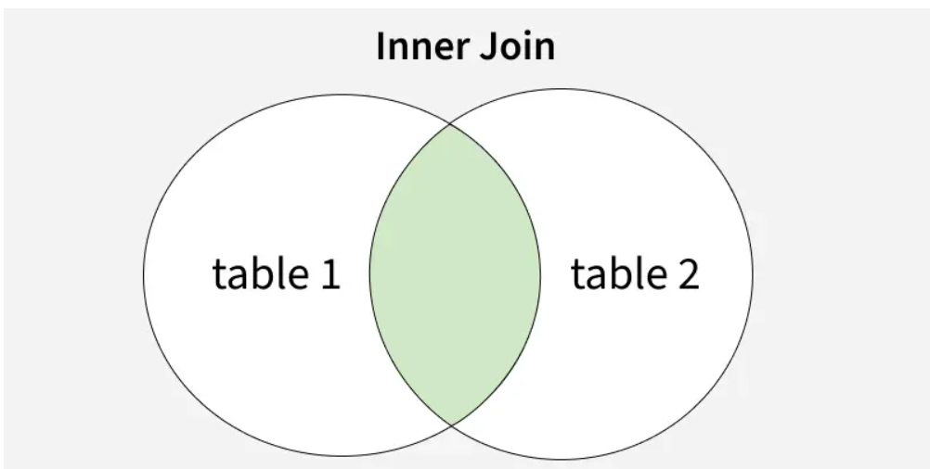  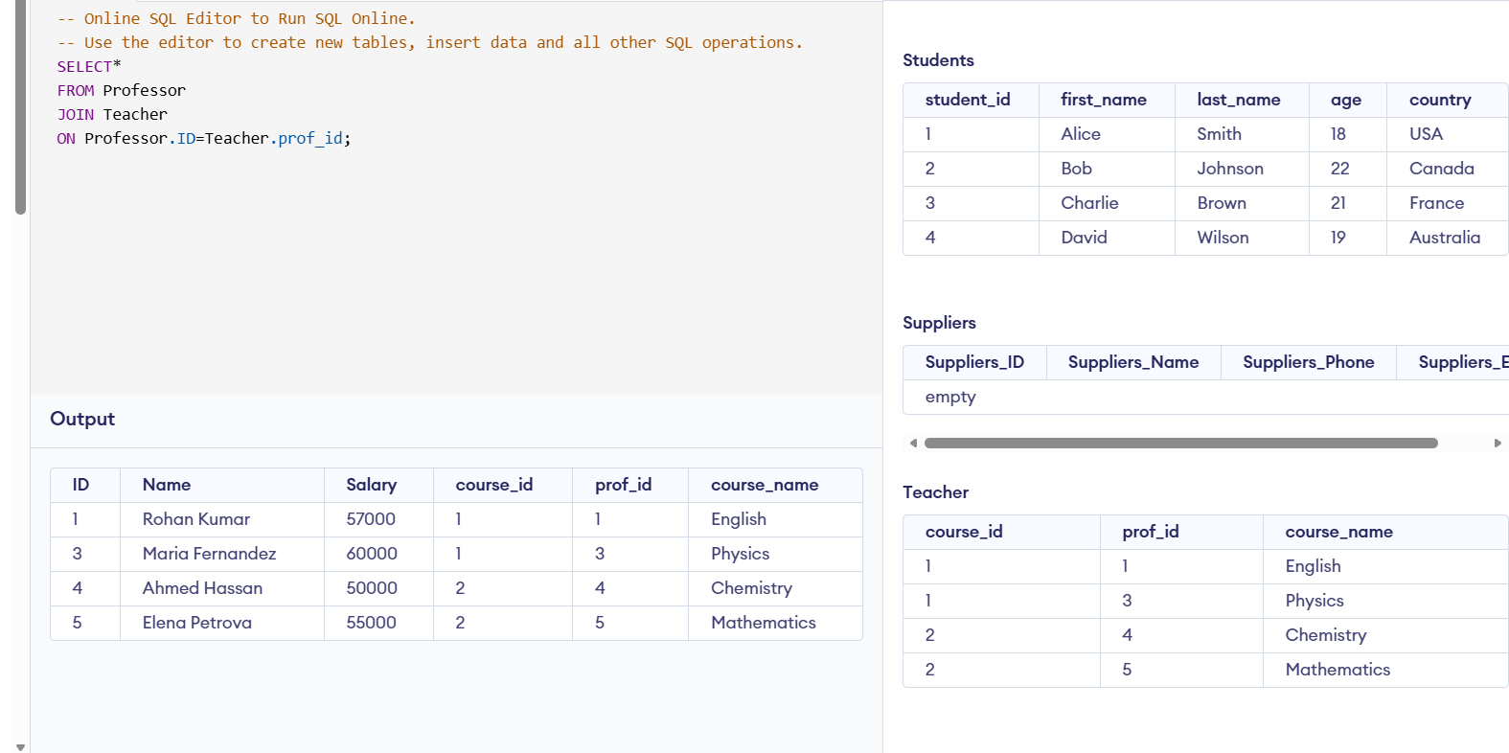
Cross join | Cross Join is used to combines every row from one table with every row from another table. It creates all possible combinations. Since it returns many rows, it should be used carefully with large tables. It does not use a join condition like ON. It is useful when you need every combination of two sets.  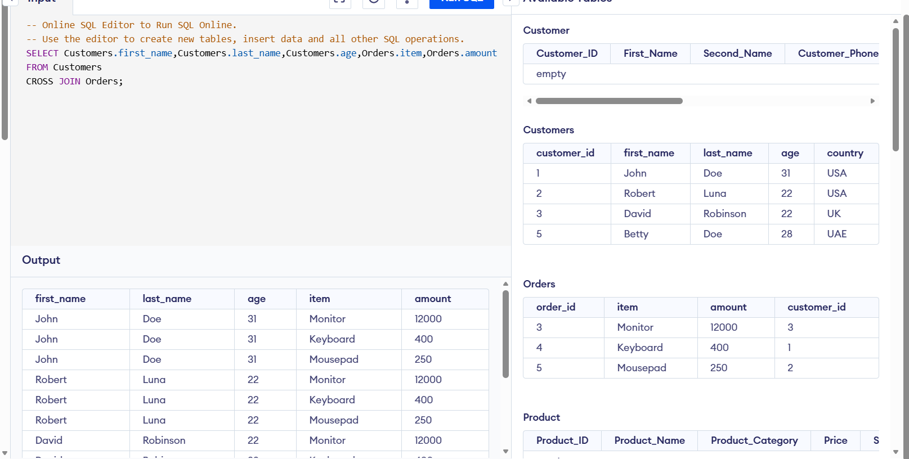  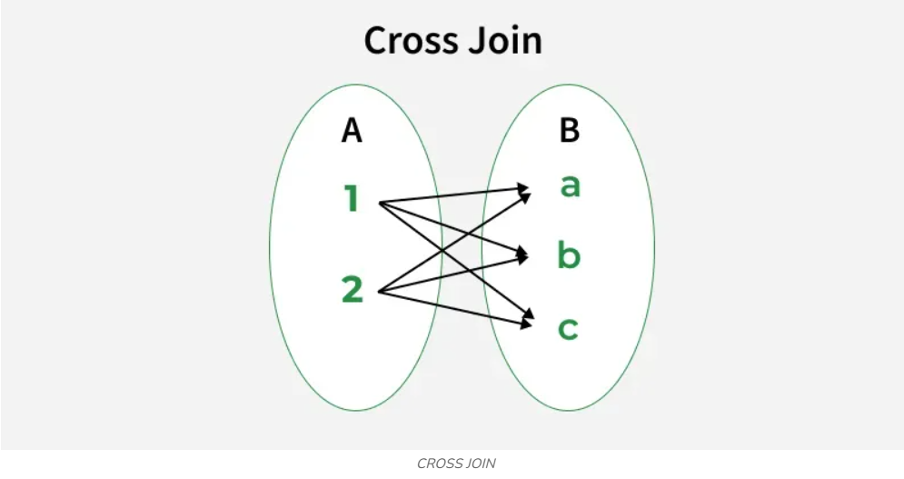
Left join | Left Join or left outer join, it returns every single record from the left table and matching records from the right table. If a row has a corresponding match in the right table, it includes that data. If it does not, it fills the right table's columns with NULL. It is useful for finding records that exist in one table but have no related data in another table.  Syntax:  SELECT columns  FROM table1  LEFT JOIN table2  ON table1.column = table2.column;  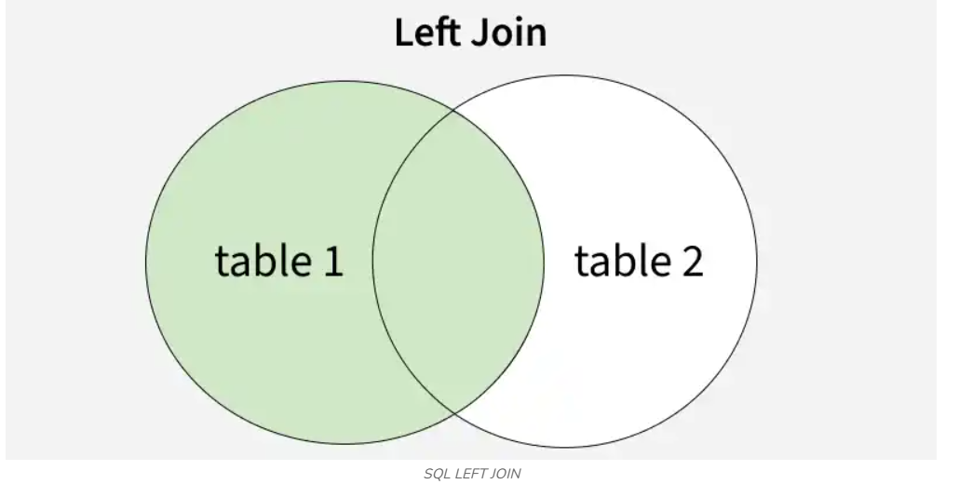  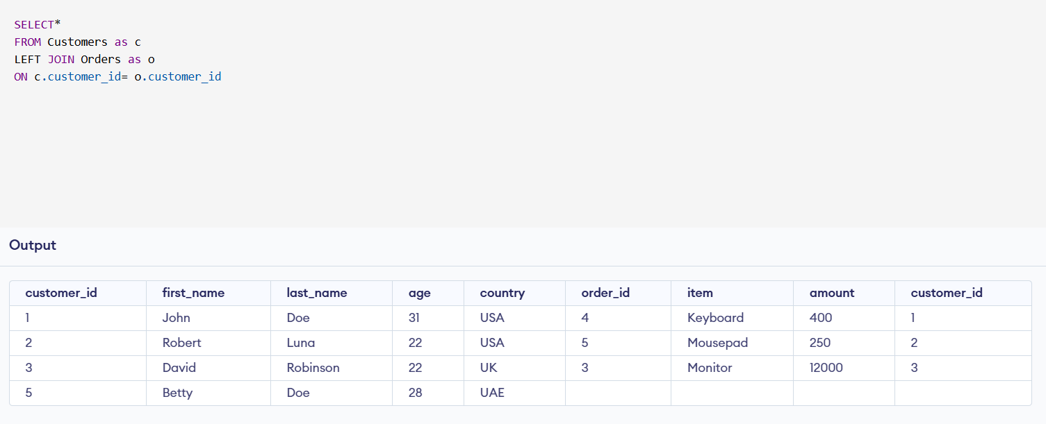

Day 4: Task 1: Written

In your groups, discuss and complete the activity below. You can either nominate one writer or split the elements between you. Everyone, however, must have the completed work below:

Imagine you have been hired by a small retail business that wants to streamline its operations by creating a new database system. This database will be used to manage inventory, sales, and customer information. The business is a small corner shop that sells a range of groceries and domestic products. It might help to picture your local convenience store and think of what they sell. They also have a loyalty program, which you will need to consider when deciding what tables to create.

Write a 500-word essay explaining the steps you would take to set up and create this database. Your essay should cover the following points:

- Understanding the Business Requirements:

- What kind of data will the database need to store? Inventory (SKU - product name, product category, price, stock count, supplier ID); SKU - sales (transaction ID, transaction date, quantity, customer ID); suppliers SKU (supplier ID, supplier name, supplier contact details), customer info SKU (customer ID, name, address, contact number, email, membership status, points total), loyalty (membership no). .

Note: SKUs, in this case, are fields in a table.

- Who will be the users of the database, and what will they need to accomplish?

- Designing the Database Schema:

- How would you structure/design the database tables to efficiently store inventory, sales, and customer information? Can you design it in Word doc.?

- What type of relationship/s between tables are necessary (and can you mention the PK and FK keys) (e.g., how sales relate to inventory and customers)?

- Implementing the Database:

- What SQL commands would you use to create the database and its tables? Top 4 or 5 queries.

- Provide examples of SQL statements for creating tables and defining relationships between them. Top 4 or 5.

- Populating the Database:

- How would you input initial data into the database tables? Can you give examples of SQL INSERT or and VALUES statements.

- Maintaining the Database:

- What measures would you take to ensure the database remains accurate and up to date?

- How would you handle backups and data security?

Your essay should include specific examples of SQL commands and explain why each step is necessary for creating a functional and efficient database for the retail business.

Your essay should include specific examples of SQL commands (a total of 3 or 4) and explain why each step is necessary for creating a functional and efficient database for the retail business. Do your research to find the commands and tell me what each command does – in one line.

Please write your 500-word essay here | To design a new database system for the retailer shop. I will first gather the information that need to be collected and stored. This information includes details about suppliers, customers, products (with stock quantities), sales transaction and customer loyalty program. The main user will be Shop owner, managers, marketing team, store staff. They will use the database to check the stock availability, can also use to record the customer purchase, manage supplier information, and update loyalty points. The database will also help to monitor business sales trends, identify popular products and improve customer service. Counter staff would enter daily sales and product data into the system using POS (point-of-sale) devices, this will ensure the information is updated automatically and remains accurate.  To build the retail database, I would use SQL commands to create the database, will set up all required tables and will define relationship between them. I would use CREATE TABLE command to create the tables such as Customers, Products, Sales, Sales_Details, Suppliers. I will also use PRIMARY KEY and FOREIGN KEYS to link the tables and build accurate relationship between the data. Once the database structure is completed. I will use INSERT INTO command to add the records(data). This will ensure the database is ready for use.  CREATE DATABASE Shop Database;  CREATE TABLE Customer (  Customer_ID INT NOT NULL PRIMARY KEY AUTOINCREMENT,  First_Name VARCHAR(50) NOT NULL,  Last_Name VARCHAR(50) NOT NULL,  Customer_Phone CHAR(15) NOT NULL,  Customer_Email CHAR(25) NOT NULL,  Address_City VARCHAR(50),  Address_Postcode VARCHAR(25),  Loyality_points_Total INT DEFAULT 0  );  After creating the tables, I will use INSERT INTO command to add initial data for existing Customer, Supplier details, Product information, Sales_details. This will help to populate the database with the basic information.  INSERT INTO Customer (Customer_ID, First_Name, Last_Name, Customer_Phone,Customer_Email, Address_City, Address_Postcode, Loyality_points_Total)  VALUES  (1,'Jane', 'Doe', '07234567890', 'jane.doe@example.com', 'Anytown', 'NE1 4AT', 100);  With the help of this command this command we will add a new customer to the Customer table with their contact details and loyalty points. To keep the database accurate and reliable, I will use data validation to ensure that only correct information with correct format is entered. For example, required fields cannot be left empty. To access the database, we will use username and passwords. Manager will have full access; staff will have a controlled access they will only have the view or update the information needed for the daily tasks. Since this is a small, independent corner shop, to protect the business data, backups could be set to run automatically at set intervals such as, every day or every hour depending on the business needs. We will keep backups stored securely so the data can be recovered safely and easily, if the system fails or information is lost.  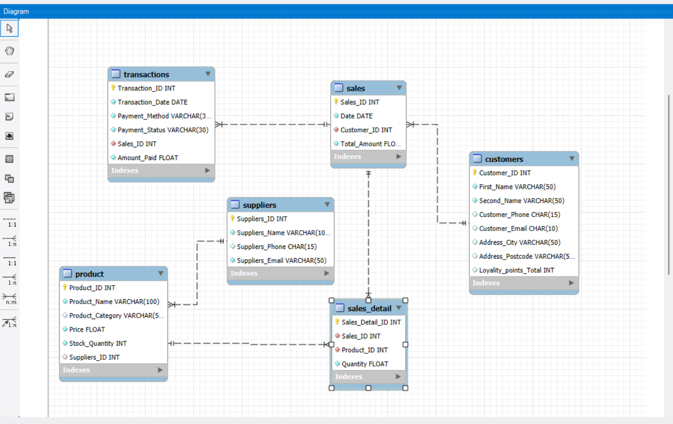  This is the database schema I have designed for a small retail business. At the centre of design, the sales_detail table which is connected by products table, it shows what item was sold and in what quantity. The customer table stores the customers details. The sales table records show each sales including the date. The product table show all sold items in the shop including stock and suppliers ID. The Suppliers table keeps supplier contact details and is linked directly to the products. Finally, the Transactions table shows payment information, date, method, status, and amount and it connects back to the sales table that show how each sale was paid for.  In short, this schema follows a snowflake structure, where the Sales_Detail table acts as the fact table, and the other tables serve as dimensions table. It ensures that all parts of the business-like sales, stock, suppliers, customers, and payments are linked together clearly and logically.  How the relationship is working in my schema:  - One customer can have many sales (one-to-many) so customer ID will appear on multiple sales records.  - One sale can contain many sale_details records(one-to-many), single sale can include multiple products.  - One product can appear in many sale_details(one-to-many).  - One supplier can supply many products (one-to-many).  - One sale links to one transaction records for its payment info.  - Sales_details act has a connector that have many-to-many relationship between sales and product.

Day 4: Task 2: SQL Practical

Complete as many as you can.

Please note: The first couple of queries have no errors; practice keying them manually to understand structure and syntax.

Then the following queries all have minor errors. You will need to use your AI tool to find the error and fix it, then run the query, and explain what you fixed in simple English – only one line explanation is required. (Try to key the code manually where possible.)

Practice using PostgreSQL queries: Use the dataset you have already created in Supabase.
Called: World combined 30. Supabase | The Postgres Development Platform

Once completed, you can save as an SQL file: (Can also save as a CSV file if you want to.)

Go to table editor > Click on the file > click on 3 dots > Export data > Export table as SQL

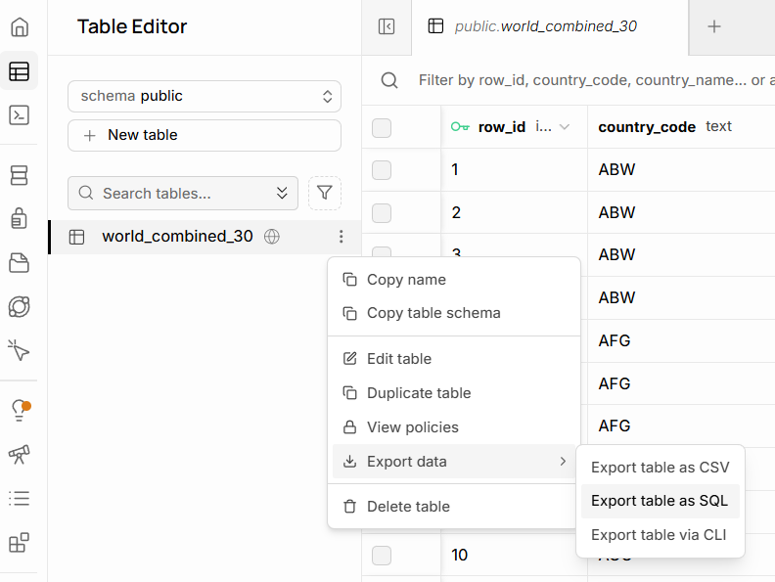

Start running these SQL queries:

Basic selection and filtering
List distinct countries in the table:

SELECT DISTINCT country_name
FROM world_combined_30;
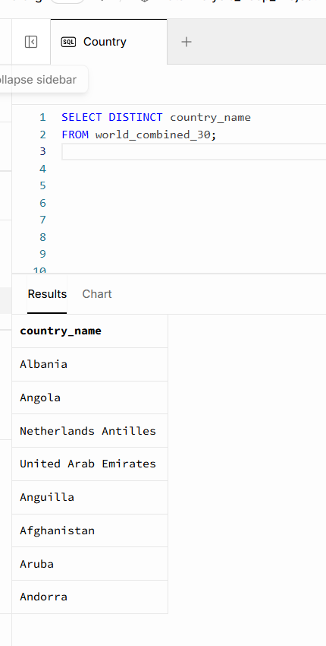

Show all languages for Angola, ordered by percentage (highest first)

SELECT language,
language_percentage
FROM world_combined_30
WHERE country_name = 'Angola'
ORDER BY language_percentage DESC

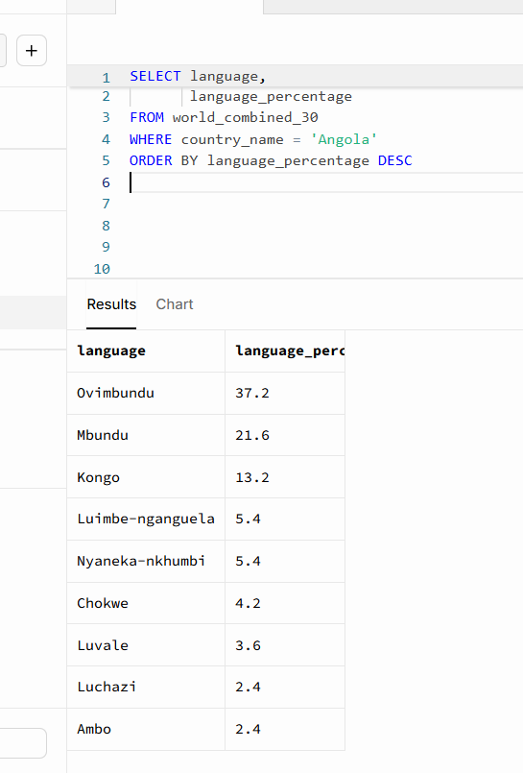

Find all countries where English appears as a language

SELECT DISTINCT country_name, country_code
FROM world_combined_30
WHERE language = 'English';

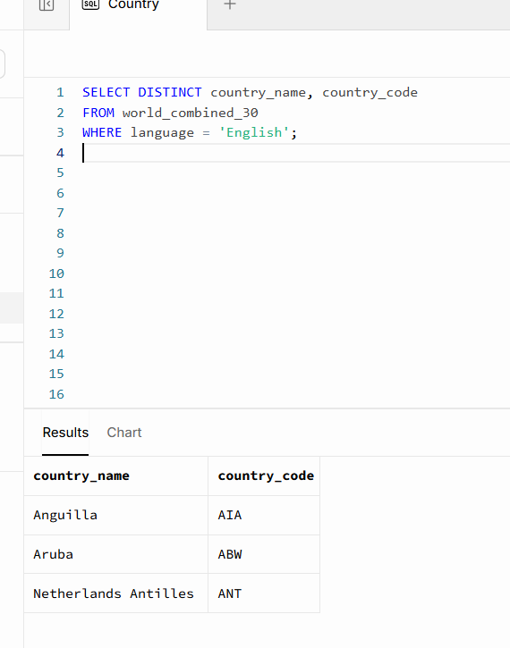

Show all non-official languages for Albania

SELECT language,
language_percentage
FROM world_combined_30
WHERE country_name = 'Albania'
AND is_official =’False’ ;
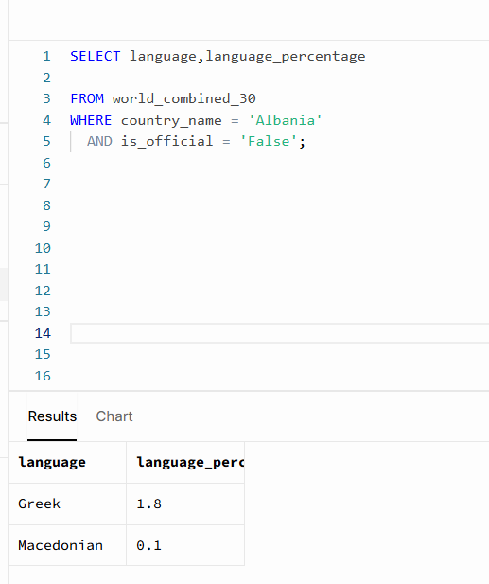

List countries whose population is between 100,000 and 3,000,000

SELECT DISTINCT country_name, country_population
FROM world_combined_30
WHERE country_population BETWEEN 100000 AND 3000000
ORDER BY country_population;
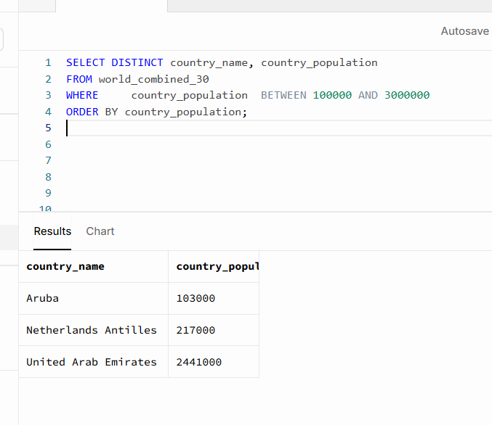

Aggregation per country
Count how many language rows each country has in DESC order

SELECT country_name, COUNT(*) AS language_count
FROM world_combined_30
GROUP BY country_name
ORDER BY language_count DESC;

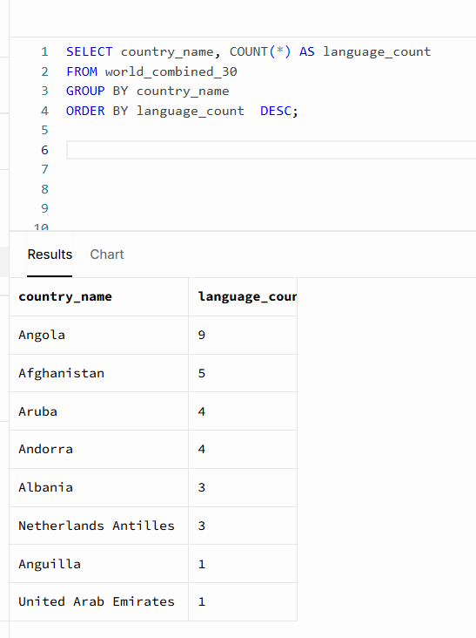

Show the maximum language percentage per country

SELECT country_name, MAX(language_percentage) AS max_language_percentage
FROM world_combined_30
GROUP BY country_name
ORDER BY max_language_percentage DESC;
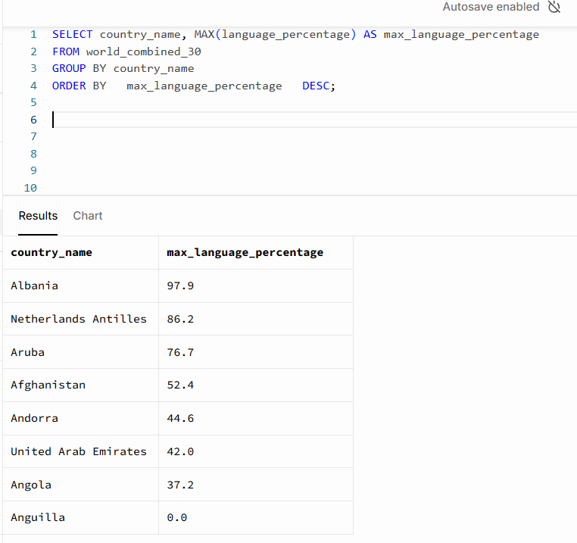

Find countries where at least one language has more than 50% share

SELECT DISTINCT country_name, language_percentage
FROM world_combined_30
WHERE language_percentage > 50;
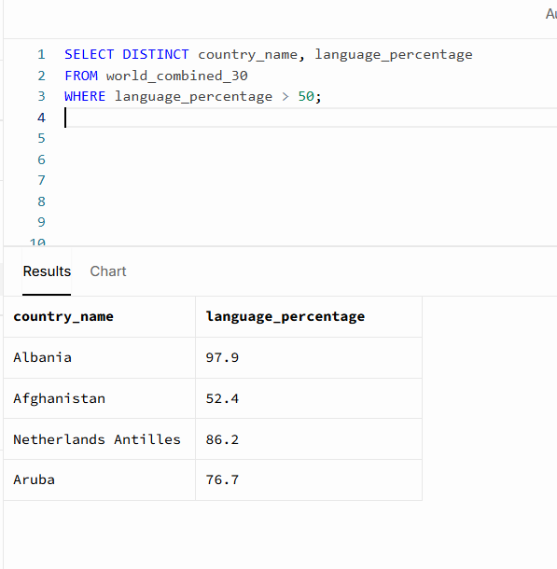

For each country, show the total percentage of official languages

SELECT country_name, SUM(language_percentage) AS total_official_percentage
FROM world_combined_30
WHERE is_official =True
GROUP BY country_name
ORDER BY total_official_percentage DESC;
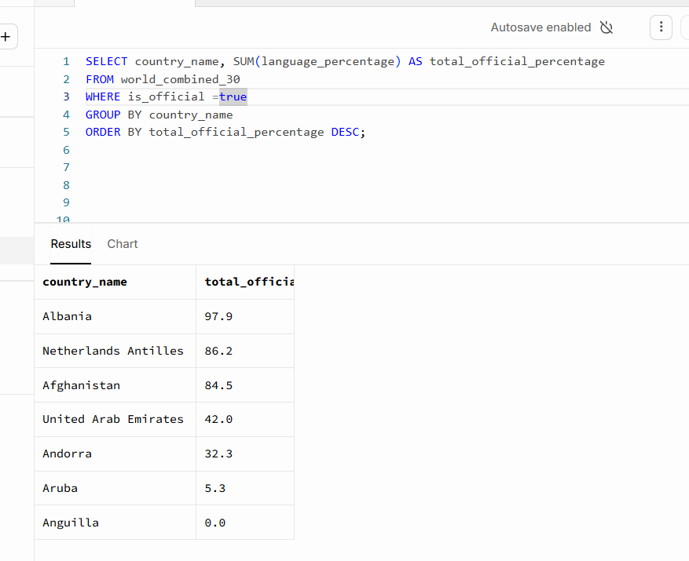

List countries that have more than one official language

SELECT country_name, COUNT(*) AS official_language_count
FROM world_combined_30
WHERE is_official = TRUE
GROUP BY country_name
HAVING COUNT(*) > 1
ORDER BY official_language_count DESC;
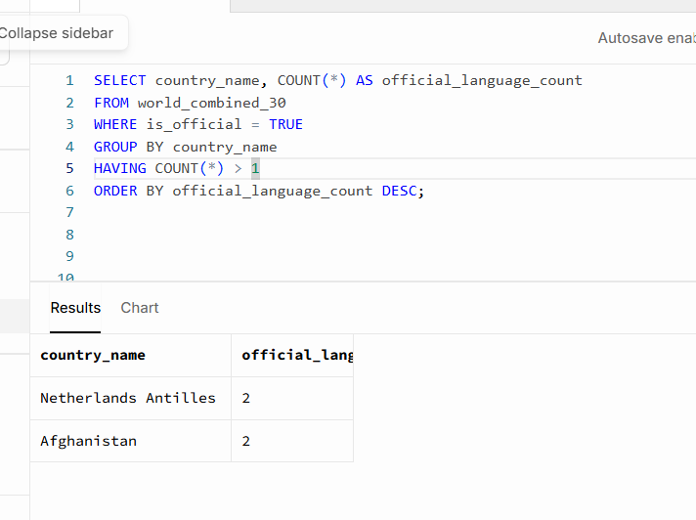

Combining filters and aggregates
Show official languages where the percentage is under 10%
SELECT country_name, language, language_percentage
FROM world_combined_30
WHERE is_official = TRUE AND language_percentage<10 ;
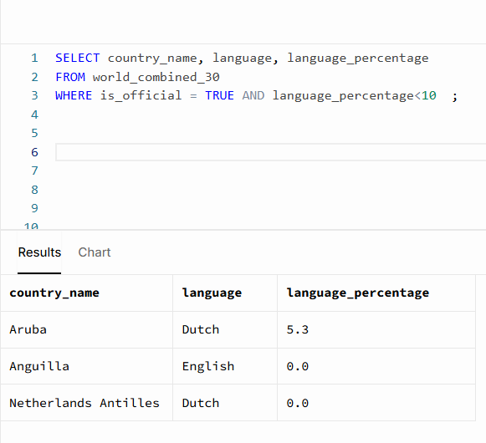

Find the country where Arabic is official

SELECT country_name, country_code, language_percentage
FROM world_combined_30
WHERE language = ' Arabic ' AND is_official = TRUE ;
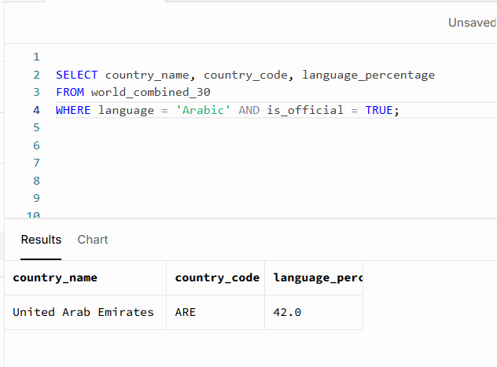

For each country, show the number of non-official languages

SELECT country_name, COUNT(*) AS non_official_count
FROM world_combined_30
WHERE is_official = FALSE
GROUP BY country_name
ORDER BY non_official_count DESC;
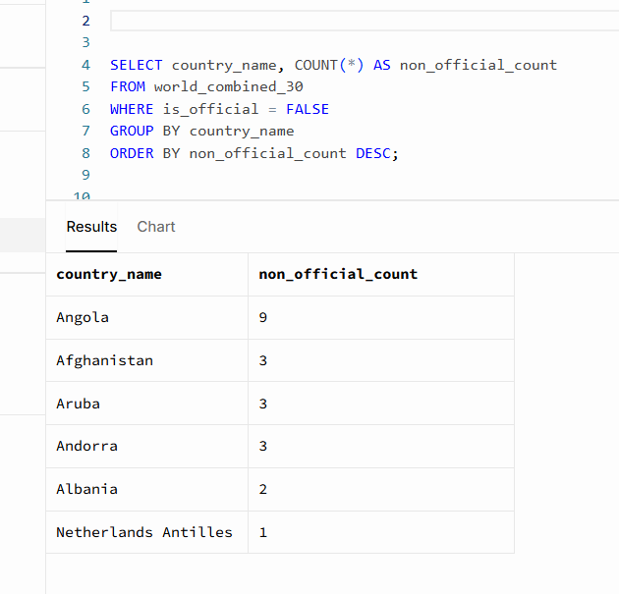

List all rows where the city name contains the word ‘la’ (case-sensitive)

SELECT *
FROM world_combined_30
WHERE city_name LIKE '%la%';
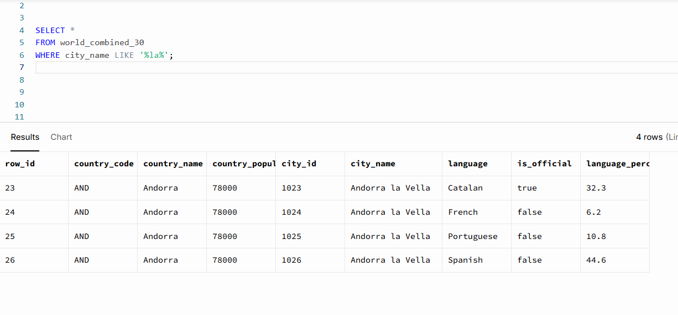

Show countries whose most spoken language (max %) is not official
SELECT country_name
FROM world_combined_30
WHERE language_percentage = (
SELECT MAX(w2.language_percentage)
FROM world_combined_30 AS w2
WHERE w2.country_name = world_combined_30.country_name
)
AND is_official = FALSE ;

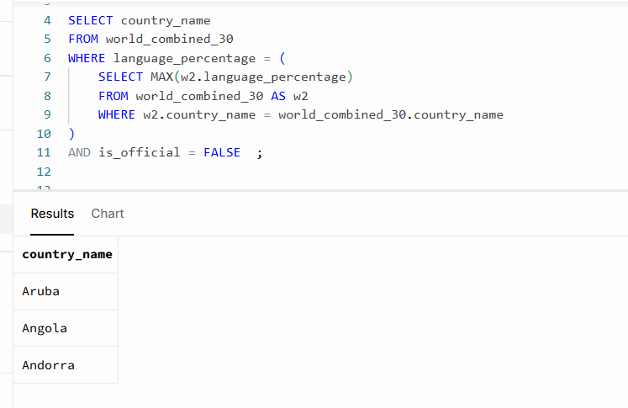

Subqueries:

List countries with population above the overall average population

SELECT DISTINCT country_name, country_population
FROM world_combined_30
WHERE country_population >
(
SELECT AVG(country_population)
FROM world_combined_30
);

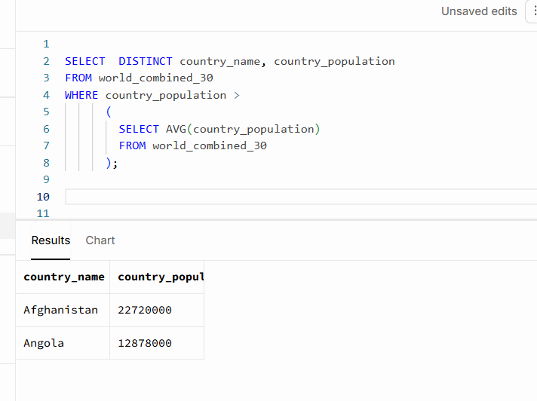

Show languages that are official somewhere and have ≥ 40% in that country

SELECT DISTINCT language, country_name, language_percentage
FROM world_combined_30
WHERE is_official = TRUE AND language_percentage >= 40%
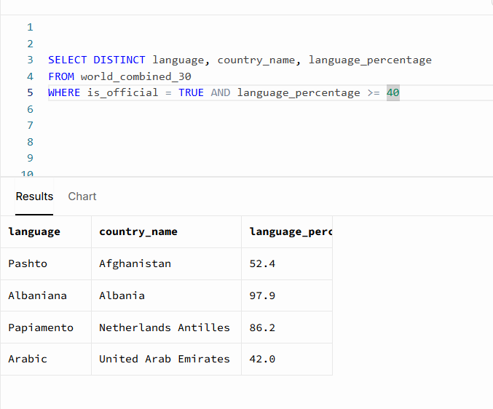

ORDER BY language;
Find countries whose total percentage of all languages is < 100 (data quality check)
Drag selected lines of code and then run, if need be.

SELECT country_name, SUM(language_percentage) AS total_language_share
FROM world_combined_30
GROUP BY country_name
HAVING SUM(language_percentage) < 100
ORDER BY total_language_share;

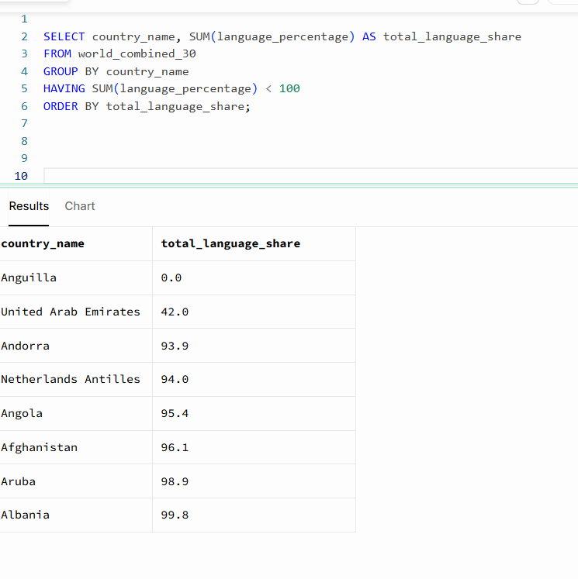

Show rows where the city appears in a country with more than 5 languages
Drag selected lines of code and then run, if need be.

SELECT *
FROM world_combined_30 AS w
WHERE country_name IN (
SELECT country_name
FROM world_combined_30
GROUP BY country_name
HAVING COUNT(*) > 5
);

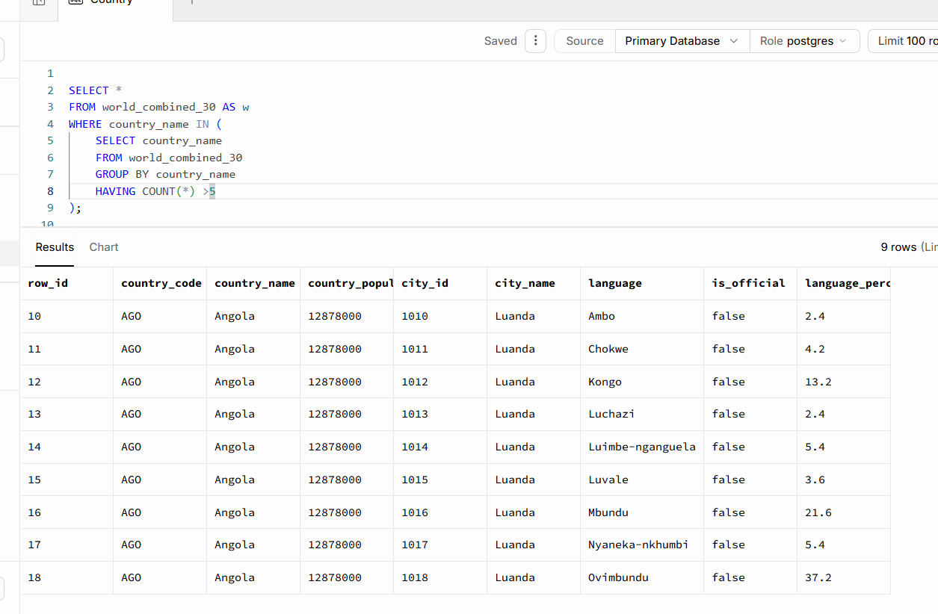

Course Notes

It is recommended to take notes from the course, use the space below to do so, or use the revision guide shared with the class:

Additional Information

We have included a range of additional links to further resources and information that you may find useful, these can be found within your revision guide.

END OF WORKBOOK

Please check through your work thoroughly before submitting and update the table of contents if required.

Please send your completed work booklet to your trainer.

