# Asset Management System

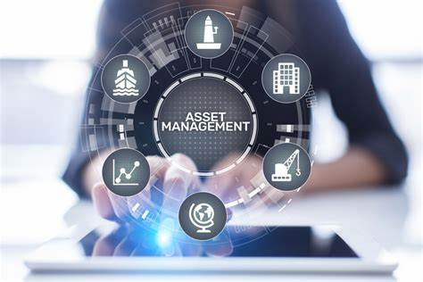

Welcome to ACS - Your Premier Asset Management Solution Provider

At ACS, we offer comprehensive Asset Management System (AMS) solutions designed to help organizations efficiently manage their assets throughout their lifecycle. With our innovative software and services, we empower businesses to maximize asset utilization, optimize maintenance processes, and improve overall operational efficiency.

## Our Solutions;

- Asset Identification & Tracking: Gain visibility into your assets with our advanced asset identification & tracking features. Our system allows you to easily label assets with unique identifiers such as barcodes, QR codes, or RFID tags. Track asset locations, movements, and usage history in real-time with our automated identification solutions.

- Barcode and RFID Asset Tagging: Our system offers barcode and RFID asset tagging solutions to streamline asset identification and tracking. Each asset is assigned a unique identifier, which can be scanned using handheld devices or mobile apps to update asset information and track movements in real-time.

- Integrate Seamlessly: For efficient invoice administration, we help you automate, integrate, and simplify billing, invoicing, payments, and audits. You’ll get a fully integrated system that communicates with all third-party products and provides you with a single point of access to all data so you can make rapid and educated business choices.

- Inventory Management: Gain real-time visibility into your inventory levels, locations, and movements with our advanced inventory management features. Track stock levels, manage stockouts and overstocks, and optimize inventory replenishment processes to ensure optimal stock availability and minimize carrying costs.

- Maintenance Management: Improve asset reliability and minimize downtime with our maintenance management tools. Our system enables you to schedule preventive maintenance tasks, track equipment maintenance history, and manage work orders efficiently. Stay on top of maintenance activities and extend the lifespan of your assets with our comprehensive maintenance management solutions.

- Asset Lifecycle Management: Optimize asset lifecycle management processes from acquisition to disposal with our asset lifecycle management features. Our system helps you track asset lifecycles, calculate depreciation, and make informed decisions about asset investments, upgrades, and retirements. Maximize asset value and minimize total cost of ownership with our asset lifecycle management solutions.

- Customizable Reporting and Analytics: Our system provides customizable reporting and analytics tools to track asset performance, monitor asset usage, and identify cost-saving opportunities. You can generate custom reports, visualize data, and gain insights to optimize asset management strategies and processes.

- Security and Access Control: Our system offers robust security features to protect sensitive asset data and control access to it. You can define user roles and permissions, restrict access to certain asset information, and track user activities to ensure data security and compliance.

These are just some of the key solutions provided by our Asset Management System. Contact us to learn more about how our system can help you streamline asset management processes, improve asset visibility, and optimize asset performance.

## Why Choose ACS?

- Industry Expertise: With years of experience in the industry, we understand the unique challenges and requirements of warehouse management. Our team of experts works closely with you to understand your business needs and provide customized solutions that deliver tangible results.

- Scalable Solutions: Whether you're a small business or a large enterprise, our AMS solutions are designed to scale with your business. Our flexible and scalable architecture allows you to add new features, modules, and users as your business grows, ensuring that your AMS system can adapt to your changing needs.

- Robust Technology: Built on the latest technology platforms, our AMS solutions offer robust features, reliability, and performance. Our cloud-based solutions provide anytime, anywhere access to your asset data, enabling you to manage your assets more effectively and efficiently.

- Customer Support: At ACS, we're committed to providing exceptional customer support and service. Our dedicated team of support professionals is available to assist you with implementation, training, troubleshooting, and ongoing support to ensure that you get the most out of your AMS investment.

Get Started Today

Ready to take control of your assets and optimize your operations? Contact us today to schedule a demo and see how our Asset Management System (AMS) solutions can help you maximize asset value, minimize costs, and drive business success.