# Fixed Asset Software

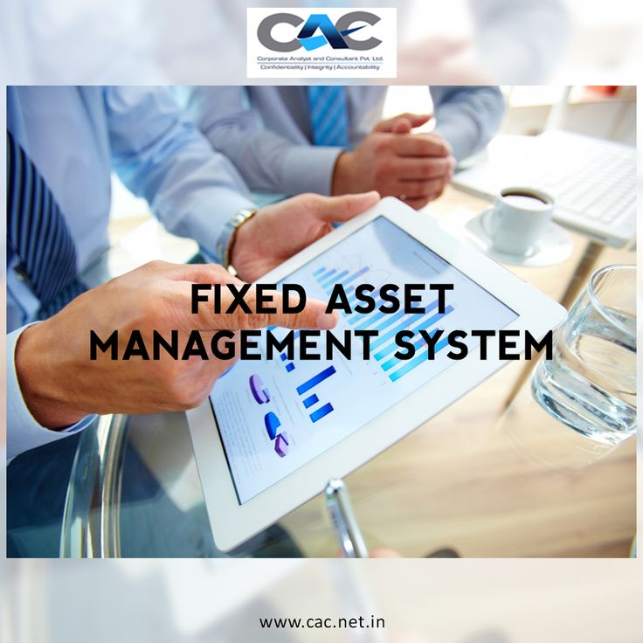

Welcome to ACS - Your Premier Fixed Asset Software Solution Provider

At ACS, we specialize in providing innovative Fixed Asset Software solutions designed to help organizations efficiently manage their fixed assets, optimize depreciation calculations, and streamline asset tracking processes. With our advanced software and services, we empower businesses to improve compliance, reduce costs, and increase operational efficiency.

Managing fixed assets, like property, equipment, and vehicles, can be a complex and time-consuming endeavor. Traditional spreadsheets and manual methods are prone to errors and inefficiencies, making it difficult to maintain accurate records and optimize asset lifecycles.

## Our Solutions;

- Asset Tracking: Our software enables businesses to track fixed assets throughout their lifecycle, from acquisition to disposal. You can record asset details such as purchase date, cost, depreciation method, and location, and track changes over time.

- Barcode and RFID Asset Tagging: We offer barcode and RFID asset tagging solutions to streamline asset identification and tracking. Each asset is assigned a unique barcode or RFID tag, which can be scanned using handheld devices or mobile apps to update asset information and track movements in real-time.

- Depreciation Calculation: Our software automates depreciation calculations based on predefined methods such as straight-line, declining balance, or units of production. You can generate depreciation schedules, track accumulated depreciation, and comply with accounting standards.

- Asset Maintenance Management: Our software helps manage asset maintenance schedules and track maintenance activities. You can schedule preventive maintenance tasks, create work orders, and track maintenance costs to ensure optimal asset performance and reliability.

- Asset Auditing and Compliance: Our software provides tools for asset auditing and compliance management. You can conduct physical audits, reconcile asset records, and generate audit trails to ensure compliance with regulatory requirements and internal policies.

- Asset Reporting and Analytics: Our software offers reporting and analytics tools to track key performance indicators (KPIs) and monitor asset performance. You can generate customizable reports, visualize data, and gain insights to optimize asset management strategies and processes.

- Integration with Accounting Systems: Our software integrates seamlessly with accounting systems to synchronize asset data, streamline workflows, and improve data accuracy. You can generate journal entries, reconcile asset accounts, and produce financial statements for reporting purposes.

- Asset Disposal and Retirement: Our software facilitates asset disposal and retirement processes, allowing you to record asset retirements, calculate gain or loss on disposal, and update asset records accordingly. You can comply with tax regulations and accounting standards for asset disposal.

- Asset Reservations and Transfers: Our software supports asset reservations and transfers, enabling you to allocate assets to different departments or locations as needed. You can track asset movements, monitor transfer requests, and update asset records in real-time.

- Security and Access Control: Our software provides security features to protect sensitive asset data and control access to it. You can define user roles and permissions, restrict access to certain asset information, and track user activities to ensure data security and compliance.

These are just some of the key solutions provided by our Fixed Asset Tracking System. Contact us to learn more about how our system can help you streamline asset management and improve operational efficiency.

## Why Choose ACS?

- Industry Expertise: With years of experience in the industry, we understand the unique challenges and requirements of fixed asset management. Our team of experts has the knowledge and expertise to deliver tailored solutions that address your specific needs.

- Scalable Solutions: Whether you're a small business or a large enterprise, our Fixed Asset Software solutions are designed to scale with your business. Our flexible and scalable architecture allows you to add new features, modules, and users as your business grows, ensuring that your fixed asset management system can adapt to your changing needs.

- Robust Technology: Built on the latest technology platforms, our Fixed Asset Software solutions offer robust features, reliability, and performance. Our cloud-based solutions provide anytime, anywhere access to your asset data, enabling you to manage your fixed assets more effectively and efficiently.

- Customer Support: At ACS, we're committed to providing exceptional customer support and service. Our dedicated team of support professionals is available to assist you with implementation, training, troubleshooting, and ongoing support to ensure that you get the most out of your Fixed Asset Software investment.

Get Started Today

Ready to streamline your fixed asset management processes and improve compliance? Contact us today to schedule a demo and see how our Fixed Asset Software solutions can help you maximize efficiency, minimize costs, and achieve business success.