# Inventory Management System

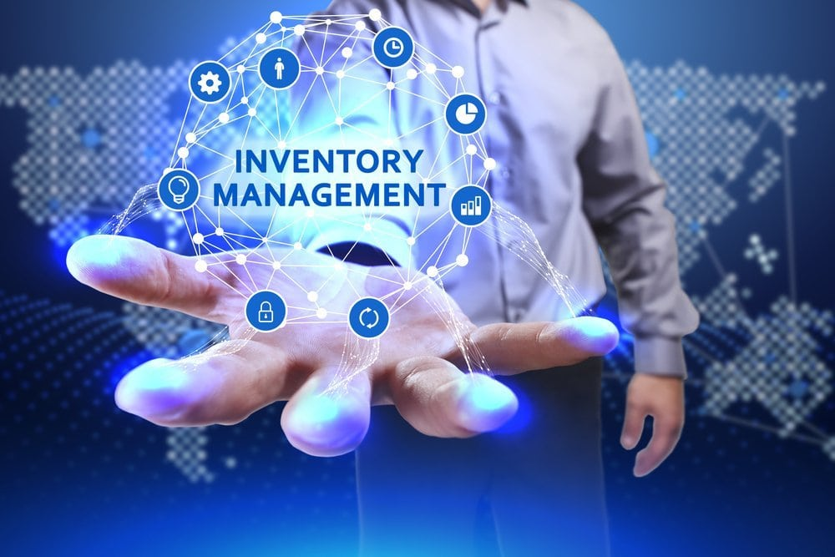

Welcome to ACS - Your Premier Inventory Management Solution Provider

**Unleash the Power of Inventory Management: Supercharge Your Business with an IMS**

In today's dynamic business landscape, efficient inventory management is no longer a luxury - it's a necessity. An inventory management system (IMS) is a powerful software solution designed to streamline and automate every aspect of your inventory journey, from the initial purchase to the final sale.

At ACS, we specialize in providing innovative Inventory Management System (IMS) solutions designed to help organizations efficiently manage their inventory, optimize stock levels, and streamline warehouse operations. With our advanced software and services, we empower businesses to improve inventory accuracy, reduce stockouts, and increase profitability.

## Our Solutions;

- Inventory Tracking: Our system allows you to track inventory levels in real-time, including stock quantities, locations, and movements. You can monitor inventory across multiple warehouses, distribution centers, and store locations to ensure accurate stock levels and prevent stockouts.

- Inventory Optimization: Our system helps optimize inventory levels to minimize carrying costs while ensuring sufficient stock to meet customer demand. You can set reorder points, safety stock levels, and lead times, and automate replenishment processes to optimize inventory levels and reduce excess inventory.

- Inventory Forecasting: Our system provides inventory forecasting capabilities to predict future demand and plan inventory levels accordingly. You can analyze historical sales data, seasonal trends, and market conditions to generate accurate demand forecasts and optimize inventory replenishment.

- Order Management: Our system streamlines order management processes from order receipt to fulfillment. You can manage order processing, order picking, packing, and shipping, and track order status in real-time to ensure timely order fulfillment and customer satisfaction.

- Supplier Management: Our system helps manage supplier relationships and optimize procurement processes. You can track supplier performance, monitor lead times, and manage vendor contracts to ensure timely delivery of goods and maintain optimal inventory levels.

- Inventory Valuation: Our system provides tools for inventory valuation and cost accounting. You can calculate inventory costs using various methods such as FIFO, LIFO, or weighted average, and generate reports to track inventory value, cost of goods sold, and gross margins.

- Warehouse Management: Our system integrates with warehouse management systems (WMS) to optimize warehouse operations and improve inventory accuracy. You can streamline receiving, putaway, picking, and packing processes, and ensure seamless inventory movements within the warehouse.

- Inventory Visibility and Reporting: Our system offers visibility into inventory levels, movements, and transactions through customizable reports and dashboards. You can generate inventory reports, analyze inventory performance metrics, and gain insights to optimize inventory management strategies.

- Integration with Other Systems: Our system integrates seamlessly with other business systems such as ERP, POS, and accounting software. This allows you to synchronize inventory data, streamline workflows, and improve data accuracy across the organization.

**Investing in an IMS is a strategic decision that goes beyond mere inventory management. It's an investment in the future of your business, empowering you to operate with greater efficiency, make data-driven decisions, and ultimately achieve your financial goals.**

## Why Choose ACS?

- Industry Expertise: With years of experience in the industry, we understand the unique challenges and requirements of inventory management. Our team of experts has the knowledge and expertise to deliver tailored solutions that address your specific needs.

- Scalable Solutions: Whether you're a small business or a large enterprise, our IMS solutions are designed to scale with your business. Our flexible and scalable architecture allows you to add new features, modules, and users as your business grows, ensuring that your IMS system can adapt to your changing needs.

- Robust Technology: Built on the latest technology platforms, our IMS solutions offer robust features, reliability, and performance. Our cloud-based solutions provide anytime, anywhere access to your inventory data, enabling you to manage your inventory more effectively and efficiently.

- Customer Support: At ACS, we're committed to providing exceptional customer support and service. Our dedicated team of support professionals is available to assist you with implementation, training, troubleshooting, and ongoing support to ensure that you get the most out of your IMS.

Get Started Today

Ready to take control of your inventory and streamline your warehouse operations? Contact us today to schedule a demo and see how our Inventory Management System (IMS) solutions can help you maximize efficiency, minimize costs, and achieve business success.