# POS System

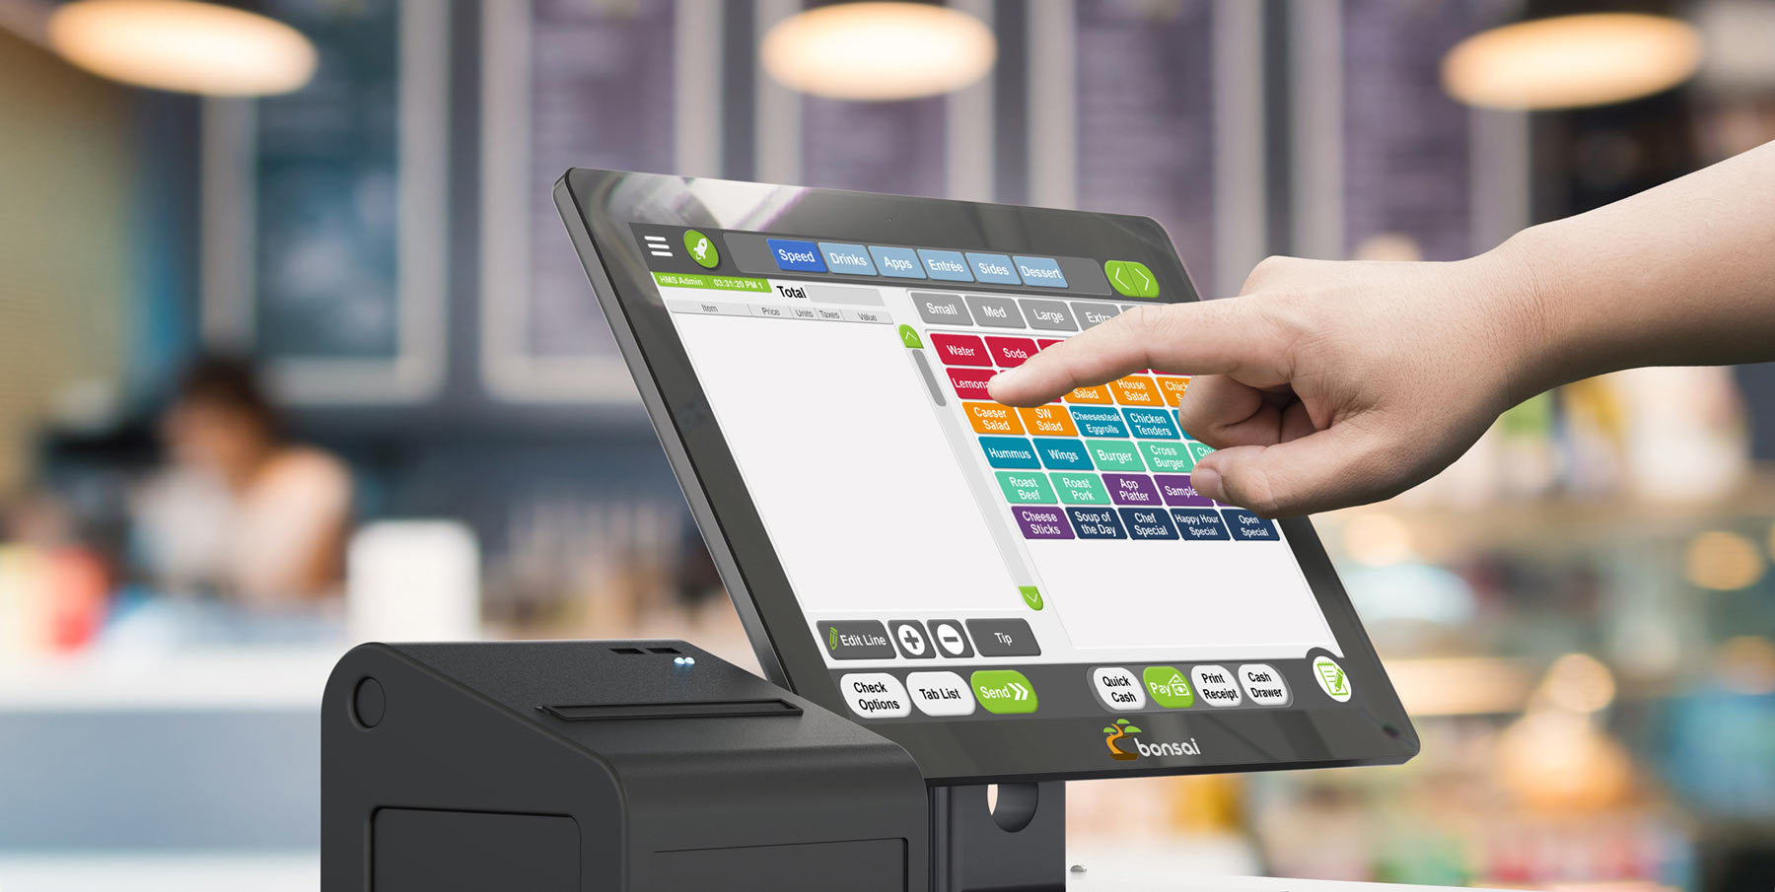

Welcome to ACS - Your Trusted Point of Sale Solution Provider

At ACS, we specialize in providing innovative Point of Sale (POS) solutions designed to help businesses streamline transactions, manage inventory, and enhance customer experience. With our advanced software and services, we empower businesses of all sizes to improve sales efficiency, increase revenue, and drive business growth.

## Our Solutions;

- Sales Processing: Our POS system allows businesses to process sales transactions quickly and efficiently. It supports various payment methods, including cash, credit/debit cards, mobile payments, and gift cards, enabling seamless transactions at the point of sale.

- Inventory Management: Our POS system helps businesses manage inventory levels in real-time. It tracks product sales and updates inventory counts automatically, allowing businesses to optimize stock levels, prevent stockouts, and streamline inventory replenishment processes.

- Product Catalog Management: Our POS system provides tools for managing product catalogs, including adding new products, updating prices, and categorizing items. Businesses can easily customize product listings, organize products into categories, and display product information at the point of sale.

- Customer Management: Our POS system enables businesses to manage customer information and relationships effectively. It captures customer data at the point of sale, including contact information, purchase history, and preferences, allowing businesses to personalize interactions and drive customer loyalty.

- Order Management: Our POS system supports order management for businesses that offer services or take orders for products that need to be fulfilled later. It allows businesses to create and track orders, manage order statuses, and schedule order fulfillment to ensure timely delivery or service completion.

- Reporting and Analytics: Our POS system offers robust reporting and analytics tools to help businesses gain insights into sales performance, inventory trends, and customer behavior. Businesses can generate custom reports, track key performance indicators (KPIs), and identify opportunities for growth and improvement.

- Integration with Accounting Systems: Our POS system integrates seamlessly with accounting software, enabling businesses to synchronize sales data, track revenue, and manage financial transactions efficiently. This integration streamlines accounting processes and ensures accurate financial reporting.

- Employee Management: Our POS system includes features for managing employee roles, permissions, and performance. It allows businesses to track employee sales, monitor productivity, and manage shifts and schedules to optimize staffing levels and improve customer service.

- Loyalty Programs and Promotions: Our POS system supports loyalty programs, discounts, and promotions to incentivize repeat business and drive sales. Businesses can create custom loyalty programs, offer discounts and rewards to loyal customers, and track program effectiveness over time.

- Mobile POS: Our POS system offers mobile POS capabilities, allowing businesses to accept payments and process transactions anywhere, anytime. This flexibility enables businesses to serve customers in-store, at events, or on the go, improving customer convenience and satisfaction.

These are just some of the key solutions provided by our Point of Sale (POS) system. Contact us to learn more about how our system can help your business streamline operations, increase sales, and improve customer experiences.

## Why Choose ACS?

- Industry Expertise: With years of experience in the industry, we understand the unique challenges and requirements of businesses like yours. Our team of experts has the knowledge and expertise to deliver tailored POS solutions that address your specific needs.

- Scalable Solutions: Whether you're a small boutique or a large retail chain, our POS solutions are designed to scale with your business. Our flexible and scalable architecture allows you to add new features, modules, and users as your business grows, ensuring that your POS system can adapt to your changing needs.

- Robust Technology: Built on the latest technology platforms, our POS solutions offer robust features, reliability, and performance. Our cloud-based solutions provide anytime, anywhere access to your sales data, enabling you to manage your business more effectively and efficiently.

- Customer Support: At ACS, we're committed to providing exceptional customer support and service. Our dedicated team of support professionals is available to assist you with implementation, training, troubleshooting, and ongoing support to ensure that you get the most out of your POS.

Get Started Today

Ready to streamline your sales processes and enhance customer experience? Contact us today to schedule a demo and see how our Point of Sale (POS) solutions can help you maximize efficiency, minimize costs, and achieve business success.