# Van Sales Management System

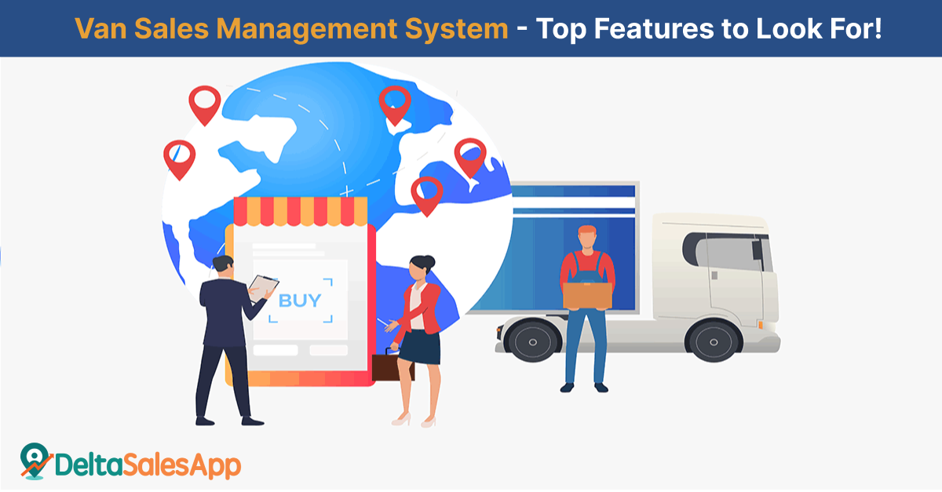

Welcome to ACS - Your Premier Van Sales Management Solution Provider

At ACS, we specialize in providing innovative Van Sales Management System (VSMS) solutions designed to help organizations optimize their mobile sales operations, improve route planning, and enhance customer satisfaction. With our advanced software and services, we empower businesses to streamline van sales processes, increase sales efficiency, and drive revenue growth.

## Our Solutions;

- Route Planning and Optimization: Our system helps optimize van routes to maximize efficiency and minimize travel time. You can define sales territories, schedule routes, and optimize visit frequencies to ensure timely customer visits and maximize sales opportunities.

- Customer Management: Our system provides tools for managing customer information, including contact details, purchase history, and preferences. You can track customer interactions, manage sales leads, and segment customers based on criteria such as location, industry, and purchase behaviour.

- Order Management: Our system streamlines the order management process from order capture to fulfillment. You can create sales orders, process payments, and generate invoices on the spot using mobile devices. Integration with inventory management and ERP systems ensures accurate inventory levels and real-time order updates.

- Product Catalog Management: Our system offers a comprehensive product catalog with detailed product information, pricing, and availability. Sales representatives can easily access product information, view product images, and provide product recommendations to customers to drive sales.

- Mobile Sales App: Our system includes a mobile sales app that enables sales representatives to access customer information, place orders, and process transactions on the go. The app works offline, allowing sales representatives to continue working even in areas with poor network coverage.

- Inventory Management: Our system provides real-time visibility into inventory levels and stock movements. You can track stock levels, monitor replenishment needs, and optimize inventory allocation to ensure product availability and prevent stockouts.

- Sales Performance Tracking: Our system helps track sales performance metrics such as sales volume, revenue, and profitability. You can generate sales reports, analyse sales trends, and identify opportunities for growth and improvement.

- Promotions and Discounts Management: Our system enables you to create and manage promotions, discounts, and special offers to incentivize sales. You can define promotion rules, track promotion effectiveness, and adjust pricing strategies to maximize sales and margins.

- Payment Processing: Our system supports various payment methods, including cash, credit cards, and mobile payments. Sales representatives can process payments securely using mobile devices, and customers receive digital receipts for their purchases.

- Integration with Accounting and ERP Systems: Our system integrates seamlessly with accounting and ERP systems to streamline financial processes and ensure data accuracy. You can synchronize sales data, update financial records, and generate financial reports for accounting and reconciliation purposes.

These are just some of the key solutions provided by our Van Sales Management System. Contact us to learn more about how our system can help you streamline van sales operations, improve sales performance, and enhance customer satisfaction.

## Why Choose ACS?

- Industry Expertise: With years of experience in the industry, we understand the unique challenges and requirements of van sales management. Our team of experts works closely with you to understand your business needs and provide customized solutions that deliver tangible results.

- Scalable Solutions: Whether you're a small distributor or a large enterprise, our VSMS solutions are designed to scale with your business. Our flexible and scalable architecture allows you to add new features, modules, and users as your business grows, ensuring that your VSMS system can adapt to your changing needs.

- Robust Technology: Built on the latest technology platforms, our VSMS solutions offer robust features, reliability, and performance. Our cloud-based solutions provide anytime, anywhere access to your sales data, enabling you to manage your van sales operations more effectively and efficiently.

- Customer Support: At ACS, we're committed to providing exceptional customer support and service. Our dedicated team of support professionals is available to assist you with implementation, training, troubleshooting, and ongoing support to ensure that you get the most out of your VSMS.

Get Started Today

we're committed to providing exceptional customer support and service. Our dedicated team of support professionals is available to assist you with implementation, training, troubleshooting, and ongoing support to ensure that you get the most out of your VSMS.