Creating to add google analytics to a website

**Team Name:** spark light

**Team Members NM Id:** Barath.N - au420720105010, Pushparaj.K- 420720105037, Rajasimman.S - au420720105040, Santhosh.B - au420720105 0 48.

**Brand Name:** Barath Tech

**Category:** Digital Marketing

**Video link :** https://drive.google.com/file/d/1Nu6UZ6KPVUTfxVLuCTG7AfpIwwZaKxCe/view?usp=drivesdk

Documentation: Screenshots were attached

**DIGITAL MARKETING:**

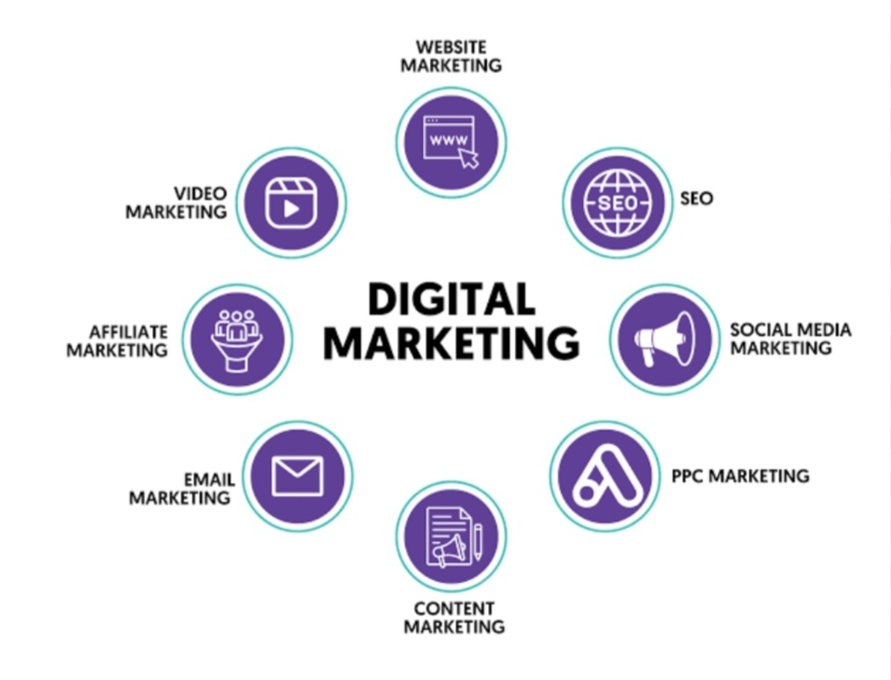

**Screenshots**



