**Internet of Things**

**PROJECT REPORT**



**HOME AUTOMATION USING TELEGRAM APP**

CB.EN.U4CSE16308 – ALAGU VIGNESH A

CB.EN.U4CSE16315 – BARATH B

CB.EN.U4CSE16531 – KEERTHANA S

TABLE OF CONTENT

1. PROBLEM STATEMENT
2. PROJECT DESCRIPTION
3. LITERATURE SURVEY
4. HARDWARE IMPLEMENTATION
   1. HARDWARE COMPONENTS
   2. BLOCK DIAGRAM
   3. HARDWARE DESIGN
   4. UML DIAGRAM
5. SOFTWARE IMPLEMENTATION
6. CHALLENGES ADDRESSED
7. INTEGRATION
8. OUTCOME

PROBLEM STATEMENT:

Social media is playing a major role in every people’s hand, we are using social media for lots of applications like chatting, video and data sharing. To make life easier we are using social media to make our home into smart home, this is achieved using a system called Raspberry Pi and telegram application.

PROJECT DESRIPTION:

Raspberry Pi, which is connected to the Network is programmed to receive chats from telegram application whenever we send messages to the configured bot to control the application based on configured commands sent through chat.

LITERATURE SURVEY:

1. P BHASKAR RAO, S.K. UMA, “RASPBERRY PI HOME AUTOMATION WITH WIRELESS SENSORS USING SMART PHONE”, International Journal of Computer Science and Mobile Computing, Vol.4 Issue.5, May- 2015, pg. 797-803
   * + The project presents a low cost and flexible home control and monitoring system using an embedded microprocessor and microcontroller, with IP connectivity for accessing and controlling devices and appliances remotely using Smart phone application.
     + This project successfully designed a system that communicates with a mobile device such as a Smartphone or laptop via Raspberry Pi.
2. Ishan Krishna, K. Lavanya, “Intelligent Home Automation System using BitVoicer”, 11th International Conference on Intelligent Systems and Control, 2017.
   * + - The ZigBee based home automation system and Wi-Fi network are unified through a mutual home gateway. The combinatory offers network interoperability, a simple and supple user interface, and distant access to the system.
3. Juan Carlos de Oliveira, Danilo Henrique Santos,” Chatting with Arduino Platform through Telegram Bot”, IEEE International Symposium on Consumer Electronics, 2016
   * + - The project introduces the integration between the smartphone messenger Telegram and the Arduino platform using Telegram Bots, allowing common people to create hardware prototypes and communicate with them using the same tool applied in the communication with other people.

HARDWARE IMPLEMENTATION:

1. HARDWARE COMPONENTS

* Raspberry Pi
* Power Source
* IR Sensor, Temperature Sensor, Motor(Actuator)
* Local Storage (SD Card)
* Relays
* Appliances
* Android Device

1. BLOCK DIAGRAM

Raspberry Pi system is connected with the internet to get chat messages from the Telegram app and the appliances which we have to control should be connected to GPIO pins of Raspberry Pi through relay circuit

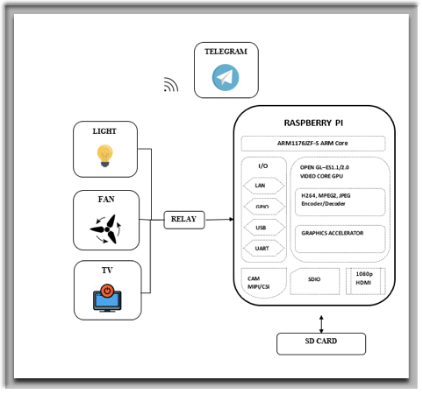

BLOCK DIAGRAM

1. HARDWARE DESIGN

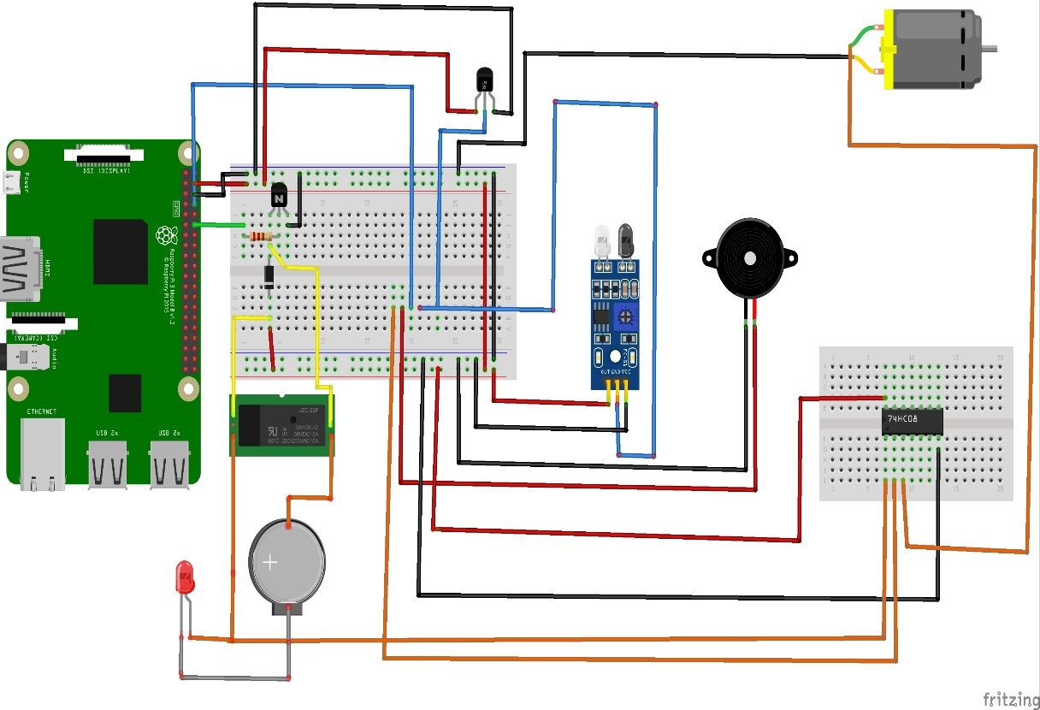

1. UML DIAGRAM

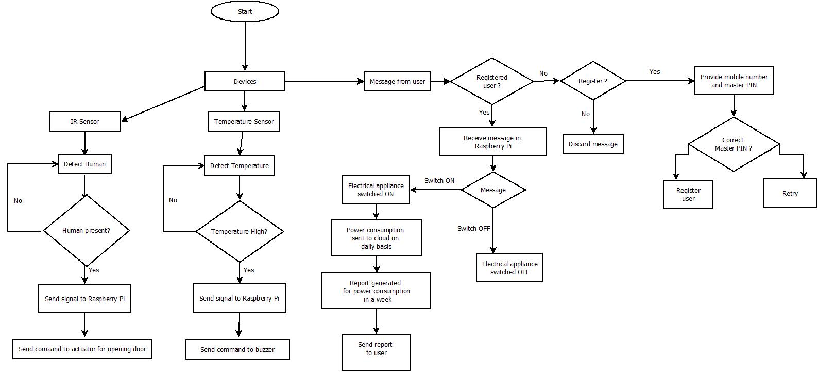

1. SOFTWARE IMPLEMENTATION:

* Python program to integrate and control the devices
* Linux os for Raspberry pi
* Communication Service – HTTPS
* Data Identifier – Segregation of data
* Identification Service – Device Identification
* Edge Analysis – Local Data processing and report generation in cloud.
* Mongo Db to store and access data
* ThingSpeak for cloud report generation and analysis.

SCREENSHOTS:

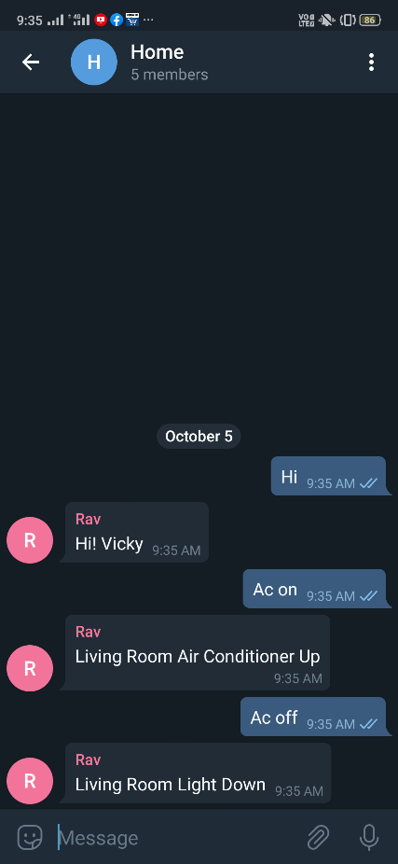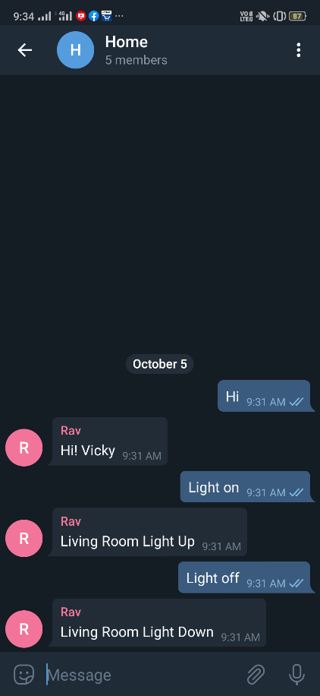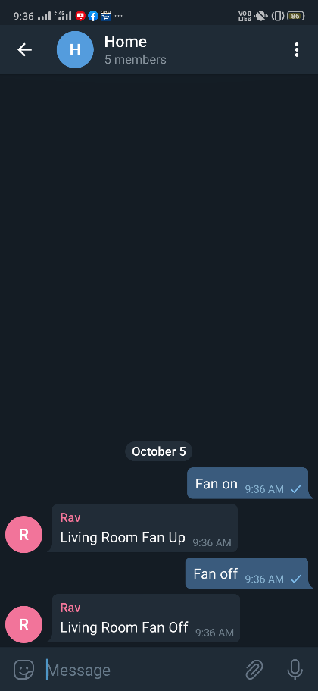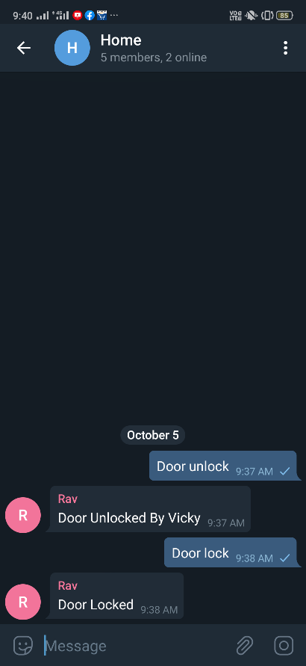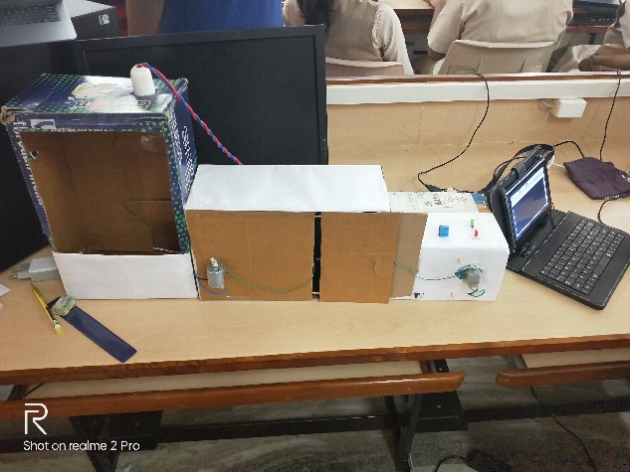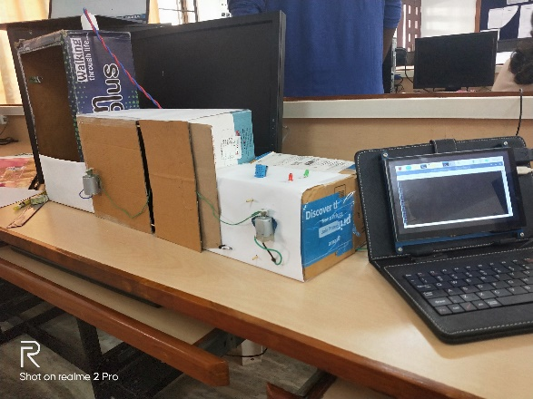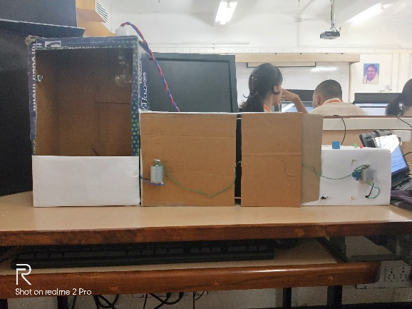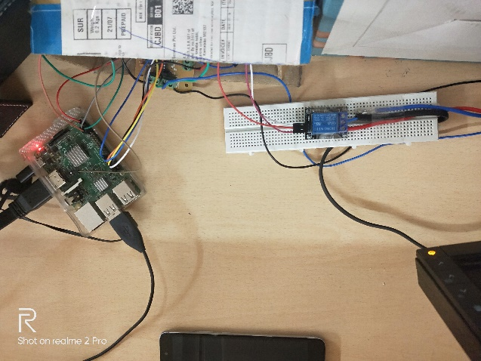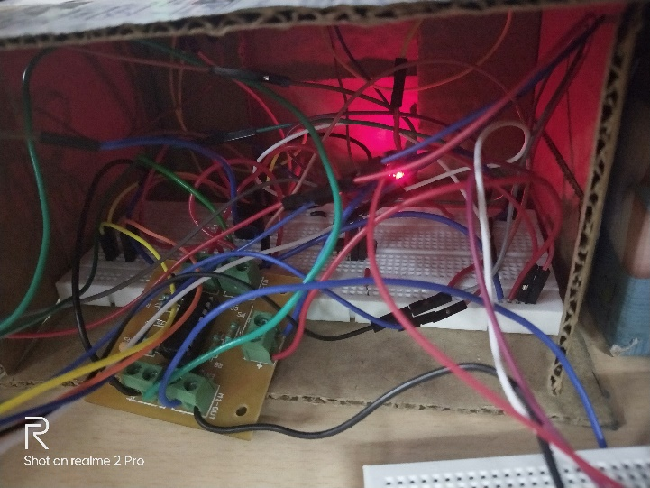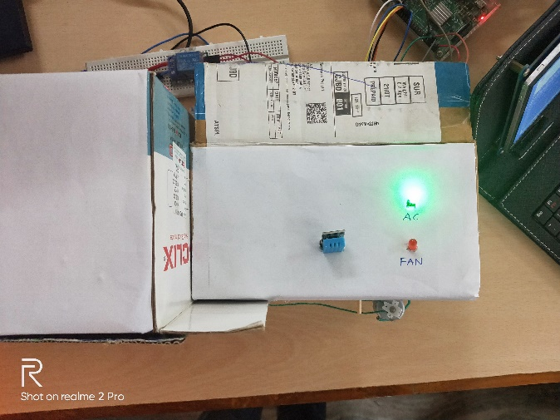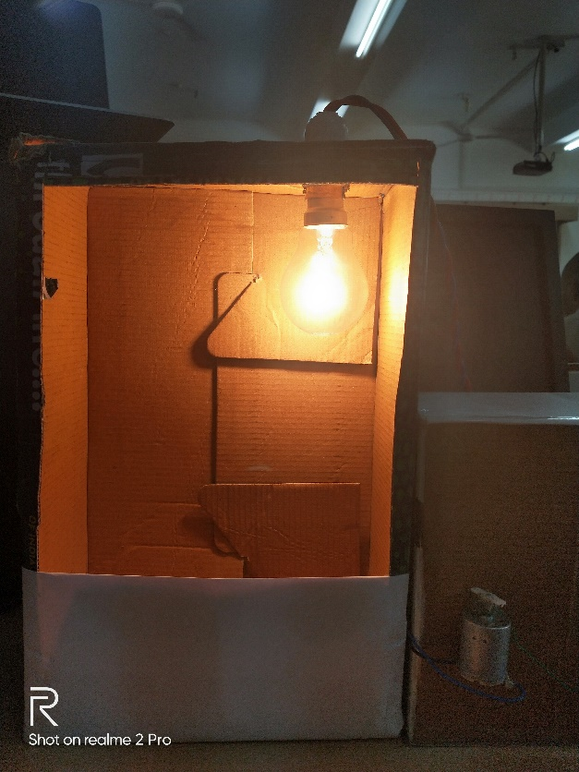

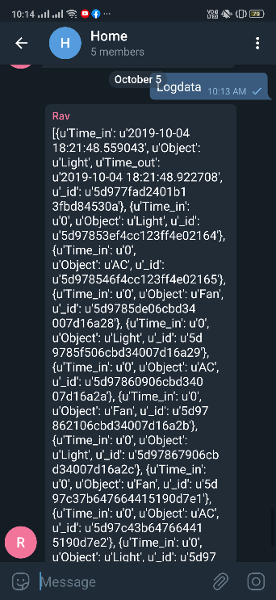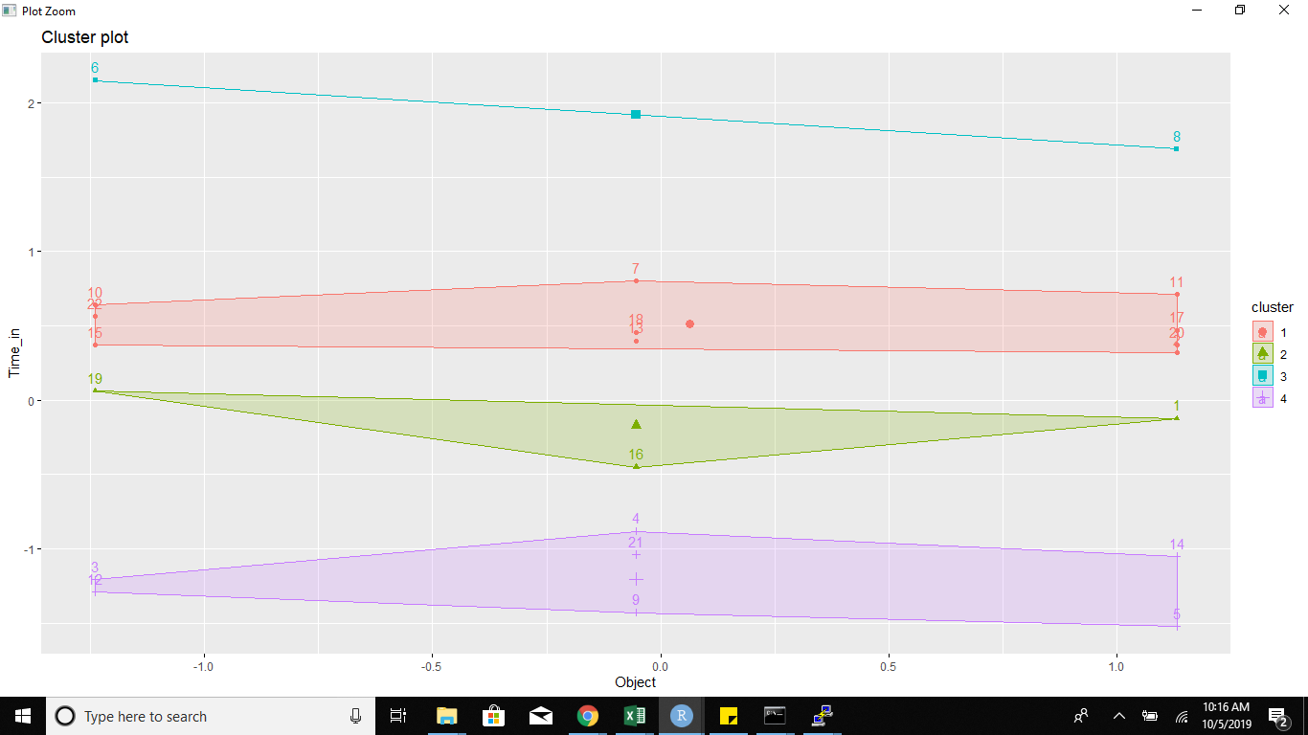

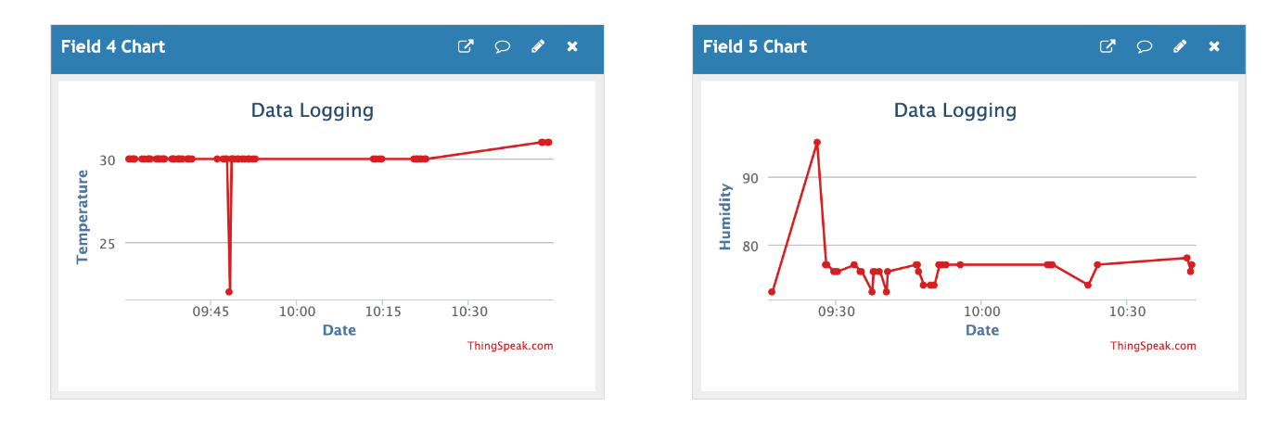

CHALLENGES ADDRESSED:

* + - * Controlled Access – Only Registered users will be allowed to control the devices.
      * Speed of IoT Service – The cloud-based Telegram app enables high speed request and response.

INTEGRATION:

* Python program for controlling the system
* OS for Raspberry pi installed
* Bot created in telegram as user interface
* Door automatically opens the door is unlocked through app and a person comes near the door.
* Door automatically closes when it is locked through app.
* Lights, fans and ACs are all controlled through telegram app.
* Temperature sensor used to detect any smoke or fire and buzzer enabled and notification is sent to user.
* Database hosted in Ec2

OUTCOME:

* + - * Home automation enabled through Raspberry pi
      * Controlled access enabled through Telegram
      * Secured access provided for the users
      * Authentication and Identification enabled
      * Edge analytics performed by mongo db and data stored in cloud.
      * Log reports generated on user request
      * Power usage and other details analysed through machine learning techniques.