AI Insights for NGO Growth
5 Practical AI-Powered Ideas to Strengthen Outreach, Engagement & Fundraising
Task 5 | Submitted to InAmigos Foundation
AI tools were used to research current practices in the nonprofit sector and identify ideas that are practical, low-cost, and realistic for NGOs to adopt. The five recommendations below focus on outreach, volunteer engagement, fundraising, and online presence, each broken down by the problem it solves, its expected benefits, and how to implement it.
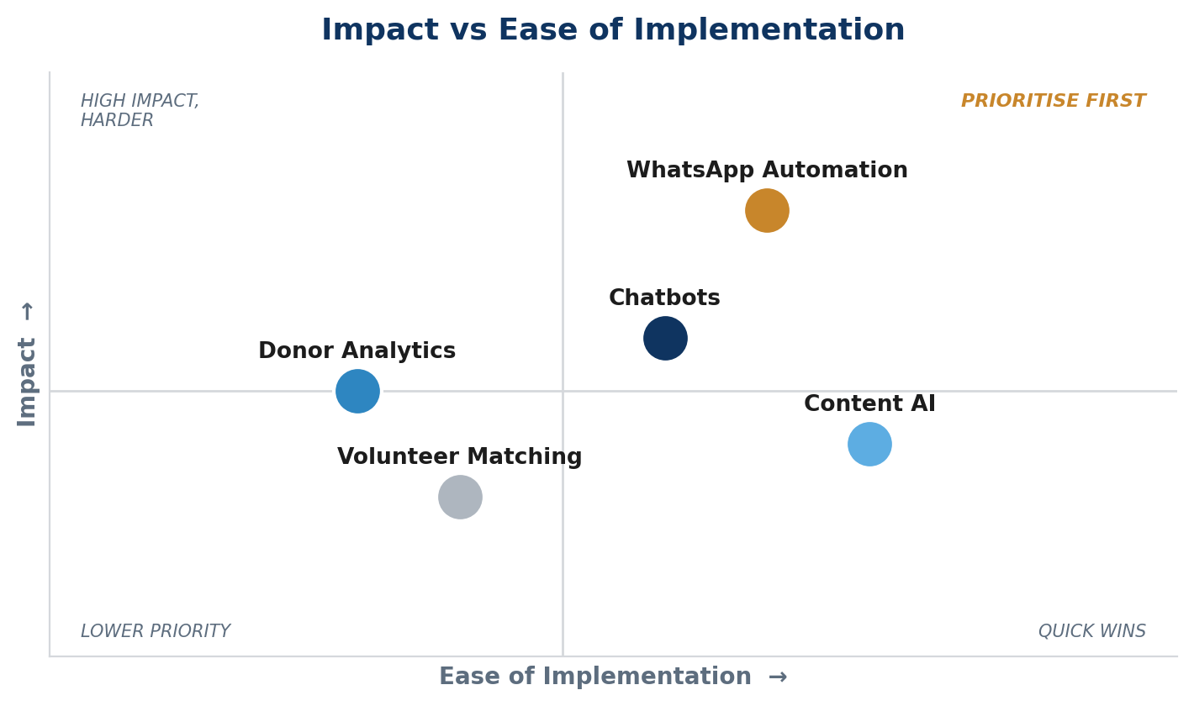
Quadrant view of all five ideas — WhatsApp Automation offers the strongest combination of impact and ease, making it the recommended starting point.
- AI-Powered WhatsApp Outreach Automation
Many NGOs, especially in India, struggle to reach donors and volunteers consistently through email, which often goes unread. Using AI-driven WhatsApp tools (such as WATI or Gupshup), NGOs can send automated reminders, event updates, and donation prompts directly to people's phones, where they are most likely to be seen.
Problem It Solves
- Low email open rates mean important updates go unseen
- Delayed or inconsistent communication during time-sensitive campaigns
Expected Benefits
- Open rates exceeding 90%, far higher than email
- Real-time, two-way communication with donors and volunteers
- Estimated impact: a 30-day reactivation drip aimed at lapsed donors can lift response rates by roughly 15-25% compared to a single email blast
How to Implement
- Set up a platform such as WATI, Twilio, or Gupshup and import the donor/volunteer contact list
- Build a 3-message drip flow for lapsed donors: Day 1 – impact update, Day 7 – specific ask tied to a current need, Day 14 – final reminder with a one-tap donation link
- Trigger event-reminder broadcasts 48 hours and 2 hours before any volunteer event to reduce no-shows
- AI Chatbot for Volunteer Screening, FAQs & Onboarding
AI chatbots can be added to an NGO's website or social pages to answer common questions, screen volunteer applicants, and walk new sign-ups through onboarding, all without needing a staff member available around the clock.
Problem It Solves
- Delayed responses cause potential donors and volunteers to lose interest
- Coordinators spend hours manually screening and replying to volunteer applications
Expected Benefits
- 24/7 availability without added staffing cost
- Faster conversion of website visitors into donors or volunteers
- Estimated impact: automating the first screening step typically cuts average volunteer response time from 2-3 days to under 1 hour, which materially reduces drop-off before onboarding even starts
How to Implement
- Set up a no-code chatbot (e.g. Tidio or ManyChat) with three flows: general FAQs, donation guidance, and volunteer screening
- In the screening flow, collect skills, availability, and location, then auto-tag applicants as 'ready to onboard' or 'needs follow-up'
- Route 'ready to onboard' applicants straight into a welcome sequence with their first task within 48 hours
- AI-Assisted Content Creation for Social Media
Tools like ChatGPT and Canva AI can turn a single weekly update or photo into ready-to-post content for Instagram, Facebook, and LinkedIn, keeping the NGO's online presence active without a dedicated marketing team.
Problem It Solves
- Inconsistent posting due to limited marketing bandwidth
- High cost of outsourcing regular content creation
Expected Benefits
- Consistent online presence that builds long-term donor trust
- Significant time savings on caption writing and basic design
- Estimated impact: NGOs that move from sporadic to weekly consistent posting commonly see follower and engagement growth in the range of 20-40% over 2-3 months, simply from frequency and consistency
How to Implement
- Each week, take one photo and one short update from field work and feed both into ChatGPT to draft 3 platform-specific captions (Instagram, Facebook, LinkedIn)
- Use Canva AI to generate a matching graphic from the NGO's existing brand template
- A staff member reviews and edits for accuracy and tone before scheduling, never publish unedited AI output
- Donor Insights Through Simple AI Analytics
By reviewing existing donation records with AI-assisted tools, NGOs can spot patterns, such as which donors give regularly and which haven't donated in a while, and follow up with the right people at the right time.
Problem It Solves
- Donor outreach treated equally instead of being prioritised
- Valuable patterns in existing data go unused
Expected Benefits
- Higher response rates through targeted, timely outreach
- Early identification of donors at risk of lapsing
- Estimated impact: segmenting and targeting only the at-risk donor group (instead of mass outreach) typically improves reactivation response rates by roughly 2-3x for the same outreach effort
How to Implement
- Export donation history into a spreadsheet and use an AI tool (e.g. ChatGPT with the data pasted in, or a CRM's built-in AI) to flag donors with no gift in the last 6 months
- Segment into three groups: active (gave in last 90 days), at-risk (90-180 days), lapsed (180+ days)
- Send the at-risk group a personalised check-in message within the same week the segment is identified, before they slide into lapsed
- AI-Based Volunteer Role Matching
Instead of manually assigning volunteers to tasks, NGOs can use a simple AI-assisted system to match volunteers to roles based on their skills, interests, and availability.
Problem It Solves
- Volunteers placed in roles that don't suit their skills or interest
- Coordinators spend excessive time on manual matching
Expected Benefits
- Higher volunteer satisfaction and longer retention
- Faster onboarding for new volunteers
- Estimated impact: NGOs that match volunteers to roles by skill and interest (rather than first-available assignment) typically see 3-month retention improve by roughly 20-30%, since mismatched volunteers are the most common reason for early drop-off
How to Implement
- Build a short intake form (5-6 fields: skills, interests, availability, location, prior experience) using Google Forms or Airtable
- Use an AI tool to score each new volunteer against 3-4 open roles based on form responses, and auto-suggest the best-fit role rather than the next available one
- Re-run the matching check every 90 days, since volunteer availability and interest often shift after the first quarter
KEY INSIGHT: Most NGOs fail to benefit from AI not due to lack of effort, but lack of prioritisation. Adopting too many tools at once dilutes results; adopting the right one first compounds them.

Conclusion
NGOs that adopt AI randomly, across too many tools at once, tend to see limited and unclear results. NGOs that prioritise one high-impact, low-cost system first, such as WhatsApp automation or chatbots, build early momentum and scale faster with fewer resources. The goal is not to use more AI; it is to use the right AI, in the right order.
Note: Percentage estimates above are illustrative ranges based on commonly reported nonprofit-sector benchmarks for similar interventions, not figures specific to any single organisation. Actual results will vary and should be measured against each NGO's own baseline.

