**Price list**

| Name | Quantity | Price | Nutrients |
| --- | --- | --- | --- |
| Eggs | 10 |  |  |
| Hana katsuo | 80 g | 390 | Energy: 340 Kcal  Protein: 72.2 g | Fat: 5.5 g  Carbon: 0.3 g |
| Rice bran oil | 900 g | 650 | 8000 Kcal | 0 g | 900 g | 0 g  Vitamin E: 456 mg |
| Sake | 1 L | 240 |  |
| Shoyu | 1 L | 160 | 126 Kcal | 0 g | 14 g | 0 g |
| Beacon slice |  | 480 | 126 Kcal | 0 g | 14 g | 0 g |
| Banana | 4 | 140 | 126 Kcal | 0 g | 14 g | 0 g |
| Hon-mirin | 1 L | 300 | 126 Kcal | 0 g | 14 g | 0 g |
| Ra-yu | 31 g | 120 |  |
| Shichimi | 15 g | 120 |  |
| Granular sugar | 400 g | 190 | 1548 Kcal | 0 g | 0 g | 400 g |
| Kaiware |  | 60 | 126 Kcal | 0 g | 14 g | 0 g |
| Abura-age |  | 160 | 126 Kcal | 0 g | 14 g | 0 g |
| Milk | 1 L | 195 | 690 Kcal | 34 g | 40 g | 48 g  Calcium: 1150 mg |
| Carrot |  |  |  |
| Onion |  |  |  |
| Soba | 3 servings | 214 | 126 Kcal | 0 g | 14 g | 0 g |
| Garlic | 1 | 240 |  |
| Ginger | 1 pack | 285 |  |
| Peanut butter | 340 g | 650 | 2159 Kcal | 91 g | 173 g | 58 g |
| Bread | 6 pieces | 110 | 960 Kcal | 26.4 g | 14.4 g | 181.2 g |
| Tomato | 3 large | 540 |  |
| Gyoza wrappings | 20 | 165 |  |
| Pork hiki meat | 500 g | 630 |  |
| Chilli | 10 slender | 260 |  |
| Shiitake mushroom | 6 large | 320 |  |
| Spagetti | 600 g (6 servings) |  | 2176 Kcal | 72 g | 12 g | 444 g |

**Soba**

Pics:

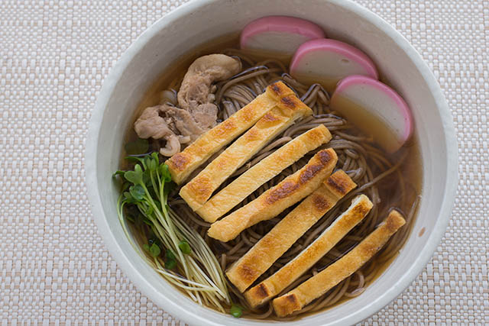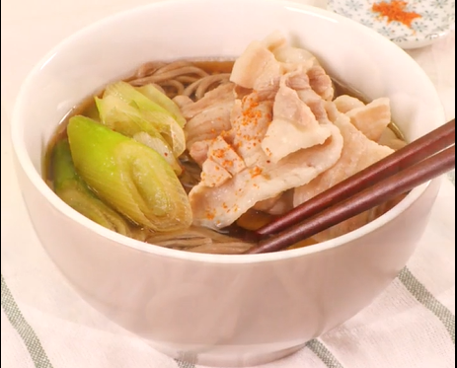

Soba noodles:

消毒

蕎麦紛：小麦粉 = 8:2

1. Add water, mix it and beat it with your hands and roll it into a flat sheet.
2. Cut the dough into thin slices
3. Put it in water and boil it for 10 min.
4. Wash it and transfer it to a new plate

Kaeshi:

Ingredients

* Shoyu 1L
* Sugar (三温糖 or ザラメ or グラニュー糖) 180g
* 本mirin 180 cc

Procedure:

1. Add mirin in a bowl and add alcohol, boil it for 1 min.
2. Add half the sugar and mix it till it dissolves. Add shoyu to it and boil it.
3. Remove the foam and boil it in low heat, after 10 min we will see vapours so stop the heat, remove the foam again
4. Store it in the shoyu bottle.

Miscellaneous:

We can use it for 1-2 months. Kaeshi can be used on eggs, soba, or meat.

Tsuyu:

Ingredients:

* お湯 - 300 cc/person
* 花かつお
* 昆布
* 料理酒　大匙1
* 味醂　大匙1

Procedure:

1. Boil water, add kombu to it.
2. Add Hana-katsuo to it - 2 hands, boil it till it bubbles.
3. Stop the stove, take out the konbu.
4. Transfer the soup (dashi) to a new bowl using a filter.
5. Add 20% kaeshi (60cc) to it and heat it.
6. Add 1 big spoon sake and mirin.
7. Stop the heat when white bubbles start forming.
8. The tsuyu gets ready. We can add soba to it and eat.

dashi : kaeshi ratio = 20% for hot soba, 30% for cold soba

Soba recipe:

Ingredients:

* 蕎麦　－　100g
* 蕎麦つゆ required amount
* 油揚げ　1 piece/person
* かいわれ　1 pack
* 蒲鉾　（かまぼこ） 3 slices
* 豚肉　1 pack
* ねぎ and 刻み葱
* 辣油
* shichimi or pepper

Procedure:

1. Fry the abura-age in a pan till it becomes brown.
2. Boil the soba in water for 10 mins.
3. Remove the water and clean the soba.
4. Add 1 tsp of shoyu, 1 tsp of mirin, 0.5 tsp of sugar and add pork and fry it. We can also use gomayu.
5. Add tsuyu+water (1:7) to it.
6. Cut the kaiware, negi, kamaboko and add it along with abura-age. Add rayu if needed.
7. Put the soba and add shichi-mi or pepper at the top.

**Omelette**

Pics:

Ingredients:

* Eggs (2-4)
* Salt
* Butter
* Onion
* Pepper
* Chilli

Procedure:

1. Put eggs in a bowl and add salt to it, mix it well
2. Add onions and chilli to it
3. Put butter/oil in pan and heat it the bubbles start forming
4. Pour the egg mixture and spread it across the pan
5. Roll the omelette and add some pepper to it in the end

Tips:

* 1
* 2

**Spagetti**

Pics:

Ingredients:

* Spagetti
* Tomato
* Onion
* Capsicum
* Pepper
* Garlic
* Oil
* Chilli

Procedure:

1. Boil the spagetti pasta in water for 10 mins
2. Remove the water and transfer it in a new plate
3. Cut the tomatoes in a + shape and boil them for 3-4 mins
4. Add it to the blender and grind it
5. Put 2 drops oil and 1 tbsp of chopped garlic in a plate
6. Add 1 chopped onion
7. Add some capsicum
8. Pour the tomato sauce to it and add some salt and chilli powder
9. Mix it well and boil it for 3-4 minutes
10. Add pepper and chilli
11. Add the boiled spagetti and mix it well

Tips:

* 1

**Bread omlette**

Pics:

Ingredients:

* Egg
* Oil
* Bread
* Onion
* Carrot
* Chilli

Procedure:

* Make omelette mixture
* Make bread toast
* Pour some oil and omelette mixture, put bread on top and pour omelette mixture on top of it

Tips:

* 1

**Gyoza**

Pics:

Ingredients:

1. Gyoza
   * 餃子の皮 20 pieces
   * 豚挽き肉 180 g
   * 白菜のみじん切り 180 g
   * 韮（にら）の小口切り 35 g
2. A

* 生姜のすりおろし　（Scrapped ginger）1
* Sake, Goma oil, Shoyu - 1 spoon
* Salt

1. Tare

* Vinegar
* Shoyu
* Ra-yu

Procedure:

* Cut the nira and cabbage
* Put the pork in a cup and add 1 spoon of shoyu, some salt, ginger, sake 1 spoon and goma oil 1 spoon
* Mix it well and make a paste
* Add cabbage and nira to it and mix it well
* Put oil in a pan and keep a small cup of water
* Take gyoza cover and put a spoon of the pork mixture in the center, wet the sides with water by wiping it with a paper
* Fold the gyoza cover and press it on the top to cover it completely
* Put the gyozas in a pan in a circular shape and put lid on top
* Heat the pan slowly and pour ½ glass of water on top of the gyozas
* Put lid on top and wait for 5 mins
* Take out the lid and add small oil to the gyozas and heat it for 2 mins.

Price:

1 gyoza = (166 + 626*180/500 + 180/5 + 5 + 200)/20 = 31.6 yen

Tips:

* 1
* 2

**Veg momos stuffings and chutney**

Pics:

Ingredients:

* Garlic - 1 tbsp
* Oil - 3 tbsp
* Cabbage - 2 small cup shredded
* Ginger - 1 inch
* Spring onion - 2 tbsp
* Carrot - 1 small cup grated
* Chilli
* Salt

Procedure:

* Pour 3 tbsp of oil, ginger, garlic and chilli. Mix it well
* Add spring onion, cabbage and carrot and mix it well
* Add some pepper and salt, don’t overcook.
* Add 2 tbsp more spring onion and mix it well.

**Momos red chutney**

Pics:

Ingredients:

* Red chilli 7-8
* Tomatoes - 3
* Garlic - 1 tbsp
* Ginger - 1 tbsp
* Oil - 1 tbsp
* Salt - 1 tbsp
* Vinegar - 1 tbsp

Procedure:

* Put 7-8 chillies and a half cup of water
* Add 3 chopped tomatoes to it and microwave it for 5 mins, grind it to a fine paste
* Put 1 tbsp oil in a pan, add ginger, onion and garlic 1 tbsp each.
* Add the grinded tomato and mix it well

Tips:

* 1

**Potato salad**

Pics:

Ingredients:

* Potato, Onion, Carrot, Cucumber, Ham, Corn
* Vinegar / lemon
* Mayonnaise / egg
* Salt and pepper

Procedure:

* Slice the onion and wash it well
* Slice the cucumber, potato and ham,
* Wash the potatoes, put it in a pan and add water and some salt
* When bubbles start forming, put in medium heat and boil for 12 mins.
* Slice the carrots and cook it in boiling water for 3 mins and drain it.
* Drain the water and mash the potatoes while they are hot.
* Add some vinegar, salt and pepper and let it cool for some time
* Add cucumber, carrot, ham, onions, corn, mayonnaise and mix it well

Tips:

* 1

**Potato salad**

Pics:

Ingredients:

* E
* O
* B
* O
* C
* C

Procedure:

* M
* M
* P

Tips:

* 1

**Potato salad**

Pics:

Ingredients:

* E
* O
* B
* O
* C
* C

Procedure:

* M
* M
* P

Tips:

* 1

**Potato salad**

Pics:

Ingredients:

* E
* O
* B
* O
* C
* C

Procedure:

* M
* M
* P

Tips:

* 1

**Potato salad**

Pics:

Ingredients:

* E
* O
* B
* O
* C
* C

Procedure:

* M
* M
* P

Tips:

* 1

**Potato salad**

Pics:

Ingredients:

* E
* O
* B
* O
* C
* C

Procedure:

* M
* M
* P

Tips:

* 1