Name: Barath M
Roll no: 727823tuit016

Problem Statement:
A retail organization wants to move from reactive reporting to predictive analytics. Management wants to :
  - Forecast future sale
  - Detect unusual sales patterns
  - Identify risks and opportunities early.
Manual analysis is no longer sufficient due to increasing data volume.
As a Advanced BI Analyst, your task is to:
  - Use Al-powered analytics in Power BI
  - Forecast future sales trends
  - Detect anomalies
  - Automatically generate insights using Smart Narratives
Questions:
- Analyse historical sales trends using line charts.
- Identify seasonality patterns in sales data.
- Use forecasting to predict future sales.
- Detect anomalies in sales data using Al
- Explain potential reasons for detected anomalies.
- Use Smart Narratives to summarize insights.
- Compare actual sales with forecasted values.
- How reliable is the forecast model?
- What actions should management take based on Al insights?

Introduction:
In today’s competitive retail environment, organizations must move beyond traditional reporting and adopt predictive analytics to make proactive business decisions. This project, Sales Forecasting and Anomaly Detection using AI in Power BI, focuses on analyzing historical sales data to identify trends, seasonal patterns, unusual behaviors, and future sales expectations.
Using Power BI’s AI-powered capabilities such as forecasting, anomaly detection, and smart narratives, the project transforms raw sales data into meaningful insights. The objective is to support management in understanding past performance, predicting future outcomes, detecting risks early, and taking data-driven strategic actions.
Dataset:

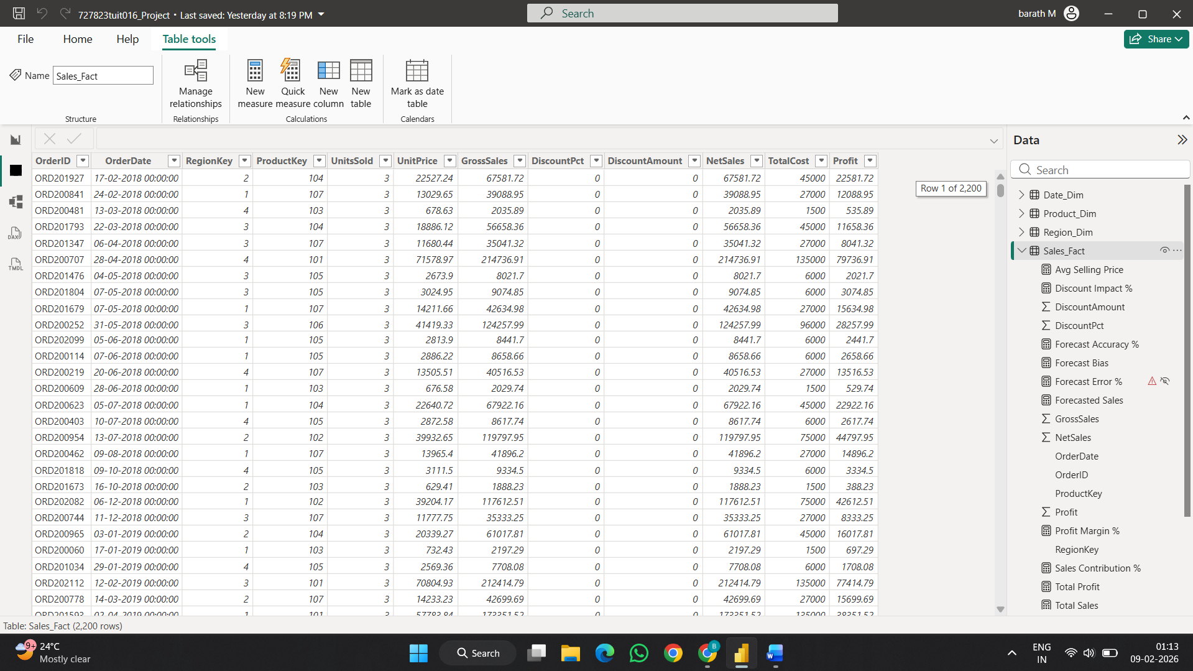
Dataset Description:
The project uses a synthetic retail sales dataset designed to simulate real-world business scenarios. The dataset includes transactional sales records across multiple years, regions, product categories, and product types.

Key attributes include:
- Order Date
- Region
- Category
- Product Name
- Sales Amount
- Profit
- Discount Percentage
- Units Sold
The dataset enables time-series analysis, forecasting, and anomaly detection.

Relationships ( Data Model Design):
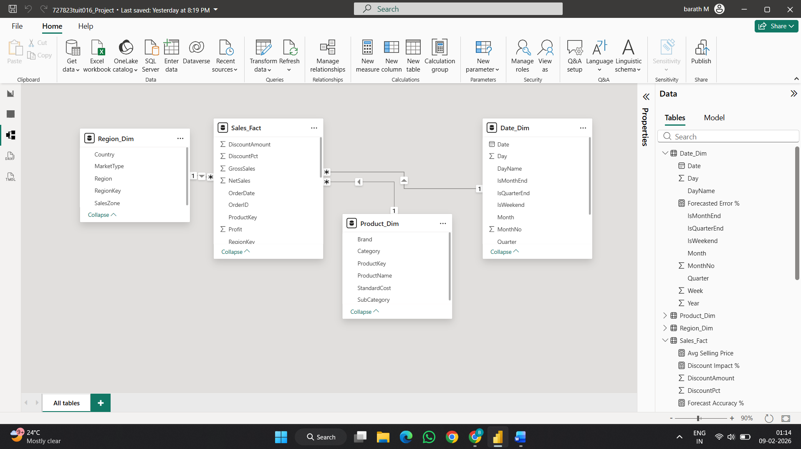
A star schema data model was implemented for efficient analysis and performance optimization. The Sales fact table is connected to Date, Product, Category, and Region dimension tables through one-to-many relationships. This structure allows flexible filtering, accurate aggregation, and scalable analytics.

Question:
1.Analyse historical sales trends using line charts:
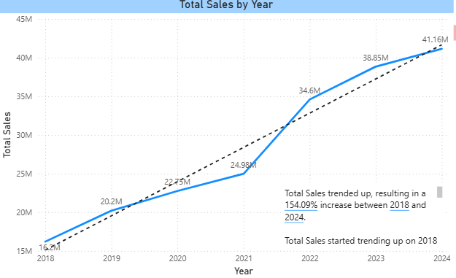

2.Identify seasonality patterns in sales data.
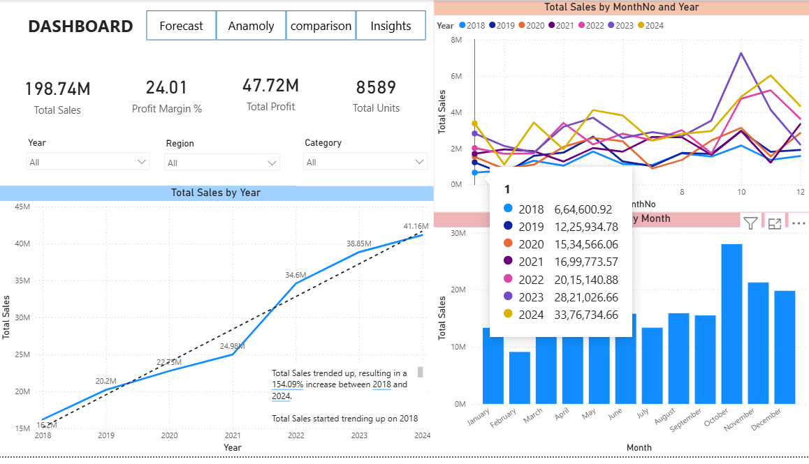

3.Use forecasting to predict future sales.
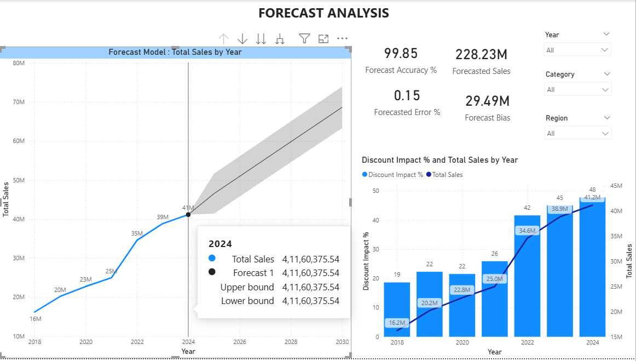
Sales forecasting was performed using Power BI’s built-in forecasting capabilities based on historical trends. The forecast provides projected sales values along with confidence intervals, helping estimate future performance while accounting for uncertainty.

4.Detect anomalies in sales data using Al
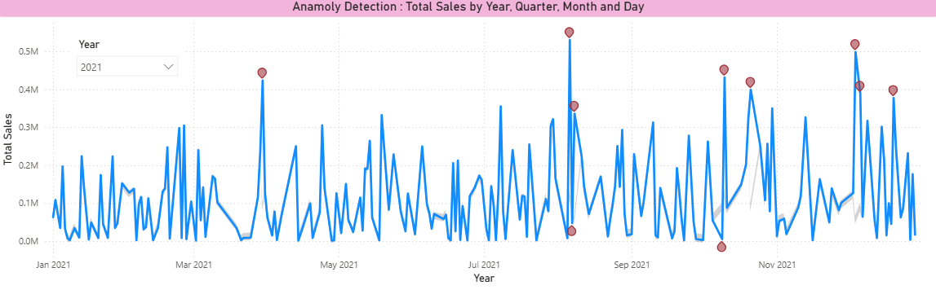
AI-based anomaly detection was used to identify unusual sales spikes and drops that deviate from expected patterns. These anomalies may indicate exceptional events such as unexpected demand surges, operational issues, or external market disruptions.
5.Explain potential reasons for detected anomalies.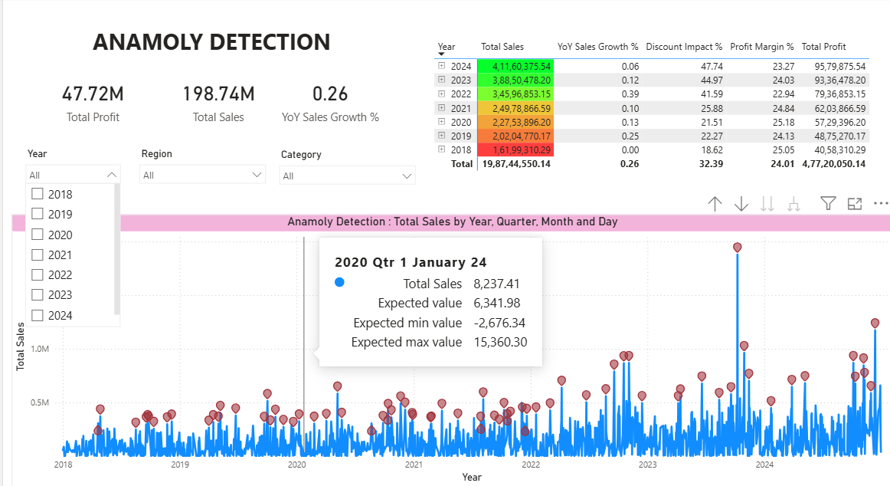
Detected anomalies were analyzed in relation to discount levels, regional performance, and product categories. Sudden spikes often correlate with heavy discounting or seasonal promotions, while sharp drops may indicate supply chain or demand-side challenges.

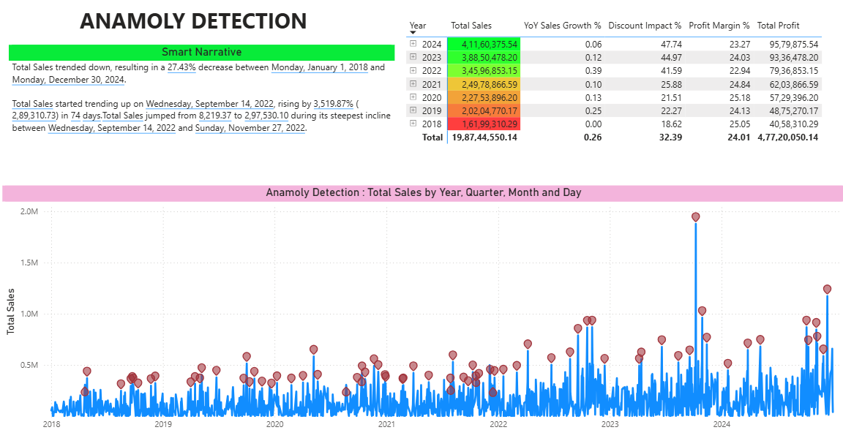
6.Use Smart Narratives to summarize insights:
Forecast reliability was evaluated using Forecast Accuracy Percentage and Forecast Error Percentage. Higher accuracy values indicate dependable predictions, while lower error percentages confirm minimal deviation between actual and forecasted sales.

7.Compare actual sales with forecasted values.
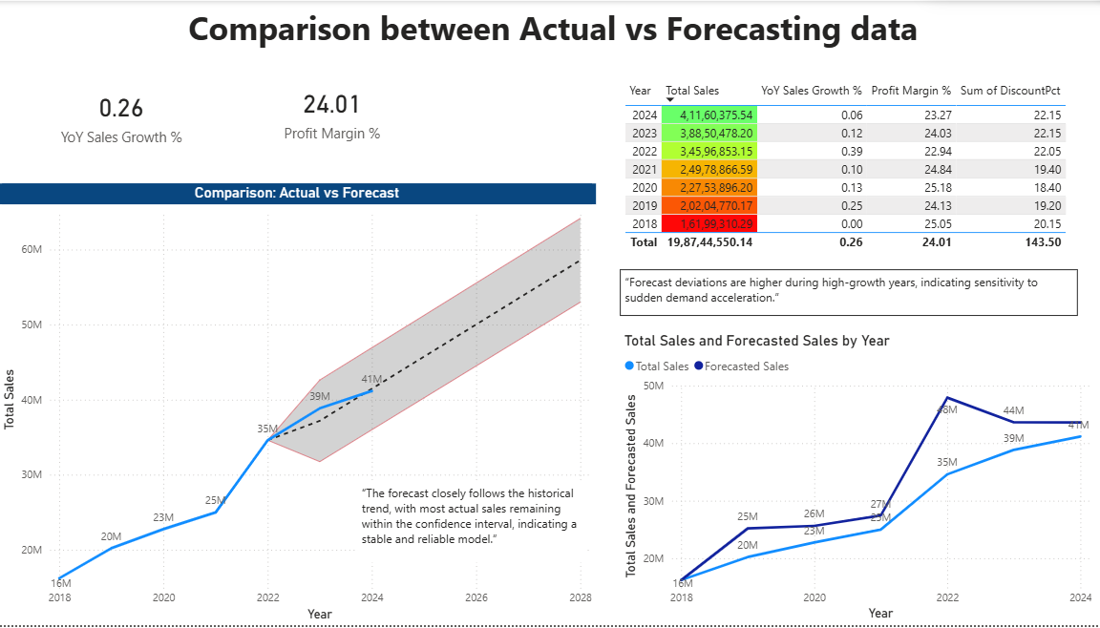
8.How reliable is the forecast model?
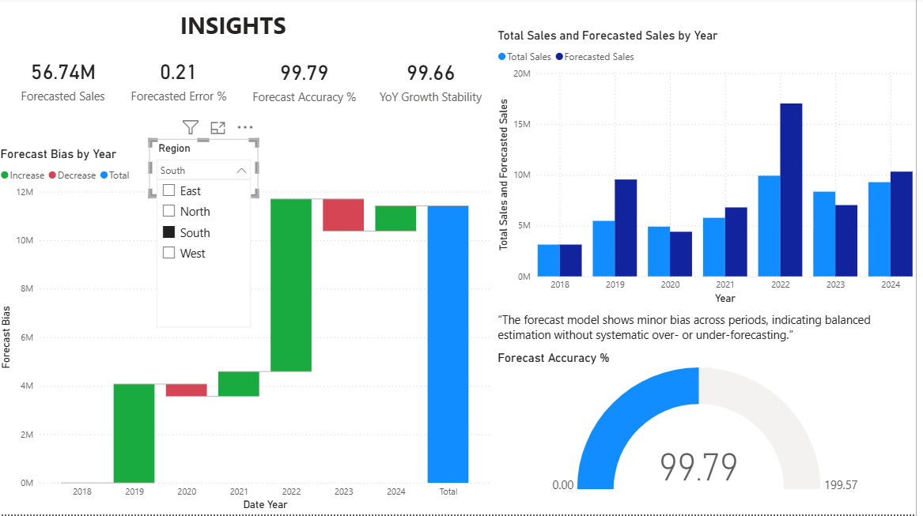

9.What actions should management take based on Al insights?
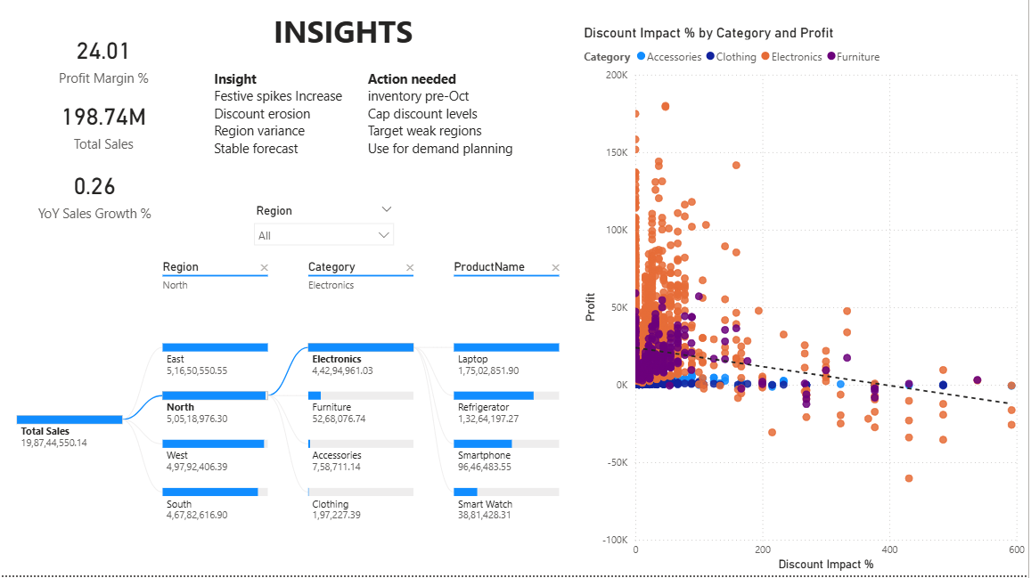
Business Insights and Management Actions:
- Sales consistently peak during seasonal periods, indicating the need for advance inventory planning.
- High discount levels increase sales volume but negatively impact profit margins.
- Forecast accuracy remains within acceptable thresholds, making it suitable for demand planning.
- Regions with unstable YoY growth require focused operational and marketing strategies.
Limitations of the Project
- Forecasting is based solely on historical sales data.
- External factors such as economic conditions and competition are not included.
- AI visuals depend on data quality and volume for accuracy.

Future Enhancements:
The forecasting accuracy can be improved by integrating machine learning models such as ARIMA or LSTM using Python or Azure Machine Learning. External market factors like inflation, economic indicators, and seasonal events can be included to make predictions more realistic. Real-time data integration would allow continuous monitoring of sales performance. Automated alert systems can be implemented to notify stakeholders when anomalies or unusual trends occur. The dashboard can be enhanced with role-based access for management users. Additional profit optimization models can support pricing decisions. Advanced scenario analysis can be added for strategic planning. Integration with ERP systems would improve data reliability. Natural language insights can enhance user interpretation. These enhancements would make the solution more intelligent and proactive.
Project Summary:
This Power BI project analyzes multi-year retail sales data to deliver end-to-end business insights through interactive dashboards. Historical sales trends and seasonality patterns are examined to understand long-term growth and recurring demand cycles. AI-based forecasting is applied to predict future sales, along with confidence intervals to assess prediction reliability.
Anomaly detection techniques are used to identify unusual sales spikes and drops, and these anomalies are further analyzed using key business drivers such as discounts, profit margins, and regional performance. Actual sales are compared with forecasted values to evaluate forecast accuracy and error, ensuring transparency and trust in the model.
Finally, the project presents executive-level insights through KPI cards, visual comparisons, and actionable recommendations, enabling management to optimize pricing strategies, improve demand planning, and reduce business risk. Overall, this solution demonstrates how AI-assisted analytics in Power BI can enhance decision-making and business performance.

