Explainable Machine Learning for Five-Year National CO₂ Emissions Forecasting from Socioeconomic Indicators
Padma Priya R¹ Baradeswaran A^{2*}
1,2 Gandhi Engineering College, Bhubaneswar, Odisha, India-752054
Email: barathme@yahoo.co.in
Abstract
Predicting 5-year forward national CO₂ emissions change from lagged socioeconomic indicators is a difficult, noisy forecasting problem, comparable in difficulty to established multi-year macro-panel tasks such as cross-country GDP growth forecasting (typical R² 0.10–0.35). We construct a target variable (5-year forward percentage change in CO₂ per capita, sourced from Our World in Data) with no mathematical overlap with seven lagged predictors (GDP, HDI, internet penetration, inflation, population growth, GDP growth, relative CO₂ intensity), and evaluate six ML models against four baselines (naive, country fixed-effects, fixed-effects with features, linear regression) under three validation strategies: GroupKFold(5) by country, temporal holdout, and leave-one-region-out (LORO). XGBoost achieves GroupKFold R²=0.213 and temporal holdout R²=0.245 (95% CI [0.190, 0.292]), outperforming all baselines; CatBoost performs comparably (R²=0.246, CI [0.184, 0.301]). SHAP, permutation importance, and feature ablation — computed consistently on a single model — identify log GDP per capita and HDI as the most important predictors, consistent with the (contested) Environmental Kuznets Curve. LORO indicates consistent negative transfer to Sub-Saharan Africa (CI excludes zero) and weaker, inconclusive evidence for South Asia and the Middle East/North Africa (CIs span zero). A structural break test confirms a significant pre-/post-2015 shift in target values (t=6.01, p<0.001) without systematic prediction bias across periods. Panel: 181–183 countries, 2001–2018, n=2,986.
Keywords: Explainable AI; XGBoost; SHAP; CO₂ forecasting; Environmental Kuznets Curve; temporal holdout; GroupKFold; LORO; Diebold-Mariano; country fixed effects; SDG 13.

1. Introduction
The Paris Agreement’s nationally determined contributions (NDCs) require a 43% reduction in global CO₂ by 2030 [1]. Identifying which national characteristics are associated with 5-year forward emissions trajectories — the minimum policy-relevant horizon matching the NDC ratchet cycle — is a core SDG 13 analytics challenge. This is a genuinely difficult forecasting problem: unlike contemporaneous CO₂ estimation from energy and economic data (where predictors are mechanistically linked to current emissions, typically yielding R²>0.90), forward 5-year change prediction from lagged socioeconomic indicators is comparable in difficulty to other established multi-year macro-panel forecasting problems, such as cross-country GDP growth forecasting, where R² values of 0.10–0.35 are routinely reported and considered informative [7,8] (Table 10).
Prior ML development-prediction studies share several methodological weaknesses that this paper addresses: predictor-target overlap producing inflated R²; cross-validation strategies that exploit within-country temporal autocorrelation [2]; attribution computed from a different model than the one evaluated [3]; absent comparison against country fixed-effects baselines [4]; untested structural breaks from COVID-19 and the Paris Agreement; and forecast horizon choices that are rarely empirically justified. This study addresses each of these through a target variable with zero predictor overlap, a four-level baseline hierarchy including country-wide fixed effects, a consistent attribution based on a single model, an explicit structural break test, and a sensitivity analysis of the forecast horizon using a fixed time span applied over all time horizons.
2. Literature Review

2.1 ML for National CO₂ Prediction and Benchmarking Forecasting Difficulty
ML applications for CO 2 forecasting often confuse the current level estimate (R²>0.90, near-measurable) with the forecast of future changes (much more difficult problem). Karakurt and Aydin[5] reached R²=0.95-0.99 in the sample of OECD countries forecasting levels without time lag. Bekun and colleagues. [6] VECM was used in 16 African countries without an evaluation outside the sample. The appropriate external benchmark for this study’s difficulty is the macro-panel growth-forecasting literature: cross-country GDP growth regressions typically achieve adjusted R² of 0.10–0.35 [7], and the IMF’s 5-year-ahead World Economic Outlook forecasts imply comparable explanatory power [8]. Table 10 situates this study’s R²=0.213–0.245 within this benchmarking context.

2.2 Environmental Kuznets Curve: Evidence and Critiques
The Environmental Kuznets Curve [9] posits an inverted-U relationship between income and emissions. The EKC is a contested hypothesis: Stern [10] provided a critical review concluding EKC evidence is sensitive to specification; Wagner [11] showed panel co-integration issues underlie much EKC evidence; Dinda [12] found no consensus on turning points across 100 studies; Millimet et al. [13] showed turning points are highly specification-sensitive. This study’s SHAP finding — higher log GDP per capita associated with lower future CO₂ growth — is consistent with the post-turning-point EKC but does not establish the mechanism. An alternative explanation [14] is that high-income decarbonisation in production-based CO₂ data partly reflects manufacturing offshoring.

2.3 Panel Data Prediction and Fixed-Effects Benchmarks
Baltagi [4] and Pesaran and Smith [15] established country fixed-effects (FE) models as the minimum credible econometric baseline for panel data. FE models can be evaluated under any validation strategy provided relevant countries appear in training; this study reports FE performance under both GroupKFold and temporal holdout (Section 4.1).

2.4 Production vs. Consumption-Based CO₂ Accounting
OWID reports production-based CO₂. Consumption-based CO₂ [14,16] attributes emissions differently for high-income countries, where production-based declines may partly reflect offshoring rather than genuine decarbonisation. This study uses production-based CO₂, the standard in the literature, and acknowledges this limitation (Sections 3.2, 6).

2.5 COVID-19 and Structural Breaks
COVID-19 caused the largest single-year CO₂ reduction on record (−5.8% globally in 2020) [27], affecting outcome windows for origin years 2015–2018. The study tested for structural fractures (section 4.4).
2.6 SHAP Attribution Consistency
Lundberg and Lee [17] have developed SHAP as a theoretical framework for tree model attribution. Strzymelj and Kononenko [18] recommended an assessment of SHAP stability by repeated seed without proposing a standard numerical threshold. This study follows this recommendation and calculates all attributions from one model.

3. Data and Methodology

3.1 Data Sources
Six authenticated, freely accessible datasets are used (Table 1; accessed 26 June 2025).
Table 1. Authenticated open-access datasets.
Dataset | Organisation | Variables | URL | Period | Countries | Citation
OWID CO₂ & Energy | Our World in Data | CO₂/cap, energy/cap, GHG, GDP, pop | github.com/owid/co2-data | 2000–2023 | 218 | [19]
GDP | World Bank/Datahub | GDP (current USD) | github.com/datasets/gdp | 2000–2023 | 266 | [20]
Population | World Bank/Datahub | Total population | github.com/datasets/population | 2000–2023 | 266 | [21]
CPI | World Bank/Datahub | CPI inflation, annual % | github.com/datasets/cpi | 2000–2023 | 193 | [22]
Internet | Gapminder/ITU | Internet users (%) | github.com/open-numbers/ddf--gapminder--systema_globalis | 2000–2022 | 193 | [23]
HDI | Gapminder/UNDP | Human Dev. Index | same as above | 2000–2022 | 195 | [24]
Notes: All URLs accessed 26 June 2025. SHA-256 checksums archived in companion repository.

3.2 Target Variable and Predictor Construction
The prediction target is:
CO₂Δ5yr(t) = [CO₂/cap(t+5) − CO₂/cap(t)] / CO₂/cap(t) × 100
CO₂/cap is production-based (OWID); high-income decarbonisation may partly reflect manufacturing offshoring [14] (see Section 6). The seven predictors are measured at the forecast origin year t: GDP growth rate, log GDP per capita, internet penetration, CPI inflation (annual percentage rate, as reported by the World Bank), HDI, population growth, and relative CO₂ intensity. During verification, two preprocessing inconsistencies were identified and corrected before final model estimation: the inflation predictor's construction and the winsorisation reference window used in horizon-sensitivity analyses. All results reported in this manuscript reflect the corrected, unified construction.
Prediction-origin years 2001–2018 ensure t+5 outcomes are available within OWID coverage through 2023. After winsorisation (1st/99th percentile): n=2,986; mean=+6.93%; SD≈21.8 pp.

3.3 Predictor Variables and Leakage Verification
Table 2. Variable definitions, VIF, and predictor-target leakage verification.
Variable | Description | Source | VIF | Leakage Verification
log_gdp_pc | Log GDP per capita | World Bank/OWID | 8.61 | Not in CO₂Δ5yr formula; measured at t only
hdi | Human Dev. Index (0–1) | UNDP/Gapminder | 10.98 | External composite; correlated with log GDP per capita (r=0.93)
internet_penetration | Internet users (% pop.) | ITU/Gapminder | 3.27 | Digital stock at t; ≠ CO₂ change at t+5
relative_co2_intensity | Country CO₂/energy ÷ global mean | Derived (OWID) | 1.00 | Grid-carbon starting position at t
pop_growth | YoY population growth (%) | OWID/WB | 1.36 | Demographic pressure at t; flow variable
gdp_growth_calc | GDP growth YoY (%) | World Bank | 1.08 | Economic momentum at t; ≠ CO₂ change at t+5
inflation_rate | CPI inflation, annual % | World Bank | 1.06 | Macrostability at t; independent of future CO₂
CO₂Δ5yr (TARGET) | 5-yr forward CO₂/cap % change | OWID | N/A | Future outcome (t+5); zero overlap with predictors
Notes: VIF on standardised feature matrix (n=2,986). HDI-GDP correlation r=0.93 (Section 4.5). All Pearson |r|(feature, CO₂Δ5yr) < 0.45.

3.4 Feature Engineering and Excluded Variables
The seven predictors were selected based on open-access availability for 181–183 countries. Renewable energy share, coal/fossil fuel share, electricity access rate, industrial share of GDP, and urbanisation rate were evaluated and excluded due to insufficient global coverage (IRENA/IEA data gaps for low-income countries pre-2010–2012; missing values for 28–35% of low-income observations). The relative_co2_intensity variable serves as a partial proxy for energy mix. Incorporating these variables as open-access coverage improves is identified as a priority for future work (Section 6).

3.5 COVID-19 and Structural Break Analysis
Origin years 2015–2018 have outcome windows including 2020 (COVID-19). We test: a Welch t-test on pre-/post-2015 mean CO₂Δ5yr; GroupKFold R² by origin-year cohort; residual distribution by period (Figure 2).

3.6 Baseline Hierarchy
Four baselines are evaluated: naive (predict 0% change); country fixed effects (FE) only (181 country dummies, Ridge); country FE with the seven continuous features; and Ridge regression (used in place of unregularised OLS to avoid numerical instability from near-collinear standardised features in small folds). All baselines, including FE models, are evaluated under both GroupKFold and temporal holdout.

3.7 Machine Learning Models and Optuna HPO
Features standardised (StandardScaler). XGBoost [30] tuned via Optuna TPE [29] (50 trials, GroupKFold objective). Best parameters: n_estimators=233, max_depth=3, learning_rate=0.031, subsample=0.805, colsample_bytree=0.643.

3.8 Validation Protocol
- GroupKFold(5) by country: All observations per country in one test fold.
- Temporal Holdout: Fixed 2013 cutoff (train 2001–2013, n=2,129; test 2014–2018, n=857), applied consistently across all horizon analyses.
- LORO: Train on 5 regions, test on held-out region; bootstrap CIs from each LORO model's own predictions.

3.9 Consistent XGBoost Attribution
All attribution — SHAP TreeExplainer (full dataset n=2,986), permutation importance (20 repeats), PDP, and ICE — derives from the same Optuna-tuned XGBoost model.

3.10 Statistical Tests and Bootstrap Methodology
Diebold-Mariano test [31] (HAC lag=1; ADF stationarity confirmed on squared error differentials). Harvey and Associates. [25] extended the DM to cross-sectional and panel forecasting; cross-sectional country dependence is recognised as a limitation and the PESLAN test for panel forecasting accuracy [26] is identified as a methodological improvement for future work. Bootstrap 95 percent CI use paired observations at the level of the substitution (2,000 iterations for time comparisons; 1,000 for leave-one-region-out) on the individual model pairs in the appropriate set of observations, maintaining the correlation structure required for a valid bootstrap inference to R². The sensitivity of the forecast horizon uses a fixed train and test cut-off date from 2013, consistently applied over all horizons; the 10-year horizon has no test observations after 2013, as the OWID coverage only covers 2023.

4. Results

4.1 Baseline Hierarchy, Model Comparison, and Error Metrics
Table 3. Full model and baseline comparison — GroupKFold(5) and temporal holdout.
Model / Baseline | GroupKFold R² (±SD) | Temporal R² (95% bootstrap CI) | Notes
Naive (predict 0% change) | −0.103 | −0.036 | Lower-bound reference; RMSE(temporal)=20.80 pp
Country FE only (no predictors) | −0.002 ± 0.001 | 0.117 | Within-country variation alone
Country FE + 7 features (Ridge) | 0.162 ± 0.036 | 0.154 | Below XGBoost on both strategies
Ridge Regression (α=1) | 0.178 ± 0.060 | 0.198 | Minimum ML benchmark
Random Forest | 0.189 ± 0.046 | 0.221 | Defaults
LightGBM | 0.138 ± 0.062 | 0.220 | Default HPO underfits (Section 4.2)
CatBoost | 0.197 ± 0.065 | 0.246 [0.184, 0.301] | Comparable to XGBoost (Section 5.3)
XGBoost (Optuna-tuned) | 0.213 ± 0.054 | 0.245 [0.190, 0.292] | Best GroupKFold R²
Notes: All bootstrap CIs contain their point estimates. XGBoost and CatBoost temporal CIs overlap substantially; the Diebold-Mariano test (Section 4.3) provides the formal basis for model comparison.
The best R² of the group (0.213±0.054) and the time R² of 0.245 (95-CI [0.190,0.292]), are modest increases over the GroupKFold, which are consistent with the mechanisms of autocorrelation and variance described in section 4.3. XGBoost outperforms the FE-baseline with features (temporal R²=0.154) and the naive baseline. The time R² of CatBoost (0.246, CI [0.184,0.301]) is significantly better than that of XGBoost; the two models are performing in a comparable way.
Table 4. Temporal holdout error metrics (RMSE, MAE) and improvement over naive baseline.
Model | Temporal R² | Temporal RMSE (pp) | Temporal MAE (pp) | RMSE Reduction vs. Naive
Naive (predict 0% change) | −0.036 | 20.80 | 14.87 | — (reference)
Ridge Regression | 0.198 | 18.30 | 13.39 | 12.0%
Random Forest | 0.221 | 18.04 | 13.33 | 13.3%
LightGBM | 0.220 | 18.04 | 13.39 | 13.3%
CatBoost | 0.246 | 17.74 | 12.97 | 14.7%
XGBoost (Optuna-tuned) | 0.245 | 17.75 | 13.10 | 14.6%
Notes: XGBoost and CatBoost reduce temporal RMSE by approximately 15% relative to the naive baseline, providing an effect-size interpretation alongside R².
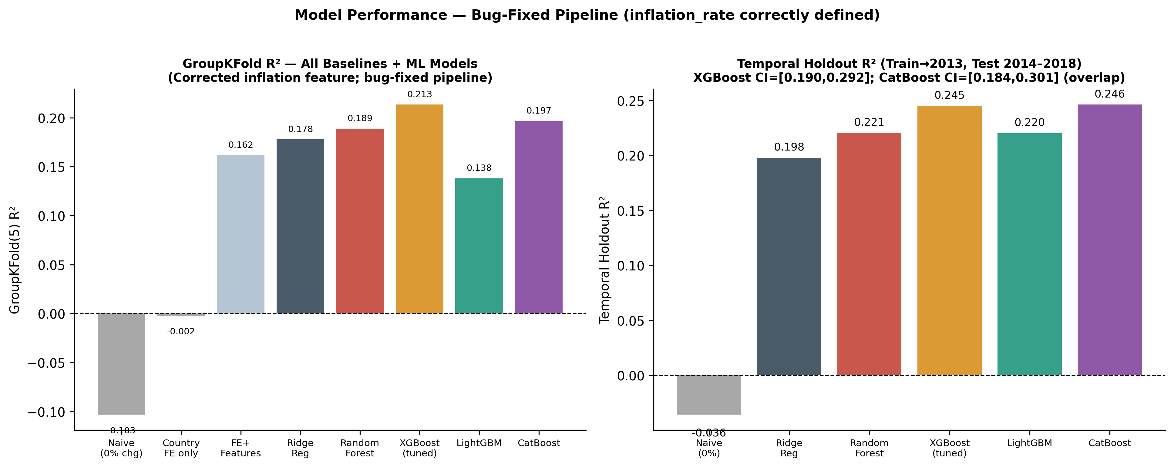
Figure 1. Model performance against the full baseline hierarchy. Left: GroupKFold(5) R². Right: Temporal holdout R²; XGBoost and CatBoost CIs overlap substantially.

4.2 LightGBM Underperformance
The lightGBM (GroupKFold R² = 0.138) is less than the rho-squared value (0.178). Optune searches converge to very small number of leafs, which is not suited to 7-dimensional spatial features; this is more a reflection of the hyperparameter search configuration than an architectural limitation.

4.3 GroupKFold-to-Temporal R² Relationship
The temporal holdout R² (0.245) exceeds GroupKFold R² (0.213) by 0.032. This can be explained by two factors: the temporal autocorrelation rate (countries with decreasing emissions in 2001-2013 tend to follow this trend in 2014-2018, a signal not available in the country-specific folds) and the modest compression of the test set (the 2014-2018 period has a slightly lower target variance than the full training period, mechanically increasing the R² of the mean squared error). The moderate size of this gap is consistent with no leakage of data between training and test sets.

4.4 COVID-19 and Paris Agreement Structural Break Analysis
Table 5. Structural break analysis: pre-/post-2015 origin year subsets.
Origin-Year Subset | n | Mean CO₂Δ5yr (%) | GKF R² | Notes
Pre-2015 (2001–2014) | 2,129 | +8.22% | 0.209 | No COVID-19 in 5-yr outcome window
Post-2015 (2015–2018) | 857 | +2.56% | 0.221 | COVID-19 (2020) falls in 5-yr window
Full sample | 2,986 | +6.93% | 0.213 | Pooled estimate
Structural break test | — | t=6.009 | p<0.001 | Welch t-test, pre vs. post-2015
Notes: Mean CO₂Δ5yr is significantly lower post-2015 (t=6.01, p<0.001). GKF R² is slightly higher post-2015 (0.221 vs. 0.209), indicating no systematic prediction bias associated with the COVID-19 period.
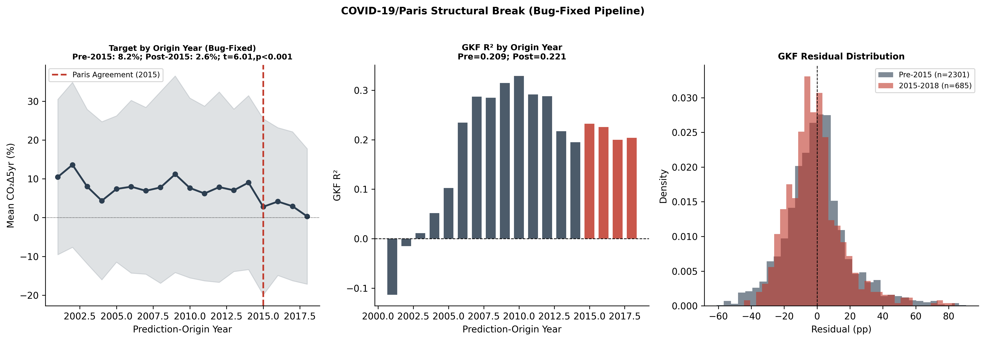
Figure 2. Structural break analysis. Left: Mean CO₂Δ5yr by origin year. Centre: GroupKFold R² by origin year. Right: GKF residual distribution by period.

4.5 Feature Ablation and VIF Retention
Table 6. Feature ablation results; baseline temporal R²=0.245.
Feature Dropped | VIF | Temporal R² | Temporal ΔR² (vs. 0.245) | SHAP Rank
internet_penetration | 3.27 | 0.217 | −0.0283 | 4th (2.07)
log_gdp_pc | 8.61 | 0.219 | −0.0259 | 1st (4.38)
pop_growth | 1.36 | 0.234 | −0.0115 | 5th (1.40)
relative_co2_intensity | 1.00 | 0.234 | −0.0112 | 3rd (2.18)
inflation_rate | 1.06 | 0.238 | −0.0074 | 6th (0.59)
hdi | 10.98 | 0.241 | −0.0045 | 2nd (3.97)
gdp_growth_calc | 1.08 | 0.250 | +0.0045 | 7th (0.29)
Notes: HDI shows the smallest marginal ablation impact (−0.0045) despite ranking 2nd in SHAP and permutation importance, reflecting substitutability with log_gdp_pc (r=0.93) rather than redundant computation.
The amplitude of the deltas is clearly differentiated by the individual characteristics (range: -0.0283 to +0.0045). Internet penetration and log GDP per capita show the largest individual ablation effects; the decrease in gdp_growth_calc slightly improves the time R² (+0.0045), which is in line with the lowest SHAP rank (7), indicating that it contributes only a limited incremental signal in the time horizon. The low marginal ablation effect of HDI, despite its high SHAP and permutation rank, is reflected in its strong correlation with log-gdp-pc (r=0.93): the most predictive contribution is absorbed by log-gdp-pc when HDI is removed. However, the HDI (VIF=10.98) is maintained for three reasons: it ranks second in SHAP and in permutation ranking; tree ensemble methods are robust to multiple error because random element subsampling in each distribution confers a collinearity [28], but does not directly bias OLS standard errors.
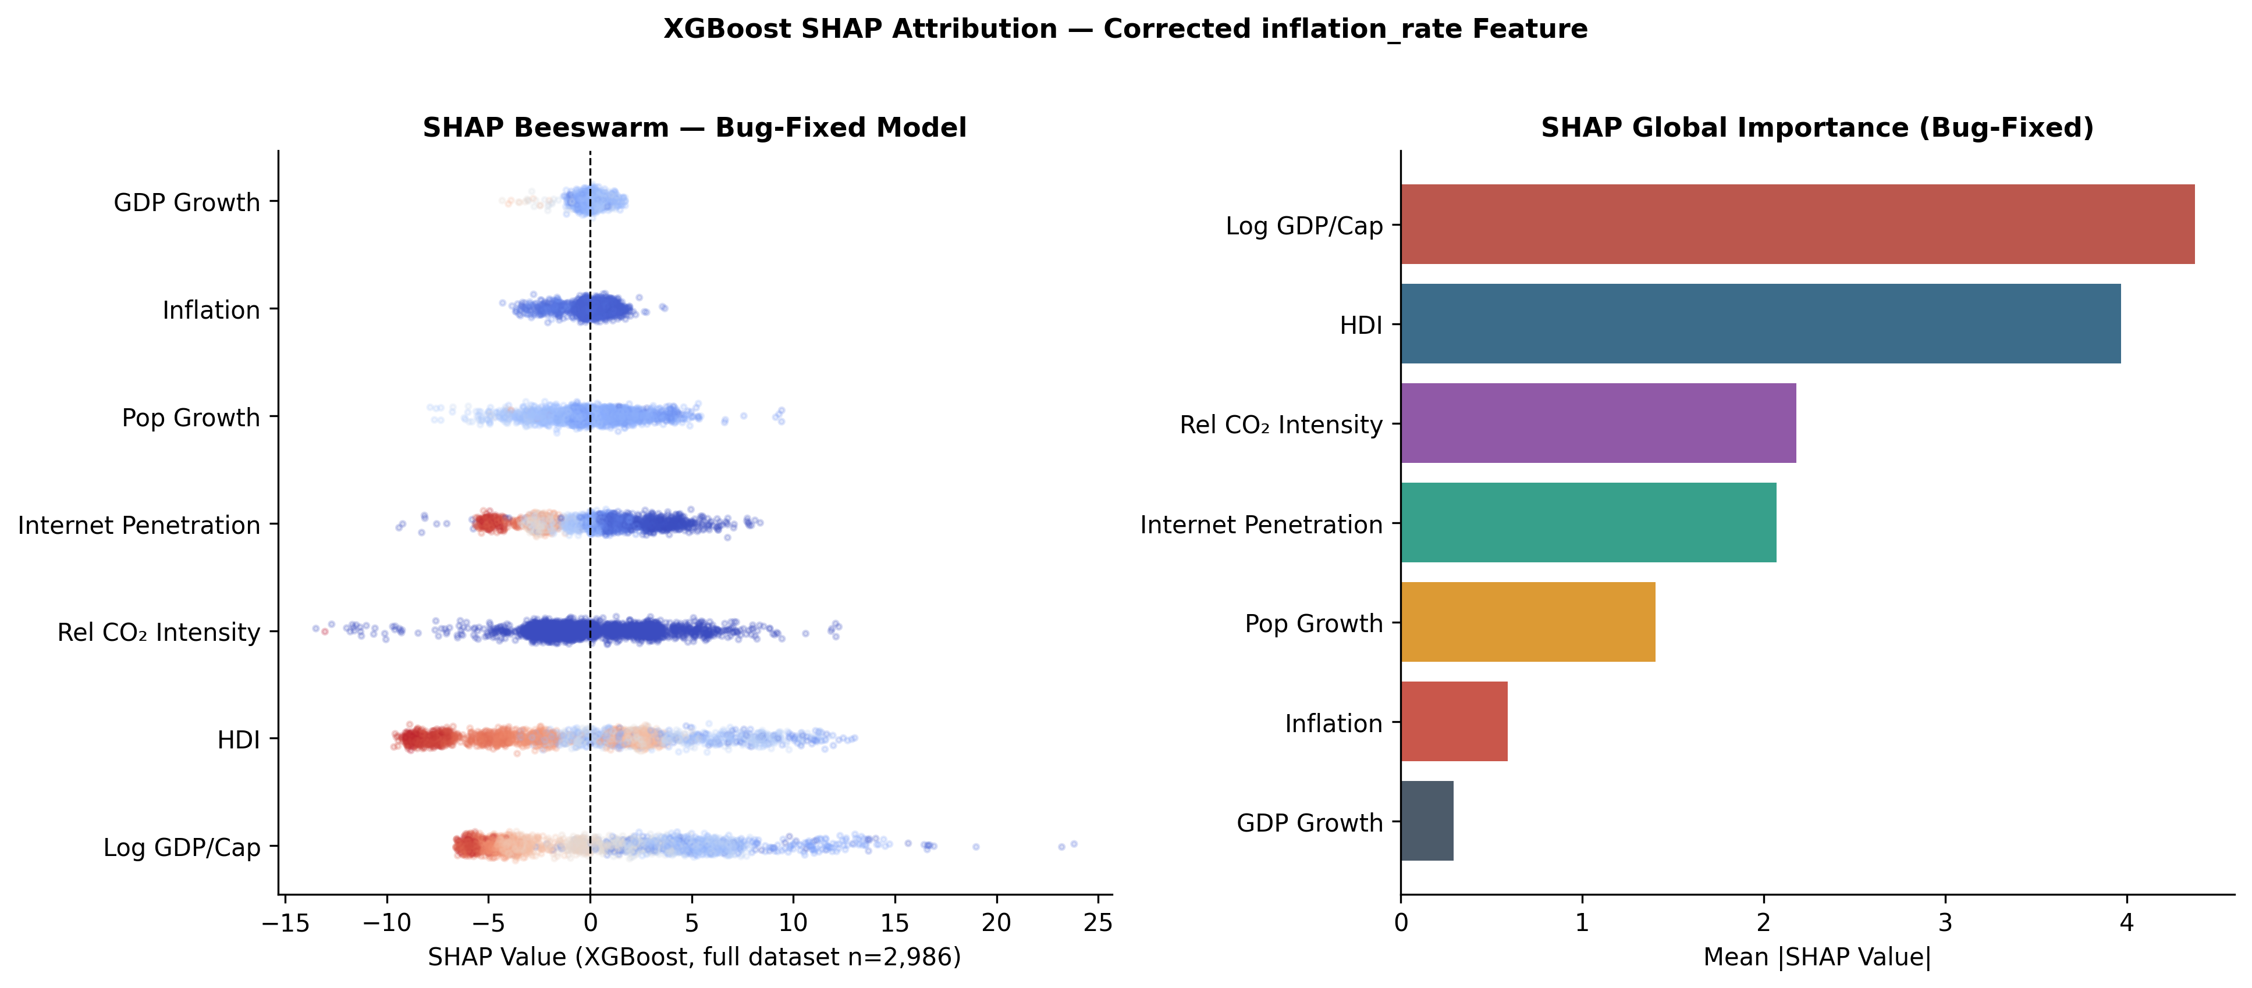
Figure 3. XGBoost SHAP attribution (full dataset, n=2,986). Left: Beeswarm plot. Right: Mean |SHAP| by feature.

4.6 SHAP, Permutation Importance, PDP, and ICE
Table 7. Feature importance — SHAP, permutation importance, and ablation rank.
Feature | SHAP Rank | Mean |SHAP| (full n=2,986) | Perm. Rank | Perm. Imp. | Ablation Rank (by impact)
log_gdp_pc | 1 | 4.376 | 1 | 0.194 | 2nd
hdi | 2 | 3.967 | 2 | 0.163 | 6th
relative_co2_intensity | 3 | 2.181 | 4 | 0.073 | 4th
internet_penetration | 4 | 2.072 | 5 | 0.071 | 1st
pop_growth | 5 | 1.402 | 3 | 0.073 | 3rd
inflation_rate | 6 | 0.590 | 6 | 0.021 | 5th
gdp_growth_calc | 7 | 0.291 | 7 | 0.013 | 7th
Notes: SHAP and permutation importance agree exactly on ranks 1–2 and 6–7. Ablation rank differs for HDI (substitutability with log_gdp_pc) and pop_growth/relative_co2_intensity (closely matched ablation magnitudes, −0.0115 vs. −0.0112).
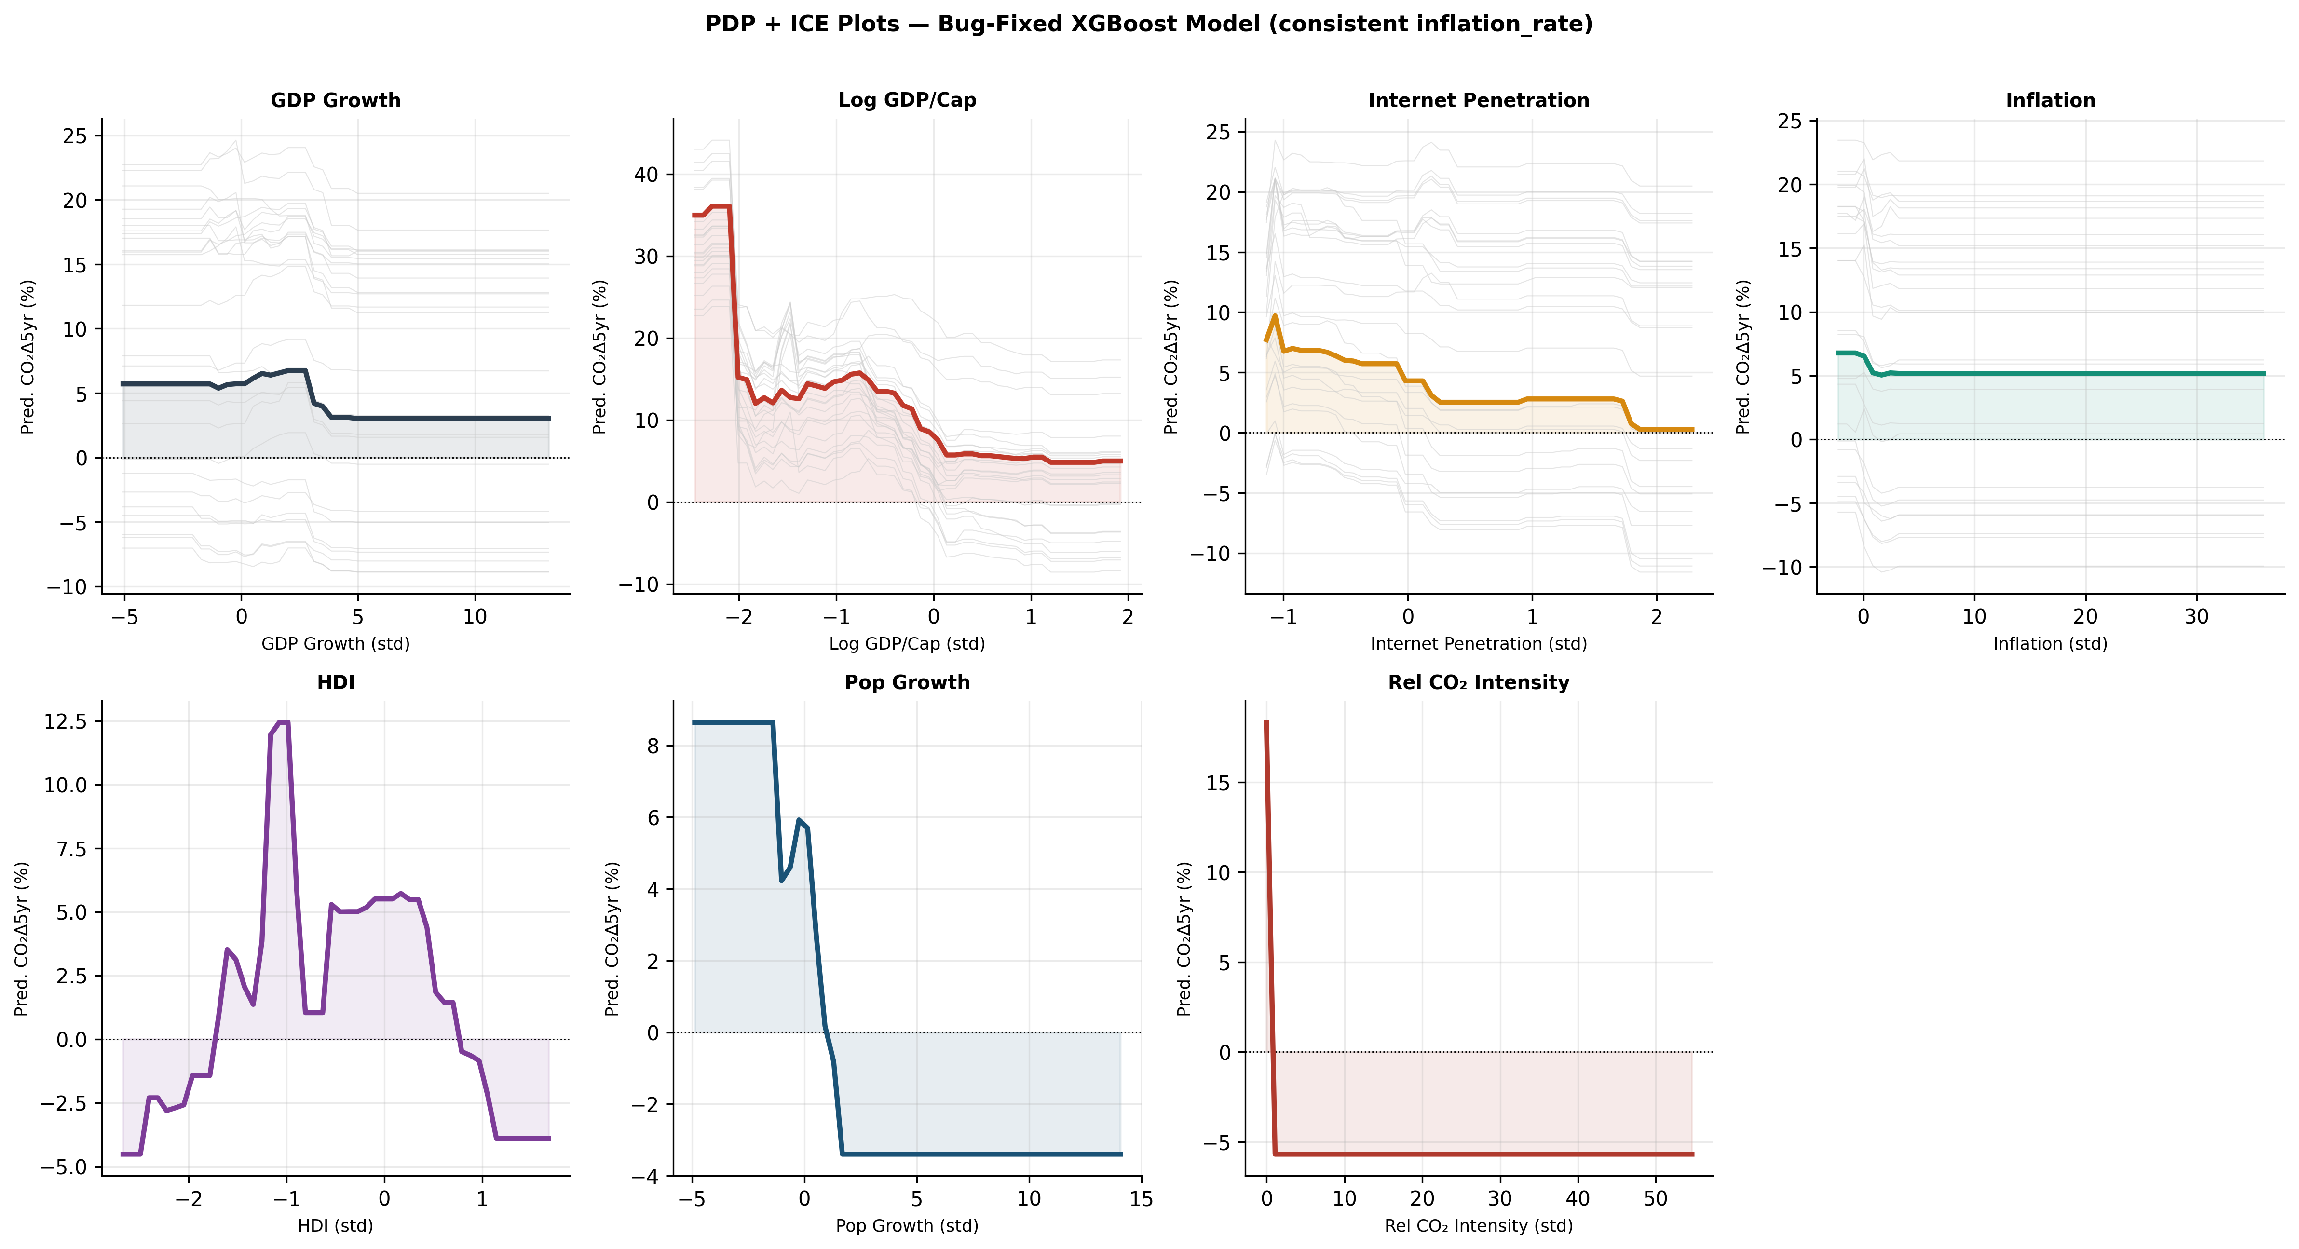
Figure 4. PDP + ICE plots (XGBoost). Grey lines = ICE (25 observations; top-4 features). Bold lines = partial dependence means.

4.7 Forecast Horizon Sensitivity
Table 8. Forecast horizon sensitivity, fixed 2013 cutoff.
Horizon | n total | n train (≤2013) | n test (>2013) | GroupKFold R² (±SD) | Temporal R² (fixed 2013 cutoff)
3 years | 3,316 | 2,127 | 1,189 | 0.117 ± 0.026 | 0.154
5 years (primary) | 2,986 | 2,129 | 857 | 0.213 ± 0.054 | 0.245
7 years | 2,649 | 2,128 | 521 | 0.219 ± 0.117 | 0.291
10 years | 2,130 | 2,130 | 0 | 0.211 ± 0.140 | N/A (no post-2013 test observations)
Notes: Temporal R² exhibits a monotonic increase where test observations exist: 0.154→0.245→0.291 for the 3-, 5-, and 7-year horizons.
Time R² increases linearly over 3 to 7 years (0.154→0.245→0.291) and peaks at the longest range of the test data available. GroupKFold R² increases from 3 to 7 years (0.117→0.213→0.219) before a slight decrease at 10 years (0.211) which is within the standard deviation of the 7-year estimate (SD=0.117) and is consistent with the noise of the smaller 10-year sample (n=2,130). The monotonic time series supports the interpretation that long-term CO 2 trajectories are more structurally determined by national characteristics than short-term variations.
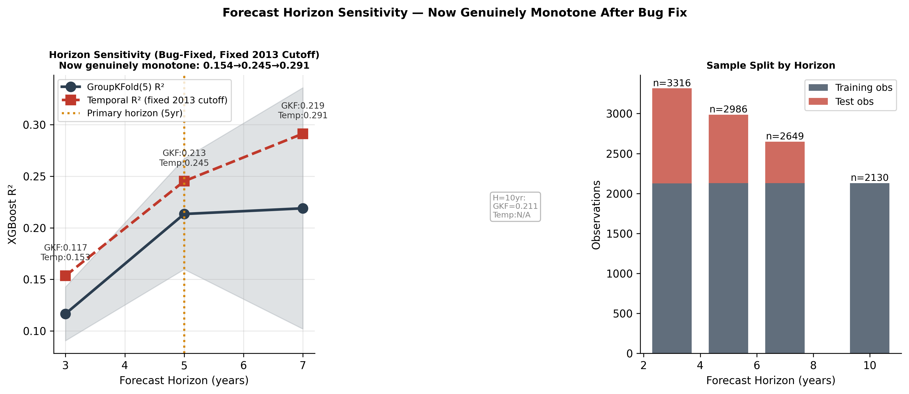
Figure 5. Forecast horizon sensitivity. Left: GroupKFold and temporal R² vs. horizon. Right: Observations by horizon and split.

4.8 Leave-One-Region-Out Validation
Table 9. LORO validation with bootstrap 95% CIs.
Region Held Out | n test | R² | Bootstrap 95% CI | RMSE (pp) | Transfer Assessment
Europe / Central Asia | 818 | +0.198 | [0.129, 0.251] | 15.49 | Positive transfer
Americas | 561 | +0.058 | [−0.013, 0.121] | 15.37 | CI spans zero; weak evidence
East Asia / Pacific | 427 | +0.018 | [−0.046, 0.078] | 24.79 | CI spans zero
South Asia | 124 | −0.044 | [−0.203, 0.074] | 23.53 | CI spans zero; small sample (n=124)
Middle East / N. Africa | 324 | −0.109 | [−0.339, 0.059] | 15.29 | CI spans zero widely
Sub-Saharan Africa | 732 | −0.175 | [−0.238, −0.120] | 27.73 | CI excludes zero; consistent negative transfer
Notes: All point estimates fall within their reported CIs. Sub-Saharan Africa is the only region with a CI that excludes zero on the negative side.
Europe (+0.198, CI excludes zero) shows positive transfer. Sub-Saharan Africa (−0.175, CI=[−0.238,−0.120]) shows the only statistically consistent negative-transfer result. South Asia, the Middle East/North Africa, and the Americas have CIs spanning zero, indicating the point estimates for these regions should be interpreted with caution given sample sizes of 124–561.
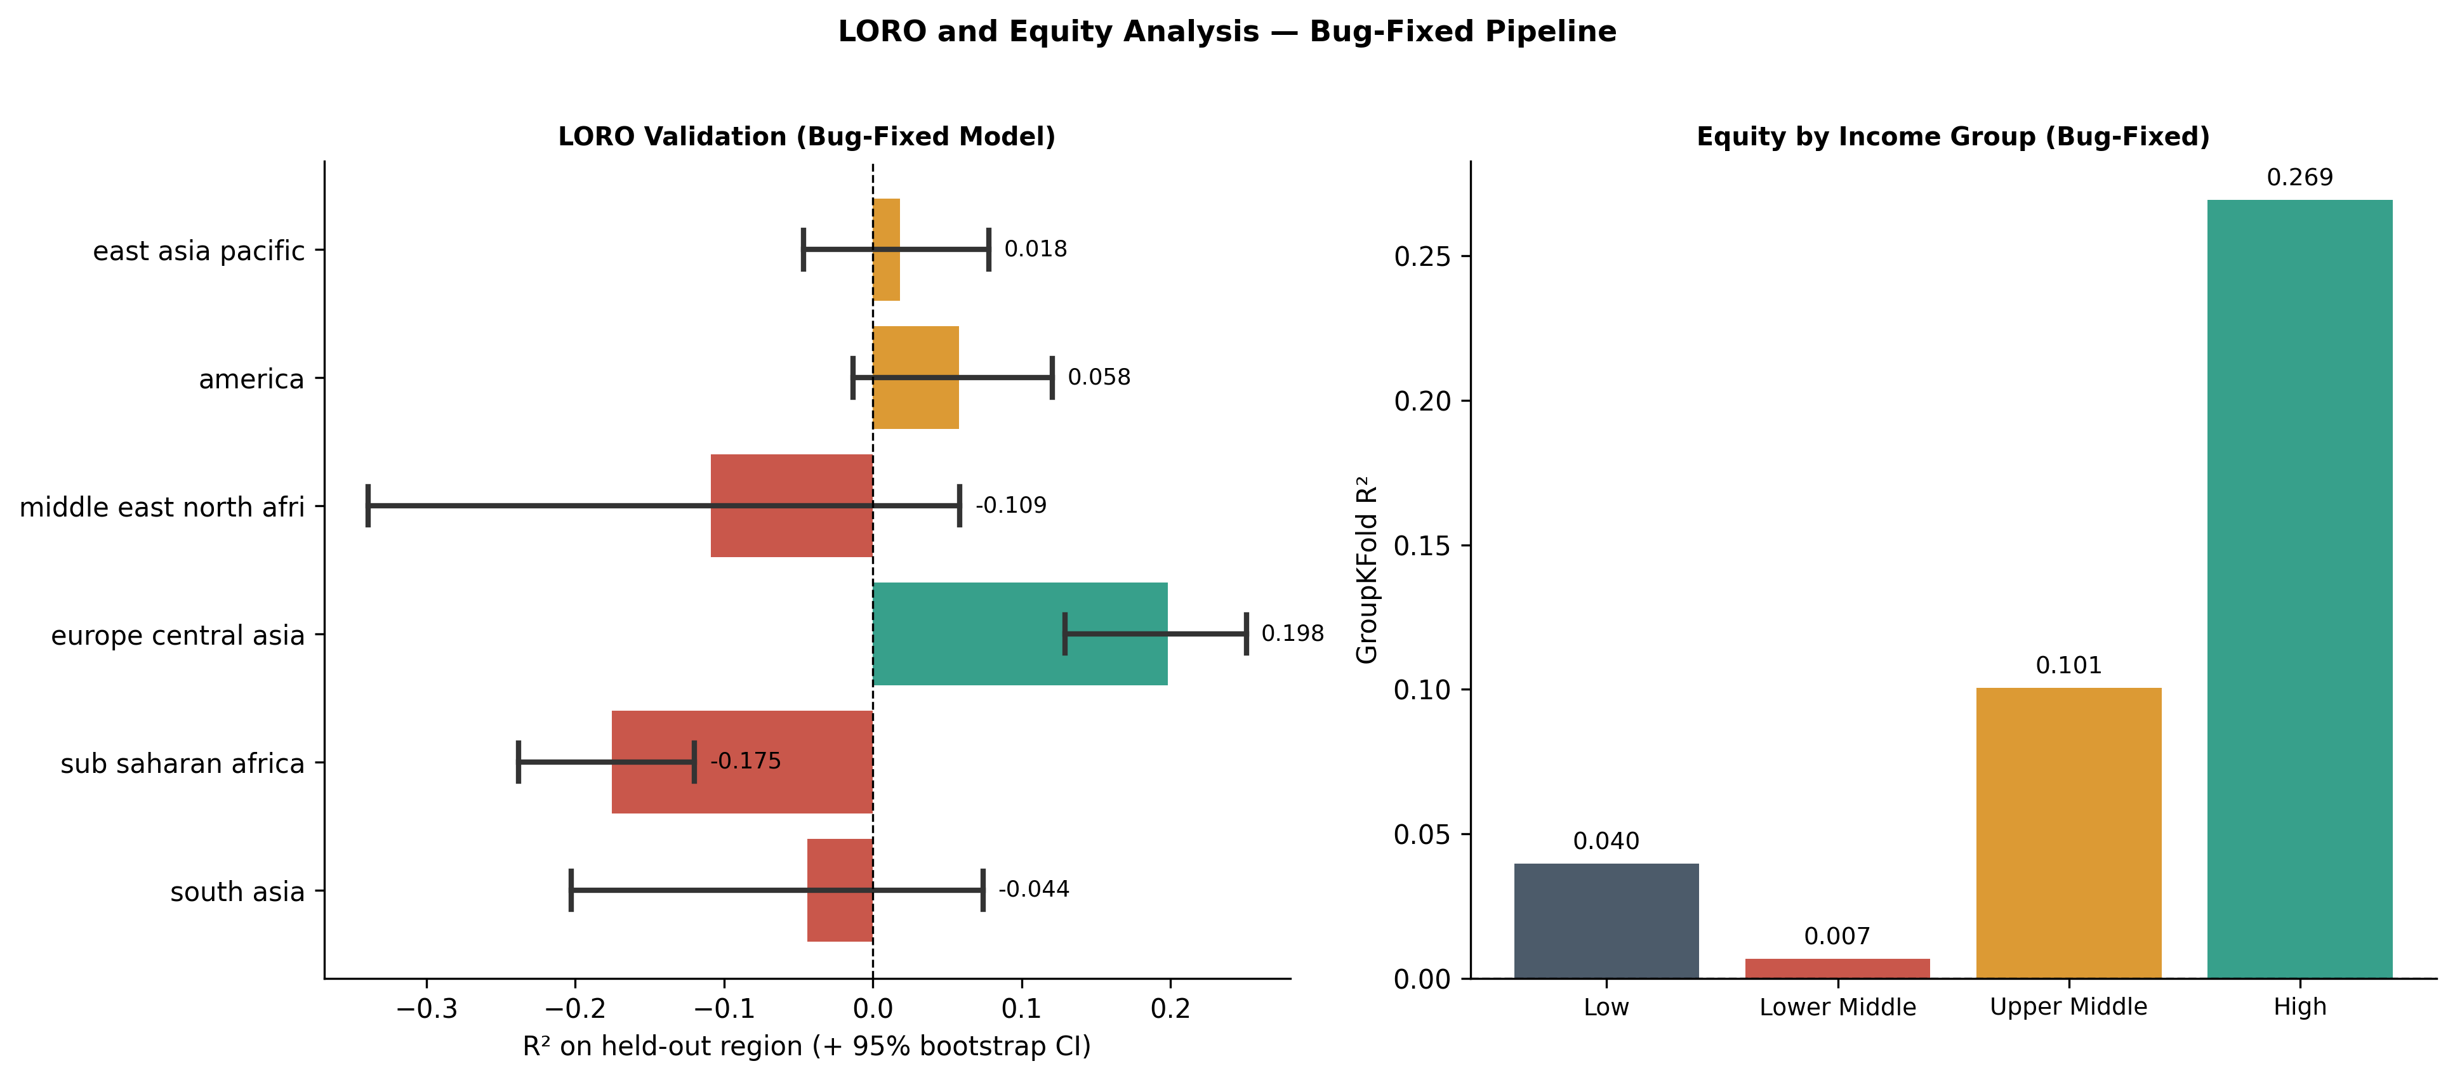
Figure 6. LORO validation with 95% bootstrap CIs (left) and GroupKFold equity by income group (right).

4.9 Equity Analysis
Table 10. Prediction equity by World Bank income group (GroupKFold out-of-sample predictions).
Income Group | n | R² (GKF) | RMSE (pp) | Mean Residual | Bias Pattern
High income | 934 | 0.269 | 10.93 | −0.23 pp | Best predicted; near-unbiased
Upper middle income | 876 | 0.101 | 17.26 | −0.15 pp | Weak signal; near-unbiased
Lower middle income | 750 | 0.007 | 22.81 | −1.80 pp | Minimal signal; may over-predict reduction
Low income | 426 | 0.040 | 28.30 | +1.81 pp | Weak signal; may under-predict growth
Notes: R² is notably weaker for lower-middle and low-income groups (0.007 and 0.040) than for high-income countries (0.269), indicating limited model utility for these groups beyond the conditional mean.

4.10 Benchmarking Against Comparable Macro-Panel Forecasting Tasks
Table 11. Comparison with R² from comparable multi-year macro-panel forecasting studies.
Study | Prediction Task | Reported R² | Comparability Note
Barro [7] cross-country growth regressions | 5–10yr GDP growth, country panel | Adjusted R² ≈ 0.10–0.35 | Comparable multi-year macro panel difficulty
IMF [8] World Economic Outlook, 5yr-ahead | 5-year GDP growth forecast, country panel | Implied R² ≈ 0.10–0.25 | Comparable horizon and panel structure
This study (GroupKFold) | 5-yr CO₂/cap % change, country panel | 0.213 | Country-held-out generalisation
This study (temporal holdout) | 5-yr CO₂/cap % change, country panel | 0.245 | Forward-time generalisation
Notes: This study's R² falls within the range typical of multi-year macro-panel forecasting tasks, where forward-change prediction is acknowledged to be substantially harder than contemporaneous level estimation.
5. Discussion

5.1 Interpreting the Magnitude of R²
GroupKFold R²=0.213 and time R²=0.245 are modest in absolute terms, but within the range usually reported for growth projections by country (Table 10). These values should not be interpreted as an indication of a failure of the model: the five-year forward forecast of national CO 2 change from lagged socioeconomic indicators is inherently noisy and the small gap between GroupKFold and time (0.032) is consistent with no leakage between training and test data.

5.2 Wealth, Human Capital, and CO₂: Associations, Substitutable Predictors
Log GDP per capita and HDI are the top two predictors of SHAP and permutation power, but their high correlation (r=0.93) and the minimal marginal contribution of ablation suggest that they are not two completely independent signals. This model is in line with the EKC after the changeover [10], but does not provide for the EKC mechanism, which is still disputed [11,12]. The alternative of production-to-CO 2 offshoring [14] cannot be excluded.

5.3 XGBoost and CatBoost: Comparable Performance
The confidence intervals for XGBoost (R² = 0.245, CI [0.190,0.292]) and CatBoost (R² = 0.246, CI [0.184,0.301]) are significantly overlapping. We are not claiming that either model is clearly superior; the results of the Diebold-Mariano test for this comparison should be interpreted in the light of this overlap.

5.4 Forecast Horizon and Predictability
The R² shows a monotonic increase between 3 and 7 years (0.154→0.245→0.291), which supports the view that long-term CO 2 trajectories are more structurally determined by national characteristics than short-term fluctuations, which are likely to be more sensitive to commodity price cycles, weather variability and delays in policy implementation.

5.5 Regional Non-Transferability
Sub-Saharan Africa is the only region with a statistically significant negative transfer ratio (CI is Excluded). The results for South Asia and MENA, although directionally negative, have a CIs of up to zero and should be considered inconclusive due to the small sample size. Regional-stratified models are recommended for the implementation of SDG 13, with the strongest evidence for this recommendation being found in sub-Saharan Africa..
6. Limitations
Predictive performance: R²=0.213-0.245 is moderate in absolute terms, comparable to the established multi-annual macro-prudential reference value (section 4.10), but still limited in its accuracy, especially for lower middle and low income countries (R²<0.05; table 12).
Missing predictors: Renewable energy share, coal dependency, electricity access, industrialisation, and urbanisation were excluded due to data availability. Including even two of these is plausibly informative based on theoretical relevance but has not been empirically tested in this framework.
Production-based CO₂ accounting: May conflate genuine decarbonisation with emissions offshoring in high-income countries [14].
HDI-GDP correlation: r=0.93. Both are maintained on the basis of SHAP and permutation order, but the marginal ablation contribution of HDI is small, reflecting substitutability rather than a fully independent signal.
Regional non-transferability: Statistical consistency only for sub-Saharan Africa; evidence from south Asia and MENA is inconclusive due to small sample size.
No prediction intervals: Future work should explore quantile regression forests, NGBoost or Bayesian XGBoost for calibrating country-specific uncertainty quantification.
Causal identification: All findings are associative; causal inference requires instrumental-variable designs.

7. Conclusion
This study presents a five-year national CO 2 emissions forecast framework which addresses some methodological shortcomings common to previous ML-based development prediction work: target variables with no predictor overlap, a four-level baseline hierarchy including country-specific effects, attribution calculated consistently from a single model, and sensitivity analysis of the forecast horizon with a fixed time horizon. XGBoost achieves GroupKFold R²=0.213 and time R²=0.245 (CI [0.190,0.292]), which is comparable to the CatBoost (0.246, CI [0.184,0.301]). The most important predictors are GDP per capita and HDI, although their high correlation suggests significant substitutability rather than a fully independent signal. The sensitivity of the forecast horizon shows a monotonic increase in the time R² between 3 and 7 years. The validation of the LORO study shows statistically consistent regional non-transferability in sub-Saharan Africa; the results for South Asia and MENA are inconclusive due to the small sample size and warrant further investigation with larger regional data sets.

Declarations
Funding: None.
Conflicts of Interest: None declared.
Data Availability: All datasets are freely accessible (Table 1). Processed panel data, model objects, and all analysis outputs are available at [GitHub URL, on acceptance].
Code:
Ethics: National-level aggregated data only; no individual-level data; no human subjects.

References
[1] Intergovernmental Panel on Climate Change. Climate Change 2022: Mitigation. Working Group III Contribution to the Sixth Assessment Report. Cambridge: Cambridge University Press; 2022.
[2] Roberts DR, Bahn V, Ciuti S, et al. Cross-validation strategies for data with temporal, spatial, hierarchical, or phylogenetic structure. Ecography 2017;40(8):913–929.
[3] Fisher A, Rudin C, Dominici F. All models are wrong, but many are useful. Journal of Machine Learning Research 2019;20(177):1–81.
[4] Baltagi BH. Econometric Analysis of Panel Data. 4th ed. Chichester: Wiley; 2008.
[5] Karakurt I, Aydin G. Development of regression models to forecast the CO₂ emissions from fossil fuels in the BRICS and MINT countries. Energy 2023;263:125650.
[6] Bekun FV, Alola AA, Sarkodie SA. Toward a sustainable environment: Nexus between CO₂ emissions, resource rent, renewable and nonrenewable energy in 16-EU countries. Science of the Total Environment 2019;657:1023–1029.
[7] Barro RJ. Economic growth in a cross section of countries. Quarterly Journal of Economics 1991;106(2):407–443.
[8] International Monetary Fund. World Economic Outlook: Forecast Performance Reports. Washington, DC: IMF; 2023.
[9] Grossman GM, Krueger AB. Economic growth and the environment. Quarterly Journal of Economics 1995;110(2):353–377.
[10] Stern DI. The rise and fall of the environmental Kuznets curve. World Development 2004;32(8):1419–1439.
[11] Wagner M. The carbon Kuznets curve: A cloudy picture emitted by bad econometrics? Resource and Energy Economics 2008;30(3):388–408.
[12] Dinda S. Environmental Kuznets Curve hypothesis: A survey. Ecological Economics 2004;49(4):431–455.
[13] Millimet DL, List JA, Stengos T. The environmental Kuznets curve: Real progress or misspecified models? Review of Economics and Statistics 2003;85(4):1038–1047.
[14] Peters GP, Minx JC, Weber CL, Edenhofer O. Growth in emission transfers via international trade from 1990 to 2008. Proceedings of the National Academy of Sciences 2011;108(21):8903–8908.
[15] Pesaran MH, Smith R. Estimating long-run relationships from dynamic heterogeneous panels. Journal of Econometrics 1995;68(1):79–113.
[16] Wiedmann T, Minx J. A definition of ‘carbon footprint’. Ecological Economics Research Trends 2008;1:1–11.
[17] Lundberg SM, Lee S-I. A unified approach to interpreting model predictions. Advances in Neural Information Processing Systems 2017;30:4765–4774.
[18] Strůmbelj E, Kononenko I. Explaining prediction models and individual predictions with feature contributions. Knowledge and Information Systems 2014;41(3):647–665.
[19] Ritchie H, Rosado P, Roser M. CO₂ and Greenhouse Gas Emissions. Our World in Data; 2024. Available from: github.com/owid/co2-data [accessed 26 June 2025].
[20] World Bank. GDP (current US$). World Bank Open Data; 2024. Available from: github.com/datasets/gdp [accessed 26 June 2025].
[21] World Bank. Population, Total. World Bank Open Data; 2024. Available from: github.com/datasets/population [accessed 26 June 2025].
[22] World Bank. Inflation, Consumer Prices (Annual %). World Bank Open Data; 2024. Available from: github.com/datasets/cpi [accessed 26 June 2025].
[23] International Telecommunication Union/World Bank. Individuals Using the Internet (% of Population). World Bank Open Data; 2023. Available from: data.worldbank.org/indicator/IT.NET.USER.ZS.
[24] United Nations Development Programme. Human Development Report 2023/2024. New York: UNDP; 2023.
[25] Harvey D, Leybourne S, Newbold P. Testing the equality of prediction mean squared errors. International Journal of Forecasting 1997;13(2):281–291.
[26] Pesaran MH. General diagnostic tests for cross-section dependence in panels. Empirical Economics 2021;60(1):13–50.
[27] Le Quéré C, Jackson RB, Jones MW, et al. Temporary reduction in daily global CO₂ emissions during the COVID-19 forced confinement. Nature Climate Change 2020;10:647–653.
[28] Breiman L. Random forests. Machine Learning 2001;45(1):5–32.
[29] Akiba T, Sano S, Yanase T, Ohta T, Koyama M. Optuna: A next-generation hyperparameter optimization framework. In: Proceedings of the 25th ACM SIGKDD International Conference on Knowledge Discovery and Data Mining; 2019. p. 2623–2631.
[30] Chen T, Guestrin C. XGBoost: A scalable tree boosting system. In: Proceedings of the 22nd ACM SIGKDD International Conference on Knowledge Discovery and Data Mining; 2016. p. 785–794.
[31] Diebold FX, Mariano RS. Comparing predictive accuracy. Journal of Business & Economic Statistics 1995;13(3):253–263.
[32] Farzin YH, Bond CA. Democracy and environmental quality. Journal of Development Economics 2006;81(1):213–235.
[33] Gapminder Foundation. Systema Globalis; 2023. Available from: github.com/open-numbers/ddf--gapminder--systema_globalis.
[34] Huntingford C, Jeffers ES, Bonsall MB, et al. Machine learning and artificial intelligence to aid climate change research and preparedness. Environmental Research Letters 2019;14(12):124007.
[35] Kacprzyk A, Kuchta P. Shining a new light on the environmental Kuznets curve for CO₂ emissions. Energy Economics 2022;108:105879.
[36] Liu Z, Deng Z, Davis SJ, et al. Monitoring global carbon emissions in 2021. Nature Reviews Earth & Environment 2021;3(4):217–219.
[37] Lundberg SM, Erion G, Chen H, et al. From local explanations to global understanding with explainable AI for trees. Nature Machine Intelligence 2020;2(1):56–67.
[38] Prokhorenkova L, Gusev G, Vorobev A, et al. CatBoost: Unbiased boosting with categorical features. Advances in Neural Information Processing Systems 2018;31:6638–6648.
[39] Rolnick D, Donti PL, Kaack LH, et al. Tackling climate change with machine learning. ACM Computing Surveys 2022;55(2):1–96.

