I created the vpc first here
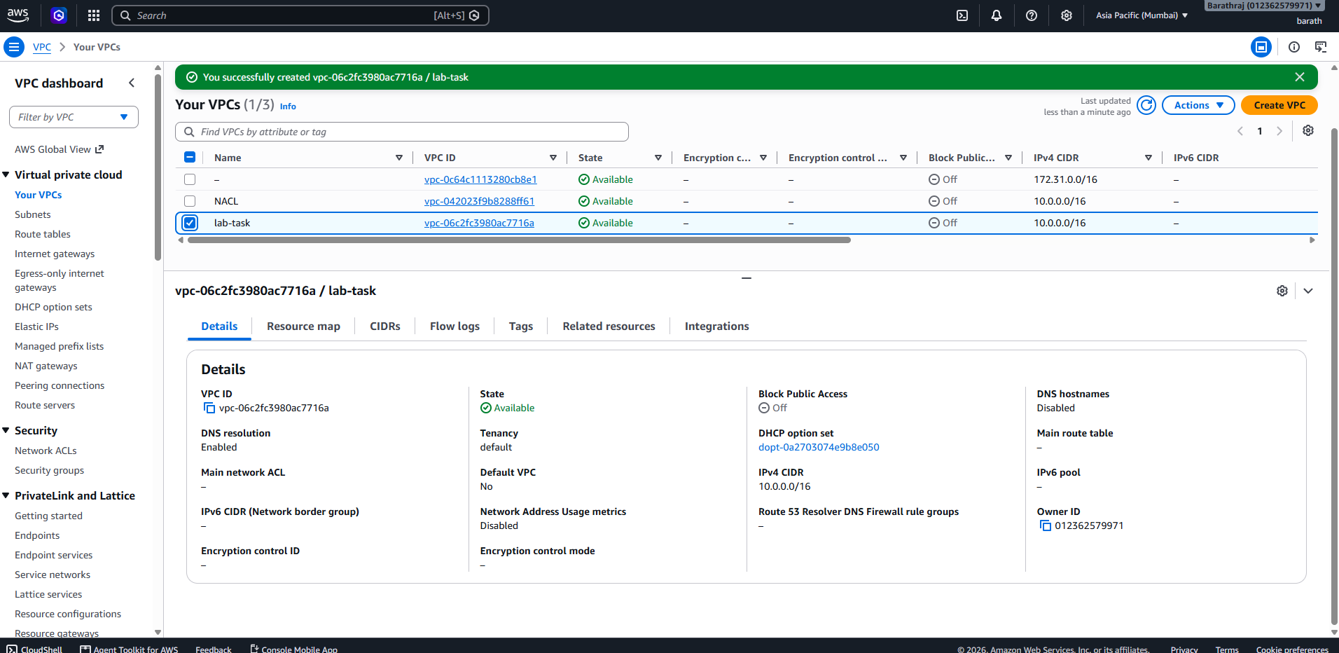
I created the 2 public subnet and 1 private subnet.
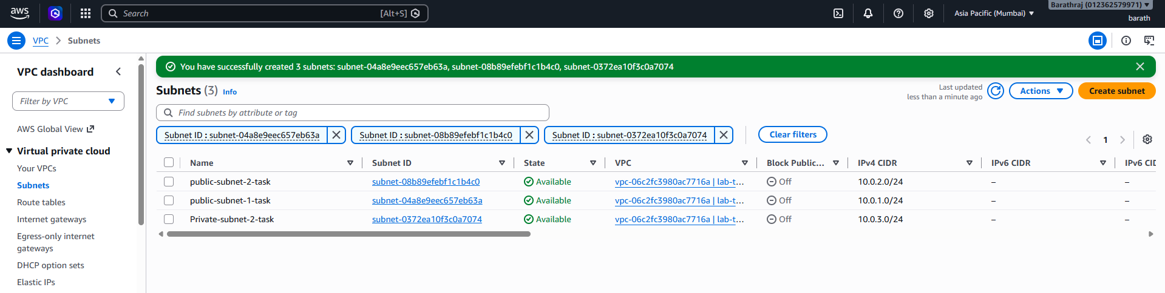

Next step I created a internetgatway and attached to vpc
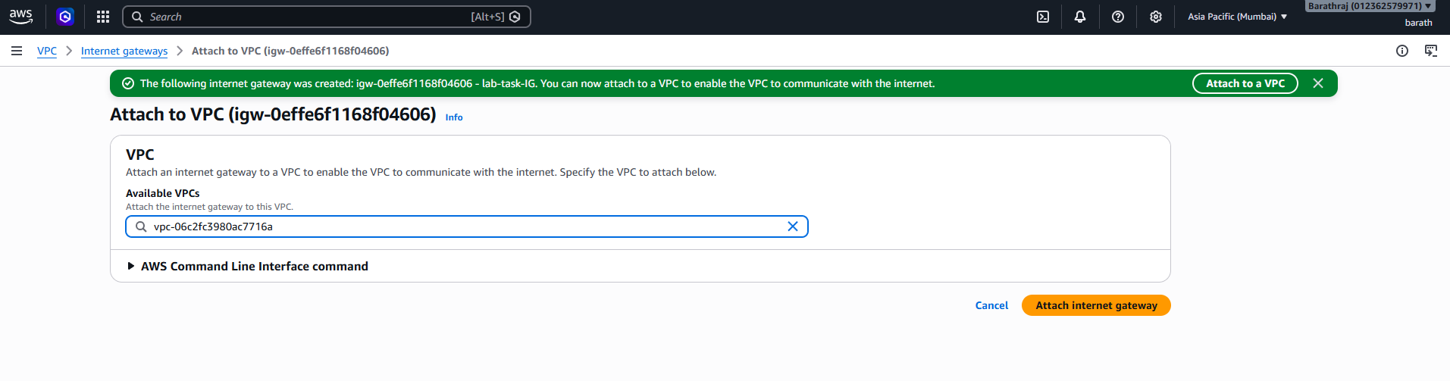
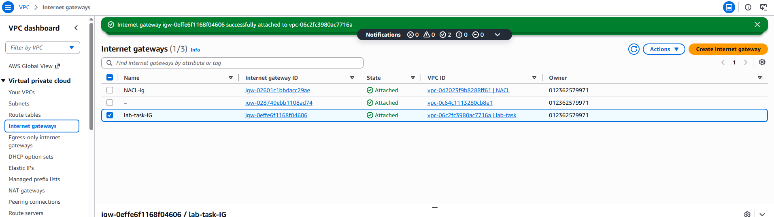

Next step I created public route table and assign public sub net only and added a route to internetgatway
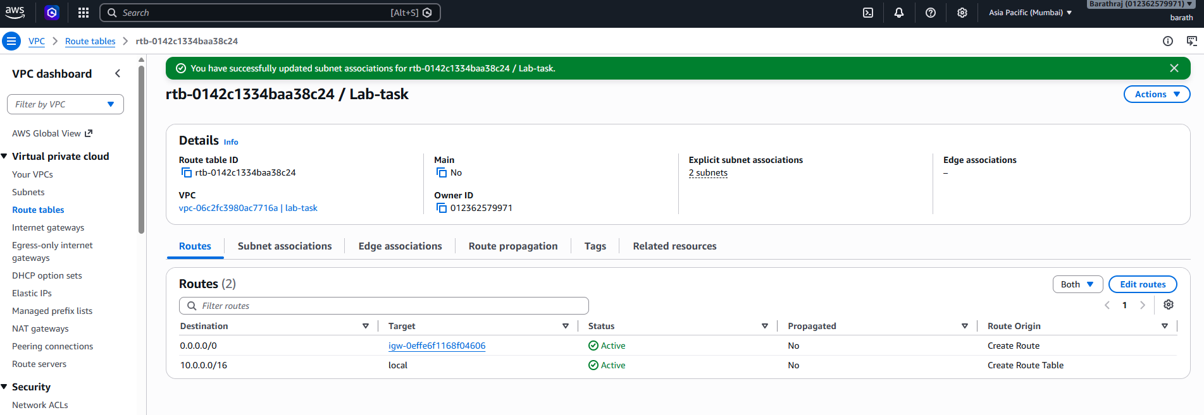
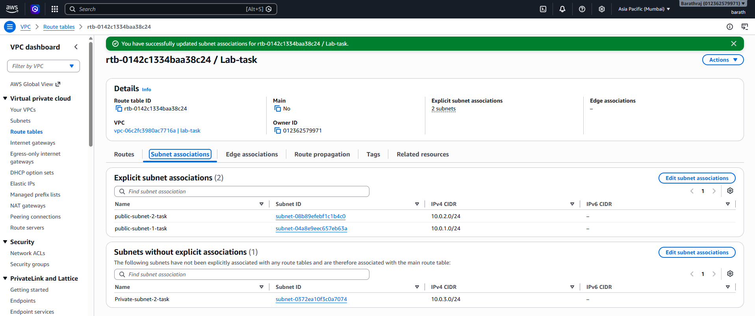
I created 2 nacl and assigned a public subnet and edited outbond and inbound roules
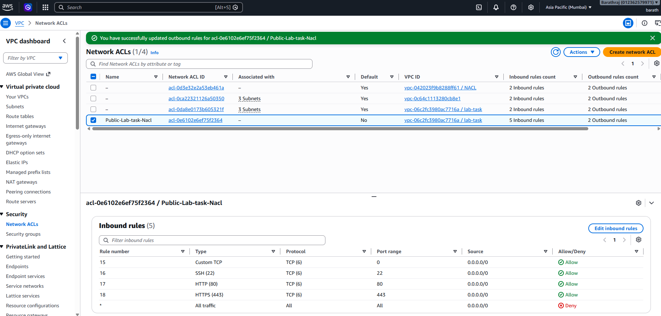
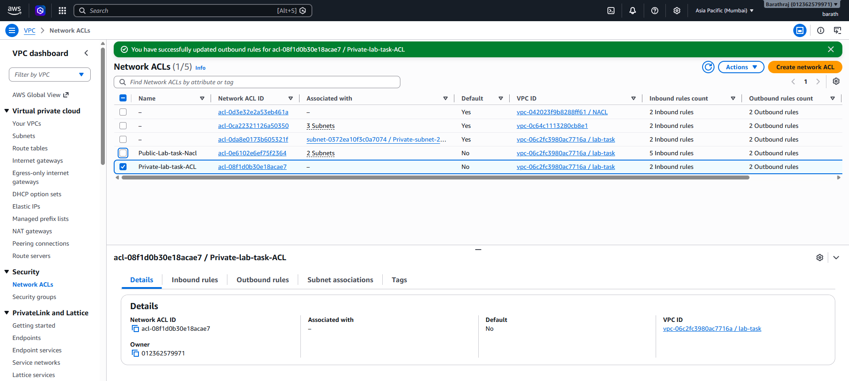

Next I created A security group and added inbound roules http and https
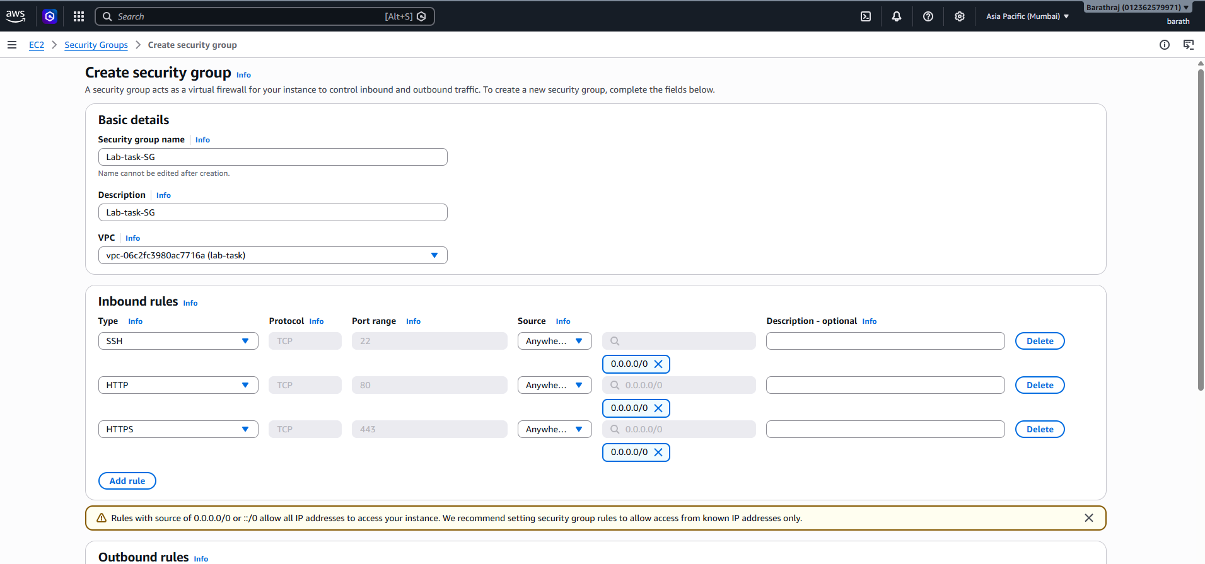
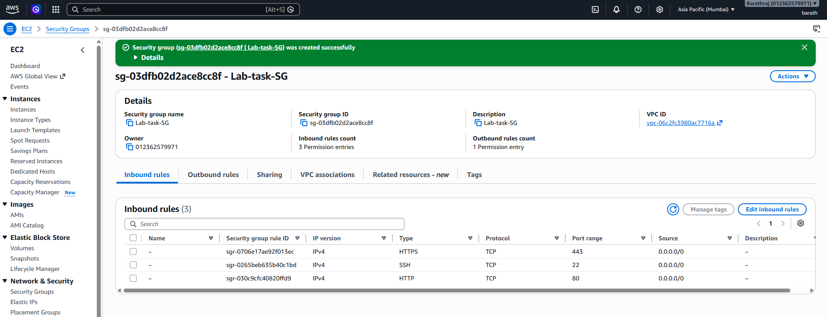

Now create the ec2 instance 1 for the web server-1
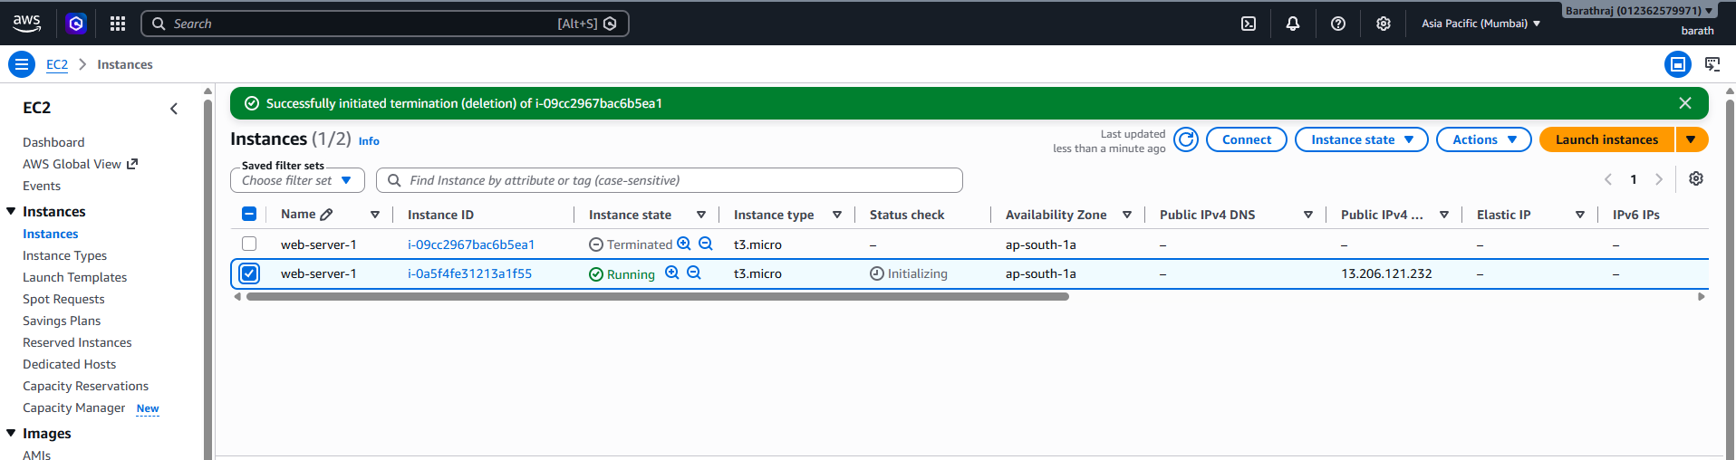
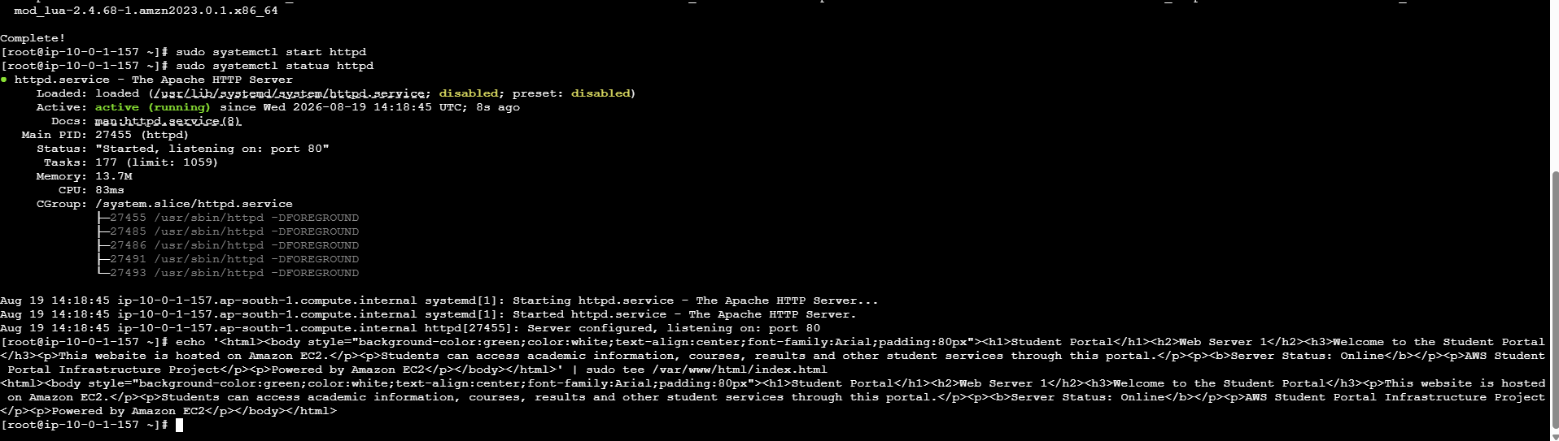

Next I created another ec2 in public subnet2 I created and lanch a web site
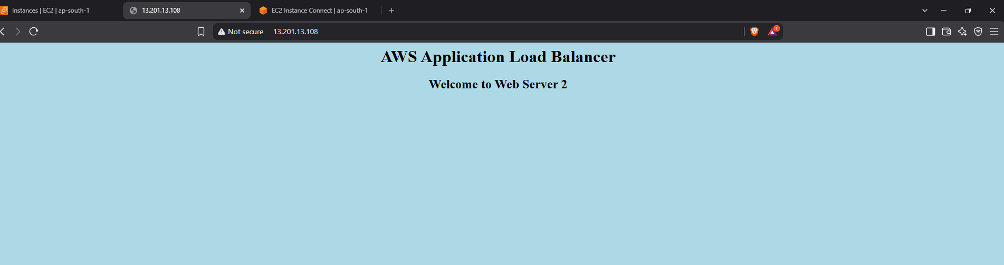
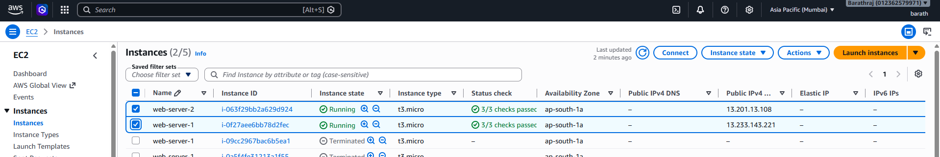

Next created AMI and lanched and checking a webserver is working 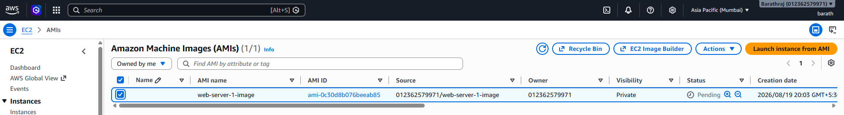
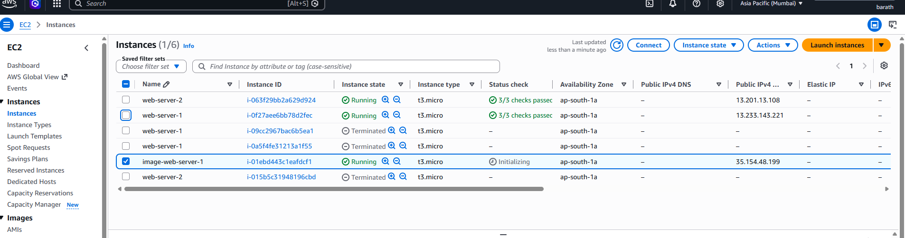
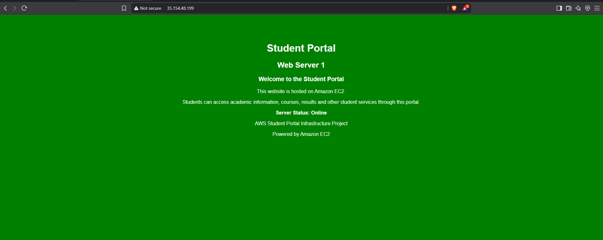
Next step creating s3 buget and uploadind a web site
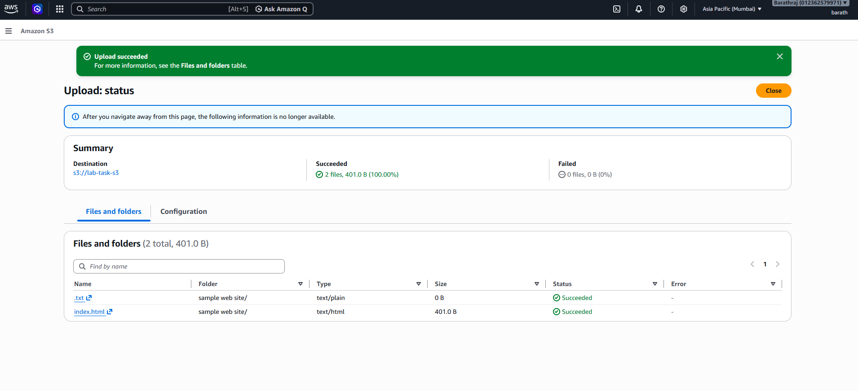
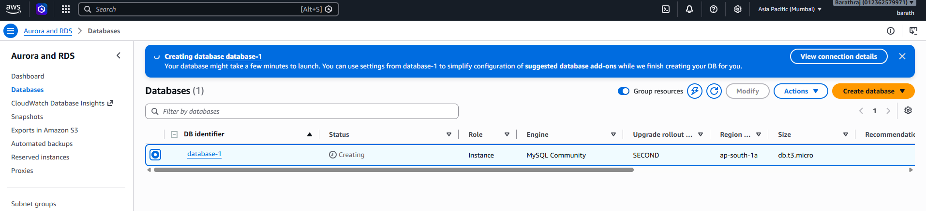

RDS EC2 instance created in private subnet
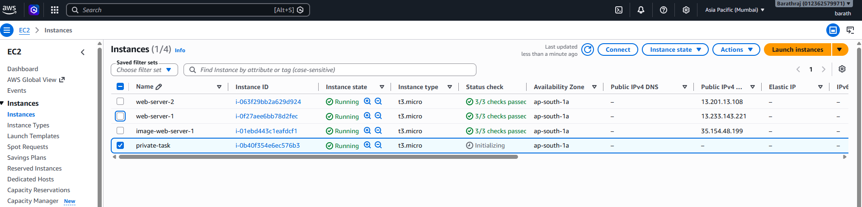
Nextv I ccreated Natgatway for private ec2 instance and attach to the royte table and attach to the private subnet.
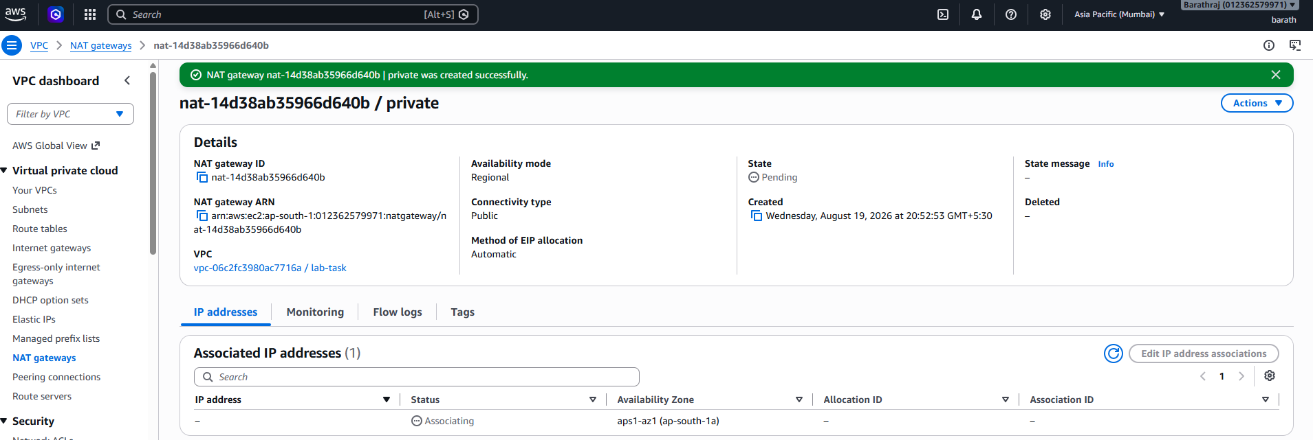

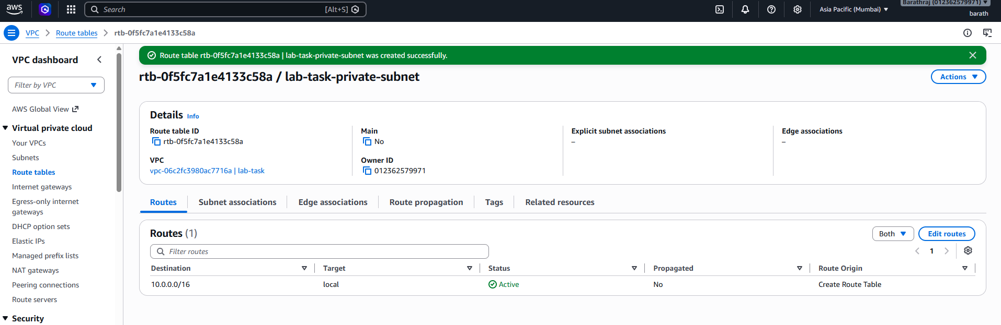
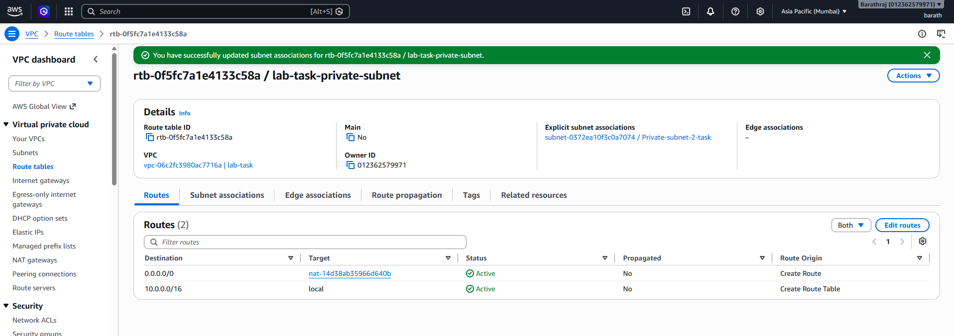
Then SSH back into EC2-1:
I copied the key and past it in the file in the Mumbai,pem and I chomd 400 mumbai.pem then I login to the private instance.

chmod 400 student-key.pem
Finally:
ssh -i student-key.pem ec2-user@10.0.3.60
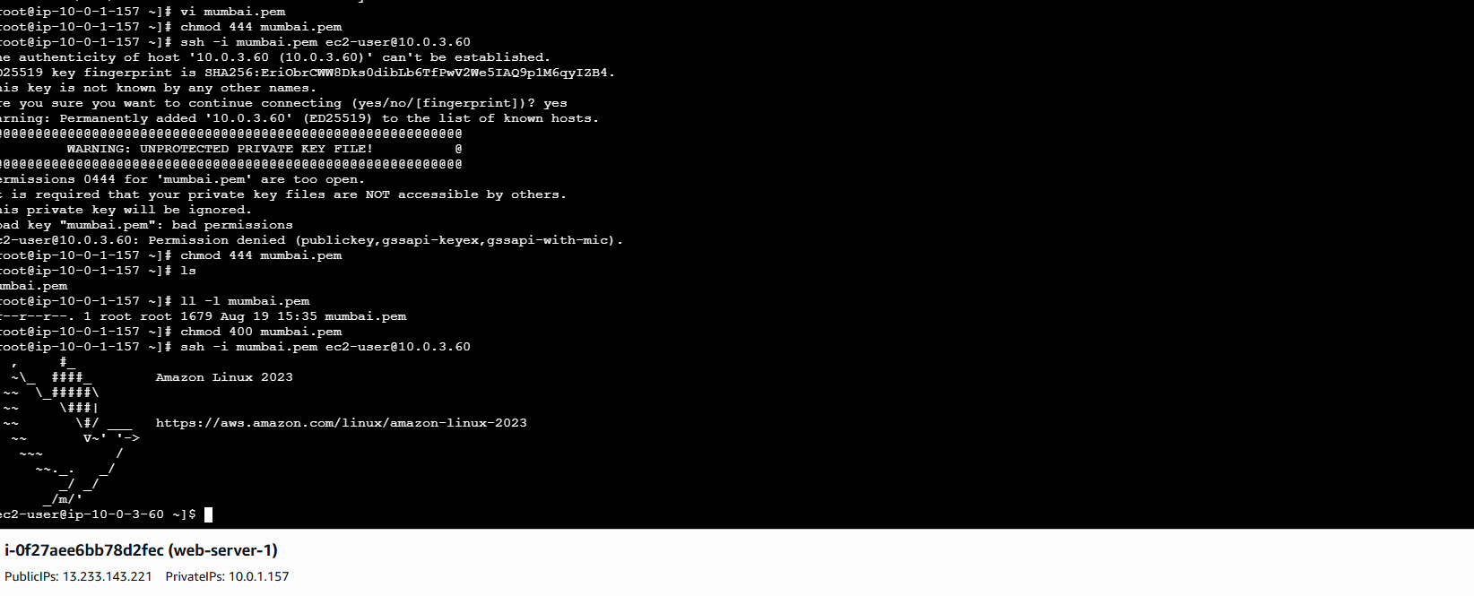
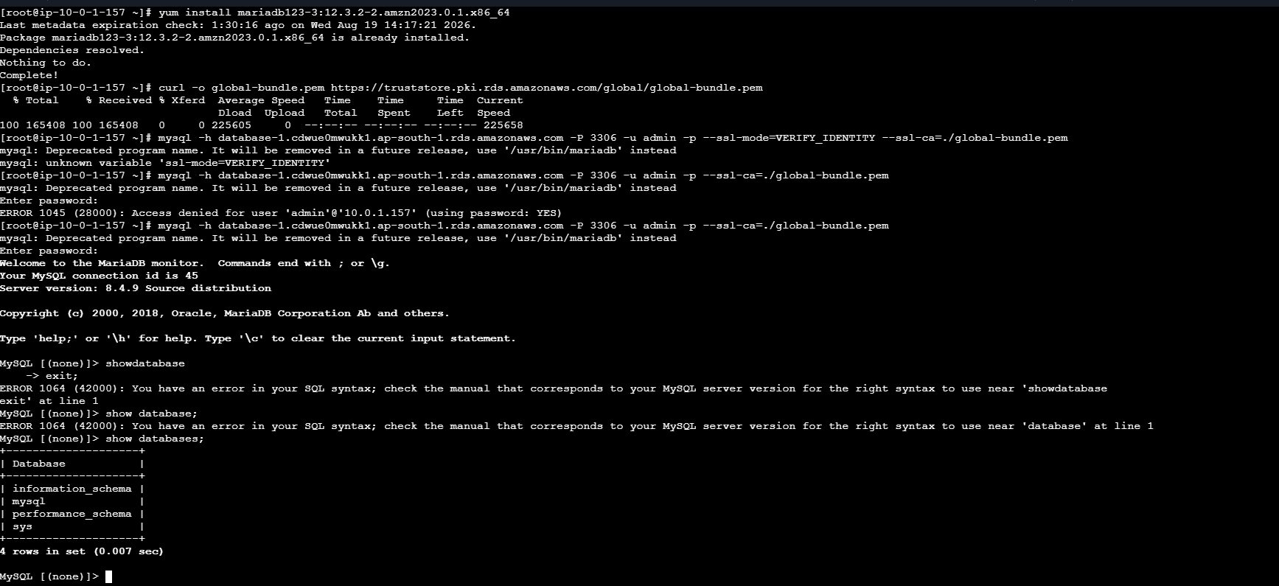

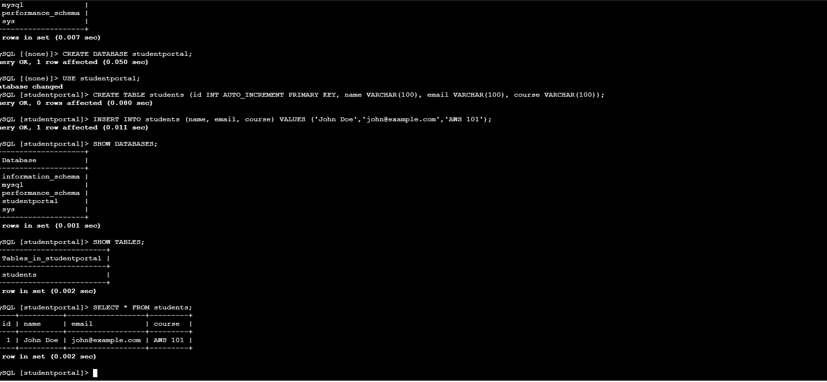

Next I create the target group:
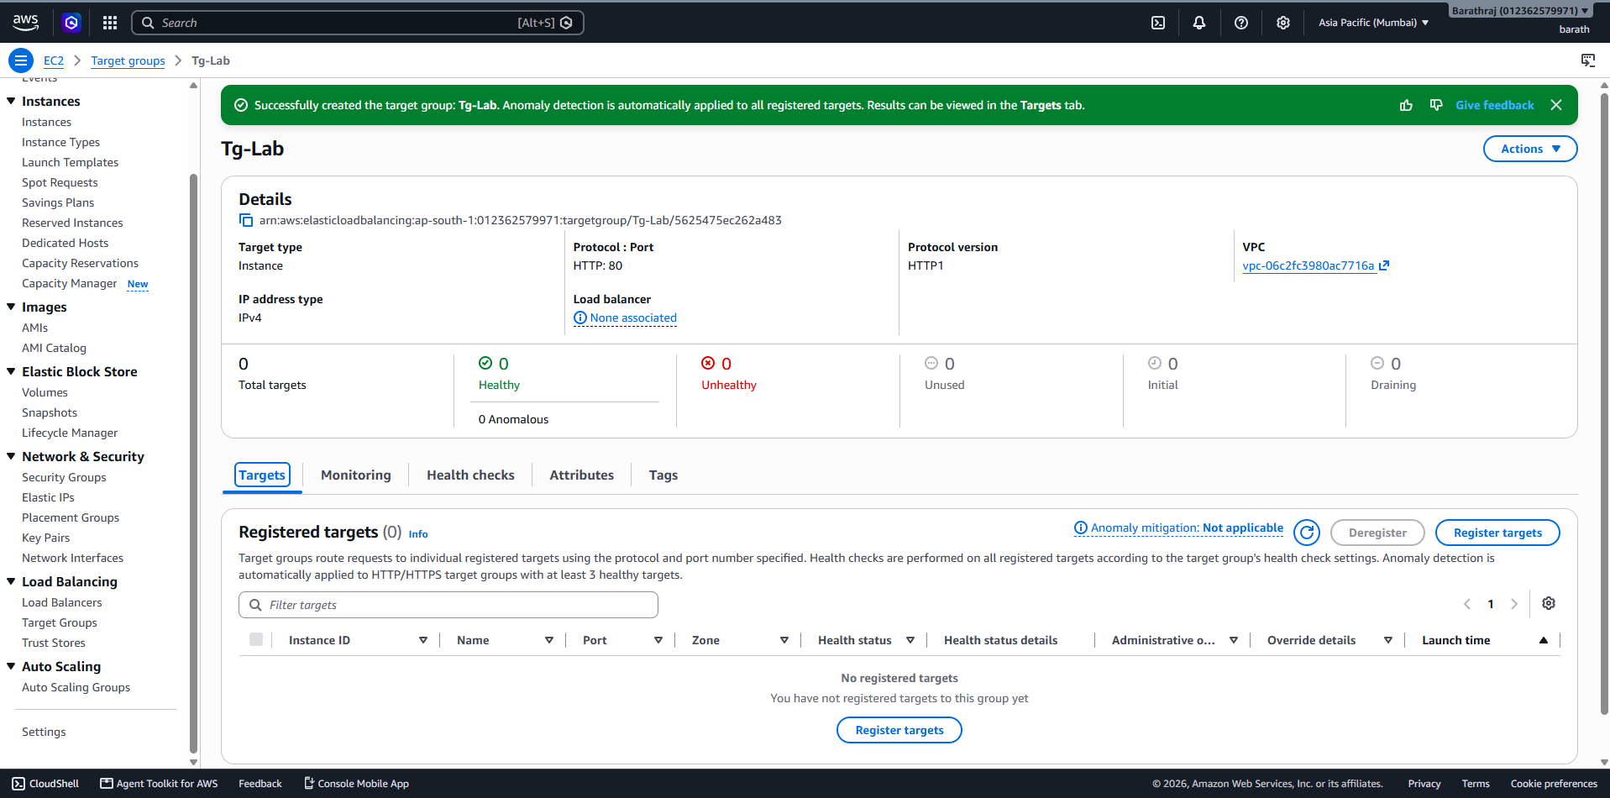
Then create a load blanacer for the web-1 and web 2:
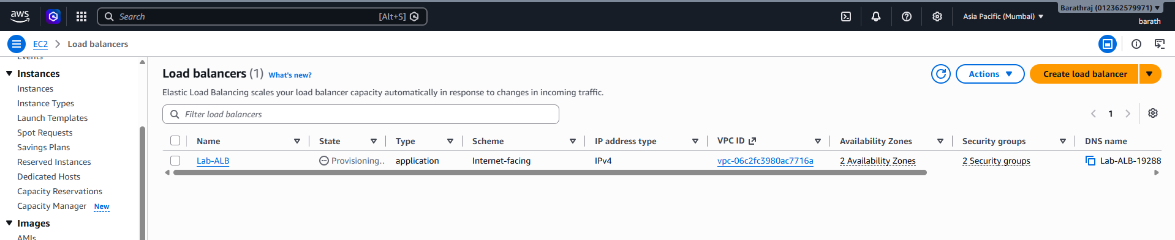
I ceate the load blancer for the web 1 and 2.
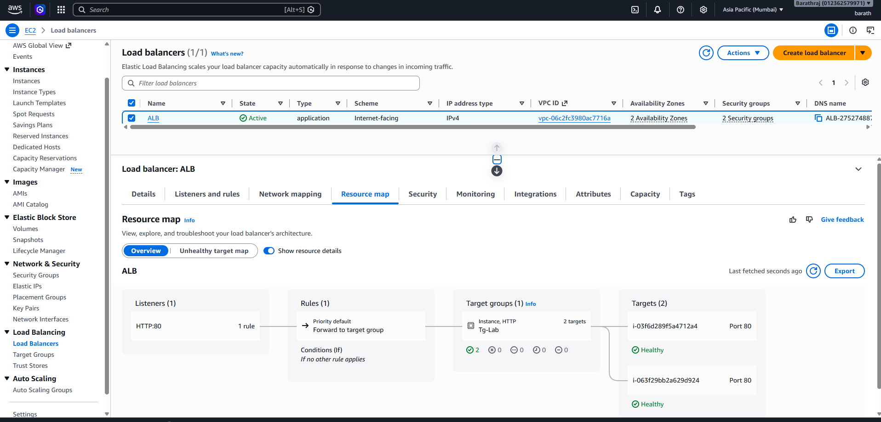


Create a route 53:
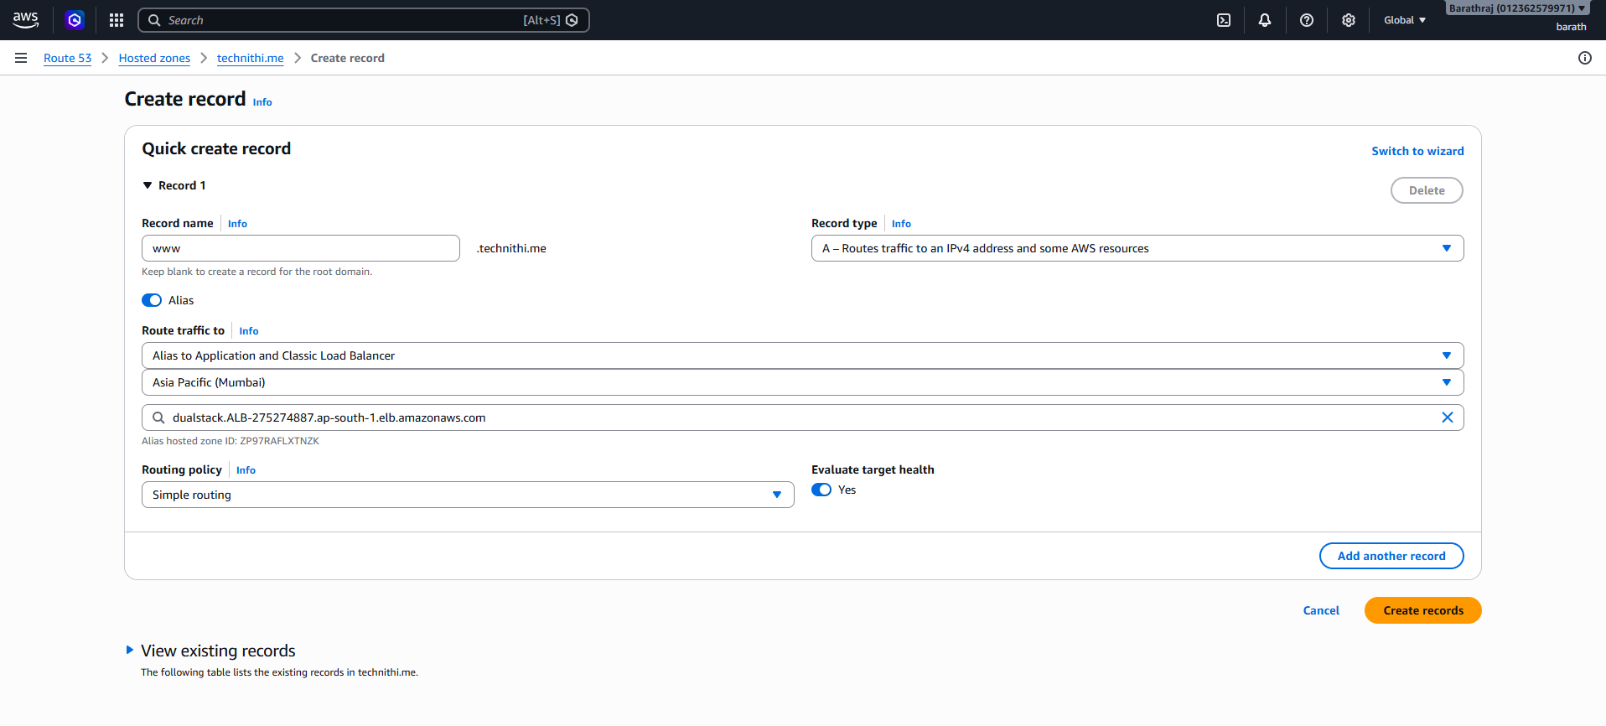

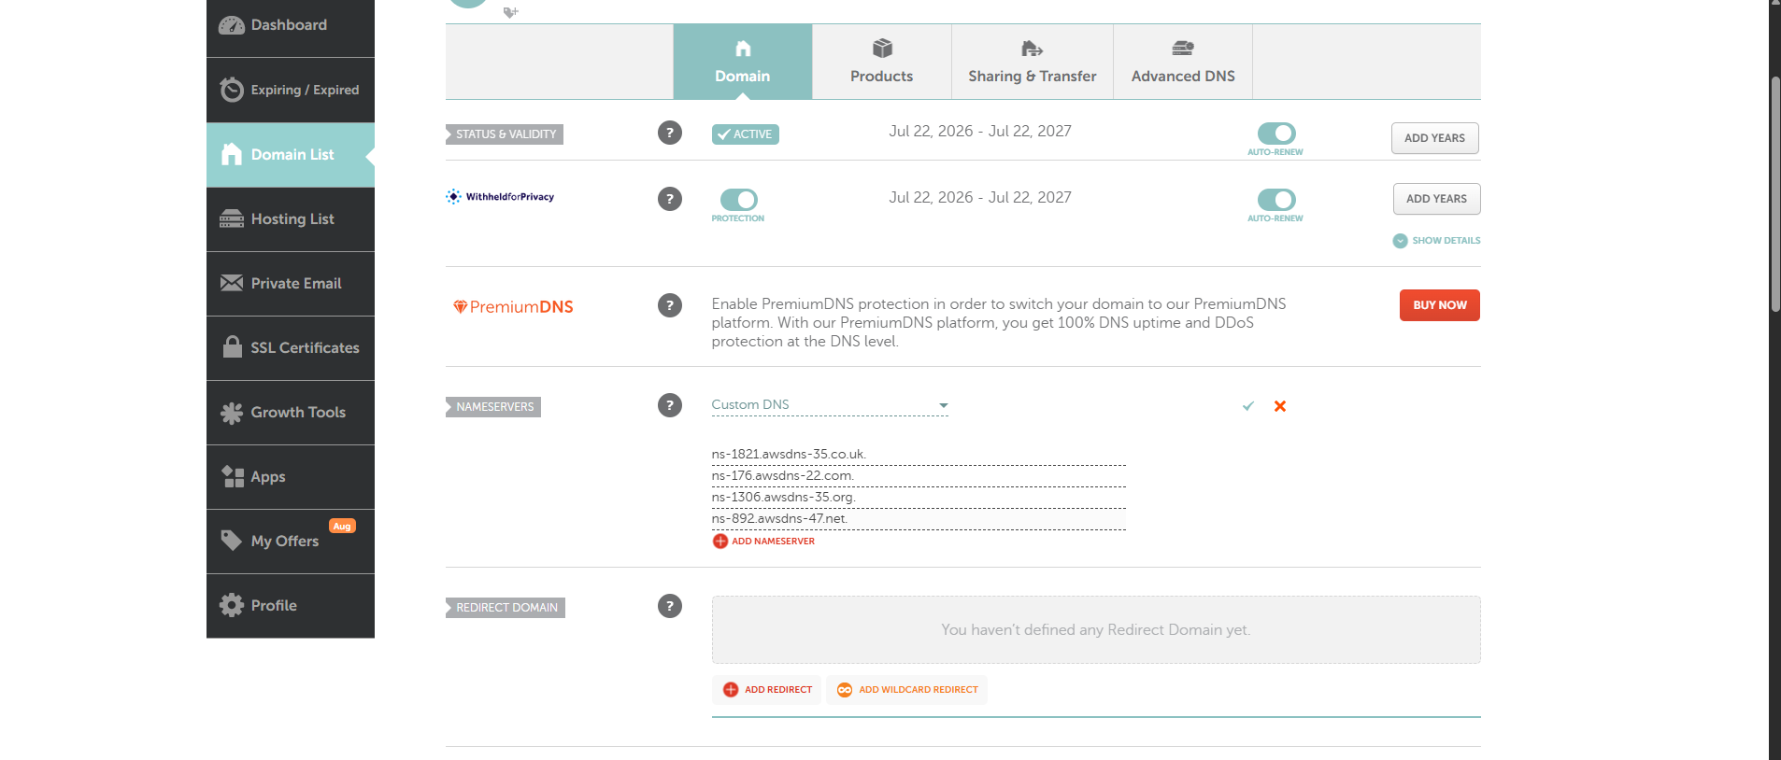
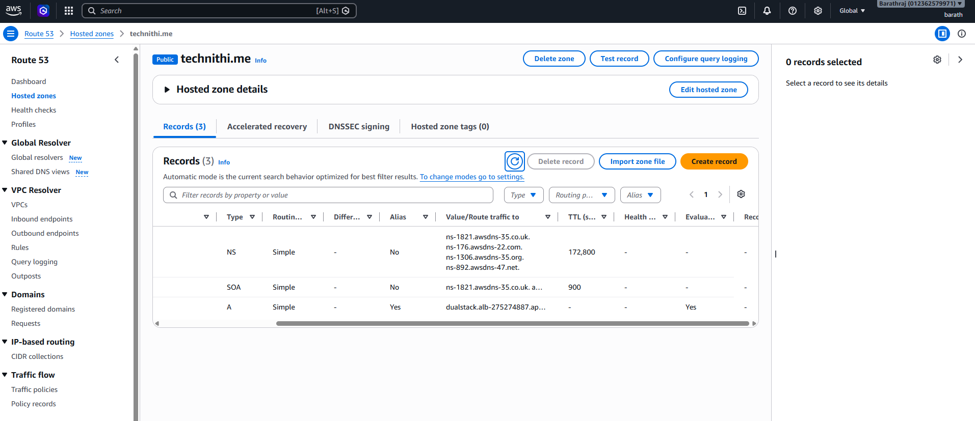

Then doing the vpc peering and checking the wheather the ip is reachiablewith this vpc:
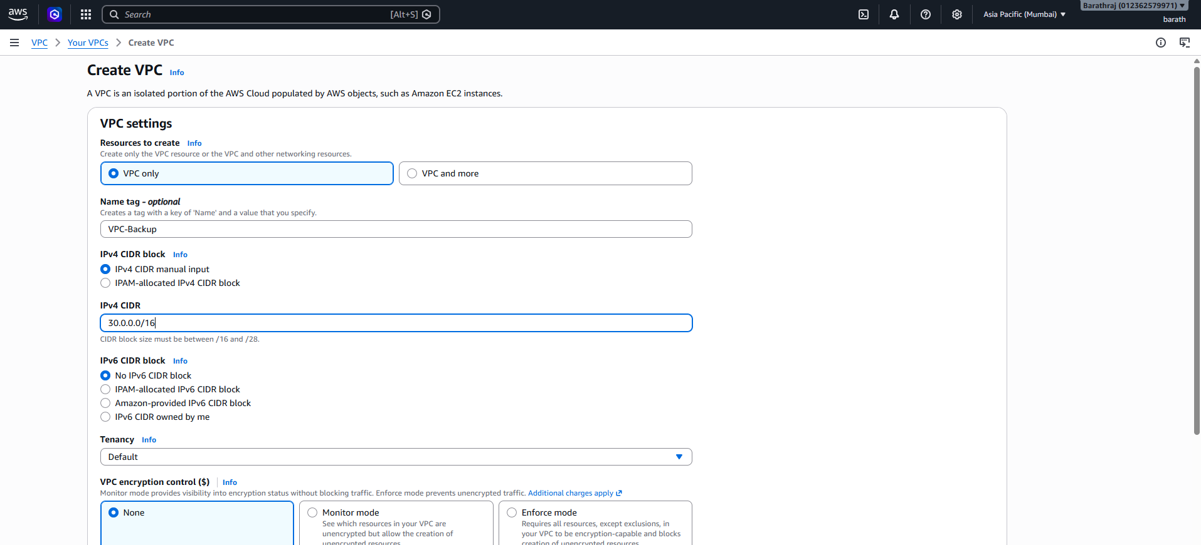
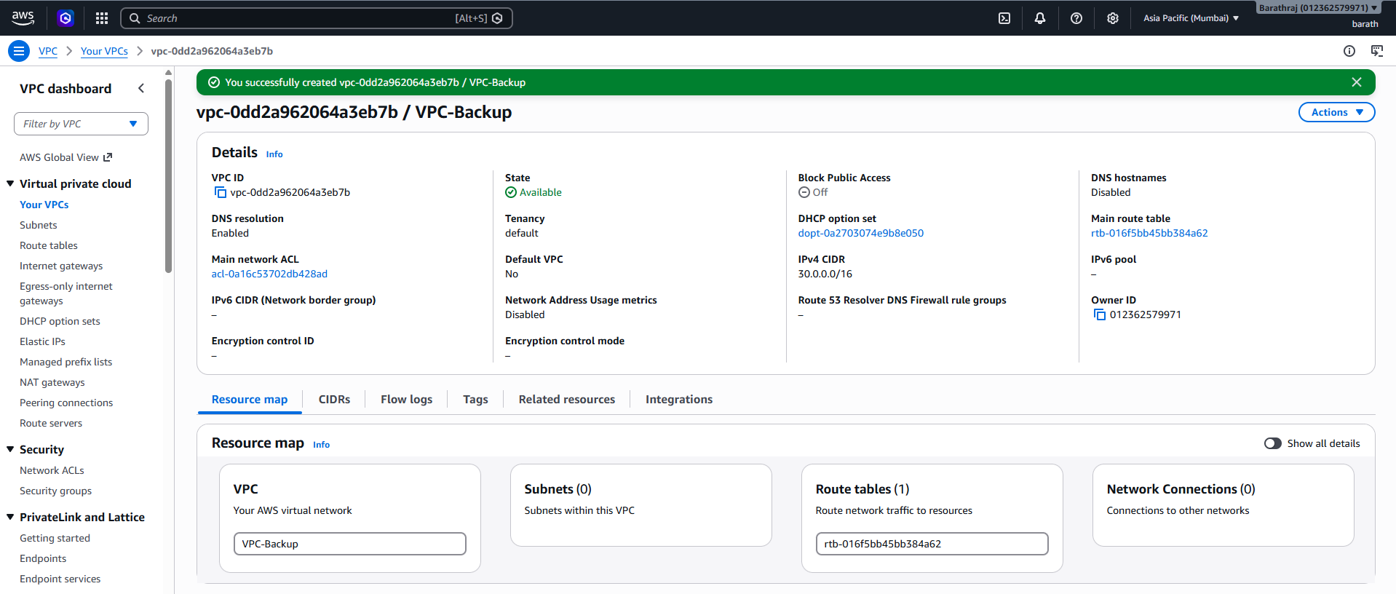
Subnet for this vpc:
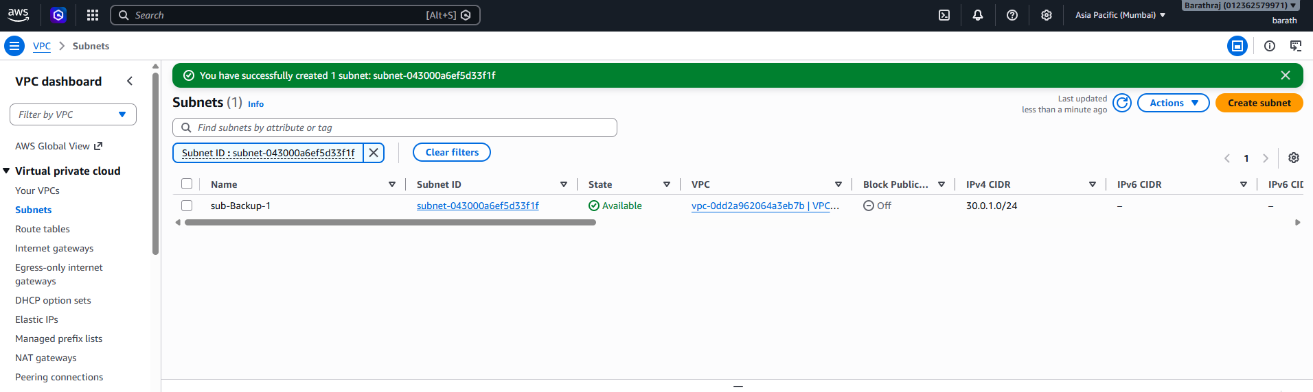
Ig gatway for this:
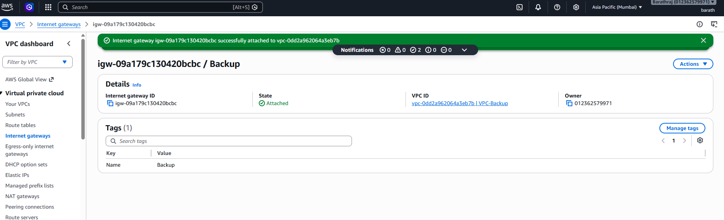
Rt table for that subnet and attack ig gate way:
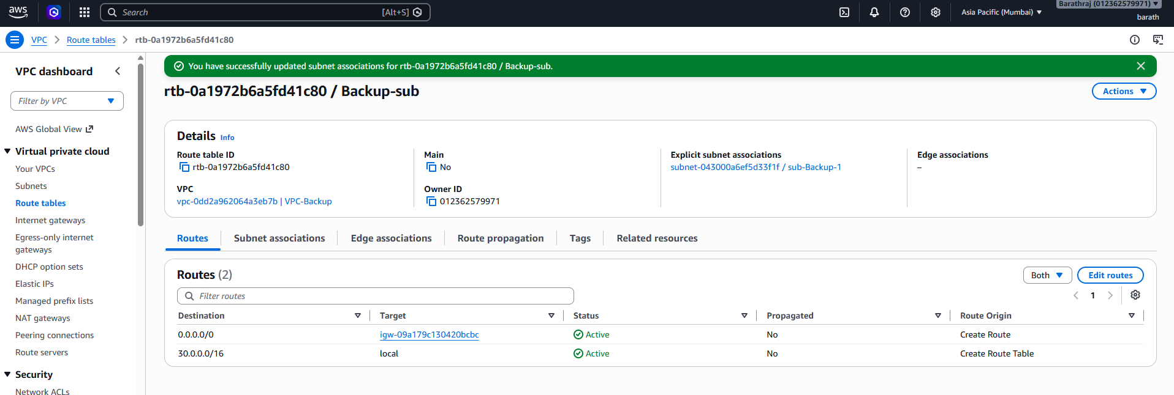
The give a perring from the original vpc and accept it In the backup vpc:
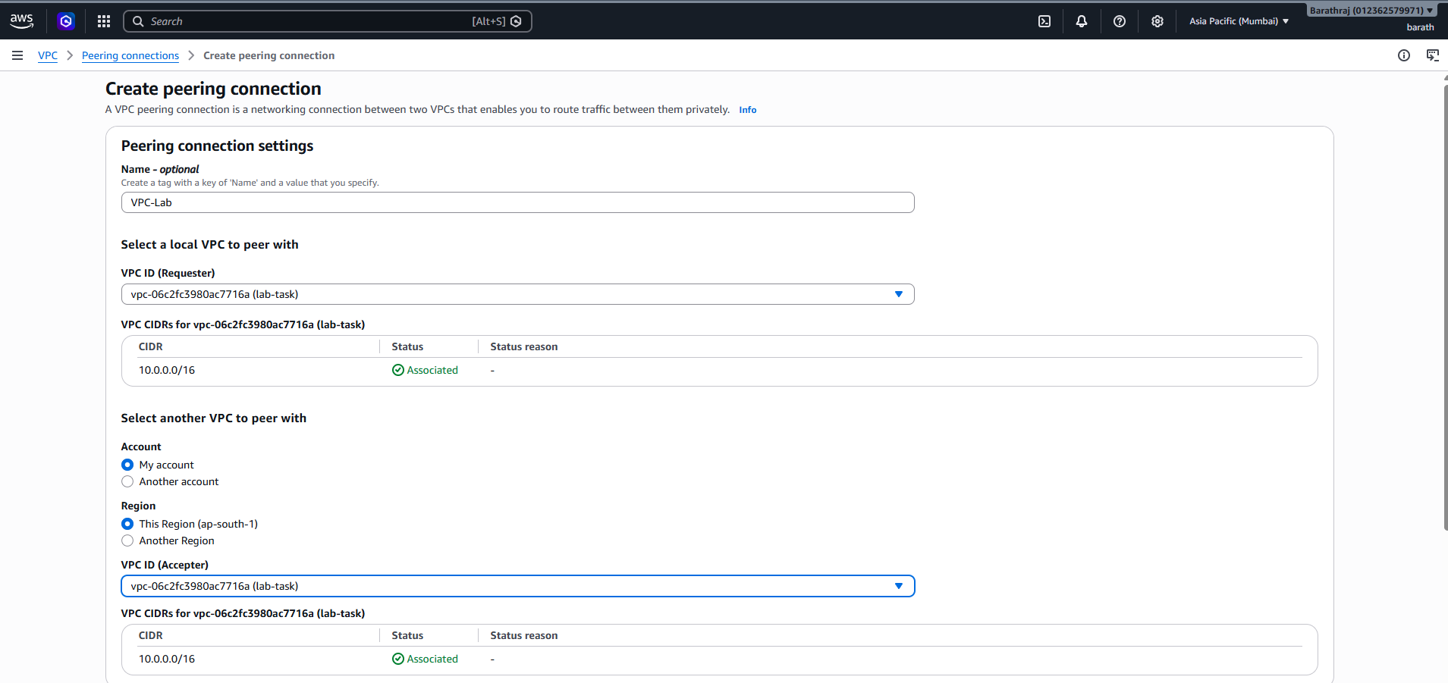
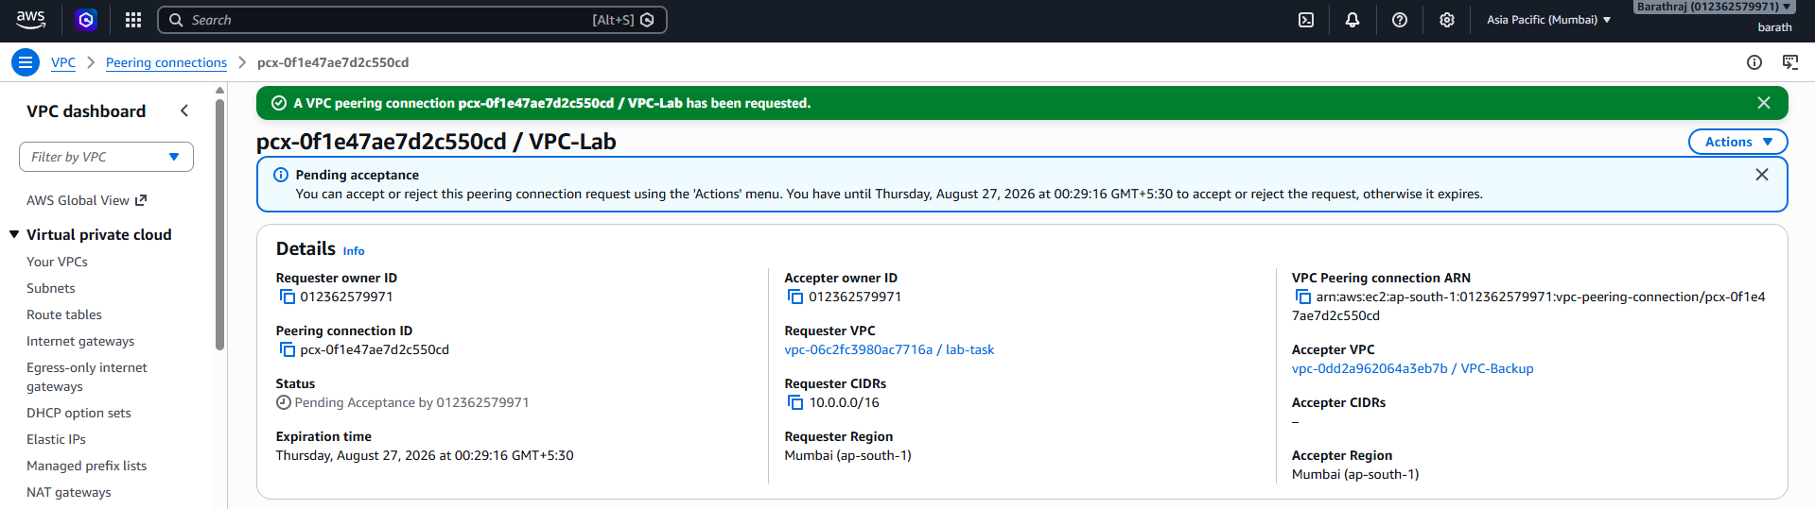

Then create a ec2 instace with that vpc and check wheather the connect is established or not.
