**Barath S Sundar**

**SQL Queries**  **IAS(DevOps)**

**INT00920**

Create table Programmer(NAME varchar(20),DOB date,DOJ date,SEX varchar(8), PROF1 varchar(10), PROF2 varchar(10), SALARY int(4));

insert into programmer(name,dob,doj,sex,prof1,prof2,salary) values

('ANAND','1966-04-12','1992-04-21','M','PASCAL','BASIC',3200),

('ALTAF','1964-07-02','1990-11-13','M','CLIPPER','COBOL',2800),

('JULIANA','1960-01-31','1990-04-21','F','COBOL','DBASE',3000),

('KAMALA','1968-10-30','1992-01-02','F','C','DBASE',2900),

('MARY','1970-06-24','1991-02-01','F','CPP','ORACLE',4500),

('NELSON','1985-09-11','1989-03-11','M','COBOL','DBASE',2500),

('PATTRICK','1965-11-10','1990-04-21','M','PASCAL',NULL,2800),

('QADIR','1965-08-31','1990-04-21','M','ASSEMBLY','C',3000),

('RAMESH','1967-05-03','1991-02-26','M','PASCAL','DBASE',3200),

('REBECCA','1967-01-01','1990-12-01','F','BASIC','COBOL',2500);



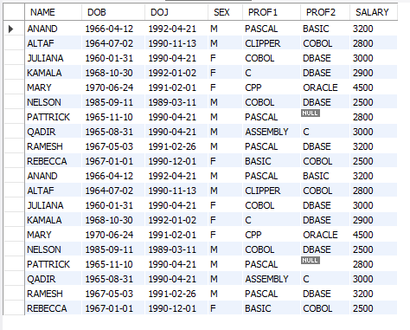

create table software (NAME varchar(20), TITLE varchar(20), DEV varchar(20), SCOST int,DCOST int, SOLD int );

insert into Software ( name, title, dev, scost, dcost, sold ) values

( 'MARY', 'README', 'CPP', 100.00, 1200, 84 ),

( 'ANAND', 'PARACHUTES', 'BASIC', 399.95, 6000, 43 ),

( 'ANAND', 'VIDEOTITLING', 'PASCAL', 7500.00, 16000, 9 ),

( 'JULIANA', 'INVENTORY', 'COBOL', 3000.00, 3500, 0 ),

( 'KAMALA', 'PAYROLLPRG', 'DBASE', 9000.00, 20000, 7 ),

( 'MARY', 'FINANCIALACC', 'ORACLE', 18000.00, 85000, 4 ),

( 'MARY', 'CODEGENRRATOP', 'C', 4500.00, 20000, 23 ),

( 'PATTRICK', 'README', 'CPP', 300.00, 1200, 84 ),

( 'QADIR', 'BOMBSAWAY', 'ASSEMBLY', 750.00, 5000, 11 ),

( 'QADIR', 'VACCINES', 'C', 1900.00, 3400, 21 ),

( 'RAMESH', 'HOTLIMGMT', 'DBASE', 12000.00, 35000, 4 ),

( 'RAMESH', 'DEADLEE', 'PASCAL', 599.95, 4500, 73 ),

( 'REMITHA', 'PCUTILITIES', 'C', 725.00, 5000, 51 ),

( 'REMITHA', 'TSRHELPPKG', 'ASSEMBLY', 2500.00, 6000, 7 ),

( 'REVATHI', 'HOSPITALMGMT', 'PASCAL', 1100.00, 75000, 2 ),

( 'VIJAYA', 'TSREDITOR', 'C', 900.00, 700, 6 );



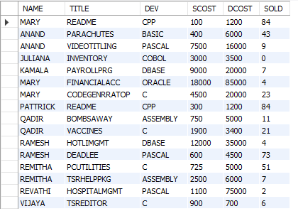

create table studies (NAME varchar(20),SPLACE varchar(20),COURSE varchar(20), COST int );

insert into Studies values

('ANAND', 'SABHARI', 'PGDCA', 4500 ),

( 'ALTAF', 'COIT', 'DCA', 7200 ),

( 'JULIANA', 'BITS', 'MCA', 22000 ),

( 'KAMALA', 'PRAGATHI', 'DCP', 5000 ),

( 'MARY', 'SABHARI', 'PGDCA', 4500 ),

( 'NELSON', 'PRAGATHI', 'DAP', 6200 ),

( 'PATRICK', 'PRAGATHI', 'DCAP', 5200 ),

( 'QADIR', 'APPLE', 'HDCP', 14000 ),

( 'RAMESH', 'SABHARI', 'PGDCA', 4500 ),

( 'RESECCA', 'BRILLIANT', 'DCAP', 11000 ),

( 'REMITHA', 'BDPS', 'DCS', 6000 ),

( 'VIJAYA', 'BDPS', 'DCA', 48000 );



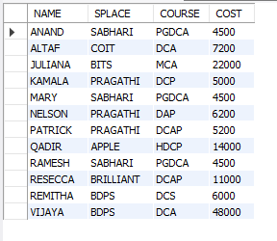

**QUERIES – I**

**1) Find out the SELLING COST AVERAGE for the packages developed in PASCAL?**

SELECT * FROM db1.programmer;

SELECT AVG(SCOST) FROM db1.software WHERE DEV LIKE 'PASCAL'

I/P:

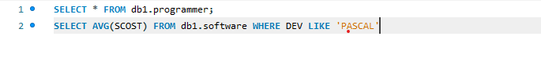

O/P:

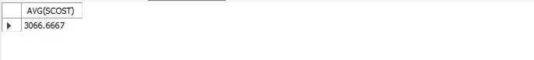

**2) Display the names and ages of all programmers.**

select name,floor(datediff(curdate(),dob)/365.5) as age from db1.programmer;

**I/p:**



**O/p:**

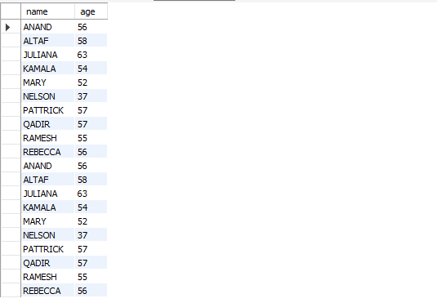

**3) Display the names and ages of all the programmers who have undergone training in DCS course.**

select p.name,floor(datediff(curdate(),dob)/365.5) as age from db1.programmer as p,db1.studies as s where p.name=s.name and course='dcs';

I/p:

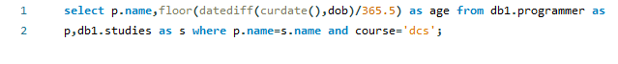

o/p:



**4) What is the highest numbers of copies sold by a package?**

SELECT * FROM db1.programmer;

select title,max(sold)from DB1.software;

I/P:



O/P:



**5) Display the names and date of birth of all the programmer born in JANUARY.**

select name,dob from db1.programmer where month(dob)=1;

**I/p:**  


O/p:

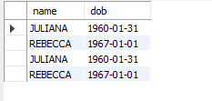

**6) Display lowest course fee.**

SELECT * FROM db1.programmer;

select min(cost),course from DB1.studies;

I/P:



O/P:



**7) How many programmer has done PGDCA course.**

SELECT * FROM db1.programmer;

select count(course)as PGDCA_complete from DB1.studies where course='PGDCA';

I/P:



O/P:



**8) How much revenue has been earned through sales of packages in C.**

select (scost*sold) as revenue from db1.software where dev='c';

I/p:

Inserting image...

O/p:

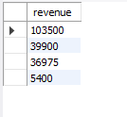

**9) Display the details of software developed by Ramesh?**

SELECT * FROM db1.programmer;

select*from DB1.programmer where name='ramesh';

I/P:



O/P:

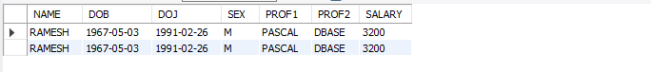

**10) How many programmers studied at SABHARI.**

SELECT * FROM db1.programmer;

select count(splace)as programmers_from_sabhari from DB1.studies where splace='SABHARI';

I/P:



O/P:

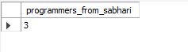

**11) Display the details of PACKAGES whose sales crossed the 20000 mark.**

SELECT * FROM db1.programmer;

select*from DB1.software where(sold*scost)>20000;

I/P:



O/P:

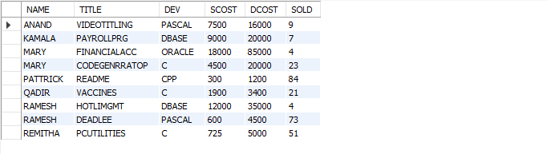

**12) Find out the number of copies which should be sold in order to recover the development cost of each package.**

select title,round(dcost/scost) as num_cpy from db1.software;

I/p:



O/p:

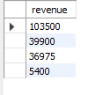

**13) What is the price of the costliest software developed in BASIC?**

SELECT * FROM db1.programmer;

select dev,max(dcost) from DB1.software where dev='basic';

I/P:



O/P:

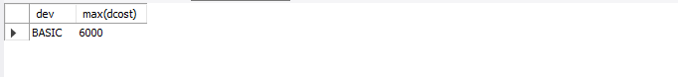

**14) Display the details of packages for which development cost has been recovered.**

SELECT * FROM db1.programmer;

select title as packages from DB1.software where scost>=dcost;

I/P:



O/P:



**15) How many packages were developed in dbase?**

SELECT * FROM db1.programmer;

select count(title)as total_packages from DB1.software where dev='dbase';

I/P:



O/P:

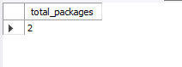

**16) How many programmers studies at paragathi?**

SELECT * FROM db1.programmer;

select count(name)as programmer_from_pragathi from DB1.studies where splace='pragathi';

I/P:

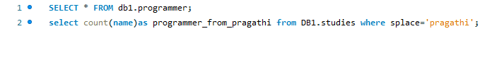

O/P:

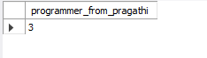

**17) How many programmers paid 5000 to 10000 for their course?**

SELECT * FROM db1.programmer;

select count(name)as 5k_to_10k from DB1.studies where cost>=5000 and cost<=10000;

I/P:



O/P:

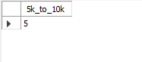

**18) What is the average course fee?**

SELECT * FROM db1.programmer;

select avg(cost)as avg_course_fee from DB1.studies;

I/P:

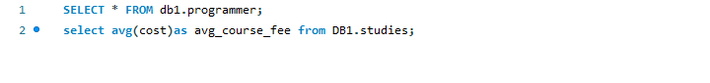

O/P:



**19) Display the details of programmers knowing c?**

SELECT * FROM db1.programmer;

select*from DB1.programmer where prof1='c' or prof2='c';

I/P:

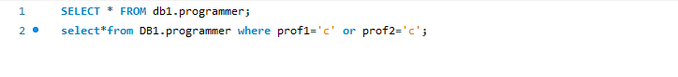

O/P:

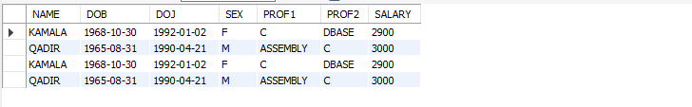

**20) How many programmers know either Cobol or Pascal?**

SELECT * FROM db1.programmer;

select count(name)as cobol_pascal from DB1.programmer where prof1='cobol' or prof2='cobol' or prof1='pascal' or prof2='pascal';

I/P:



O/P:



**21) How many programmers don't know Pascal & C?**

SELECT * FROM db1.programmer;

select count(name)as no_c_pascal from DB1.programmer where prof1!='c' and prof2!='c' and prof1!='pascal' and prof2!='pascal';

I/P:



O/P:

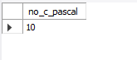

**22) How old is the oldest male programmers?**

select max(floor(datediff(curdate(),dob)/365))as oldest_pro from db1.programmer where sex='m';

I/p:



o/p:



**23) What is the average age of female programmers?**

select avg(datediff(curdate(),doj)/365) as avg_age_female from db1.programmer where sex='f';

I/p:



O/p:



**24) Calculate the experience in years for each programmers and display along with the names in descending order?**

select year(doj),name from db1.programmer order by name desc;

I/p:



O/p:

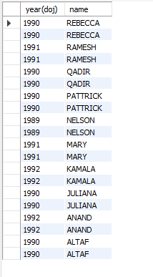

**25) Who are the programmers who celebrate their birthday during the current month?**

select name from db1.programmer where month(doj)=month(dob);

I/p:



o/p:

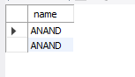

**26) How many female programmers are there?**

SELECT * FROM db1.programmer;

select count(name)as female_programmer from DB1.programmer where sex='f';

I/P:



O/P:

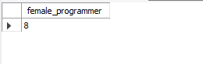

**27) What are the languages known by the male programmers?**

SELECT * FROM db1.programmer;

select prof1,prof2,sex from DB1.programmer where sex='m';

I/P:



O/P:

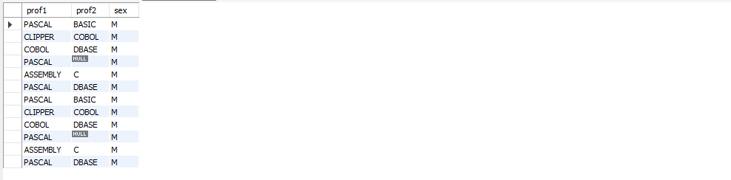

**28) What is the Average salary?**

SELECT * FROM db1.programmer;

select avg(salary) avg_salary from DB1.programmer;

I/P:



O/P:



**29) How many people draw 2000 to 4000?**

SELECT * FROM db1.programmer;

select avg(salary) avg_salary from DB1.programmer; select count(name) from DB1.programmer where salary>=2000 and salary<=4000;

I/P:



O/P:



**30) Display the details of those who don't know Clipper, Cobol or Pascal? 4**

SELECT * FROM db1.programmer;

select*from DB1.programmer where prof1!='cobol' and prof2!='cobol' and prof1!='pascal' and prof2!='pascal' and prof1!='clipper' and prof2!='clipper';

I/P:



O/P:



**31) How many Female programmers knowing C are above 24 years of age?**

select count(name) from db1.programmer where prof1='c' or prof2='c' and

sex='f' and floor(datediff(curdate(),dob)/365)>24;

I/p:  


o/p:  
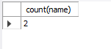

**32) Who are the programmers who will be celebrating their Birthday within a week?**

select name from db1.programmer where (week(curdate())=week(dob));

I/p:



o/p:

Inserting image...

**33 Display the details of those with less than a year's experience?**

select * from db1.programmer where sex='f' and (prof1='cobol' or

prof2='cobol') and floor(datediff(curdate(),doj)/365)<1;

I/p:  
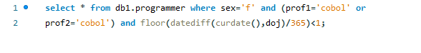

o/p:  
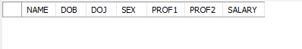

**34 Display the details of those who will be completing 2 years of service this year?**

select * from db1.programmer where sex='f' and

(prof1='cobol' or prof2='cobol') and floor(datediff(curdate(),doj)/365)=2;

I/p:  
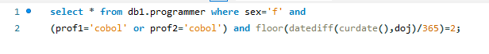

O/P:  


**35 Calculate the amount to be recovered for those packages whose development cost has not been recovered?**

select title,((scost*sold)-dcost) as recovery

from db1.software where ((scost*sold)-dcost)<0;

I/P:



O/P:  
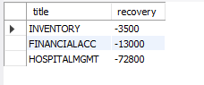

**36) List the packages which have not been sold so far?**

select title,sold from db1.software where sold=0;

I/p:



o/p:  
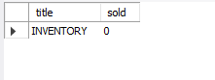

**37) Find out the cost of the software developed by Mary?**

SELECT * FROM db1.programmer;

select name,scost,dcost from DB1.software where name='mary';

I/P:



O/P:

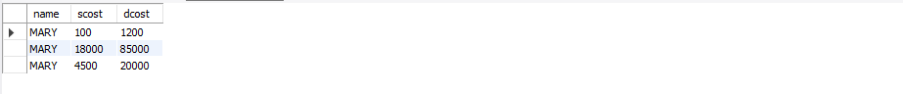

**38) Display the institute’s names from the studies table without duplicates?**

SELECT * FROM db1.programmer;

select distinct splace from DB1.studies;

I/P:



O/P:

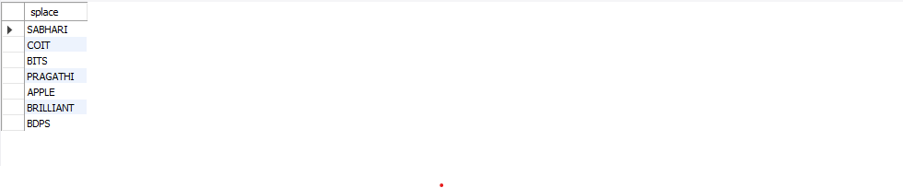

**39) How many different courses are mentioned in the studies table?**

SELECT * FROM db1.programmer;

select count(distinct course) from DB1.studies;

I/P:



O/P:

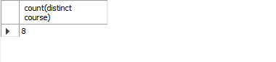

**40) Display the names of the programmers whose names contain 2 occurrences of the letter A?**

select name from DB1.programmer where name like '%a__';

**I/P:**



O/P:

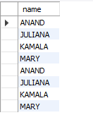

**41) Display the names of programmers whose names contain unto 5 characters?**

select name from DB1.programmer where name like '_____';

I/P:



O/P:

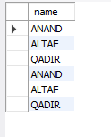

**42) How many female programmers knowing COBOL have more than 2 years experience?**

select count(name) from db1.programmer where sex='f' and (prof1='cobol' or prof2='cobol')

and floor(datediff(curdate(),doj)/365)>2;

I/p:



o/p:



**43) What is the length of the shortest name in the programmer table?**

SELECT * FROM db1.programmer;

select min(length(name)) from db1.programmer;

I/P:

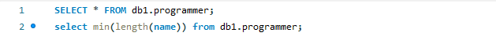

O/P:

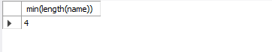

**44) What is the average development cost of a package developed in COBOL?**

SELECT * FROM db1.programmer;

select avg(dcost)as avg_dcost_cobol from DB1.software where dev='cobol';

I/P:



O/P:

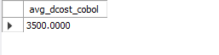

**45) Display the name, sex, dob (DD/MM/YY format), doj for all the programmers without using conversion function?**

**s**elect name,sex,date_format(dob,'%d-%m-%y')as dob,doj from db1.programmer;

I/p:



o/p:  
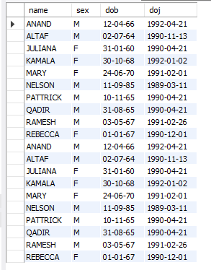

**46) Who are the programmers who were born on the last day of the month?**

select name,dob from db1.programmer where day(dob) like '31';

I/p:



o/p:  
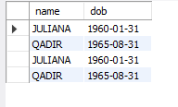

**47) What is the amount paid in salaries of the male programmers who do not know Cobol?**

SELECT * FROM db1.programmer;

select sex,salary from DB1.programmer where prof1!='cobol' and prof2!='cobol' and sex='m';

I/P:



O/P:

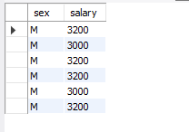

**48) Display the title, scost, dcost and difference between scost and dcost in descending order of difference?**

SELECT * FROM db1.programmer;

select title,scost,dcost,scost-dcost diff from DB1.software order by diff desc;

I/P:



O/P:

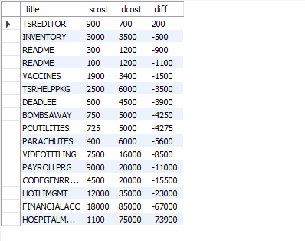

**49) Display the name, dob, doj of those month of birth and month of joining are same?**

select name,dob,doj from db1.programmer where month(dob)=month(doj);

I/p:  
Inserting image...

o/p:  
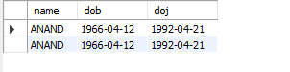

**50) Display the names of the packages whose names contain more than 1 word?**

**QUERIES – II**

**1) Display THE NUMBER OF packages developed in EACH language.**

select dev,count(title) from DB1.software group by dev;

I/P:



O/P:

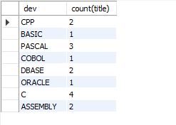

**2) Display THE NUMBER OF packages developed by EACH person.**

select name,count(title) from DB1.software group by name;

I/P:



O/P:

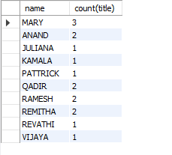

**3) Display THE NUMBER OF male and female programmer.**

select sex,count(sex) from DB1.programmer group by sex;

I/P:

Inserting image...

O/P:

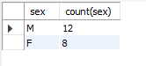

**4) Display THE COSTLIEST packages and HIGEST selling developed in EACH language.**

select dev,max(scost),max(sold)from DB1.software group by dev;

I/P:

Inserting image...

O/P:

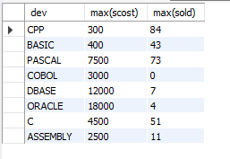

**5) Display THE NUMBER OF people BORN in EACH YEAR.**

select extract(year from dob)as year,count(name) as no_ppl_born_each_year

from db1.programmer group by extract(year from dob);

I/p:

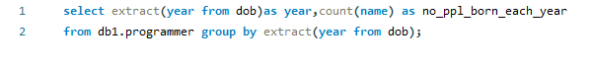

o/p:  
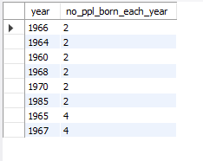

**6) Display THE NUMBER OF people JOINED in EACH YEAR.**

select extract(year from doj)as year,count(name) as no_ppl_joined_each_year

from db1.programmer group by extract(year from doj);

I/p:  


o/p:  
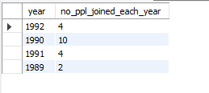

**7) Display THE NUMBER OF people BORN in EACH MONTH.**

select extract(month from dob)as month,count(name) as no_pplborn_each_month

from db1.programmer group by extract(month from dob) order by month asc;

I/p:



o/p:

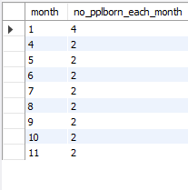

**8) Display THE NUMBER OF people JOINED in EACH MONTH.**

select extract(month from doj)as month,count(name) as no_ppl_join_each_month

from db1.programmer group by extract(month from doj) order by month asc;

I/p:  
Inserting image...

o/p:

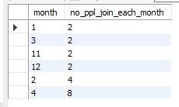

**9) Display the language wise COUNTS of prof1.**

select prof1,count(prof1) from DB1.programmer group by prof1;

I/P:



O/P:

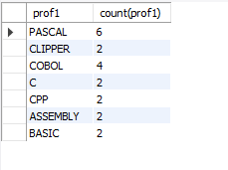

**10) Display the language wise COUNTS of prof2.**

select prof1,count(prof2) from DB1.programmer group by prof2;

I/P:

Inserting image...

O/P:

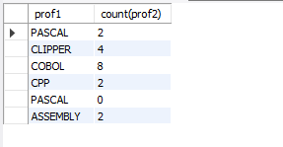

**11) Display THE NUMBER OF people in EACH salary group.**

select salary,count(name) from DB1.programmer group by salary;

I/P:



O/P:

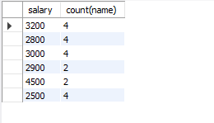

**12) Display THE NUMBER OF people who studied in EACH institute.**

select splace,count(name) from DB1.studies group by splace;

I/P:



O/P:

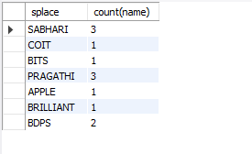

**13) Display THE NUMBER OF people who studied in EACH course.**

select course,count(name) from DB1.studies group by course;

I/P:



O/P:

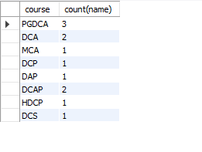

**14) Display the TOTAL development COST of the packages developed in EACH language.**

select dev,sum(dcost) from DB1.software group by dev;

I/P:



O/P:

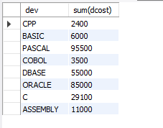

**15) Display the selling cost of the package developed in EACH language.**

select dev,sum(scost) from DB1.software group by dev;

I/P:



O/P:

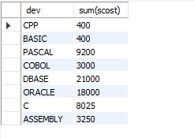

**16) Display the cost of the package developed by EACH programmer.**

select name,sum(dcost) from DB1.software group by name;

I/P:



O/P:

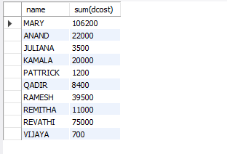

**17) Display the sales values of the package developed inEACH programmer.**

select name,sum(scost*sold) from DB1.software group by name;

I/P:



O/P:

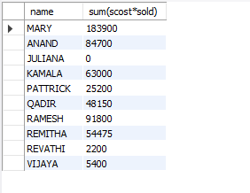

**18) Display the NUMBER of packages developed by EACH programmer.**

select name,count(title) from DB1.software group by name;

I/P:



O/P:

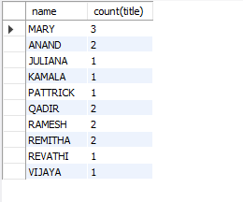

**19) Display the sales COST of packages developed by EACH programmer language wise.**

select sum(scost) from DB1.software group by dev;

I/P:



O/P:

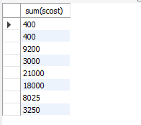

**20) Display EACH programmers name, costliest package and cheapest packages developed by Him/Her.**

select name,min(dcost),max(dcost) from DB1.software group by name;

I/P:



O/P:

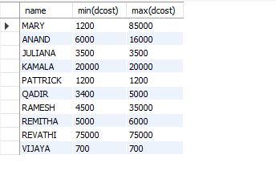

**21) Display EACH language name with AVERAGE development cost, AVERAGE cost, selling cost and AVERAGE price per copy.**

select dev,avg(dcost),avg(scost) from DB1.software group by dev;

I/P:



O/P:

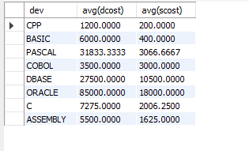

**22) Display EACH institute name with NUMBER of courses, AVERAGE cost per course.**

select splace,count(course),avg(cost) from DB1.studies group by splace;

I/P:



O/P:

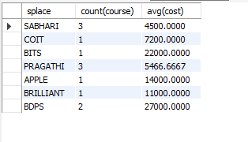

**23) Display EACH institute name with NUMBER of students. 5**

select splace,count(name) from DB1.studies group by splace;

I/P:  
Inserting image...

O/P:

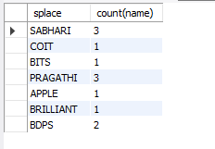

**24) Display names of male and female programmers.**

select name from DB1.programmer where sex in('m','f');

I/P:  


O/P:

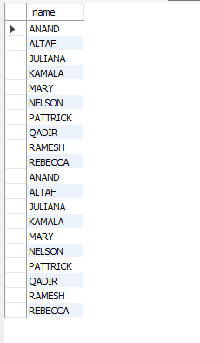

**25) Display the programmer's name and their packages.**

select title as package,name from DB1.software;

I/P:



O/P:  
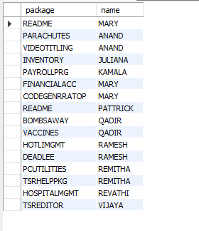

**26) Display the NUMBER of packages in EACH language.**

select dev,count(title) from DB1.software group by dev;

I/P:



O/P:

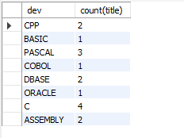

**27) Display the NUMBER of packages in EACH language for which development cost is less than 1000.**

select dev,count(title) from DB1.software where dcost<1000 group by dev;

I/P:



O/P:

**28) Display the AVERAGE difference BETWEEN scost and dcost for EACH language.**

select dev,avg(scost-dcost)from DB1.software group by dev;

I/P:



O/P:

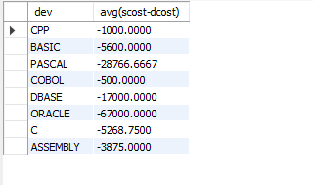

**29) Display the TOTAL scost, dcsot and amount TOBE recovered for EACH programmer for whose dcost HAS NOT YET BEEN recovered.**

select sum(scost),sum(dcost),sum(dcost-(sold*scost))from DB1.software group by name having sum(dcost)>sum(sold*scost);

I/P:  


O/P:

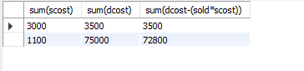

**30) Display highest, lowest and average salaries for THOSE earning MORE than 2000.**

select max(salary),min(salary),avg(salary) from DB1.programmer where salary>=2000;

I/P:



O/P:

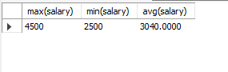

**QUERIES – III**

**1) Who is the highest paid C programmer?**

select name,max(salary) from DB1.programmer where prof1='c' or prof2='c';

I/P:



O/P:



**2) Who is the highest paid female cobol programmer?**

select name,max(salary) from DB1.programmer where prof1='cobol' or prof2='cobol' and sex='f';

I/P:



O/P:  
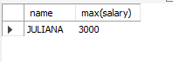

**3) Display the name of the HIGEST paid programmer for EACH language (prof1)**

select name,prof1 as highest_paid_programmer_in_each_laung from db1.programmer

where(salary,prof1)in(select max(salary),prof1 from db1.programmer group by prof1) ;

I/p:

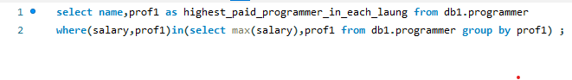

o/p:  
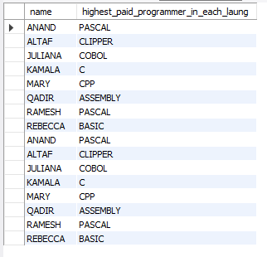

**4) Who is the LEAST experienced programmer?**

select name as least_experienced_programmer from db1.programmer

where ((curdate()-doj)/365)=(select min((curdate()-doj)/365) from db1.programmer);

I/p:



o/p:  
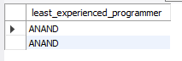

**5) Who is the MOST experienced programmer?**

select name as most_experienced_programmer from db1.programmer

where ((curdate()-doj)/365)=(select max((curdate()-doj)/365) from db1.programmer);

I/p:



o/p:  


**6) Which language is known by ONLY ONE programmer?**

select prof1 from db1.programmer group by prof1 having prof1 not in(select prof2 from db1.programmer)union

select prof2 from db1.programmer group by prof2 having prof2 not in(select prof1 from db1.programmer);

I/p:



o/p:  
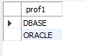

**7) Who is the YONGEST programmer knowing DBASE?**

select name as youngest_programmer_dbase from db1.programmer where prof2='dbase'

and((curdate()-dob)/365)=(select min((curdate()-dob)/365) from db1.programmer);

I/p:



o/p:



**8) Which institute has MOST NUMBER of students?**

select splace,count(name) from db1.studies group by splace;

I/p:

Inserting image...

o/p:

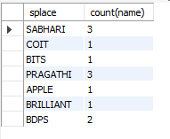

**9) Who is the above programmer?**

select p.name,s.splace from db1.programmer as p,db1.studies as s where p.name=s.name;

I/p:



o/p:

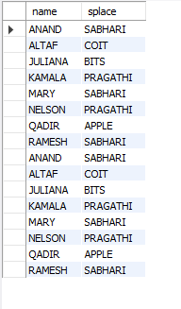

**10) Which female programmer earns MORE than 3000/- but DOES NOT know C, C++, Oracle or Dbase?**

select name from db1.programmer where sex='f' and salary>=3000

and prof1 not in('c','c++','oracle','cobol')and prof2

I/p:



o/p:



**11) Which is the COSTLIEST course?**

select course,max(cost) from DB1.studies;

I/P:



O/P:  
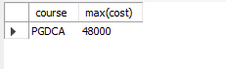

**12) Which course has been done by MOST of the students?**

select max(course)from db1.studies;

I/p:



o/p:

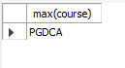

**13) Display name of the institute and course Which has below AVERAGE course fee?**

select splace,course from DB1.studies where cost<(select avg(cost)from DB1.studies);

I/P:



O/P:

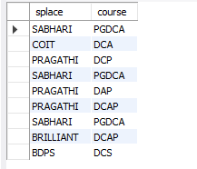

**14) Which institute conducts COSTLIEST course?**

select splace as costliest_course,institue from DB1.studies where cost=(select max(cost)from DB1.studies);

I/P:



O/P:

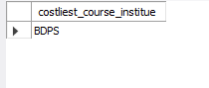

**15) Which course has below AVERAGE number of students?**

select course from db1.studies group by course having count(*)< (select count(*)/2 from db1.studies);

I/p:

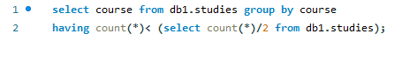

o/p:

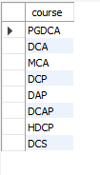

**16) Which institute conducts the above course?**

select splace from db1.studies group by course having

count(*)< (select count(*)/2 from db1.studies);

I/p:

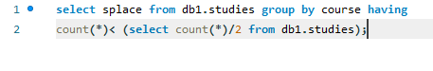

o/p:

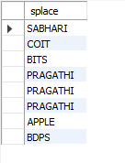

**17) Display names of the course WHOSE fees are within 1000(+ or -) of the AVERAGE fee.**

select course from db1.studies where cost between (select avg(cost)+1000 from db1.studies)

and (select avg(cost)-1000 from db1.studies);

I/p:



o/p:



**18) Which package has the HIGEST development cost?**

select title as package,dcost from DB1.software where dcost=(select max(dcost) from DB1.software);

I/P:



O/P:  
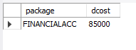

**19) Which package has the LOWEST selling cost?**

select title as package,scost from DB1.software where scost=(select min(scost)from DB1.software);

I/P:



O/P:

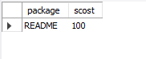

**20) Who developed the package, which has sold the LEAST number of copies?**

select name from DB1.software where sold=(select min(sold)from DB1.software);

I/P:



O/P:



**21) Which language was used to develop the package WHICH has the HIGEST sales amount?**

select title as package,scost from DB1.software where scost=(select max(scost)from DB1.software);

I/P:  


O/P:  


**22) How many copies of the package that has the LEAST DIFFRENCE between development and selling cost were sold?**

select sold,title from db1.software where title=(select title from

db1.software where (dcost-scost)=(select min(dcost-scost)from db1.software));

I/p:



o/p:



**23) Which is the COSTLIEAST package developed in PASCAL?**

select title from db1.software where dcost=(select max(dcost)from

db1.software where dev like 'pascal');

I/p:



o/p:

Inserting image...

**24) Which language was used to develop the MOST NUMBER of package?**

select dev from db1.software group by name having

max(name)=(select max(name)from db1.software);

I/p:



o/p:



**25) Which programmer has developed the HIGEST NUMBER of package?**

select name from db1.software group by name having

max(name)=(select max(name)from db1.software);

I/p:



o/p:



**26) Who is the author of the COSTLIEST package?**

select name from db1.software having max(sold*scost);

I/p:



o/p:



**27) Display names of packages WHICH have been sold LESS THAN the AVERAGE number of copies?**

select title from db1.software where sold<(select avg(sold) from db1.software);

I/p:



o/p:

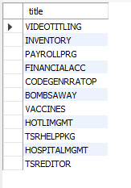

**28) Who are the female programmers earning MORE than the HIGEST paid male programmers?**

select name from programmer where sex='f' and salary>(select max(salary) from programmer where sex='m');

**I/p:**

Inserting image...

o/p:

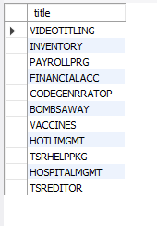

**29) Which language has been stated as prof1 by MOST of the programmers?**

select max(prof1) from db1.programmer;

I/p:



o/p:  
Inserting image...

**30) Who are the authors of packages, WHICH have recovered MORE THAN double the development cost?**

select distinct name from db1.software where sold*scost > 2*dcost;

I/p:



o/p:  
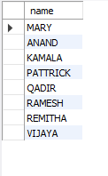

**31) Display programmer names and CHEAPEST package developed by them in EACH language?**

select p.name,min(sold*scost),dev from db1.programmer as

p,db1.software as s where p.name=s.name group by dev;

I/p:



o/p:

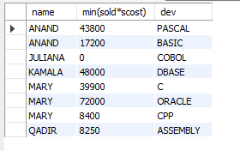

**32) Who is the YOUNGEST male programmer born in 1965?**

select name,dob from db1.programmer where extract(year from dob)=1965

order by dob asc limit 1;

I/p:  
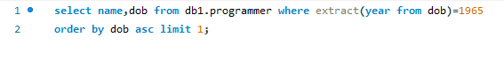

o/p:

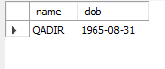

**33) Display language used by EACH programmer to develop the HIGEST selling and LOWEST selling package.**

select name,dev,scost from db1.software where sold in(select max(sold)from db1.software group by name)union

select name,dev,scost from db1.software where sold in(select min(sold)from db1.software group by name);

I/P:



o/p:  
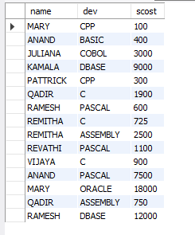

**34) Who is the OLDEST female programmer WHO joined in 1992**

select name,doj from DB1.programmer where doj = (select min(doj)from

DB1.programmer where extract(year from doj) like '1992');

I/P:



O/P:

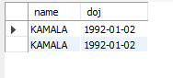

**35) In WHICH year where the MOST NUMBER of programmer born?**

select year(dob),count(*) from DB1.programmer group by

year(dob) order by count(*) desc limit 1;

I/P:

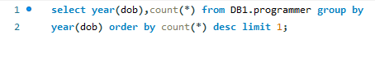

O/P:



**36) In WHICH month did MOST NUMBRER of programmer join?**

select distinct extract(month from doj)as month_of_most_number_of_programmers_joined from DB1.programmer

where extract(month from doj)=(select min(extract(month from doj))from DB1.programmer);

I/p:



o/p:

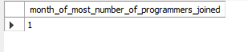

**37) In WHICH language are MOST of the programmer's proficient?**

select prof1,count(*) from db1.programmer group by prof1 order by count(*) desc limit 1;

I/p:

Inserting image...

o/p:



**38) Who are the male programmers earning BELOW the AVERAGE salary of female programmers?**

select name from db1.programmer where sex='m' and salary<(select avg(salary)

from db1.programmer where sex='f');

I/p:  
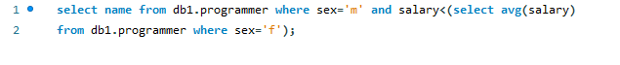

o/p:

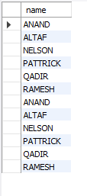

**QUERY – IV**

**1) Display the details of THOSE WHO are drawing the same salary.**

select*from db1.programmer as p1,db1.programmer as p2 where

p1.name!=p2.name and p1.salary=p2.salary;

I/p:



o/p:

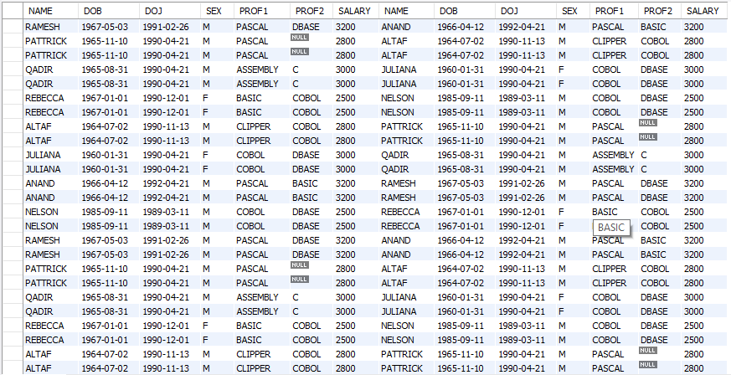

**2) Display the details of software developed by male programmers earning MORE than 3000.**

select s.* from DB1.programmer p,DB1.software s where p.name=s.name and salary>3000 and sex='m';

I/P:



O/P:  
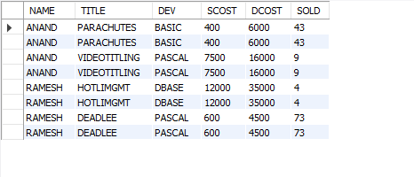

**3) Display details of packages developed in PASCAL by female programmers.**

select s.* from DB1.programmer p,DB1.software s where p.name=s.name and sex='f' and dev='pascal';

I/P:



O/P:  


**4) Display the details of the programmer WHO joined BEFORE 1990.**

select*from db1.programmer where extract(year from doj)<1990;

I/p:



o/p:  
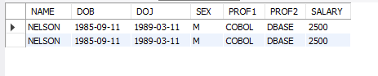

**5) Display details of software developed in C by female programmers of PRAGATHI.**

select s.* from DB1.software as s,DB1.programmer as p,DB1.studies as st where st.splace='pragathi' and dev='c' and st.name=s.name and p.name=s.name;

I/P:  


O/P:  
Inserting image...

**6) Display NUMBER of packages NUMBER of copies sold and sales value of EACH programmer Institute-wise.**

Select st.splace, count(s.dev), count(s.sold), sum(s.sold*s.scost)

from db1.software as s,db1.studies as st where s.name=st.name group by st.splace;

I/p:



o/p:

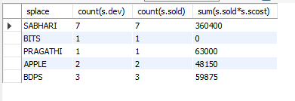

**7) Display details of software developed in DBASE by male programmers WHO belong to the institute on which MOST NUMBER OF programmer’s studies.**

select s.* from db1.software as s,db1.programmer as p,db1.studies as st where s.name=p.name and

st.name=p.name and s.dev='dbase' and p.sex='m' and (select count(splace) from db1.studies group by st.name);

I/p:



o/p:

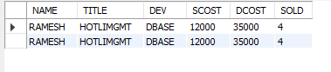

**8) Display the details of the software that was developed by male programmers born BEFORE 1965 and female programmers born AFTER 1975.**

select s.* from db1.programmer as p,db1.software as s where s.name=p.name

and sex='m' and year(dob)<1965 or sex='f' and year(dob)>1975;

I/p:

Inserting image...

o/p:

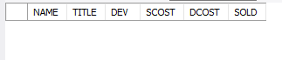

**9) Display the details of the software that was developed in the language that is NOT the programmer’s first proficiency.**

select s.* from db1.software as s,db1.programmer as p

where s.name=p.name and p.prof1!=s.dev;

I/p;

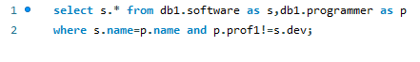

o/p:

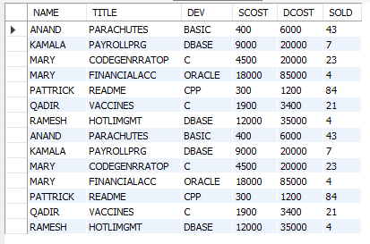

**10) Display details of software that was developed in the language which is NEITHER first NOR second proficiency of the programmer.**

select s.* from DB1.programmer as p,DB1.software as s where s.name=p.name and(dev<>prof1 and dev<>prof2);

I/P:



O/P:  
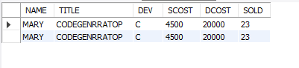

**11) Display details of software developed by male students of SABHARI.**

select*from DB1.software as s,DB1.studies as st,DB1.programmer as p where splace='sabhari' and sex='m' and s.name=st.name and p.name=s.name;

I/P:



O/P:

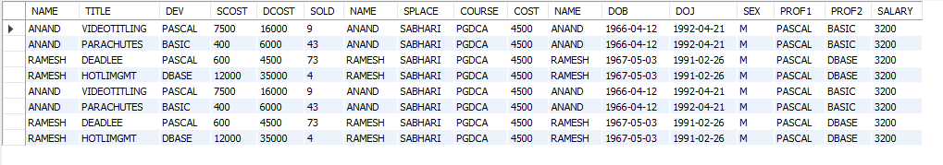

**12) Display the names of programmers WHO HAVE NOT developed any package.**

select name from db1.programmer where name not in(select name from db1.software);

**I/p:**



o/p:

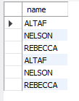

**13) What is the total cost of the software developed by the programmers by APPLE?**

select sum(scost) from db1.software as s,db1.studies as st

where s.name=st.name and splace='apple';

I/p:



o/p:  


**14) Who are the programmers WHO JOINED in the same day?**

select distinct p1.name,p1.doj from db1.programmer as p1,db1.programmer

as p2 where p1.doj=p2.doj and p1.name!=p2.name;

I/p:



o/p:

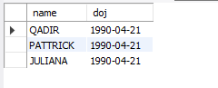

**15) Who are the programmers WHO HAVE THE SAME PROF2?**

select distinct p1.name from db1.programmer as p1,db1.programmer

as p2 where p1.prof2=p2.prof2 and p1.name!=p2.name;

I/p:



o/p:

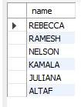

**16) Display the total sales values of software, institutes-wise.**

select st.splace,sum(s.sold*s.scost)from db1.software as s,db1.studies

as st where st.name=s.name group by st.splace;

I/p:



o/p:

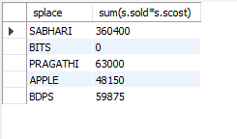

**17) In which institutes did the person who developed the COSTLIEST package study?**

select max(dcost),splace from db1.software as

s,db1.studies as st where s.name=st.name;

I/p:



o/p:

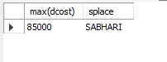

**18) Which language listed in prof1 and prof2 HAS NOT BEEN used to develop any package?**

select prof1 from db1.programmer where prof1 not in(select dev from db1.software) union select prof2

from db1.programmer where prof2 not in(select dev from db1.software);

I/p:



o/p:

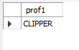

**19) How much does the person WHO developed the HIGHEST selling package earn and WHAT course did he/she undergo?**

select max(scost*sold),course,s.name from db1.software

as s,db1.studies as st where s.name=st.name;

I/p:



o/p:

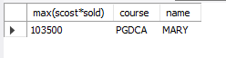

**20) How many months will it take for each programmer to recover the cost of the course underwent?**

select p.name,ceil(scost/salary) from db1.programmer as p,db1.studies

as st,db1.software as s where st.name=p.name and p.name=s.name;

I/p:

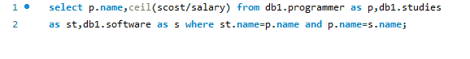

o/p:

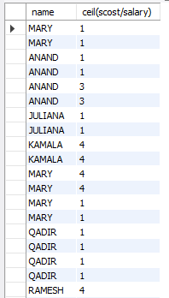

**21) Which is the COSTLIEST package developed by a person with under 3 year’s expenences?**

select s.title from db1.software as s,db1.programmer as p

where(curdate()- year(doj)/12)>3 and s.name=p.name;

I/p:



o/p:

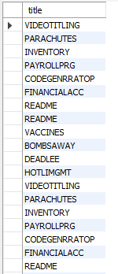

**22) What is the AVERAGE salary for those WHOSE software's sales value is more than 50,000?**

select avg(salary) from db1.programmer as p,db1.software

as s where p.name=s.name and scost*sold>50000;

I/p:

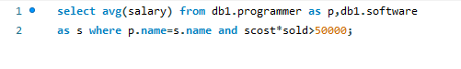

o/p:



**23) How many packages were developed by the students WHO studied in the institute that Charge the LOWEST course fee?**

select count(s.name) from db1.software s,db1.studies st where s.name=st.name group

by s.name,cost having min(cost)=(select min(cost) from db1.studies);

I/p:



o/p:

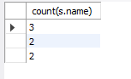

**24) How many packages were developed by the person WHO developed the CHEAPEST package? Where did he\she study?**

select count(*) from db1.programmer as p,db1.software as s where s.name=p.name

group by dev having min(dcost)=(select min(dcost) from db1.software);

I/P:

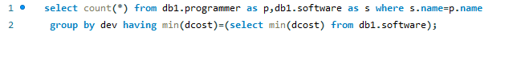

O/P:



**25) How many packages were developed by female programmers earning MORE than the HIGHEST paid male programmer?**

select count(dev) from DB1.programmer as p,DB1.software as s where s.name=p.name and sex='f' and

salary>(select max(salary) from DB1.programmer p,DB1.software s where s.name=p.name and sex='m');

I/p:  


o/p:  


**26) How many packages were developed by the MOST experienced programmers from BDPS?**

select count(dev) from db1.software as s,db1.studies as

st where s.name=st.name and splace='bdps';

I/p:  


o/p:  
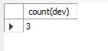

**27) List the programmers (from software table) and institutes they studied, including those WHO DIDN'T develop any package.**

select name,splace from db1.studies where name not in(select name from db1.software);

I/p:\



o/p:  
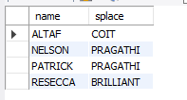

**28) List each profit with the number of programmers having that prof1 and the number of packages developed in that prof1.**

select count(*),sum(scost*sold-dcost) "PROFIT" from db1.software where

dev in (select prof1 from db1.programmer) group by dev;

I/p:



o/p:  
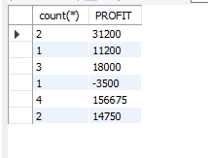

**29) List programmer names (from programmer table) and number of packages EACH developed.**

select p.name,count(dev) from DB1.programmer as p,DB1.software

as s where p.name=s.name group by p.name;

I/P:

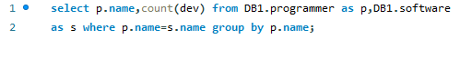

O/P:

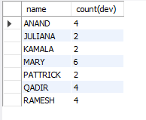

**30) List all the details of programmers who have done a course at S.S.I.L.**

select*from DB1.programmer,DB1.studies,DB1.software where splace='BITS' and

DB1.programmer.name=studies.name and DB1.software.name=DB1.programmer.name;

I/p:  
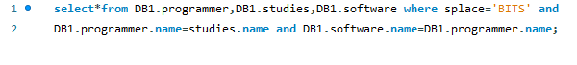

O/P:  
