# RESUME

# 

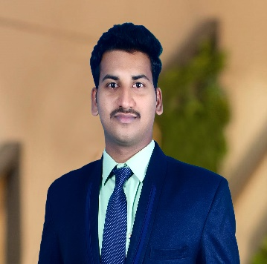

# BHUMAGANI ARAVIND

E- mail : baravind031@gmail.com

C o n t a c t : 8184872014

# C A R E E R O B J E C T I V E

To work in an organization which provides me with good opportunities to enhance my technical and inter personal skills along with significant contribution to growth of the organization.

# E D U C A T I O N

|  |  |  |  |  |
| --- | --- | --- | --- | --- |
| **Degree/ Examination** | **Year of Passing** | **School/Institute** | **Board/University** | **Percentage** |
| MCA | 2024 | Ajeenkya DY Patil  University, Pune | Ajeenkya DY Patil University, Pune | - |
| B.Sc.  (Computer Science) | 2022 | Sri Venkatateswara Degree and PG College, Ananthapuram | Sri Krishnadevaraya University, Ananthapuram | 70% |
| Intermediate | 2018 | LRG Naidu Junior College, Hindupur | Board of Intermediate Education, Andhra Pradesh | 66.6% |
| S.S.C | 2016 | Hope School | Board of Secondary School Certificate, Andhra Pradesh | 83% |

**CERTIFICATION/ INTERNSHIPS/ PROJECT WORK/ TRAINING**

* I had Completed course on “Python Full Stack” from Besant Technologies, Bangalore.

# SOFTWARE SKILL SET

* Languages : HTML5, CSS3, Bootstrap5, Java Script, Python, SQL

# AREAS OF INTERESTS

* Python
* Frontend Developer

# ACADEMIC ACHIEVEMENTS & CO-CURRICULAR ACTIVITIES

* I have received Best Student award in class 10th, year 2016
* Participated in sports meet conducted by Hope School, year 2015

# E X T R A C U R R I C U L A R A C T I V I T I E S

* Worked as people’s leader in my School, year 2015
* Served as coordinator in Inter College fest, year 2017

# S T R E N G T H S

* Adaptability
* Multitasking
* Dedication to work

# P E R S O N A L D E T A I L S

* Name : Bhumagani Aravind
* Date of Birth : 14-06-2000
* Linguistic Proficiency : Telugu, English, Hindi
* Address : 4-34A, Petlakuntapalli (v), Gorantala (M), Sri Sathya sai (Dist), 515231.

# D E C L A R A T I O N

I hereby declare that the information furnished above is true to best of my knowledge.

D a t e : S i g n a t u r e :