AdTree Radius Calibration: Investigation Summary
Tree reconstruction project — Babice dataset, test case IND01_054

1. Background
AdTree produces a connected centerline skeleton with a radius estimate per cylinder, but these raw radii are known to be unreliable. The pipeline calibrates AdTree's radii against AdQSM — an independent QSM reconstruction of the same tree — grouped by branch order (the number of forks between a cylinder and the tree base). AdQSM's own BranchStructure.txt provides, for each branch order, a set of measured branch diameters that AdTree's radii are scaled to match.

2. Problem: calibration coupled to an unrelated pruning parameter
The original calibration computed, for each branch order, a single multiplicative factor: the median AdQSM radius for that order divided by the median AdTree radius for that order. The AdTree side of that ratio was computed from whichever cylinders survived pruning at the current RADIUS_THRESHOLDS value (a parameter that removes branches thinner than a chosen radius from the exported model).
This coupling is a problem because pruning removes the thinnest cylinders of each order first. A more aggressive pruning threshold mechanically raises that order's surviving AdTree median — which shrinks the calibration factor — which rescales every cylinder of that order, including thick cylinders that were never themselves pruned. As a result, the calibrated volume of branches with diameter ≥ 10 cm (the size class compared against the destructive field reference) varied by more than 30× depending only on RADIUS_THRESHOLDS, a parameter that should only affect which thin twigs are excluded from the model — not how strongly the surviving branches are rescaled.

3. First fix: freeze the calibration reference — partial success
Decoupling the calibration reference from RADIUS_THRESHOLDS (computing the per-order median ratio once, from a fixed reference pruning level, and reusing it for every RADIUS_THRESHOLDS value) made results fully reproducible: the ≥10cm branch volume became identical across every tested pruning threshold (2–20 mm) for a given fixed reference.
However, testing several candidate fixed-reference thresholds (2, 3, 4, 5 mm) showed the result still depended heavily on which threshold was chosen as the reference — branch volume ranged from 0.20 to 0.65 m³ across that narrow window alone, with no plateau found even when extending the comparison up to 20 mm. Freezing the reference solved reproducibility, but not correctness: it relocated an arbitrary choice rather than removing it. This motivated moving away from a single per-order ratio entirely.

4. Regression-based calibration
Instead of reducing each branch order's radius distribution to one median value, AdTree and AdQSM radii were quantile-matched (percentile-for-percentile) within each branch order, producing many paired data points spanning the full size range instead of a single point. A smooth curve was then fit through these pairs, replacing the discrete per-order ratio with a continuous, statistically grounded relationship.

4.1 Global regression
A single power-law curve (AdQSM radius ≈ a · AdTree radius^b) fit across all branch orders pooled together, using a robust (Theil–Sen) log-log regression: a = 0.2557, b = 0.670, R² = 0.97 (IND01_054, AdQSM variant 08 — nearly identical across all three tested AdQSM parameter variants).
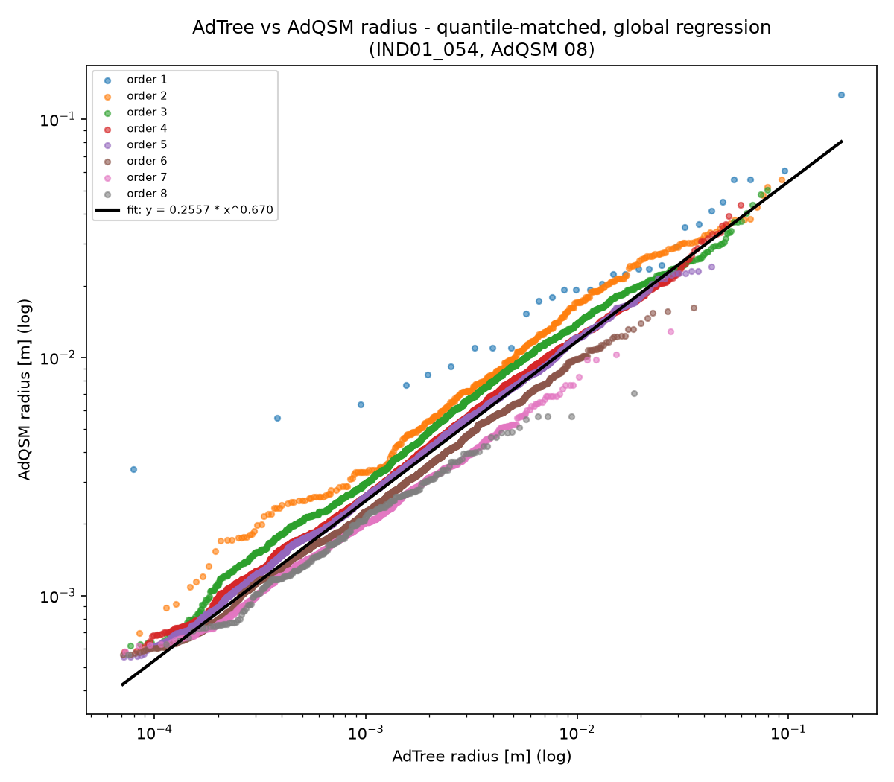
Figure 1. AdTree vs. AdQSM radius, quantile-matched, single global fit. Colour = branch order.
The diagnostic plot revealed a systematic order-dependent bias the single curve cannot capture: orders 1–3 (thick, trunk-adjacent branches) sit visibly above the fitted line, while orders 6–8 (thin, high-order twigs) sit below it. Because the ≥10cm comparison is dominated by order-1/2 cylinders, the global fit — pulled toward the numerically dominant thin orders — under-corrects exactly the branches that matter most: ≥10cm branch volume came out at 0.037 m³, the worst result of every method tested.

4.2 Per-order regression — adopted method
A separate power-law curve was fit per branch order (sparse orders below a minimum pair-count threshold are merged upward with the next order; this merge was not triggered for any order in this tree). This respects the order-dependent behaviour the global fit missed, while remaining a smooth, robust fit — unlike interpolation (below), it is not swayed by noise or measurement-precision artifacts in any single data point.
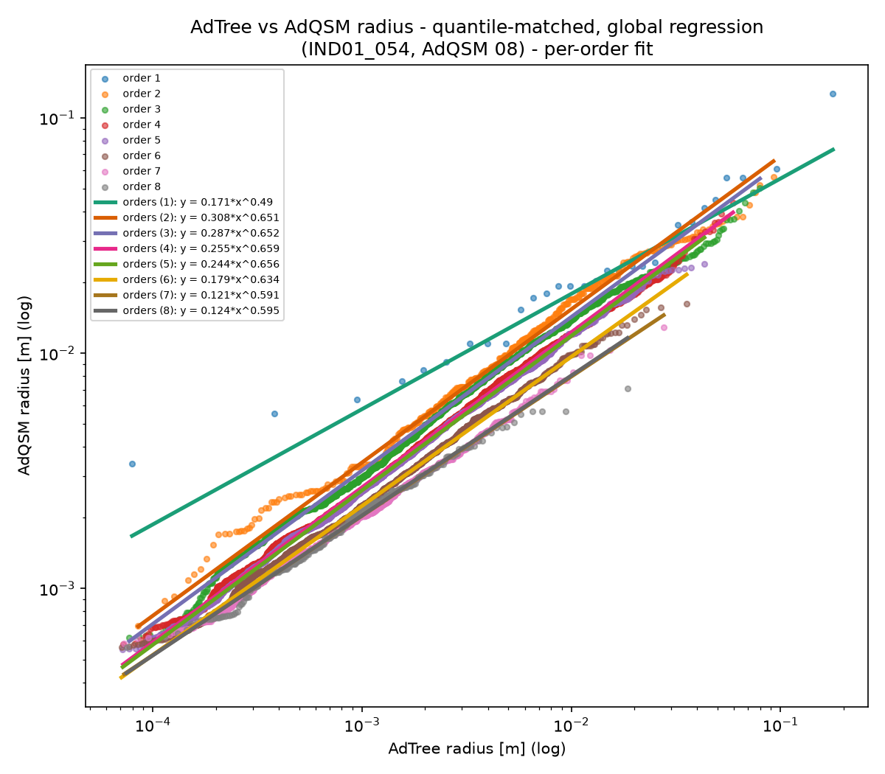
Figure 2. Per-order fit: one curve per branch order (or merged group of orders).
Result: ≥10cm branch volume = 0.087 m³, an improvement over the global fit. This is the calibration method adopted going forward: it is the most methodologically defensible of the curve-based approaches — order-aware, robust to local noise, and not reliant on an arbitrary population-truncation choice the way the median-ratio approach was.

4.3 Per-order interpolation — tested and rejected
As an alternative to fitting a parametric curve, a monotonic interpolator (PCHIP) was tested, passing exactly through every quantile-matched point instead of approximating them. This exposed a data-quality issue: AdQSM's own reported per-branch diameters contain many repeated (tied) values — evidently a limited-precision artifact of AdQSM's own output, not real signal. Because an exact interpolator must pass through every point, repeated values force artificial flat ‘shelf’ segments followed by sharp jumps.
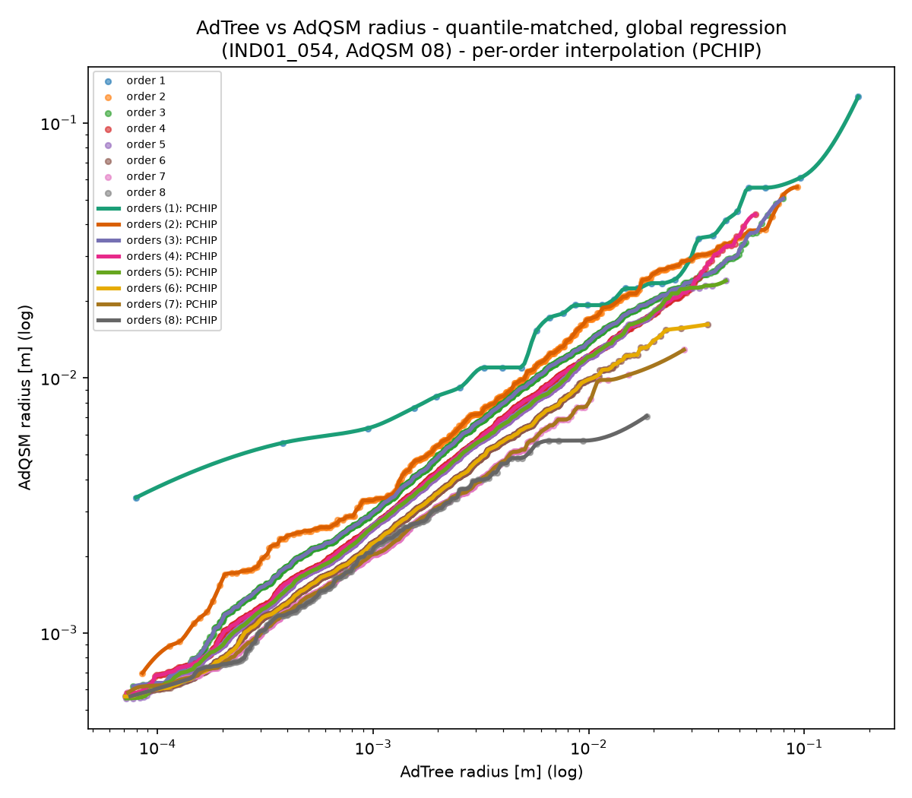
Figure 3. Per-order PCHIP interpolation — note the stair-step artifacts in the order-1 curve, caused by tied AdQSM values.
Result: ≥10cm branch volume = 0.125 m³ — numerically closer to the reference than the global fit, but rejected as a calibration method because it bakes AdQSM's own measurement-precision noise directly into the calibration curve. Regression's smoothing is preferred precisely because it does not do this.

5. Results comparison
Method | branch_m3 (≥10cm dia. only) | Stable across RADIUS_THRESHOLDS?
Old (threshold-coupled, buggy) | 0.020 – 0.647 (varies with pruning) | No
calref=min5mm (fixed-reference median ratio) | 0.196 | Yes
Global regression (all orders pooled) | 0.037 | Yes
Per-order regression — adopted | 0.087 | Yes
Per-order interpolation (PCHIP) | 0.125 | Yes
Destructive reference (field measurement) | 0.461 | —

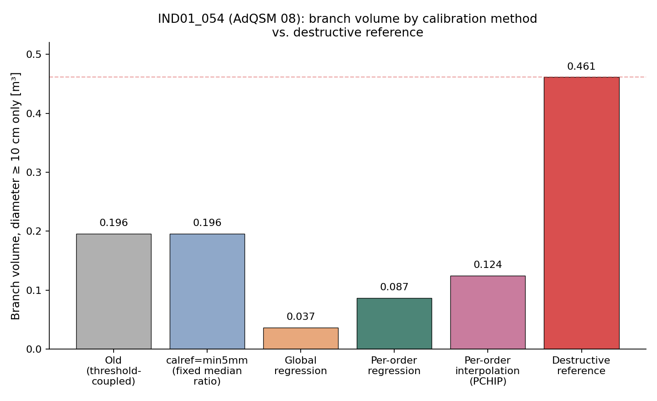
Figure 4. Branch volume (≥10cm diameter) by method, IND01_054 / AdQSM variant 08, against the destructive-reference line.

6. Interpretation: closeness to the reference is not, by itself, validation
The fixed-reference median-ratio method (calref=min5mm) numerically lands closest to the destructive reference among the tested alternatives (0.196 vs. 0.461 m³). Inspecting the underlying quantile-matched pairs for order 1 individually showed why: the median ratio (≈1.6) is computed from the middle of that order's size distribution, but the branches that actually populate the ≥10cm class have a directly observed ratio closer to 0.65–1.0. Applying the median's larger ratio to those branches over-corrects them — and because volume scales with radius squared, this over-correction is amplified. The median method's apparent accuracy is likely a coincidental partial cancellation between an over-correction in calibration and a separate, unrelated under-count in reconstruction completeness — not evidence that the calibration itself is correct.
None of the tested calibration methods closed the gap to the 0.461 m³ reference. The remaining shortfall (roughly 2–5×, depending on method) most plausibly reflects a reconstruction-completeness limitation shared by AdTree and/or AdQSM — branches not fully resolved in the crown above the first major fork — rather than a remaining flaw in how the radius calibration curve is shaped. This is a separate, previously identified open item, not something a radius-calibration curve can fix by construction: no rescaling of existing cylinders can add volume for branches that were never reconstructed in the first place.

7. Decision
- Per-order regression is adopted as the primary calibration method going forward (smooth, order-aware, robust to per-branch measurement noise).
- The fixed-reference median-ratio method (calref=min5mm) is retained as a secondary/backup reference point for comparison, given its simplicity — not as the primary calibrated output.
- Global regression and per-order interpolation are not carried forward as calibration methods, based on the findings above.
- The residual gap to the destructive reference is treated as a separate, open reconstruction-completeness question, to be investigated independently of radius calibration.

8. Addendum: radius-statistic weighting corrects a resampling-density bias
Across a 9-combination sweep of the adaptive resampling settings (SEG_LEN_MIN, SEG_LEN_K — the parameters controlling how densely the AdTree skeleton is resampled into cylinders), raw AdTree volume varied by only 0.34% between the extremes, while the adopted per-order-regression calibrated volume (Section 4.2) varied by 33.6% over the same sweep. A purely representational choice — how finely a branch is discretised into cylinders — was changing the calibrated answer, even though the tree being described was unchanged.
The cause traced to how the per-order radius statistics behind both calibration methods are computed. build_quantile_matched_pairs() (the quantile-matched pairs feeding the per-order regression) and compute_order_calibration_factors() (the calref=min5mm median ratio) both treat each AdTree cylinder as one sample, regardless of its length. The adaptive resampling target length is proportional to radius in the linear region (length = SEG_LEN_K × radius, so cylinders per metre of branch scales as 1/radius) and clamped to a constant floor below a break radius. Changing SEG_LEN_MIN or SEG_LEN_K therefore changes how densely different radius ranges are sampled into cylinders — reweighting the per-order radius distribution the statistic sees, without changing the branch it describes.
Evidence: between two SEG_LEN settings whose per-order total cylinder length and volume agreed to within 1% (confirming the underlying geometry was unchanged), order 1's median AdTree radius shifted by 39% when computed unweighted, versus 0.15% when each cylinder was weighted by its own length.

8.1 Fix: optional length weighting
Both functions gained an optional weighting parameter (“none” | “length”), additive and backward-compatible: the default (“none”) reproduces today's behaviour exactly, byte-for-byte, and every existing row/output is unaffected. Under “length”, each cylinder's contribution to the per-order statistic is weighted by its own length instead of counted once regardless of length, using a plain cumulative-weight interpolation (no new dependency). adtree_reconstruct_compare.py now computes BOTH variants in every run, writing each to its own distinct row/filename (a “-wlen” tag), so neither overwrites the other.
Result: over the same two extreme SEG_LEN cases, the per-order-regression spread fell from 29.5% to 0.61% (branch volume alone: 50.4% to 0.95%); the calref=min5mm spread fell from 15.4% to 0.17%. For comparison, the raw AdTree control (geometry only, unaffected by calibration) sits at 0.10% — length weighting brings both calibration methods to within the same order of magnitude as that control, from being 30–150× larger than it.

8.2 Limitation: the fix is not uniform across branch orders
Length weighting does not improve every order equally. Comparing the fitted per-order regression coefficients between the same two SEG_LEN cases, the ratio moves toward 1 (i.e. more stable) for orders 1 through 5 under weighting, but away from 1 for orders 6 and 7 (order 7: 1.053 unweighted → 1.105 weighted). Those two orders together carry only about 3.2% of total branch volume, so the aggregate result above is unaffected — but the mechanism should not be described as fixing every order uniformly; it does not.

8.3 Open question: does AdQSM's branch order match AdTree's?
While investigating this, branch orders 8 and above were found to receive no calibration at all from either method, for a structural reason unrelated to weighting: this AdQSM variant's BranchStructure.txt has no rows for those orders, so build_quantile_matched_pairs() has nothing to match them against. Those cylinders retain their raw AdTree radii via the existing “leave unscaled” fallback. They account for a small share of volume (0.35% of the whole tree) but a disproportionate share of branch length (22.97%) — most of the tree's fine branching structure, by length, is currently uncalibrated. Whether AdTree and AdQSM define “branch order” the same way is an open question, not investigated as part of this addendum, and is recorded here for future follow-up rather than answered.

8.4 Decision
- Length weighting is adopted as an available, optional radius-statistic mode for both calibration methods — additive, not a replacement.
- The unweighted variant is retained, not removed, and continues to run alongside the weighted variant in every reconstruction, as a comparison baseline while further beech trees are processed.
- The order-6/7 exception (Section 8.2) is accepted as a known, documented limitation, not grounds to withhold the fix from the well-populated orders where it demonstrably works.
- Whether AdQSM and AdTree branch orders correspond one-to-one (Section 8.3) is left open for separate investigation; it is independent of the weighting question and should not block adopting length weighting.

