WORLD ROBOT OLYMPIAD 2026
Future Engineers Category

Technical Engineering Documentation

Team Name | Superiores Junior
Country/Region | México
Team Members | Arlee, Arath, Alexis
Coach | Eduardo Alvarado González
Age group | Future Engineers (14–22)
Season | WRO 2026
Repository GitHub | https://github.com/barbaraarlee1726-dot/WRO-2026-Superiores-Junior

Summary.

This document presents the technical engineering documentation for the Superiores Junior's autonomous vehicle developed for the WRO Future Engineers 2026 competition under the theme “Robots Meet Culture.” The report covers the mechanical design and chassis, the power and sensor architecture, the software strategy and obstacle avoidance logic, system-level engineering decisions, and reproducibility via the team’s GitHub repository. All design decisions are justified through iterative testing and data-driven trade-off analysis.
I. MOBILITY AND MECHANICAL DESIGN

We choose a medium EV3 motor, we implement a steering system for using only 1 motor to give more speed in all the robot, our design consists of a strong chassis, taking advantage of our height.

A. Chassis Design
We chose a steering system for our robot, our robot takes advantage of the height, that´s why we use a steering system for a strong and fast robot. Our chassis is strong and resistance to support all the weight.
.

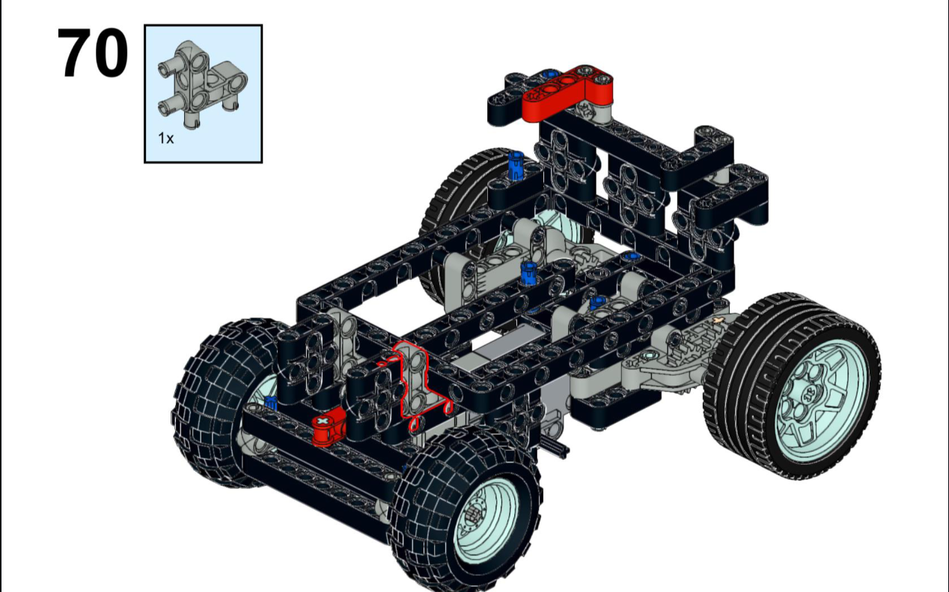

B. Steering Mechanism
We use a different type of steering system that is much more efficient and faster, handles much better, and doesn't get stuck

C. Mechanical Stability and Iterations
The stability of our robot is largely due to our chassis and steering design.
II. POWER ARCHITECTURE AND SENSORS

A. Power System Design
We use two rechargeable 18650 Li-ion batteries, each with a capacity of 3.7 V and 2,200 mAh, which power the robot and its electronic components.
B.Selection and Justification of Sensors
Our main camera was a DFRobot Husky Lens; we chose it because of its advanced AI system, which simplifies programming and object detection. We used ultrasonic sensors because of their simplicity and compact size.

C. Weaknesses and Mitigations
When we first started programming our sensors, their extremely high sensitivity caused them to behave erratically and unpredictably; additionally, because the robot was heavier than usual, its speed was reduced.
III. REPRODUCIBILITY AND QUALITY ON GITHUB

A. Estructura del Repositorio
We have structured our entire GitHub repository very similarly to the teachers', including the following items (as well as 2D and 3D models)
Contents:-Project Overview-Vehicle Photos-Components and Hardware-Mobility-Management-Chassis-Steering System-Movement and Traction System-Differential-Documentation-Power and Sense Management-Power Management-Sense Management-Obstacle Management-WRO 2026 Competition Info.

B. Summary of the Breeding Guide
The steps would be to build the robot's chassis using the guide in the “Models” section, 3D print the parts, purchase the electronic components, and assemble them (Components and Hardware). Finally, upload the src code.
VI. CONCLUSION
In conclusion, from my perspective, the most important thing for me was committing to completing the challenge, learning new things, and above all, working as a team and thinking outside the box.

Acknowledgments:
The team would like to thank Eduardo Alvarado González for his guidance throughout the season, Normal Superior Moises Sáenz for providing the facilities, and [any sponsors/mentors].

