**Supplement 6: Differences between men and women in highest ranked metabolites in the prediction for sex**

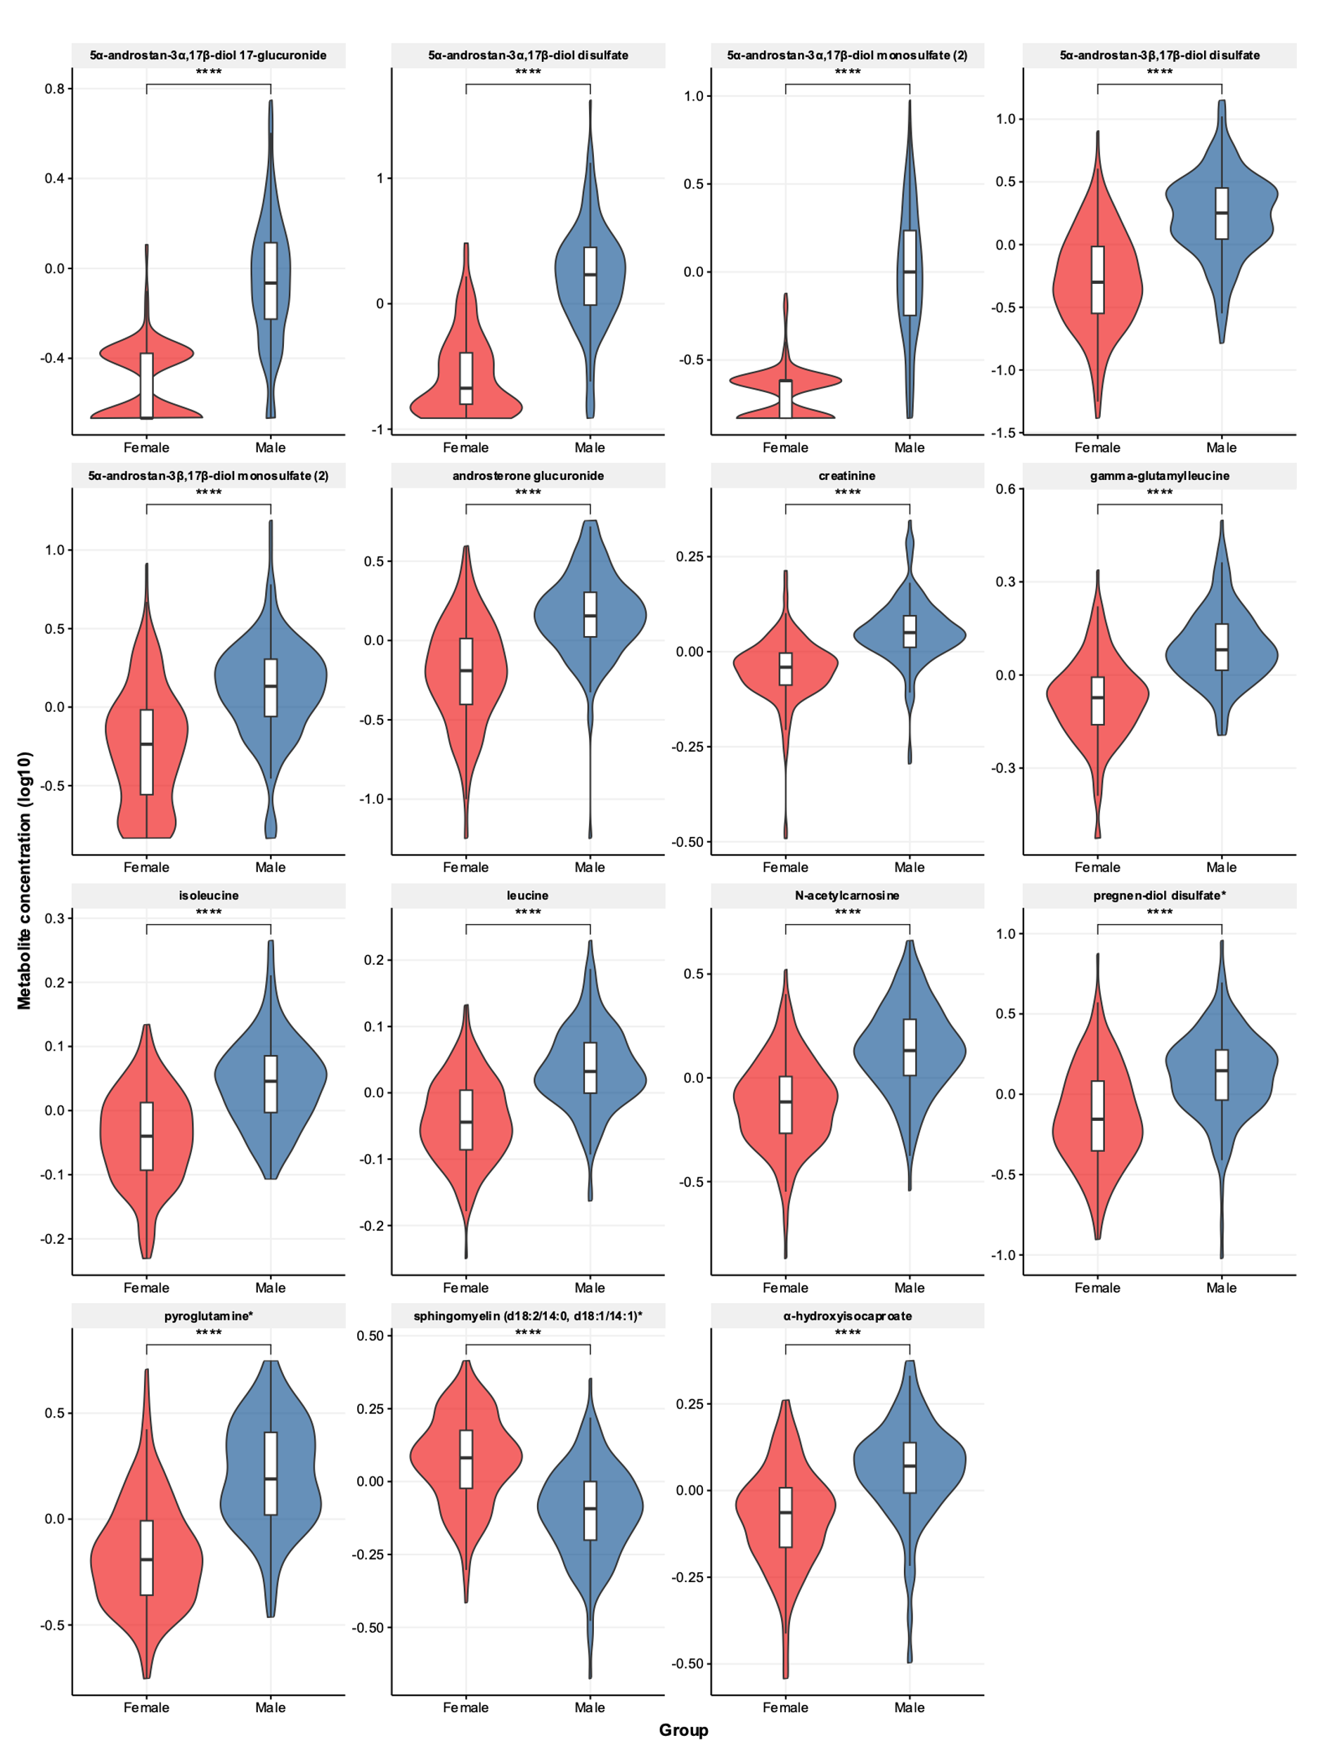

Differences in metabolite concentrations (log10 scale) between men and women. Metabolite levels were log10-transformed since some of these metabolites had a nonnormal distribution. All differences between men and women were very significant, **** = p-value < 1*10-15 using Mann-Whitney U tests.