File permissions in Linux

Project description
The research team at my organization needs to update the file permissions for certain files and directories within the projects directory. The permissions do not currently reflect the level of authorization that should be given. Checking and updating these permissions will help keep their system secure. To complete this task, I performed the following tasks:

Check file and directory details.
To check the permissions assigned to all the files in the “Projects Directory”, I first changed directory to the projects directory using the command “cd projects”. Then I use the command “ls -la” to list the permissions of all files including hidden files. Please see Screenshot below:
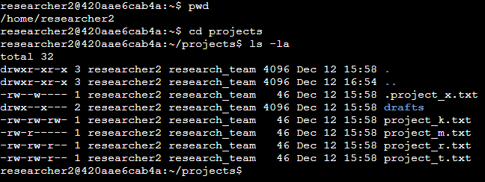

Describe the permissions string.
Note: The 10-character string shows the permissions set for the directory of file or directory. for example, “drwxrwxrwx”.
1st Character d = this shows that this is a directory, a file will be represented by -.
2nd – 4th Characters rwx = shows r = read, w = write and x = execute permissions for the user.
5th – 7th Characters rwx = shows r = read, w = write and x = execute permissions for the group.
8th – 10th Characters rwx = shows r = read, w = write and x = execute permissions for others.

In the /home/researcher2/projects directory, there are five files with the following names and permissions:
- project_k.txt
Permissions: -rw-rw-rw-
  - User = read, write,
  - Group = read, write
  - Other = read, write
- project_m.txt
Permissions: -rw-r-----
  - User = read, write
  - Group = read
  - Other = none
- project_r.txt
Permissions: -rw-rw-r--
  - User= read, write
  - Group = read, write
  - Other = read
- project_t.txt
Permissions: -rw-rw-r--
  - User = read, write
  - Group = read, write
  - Other = read
- .project_x.txt
Permissions: -rw--w----
  - User = read, write
  - Group = write
  - Other = none
There is also one subdirectory inside the projects directory named drafts. The permissions on drafts are:
Permissions: drwx—x---
- User = read, write, execute
- Group = execute
- Other = none
See screenshot below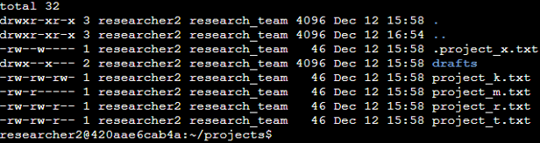

Change file permissions.
Based on the file permissions, project_k.txt has write permissions for “other”. The organization does not allow “other’ to have write access to any file. The file was therefore modified to remove write access to “other” using the command “chmod o-w project_k.txt”. I ran an “ls -la" to confirm the permissions have been changed successfully.
NOTE: chmod is a linux command used to modify and change permissions on files and directories.
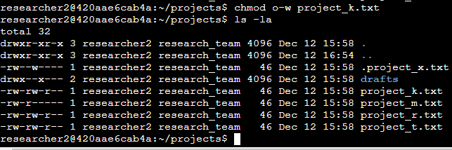

Change file permissions on a hidden file.
The research team has archived .project_x.txt, which is why it’s a hidden file. According to the Organization, this file should not have write permissions for anyone, but the user and group should be able to read the file. The permissions set shows that the user and group have write permissions which is a security risk. I run a “chmod u-w,g+r,g-w .project_x.txt” this command removed the write permission from the user , added read permission to the group and removed the write permission from the group simultaneously. The user already had read permissions, so I didn’t need to modify it. I finished by confirming this was completed by running ”ls -la”
NOTE: ls -la command is used to list permissions for regular files and hidden files.
ls -l is command is used to list permissions for files and directories

Change directory permissions.
The organization policy states that only researcher2 should be allowed to access the drafts directory and its contents. However, permissions set shows that the group has execute access. The permissions were modified to remove execute access from the group with the command “chmod g-x drafts” as shown below:

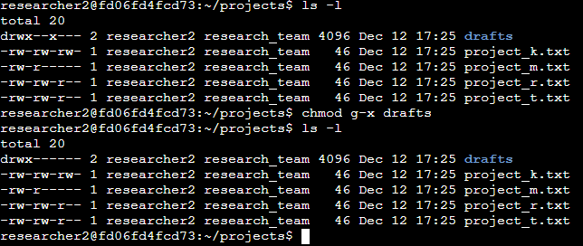

Summary
I changed multiple permissions to match the level of authorization my organization wanted for files and directories in the projects directory. The first step in this was using ls -la to check the permissions for the directory. This informed my decisions in the following steps. I then used the chmod command multiple times to change the permissions on files and directories.

