Apply filters to SQL queries

Project description
My organization is working to make their system more secure. It is my job to ensure the system is safe, investigate all potential security issues, and update employee computers as needed. The following steps provide examples of how I used SQL with filters to perform security-related tasks.

Retrieve after hours failed login attempts.
I discovered a potential security incident that involved login attempts and employees’ machines. Upon intial investigations I realized the incident occurred after business hours. To further investigate this, I run queried the log_in_attempts table and reviewed after hours login activity. I used the query below to identify all failed login attempts that occurred after 18:00. I started by selecting all data from the log_in_attempts table. Then, I used a WHERE clause with an AND operator to filter my results to output only login attempts that occurred after 18:00 and were unsuccessful. The first condition is login_time > '18:00', which filters for the login attempts that occurred after 18:00. The second condition is success = FALSE which filters for the failed login attempts which is represented by 0 in the table.

SELECT *
FROM log_in_attempts
WHERE login_time > '18:00' AND success = 0;
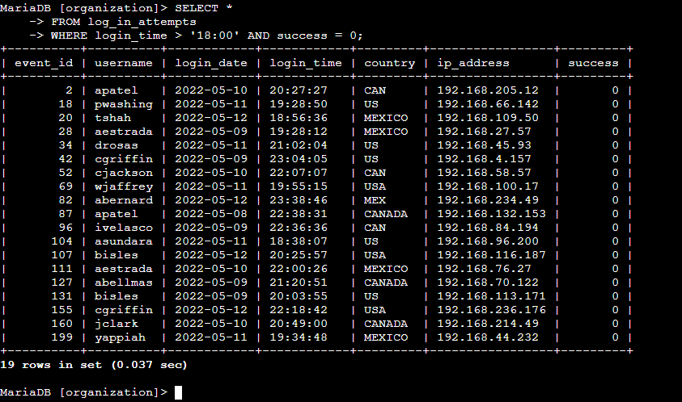

Retrieve login attempts on specific dates.
A suspicious event occurred on 2022-05-09. To investigate this event, I reviewed all login attempts which occurred on this day or the day before. I created the query below that identifies all login attempts that occurred on 2022-05-09 or 2022-05-08.I started by selecting all data from the log_in_attempts table. Then, I used a WHERE clause with an OR operator to filter my results to output only login attempts that occurred on either 2022-05-09 or 2022-05-08. The first condition is login_date = '2022-05-09', which filters for logins on 2022-05-09. The second condition is login_date = '2022-05-08', which filters for logins on 2022-05-08.

SELECT *
FROM log_in_attempts
WHERE login_date = '2022-05-09' OR login_date = '2022-05-08';
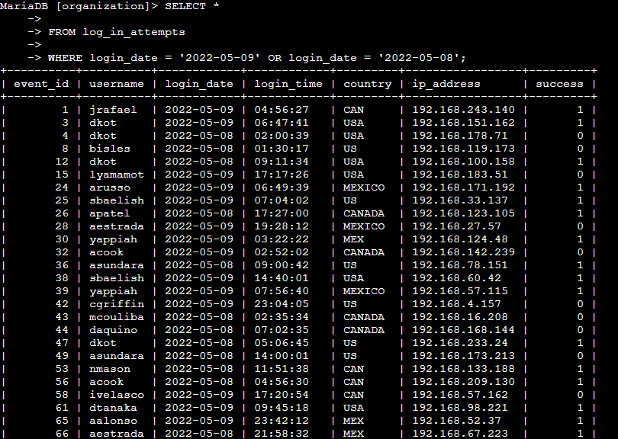

Retrieve login attempts outside of Mexico.
The team has determined that this activity didn't originate in Mexico. I investigated the login attempts that occurred outside of Mexico. To do this, I used filters in SQL to create a query that identifies all login attempts that occurred outside of Mexico. I started by selecting all data from the log_in_attempts table. Then, I used a WHERE clause with NOT to filter for countries other than Mexico. I used LIKE with MEX% as the pattern to match because the dataset represents Mexico as MEX and MEXICO. The percentage sign (%) represents any number of unspecified characters when used with LIKE.
See Query below:

SELECT *
FROM log_in_attempts
WHERE NOT country LIKE 'MEX%';
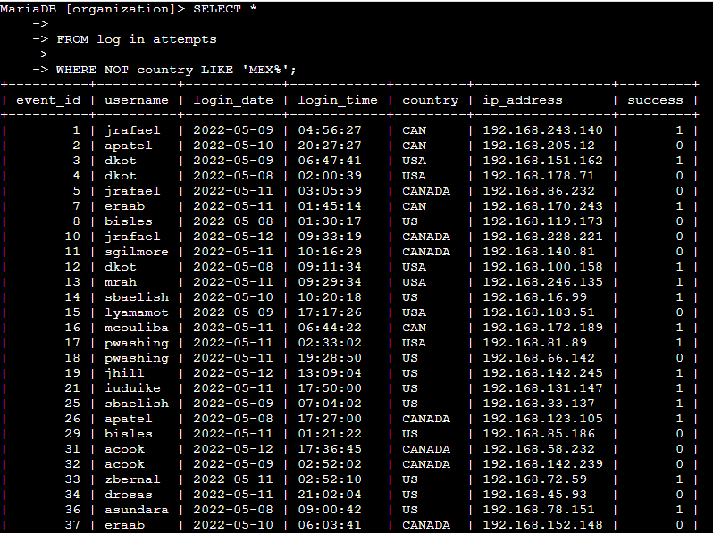

Retrieve employees in Marketing.
My team wants to perform security updates on specific employee machines in the Marketing department. I am responsible for getting information on these employee machines and will need to query the employees table. I used filters in SQL to create a query that identifies all employees in the Marketing department for all offices in the East building.
Some examples of values in this column are East-170, East-320, and North-434. I used the following query incorporating the LIKE keyword with % to filter for the East building.) I started by selecting all data from the employees table. Then, I used a WHERE clause with AND to filter for employees who work in the Marketing department and in the East building. I used LIKE with East% as the pattern to match because the data in the office column represents the East building with the specific office number. The first condition is the department = 'Marketing' portion, which filters for employees in the Marketing department. The second condition is the office LIKE 'East%' portion, which filters for employees in the East building.

SELECT *
FROM employees
WHERE department = ‘Marketing’ AND office LIKE 'East%';
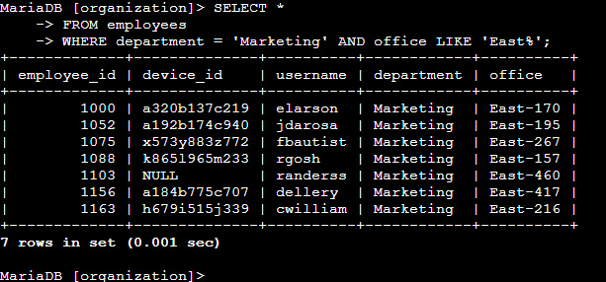

Retrieve employees in Finance or Sales.
The team now needs to perform a different security update on machines for employees in the Sales and Finance departments. I used filters in SQL to create a query that identifies all employees in the Sales or Finance departments. I run the query below to achieve this. I started by selecting all data from the employees table. Then, I used a WHERE clause with OR to filter for employees who are in the Finance and Sales departments. I used the OR operator instead of AND because I want all employees who are in either department. The first condition is department = 'Finance', which filters for employees from the Finance department. The second condition is department = 'Sales', which filters for employees from the Sales department.

SELECT *
FROM employees
WHERE department = ‘Finance’ OR department = 'Sales';
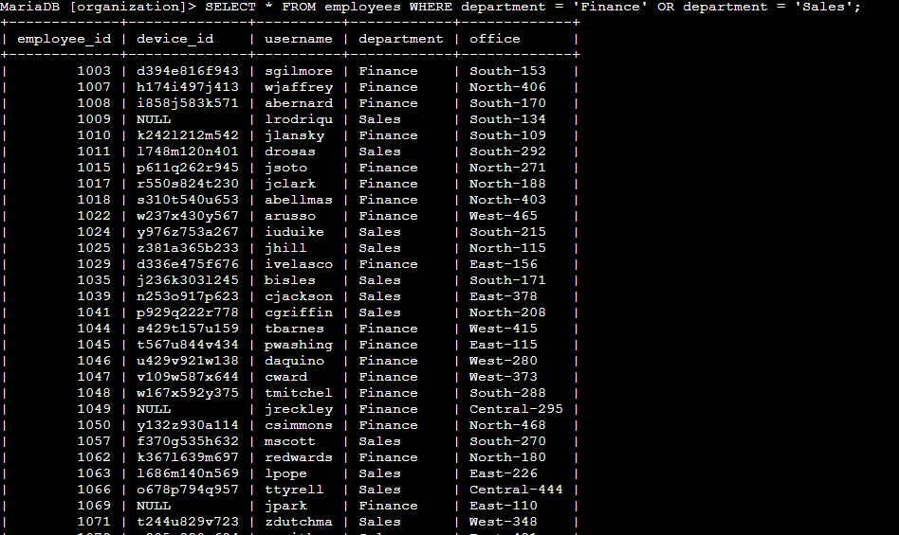

Retrieve all employees not in IT
The team needs to make one more update to employee machines. The employees who are in the Information Technology department already had this update, but employees in all other departments need it. I used filters in SQL to create a query which identifies all employees not in the IT department. (The department of the employee is found in the department column, which contains values that include Information Technology.) I run the command bellow using the operator ‘!=’ to filter all departments except “Information Technplogy’

SELECT *
FROM employees
WHERE department != ‘Information Technology’;
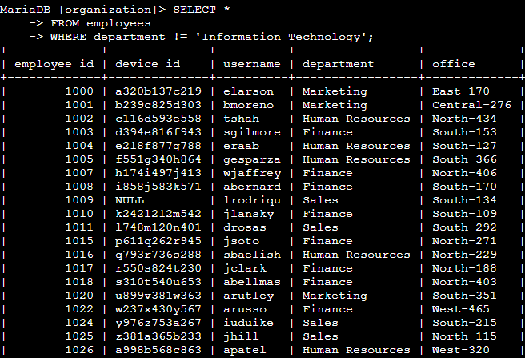

Summary
I applied filters to SQL queries to get specific information on login attempts and employee machines. I used two different tables, log_in_attempts and employees. I used the AND, OR, and NOT operators to filter for the specific information needed for each task. I also used LIKE, != and percentage sign (%) wildcard to filter for patterns.

