DCA EPMS Browser Access Guide

# References

## Authorization

## Training/Certification

## Equipment/Information

## Policies

## Related Procedures

# Security Considerations

# Procedure(s)

Please note, screen captures are representative and not specific to this project.

* Internet Browser: The Schneider Electric PowerLogic EPMS requires the use of Microsoft Internet Explorer. Do not use other browsers.
* Accessing the EPMS
  + Type in the EPMS server IP address including “/citect” at the end.
  + Example: <http://192.168.0.0/citect> (this is not the actual address)
* CAB file: The EPMS requires installation of a Cab file to function.
  + This will occur automatically when you type in the server IP address to access the EPMS. You will receive security warnings. You will have to type in a Windows admin user level user name and password for the local computer to allow the installation of the Cab file to proceed.
  + To verify that the Cab file is installed
    - Open the Windows Control Panel
    - Open Program and Features
    - Look for a program called, Citect Web Client 7.20
* Trusted Sites: If you are unable to load the file or the EPMS “site” is blocked, try making it a Trusted Site within Microsoft Internet Explorer.
  + From within Internet Explorer click on the gear below the red X in the upper right corner.
  + Choose Internet Option, likely the second from the bottom choice.
  + A new window with multiple tabs across the top will open, choose the Security tab.
  + Choose (click once) on the Trusted Sites (green check mark image) option.
  + Click on the Sites button.
  + In the new window that opens, type in the DCA EPMS server address, starting with http:// into the blank labeled as, “Add this website to the zone:”
  + Click the Add button.
  + Do NOT check the box for, “Require server verification…”
  + Click the Close button and that window will close.
  + Click the Apply button and then the OK button and the Internet Options window will close.
  + Close and reopen Internet Explorer.
  + Type in the EPMS server address ending with “/citect” to verify system access.
  + If a popup window prompts for a username and password, type in the EPMS server Windows account information. If it is your first login you may be forced to change your password.
* Problems: If you experience difficulties or for further assistance contact the Amazon IPS-Controls team.
  + Current team members supporting the project are the team manager Bill Bauerle and Controls Engineer Brian Bacon.

Screens showing navigation to the Control Panel and installed programs to verify Cab file installation:

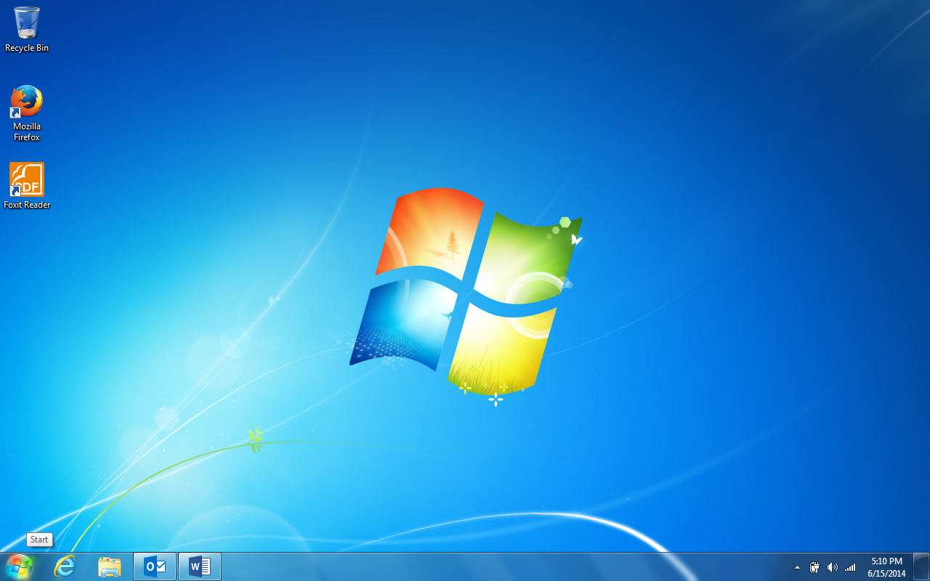

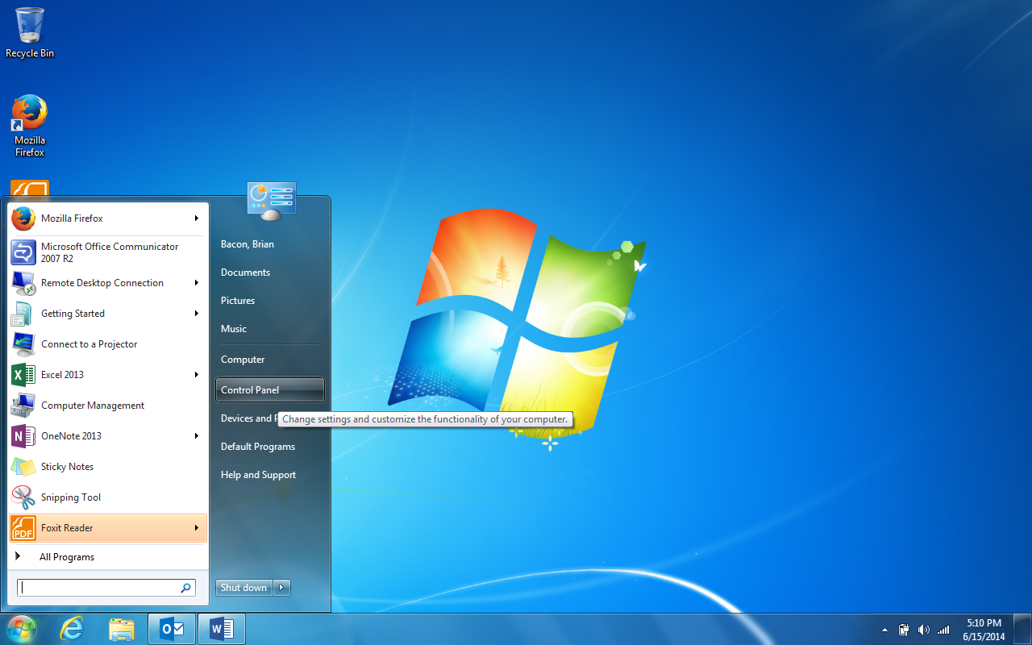

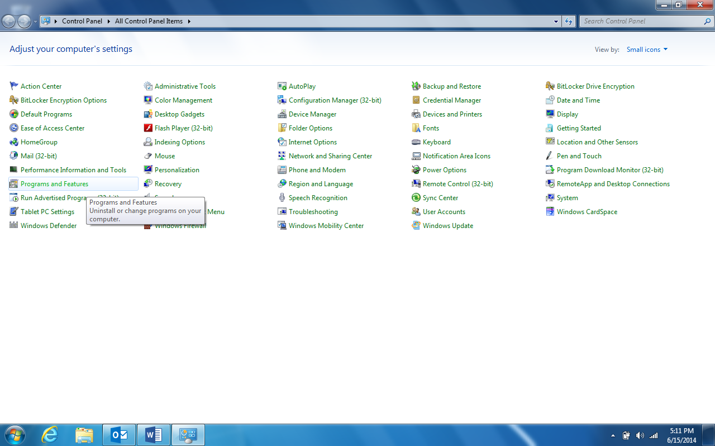

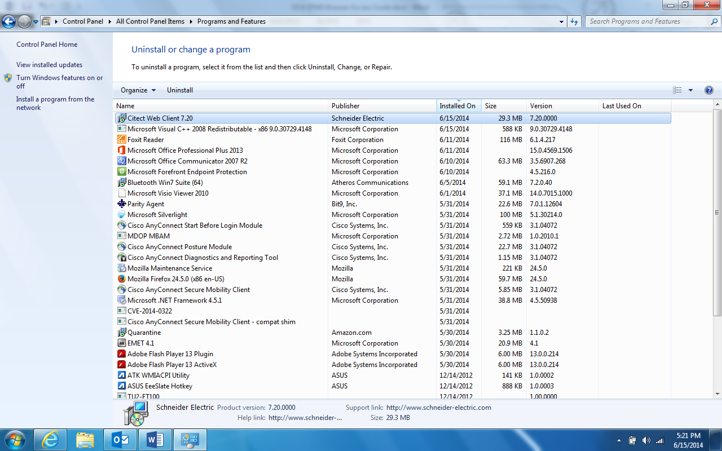

Screens showing navigation to Internet Options and Trusted Sites setup:

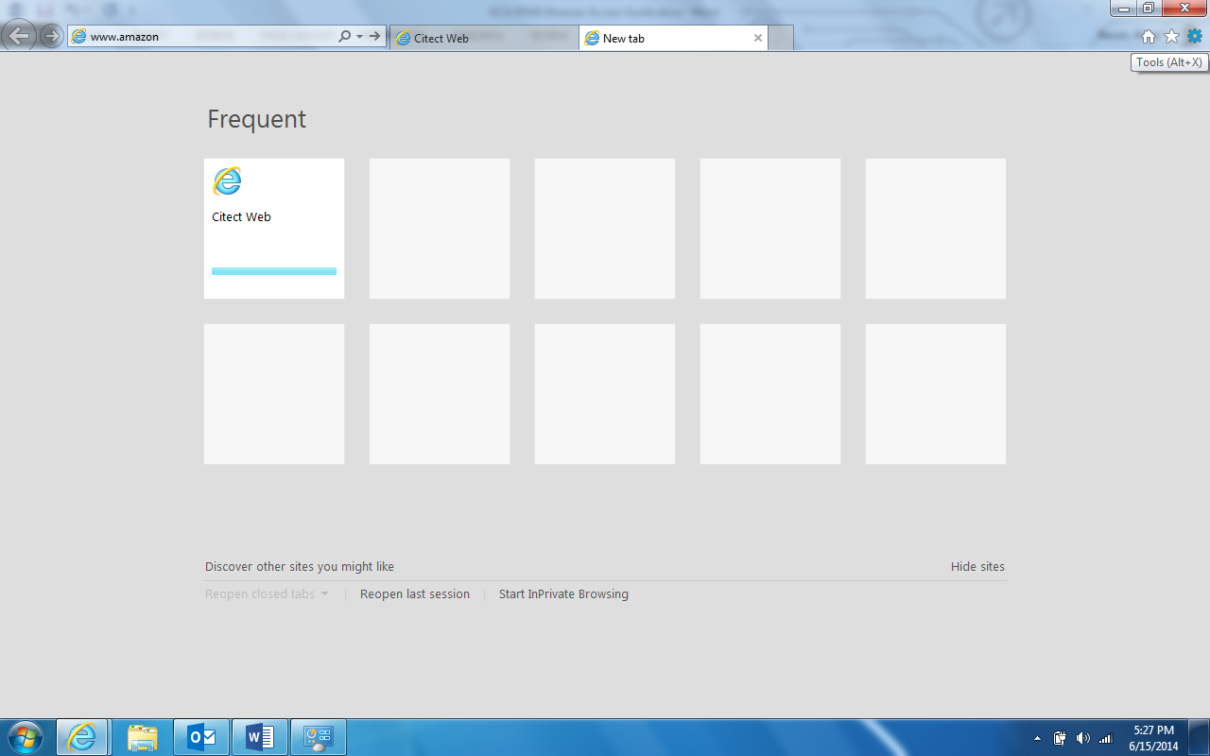

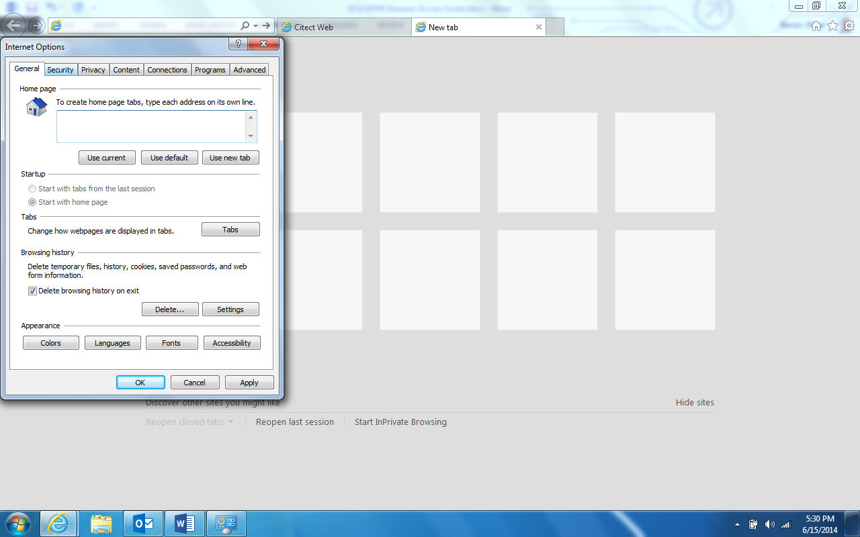

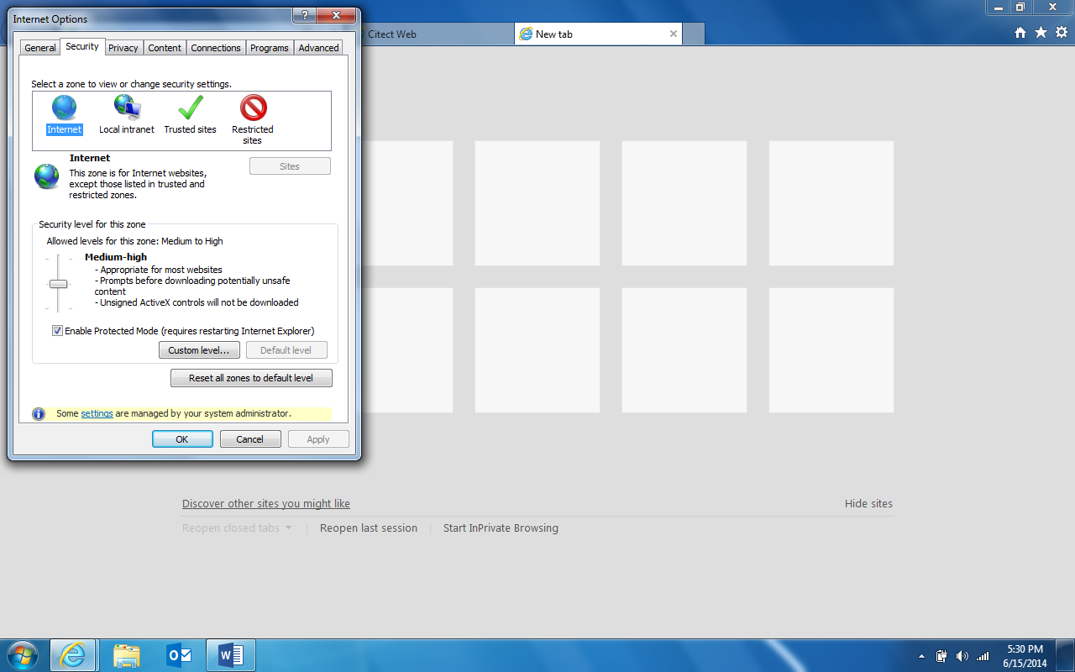

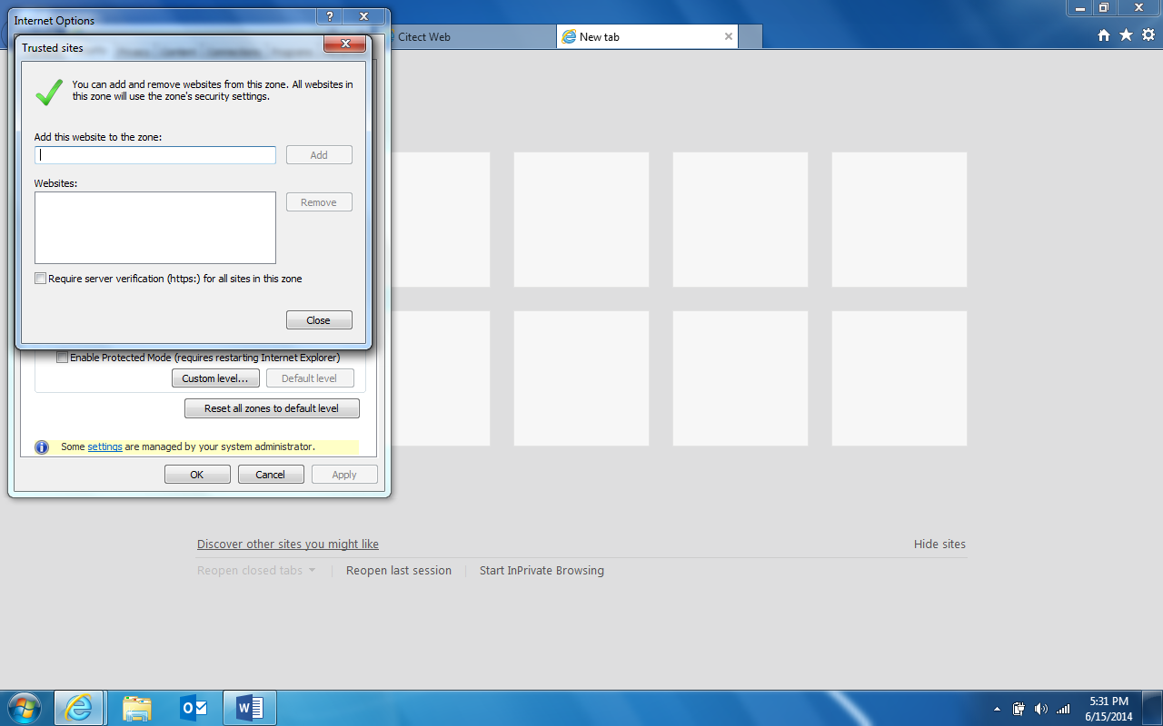

Screens showing access to the PowerLogic EPMS. (not actual examples from this project):

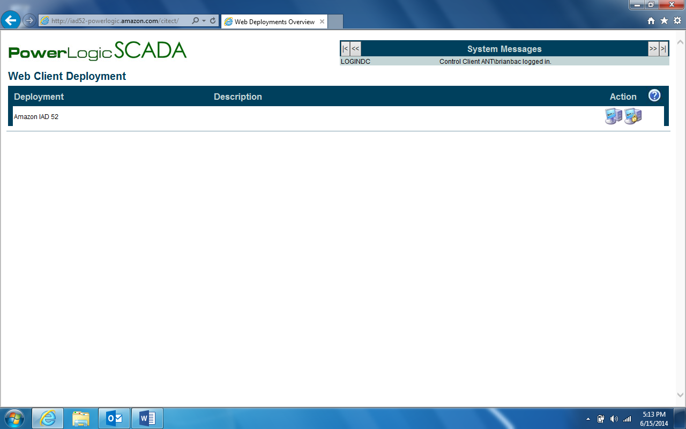

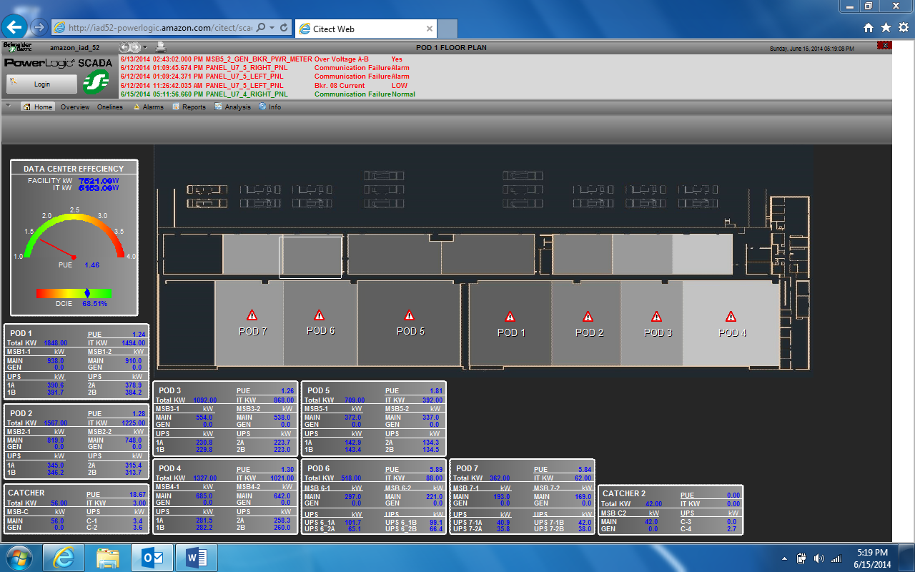

## Document Properties

|  |  |
| --- | --- |
| **Property** | **Value (replace explanation text with info)** |
| Site Code | DCA<#> |
| Filename | The EOPs and SOPs currently follow the format <scope>_<docType>_<description>. For example pdx_eop_rack-down |
| Title | For example, the Title for the filename above is "Emergency Operating Procedure Rack-Down Event" |
| Version number/Date version published | This may be automatically generated as a property of the doc (if it's in version control) or it may need to be added manually. |
| Doc Type | SOP/EOP/Checklist/Admin Practice/Form/Informational/Reference |
| Zone | What's the scope of the doc: Global, Regional, Cluster, Site |
| Technical Owner | Each doc needs an owner who is responsible for creating the draft and revising it as necessary. |
| Technical Writer | There should be a specific person from the publication side to manage the workflow, reporting, and publishing for each doc. |
| Affected Equipment | If we had a flag raised on a piece of equipment in an Agile, should this doc change? If so, list that equipment here. |
| Sensitivity rating | Public, Confidential, Highly Confidential, Critical. This might have to change for MVP. |
| Origin | Where did the "original" come from? For example, is it an MVP flavor of a commercial doc or is it from scratch.   * MVP Original * DCGS Unchanged * DCGS Changed * W * Twiki |
| URL | Where can techs view the most current version of the doc |
| Physical location | Where does the authoritative version of the doc live (eventually this is expected to be in Agile) |
| Audience | What role is this intended for. Data Tech, Electrical Engineer, Vendor, etc. |
| Renewal date | The date by which this doc should be reviewed by the technical owner (each month, each year, etc.) |
| Special requirements | What PPE is required for this work? |
| Safety considerations | What are the possible hazards the employee might be at risk of. |
| Physical requirements | Climb a ladder, lift over 50 lb., etc. |

## Status

|  |  |  |
| --- | --- | --- |
| **Status** | **Date mm/dd/yy** | **Approver/Reviewer Name** |
| Original filed |  | NA |
| Writer sent to SME for review |  | NA |
| SME sent to Writer |  | NA |
| Writer sent to SME for approval |  | NA |
| SME approved |  |  |
| Writer copy edited |  | NA |
| Site Manager approved |  |  |
| Regional Manager approved |  |  |
| Writer published |  | NA |