Site Maintenance

This document details AWS C2S FIL site maintenance scope and responsibilities between Sponsor (WTC) and AWS C2S data center support personnel. AWS maintains two (2) Forward Installation Location (FIL) sites on WTC property (DCA50, DCA51) and staffs these facilities with DataTechs (DTs) and Engineering Operations Technicians (EOTs). These personnel are responsible for the AWS facilities maintenance and ensuring operational capacity. As a WTC facility tenant, AWS will rely on WTC resources for access to the work site and general maintenance of the FIL pad security, drive path, and surrounding environment. All issues or events encountered will be coordinated through the WTC Service Desk by onsite AWS C2S DTs and EOTs.

# References

## Authorization

AWS C2S FIL unescorted access

WTC Site access

## Training/Certification

AWS Data Center Safety

Equipment appropriate (Kubota, chainsaw, etc)

## Equipment/Information

Fall protection (as necessary)

Personal protection (eye, hearing, impact (shoes/helmets), safety vests)

AWS-provided equipment (trash bags, shovels, buckets, chainsaws, snowblowers)

DCA Emergency Contact List

## Related Procedures

DCA Emergency Response Plan

DCA Site Notification

AWS Data Center Safety

# Security Considerations

AWS C2S Personnel actively performing site maintenance activities will NOT escort uncleared personnel or vendors during their activity.

# General Site Maintenance

General site maintenance will include typical, non-event based activities performed on an as-needed basis. AWS C2S personnel will be directly responsible for all AWS-provided equipment placed on the FIL pad and will have no expectation of the Sponsor or WTC resources to provide support for those resources. AWS C2S personnel will continually monitor all FIL pad resources and report to WTC Service Desk any issues that require attention. Please reference the attached ‘Bravo’ and ‘Delta’ site maps— resources and space OUTSIDE of the red box is considered WTC-responsibility (everything INSIDE of the red box is AWS responsibility). At this time, AWS C2S will assume that WTC personnel have authority over the following general site maintenance duties:

* WTC site access (gates, roads)
* C2S FIL pad access (gate, drive path)
* Green-space maintenance
* Animal control (i.e. deer and other animals inside fence line)
* Fence maintenance
* Pad lighting (pole-based, free standing—not associated with Perdix structures)
* Pad drainage (prevent pad flooding)
* Easements to demarcation shacks
* FIL pad primary transformer service and maintenance

Typical worst case scenarios include trees falling on the fences, heavy rains causing water buildup/flooding on the pad, or deer getting corralled inside the fence line—all cases in which AWS C2S would report the event to WTC Service Desk for resolution.

AWS will maintain tools, spares, and resources onsite and offsite to effectively support the AWS C2S deployed solution. FIL site ‘baseline’ operational capacity includes complete access with complete resource availability throughout the solution – deviations from this posture will be documented, reported, and subject to quick resolution.

# Event response

Outside of general site maintenance, AWS C2S personnel will closely coordinate with WTC Service Desk resources during all unplanned events (both emergency and non-emergency) to ensure C2S availability and FIL site operational capacity. AWS C2S personnel will monitor weather status via WTC Weather Line and security posture from the WTC SPO. As ‘mission essential’, AWS C2S personnel will either be present at the WTC sites during events or sheltering nearby awaiting clearance to return to the sites.

Once personnel have site access or events have subsided permitting safe FIL pad presence, AWS C2S will restore the site to its baseline (normal) state. This will involve close coordination with WTC personnel to remove debris (i.e. tree limbs, heavy brush, or deep snow during winter months) from the main pad areas (as defined OUTSIDE of the red box in the attached diagrams). AWS C2S personnel will work in and on the AWS-equipment (as defined INSIDE of the red box in the attached diagrams) to remove foreign debris and coordinate disposal either by AWS-contracted vendors or WTC resources (as available). Specifically, AWS C2S personnel will:

* Stack and deliver organic debris (trees, brush, branches) to WTC-controlled area (outside gate and drive path areas) for removal
* Remove all non-organic debris via dumpster or WTC-coordination
* Dump snow off-pad into the defined retention areas or coordinate placement with WTC personnel for removal
* Based on simple visual inspection, ensure all drain lines are free of debris and water runoff is clean and free from contaminants

Typical worst case scenarios include tornadoes and heavy snowstorms in which AWS and WTC would coordinate to assure timely restoration of baseline capabilities. In such cases, AWS C2S personnel will execute additional facilities inspections to thoroughly validate the facilities’ safety (mechanical, electrical, and environmental), functionality (mechanical, electrical), and operation capacity (electrical, cooling, and network access).

## Bravo Site Map

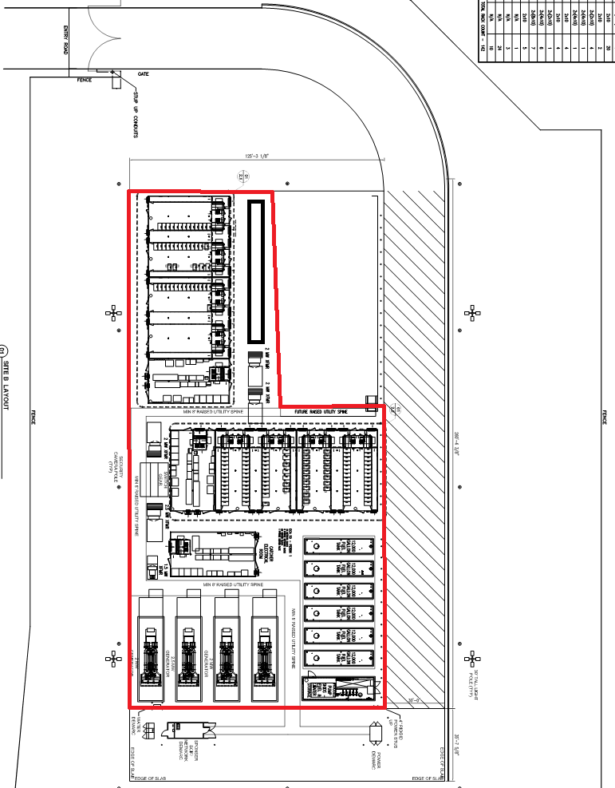

## Delta Site Map

## Document Properties

|  |  |
| --- | --- |
| **Property** | **Value** |
| Site Code | DCA50, DCA51 |
| Filename | dca_dceo_sop_site-maintenance |
| Title | AWS C2S FIL Site Maintenance |
| Version number/Date version published | Draft |
| Doc Type | SOP |
| Zone | Site |
| Technical Owner | Swilleye |
| Technical Writer | beelliot |
| Affected Equipment | No critical equipment effected |
| Sensitivity rating | Amazon Confidential |
| Origin | Original |
| URL | TBD |
| Physical location | TBD |
| Audience | AWS C2S DCO, DCEO  Sponsor WTC maintenance |
| Renewal date | 1/1/15 |

## Status

|  |  |  |
| --- | --- | --- |
| **Status** | **Date mm/dd/yy** | **Approver/Reviewer Name** |
| Original filed |  | NA |
| Writer sent to SME for review |  | NA |
| SME sent to Writer |  | NA |
| Writer sent to SME for approval |  | NA |
| SME approved |  |  |
| Writer copy edited |  | NA |
| Site Manager approved |  |  |
| Regional Manager approved |  |  |
| Writer published |  | NA |