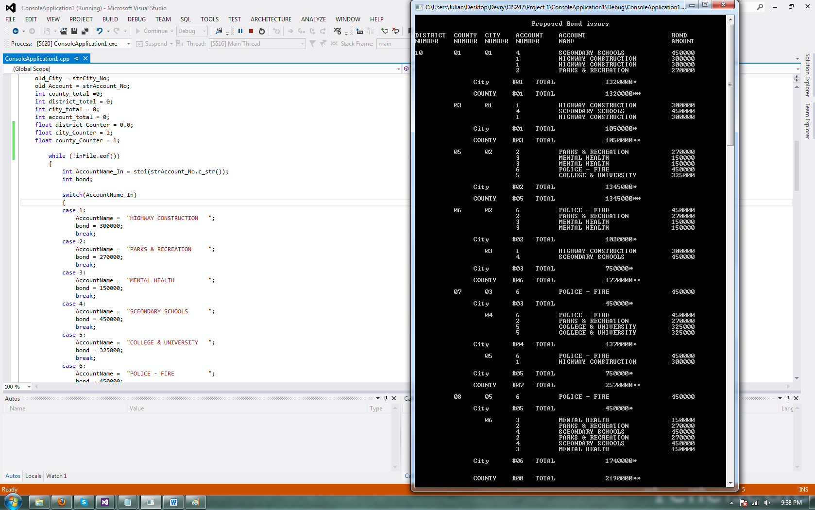

//Project 1 CIS247C

//Created by Julian Barber

#include "stdafx.h"

#include <iostream>

#include <string>

#include <fstream>

#include <iomanip>

#include <conio.h>

using namespace std;

//Functions

void Heading();

int main()

{

char ch;

string strDistrict_No, strCounty_No, strCity_No, strAccount_No, strFiller_1, strFiller_2, AccountName;

string old_District,old_County,old_City,old_Account;

int subtotal=0;

int total=0;

cout << endl << fixed << setprecision(2);

ifstream inFile;

inFile.open("FBRK.TXT", ios::in);

Heading();

if (inFile.is_open())

{

getline(inFile, strDistrict_No, ',');

getline(inFile, strCounty_No, ',');

getline(inFile, strCity_No, ',');

getline(inFile, strFiller_1, ',');

getline(inFile, strAccount_No, ',');

getline(inFile, strFiller_2, '\n');

old_District = strDistrict_No;

old_County = strCounty_No;

old_City = strCity_No;

old_Account = strAccount_No;

int county_total =0;

int district_total = 0;

int city_total = 0;

int account_total = 0;

float district_Counter = 0.0;

float city_Counter = 1;

float county_Counter = 1;

while (!inFile.eof())

{

int AccountName_In = stoi(strAccount_No.c_str());

int bond;

switch(AccountName_In)

{

case 1:

AccountName = "HIGHWAY CONSTRUCTION ";

bond = 300000;

break;

case 2:

AccountName = "PARKS & RECREATION ";

bond = 270000;

break;

case 3:

AccountName = "MENTAL HEALTH ";

bond = 150000;

break;

case 4:

AccountName = "SCEONDARY SCHOOLS ";

bond = 450000;

break;

case 5:

AccountName = "COLLEGE & UNIVERSITY ";

bond = 325000;

break;

case 6:

AccountName = "POLICE - FIRE ";

bond = 450000;

break;

default:;

}//endSwitch

if (old_District != strDistrict_No)

{

cout << "\n City #"<< old_City << " TOTAL " << city_total << "*" << endl;

cout << endl;

old_City = strCity_No;

city_total = 0;

cout << "\n COUNTY #"<< old_County << " TOTAL " << county_total << "**" << endl;

cout << endl;

old_County = strCounty_No;

county_total = 0;

cout << "\n DISTRICT #"<< old_District << " TOTAL " << district_total << "***" << endl;

cout << endl;

old_District = strDistrict_No;

total = district_total + total;

district_total = 0;

district_Counter=0;

}//end of if loop

if(old_County != strCounty_No)

{

cout << "\n City #"<< old_City << " TOTAL " << city_total << "*" << endl;

old_City = strCity_No;

city_total = 0;

cout << "\n COUNTY #"<< old_County << " TOTAL " << county_total << "**" << endl;

cout << endl;

old_County = strCounty_No;

county_total = 0;

county_Counter=0;

}//end of if loop

if(old_City != strCity_No)

{

cout << "\n City #"<< old_City << " TOTAL " << city_total << "*" << endl;

cout << endl;

old_City = strCity_No;

city_total = 0;

city_Counter=0;

}//end of if loop

//flags for final control break

if (district_Counter == 0)

{

cout << strDistrict_No << " " << strCounty_No << " " << strCity_No << " " << strAccount_No << " " << AccountName << " " << bond << endl;

district_Counter++;

}

else

if (city_Counter == 0)

{

cout << " " << strCity_No << " " << strAccount_No << " " << AccountName << " " << bond << endl;

city_Counter++;

}

else

if (county_Counter == 0)

{

cout << " " << strCounty_No << " " << strCity_No << " " << strAccount_No << " " << AccountName << " " << bond << endl;

county_Counter++;

}

else

cout << " " << strAccount_No << " " << AccountName << " " << bond << endl;

//Total counters

district_total = district_total + bond;

county_total = county_total + bond;

city_total = city_total + bond;

total = total + bond;

//get next line

getline(inFile, strDistrict_No, ',');

getline(inFile, strCounty_No, ',');

getline(inFile, strCity_No, ',');

getline(inFile, strFiller_1, ',');

getline(inFile, strAccount_No, ',');

getline(inFile, strFiller_2, '\n');

}//end of while

cout << "\n City #"<< old_City << " TOTAL " << city_total << "*" << endl;

cout << "\n COUNTY #"<< old_County << " TOTAL " << county_total << "**" << endl;

cout << "\n DISTRICT #"<< old_District << " TOTAL " << district_total << "***" << endl;

cout << "\n Final "<< " TOTAL " << total << "****"<< endl;

inFile.close();

}//end of if

else

cout << "Could not read the file\n";

system("PAUSE");

ch = _getch();

return 0;

}

void Heading()

{

cout << " Proposed Bond issues" << endl;

cout << " " << endl;

cout << "DISTRICT COUNTY CITY ACCOUNT ACCOUNT BOND" <<endl;

cout << "NUMBER NUMBER NUMBER NUMBER NAME AMOUNT" << endl;

cout << " " << endl;

}