CIS 353 Assignment#04 **Due Date:** 11/08/2024, by 11:59pm

Use this website to create ER diagram: <https://app.diagrams.net/>

**NO HAND SKETCHES WILL BE GRADED FOR THIS ASSIGNMENT**

**Task #1a:** 40+40+20 points

**Task#1b:**

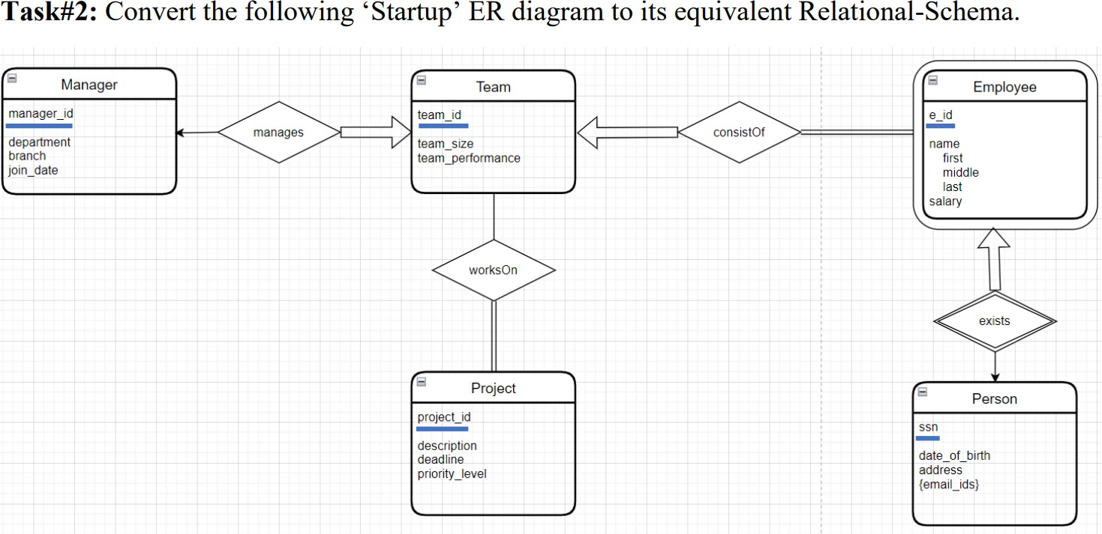

Manager(manager-id, department, branch, join-date)

Team(team-id, team-size, team-performance, manager-id: Not NULL, Unique)

Employee(e-id, first, middle, last, salary, ssn: Not Null, Unique)

TeamMembers(team-id, e-id: Unique)

Project(project-id, description, deadline, priority-level, team-id: Not NULL)

Person(SSN, date-of-birth, address, email-ids)

**Submission:** Copy **all the two diagrams and your answers** into a word/pdf document, and upload the file through the submission link provided on blackboard.