Artur Barbosa

April 6th, 2016

Database Management

CMPT 308- Rivas

**Lab 7**

1a. Mr. Johnson, the spreadsheet you’ve created is good, but it may cause a few problems down the road. I will help reorganize your data so you will be able to add future listings without having database issues. I will also organize your data in a clearer format, making it easier to read.

1b

|  |  |  |  |  |
| --- | --- | --- | --- | --- |
| **PackageID** | **TagNumber** | | **InstallDate** | **SoftwareCostUSD** |
| AC01 | 32808 | | 09-13-2005 | 754.95 |
| DB32 | 32808 | | 12-03-2005 | 380.00 |
| DB32 | 37691 | | 06-15-2005 | 380.00 |
| DB33 | 57772 | | 05-27-2005 | 412.77 |
| WP08 | 32808 | | 01-12-2006 | 185.00 |
| WP08 | 37691 | | 06-15-2005 | 227.50 |
| WP08 | 57222 | | 05-27-2005 | 170.24 |
| WP09 | | 59536 | 10-30-2005 | 35.00 |
| WP09 | | 77740 | 05-27-2005 | 35.00 |

1c. The primary key for this 1nf table would be {PackageID, TagNumber)

2a

|  |  |  |  |  |  |  |
| --- | --- | --- | --- | --- | --- | --- |
| **PackageID** | **TagNumber** | | **InstallDate** | **SoftwareCostUSD** | **Software Package** | **Model** |
| AC01 | 32808 | | 09-13-2005 | 754.95 | Zork | IBM |
| DB32 | 32808 | | 12-03-2005 | 380.00 | Portal | Apple |
| DB32 | 37691 | | 06-15-2005 | 380.00 | Zork | IBM |
| DB33 | 57772 | | 05-27-2005 | 412.77 | Zork | IBM |
| WP08 | 32808 | | 01-12-2006 | 185.00 | Portal | Apple |
| WP08 | 37691 | | 06-15-2005 | 227.50 | Portal | Apple |
| WP08 | 57222 | | 05-27-2005 | 170.24 | Zork | IBM |
| WP09 | | 59536 | 10-30-2005 | 35.00 | Portal | Apple |
| WP09 | | 77740 | 05-27-2005 | 35.00 | Zork | IBM |

2b. The functional dependencies consist of:

{PackageID, TagNumber) -> {InstallDate}

{PackageID, TagNumber) ->{SoftwareCostUSD}

{PackageID, TagNumber) ->{Software Package}

{PackageID, TagNumber) ->{Model}

2c. This table is not in third normal form because it is not in 2NF and it has a transitive dependency.

3a.

**Packages**

|  |  |  |  |
| --- | --- | --- | --- |
| **PackageID** | **TagNumber** | | **InstallDate** |
| AC01 | 32808 | | 09-13-2005 |
| DB32 | 32808 | | 12-03-2005 |
| DB32 | 37691 | | 06-15-2005 |
| DB33 | 57772 | | 05-27-2005 |
| WP08 | 32808 | | 01-12-2006 |
| WP08 | 37691 | | 06-15-2005 |
| WP08 | 57222 | | 05-27-2005 |
| WP09 | | 59536 | 10-30-2005 |
| WP09 | | 77740 | 05-27-2005 |

**Software**

|  |  |  |  |  |
| --- | --- | --- | --- | --- |
| **Package ID** | **TagNumber** | **Software Package** | **Model** | **SoftwareCostUSD** |
| AC01 | 32808 | Zork | IBM | 754.95 |
| DB32 | 32808 | Portal | Apple | 380.00 |
| DB32 | 37691 | Zork | IBM | 380.00 |
| DB33 | 57772 | Zork | IBM | 412.77 |
| WP08 | 37808 | Portal | Apple | 185.00 |
| WP08 | 37691 | Portal | Apple | 227.50 |
| WP08 | 57222 | Zork | IBM | 170.24 |
| WP09 | 59536 | Portal | Apple | 35.00 |
| WP09 | 77740 | Zork | IBM | 35.00 |

3b.

TABLE 1

{PackageID, TagNumber} -> Install Date

TABLE 2

PackageID, TagNumber} -> Software Package

PackageID, TagNumber} ->Model

PackageID, TagNumber} ->SoftwareCostUSD

3c. The new tables are in third normal for because there are no repeating groups, a primary key, no partial dependencies, and no transitive dependencies.

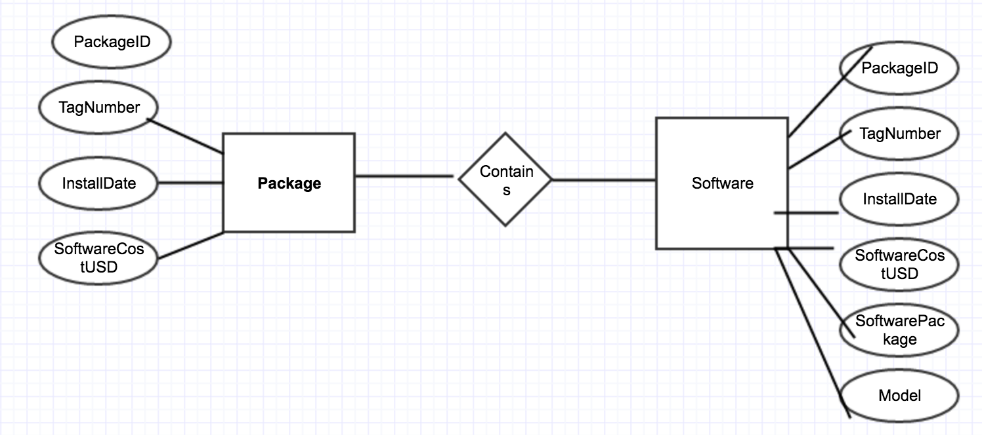

Primary Key: {PackageID, TagNumber}

Foreign Key:{ PackageID, TagNumber}