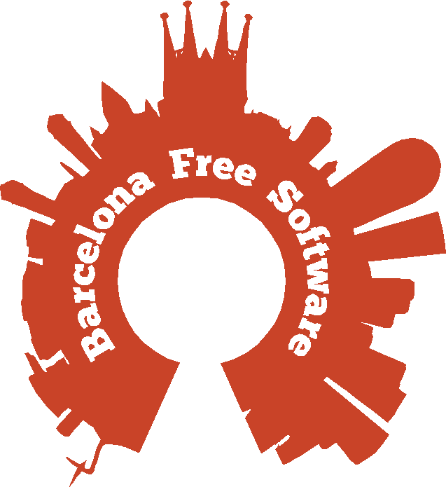

Barcelona Free Software, sponsorship opportunities
The Barcelona Free Software group organizes presentations and discussions about Free and Open Source software in Barcelona. Our main mission is to gather and enrinch the flourishing technology community in the area.
We do this by making sure that projects have a channel to explain what they do and by facilitating the encounter with possible new collaborators. This happens in a relaxed atmosphere where problems get to be solved and connections can be made.
To make sure the group is sustainable, we've set up the following sponsorship program.

The Barcelona Free Software group is organized by KDE España organization. KDE España has been active as a non profit organization during the last 7 years spreading KDE and Free Software in Spain.

/Collaborator/
- 100 €/year
- Logo and description on our website (under construction at the moment).
- We can make some information about the organization available for the meetup attendants. Be it stickers, t-shirts or leaflets.

/Patron/
- Everything in /Collaborator/
- 500 €/year
- Mention in Our Sponsors in http://www.meetup.com/Barcelona-Free-Software
- We can bring your roll-up banner to the presentations.
- Mention during the introduction before the talks.
- Logo on the posters we provide for offline advertising.

