Results:
The apk files that were run are: these were downloaded from various online sources such as afwsamples, malwarebazaar,etc.
7b71bdbb48e1ad7fb26d112ea9289a951923b4fbf41b983edd0567b8b9f1661e [MConverter.eu].apk
89d76dc36286af71838ab3e96c030e4865659686f7e864a2130a6b771b8e994c [MConverter.eu].apk
fe4e697561685131a36652c9d0cb67fe3ff3196d1e23c3d6b0783a72ebe296cb.apk
com.afwsamples.testdpc_8.0.1-8001_minAPI21(nodpi)_apkmirror.com.apk
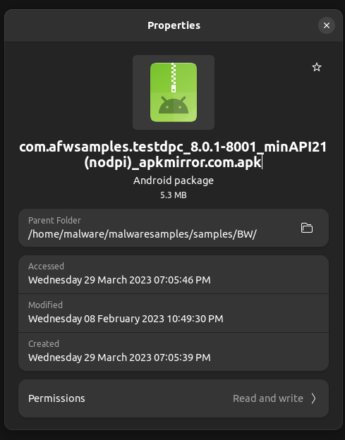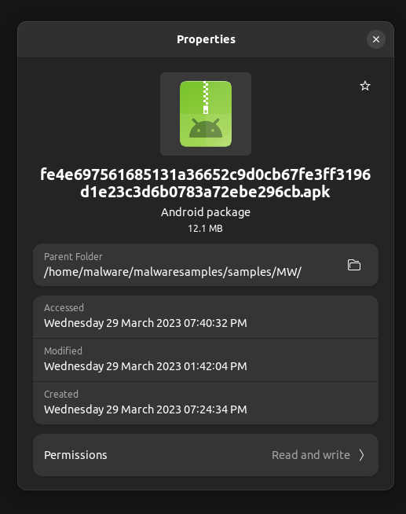
As we can see above, the left file is a benign file and the right file is malware file, hence placed in the respective folders (BW and MW respectively)
These files could either be malicious or benign apks, and it was upto our tool to categorise them. Some were even converted files, hence it had to mark them as invalid.
Json file for one of the benign apks:
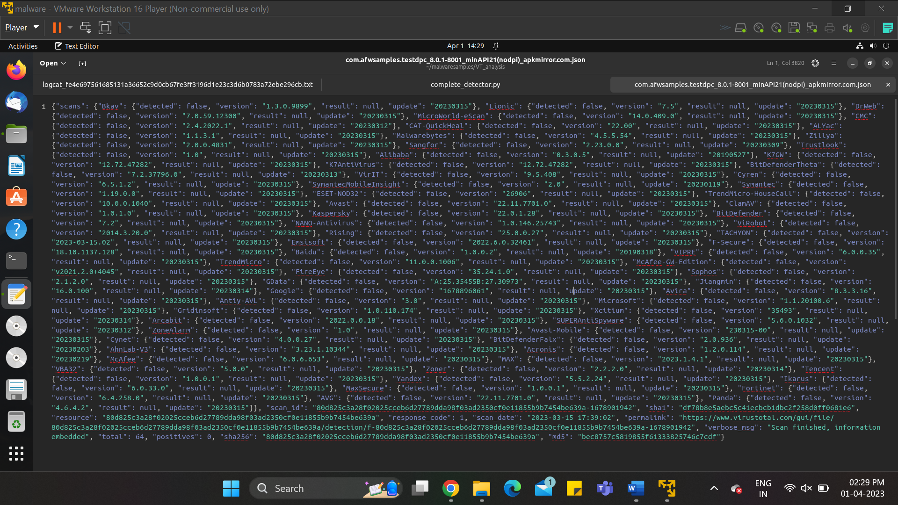
The static analysis by flowdroid will be as follows:
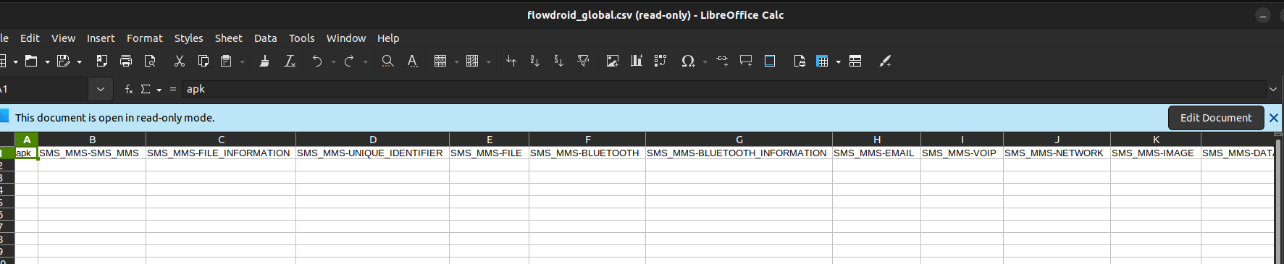
Showing the generated processed outputs for flowdroid:
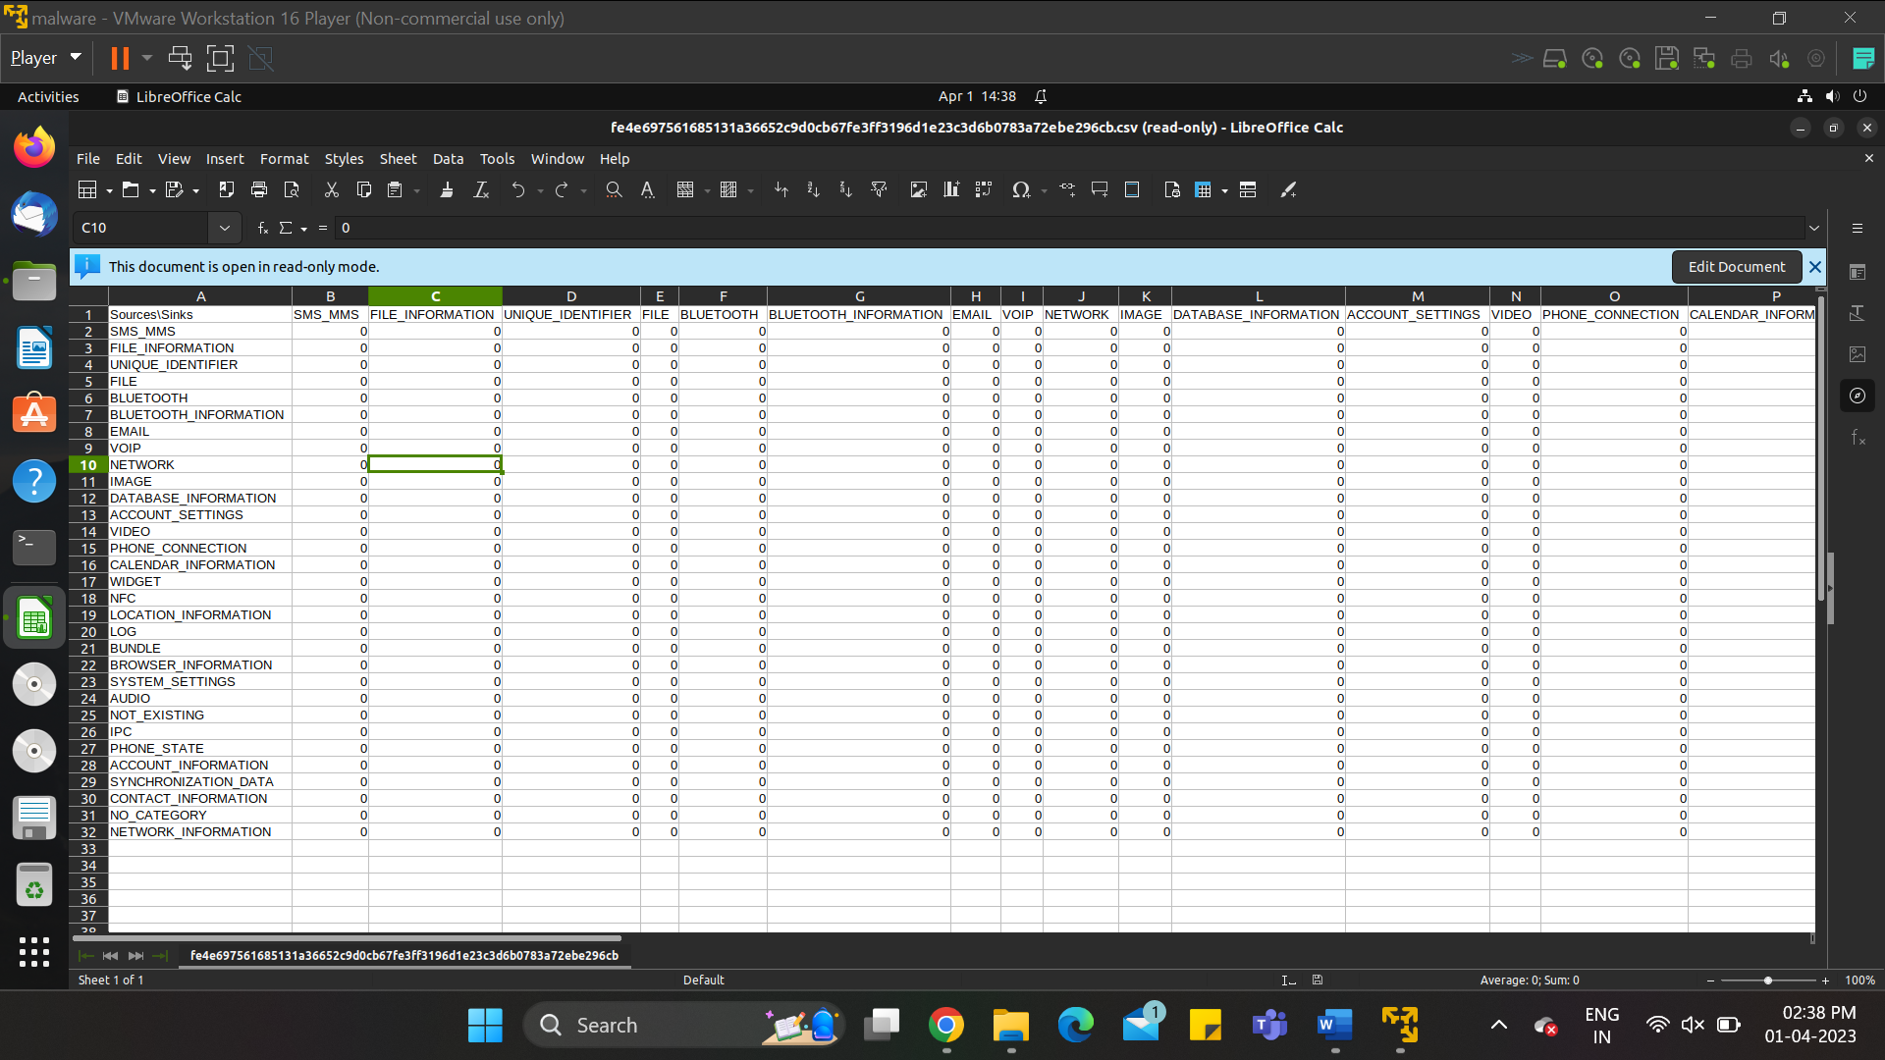
Invalid apk’s stored separately in respective folder:
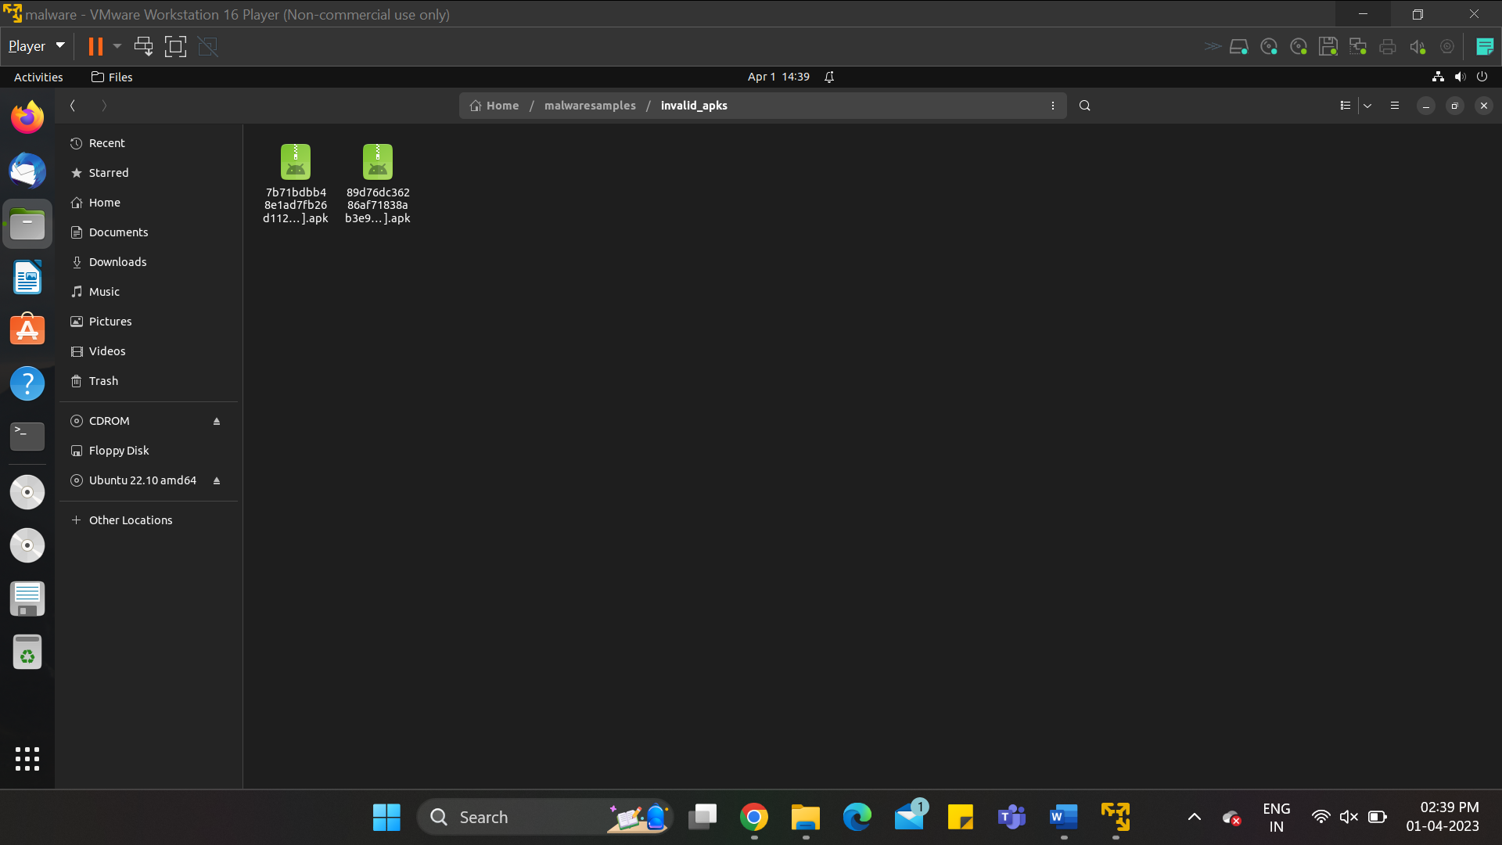
Virustotal outputs: The Virustotal outputs from pre-static analysis are also very similar to the previously obtained Json files, because the same features were extracted and processed in both cases.

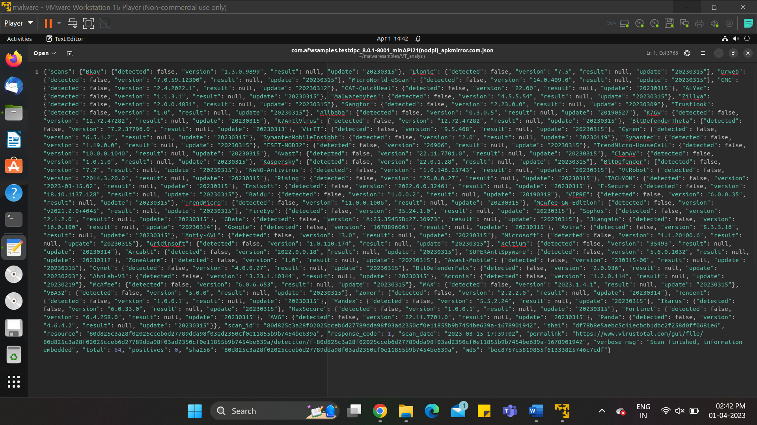

For a malware, the proof is just finding a “true” marked label in this Json file: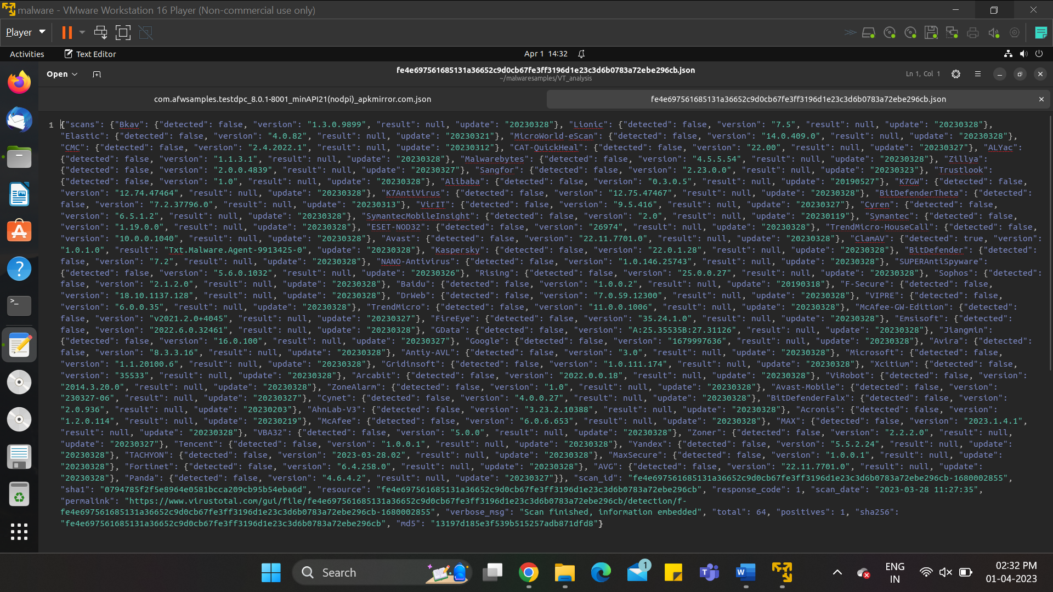
As we can see in below screenshot, clamAV flagged the file as malicious, as it detected traces previously categorised as malware in this file aswell. It even has the name of the malware agent written, which has been highlighted.
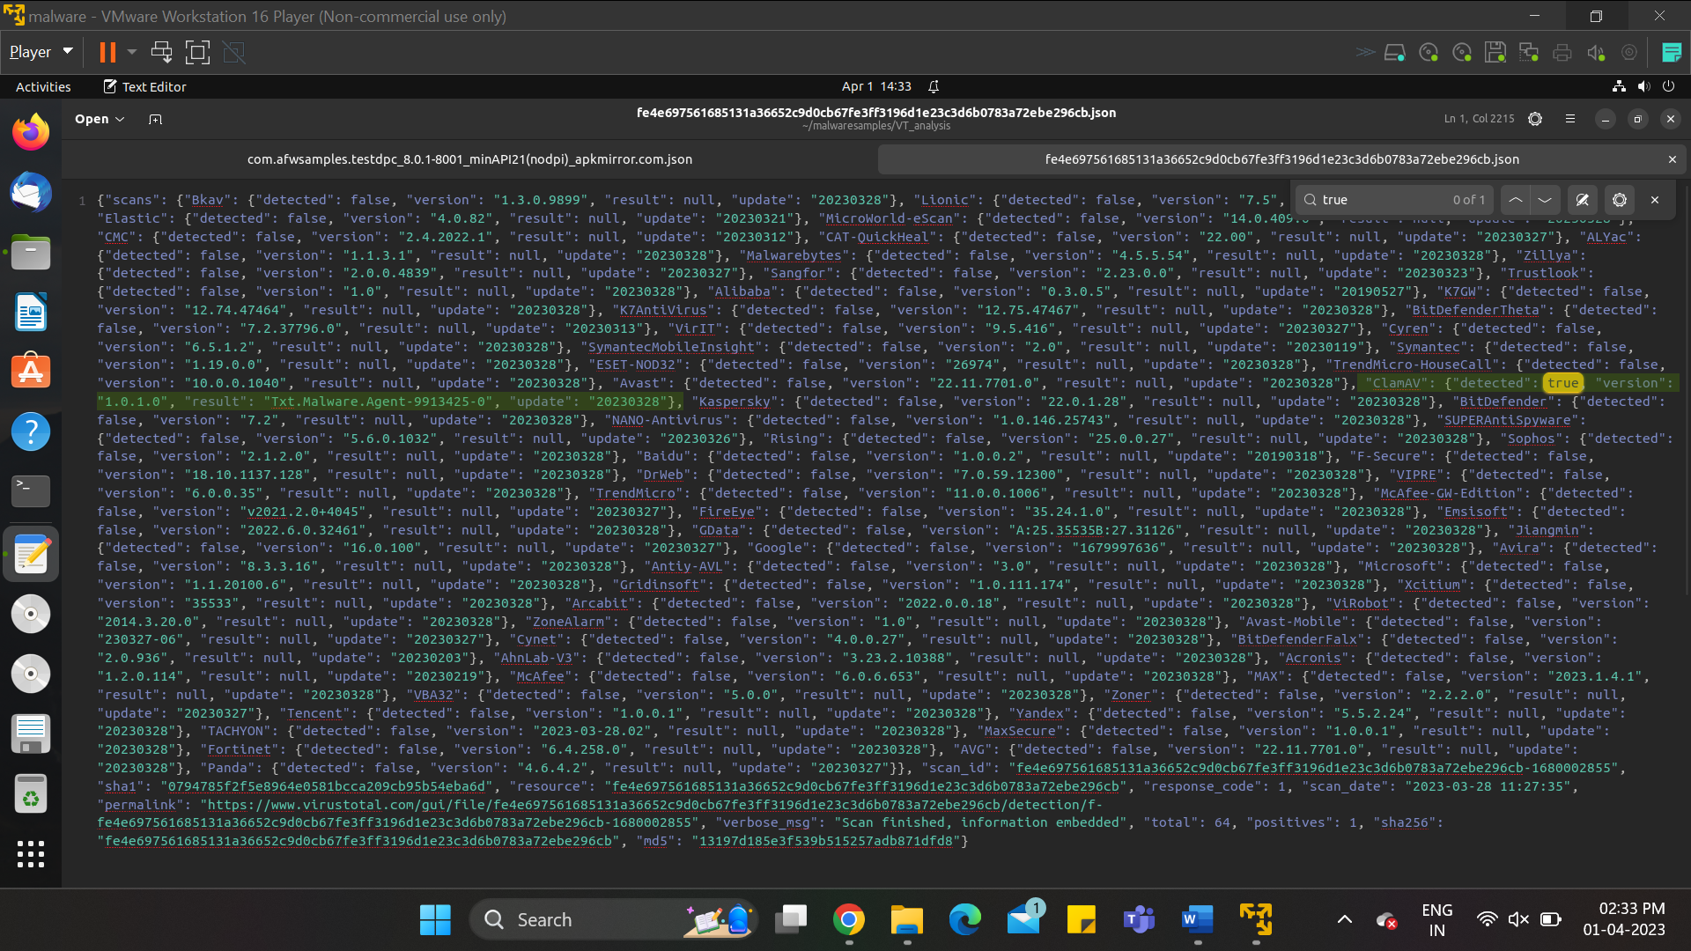
This output is also directly analysed by our tool, and the apk is already placed in the malware folder inside samples folder.
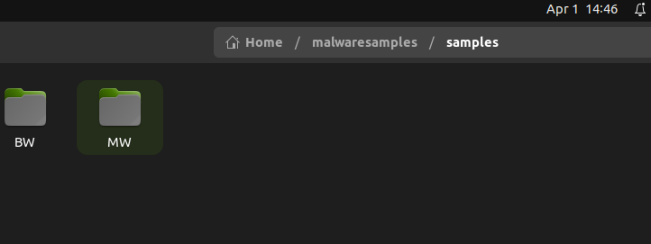
(separate files created)
