Once the application is launched, you can use the combo box on the right-hand side
to change the game type between Standard, Ping and Nuke. In case the game mode is not standard, the knights will act as special pieces - Ping or Nuke, respectively.

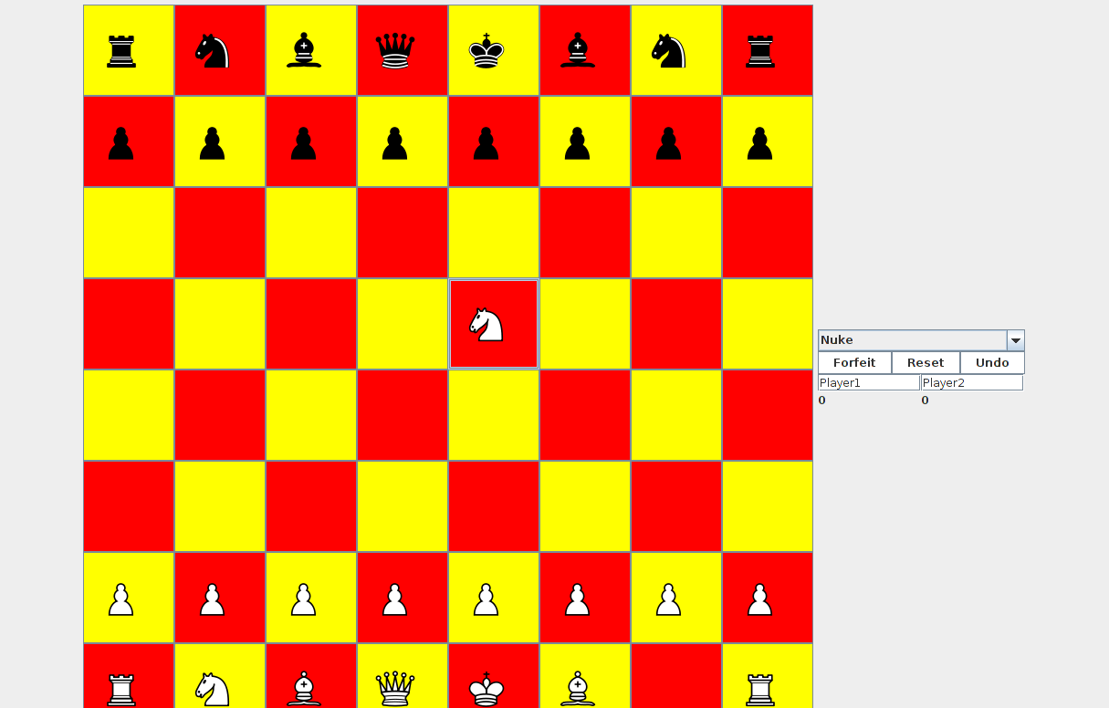

To enter the names for player 1 and player 2, click in the text field, type in the
name and then press "Enter". If you keep the same player names for the duration of
more than one game, then the score will be cumulative.

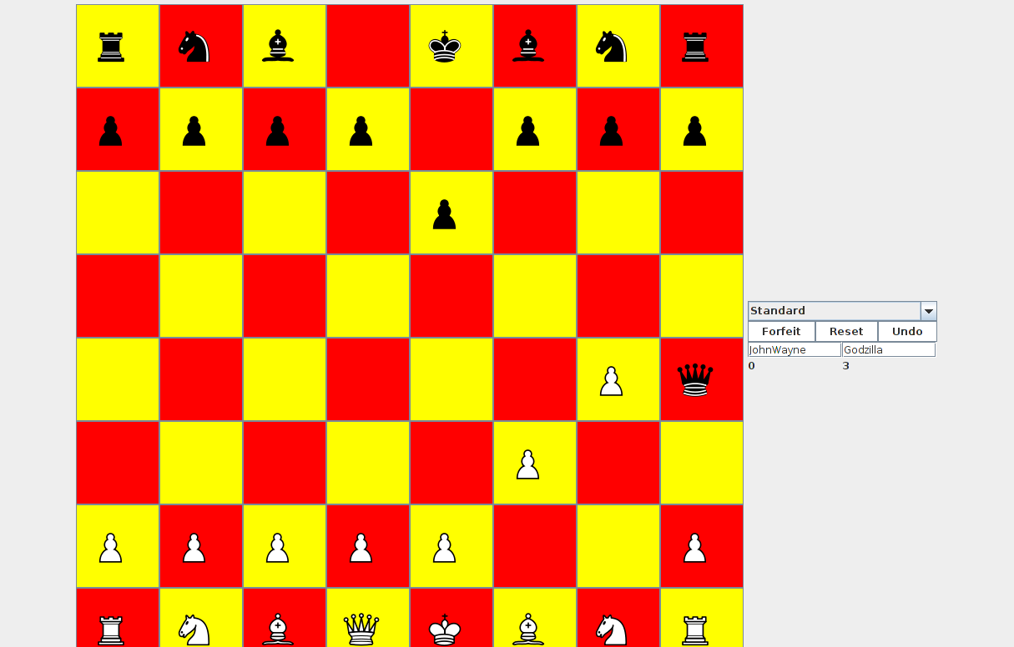

If you want to forfeit the game, click the "Forfeit" button.
If both players agree to restart the game, they each have to press the "Reset" button.
Each player still has to make a move within the turn that they press the "Reset" button.
To undo a move, click the "Undo" button right after the move was performed. You may only
undo your own moves.

Play the game by clicking on any of the squares to select a piece and then move it to the
appropriate place. The pieces' movements correspond to those of a standard chess game, except
for the two special pieces. Ping is a combination of a king and a bishop - it can move diagonally,
but only one square at a time. TelePortahPotty is a nuke and it can move anywhere on the board
on its first move, after which it cannot move anymore.

