The map:
The blue square is the position of the party
The red squares are enemies
The brown areas are towns
The black square is the capital
A red square over a brown square means an enemy party stationed in a town

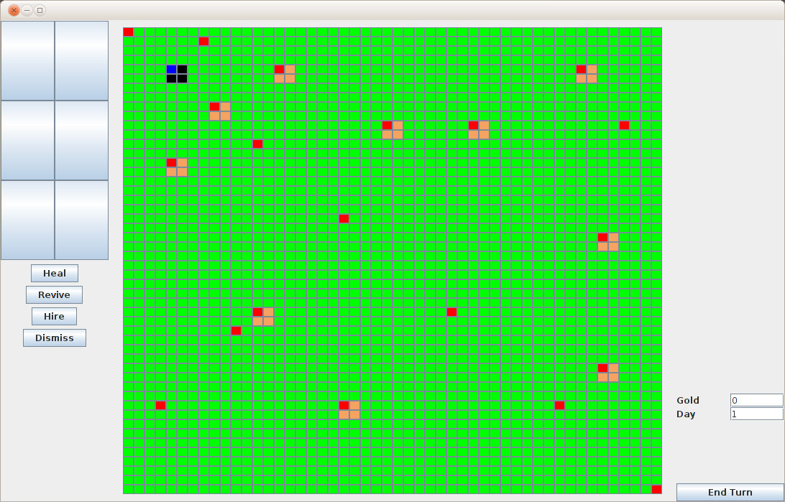

Movement:
To move to a certain square, double-click it
First click will show the path to that square
If you are happy with the path, perform the second click and the party will move to the next available square
The blue squares represent the possible distances. If a square is gray, then it cannot be reached in this turn.

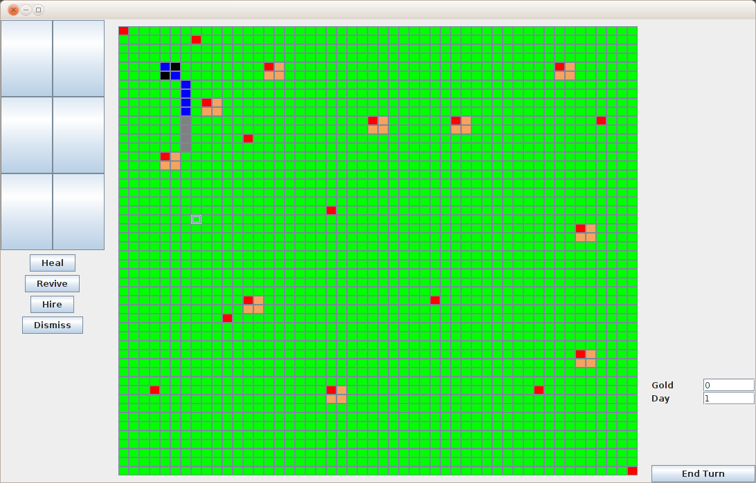

If you select one of the enemies, then the conflict squares will be colored in red. You cannot proceed further unless you fight the enemy.

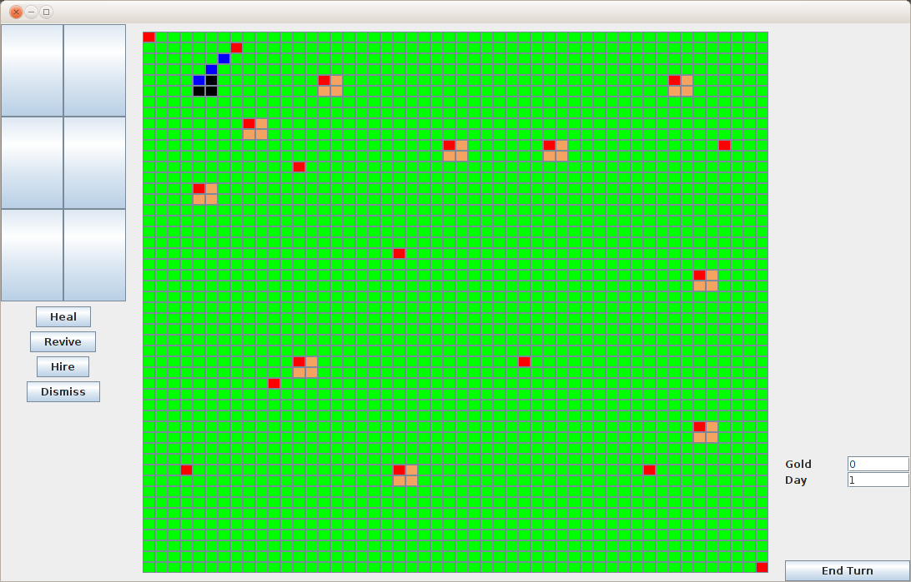

To end the turn, click the end turn button. The hero will regain his movement points and the captured cities, along with the capital, will generate income. The day will advance and each enemy still present on the map will gain 5 experience points.

For testing purposes, our game will begin with the hero being dead.
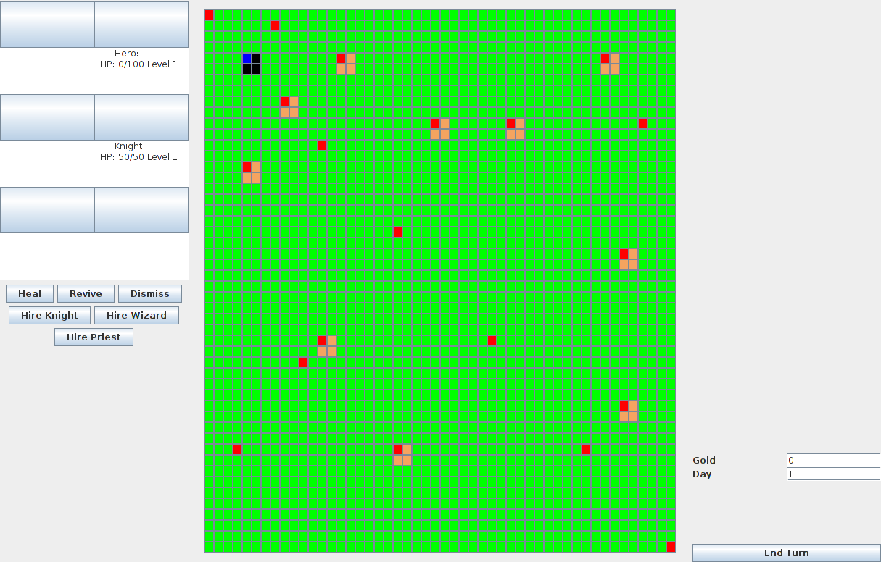

To revive him, wait until you have 150 gold (which would mean three turns controlling none of the cities). The hero's health should be 1.

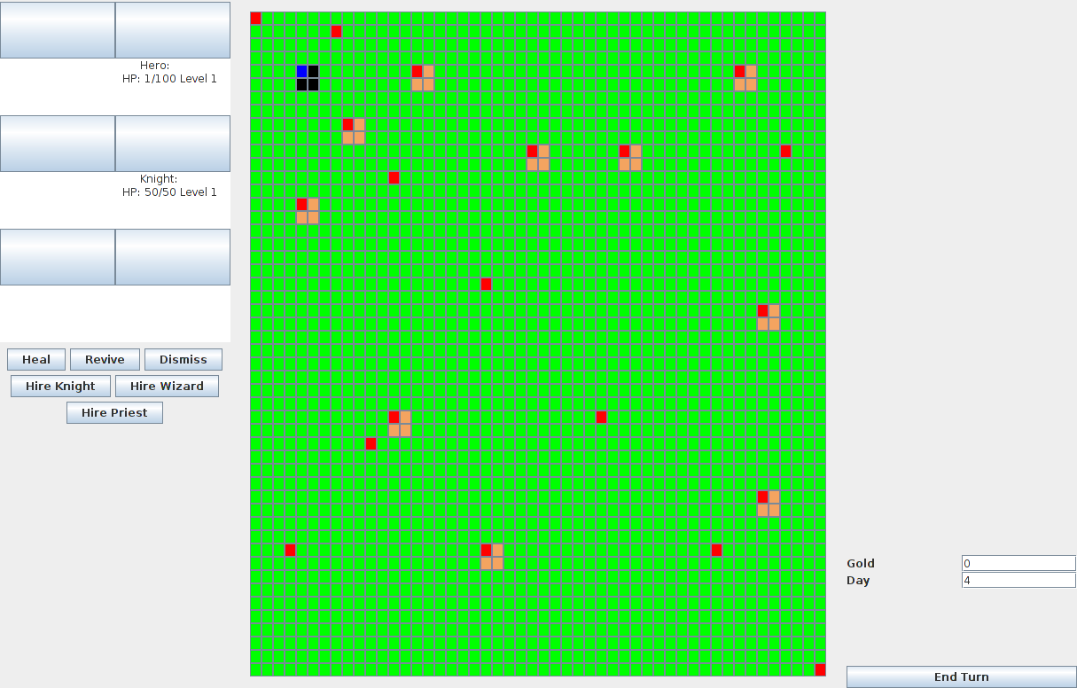
If you wait a few more turns and there is enough gold to heal him, press the “heal” button to restore the hit points.
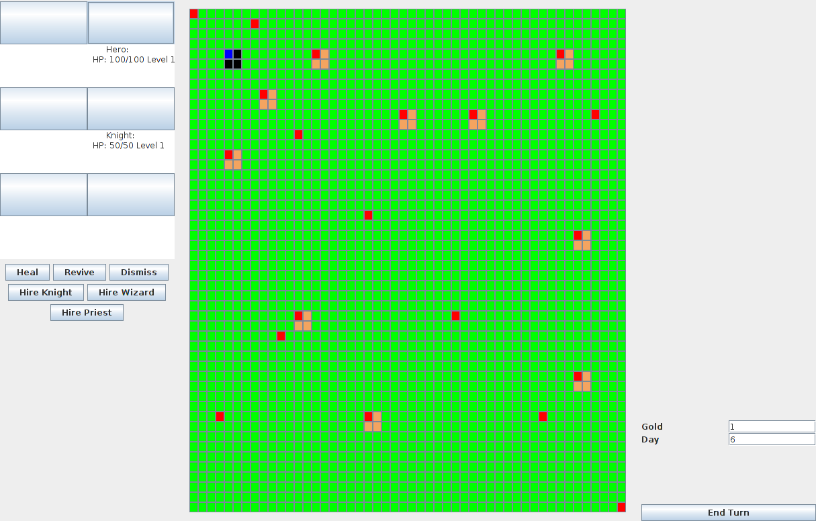

To see what you would have to deal with, click on any enemy party and the enemy party's information will be displayed on the right-side of the screen.

