**Software Requirements**

**Specification**

**for**

**FINAL YEAR PROJECT MANAGEMENT.**

**Version 1.0 approved**

**Prepared by Hadiya faisaL**

**AIMEN ASAD**

**BAREERA FATIMA**

**Fast nuces Islamabad 7th -April -2024**

***Software Requirements Specification for FYP Page 2***

# Table of Contents

**Table of Contents ii**

**Revision History ii**

1. **Introduction 1**
   1. Purpose 1
   2. Document Conventions 1
   3. Intended Audience and Reading Suggestions 1
   4. Product Scope 1
   5. References 1
2. **Overall Description 2**
   1. Product Perspective 2
   2. Product Functions 2
   3. User Classes and Characteristics 2
   4. Operating Environment 2
   5. Design and Implementation Constraints 2
   6. User Documentation 2
   7. Assumptions and Dependencies 3
3. **External Interface Requirements 3**
   1. User Interfaces 3
   2. Hardware Interfaces 3
   3. Software Interfaces 3
   4. Communications Interfaces 3
4. **System Features 4**
   1. System Feature 1 4
   2. System Feature 2 (and so on) 4
5. **Other Nonfunctional Requirements 4**
   1. Performance Requirements 4
   2. Safety Requirements 5
   3. Security Requirements 5
   4. Software Quality Attributes 5
   5. Business Rules 5
6. **Diagrams 5**
   1. Use Case Diagram 5
   2. Activity Diagram 5
   3. Sequence Diagram
   4. Class Diagram 6

**Appendix A: Glossary 6**

**Appendix B: Analysis Models 6**

Appendix C: To Be Determined List 6

***Software Requirements Specification for FYP Page 3***

# Revision History

|  |  |  |  |
| --- | --- | --- | --- |
| **Name** | **Date** | **Reason For Changes** | **Version** |
| **Fyp management** | 23-jan-20  23 | A web-based application to manages and register FYP smoothly and efficiently | 1.00 |
|  |  |  |  |

# Introduction

## 1.1 Purpose

The software requirements specified in this document pertain to the FYP Management System, aimed at facilitating the management of final year projects (FYPs) within the university setting. This system is designed to address inefficiencies in communication, time-consuming project allocation and registration processes, error-prone paperwork, and unnecessary administrative burdens experienced by students, supervisors, committee members, and panel members involved in the FYP process.

The scope of this SRS covers the development of a web-based FYP management system that streamlines communication channels, automates project allocation and registration procedures, eliminates paper-based processes, and reduces administrative burdens for all stakeholders. By doing so, the system aims to mitigate frustration, minimize delays, and reduce the potential for errors in the FYP process.

## 1.2 Document Conventions

The software document (SRS) follows the following convention:

* **Fonts:** Arial font is used throughout the document for consistency and readability.
* **Headings:** All major headings are formatted in bold and centered for easy navigation.
* **Subheadings:** Subheadings are formatted in bold italics to distinguish them from main headings.
* **Priority Levels:** Each requirement statement is assigned its own priority level based on its criticality and importance to the system. Priority levels are denoted using numerical indicators, with '1' representing the highest priority and '3' representing the lowest priority.

## 1.3 Intended Audience and Reading Suggestions

**1.3.1 Intended Audience**

This SRS is intended for a diverse set of readers involved in the development and implementation of the FYP Management System. The primary audience includes:

* ***Developers:*** Individuals responsible for designing, coding, and implementing the FYP Management System.
* ***Project Managers***: Those overseeing the development process, ensuring adherence to requirements, timelines, and budget constraints.
* ***Users:*** Students, supervisors, committee members, and panel members who will interact with the FYP Management System.
* ***Testers:*** Individuals responsible for testing the system to ensure functionality, reliability, and usability.
* ***Documentation Writers:*** Those tasked with creating user manuals, technical documentation, and training materials.

**1.3.2 Document Content and Organization**

The SRS is organized into several sections, each addressing specific aspects of the FYP Management System:

1. **Introduction**: Provides an overview of the document, including its purpose, scope, and intended audience.
2. **Overall Description**: Describes the general factors influencing the FYP Management System, such as user characteristics, constraints, and assumptions.
3. **Specific Requirements**: Details the functional and non-functional requirements of the system, organized into subsections for clarity.
4. **External Interface Requirements**: Specifies the external interfaces of the system, including user interfaces, hardware interfaces, and software interfaces.
5. **System Features**: Presents a comprehensive list of features and functionalities that the FYP Management System will provide to its users.
6. **Other Nonfunctional Requirements**: Outlines additional non-functional requirements such as performance, security, and scalability.
7. **Appendices**: Includes supplementary information, such as glossary terms, references, and appendices for detailed technical specifications.

## 1.4 Product Scope

*The main role of the FYP The executives Framework is to improve the proficiency, straightforwardness, and adequacy of the FYP cycle for all partners, including understudies, bosses, board of trustees individuals, and board individuals. Via robotizing manual assignments, working with correspondence, and wiping out desk work, the framework expects to decrease deferrals, mistakes, and managerial weights usually experienced in FYP the executives.*

*The turn of events and execution of the FYP The executives Framework line up with the college's essential goals of advancing scholastic greatness, encouraging development, and improving the understudy growth opportunity. By putting resources into innovation arrangements like the FYP The board Framework, the college exhibits its obligation to utilizing advanced devices to work on functional proficiency, support scholarly achievement, and drive authoritative greatness.*

## 1.5 References

*This SRS documents refers from Copyright © 1999 by Karl E. Wiegers. Permission is granted to use, modify, and distribute this document.*

# Overall Description

## 2.1 Product Perspective

*The FYP Management System described in this SRS is a new, standalone product developed to address the challenges and inefficiencies inherent in the management of final year projects (FYPs) within the university environment. While it is not directly replacing any existing systems, it serves as a significant enhancement over manual and fragmented processes commonly used for FYP management.*

*The need for a comprehensive FYP Management System arose from the recognition of the limitations and drawbacks associated with traditional methods of managing final year projects. These methods often rely on manual communication, paper-based processes, and ad-hoc administrative procedures, leading to inefficiencies, errors, and delays in project execution.*

## 2.2 Product Functions

1. ***User Management:***

* Creation and management of user accounts for FYP Committee, Project Supervisors, Panel Members, and Students.
* Assignment of roles and privileges to users based on their roles in the FYP process.

***2. FYP Registration****:*

* Registration of students into FYP 1, including group formation, project title submission, and assignment of supervisors.
* Immutable group creation to ensure finalized groups cannot be modified after creation.

***3.FYP Committee Interface:***

* Management of user accounts and roles.
* Allocation of FYPs to supervisors, with workload management.
* Creation of evaluation panels and assignment of FYPs for evaluation.
* Generation of reports including missing evaluations, faculty workload, and grades statistics.

***4. Panel Members Interface:***

* Viewing and evaluation of FYPs assigned to their panel.
* Completion of evaluation forms and identification of missing evaluations.

***5.Project Supervisors Interface****:*

* Monitoring and supervision of assigned FYPs, including viewing group information and grades.
* Reviewing comments and suggestions provided by panel members.
* Monitoring deadlines for assessments.

***6.Students Interface****:*

* Viewing group members, project details, and assigned panels.
* Accessing evaluation comments and suggestions from panel members.
* Viewing deadlines for presentations and document submissions.
* Accessing grades once finalized.

## 2.3 User Classes and Characteristics

**1.FYP Committee Members**

* **Characteristics**: Experienced faculty members responsible for overseeing the FYP process.
* **Frequency of Use**: Regularly access the system to manage FYP allocations, evaluations, and deadlines.
* **Privilege Level**: Highest level of access with authority to create and manage user accounts, assign roles, and generate reports.
* **Requirements**: Ability to allocate FYPs to supervisors, create evaluation panels, monitor faculty workload, and generate comprehensive reports.

#### 2.Panel Members

* **Characteristics**: Faculty members assigned to evaluate FYPs.
* **Frequency of Use**: Access the system intermittently to evaluate assigned FYPs and provide feedback.
* **Privilege Level**: Limited access focused on reviewing FYPs and submitting evaluation forms.
* **Requirements**: Access to assigned FYPs, ability to fill evaluation forms, and view deadlines.

#### 3.Project Supervisors

* **Characteristics**: Faculty members supervising FYP groups.
* **Frequency of Use**: Regularly interact with the system to monitor student progress and provide guidance.
* **Privilege Level**: Moderate access level allowing supervision of assigned FYPs and interaction with evaluation feedback.
* **Requirements**: Access to active FYP groups, ability to view evaluation feedback, and monitor deadlines.

#### 4.Students

* **Characteristics**: Final year undergraduate students participating in FYPs.
* **Frequency of Use**: Regularly engage with the system for project updates, deadlines, and evaluation feedback.
* **Privilege Level**: Limited access focused on viewing project details, submitting deliverables, and accessing evaluation feedback.
* **Requirements**: Access to group information, project details, submission deadlines, and viewing evaluation feedback.

## 2.4 Operating Environment

The FYP Management System will operate in a web-based environment, accessible via modern web browsers. The software is designed to be platform-independent, compatible with a variety of hardware platforms. The following describes the operating environment:

* **Hardware Platform**: The system should be compatible with standard computing hardware such as desktop computers, laptops, tablets, and mobile devices.
* **Operating System**: The software should be compatible with a wide range of operating systems including, but not limited to:
* Windows (Windows 11, Windows 10)
* macOS (macOS Catalina, macOS Mojave, macOS High Sierra)
* Linux distributions (Ubuntu, Fedora, CentOS)
* Mobile operating systems (iOS, Android)
* **Web Browsers**: The system should be accessible via modern web browsers including, but not limited to:
* Google Chrome
* Mozilla Firefox

## 2.5 Design and Implementation Constraints

*Several items and issues will limit the options available to developers during the design and implementation of the FYP Management System. These constraints include:*

* ***Hardware Limitations****: The system must accommodate varying hardware capabilities of end-user devices, ensuring optimal performance across different platforms and devices.*
* ***Specific Technologies and Tools****: Utilization of specific technologies, tools, and databases mandated by the university's IT policies or infrastructure, or dictated by the development team's expertise and familiarity.*
* ***Security Considerations****: Implementation of robust security measures to protect sensitive data, prevent unauthorized access, and ensure compliance with cybersecurity standards.*
* ***Language Requirements****: The system should support English languages to accommodate users from requiring internationalization and localization efforts.*
* ***Documentation and Maintenance Expectations****: Provision of comprehensive documentation to facilitate system maintenance and future enhancements, ensuring smooth handover to the customer's organization for ongoing support and management.*

## 2.6 User Documentation

* **Tutorials**: Interactive tutorials will be available to users, offering guided walkthroughs of key processes and functionalities within the FYP Management System. These tutorials will demonstrate how to perform common tasks such as FYP registration, project allocation, and evaluation submission.
* **Demo Sessions**: Prior to the commencement of the FYP registration process, demo sessions will be conducted for users to familiarize themselves with the system. These sessions will provide hands-on training and demonstrations on how to use the FYP Management System effectively.

## 2.7 Assumptions and Dependencies

* ***Accessibility of Essential Assets:*** *It is accepted that the undertaking will approach the important equipment, programming, and HR expected for improvement, testing, and arrangement of the FYP The executives Framework.*
* ***Timely Feedback from Stakeholders:*** *The venture relies upon convenient criticism and contribution from partners, including employees, understudies, and regulatory staff, to guarantee that the framework meets their necessities and assumptions.*

# 3. External Interface Requirements

## 3.1 User Interfaces

The FYP Management System requires several user interfaces to facilitate interactions between users and the software components. These interfaces are designed to be intuitive, user-friendly, and consistent across the system. Below are the logical characteristics of each interface:

1. **User Interface Components:**

* **FYP Committee Interface**
* **Panel Members Interface**
* **Project Supervisors Interface**
* **Students Interface**

**2.GUI Standards:**

* The user interfaces will adhere to established GUI standards and best practices for web application design, ensuring consistency and ease of use.
* Common GUI elements such as menus, buttons, forms, and navigation bars will be implemented following recognized design patterns.

**3.Screen Layout Constraints:**

* Screen layouts will be designed to optimize user experience and accommodate various screen sizes and resolutions, including desktop and mobile devices.
* Responsive design principles will be employed to ensure adaptability across different devices and screen orientations.

**4.Style Guides:**

* The user interface design will adhere to established style guides or design principles, ensuring visual consistency and brand identity throughout the system.

## 3.2 Hardware Interfaces

The FYP Management System interacts with hardware components to support various functionalities and provide users with access to the system. Below are the logical and physical characteristics of each interface between the software product and the hardware components:

1. **Supported Device Types:**
   * The software product is designed to be accessed through various hardware devices, including:
   * Desktop computers
   * Laptops
   * Tablets
   * Mobile phones
2. **Data and Control Interactions:**
   * The interactions between the software product and hardware components involve data exchange and user input/output:
   * Input: Users interact with the system through input devices such as keyboards, mice, touchscreens, and styluses.
   * Output: The system provides feedback and visual information to users through display devices such as monitors, screens, and mobile device displays.
   * Data Transfer: Data is transmitted between the software and hardware components to facilitate user interactions, process requests, and display information.
3. **Communication Protocols:**

The software product utilizes standard communication protocols to interface with hardware components:

* + For web-based access, HTTP/HTTPS protocols are used for communication between client devices and the server hosting the FYP Management System.
  + Communication between the server and database management system (DBMS) may utilize protocols specific to the DBMS, such as MySQL, PostgreSQL, or MongoDB.

## 3.3 Software Interfaces

*1.* ***Database Management System (DBMS):***

#### ● Name and Version: MySQL 8.0

* ***Reason:*** *The framework will depend on the MySQL data set to store and oversee information connected with FYP enlistments, understudy data, project subtleties, assessments, and client accounts.*
* ***Data Items:*** *Incoming data items will include user registration details, project information, evaluation scores, and system configurations. Outgoing data items will consist of query results, reports, and notifications.*

***2. Operating System****:*

* ***Name and Version****: Linux Ubuntu 20.04 LTS or any os*
* ***Purpose****: The operating system provides the underlying platform for hosting the FYP Management System, managing system resources, and executing system-level tasks*
* ***Data Items****: No specific data items are exchanged between the FYP Management System and the operating system.*
* ***Services Needed****: Process management, memory allocation, file system access, and network communication*

**3. *Communication Nature***: The FYP Management System interacts with the operating system through system calls and system libraries, abstracting hardware interactions and providing an interface for application development.

### 3.4 Communications Interfaces

*The FYP Management System requires several communications functions to facilitate interactions between users and the system components. Below are the requirements associated with communication functions required by this product:*

1. **Web Browser Communication**:

* **Purpose**: Users will access the FYP Management System through web browsers to perform actions such as project registration, evaluation submission, and report generation.
* **Message Formatting**: HTTP (Hypertext Transfer Protocol) and HTTPS (HTTP Secure) protocols will be used for communication between web browsers and the system.
* **Communication Security**: HTTPS will be utilized to encrypt data transmitted between the user's web browser and the system, ensuring confidentiality and integrity of user data.
* **Data Transfer Rates**: The system will optimize data transfer rates to minimize latency and ensure responsive user experience, employing techniques such as data compression and efficient resource utilization.

**2.Network Server Communications**:

* **Purpose**: The system will communicate with network servers to fetch and update data, perform system operations, and manage user sessions.
* **Communication Protocols**: TCP/IP (Transmission Control Protocol/Internet Protocol) will be used for network server communications.
* **Security**: Communication between the system and network servers will be secured using encryption mechanisms such as SSL/TLS to prevent eavesdropping and data tampering.
* **Synchronization Mechanisms**: The system will employ synchronization mechanisms to ensure consistency and coherence of data across distributed network servers, utilizing techniques such as distributed locking and conflict resolution algorithms.

**4. System Features**

### 4.1 System Feature 1

* **Description:** Allow FYP Committee members to manage user accounts, including creation, editing, and deactivation, to ensure proper access control and maintain accurate user data.
* **Priority:** High

#### 4.1.2 Stimulus/Response Sequences

1. **Create User Account:**
   * **Stimulus:** FYP Committee member selects option to create a new user account.
   * **Response:**
   * System displays a form for entering user details.
   * System validates entered information.
   * Upon successful creation, system displays confirmation message and lists the new user.
2. **Edit User Account:**
   * **Stimulus:** FYP Committee member selects option to edit an existing user account.
   * **Response:**
   * System displays a pre-populated form with current user information.
   * System allows editing of relevant user details.
   * Upon successful update, system displays confirmation message and reflects changes in user list.
3. **Deactivate User Account:**
   * **Stimulus:** FYP Committee member selects option to deactivate a user account.
   * **Response:**
   * System prompts for confirmation before deactivation.
   * Upon successful deactivation, user is marked as inactive and loses access to the system.

#### 4.1.3 Functional Requirements

* **REQ-1:** The system shall provide a user registration form with fields for username, email, password, and other required information.
* **REQ-2:** The system shall validate user input to ensure all required fields are filled and email is in valid format.
* **REQ-3:** The system shall check uniqueness of username and email.
* **REQ-4:** If username or email is already in use, system shall display an error message.
* **REQ-5:** Upon successful registration, system shall create a new user account and store user's information.
* **REQ-6:** System shall send confirmation email for account verification.
* **REQ-7:** System shall handle errors gracefully and provide informative messages.

### 4.2 System Feature 2

#### 4.2.1.1 Description and Priority

**Description:** Enable panel members to search for specific Final Year Projects (FYPs) assigned to their panel, facilitating quick access for evaluation purposes.

**Priority:** Medium

***4.2.2 Stimulus/Response Sequences*** ● **Search for Project:**

* **Stimulus:** Panel member utilizes the search functionality to find a Final Year Project (FYP).
* **Response:**
* System provides a search interface with options to search by project title, group members, or other relevant keywords.
* Upon entering search criteria, system filters the list of assigned FYPs accordingly.
* System displays search results, allowing panel member to quickly find the desired project for evaluation.

#### 4.2.3 Functional Requirements

* **REQ-1:** The system shall provide a search bar or filter options within the panel members interface.
* **REQ-2:** Panel members shall be able to search for FYPs by project title.
* **REQ-3:** Panel members shall be able to search for FYPs by group members' names.
* **REQ-4:** System shall support searching by other relevant keywords associated with FYPs.
* **REQ-5:** Upon entering search criteria, system shall dynamically update the list of assigned FYPs to display matching results.
* **REQ-6:** System shall ensure search functionality is efficient and responsive, providing quick access to desired projects for evaluation.

**4.3 System Feature 3 Faculty Member Assignment Control**

4.3.1 Description and Priority

* **Description:** Ensure that each faculty member is assigned to only one panel to prevent conflicts of interest and maintain clarity in the evaluation process.
* **Priority:** High

#### 4.3.2 Stimulus/Response Sequences

* **Faculty Member Panel Assignment:**
* **Stimulus:** A faculty member attempts to join a panel.
* **Response:**
* System checks if the faculty member is already assigned to another panel.
* If the faculty member is already assigned to a panel:
* System prevents them from joining the new panel.
* System displays a clear error message indicating the faculty member's existing panel assignment.

#### Functional Requirements

* **REQ-1:** System shall maintain a record of panel assignments for each faculty member.
* **REQ-2:** When a faculty member attempts to join a panel, system shall verify their current panel assignment status.
* **REQ-3:** If the faculty member is already assigned to a panel:

1. System shall prevent them from joining the new panel.
2. System shall display an error message informing the faculty member of their existing panel assignment.

* **REQ-4:** Error message displayed by the system shall be clear and informative, indicating that the faculty member cannot join another panel due to an existing assignment.

#### 4.4 System Feature: View Assigned Final Year Projects and Missing Assessment Forms

##### 4.4.1 Description and Priority

* **Description:** Faculty members want to view a comprehensive list of Final Year Projects (FYPs) assigned to their panel and be notified of any missing assessment forms for the projects allocated to their panel.
* **Priority:** High

***4.4.2 Stimulus/Response Sequences*** ● **View Assigned FYPs:**

* **Stimulus:** Faculty member navigates to the assigned FYPs section.
* **Response:**
* System displays a list of all FYPs assigned to the faculty member's panel.
* The list includes details such as project titles, group members, and FYP descriptions.
* **Notification for Missing Assessment Forms:**
* **Stimulus:** Faculty member accesses the evaluation section for a specific project.
* **Response:**
* System checks for any pending evaluation forms for the project.
* If there are missing assessment forms:
* System displays a notification indicating the presence of missing evaluation forms.
* Faculty member receives notifications about the missing assessment forms.

##### 4.4.3 Functional Requirements

* **REQ-1:** System shall provide a dedicated section for faculty members to view assigned FYPs.
* **REQ-2:** When faculty member navigates to the assigned FYPs section, system shall display a comprehensive list of all FYPs assigned to their panel.
* **REQ-3:** The list of assigned FYPs shall include details such as project titles, group members, and FYP descriptions.
* **REQ-4:** System shall provide notifications to faculty members if there are any missing assessment forms for the projects allocated to their panel.
* **REQ-5:** When a faculty member accesses the evaluation section for a specific project, system shall check for any pending evaluation forms.

**REQ-6:** If there are missing assessment forms, system shall display notifications to inform the faculty member about the presence of missing evaluation forms.

**REQ-7:** Notifications regarding missing assessment forms shall be delivered to faculty members through the system's notification mechanism.

**4.5 System Feature: Supervisor Access and Monitoring**

##### 4.5.1 Description and Priority

* **Description:** Supervisors need to access the system securely, view the projects they are supervising, access evaluations, receive notifications for deadlines, monitor project assignments to panels, and view panel member feedback.
* **Priority:** High

***4.5.2 Stimulus/Response Sequences* Login Authentication:**

* **Stimulus:** User attempts to log in with valid or invalid credentials.
* **Response:** System authenticates the credentials and grants access or displays an invalid credentials error message.

**View Assigned Projects:**

* **Stimulus:** Supervisor navigates to the project list.
* **Response:** System displays a list of all active Final Year Projects assigned to the supervisor.

**Access Evaluations:**

* **Stimulus:** Supervisor selects a specific project.
* **Response:** System provides access to the evaluations and feedback for the selected project.

**Receive Deadline Notifications:**

* **Stimulus:** Supervisor accesses the notification section.
* **Response:** System displays upcoming deadlines related to FYP assessments.

**View Project Assignments:**

* **Stimulus:** Supervisor accesses project details.
* **Response:** System shows the names and roles of panel members assigned to each project.

**View Panel Member Feedback:**

* **Stimulus:** Supervisor accesses project evaluations.
* **Response:** System displays comments and suggestions submitted by panel members.

##### 4.5.3 Functional Requirements

* **REQ-1:** System shall authenticate supervisor credentials during login attempts.
* **REQ-2:** Upon successful login, system shall display a list of projects assigned to the supervisor.
* **REQ-3:** System shall provide access to evaluations and feedback for each project supervised by the logged-in supervisor.
* **REQ-4:** System shall notify supervisors of upcoming deadlines related to FYP assessments.

**REQ-5:** System shall show project assignments to different panels, including panel member names and roles.

* **REQ-6:** System shall display comments and suggestions provided by panel members during project evaluations.

**4.6 System Feature: Student Interaction and Information Access**

**4.6.1 Description and Priority**

* **Description:** Students need access to various features to stay informed about their Final Year Project (FYP) details, including group members, evaluation panels, comments from panels, deadlines, grades, and communication with supervisors. ● **Priority:** High

***4.6.2 Stimulus/Response Sequences* View FYP Group Details:**

* **Stimulus:** Student navigates to the dashboard.
* **Response:** System displays the student's FYP group details, including group members, project title, description, and supervisor information.

**View Assigned Evaluation Panels:**

* **Stimulus:** Student navigates to the designated section.
* **Response:** System clearly shows the evaluation panels assigned to evaluate the student's FYP without revealing individual panel member names.

**View Comments and Suggestions from Panels:**

* **Stimulus:** Student accesses the comments section.
* **Response:** Interface displays comments and suggestions from the evaluation panels while keeping panel member names hidden.

**View Deadlines for Presentations and Submissions:**

* **Stimulus:** Student navigates to the deadlines section.
* **Response:** Interface displays deadlines for FYP presentations and document submissions.

**View Final Grades for FYP:**

* **Stimulus:** Grades are finalized for the FYP.
* **Response:** Interface presents individual and group grades, including any additional comments from the evaluation panels.

**User-Friendly Interface for Easy Navigation:**

* **Stimulus:** Student interacts with different sections.
* **Response:** Interface ensures easy navigation for the student with an intuitive design.

**Receive Notifications for Upcoming Deadlines and Announcements:**

* **Stimulus:** There are upcoming deadlines or announcements.
* **Response:** Student receives timely notifications to stay updated on important events.

**Option to Contact Supervisor Through Interface:**

* **Stimulus:** Student needs to communicate with the supervisor.
* **Response:** Interface provides a communication channel for students to easily contact their supervisors regarding project-related queries.

##### 4.6.3 Functional Requirements

* **REQ-1:** System shall display FYP group details on the dashboard, including group members, project title, description, and supervisor information.
* **REQ-2:** Interface shall clearly show assigned evaluation panels for the student's FYP without revealing individual panel member names.
* **REQ-3:** Comments section shall display comments and suggestions from evaluation panels while keeping panel member names hidden.
* **REQ-4:** Deadlines section shall display deadlines for FYP presentations and document submissions.
* **REQ-5:** Grades section shall present individual and group grades for the FYP, including any additional comments from the evaluation panels.
* **REQ-6:** Interface design shall prioritize easy navigation for students, ensuring an intuitive user experience.
* **REQ-7:** System shall send notifications to students for upcoming deadlines and announcements to keep them informed.
* **REQ-8:** Interface shall provide a communication channel for students to contact their supervisors regarding project-related queries.

**4.7 System Feature: FYP Committee Member Management**

##### 4.7.1 Description and Priority

* **Description:** FYP Committee members need tools to manage user accounts, including creating, editing, and deactivating accounts, as well as managing roles and permissions. Additionally, they require features to view and search for users and user groups, create and manage student accounts, assign FYP projects to supervisors and evaluation panels, set deadlines, generate reports on missing evaluations, supervisor workload distribution, and student grades statistics. ● **Priority:** High

***4.7.2 Stimulus/Response Sequences* Manage User Accounts:**

* *Create New User Account:*
* **Stimulus:** Committee member navigates to the "User Management" section and selects the option to create a new user account.
* **Response:** System displays a form for entering user details, validates the information, and upon successful creation, confirms with a message and lists the new user.

*Edit Existing User Account:*

* **Stimulus:** Committee member selects the option to edit an existing user account.
* **Response:** System displays a form with pre-populated user information for editing, and upon successful update, confirms with a message and reflects changes in the user list.
* *Deactivate User Account:*
* **Stimulus:** Committee member selects the option to deactivate a user account.
* **Response:** System prompts for confirmation, deactivates the user upon confirmation, and updates the user list to reflect the deactivated status.

**View and Search Users/User Groups:**

* **Stimulus:** Committee member navigates to the "User Management" section and accesses the user list view or uses the search functionality.
* **Response:** System displays a comprehensive list of users with their details and allows filtering based on search criteria, providing case-insensitive and partial match support.

**Create and Manage Student Accounts:**

* *Create New Student Account:*
* **Stimulus:** Committee member navigates to the "Student Management" section and selects the option to create a new student account.
* **Response:** System displays a form for entering student details, validates the information, confirms upon successful creation, and lists the new student in the student list view.
* *Edit Existing Student Account:*
* **Stimulus:** Committee member selects the option to edit a student's profile.
* **Response:** System displays a pre-populated form for editing student information, confirms upon successful update, and reflects changes in the student list view.
* *Deactivate Student Account:*
* **Stimulus:** Committee member selects the option to deactivate a student account.
* **Response:** System prompts for confirmation, deactivates the student upon confirmation, and updates the student list view to reflect the deactivated status.

##### 4.7.3 Functional Requirements

* **REQ-1:** System shall provide functionality to manage user accounts, including creating, editing, and deactivating accounts, with appropriate validations and notifications.
* **REQ-2:** System shall allow viewing and searching for users and user groups, with filtering capabilities based on specified criteria.
* **REQ-3:** System shall provide tools for creating and managing student accounts, ensuring data accuracy and efficient access management.
* **REQ-4:** System shall enable FYP Committee members to assign FYP projects to supervisors and evaluation panels, maintaining fair evaluation processes and workload distribution.
* **REQ-5:** System shall support setting deadlines for FYP project submissions and evaluations, facilitating project timeline management.

**REQ-6:** System shall generate reports on missing evaluations, supervisor workload distribution, and student grades statistics, providing insights for process improvement and monitoring project progress.

# 5. Other Nonfunctional Requirements

### 5.1 Performance Requirements

* **Response Time:** The system shall respond to user interactions within 2 seconds under normal load conditions to ensure a smooth user experience.
* **Scalability:** The system should be capable of handling a 20% increase in concurrent users without degradation in performance.
* **Database Queries:** Database queries should execute within 500 milliseconds to ensure efficient data retrieval

## 5.2 Safety Requirements

* **Data Integrity:** The system must ensure the integrity of user data to prevent data loss or corruption.
* **Access Control:** Access to sensitive information should be restricted based on user roles and permissions to prevent unauthorized access.
* **Backup and Recovery:** Regular backups of system data should be performed to facilitate quick recovery in case of system failures or data loss.

## 5.3 Security Requirements

* **User Authentication:** The system shall implement secure user authentication mechanisms, such as password hashing and salting, to protect user accounts from unauthorized access.
* **Data Encryption:** Sensitive data, including user credentials and project details, should be encrypted during transmission and storage to prevent data breaches.
* **Logging and Auditing:** The system should maintain detailed logs of user activities for auditing purposes, helping to identify and mitigate security breaches.

### 5.4 Software Quality Attributes

* **Reliability:** The system should have a reliability rate of at least 99%, minimizing downtime and ensuring uninterrupted access to users.
* **Maintainability:** The codebase should follow coding best practices and be well-documented to facilitate ease of maintenance and future enhancements.
* **Usability:** The user interface should be intuitive and user-friendly, with a learnability rate of 90% for new users.

**Portability:** The system should be compatible with modern web browsers and mobile devices to ensure accessibility across different platforms.

### 5.5 Business Rules

* **Access Control:** Only authorized users with specific roles (e.g., FYP Committee members, faculty supervisors) should have access to certain functionalities and data within the system.
* **Assignment Rules:** FYP projects should be assigned to evaluation panels and supervisors based on expertise, workload, and fairness principles, ensuring balanced workload distribution and fair evaluation processes.
* **Deadline Compliance:** Students, faculty supervisors, and evaluation panel members must adhere to project submission and evaluation deadlines as per the established timeline to maintain project schedule integrity.

1. **Diagrams**

**6.1 Use Case Diagram**

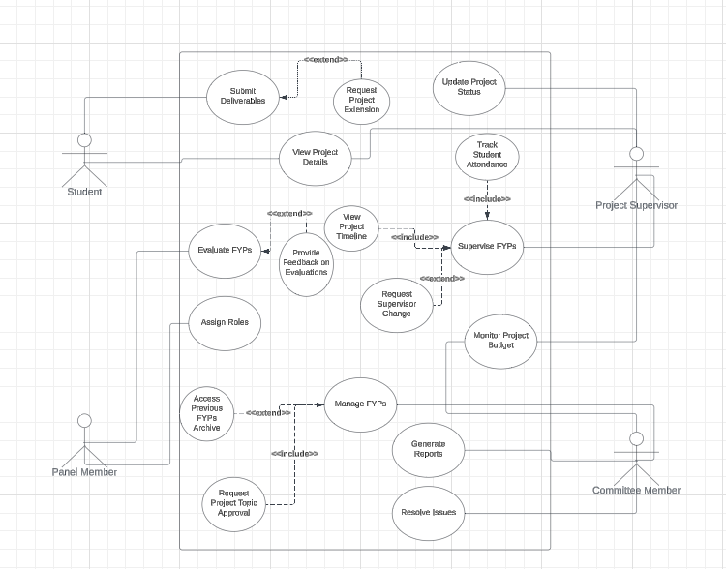

### 6.2 Activity Diagram

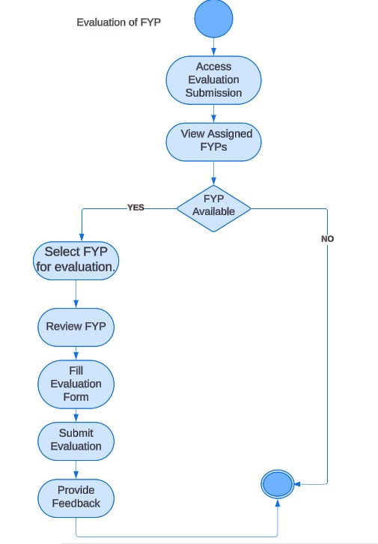

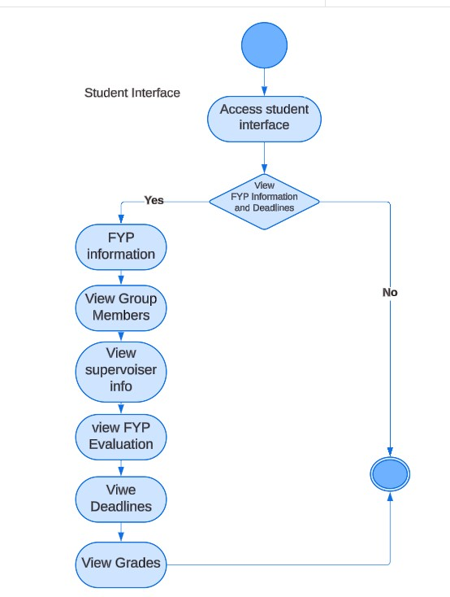

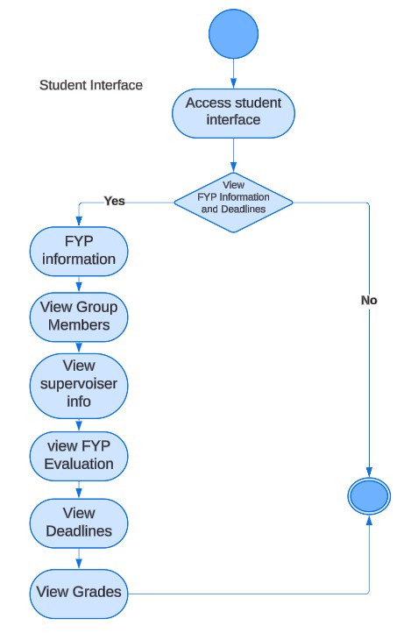

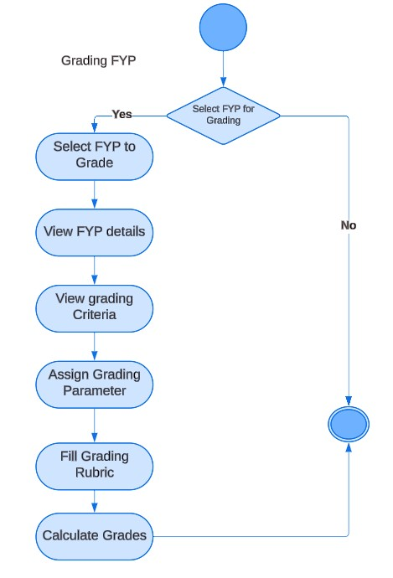

### 6.3 Sequence Diagram

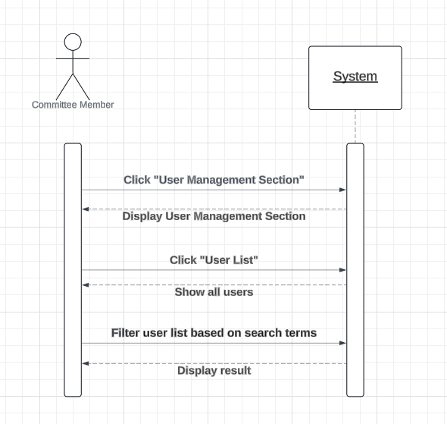

### Activity Diagram

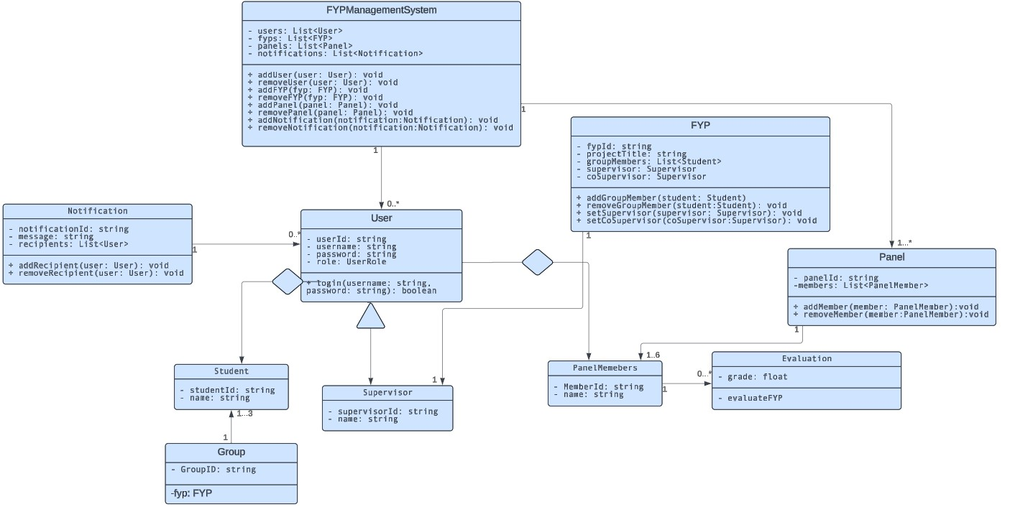

**Appendix A: Glossary**

* **FYP:** Final Year Project
* **SRS:** Software Requirements Specification
* **UI:** User Interface
* **FYP Committee:** Final Year Project Committee
* **API:** Application Programming Interface
* **GUI:** Graphical User Interface
* **HIPAA:** Health Insurance Portability and Accountability Act
* **CSV:** Comma-Separated Values (file format)
* **PDF:** Portable Document Format (file format)
* **HTML:** Hypertext Markup Language
* **CSS:** Cascading Style Sheets
* **JSON:** JavaScript Object Notation (data interchange format)
* **HTTPS:** Hypertext Transfer Protocol Secure
* **SQL:** Structured Query Language (database language)
* **DNS:** Domain Name System
* **SSL/TLS:** Secure Sockets Layer/Transport Layer Security

**Appendix B: Analysis Models layer structured**

**Appendix C: To Be Determined List**