AI Transparency Declaration Statement

Module: Web Development 55-407821

Task One: Prototype Web Application

SHU AI Transparency Scale (AITS) | AI for Shaping
Transparency Statement | AI has been used to shape the initial and/or final parts of the activity.
AI Contributions | AI is used for shaping parts of the activity. This includes initial outlining, concept development, prompting thinking, and/or improving structure/quality of the final output.
Human Contribution | Most of the activity is human developed/generated. AI ideas and suggestions are refined and reviewed. AI outputs are used for discrete and specific goals/outcomes.

Briefly describe how AI was used or confirm that no AI was used.

AI was used to assist with shaping part of my NavBar.jsx file. I became confused when implementing dropdown menu functionality and my code was not running as expected. I made use of AI suggestions (via copilot) to help rearrange a small section of the code so that the navigation and dropdown worked properly. I have included a screenshot of this bit of code. I can confirm the majority of the code was written by me.
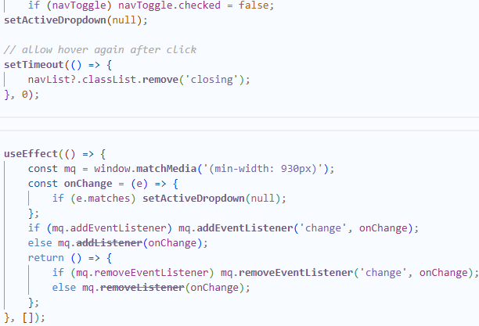

Student Name: Adesuwa Nosa-Ogie

Student ID: c5008401

Date: 17/12/2025

