Site Plan — Jeff Jensen Web Developer Portfolio
Author: Jeff Jensen
Course: BYU-Idaho WDD 130 — Web Fundamentals
Site Name: Jeff Jensen | Front-End Web Developer

Purpose
This site is a personal portfolio that showcases my web design and development work. Its purpose is to present my projects, skills, and background in a clean, professional way so that a potential employer, client, or collaborator can quickly understand what I can build and how I work. It also serves as a living record of my growth as a front-end developer.

Audience
My primary audience is potential employers and clients who are evaluating whether to hire or work with a front-end web developer. Secondary audiences include instructors and fellow students reviewing my work, and anyone curious about learning web development who wants to see real, hosted examples.

Logo
The logo is a circular "JJ" monogram badge in the site's brand palette — a dark-slate disc with a teal ring and an orange accent. It is simple, reads well at small sizes, and appears in the header of every page.

Site logo (logo.png)

Color Scheme
A six-color palette built around a professional dark-slate and teal combination, with orange reserved for accents and interaction states. Hex values below are used as CSS variables so the whole site stays consistent.
Swatch | Color | Usage
#2C3E50 | Primary — Dark Slate | Headers, nav, footer, headings
#18BC9C | Secondary — Teal | Links, buttons, accents
#F39C12 | Accent — Orange | Hover states, highlights, call-to-action
#ECF0F1 | Background — Light Gray | Page background
#FFFFFF | Surface — White | Cards, content panels
#7F8C8D | Muted — Gray | Secondary text, borders

Typography
Headings & Navigation: Montserrat (bold, geometric sans-serif — strong and modern for titles).
Body & Content: Open Sans (highly readable humanist sans-serif for paragraphs, lists, and forms).
Both fonts are loaded from Google Fonts with system sans-serif fallbacks (Helvetica, Arial).

Site Structure
The site has a home page and two child pages. Every page shares the same header, navigation, and footer, and links to both child pages.
- Home (index.html) — introduction and featured work.
- About Me (about.html) — background, skills, and goals.
- Projects (projects.html) — detailed portfolio of builds.

Content
All text and media needed to build each page is specified below. Images marked (have) already exist in the repository; images marked (create) still need to be produced or captured.

Home Page (index.html)

Header & Navigation
- Logo (JJ monogram) linking to Home.
- Site title: Jeff Jensen — Front-End Web Developer
- Nav links: Home | About Me | Projects

Hero Section
- Heading (h1): Clean, Usable Websites — Built by Hand
- Paragraph: I'm Jeff Jensen, a front-end web developer studying at BYU-Idaho. I design and code responsive, accessible websites from the ground up — semantic HTML, modern CSS, and a focus on making things easy to read and easy to use.
- Button: "View My Projects" (links to projects.html)
- Image: Hero banner — a tidy developer workspace or a code-on-screen photo (create).

Featured Projects Section
Heading (h2): "Featured Projects". Short intro: "A few recent builds — each one started as a wireframe and became a live, hosted site." Three cards, each with an image, title, one-sentence description, and a link:
- Whitewater Rafting — "A multi-page site for an outdoor adventure company, built with CSS Grid and a mobile-first layout." Image: rafting hero (have).
- Optimized Image Gallery — "A fast-loading art gallery that cut page weight from 57 MB to under 100 KB with image optimization and thumbnails." Image: gallery screenshot (have).
- WDD 130 Portal — "A portfolio hub that links all my coursework, styled with a shared design system." Image: portal screenshot (have).

Skills & Highlights Section
- Heading (h2): Skills & Highlights
- Paragraph: I work comfortably with semantic HTML5, CSS layout (Flexbox and Grid), responsive design, Git and GitHub, and hosting with GitHub Pages. I'm currently expanding into JavaScript and dynamic web apps.
- Image: A headshot or a photo of me at work (have: profile.png).

Footer
- Copyright, contact email (jeff@barefootbetters.com), and social links. Working links to About Me and Projects.

About Me Page (about.html)

Main Content
- Heading (h1): About Me
- Intro paragraph: Hi, I'm Jeff — a web development student at BYU-Idaho and a lifelong builder. Before diving into front-end development, I started and ran my own small business, which taught me to care about the details that make a product actually work for real people. That same mindset shows up in how I build websites: I want them to be clear, fast, and pleasant to use.
- Second paragraph: Outside of code, I spend time outdoors with my family and tinker with creative side projects that keep me learning.

What I'm Learning (list)
- Semantic, accessible HTML5
- Modern CSS layout with Flexbox and Grid
- Responsive, mobile-first design
- Git, GitHub, and publishing with GitHub Pages
- JavaScript and dynamic web apps (in progress)

Goals (list)
- Finish the WDD program with a portfolio I'm proud of.
- Apply these skills to my own business website.
- Grow into full-stack development.

Media & Links
- Image 1: profile photo (have: profile.png).
- Image 2: a workspace or outdoor/family photo that reflects my personality (create).
- Working links to Home and Projects.

Projects Page (projects.html)

Main Content
- Heading (h1): Projects
- Intro paragraph: A closer look at the sites and exercises I've built during the WDD program. Each entry links to the live, hosted version so you can click through and try it.
Project entries (each with a screenshot, a short write-up, and a link to the live site):
- Whitewater Rafting — a fictional adventure-company site demonstrating multi-page layout, CSS Grid, and responsive design.
- Optimized Image Gallery — a performance case study: reducing a 57 MB gallery to under 100 KB with JPG optimization and thumbnails.
- WDD 130 Portal — a hub page linking all coursework, built with a reusable stylesheet and design tokens.
- ICE Challenges — a set of small in-class builds (tables, forms, holiday theming) showing focused skills.

Media & Links
- Image 1 & 2 (minimum): screenshots of at least two featured projects (have: rafting, gallery, portal screenshots).
- Working links to Home and About Me, plus outbound links to each live project.

Wireframes

Home Page Wireframe
Layout for the home page: header with logo and navigation, a hero section, a three-card featured-projects grid, a skills/highlights band, a links row to the child pages, and a footer.
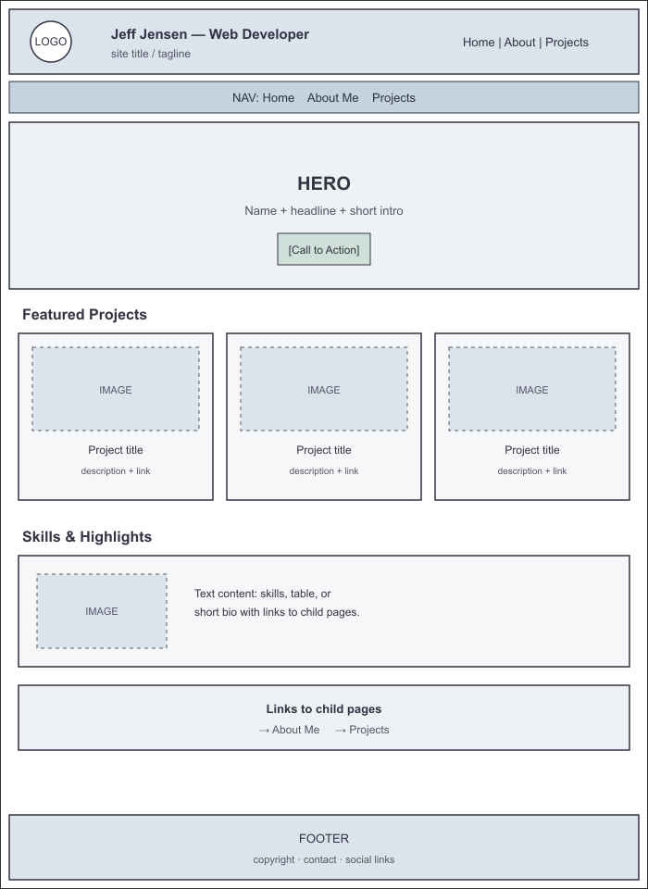
Home page wireframe

Child Page Wireframe
Shared layout for the About Me and Projects pages: the same header and navigation, a page title, an intro block, a two-column image-and-text area, a full-width section with a second image and working links, and the footer.
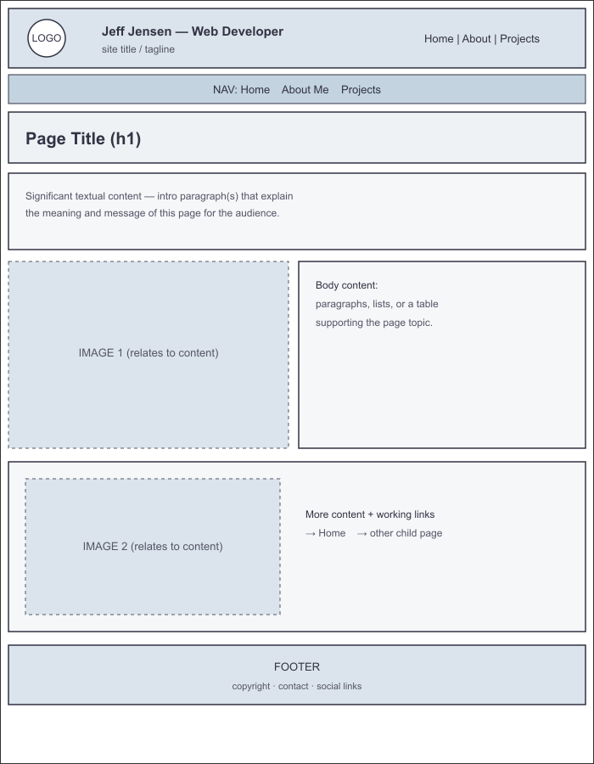
Child page wireframe (About Me / Projects)

