Functionality Description

***Log-in***

|  |  |  |  |  |
| --- | --- | --- | --- | --- |
| **Rev** | **Repository rev** | **Description of change** | **Author** | **Date** |
| 01.00 | 1.1 | Initial | Bar Einstein | November 17, 2018 |
|  |  |  |  |  |
|  |  |  |  |  |
|  |  |  |  |  |

**Table of Contents**

1. Overview 2

2. Detailed Description 2

2.1. Registration 2

2.2. Login 4

2.3. Forgot Password 5

2.4. Create a new team 6

1. Overview

This document describes how a user can register or create a new team account at **betmagen.com**. The document includes also explanation of an existing user login and the password recovery option.

1. Detailed Description

After user enters into **betmagen.com** site, the following form will be opened:

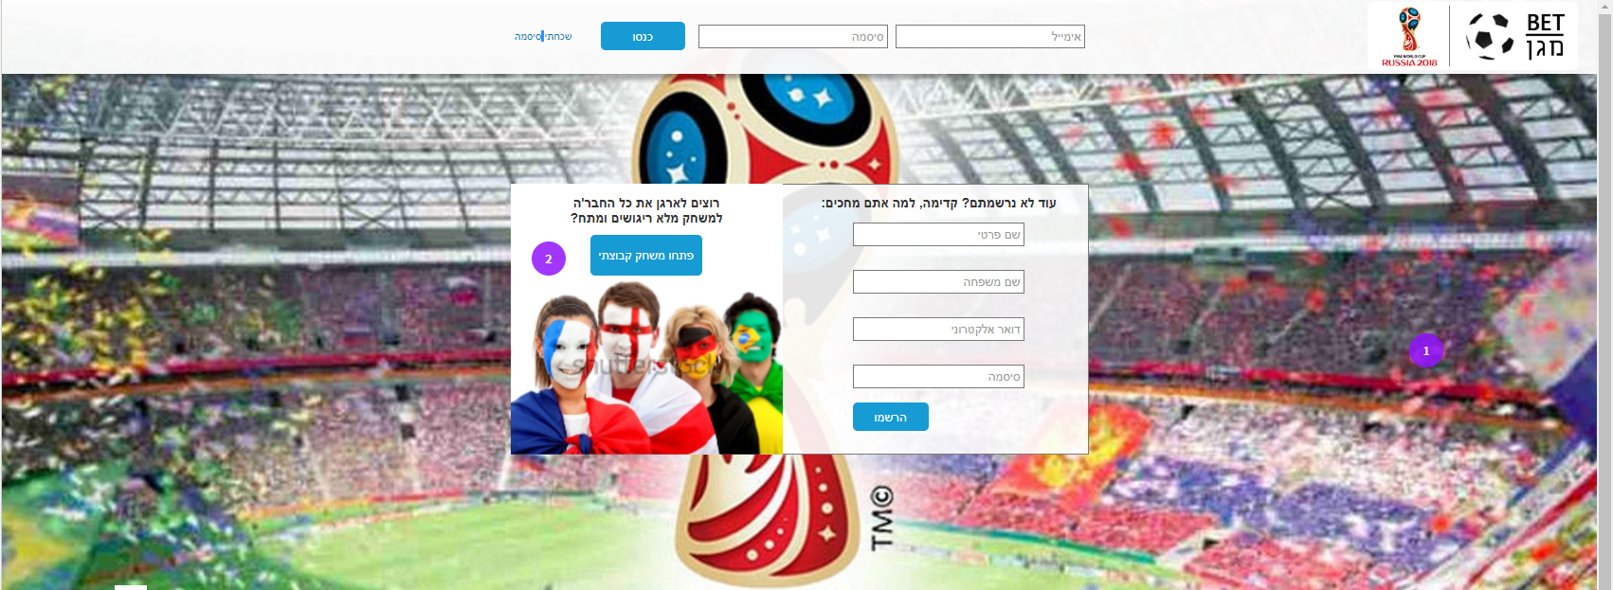

* 1. Registration

There are two different registration processes in **betmagen.com**:

1. Through the normal entrance to the site.
2. Through entrance to the site via link of a specific team account.

The registration form:

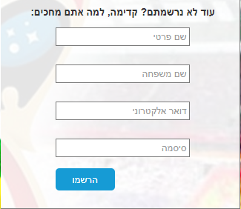

Parameters:

* שם פרטי – text field
* שם משפחה – text field
* דואר אלקטרוני – text field
* סיסמה – text field
* קוד קבוצה – text field (Note: in case the user entered to the site by link of specific team account, the field value will the team name in ‘read only’ mode.
* נייד - text field, not mandatory.
* אני מסכים לקבל עדכונים און ליין בסמס – check box, by default ‘Checked’

The user needs to feed the details and then to press on “הרשמו” button.

After the user click on “הרשמו” button, the system should check:

* If the “שם פרטי” field is empty. If yes, show error message: “יש להזין שם פרטי”
* If the “שם פרטי” field contains only Hebrew characters. If not, show error message: “יש להזין שם פרטי עם אותיות בעברית בלבד”
* If the “שם משפחה” field is empty. If yes, show error message: “יש להזין שם משפחה”
* If the “שם משפחה” field contains only Hebrew characters. If not, show error message: “יש להזין שם משפחה עם אותיות בעברית בלבד”
* If the “דואר אלקטרוני” field is empty. If yes, show error message: “יש להזין כתובת דואר אלקטרוני”
* If the “דואר אלקטרוני” field is in valid format. If not, show error message: “כתובת דוא"ל לא תקינה”
* If the submitted email already exists. If yes, show error message: “כבר קיים במערכת משתמש עם כתובת הדוא"ל שהוזנה”
* If the “סיסמה” field is empty. If yes, show error message: “יש להזין סיסמה”
* If the “קוד קבוצה” field is empty. If yes, show error message: “יש להזין קוד קבוצה”
* If the submitted team code is exists. If no, show error message: “קוד קבוצה שגוי”

If all tests are **OK**, the system automatically will perform the follows actions:

* Add a new user to users table [need to complete the relevant table in DB] when the given team will be the user main team. The user status will by default ‘Not Active’
* Send a welcome mail to the user e-mail account.
* Send a SMS to the relevant team mangers that announce about new user login.
* Open the betmagen main page for the relevant team which the user belongs to.
  1. Login

At the top part of the login page, there is a form for entering of an existing user:



The use needs to insert is email and password and then press on “כנסו” button.

After the user click on “כנסו” button, the system should check:

* If the “אימייל” field is empty. If yes, show error message: “יש להזין כתובת אימייל”
* If the “סיסמה” field is empty. If yes, show error message: “יש להזין סיסמה”
* If there is an existing user with the given email and password. If not, show error message: “כתובת דוא"ל או סיסמה אינם נכונים”

If all tests are **OK**, the system automatically will update the user last_login and no_of_visits field and will open the betmagen main page for the relevant team which the user belongs to.

* 1. Forgot Password

In case of a user forgot his own password, he has the option to recover it and get it directly to his email.

By click on “שכחתי סיסמה” link the system will open a new layer that asks the user to insert his email address:

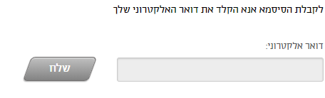

After the user click on “שלח” button, the system should check if the given email is exists in system:

* If not, show error message: “כתובת הדואר האלקטרוני לא נמצאה במערכת”
* If yes, the system will send an email to the user with his own password and will display a success message: “הסיסמא נשלחה לכתובת הדואר”
  1. Create a new team

After the user clicks on “פתחו משחק קבוצתי” button, the system will open the following form:

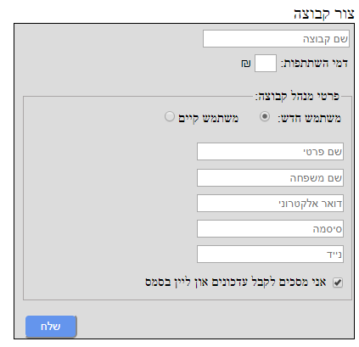

Parameters:

**Team details**

* שם קבוצה – text field
* דמי השתתפות– select box with options: (30, 50, 100, 200). By default 100 ₪

**Team manager details**

* Radio buttons for choosing the relevant manager status: משתמש חדש or משתמש קיים. By default משתמש חדש

**Note**: if the user is an existing user, the system will display only text fields for email and password

* שם פרטי – text field
* שם משפחה – text field
* דואר אלקטרוני – text field
* סיסמה – text field
* נייד - text field, not mandatory.

After the user click on “שלח” button, the system should check:

* If the “שם קבוצה” field contains only Hebrew or English letters or digits. If not, show error message: “שם קבוצה לא תקין”
* If the “שם קבוצה” field is empty. If yes, show error message: “יש להזין שם קבוצה”
* If the submitted team name is already exists. If yes, show error message: “שם קבוצה קיים במערכת”.
* For a new user, the system will perform the same tests as described above in the registration form
* For an existing user the system will perform the same tests as described above in the ‘login in’ form

If all tests are **OK**, the system automatically will perform the follows actions:

* Create a new team in the teams table. The opener user will be the team manager by default.
* Check the opener user type:
  + If the opener is a new user - add a new user to users table when the new team will be the user main team (exactly like the in the process of registering a new user).
  + If the opener is an existing user - add the new team to the list of teams that the user is member in. (The new team will be a sub team for the user).
* Display success message with the new team details: name and code
* Send an email to the opener e-mail account. The email will include details about the new team and a unique link that the manager can send to optional members that he wishes to attach to the team
* Send a SMS to the opener e-mail account. The email will include details about the new team and a unique link that the manager can send to optional members that he wishes to attach to the team.