Fair QoS Resource Management in Grids

Nikolaos Doulamis², Anastasios Doulamis²,
Emmanouel A. Varvarigos¹ and Theodora Varvarigou²

¹Dept. of Computer Engineering and Informatics, University of Patras, Greece
²Dept .of Electrical and Computer Engineering, National Technical University of Athens, Greece

E-mail: ndoulam@cs.ntua.gr, manos@ceid.upatras.gr

Abstract

Resource management in a Grid has to able to guarantee commercial or industrial applications a personalized Quality of Service (QoS). This QoS has to be provided in an often non-benign environment, where resources are scarce, and vary in a dynamic way. We consider the QoS scheduling problem whose target is to determine when and on which resources the jobs should be executed, in order to satisfy their QoS requirements. We propose a new algorithm for fair QoS scheduling in a Grid, and we compare it to other scheduling schemes such as the Earliest Deadline First and the Least Laxity First schemes. Our algorithm uses a max-min fair sharing approach for providing fair access to Grid users. When there is no shortage of resources, the algorithm assigns to each task enough computational power for it to finish within its deadline. When there is congestion, the main idea is to fairly reduce the CPU rates assigned to the tasks, so that the share of resources that each user gets is proportional to the user’s weight. The weight of a user may be defined as the user’s contribution to the Grid infrastructure or the price he is willing to pay for services or any other socioeconomic consideration. In our algorithms, all tasks whose requirements are lower than their fair share CPU rate are served at their demanded CPU rates. However, the CPU rates of tasks whose requirements are larger than their fair share CPU rate are reduced to fit the total available computational capacity in a fair manner.

Keywords : Grid Computing, Fair Grid Scheduling.

Introduction
There are many reasons to seek more computational power than existing computers can give. At the same time it seems that the increase in computational power that can be achieved by improvements in the speed of electronic devices alone is approaching a limit posed by physical constraints. The Computational Grid promises faster computation by taking a different approach. Instead of focusing on a single computer (or more generally device) to make it more powerful, it tries to create organizations of computers (or devices, respectively), which can efficiently cooperate and execute a given set of computation tasks [1].
Grid computing is distinguished from conventional distributed computing by its focus on large-scale resource sharing, innovative applications, and, in some cases, high-performance orientation. It supports the sharing, interconnection and use of diverse resources in dynamic computing systems that can be sufficiently integrated to deliver computational power to applications that need it in a transparent way [2]. The Grid is often considered as the natural evolution of the Internet, and it is expected to fundamentally change not only the way scientists and businesses work, but also the way they think about computing and resources. Grids promise –but have not yet delivered – users the ability to transparently access significantly more computing, storage and other resources, treating them as belonging to a single computer.
The ability to provide an agreed upon Quality of Service (QoS) is important for the success of the Grid, since, without it users, may be reluctant to pay for Grid services or contribute resources to Grids, which would hinder its development and limit its economic significance. The need for QoS has been confirmed by the Global Grid Forum (GGF) in the special working group dealing with the area of scheduling and resource management for Grid computing. Despite recent advances in Grid technology, many emerging network applications in the area of high performance computing and information analysis are still unable to satisfy their QoS requirements. Examples include collaborative visualisation of large datasets or computationally demanding data analyses, which usually require data streaming at 100s or even 1000s of Mbps, guaranteed high computational power, and completion within a specific deadline [1]. New abstractions and concepts should be introduced at the architecture level to allow users to make service level agreements (SLAs) with the Grid, and new capabilities are required to enable the enforcement of the SLAs by the Grid through the delivery of the agreed QoS to the users.
A successful Grid is a Grid that many users will like to use and may therefore have, by definition, more users than the underlying resources are able to handle. Meeting the QoS requirements of one user, however, should not be achieved by sacrificing the QoS of another user. When the desired QoS cannot be provided, the degradation in the QoS provided should be graceful and fair to all users. This naturally leads to the need of congestion control and the associated notion of fairness, which are two of the issues we address in this paper. Fairness does not mean that all users have equal access to Grid resources. Our notion of fairness is based on the max-min fair share idea, and it takes into account the QoS requirements of the users, and also a weighting parameter that is determined by economic considerations. The weighting parameter permits us, in case of congestion, to treat more favourably (in a quantifiable way) users who are willing to pay more for the service they get or who have contributed more resources to the common Grid infrastructure. When there is no congestion, each user gets the requested QoS, but when congestion arises (meaning that the desired QoS cannot be delivered to all users), the QoS that each user receives (as measured by the computational power he is given, or his completion time, or the amount of time by which he misses his deadline) is degraded in a way determined by his requested QoS and the weighting factor.
Computers running a task on a Grid, have to get the required code and data from a remote machine; also, when doing computations, machines may have to exchange intermediate results. In many cases, the time required for communication is more than the time spent by machines on computations. The success stories of the Grid are currently limited mainly to coarse grain computation. If Grids are eventually to be used for fine grain computations, communication will become a performance bottleneck. It is therefore important that the scheduler of a Grid resource manager takes communication delays into account when assigning tasks to processors.
Scheduling and resource management are important in optimizing Grid resource allocation, and determining its ability to deliver the negotiated QoS and provide fair access to all users [3]. The resource manager receives information about the job characteristics and requirements and determines when and on which processor each job will execute. The objectives that we set for the resource manager of a Grid is to assign computational resources to computational tasks in an efficient and fair way, while meeting to the degree possible the QoS requirements of the individual tasks. Efficiency in the use of resources is clearly important because this is what motivated the Grid in the first place. Fairness is important because it is inherent in the notion of sharing, which is the raison d’etre of the Grid. Meeting the requirements of the users is important because otherwise the users will not want to use, pay, or contribute resources to the Grid.
The remainder of the paper is organized as follows. In section 2, we discuss the role of the resource manager, provide an overview of previous work on scheduling, and compare our approach to previously proposed scheduling schemes. In section 3, we discuss the relation between the scheduling policy and the adopted charging policy, an issue that is closely related to the commercial exploitation of Grid computing. In section 4, we introduce some basic notation and give the formulation on which our algorithms will be based. In contrast to previous approaches on Grid resource management, our scheduling algorithms address the “admission control problem”, and use ideas derived from the networking literature to obtain efficient and fair scheduling schemes for the Grid environment. In section 5, we present urgency-based scheduling schemes and a modified Earliest Completion Time (ECT) policy used for processor assignment. Starting with section 6, we turn our attention to Grid scheduling algorithms that take fairness into account. We introduce the notion of fair completion time for a task submitted for execution. We then propose three different scheduling schemes: The first is the Simple Fair Task Order (SFTO) scheme, where scheduling is performed by ordering the tasks according to their fair completion times, and then assigning each of them to the appropriate processor using a modified ECT-based policy. The second scheme, called Adjusted Fair Task Order (AFTO), refines the SFTO policy by ordering the tasks using the adjusted fair completion times, resulting in more fair treatment of the jobs. In section 7 we present the Max-min Fair Share (MMFS) scheduling algorithm, which simultaneously addresses the problem of finding a fair task order and assigning a processor to each task. Based on a Max-Min fair sharing policy. Experimental results and comparisons with traditional scheduling schemes, such as the Earliest Deadline First (EDF) and the First Come First Served (FCFS) schemes, are presented in section 8. Finally, section 9 concludes the paper.

Resource Management and Scheduling
Central to the performance of any Grid architecture is the resource management tool used to schedule computation and communication tasks on the available resources. The Grid is inherently dynamic: machine loads, network latencies and bandwidths, change continually. Available resources and application requirements can be dramatically different from one hour to the next. Resources are not exclusively dedicated to Grid usage, and may temporarily be removed from the grid to solely work on a local problem. The resource management tool must be able to adapt to such a dynamic environment. To meet its objectives the resource manager uses any information that is available about the expected workload of the tasks, their QoS requirements (including deadlines), estimates of the communication delays involved, the current and future utilization profile of the available processors, and the price that the user pays or other contribution that the user makes to the system. The performance measuring tools, resource map, and task requirements (expected task duration, task deadlines, fault tolerance requirements etc) provide the inputs, and the decisions on the processing, storage, and communication resources that will be used, and the times for which they will be reserved form the outputs of the scheduler.
In order to provide the agreed QoS to the users, while using the available resources efficiently (that is, on demand), the Grid resource manager has to be able to reserve (parts of) resources for the execution of specific tasks. The requirement of on demand and efficient use of resources implies that resources (or parts of resources) should be allocated to a task only for the time period during which they are actually used, and should be available to other tasks for the remaining time. This leads to the need of timed reservation of resources and task scheduling. In this paper we do not address the problem of how reservations and schedules are enforced locally at a processor; we only consider algorithms for the resource manager to decide where and when each task will run in a way that will make fair and efficient use of the available resources.
We will say that a task is non-preemptable if once it starts execution on a processor, it has to be completed on that processor, and once it starts execution it cannot be interrupted by other tasks and resume execution later. In the scheduling algorithms we will propose we will assume that tasks are non-preemptable. This is the most limiting case, since any scheduling algorithm that works with non-preemptable tasks also works when this constraint is removed giving the scheduler more freedom. Task preemptions and interruptions are in any case undesirable, since they imply considerable overhead for transferring data to other processors, saving process state information, and so on. We also assume in our algorithms that when a task is executed on a machine it occupies 100% of its computational power, that is, time sharing is not supported. We consider this assumption reasonable since a) local, non-grid jobs can be accounted for by excluding from the machine’s computational capacity the fraction used by these jobs, and b) the ability to execute multiple grid jobs simultaneously on a machine cannot improve performance (the processor sharing discipline is the worse performing among work-conserving disciplines), and c) any schedule obtained under this assumption is also feasible under the assumption that time-sharing is available. The assumption that a time-sharing capability is not available makes the scheduling problem more difficult.
Several scheduling algorithms have been reported in the literature. The most well-known scheduling algorithm is the Earliest Deadline First (EDF) [4], which assigns the highest priority to the task with the most imminent deadline. Another scheduling approach is the Slack Time algorithm, also referred as Least Laxity First (LLF) [5][6], where the tasks are selected for execution in order of non-decreasing slack time, defined as the difference between the task’s relative deadline and its remaining computational time.
The aforementioned schemes have been designed for the case where there is a single processor on which tasks are scheduled. Even though these schemes can be extended in a natural way to the case of a multiprocessor environment to determine the order in which the tasks are considered for assignment to processors, they do not determine the specific processor on which the selected tasks are assigned. A simple rule to determine the processor on which a task is executed is the Earliest Start Time (EST) rule. The earliest start time is the earliest time that a task can start its execution. Another popular rule is the Minimum Processing Time First rule (MPTF), where the processor giving the minimum processing time is selected. In case of multiprocessor systems the authors in [8] have shown that an integrated heuristic that takes into account both the task deadline and earliest start time performs better than the EDF, LLF and MPTF algorithms. The authors in [9] also proposed several heuristic scheduling algorithms for the multiprocessor case. In particular, when a task arrives at a node, the local scheduler at that node attempts to ensure that the task will complete execution on that node before its deadline. If the attempt fails, the scheduling components on other nodes cooperate to determine which other node in the system has sufficient resource surplus to guarantee completion of the task within its deadline.
The previously mentioned scheduling algorithms assume that the tasks are non-preemptable. Scheduling algorithms dealing with preemptable tasks have also been reported in the literature [10], [11], [13]. In this case, it is assumed that each task can be divided into smaller units, each of which is executed independently. The ability to feasibly schedule preemptable tasks is always higher than the ability to feasibly schedule corresponding non-preemptable tasks. However, this increase in schedulability is obtained at the expense of a higher implementation overhead. To address this difficulty, task parallelization can be performed as an intermediate solution, which tries to meet the conflicting requirements of schedulability and overhead. An extension of the myopic algorithm of [8] to a parallel system has been reported in [12].
A drawback of the previously mentioned scheduling algorithms is that they do not deal with congestion, in the sense that they do not say what happens when the tasks cannot all be feasibly scheduled. As a result, fairness considerations also play no role in these algorithms. Fair scheduling schemes have been extensively studied in the networking literature, especially for scheduling packet flows over Internet routers. Towards this direction, the Generalized Processor Sharing scheme (GPS) has been proposed for fair scheduling over packet switched networks [14]. The GPS scheme provably provides guarantees on the delay and bandwidth of a session in a network of switches, but is hard to implement. The GPS scheme is emulated in practice using the Weighted Fair Queuing (WFQ) algorithm [15], which exploits concepts of the Max-Min Fair sharing scheme [16]. GPS-based algorithms are widely implemented in the Internet and mobile communications today. Some of the ideas we will use for fair QoS scheduling in Grids are drawn from concepts introduced in the related networking literature.

Scheduling Evaluation and its Relation to the Charging Policy
Evaluating the efficiency of a scheduling algorithm depends on the utility function that we seek to optimize, which in turn depends on techno-economic criteria. For example, a scheduling algorithm that maximizes the number of tasks served by the Grid tends to favour tasks of low workload at the expense of tasks of heavy workload. The opposite is true when the evaluation criterion used is the total workload served, since in that case there is a tendency to reject tasks of low workload in favour of tasks of heavy workload. A fair scheduling algorithm, however, should not favor tasks of specific characteristics (e.g., of high or low workload) against others.
In the QoS scheduling problem, the goal is to appropriately assign all the tasks requesting service to the available processors so that the time constraints are satisfied. The time constraints of a task are the task’s deadline (which is the time by which it is desirable for it to complete execution) and the task’s earliest starting time on each processor (which is the earliest time at which the task can start execution at that processor; it takes into account the communication delay incurred for transferring the task at that processor and the current load of that processor.) This problem may have zero, one, or many feasible solutions. Often, finding a single feasible schedule may not be sufficient. In some cases, the goal may be to find the optimal schedule among all feasible schedules, according to a desired optimality criterion. In other cases a feasible solution may not exist, in the sense that some tasks cannot be scheduled to meet their respective deadlines. In this case, we need criteria to select in a "fair" way the tasks that are rejected and the tasks that receive a degraded QoS. The fairness of a solution depends on the adopted charging policy of the system.
A common measure for evaluating the scheduling performance is the success ratio, defined as the ratio of the number of tasks that are feasibly scheduled (i.e., the tasks whose time constraints are met) over the total number of tasks requesting service. This measure treats all tasks equally, regardless of their workload, and it does not take into account the users’ contribution to the Grid infrastructure or the price that a user pays for the service he receives. Another performance measure is the total workload of all feasibly scheduled tasks. Here, the charging policy is implemented per workload unit, and it is more beneficial to serve tasks of heavy workload than tasks of low workload. In such a case the fees charged are proportional to the customer task workload, so it is preferable to serve few customers who are willing to pay a lot, rather than a lot of customers who are willing to pay only little for their services. Such a policy is similar to the one used in traditional telephone networks.
The objective of the algorithms we will present in Sections 6 and 7 for scheduling tasks with deadlines on resources is to optimise a fairness criterion. A fair scheduler tries to meet the QoS requirements of the users. When this is not possible, the resources are allocated so that the degradation in QoS perceived by each user is done in a (weighted) fair way. For example, tasks submitted by users who are willing to pay a higher fee or who contribute more to the Grid infrastructure are treated more favourably (in a measurable way) than those of other users.

Notation and Problem Formulation
We let N be the number of tasks that have to be scheduled. We define the workload 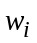 of task , i=1,2,...,N, as the duration of the task when executed on a processor of unit computation capacity. The task workloads are assumed to be known a priori to the scheduler, and are provided by a prediction mechanism, such as script discovery algorithms, databases containing statistical data on previous runs of similar tasks, etc. An algorithm for workload prediction of 3D rendering in a Grid architecture is presented in one of our earlier works in [17]. We assume the tasks are non-preemptable, so that when they start execution on a machine they run continuously on that machine until completion. We also assume that time-sharing is not available and a task served on a processor occupies 100% of the processor capacity.
We assume that there are M processors in the system, and the computation capacity of processor j is equal to 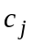 units of capacity. (The computation capacity of a processor is the available capacity of the processor, and it does not include capacity occupied by local tasks). The total computation capacity  of the Grid is defined as
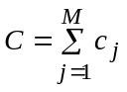 (1)
That is, if the Grid could be viewed as a single computer it would have computation capacity equal to C.
Let d_{ij} be the communication delay between user i and processor j. More precisely, d_{ij} is (an estimate of) the time that elapses between the time a decision is made by the resource manager to assign task to processor j, and the arrival of all files necessary to run task to processor j. We assume that the communication delays d_{ij} are known to the scheduler, and they are provided by a prediction mechanism that takes into account the size of the files that have to be transferred, the available bandwidth and propagation delays in the network, and statistical data.
Each task is characterized by a deadline 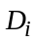 that defines the time by which it is desirable for the task to complete execution. In our formulation, is not necessarily a hard deadline. In case of congestion the scheduler may not assign sufficient resources to the task to complete execution before the deadline. In that case the user may choose not to execute the task, as may be the case when he/she expects the results to be outdated or not useful by the time they are provided. We use together with the estimated task workload and the communication delays d_{ij}, to obtain estimates of the computation capacity that task would have to reserve to meet its deadline if assigned to processor j. If the deadline constraints of all tasks cannot be met, our target is that a schedule that is feasible with respect to all other constraints is still returned, and the amounts of time by which the tasks miss their respective deadlines is determined in a fair way.
We let 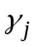 be the estimated completion time of the tasks already running on or already scheduled on processor j. is equal to zero (that is, the present time) when no task has been allocated to processor j at the time a task assignment is about to be made; otherwise, corresponds to the remaining time until completion of the tasks already allocated to processor j. We define the earliest starting time of task on processor j as
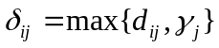. (2)
δ_{ij} is the earliest time at which it is feasible for task to start execution on processor j. We define the average of the earliest starting times of task over all the M available processors, as
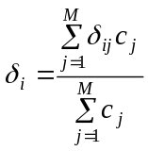 (3)
We will refer to 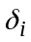 as the grid access delay for task , and it can be viewed as the (weighted) mean delay required for task to access the total grid capacity . Since in a Grid computation power is distributed, plays a role reminiscent of that of the (mean) memory access time in uni-processor computers.
In the fair scheduling algorithm that we will propose in Section 6, the demanded computation rate 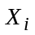 of a task will play an important role, and is defined as
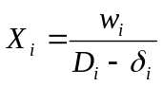. (4)
can be viewed as the computation capacity that the Grid should allocate to task for it to finish just before its requested deadline D_{i} if the allocated computation capacity could be accessed at the mean access delay δ_{i}. As we will see later, the computation rate allocated to a task may have to be smaller than its demanded rate . This may happen if more jobs request service than the Grid can support (congestion), in which case some or all of the jobs may have to miss their deadline. The fair scheduling algorithms of Sections 6 and 7 attempts to degrade the QoS experienced by the tasks (as measured by the computation rate allocated to the task, or the amount of time by which the deadline is missed as a percentage of D_{i}-δ_{i}) in a (weighted) fair way.
The scheduling algorithms that we will propose (except for the MMFS algorithm proposed in section 7) consist of two phases. In the first phase, we determine the order in which tasks will be considered for assignment to processors (the “queuing order” phase) and in the second phase we determine the processor on which each task is scheduled (the “processor assignment” phase).

Earliest Deadline First and Earliest Completion Time rules
The most widely used urgency-based scheduling scheme is the Earliest Deadline First (EDF) method, also known as the deadline driven rule. This method dictates that at any point the system must assign the highest priority to the task with the most imminent deadline. The most urgent tasks (i.e., the task with the earliest deadline) are served first, followed by the remaining tasks according to their urgency.
The EDF rule answers only the “queuing order” question, but it does not determine the processor where the selected task is assigned. To answer the “processor assignment” question, the Earliest Completion Time (ECT) technique presented next can be used.
If task 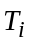 starts execution on processor j at the earliest starting time δ_{ij}, its completion time will be δ_{ij+} w_{ij}, where 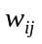= w_{i}/c_{j} is the execution time of task on processor j. (Recall our assumption that each task occupies 100% of a processor’s capacity when executed; in this way, tasks are executed in the earliest possible time). Among the M available processors, the ECT rule selects the one that minimizes the following quantity
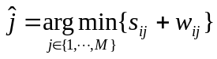 (5)
The earliest starting time δ_{ij} depends through Eq. (2) on the time γ_{j} at which the last task already allocated to processor j is expected to complete service.
A note regarding the way γ_{j} is defined is necessary here. One way to define γ_{j} is to define it as the processor release time, that is, the time at which all tasks already scheduled on this processor finish their execution. Figure 1 illustrates a scheduling scenario in which a) the task queuing order is selected using the EDF algorithm b) the processor assignment is selected using the ECT approach and c) γ_{j} is defined as the processor release time.

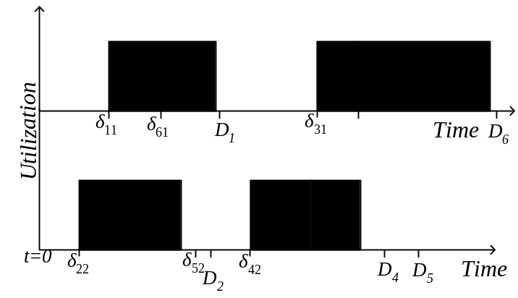
Figure 1. An example of the Earliest Deadline First/Earliest Completion Time (EDF/ECT) algorithm for the case γ_{j} is defined as the processor release time. In this figure, we assume that all tasks T_{i}, i=1,2,..,6, request service at time t=0, the processors have equal computational capacity (c₁=c₂), and both processors are initially idle. We also assume that D₁<D₂<•••<D₆ and 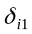=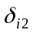. The task T₁ of the earliest deadline D₁ is first assigned for execution on processor 1 (processor 1 is chosen randomly in this case since there is tie). Task T₂ is then assigned for execution on processor 2 (since it is the processor that yields the earliest completion time). In a similar way, we assign the remaining tasks.
Defining γ_{j} as the processor release time makes it easy to compute, and independent of the task that is about to be scheduled, but it has the drawback that gaps in the utilization of a processor are created (for example, the gap between tasks T₁ and T₃ in Fig. 1), resulting in a waste of processor capacity. An obvious way to overcome this problem is to examine the capacity utilization gaps, and in case a task fits within a capacity gap, to assign the task to the corresponding time interval. Among all candidates time intervals the one that provides the earliest completion time is selected. Figure 2 shows how the schedule for the example given in Fig. 1 is improved by exploiting capacity gaps. The completion times of tasks T₅ and T₆ are shorter than those obtained in Fig. 1.
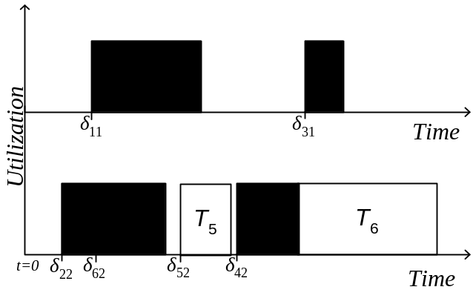
Figure 2. An example of the EDF/ECT algorithm that exploits processor utilization gaps.

Fair Scheduling
The scheduling algorithms described in the preceding section do not adequately address congestion and they do not take fairness considerations into account. For example, tasks with relative urgency (with the EDF rule) or tasks that have small workload (with the ECT rule) are favored against the remaining tasks. With the ECT rule, tasks that have long execution times have a higher probability of missing their deadline even if they have a late deadline. Also, with the EDF rule, a task with a late deadline is given low priority until its deadline approaches, giving no incentive to the user to specify a honest deadline (especially in the absence of any pricing mechanism). To overcome these difficulties, we propose in this section an alternative approach, where the tasks requesting service are queued for scheduling according to what we call their fair completion times. The fair completion time of a task is found by first estimating its fair task rates using a Max-Min fair sharing algorithm as described in the following subsection.

Estimation of the Task Fair Rates
In our initial presentation, we assume that all tasks have equal weights, and all users are equivalent.

Ideal Non-weighted Max-min Fair Sharing of Grid Resources
Intuitively, in max-min fair sharing, all users are given an equal share of the total resources, unless some of them do not need their whole share, in which case their unused share is divided equally among the remaining “bigger” users in a recursive way.
The max-min fair sharing algorithm is described more formally as follows. The demanded computation rates 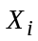, i=1,2,…,N, of the tasks are sorted in ascending order, say, X₁<X₂<•••<X_{N}. Initially, we assign capacity C/N to the task 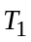with the smallest demand 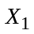, where C is the total grid computation capacity [Eq. (1)]. If the fair share C/N is more than the demanded rate of task , the unused excess capacity of 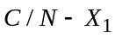 is again equally shared to the remaining tasks N-1 so that each of them gets additional capacity 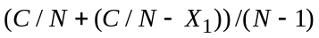. This may be larger than what task 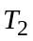 needs, in which case the excess capacity is again equally shared among the remaining N-2 tasks, and this process continues until there is no computation capacity left to distribute or until all tasks have been assigned capacity equal to their demanded computation rates. When the process terminates each task has been assigned no more capacity than what it needs, and, if its demand was not satisfied, no less capacity than what any other task with a greater demand has been assigned. This scheme is called max-min fair sharing since it maximizes the minimum share of a task whose demanded computation rate is not fully satisfied.
We can mathematically describe the previous algorithm as follows. We denote by 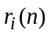 the non adjusted fair computation rate of the task at the n^{th} iteration of the algorithm. Then is given by
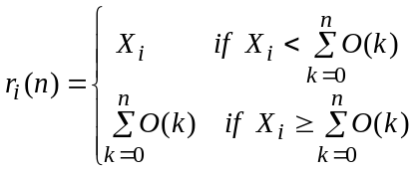, 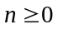 (6a)
where
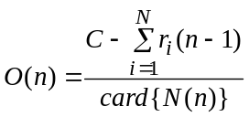, 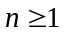 (6b)
with 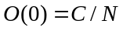 (6c)
In Eq. (6b), 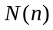 is the set of tasks whose assigned fair rates are smaller than their demanded computation rates at the beginning of the n^{th} iteration, that is,
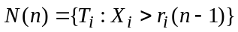 and N(0)=N, (7)
while the function 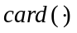 returns the cardinality of a set. The process is terminated at the first iteration 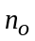 at which either 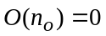 or the number 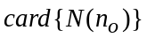=0. The former case indicates congestion, while the latter indicates that the total grid computation capacity can satisfy all the demanded task rates, that is,
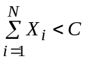 (8)
The non-adjusted fair computation rate of task are obtained at the end of the process as
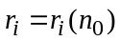 (9)

Ideal Weighted Max-min Fair Sharing of the Grid Resources
We now consider the case where users have different priorities. More specifically, we assume that each task is assigned an integer weight 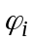, determined, for example, by the contribution the user submitting the task (or his organization) makes to the grid infrastructure, or by the price he is willing to pay for the services he receives, or by any other consideration. We assume, without loss of generality, that the smallest task weight is equal to one. In weighted max-min fair sharing, when the demanded rates of the tasks cannot be satisfied, the rate that each task receives is proportional to its weight, provided that the task needs that computation rate.
To be more precise, we allocate computation capacity as if the number of submitted tasks is equal to the sum of the respective weights, that is, as if there were 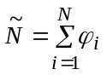virtual tasks. An equal fair sharing is performed for all 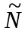 virtual tasks using the algorithm of Section 6.1.1. Equation (6) is then modified as follows
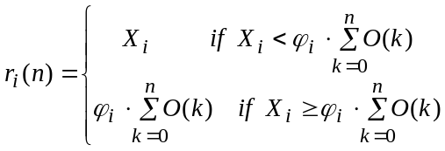, (10)
where
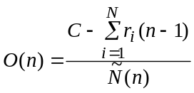, (11)
and 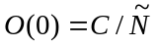, with (12)
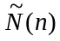 is the sum of the weights of the tasks whose assigned fair rates are smaller than their demanded computation rates at the beginning of the n^{th} iteration of the algorithm, that is:
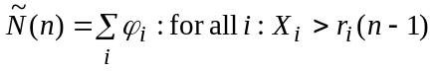 and 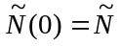 (13)
The process is terminated at an iteration at which either or 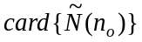=0.

Fair Task Queue Order Estimation
As mentioned in Section 3, a scheduling algorithm should answer two questions. First, it has to choose the order in which the tasks are considered for assignment to a processor (the queue ordering problem). Second, for task that is located each time at the front of the queue, the scheduler has to decide the processor on which the task is assigned (the processor assignment problem). To solve the queue ordering problem in fair scheduling, we will describe shortly, in Sections 6.2.2 and 6.2.3, several ordering disciplines of different degrees of implementation complexity. Before doing so, however, we have to introduce some additional notation that will be useful in our presentation.

Non-adjusted Fair Completion Time Estimation
We define the non-adjusted fair completion time t_{i} of task T_{i} as
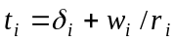. (14)
t_{i} can be thought of as the time at which the task would be completed if it could obtain constant computation rate equal to its fair computation rate starting at time (recall that is the mean grid access time for task T_{i}). Note that finishing all tasks at their fair completion time is unrealistic because the grid is not really a single computer that can be accessed by user i at any desired computation rate at a uniform delay . More precisely, a) the task is actually assigned to a specific processor j and the earliest starting time on that processor is δ_{ij}, b) even if r_{i}<c_{j}, it may not be possible to execute the task at rate on that processor (we do not assume that time sharing is supported), c) the estimates w_{i} of the task workloads may be inaccurate. The non-adjusted fair completion times t_{i,} are used by our algorithm as an index for determining the order in which tasks are processed by the scheduler

Simple Fair Task Order (SFTO)
According to the Simple Fair Task Order (SFTO) rule, the tasks are ordered in the queue in increasing order of their non-adjusted fair completion times t_{i}. In other words,, the task that is first considered for assignment to a processor is the one for which it would be “fair” to finish sooner. As described earlier, the non-adjusted fair completion times are estimated from the non-adjusted computational rates , which are in turn estimated from the tasks’ demanded rates and the total grid processor capacity C. The SFTO rule is simple to implement, but it is not as fair as some of the other rules described in the following. Its performance and its fairness characteristics are rather good as shown by the simulation results presented in Section 8.

Adjusted Fair Task Order (AFTO)
An issue not addressed in the definition of the non-adjusted fair completion times given in Section 6.2.1 and in the SFTO scheme presented in Section 6.2.2 is that when tasks become inactive (because they complete execution), more capacity becomes available to be shared among the active tasks, and the fair rate of the active tasks should increase. Also, when new tasks become active (because of new arrivals), the fair rate of existing tasks should decrease. Therefore, the fair computational rate of a task is not really a constant , as assumed so far, but it is a function of time, which increases when tasks complete execution, and decreases when new tasks arrive. By accounting for this time-dependent nature of the fair computational rates, the adjusted fair completion times, denoted by t_{i}^{,a} can be calculated, which better approximate the notion of max-min fairness. In the Adjusted Fair Task Order (AFTO) scheme, the tasks are ordered in the queue in increasing order of their adjusted fair completion times t_{i}ª. The AFTO scheme results in schedules that are fairer than those produced by the SFTO rule; it is however more difficult to implement and more computationally demanding than the SFTO scheme, since the adjusted fair completion times t_{i}ª are more difficult to obtain than the non-adjusted fair completion times t_{i}. The way the adjusted fair completion times can be computed is described next. Simulation results on the computation complexity of all schemes will be presented in Section 8.
Adjusted Fair Completion Times Estimation
To compute the adjusted fair completion times t_{i}ª, the fair rate of the active tasks at each time instant must be estimated. This can be done in two ways. In the first approach, each time unused processor capacity is divided, it is equally divided among all active tasks. In the second approach, the rates of all active tasks are re-calculated using the max-min fair sharing algorithm, as described in section 6.1, based on their respective demanded rates. The first approach is considerably less computationally intensive than the second one, since the max-min fair sharing algorithm is activated only once. The second approach, however, yields a schedule that is fairer. Regardless of the approach used, the estimated fair rate of each task is a function of time, denoted by 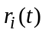.
Having estimated the fair rates , the fair completion time can be obtained using the following algorithm. We assume that the rates of all tasks have been normalized so that the minimum fair task rate equals 1. We introduce a variable called the round number, which defines the number of rounds of service that have been completed at a give time [18]. A non-integer round number represents a partial round of service. The round number depends on the number and the rates of the active tasks at a given time. In particular, the round number increases with a rate equal to the sum of the rates of all active tasks, i.e., with a slope equal to 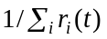. Thus, the rate with which the round number increases changes and has to be recalculated each time a new arrival or task completion takes place.
Based on the round number, we define the finish number 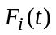 of task T_{i} at time t as
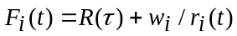 (15)
where is the last time a change in the number of active tasks occurred (and therefore the last time that the round number was recalculated), and 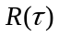 is the round number at time . is recalculated each time new arrivals or task completions take place. Note that is not the time that task T_{i} will complete its execution. It is only a service tag that we will use to determine the order in which the tasks are assigned to processors. Using Eq. (15), the adjusted fair completion times t_{i}ª can be computed as the time at which the round number reaches the estimated finish number of the respective task. Thus,
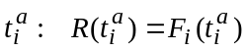 (16)
As mentioned earlier, the task adjusted fair completion times determine the order in which the tasks are considered for assignment to processors in the AFTO scheme: the task with the earliest adjusted fair completion time is assigned first, followed by the second earliest, and so on.

Fair Processor Assignment
The SFTO scheme or the AFTO scheme is used to determine the order in which the tasks are considered for assignment to processors, but it still remains to determine the particular processor where each task is assigned. A simple and efficient way to do the processor assignment is to use the earliest completion time rule (ECT), modified so that it exploits the capacity gaps, (section 5.1). According to this rule, each task is assigned to the processor that yields the earliest completion time. Simulation results on the performance of the SFTO and AFTO schemes when combined with the ECT rule are described in Section 8.

Max-Min Fair Scheduling (MMFS)
In this section, we present an alternative fair scheduling scheme that simultaneously obtains a fair task queuing order and a fair processor assignment.
In this algorithm our goal is to assign a schedulable (actual) rate 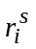 to each task so that it is as close as possible to its fair task rate 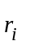(derived by applying the max-min fair sharing algorithm on the demanded rates 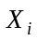, as described in section 6.1). The schedulable rates are smaller or equal to the task fair rates (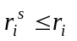) and they are chosen so as not to violate the processor capacity constraints. This is expressed in the following constrained minimization problem
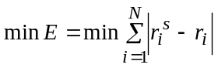 (17a)
subject to
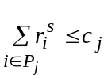 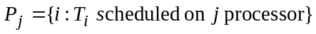 (17b)
The set 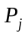 contains all tasks scheduled on processor j. The total deviation E of the schedulable rates from the fair rates will be referred to as the error of the scheduler.
Since tasks are non-preemptable (they cannot be split in smaller units that are executed on different processors), the sum of the rates of the tasks assigned for execution to a processor may be smaller than the processor capacity, and some processors may not be fully utilized. A processor with unused capacity will be called an underflow processor. In an optimal solution, tasks assigned to underflow processors have schedulable rates that are equal to their respective fair rates, 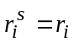, and do not contribute to the error E (otherwise we could assign additional capacity to those tasks and reduce the error). Only tasks assigned to fully utilized processors may contribute to the error E (but not all tasks assigned to fully utilized processors contribute to the error).
We define the overflow 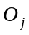 of processor j as
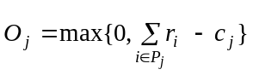 (18a)
and the underflow 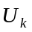 of processor k as
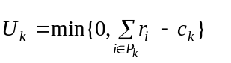 (18b)
Processors for which O_{j}>0 will be referred to as overflow processors, while underflow processors are those for which U_{k}<0.
In an optimal solution we have
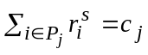, for all j for which O_{j}>0.
and the error E is equal to the sum of the total processor overflow
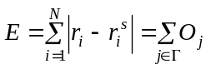 (19)
where Γ is the set of overflow processors (underflow processors do not contribute to the error E).
Therefore, the minimization problem of Eq. (17) can be rewritten as
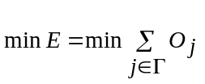 (20a)
subject to
, (20b)
Equation (20) states that scheduling the tasks with rates as close as possible to their respective fair rates [Eq. (17)] is equivalent to finding a solution that minimizes the overall processor overflow. However, the minimization of Eq. (20a) subject to the constraint of (20b) is computationally intensive (it is the similar to the bin-packing problem, which is NP-complete), since every possible task assignment to the M available processors should be examined. In what follows, we propose a heuristic task rearrangement scheme of polynomial time, to obtain a good assignment of tasks to processors.

Processor Assignment
The proposed algorithm combines processors of capacity overflow with processors of capacity underflow to obtain a better exploitation of the overall processor capacity. More specifically, given an assignment of tasks to processors, we consider the rearrangement where a task of rate assigned to an overflow processor is substituted for a task of rate 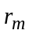 assigned to an underflow processor. After the task rearrangement, the overflow (underflow) capacity of the processors is updated as follows
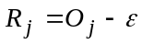 (21a)
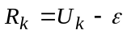 (21b)
where 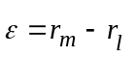 (21c)
Equation (21c) expresses the task rate difference between the two selected tasks, while 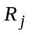 and 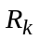 are the updated processor residuals. If 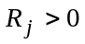, processor j remains at the overflow state after the task rearrangement, while if 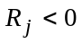 processor j turns to the underflow state.
The tasks with rates and that re exchanged are selected so as to reduce the overall processor overflow, or equivalently reduce the error E given by Eq. (19). A reduction is accomplished only if the task rate difference as expressed by Eq. (21c) satisfies the following equation
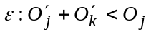 (22)
where 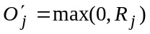 and similarly 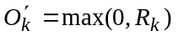.
The explanation of Eq. (22) is the following: Initially, processor j is overflow and processor k is underflow, so that only processor j contributes to the error E [see Eq. (20)]. After the task rearrangement, the total contribution of the processors j and k to the error E should be less that their initial contribution, for the rearrangement to yield an error reduction. Such rearrangements between overflow and underflow processors are repeated until no task rearrangement that satisfies Eq. (22) can be found.
An example of a rearrangement is shown in Fig. 3, where we consider two processors with capacities 20 and 25, and six tasks with fair rates 2, 5, 5, 6, 9, 10 that have to be scheduled. Initially, processor 1 is overflow (the processor capacity is 20 and the sum of the rates of the assigned tasks is 21), while processor 2 is underflow (the processor capacity is 25 and the sum of the rates of the assigned tasks is 16). By rearranging the task of rate 2 initially assigned to processor 2 with the task of rate 10 initially assigned to processor 1, both processors turn to the underflow state, resulting in a reduction in the error.
This scheme assigns tasks to the available processors so that their actual scheduled rates are as close as possible to their respective fair rates, but it does not guarantee that a feasible solution is found, i.e., it does not guarantee that all tasks are assigned to the available processors without any violation of the respective deadlines.
As a result, a rate reduction is required for those tasks that are assigned to overflow processors, so as to achieve a feasible solution. In Section 7.2, a fair rate reduction is proposed so that the feasible solution is obtained.
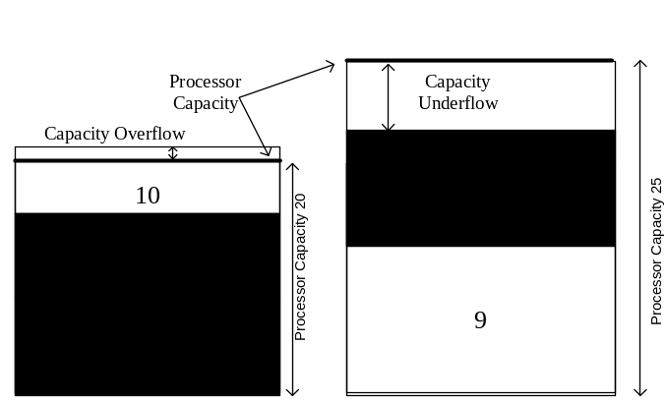 | 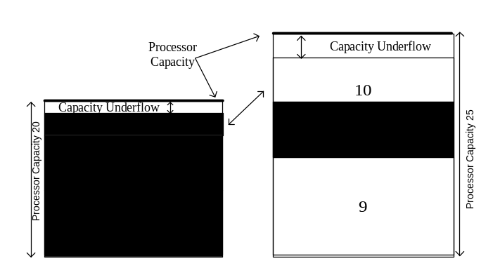
(a) | (b)
Figure 3. The idea of the task re-arrangement. (a) Initial task assignment. (b) Task re-arrangement.

Initial Processor Arrangement
For the preceding scheme to work well, we have to start with a good initial assignment. In what follows, we present a method similar to a heuristic algorithm used in the bin packing problem, which is a well-studied problem in the literature.
Initially, the algorithm sorts the tasks with respect to their fair rates in a descending order. To obtain an initial assignment, the task of the largest fair rate is first assigned to a processor, followed by the task of the second largest fair rate, and so on. The algorithm assigns, if possible, the task to a processor of adequate available capacity. If more than one processors of adequate available capacity exist, we choose the one that would leave the smallest residual capacity after the task assignment is made. In case a selected task cannot be feasibly scheduled on any processor, the task is assigned to the processor of minimal overflow. This process is terminated when all tasks have been scheduled on the available processors.

Fair Sharing of Overflow Capacity and Task Queuing Order
In the previous section, we have described an algorithm for the assignment of tasks to processors so that the task schedulable rates are as close as possible to their respective fair rates. The solution obtained however is not necessarily feasible, since some processors may be overflow. In this section, we describe an algorithm to reduce the schedulable task rates 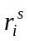 of the overflow processors in a fair way in order to obtain a feasible solution. In this way, tasks assigned to overflow processors will not be able to meet their deadline, but the amount by which they will miss their deadline will be determined in a fair way.
In the simple case where all users have equal weights φ_{i}=1, the processor overflow is equally shared among all tasks assigned to the processor, and the schedulable task rates are given by
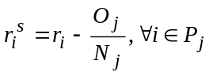 (22)
where 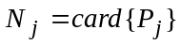. is the number of tasks assigned to the processor j. Equation (22) also covers the underflow case, since in that case 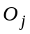=0 and 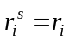.
In the case where a different weight is assigned to each task , the rate reduction is performed according to
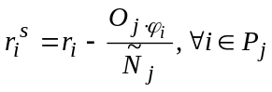 (23)
where 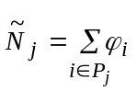.
After finding the schedulable task rates (the solution also gives the processor each task is assigned to), the tasks are scheduled for execution in an ascending order of their fair completion times on the processor to which they have been assigned. That is, the task with the earliest completion time is first scheduled for execution, followed by the second earliest task, and so on.

Experimental Results
The proposed scheduling algorithms have been designed as part of the scheduler module of a Grid toolkit being implemented as part of the EU funded GRIDLAB (A Grid Application Toolkit and Testbed) project. A brief description of the GRIDLAB architecture is described in section 8.1. In section 8.2, several criteria are proposed for measuring the performance of the presented Grid scheduling algorithms, while in section 8.3 simulation results and comparisons with traditional scheduling policies are given.
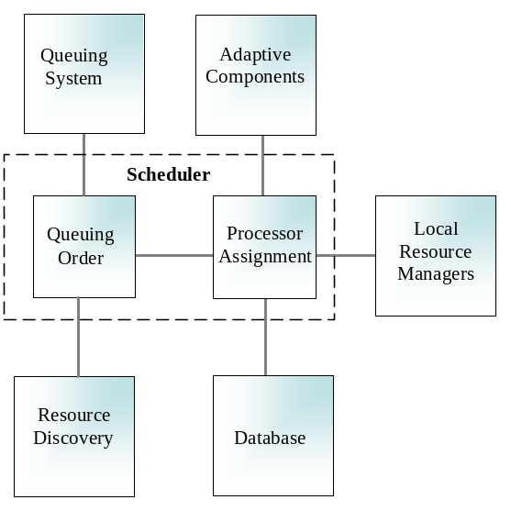
Figure 4. The architecture of the scheduler architecture adopted in the GRIDLAB infrastructure.

Scheduler Architecture
Figure 4 depicts the scheduler architecture adopted in the GRIDLAB infrastructure, the main modules of which are the following:
- Queuing System: Each time a task is submitted for execution, its characteristics (e.g., the task deadline) are stored in a database, which is the core of the Queuing System module.
- Queuing Order: This unit addresses the task queue ordering problem, that is, it determines the order in which the tasks are considered for assignment to the available resources. The Queuing order unit communicates with the queuing system module, where the tasks requesting service along with their respective characteristics are stored, and with the Resource Discovery module, which determines the available resources of the infrastructure.
- Processor Assignment: The information collected by the Queuing Order unit is then passed to the Processor Assignment unit, which determines the processor on which each task is assigned.
- Adaptive Components: This module is responsible for a) predicting the workload of the tasks requesting service, b) estimating the tasks ready times 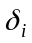 through the respective communication delays 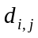 and the processor release times of the tasks already allocated to processor j The adaptive component module provides the information required by the scheduler to perform the task queue ordering and the processor assignment functions. A method for predicting the task workload in the particular case of 3D rendering applications in described in [17].
- Resource Discovery: This module determines the available resources of the Grid.
- Local Resource Manager: This module is responsible for implementing the task execution locally as instructed by the scheduler.
In the following subsections, we will compare the performance of the fair scheduling algorithms proposed in sections 6 and 7 with that of the First Come First Serve (FCFS) and the Earliest Deadline First (EDF) policies.

Objective Evaluation
One criterion that we will use for measuring the performance of a scheduling algorithm is the relative error between the demanded task rates and the actual schedulable rates defined as
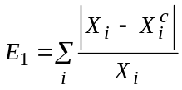 (24)
where 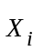 is the demanded rate and 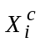 is the actual rate allocated to the i^{th} task. Low values of error 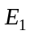 indicate that most of the tasks are served at rates close to their respective demanded rates.
In the FCFS and EDF algorithms, the tasks are either executed at their demanded rates , or they are rejected. Therefore, for the FCFS and EDF schemes, the actual task rates are equal to 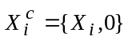 (depending on whether the task is assigned for execution or not). In contrast, in the fair scheduling schemes we proposed, all tasks are executed, possibly at a rate smaller than their demanded rate. Execution of a task with a rate smaller than its demanded rate means that the task deadline is violated.
Another criterion we will use for comparing the performance of the scheduling schemes is the ratio
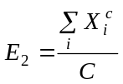 (25)
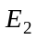 expresses the efficiency of the scheduling algorithm in allocating the available processor capacity; the greater the value of , the better is the scheduling efficiency. When 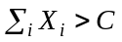, an ideal scheduler would use the total offered processor capacity and would equal 1. When 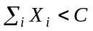, an ideal scheduler would serve all tasks with rates equal to the demanded ones. In practice, however, due to task and processor constraints (tasks are non-preemptable, time sharing is not allowed, and so on), the ideal case cannot be achieved.
A third criterion we will use for evaluating scheduling efficiency is the average relative deviation of the demanded task deadlines to the actual task completion times,
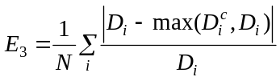 (26)
where 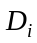 is the requested deadline and 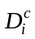 is the actual completion time of the i^{th} task. Tasks whose actual completion times are smaller than their respective deadlines do not contribute to 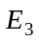.
As already mentioned, the FCFS and EDF algorithms do not permit any violations of the task deadlines and they may reject tasks, in which case the error becomes equal to infinity. To overcome this difficulty, we evaluate the performance of these schemes assuming that tasks whose deadline is violated are put in a waiting list, and reapply for execution after the completion of the last feasibly assigned task.
0  0.5  1  1.5  2  2.5  0  0.1  0.2  0.3  0.4  0.5  0.6  Average Error E₁  FCFS  EDF  SFTO  AFTO  MMFS  Normalized Load ρ | Average Error E₂  0  0.5  1  1.5  2  2.5  0  20  40  60  80  100  FCFS  EDF  SFTO  AFTO  MMFS Average Error E₁  Normalized Load ρ
(a) | (b)
Average Error E₃
0
0.5
1
1.5
2
2.5
0
0.05
0.1
0.15
0.2
0.25
0.3
0.35
0.4
Normalized Load ρ
FCFS
EDF
SFTO
AFTO
MMFS Average Error E₁

(c)
Figure 5. The errors E₁, E₂ and E₃ versus the normalized load p for the First Come- First Serve (FCFS), Earliest Deadline First (EDF), Simple Fair Task Order (SFTO), Adjusted Fair Task Order (AFTO) and the Max-Mix Fair Scheduling (MMFS) scheduling policies.

Simulation Results
The architecture for which the simulation results were obtained consists of 5 processors of different capacities. Several tasks of varying workload, ready times and deadlines are submitted. More specifically, it is assumed that the task workload follows a Gaussian distribution with a varying mean and variance. We define the normalized load of the system as
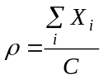 (27)
Considering different values for the variance of the Gaussian distribution, permits the evaluation of scheduling efficiency for the case of symmetric and the assymetric workloads. Small values of the variance indicate that a number of tasks of similar workload characteristics are submitted to the system, and large values of the variance indicate very different workloads for the submitted tasks. To evaluate the scheduling efficiency, we conducted several experiments by applying a particular scheduling policy and then we estimated the average value for each of the criteria mentioned above.
Figure 5(a) presents the simulation results obtained for the SFTO, AFTO, and MMFS schemes using criterion , which is plotted against the normalized load . For comparison purposes, we also depict the results obtained for the FCFS and EDF schemes. The simulations were performed assuming that the 5 processors have the same computational capacity (symmetric processor case). We observe that the MMFS scheduling policy yields the highest efficiency with respect to criterion , with the AFTO scheme coming second. The worst performance is obtained for the FCFS scheme. For light load (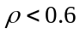), all algorithms efficiently schedule the tasks, but as the load increases, the MMFS policy outperforms the other schemes. Figure 5(b) shows the results obtained for the SFTO, AFTO and MMFS schemes and the FCFS and EDF schemes using criterion . Similar capacities are assumed for all processors. Again, the MMSF scheduling policy yields the best results, with the AFTO scheme coming next. The performance of the MMSF scheme is close to that of an ideal scheduer, even for heavy load 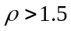 (congestion). Criterion , which expresses the deviation between the demanded deadlines and the actual completion times, is depicted in Fig. 5(c). The best performance is again obtained for the MMSF scheme. For light load, all scheduling schemes have similar performance, but as the load increases, MMSF outperforms the other schemes.
The effect of the task workload variance on scheduling performance is illustrated in Fig. 6. Particularly, Fig. 6(a-c) present the criteria , and for the FCFS, EDF, SFTO, AFTO and MMFS scheduling policies as a function of the workload variance. In these figures, the load is held constant to 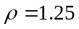, the number of tasks is equal to 25, and all processors have equal computation capacities (symmetric processor case). The MMFS scheme performs better than the other scheduling methods examined, for all values for the workload variances and all criteria E₁, E₂ and E₃. Note that as the workload variance increases, the performance of all the schemes improves (except for that of MMFS, which remains almost the same since it is close to the ideal case).

0.1  0.2  0.3  0.4  0.5  0.2  0.25  0.3  0.35  0.4  0.45  Workload Variance  Average Error E₁  FCFS  EDF  SFTO  AFTO  MMFS Average Error E₁ | 0.1  0.2  0.3  0.4  0.5  75  80  85  90  95  100  Workload Variance  FCFS  EDF  SFTO  AFTO  MMFS Average Error E₁  Average Error E₂
(a) | (b)
Average Error E₃
0.1
0.2
0.3
0.4
0.5
0.04
0.06
0.08
0.1
0.12
0.14
Workload Variance
FCFS
EDF
SFTO
AFTO
MMFS Average Error E₁

(c)
Figure 6. The errors E₁, E₂ and E₃ versus the variance of the task workload for the FCFS, EDF, SFTO, AFTO and the MMFS scheduling policies.
Figure 7 presents the effect of the number of tasks to the scheduling performance using criteria E₁, E₂ and E₃. The results have been obtained for load 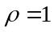. As is observed, the MMFS scheduling policy yields the best results compared to the other examined approaches. It is also observed that as the number of tasks increases the scheduling efficiency also increases but with a decreasing rate. This indicates that for a large number of small tasks the scheduling algorithms better exploit the available processor capacity of the Grid infrastructure.
Average Error E₁  5  10  15  20  0.25  0.3  0.35  0.4  0.45  0.5  Number of Tasks  FCFS  EDF  SFTO  AFTO  MMFS Average Error E₁ | 5  10  15  20  50  55  60  65  70  75  80  Number of Tasks  Average Error E₂  FCFS  EDF  SFTO  AFTO  MMFS Average Error E₁
(a) | (b)
5
10
15
20
0.1
0.15
0.2
0.25
0.3
0.35
Number of Tasks
Average Error E₃
FCFS
EDF
SFTO
AFTO
MMFS Average Error E₁

(c)
Figure 7. The errors E₁, E₂ and E₃ versus the number of submitted tasks for the FCFS, EDF, SFTO, AFTO and MMFS scheduling policies.

All the previous results have been obtained using a small variation of the processor capacity. In Fig. 8, we present the effect of the variation of the processor capacity on the scheduling performance with respect to the error E₃ (asymmetric processor case). In particular, Fig. 8(a) illustrates the scheduling performance for a medium differentiation in the processor capacity, while Fig. 8(b) presents the results when the variation in the processor capacities is high. As is observed, the MMSF scheduling policy is sensitive to the variation of the processor capacity, while the performance of the remaining examined schemes, such as the AFTO and SFTO, remain almost the same. In particular, as the variation increases, the MMSF scheduling efficiency decreases. Indeed, for very high variations of the processor capacity, the MMSF policy becomes worse than that of the simpler scheduling schemes. This is due to the fact that the algorithm of the MMSF scheduling policy, which allocates the tasks to the available processor (see section 7.1) fails to estimate a solution close to the global minimum of error E [Eq. (17)]. In other words, the algorithm is trapped to a local minimum, and therefore exploitation of the available processor capacity is not so efficient. In the case of very high variation of the processor capacity, the proposed AFTO policy presents the best results, with the SFTO scheme coming second.
0.5  1  1.5  2  2.5  0  0.05  0.1  0.15  0.2  0.25  0.3  0.35  Normalized Load ρ  Average Error E₃  FCFS  EDF  SFTO  AFTO  MMFS Average Error E₁ | 0.5  1  1.5  2  2.5  0  0.05  0.1  0.15  0.2  0.25  0.3  0.35  0.4  Normalized Load ρ  Average Error E₃  FCFS  EDF  SFTO  AFTO  MMFS Average Error E₁
(a) | (b)

Figure 8. The error E₃ versus the normalized load for the FCFS, EDF, SFTO, AFTO and MMFS scheduling policies. (a) Case of medium variation in the processor capacities and (b) Case of very high variation in the processor capacities.
The computational complexity of the EDF, SFTO, AFTO and MMFS scheduling schemes is presented in Table I for different values for the number of tasks requesting service. The computational complexity has been normalized with respect to the cost of the EDF scheme when the number of submitted tasks is equal to 10. As expected, the computational complexity for all schemes increases with the number of tasks. The AFTO policy is the most computationally demanding, especially for large number of tasks., because it requires the estimation of the respective adjusted fair rates. The MMFS policy yields the lowest computational load.

 | Normalized Computational Complexity
Number of Tasks | 10 | 15 | 20 | 25 | 30
EDF | 1.00 | 2.00 | 2,93 | 3,94 | 4,87
SFTO | 1.01 | 2.08 | 3.06 | 4.15 | 5.22
AFTO | 1.14 | 2,88 | 3,94 | 5,88 | 15,75
MMFS | 0,75 | 1.02 | 1.45 | 1.62 | 1.74

Table I: Normalized computational complexity for the EDF, SFTO, AFTO and MMFS scheduling policies. Normalization has been performed with respect to the complexity of the EDF scheme in case that the number of tasks is 10.

Conclusions
Scheduling efficiency is a key to the success of computational Grids, and especially to Grid’s capability to deliver commercial applications a guaranteed and personalized Quality of Service (QoS). The adopted scheduling strategy affects the flexibility of the Grid and the degree of performance guarantees that can be offered. This is important since Grids are expected to provide a wide range of services and run applications with very diverse characteristics, properties and QoS requirements.
In this paper, we proposed three new scheduling algorithms for the Grid environment that could be used to implement a fair QoS resource management policy. In the Simple Fair Task Order (SFTO), the tasks are ordered in the queue in an increasing order with respect to their non-adjusted fair completion times. The non-adjusted fair completion times are obtained by the non-adjusted fair computational rates of the tasks by applying a min-max fair sharing algorithm. An improved version of the SFTO scheme is the Adjusted Fair Task order (AFTO) scheduling policy, where the fair rates are dynamically adjusted each time tasks become inactive (e.g., they complete execution) or active (e.g., new arrivals) to better exploit the offered Grid processor capacity. In the AFTO scheme, the fair rates of the tasks are not constant, as is assumed in the SFTO scheme, but they increase when tasks complete execution and decrease when new tasks arrive. In both scheduling methods the processor at which the tasks are assigned for execution is found based on the Earliest Completion Time (ECT) policy modified so that processor capacity gaps are taken into account. Finally, in the third fair Grid scheduling scheme that we presented, the Max-Min Fair Scheduling (MMFS) scheme, the selection of a fair task queuing order and the selection of a processor assignment are simultaneously addressed. In particular, the algorithm allocates the tasks to the available processors so that the actual task rate after the scheduling is much as close to the fair ones as obtained by the max-min fair sharing scheme.
Experimental results and comparisons with the traditional First Come Fist Serve (FCFS) and Earliest Deadline First (EDF) scheduling schemes, indicate that our proposed scheduling schemes are fairer and better exploit the available Grid resources. In particular, when the variation in the processors capacities is small, the MMFS scheme outperforms the other schemes with respect to all the examined criteria. The performance of the MMFS scheme deteriorates when there is very high variation in the processor capacities, because the algorithm is trapped to local minima solutions. In this asymmetric processor case, the AFTO scheduling policy yields the best performance. The AFTO scheme requires higher computational load than the other scheduling policies, while the MMFS policy has the lowest processing requirements.

References
- I. Foster, C. Kesselman, S. Tuecke, “The Anatomy of the Grid: Enabling Scalable Virtual Organizations,” International Journal. Supercomputer Applications, Vol. 15, No. 3, 2001.
- W. Leinberger, V. Kumar, “Information Power Grid: The new frontier in parallel computing?” IEEE Concur., Vol. 7, No. 4, pp. 75-84, October-December 1999.
- Scheduling Working Group of the Grid Forum, Document: 10.5, September 2001.
- M. S. Fineberg and O. Serlin, "Multiprogramming for Hybrid Computation," Proc. of IFIPS Fall Joint Computer Conference, Thompson, Washington DC, 1967.
- J. A. Stankovic et. al., "Implications of Classical Scheduling Results for Real Time Systems," Computer pp. 16-25, June 1995.
- M. L. Dertouzos and A.K.-L. Mok, "Multiprocessor On-line scheduling for Hard Real Time Tasks," IEEE Trans. on Software Eng. pp. 1497-1506, Dec. 1989.
- G. Manimaran, C. Siva Ram Murthy, Machiraju Vijay, and K. Ramamritham, "New Algorithms for Resource Reclaiming from Precedence Constrained Tasks in Multiprocessor Real-time Systems," Journal of Parallel and Distributed Computing, vol. 44, no. 2, pp. 123-132, Aug. 1997.
- K. Ramamritham, J.A.Stankovic, and P.-F. Shiah, "Efficient Scheduling Algorithms for Real-time Multiprocessor Systems," IEEE Trans. on Parallel and Distributed Systems, vol.1, no.2, pp.184-194, Apr. 1990.
- W. Zhao, K. Ramamritham and J. A. Stankovic, “Scheduling tasks with resource requirements in hard real time systems,” IEEE Trans. on Software Engineering, vol. 12, no.3, pp.360-369, May 1990.
- J.Y-T. Leung and M.L. Merrill, “A Note on Preemptive, “Scheduling of Periodic, Real-Time Tasks,” Information Processing Letters, Nov. 1980, pp. 115-118.
- X. Deng, N. Gu, T. Brecht, K.-C. Lu, Preemptive Scheduling of Parallel Jobs on Multiprocessors, SIAM Journal on Computing, Vol. 30, No. 1, pp. 145-160, 2000.
- G. Manimaran and C. Siva Ram Murthy, An efficient dynamic scheduling algorithm for multiprocessor real-time systems, IEEE Trans. Parallel and Distributed Systems, vol.9, no.3, pp.312-319, March 1998.
- L. E. Jackson and G. N. Rouskas, “Deterministic Preemptive Scheduling of Real Time Tasks,” IEEE Computer, vol. 35, no. 5, pp. 72-79, May 2002.
- A.K Parekh, R.G Gallager, "A generalized processor sharing approach to flow control in integrated services networks: the single-node case," IEEE/ACM Tran. on Networking, Vol. 1, No. 3, pp. 344 -357, 1993.
- A. Demers, S. Keshav and S. Shenker, “Design and Analysis of a Fair Queuing Algorithm,” Proc. of the ACM SIGCOMM, Austin, September 1989.
- D. Bertsekas, R. Gallager, Data Networks, 2nd ed.,Prentice Hall 1992 (section starting on p.524).
- N. Doulamis, A. Doulamis, A. Panagakis, K. Dolkas, T. Varvarigou and E. Varvarigos, “A Combined Fuzzy -Neural Network Model for Non-Linear Prediction of 3D Rendering Workload in Grid Computing,” IEEE Trans. on Systems Man and Cybernetics, Part-B, Vol. 34, No. 2, pp. 1235-1247, April 2004.
- S. Keshav, An Engineering Approach to Computer Networking. Addison-Wesley, 1997.

