Cybage Website Report: Readdy vs Test (Content & Links)
Reference (correct): https://cybage.readdy.co
Tested: https://test-cybage-corporate.pantheonsite.io
Checked live: 21 September 2026 - 50 pages on each site, every link on the test site checked for HTTP status, all card sliders and the Success Stories LOAD MORE pages scrolled
Scope: Links, READ MORE / card links, content and missing sections only. Design and heading-tag (H1) issues are not included.
Status: QA only - nothing was changed on the test site.

Summary
Category | Issues
A. Broken links (404) on test | 5
B. Links that go to Home (/) or have no URL | 8
C. URL / alias mismatch and missing pages | 5
D. Missing sections / missing content | 13
E. Content that differs from readdy | 7
Total | 38

All issues at a glance
# | Category | Page | Issue
1 | A | Home | 5 links on the Home page open a 404 page.
2 | A | Industry pages (Media, Software, Healthcare, Supply Chain, Financial Services) | READ MORE on success-story cards opens a 404 on 5 industry pages.
3 | A | Salesforce | 6 in-text links on the Salesforce page open a 404.
4 | A | Privacy Policy | "Data Protection Policy" link opens a 404.
5 | A | Footer (all pages) | Footer menu has links that open a 404, and several items with no link.
6 | B | All Services, Industries, Platforms & Partner pages | READ MORE on insight cards goes to the Home page instead of the article.
7 | B | All Services, Industries, Platforms & Partner pages | VIEW ALL CUSTOMER SUCCESS STORIES goes to Home.
8 | B | All Services & Industry pages, Partner pages | Contact CTAs go to the Home page instead of the contact form.
9 | B | Home + AI Hub | News and CTA buttons go to Home.
10 | B | AI Hub | All READ MORE links in the AI Hub blog carousel go to Home; one EXPLORE MORE has no URL.
11 | B | Media & Advertising | EXPLORE MORE on the 3 platform cards goes to Home.
12 | B | Cybage Foundation | VISIT THE WEBSITE buttons go to Home.
13 | B | Partner Ecosystem + Service pages | 7 partner logos have no link (empty href); also 1 logo each on AI-Native, Data AI & Agentic, Intelligent Operations.
14 | C | Our Leadership | Readdy URL /our-leadership gives 404 on test (page lives at /about/our-leadership).
15 | C | Glossary | Readdy URL /glossary gives 404 on test (page lives at /insights/glossary).
16 | C | Cybage Times | Readdy URL /insights/cybage-times gives 404 on test (test uses an underscore).
17 | C | Success Stories | All 65 story links work (HTTP 200), but 57 of them use raw /node/ID URLs (no URL alias).
18 | C | 404 page (site-wide) | Custom 404 page is missing; test shows the default Drupal "Page Not Found".
19 | D | Home | Text missing on the Home page.
20 | D | Global Capability Centers | Several content blocks are missing.
21 | D | Enterprise Modernization | Closing heading and a card label are missing.
22 | D | Travel & Hospitality | Two capability descriptions and the closing text are missing.
23 | D | Software & Hi-Tech | Stats section and one expert title missing.
24 | D | Supply Chain & Logistics | Stats section (5 numbers) and a button are missing.
25 | D | Healthcare & Life Sciences | One capability description missing.
26 | D | TAPAS | Case study results missing.
27 | D | AWS | Platforms section and a linked phrase are missing.
28 | D | Newsroom | Award / recognition items missing.
29 | D | Cybage Foundation | CybageKhushboo description missing.
30 | D | Why Join Cybage | Bullet points missing or different.
31 | D | Diversity & Inclusion + Contact Us | Text missing / changed.
32 | E | Media & Advertising | Datatrans description is different.
33 | E | Industries | Financial Services card: one bullet missing and the button label differs.
34 | E | Services | First button label is shortened.
35 | E | Platforms & Frameworks | Card descriptions differ from readdy (5 cards).
36 | E | Financial Services | Stats and a card title differ; closing text missing.
37 | E | ServiceNow | Stats text differs; 2 stats missing.
38 | E | Microsoft / Sustainability / Corporate Governance | Small wording errors.

A. Broken links (404) on test

1. Home
Page | Home
Section | Hero slider + Customer Success Stories cards
Readdy URL | https://cybage.readdy.co/
Test URL | https://test-cybage-corporate.pantheonsite.io/
Issue | 5 links on the Home page open a 404 page.
Readdy has | Links go to the correct live pages.
Test has | EXPLORE MORE (hero) -> /services/AI-Native-Engineering (404)  READ MORE (FinTech story) -> /industries/financial-technology-solutions (404)  READ MORE (ad exchange story) -> /industries/Media-and-Advertising (404)  READ MORE (AI-driven delivery story) -> /industries/software-hitech (404)  READ MORE (Healthcare data story) -> /industries/supply-chain (404)
Fix | Update each link: /services/ai-native-product-platform-engineering, /industries/financial-services, /industries/media-advertising, /industries/software-hi-tech, /industries/supply-chain-logistics (or the matching success-story page).

TEST: https://test-cybage-corporate.pantheonsite.io/
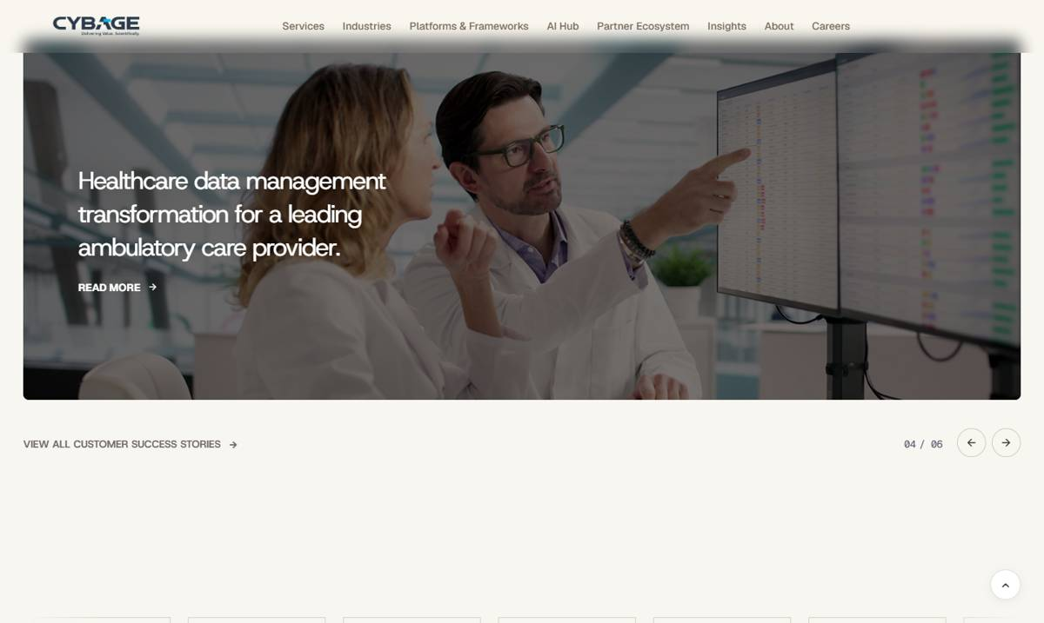
TEST: https://test-cybage-corporate.pantheonsite.io/services/AI-Native-Engineering
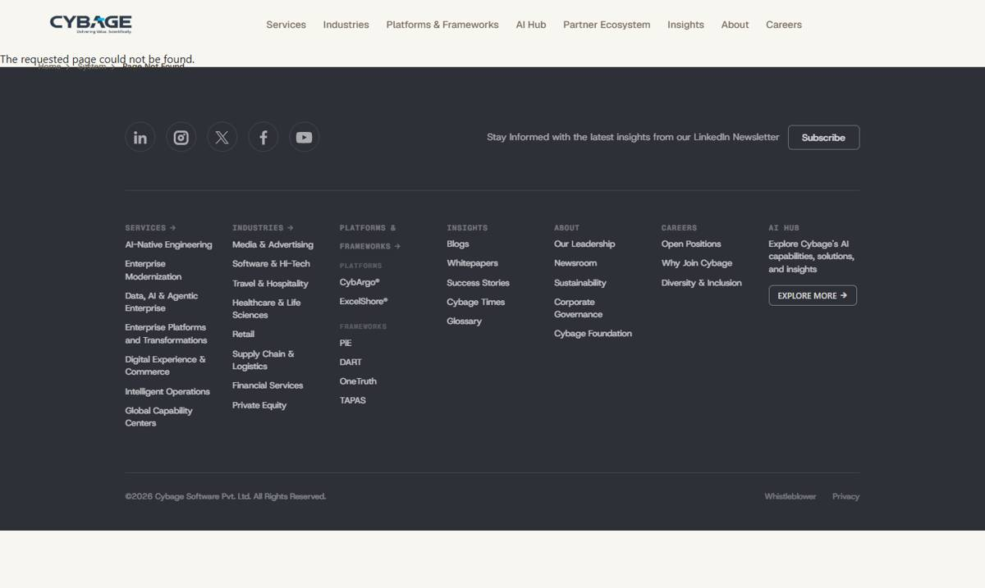

2. Industry pages (Media, Software, Healthcare, Supply Chain, Financial Services)
Page | Industry pages (Media, Software, Healthcare, Supply Chain, Financial Services)
Section | Customer Success Stories slider - READ MORE
Readdy URL | https://cybage.readdy.co/industries/media-advertising
Test URL | https://test-cybage-corporate.pantheonsite.io/industries/media-advertising
Issue | READ MORE on success-story cards opens a 404 on 5 industry pages.
Readdy has | READ MORE opens the success story.
Test has | Media & Advertising -> /industries/Media-and-Advertising (404)  Software & Hi-Tech -> /industries/software-hitech (404)  Healthcare & Life Sciences -> /success-story/cloud-native-transformations (404)  Supply Chain & Logistics -> /industries/supply-chain (404)  Financial Services -> /industries/financial-technology-solutions (404)
Fix | Point each READ MORE to the correct success-story page.

TEST: https://test-cybage-corporate.pantheonsite.io/industries/healthcare-life-sciences
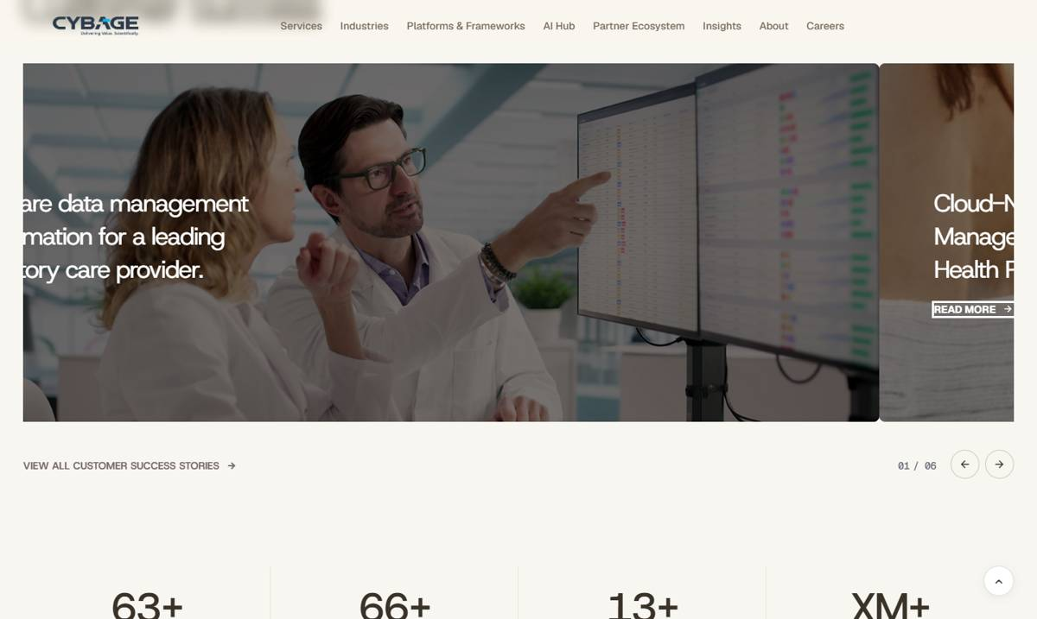

3. Salesforce
Page | Salesforce
Section | System Integration / AI & Agentforce / Data & Analytics / Quality Assurance / Cloud Platform
Readdy URL | https://cybage.readdy.co/partner-ecosystem/salesforce
Test URL | https://test-cybage-corporate.pantheonsite.io/partner-ecosystem/Salesforce
Issue | 6 in-text links on the Salesforce page open a 404.
Readdy has | modernisation expertise -> /services/ai-native-product-platform-engineering  AI-driven experiences -> /services/data-ai-agentic-enterprise  Argo's governance layer -> /platforms-frameworks/cybargo  Data, AI & Agentic Systems expertise -> /services/data-ai-agentic-enterprise  intelligent quality & engineering assurance -> /services/intelligent-operations  CI/CD implementation -> /services/ai-native-product-platform-engineering
Test has | /services/AI-Native-Engineering (404)  /services/agentic_enterprise (404) x2  /platforms/argo (404)  /services/intelligent-quality-engineering-assurance (404)  /services/AI-Native-Engineering (404)
Fix | Replace the 6 hrefs with the readdy URLs listed.

TEST: https://test-cybage-corporate.pantheonsite.io/partner-ecosystem/Salesforce
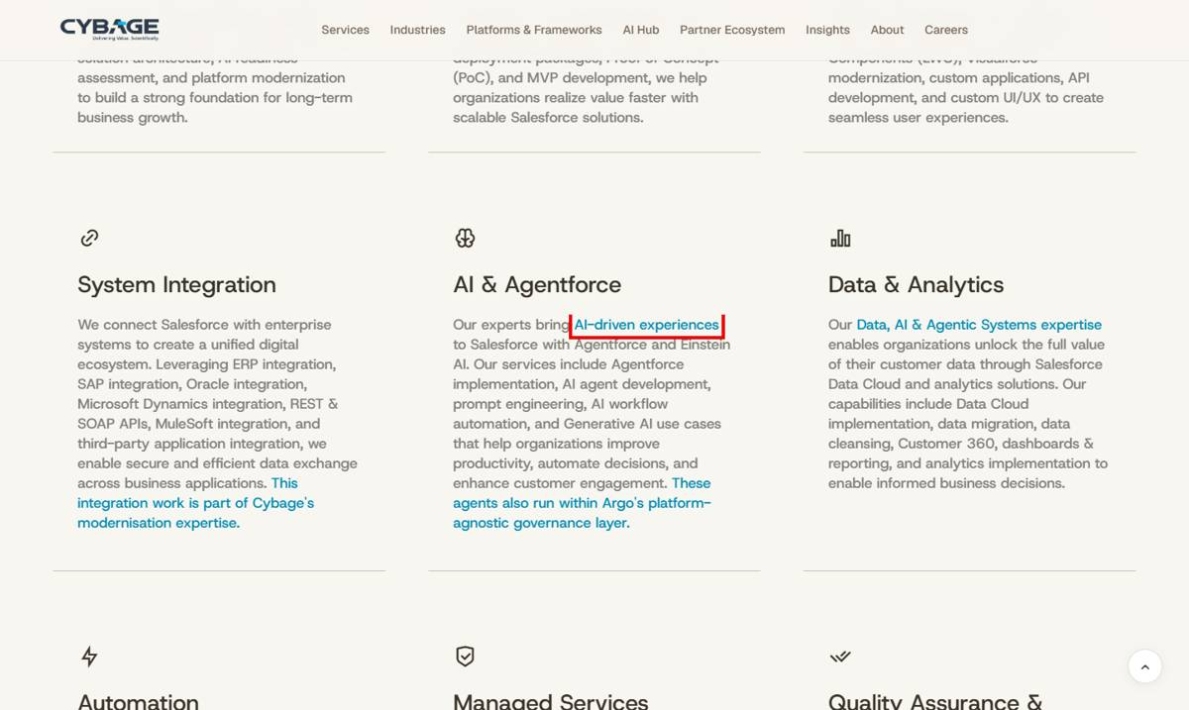
READDY: https://cybage.readdy.co/partner-ecosystem/salesforce
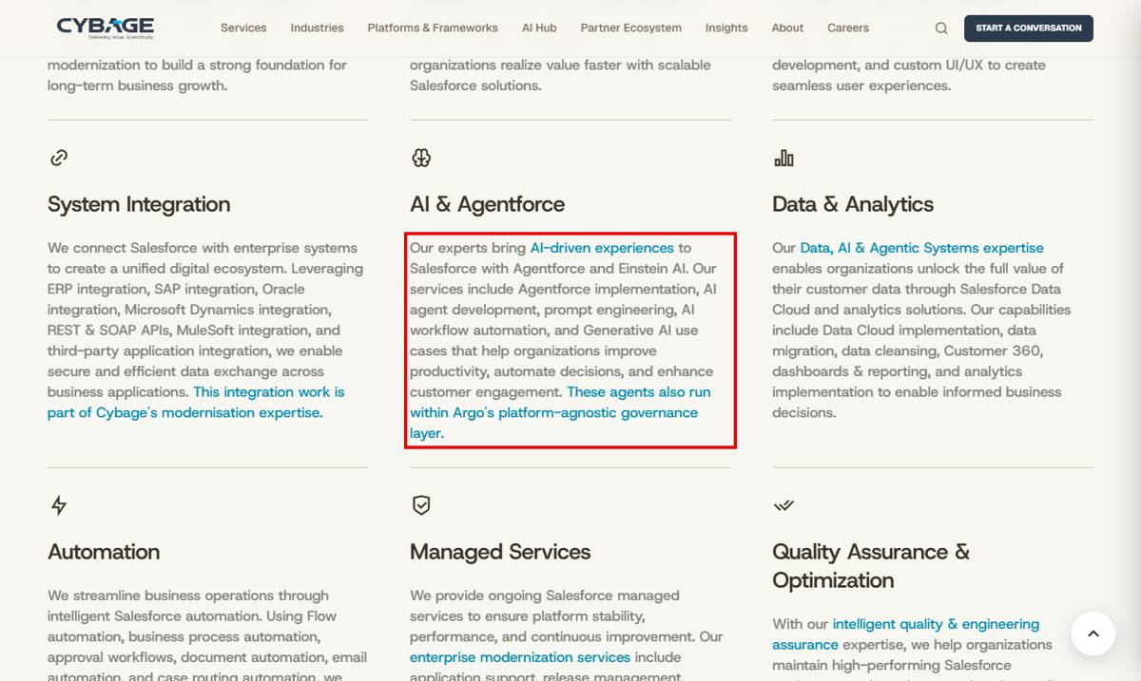

4. Privacy Policy
Page | Privacy Policy
Section | Contacting the website
Readdy URL | https://cybage.readdy.co/privacy-policy
Test URL | https://test-cybage-corporate.pantheonsite.io/privacy-policy
Issue | "Data Protection Policy" link opens a 404.
Readdy has | -
Test has | Data Protection Policy -> /about/privacy-policy (404)
Fix | Point the link to the correct Data Protection Policy page.

TEST: https://test-cybage-corporate.pantheonsite.io/privacy-policy
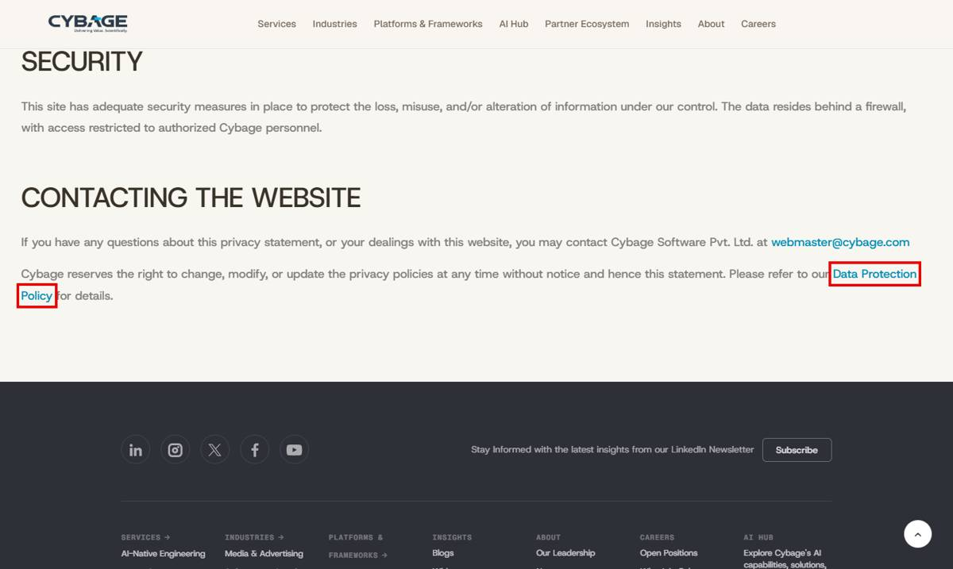

5. Footer (all pages)
Page | Footer (all pages)
Section | Footer menu
Readdy URL | https://cybage.readdy.co/
Test URL | https://test-cybage-corporate.pantheonsite.io/
Issue | Footer menu has links that open a 404, and several items with no link.
Readdy has | AI-Native Product & Platform Engineering -> /services/ai-native-product-platform-engineering  Media & Advertising -> /industries/media-advertising  Software & Hi-Tech -> /industries/software-hi-tech  Supply Chain & Logistics -> /industries/supply-chain-logistics  PLATFORMS & FRAMEWORKS -> /platforms-frameworks  Newsroom, Corporate Governance, Cybage Foundation, Why Join Cybage -> their pages
Test has | AI-Native Engineering -> /services/AI-Native-Engineering (404)  Media & Advertising -> /industries/Media-and-Advertising (404)  Software & Hi-Tech -> /industries/software-hitech (404)  Supply Chain & Logistics -> /industries/supply-chain (404)  PLATFORMS & FRAMEWORKS / FRAMEWORKS -> /platforms (404)  Newsroom, Corporate Governance, Cybage Foundation, Why Join Cybage, AI HUB, Whistleblower -> # (no link)  INSIGHTS, ABOUT, CAREERS -> / (Home)  Data, AI & Agentic Enterprise -> services/data-ai-agentic-enterprise (missing leading /)
Fix | Update the footer menu links to the readdy URLs; Whistleblower -> mailto:Whistleblower@cybage.com.

TEST: https://test-cybage-corporate.pantheonsite.io/
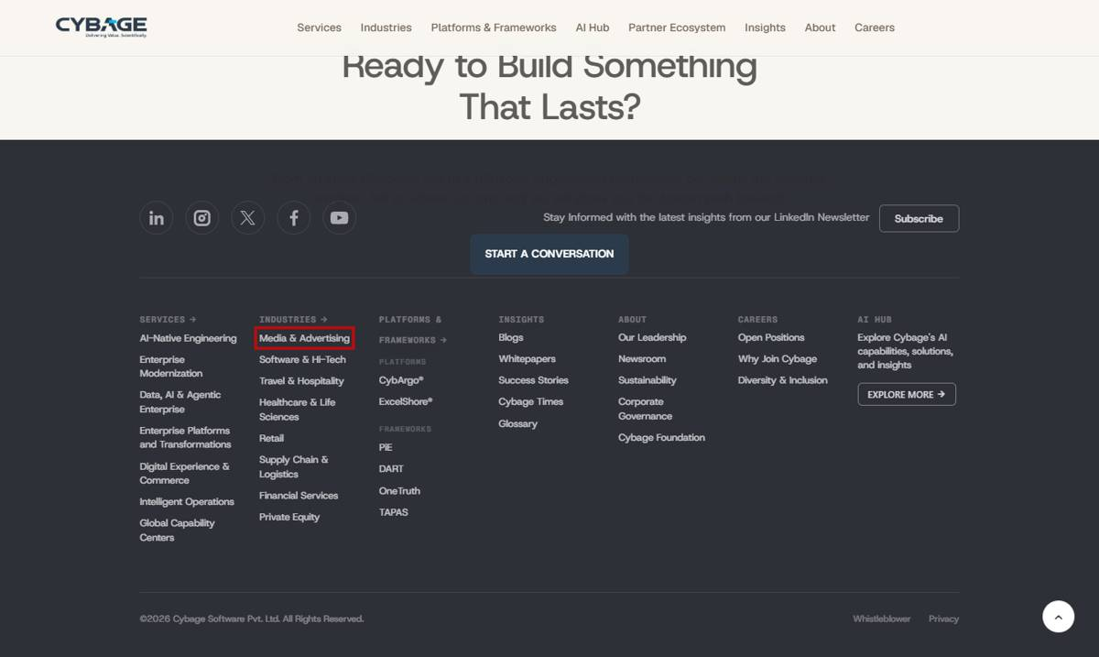
READDY: https://cybage.readdy.co/
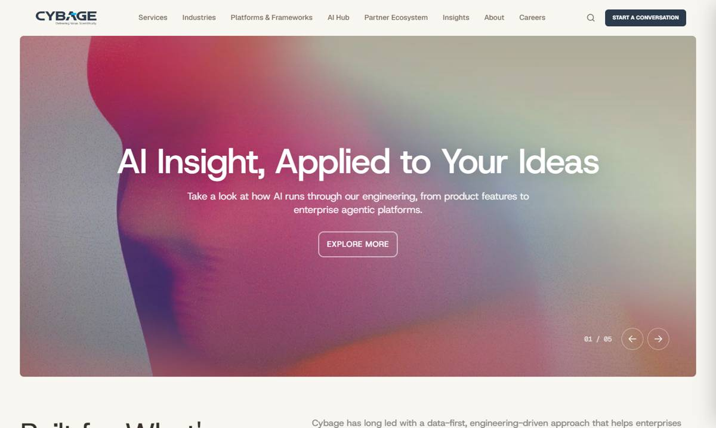

B. Links that go to Home (/) or have no URL

6. All Services, Industries, Platforms & Partner pages
Page | All Services, Industries, Platforms & Partner pages
Section | Insights / Blogs / Whitepapers cards - READ MORE
Readdy URL | https://cybage.readdy.co/services/data-ai-agentic-enterprise
Test URL | https://test-cybage-corporate.pantheonsite.io/services/data-ai-agentic-enterprise
Issue | READ MORE on insight cards goes to the Home page instead of the article.
Readdy has | Each card opens its own blog / whitepaper / story.
Test has | READ MORE -> / (Home) on: all 8 Services pages, all 8 Industry pages, CybArgo, all 8 Partner pages, Why Join Cybage (every READ MORE card in the Insights / Blogs / Whitepapers sliders)
Fix | Link each card to its article URL (the card title's own page).

TEST: https://test-cybage-corporate.pantheonsite.io/services/data-ai-agentic-enterprise
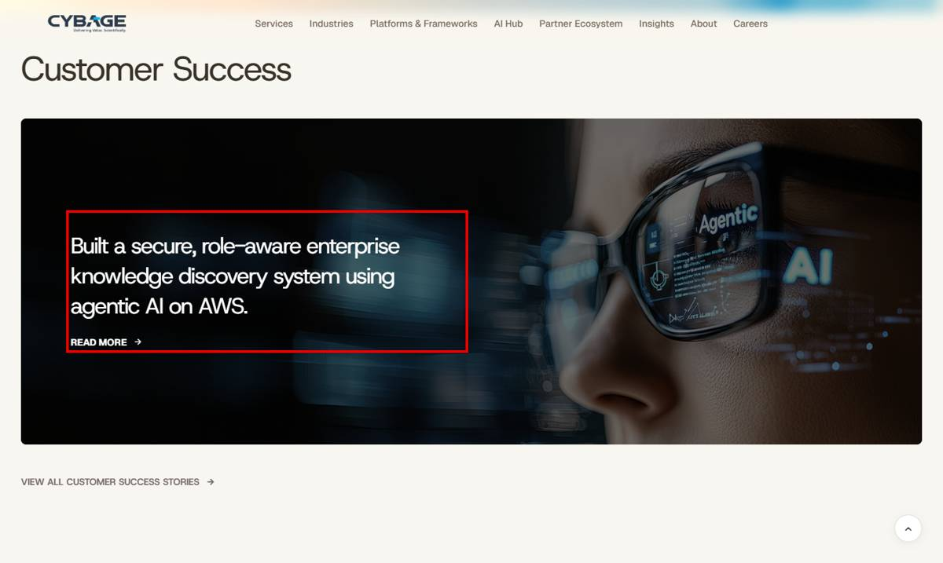
READDY: https://cybage.readdy.co/services/data-ai-agentic-enterprise
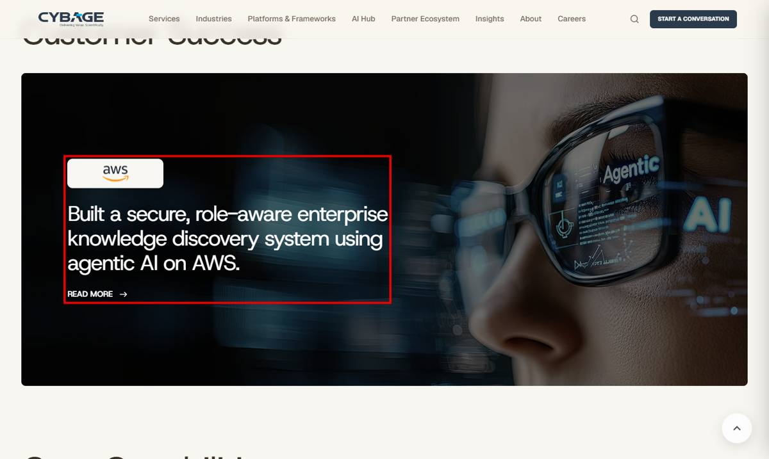

7. All Services, Industries, Platforms & Partner pages
Page | All Services, Industries, Platforms & Partner pages
Section | Customer Success Stories - VIEW ALL CUSTOMER SUCCESS STORIES
Readdy URL | https://cybage.readdy.co/partner-ecosystem/aws
Test URL | https://test-cybage-corporate.pantheonsite.io/partner-ecosystem/aws
Issue | VIEW ALL CUSTOMER SUCCESS STORIES goes to Home.
Readdy has | Goes to the success stories listing (/case-study on readdy).
Test has | href = / on Home, all 8 Services pages, all 8 Industry pages, CybArgo and all 8 Partner pages.
Fix | Point to /insights/success-stories.

TEST: https://test-cybage-corporate.pantheonsite.io/partner-ecosystem/aws
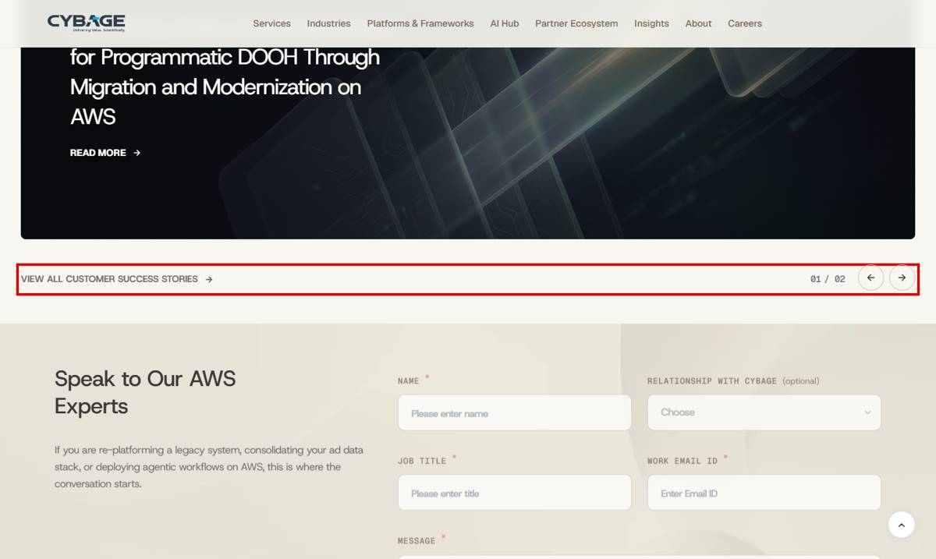
READDY: https://cybage.readdy.co/partner-ecosystem/aws
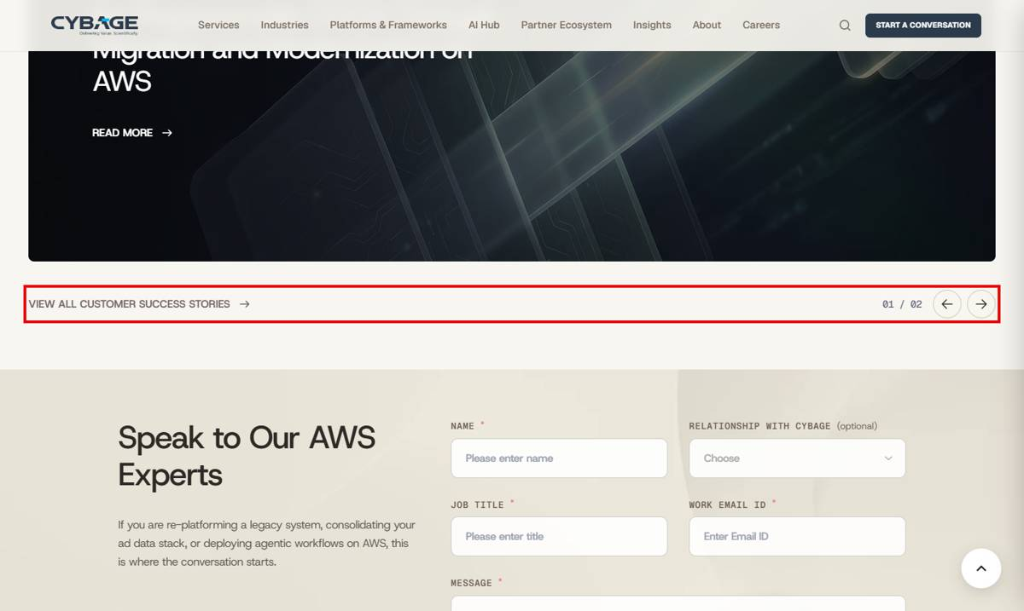

8. All Services & Industry pages, Partner pages
Page | All Services & Industry pages, Partner pages
Section | Hero / closing CTA - TALK TO OUR TEAM / TALK TO AN EXPERT etc.
Readdy URL | https://cybage.readdy.co/partner-ecosystem/aws
Test URL | https://test-cybage-corporate.pantheonsite.io/partner-ecosystem/aws
Issue | Contact CTAs go to the Home page instead of the contact form.
Readdy has | Partner pages: #get-in-touch (scrolls to form); TAPAS: #how-tapas-works
Test has | href = / for: TALK TO OUR TEAM / ENGINEERS / EXPERTS / PLATFORM ENGINEERS / OPERATIONS ENGINEERS (all 8 Services + 8 Industry pages), TALK TO OUR AWS PRACTICE, VIEW CYBAGE ON AWS PARTNER DIRECTORY, EXPLORE OUR MICROSOFT / GOOGLE CLOUD / SALESFORCE EXPERTISE, TALK TO AN EXPERT (ServiceNow), SPEAK TO OUR DATABRICKS PRACTICE, EXPLORE THE PARTNERSHIP (Infios, Snowflake), SPEAK TO OUR PARTNERSHIPS TEAM, EXPLORE HOW TAPAS WORKS
Fix | Point contact CTAs to the page's contact form (#get-in-touch) or /contact-us; TAPAS button to #how-tapas-works.

TEST: https://test-cybage-corporate.pantheonsite.io/partner-ecosystem/aws
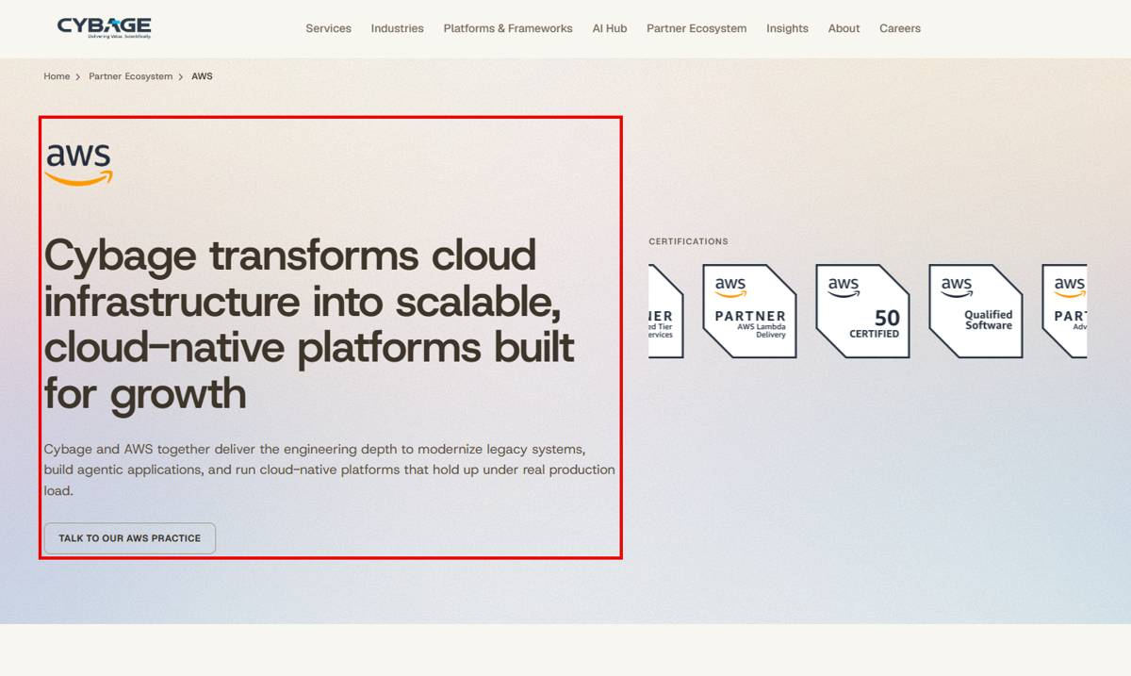
TEST: https://test-cybage-corporate.pantheonsite.io/platforms-frameworks/tapas
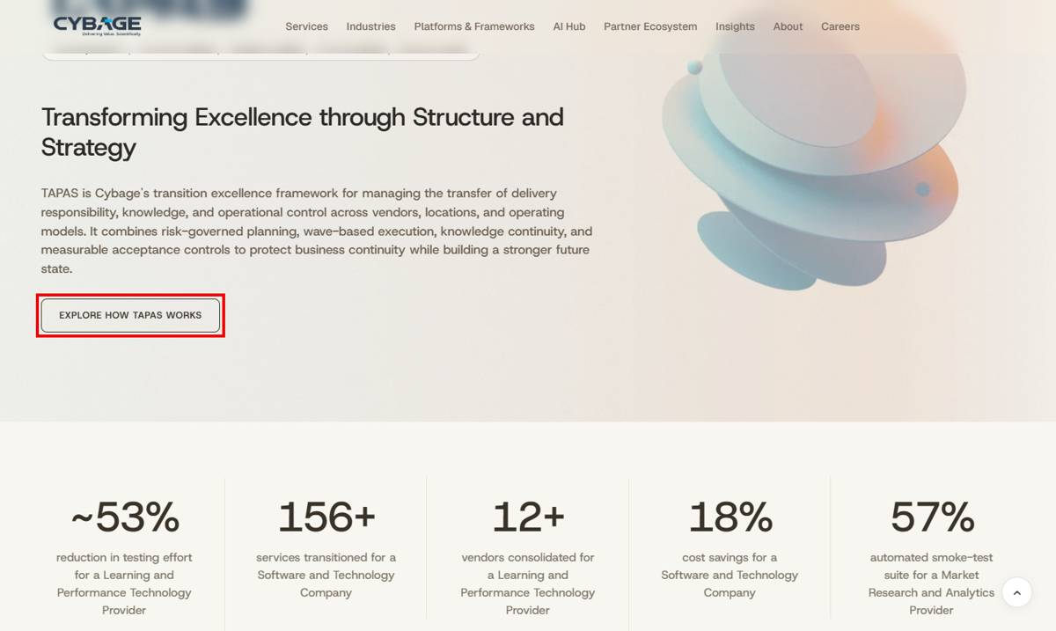

9. Home + AI Hub
Page | Home + AI Hub
Section | News cards (READ THE ARTICLE / READ THE ANNOUNCEMENT), Foundation (EXPLORE MORE), Careers (EXPLORE OPPORTUNITIES)
Readdy URL | https://cybage.readdy.co/
Test URL | https://test-cybage-corporate.pantheonsite.io/
Issue | News and CTA buttons go to Home.
Readdy has | -
Test has | READ THE ARTICLE (x2), READ THE ANNOUNCEMENT (x3), EXPLORE MORE (ISG leader, Foundation x2), EXPLORE OPPORTUNITIES -> / on Home; same news cards on AI Hub.
Fix | Link to the news article / Foundation page / Open Positions page.

TEST: https://test-cybage-corporate.pantheonsite.io/
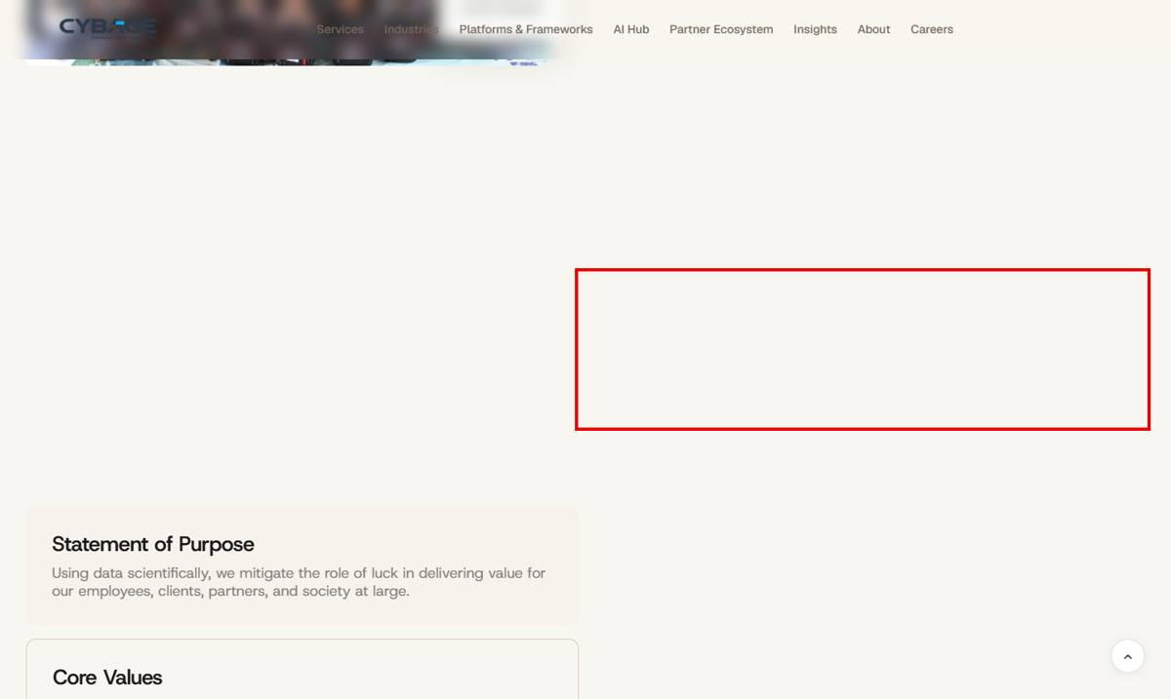
TEST: https://test-cybage-corporate.pantheonsite.io/
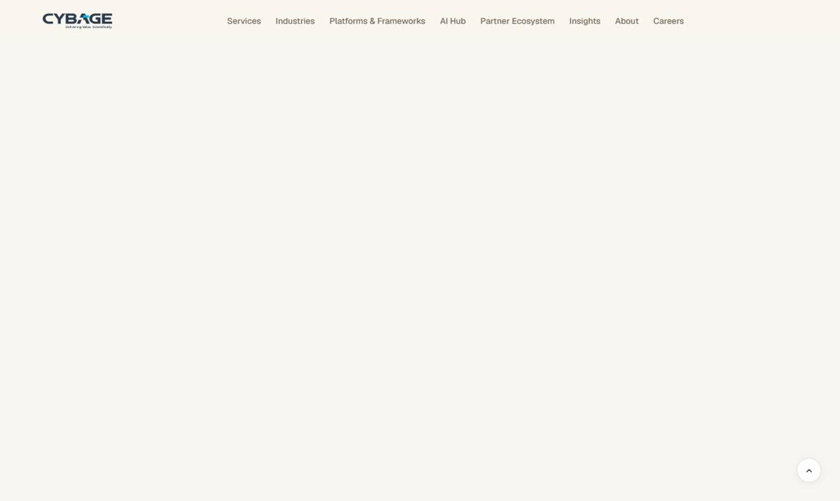

10. AI Hub
Page | AI Hub
Section | Blogs carousel + AI in Practice
Readdy URL | https://cybage.readdy.co/ai-hub
Test URL | https://test-cybage-corporate.pantheonsite.io/ai-hub
Issue | All READ MORE links in the AI Hub blog carousel go to Home; one EXPLORE MORE has no URL.
Readdy has | READ MORE opens the article (cybage.com/blog/...).
Test has | Every READ MORE in the blog carousel -> / ; EXPLORE MORE (AI in Practice) -> (empty) and 5 more EXPLORE MORE -> /
Fix | Link each card to its article.

TEST: https://test-cybage-corporate.pantheonsite.io/ai-hub
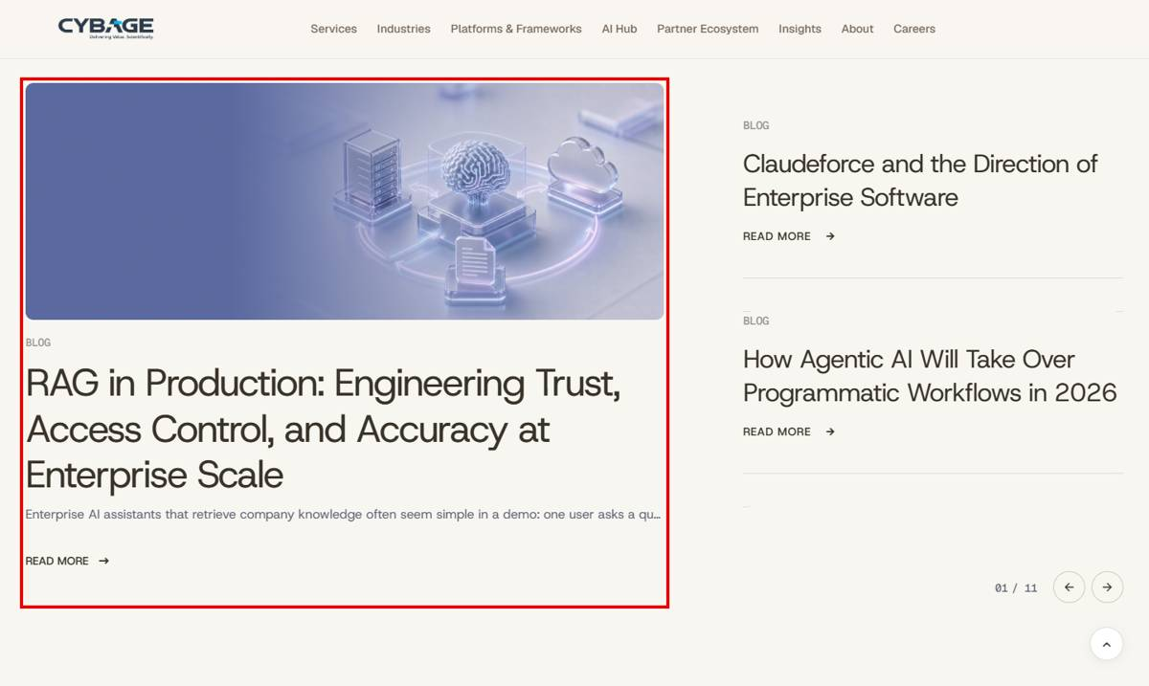
READDY: https://cybage.readdy.co/ai-hub
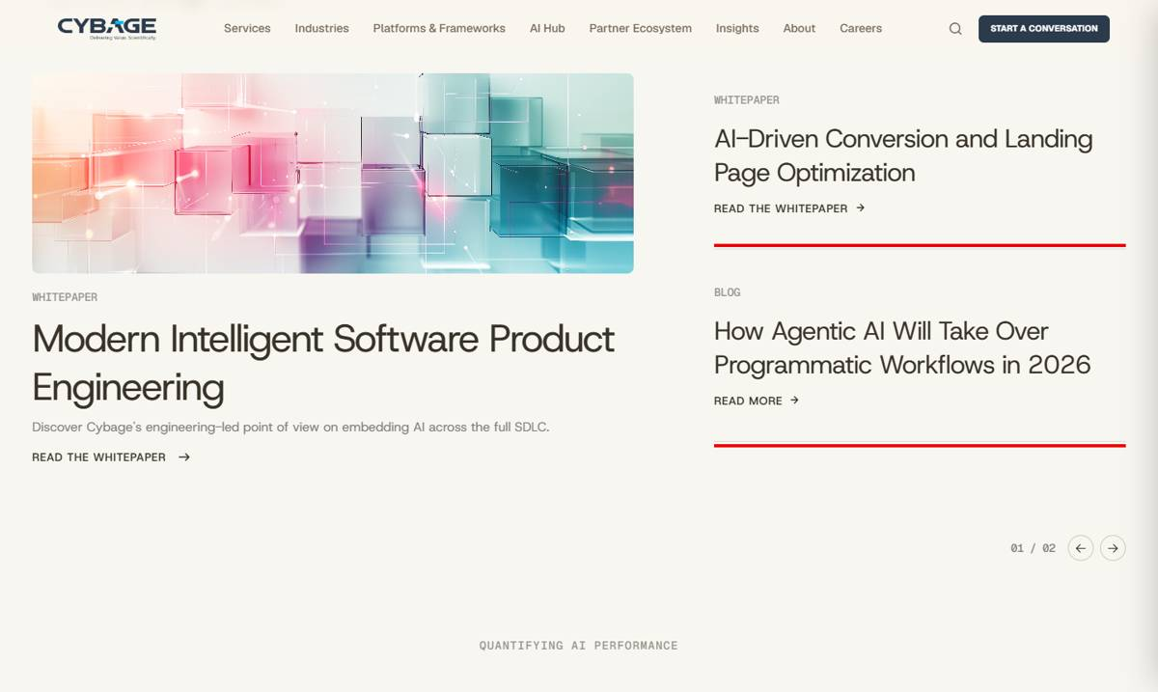

11. Media & Advertising
Page | Media & Advertising
Section | Platforms (Datatrans, DAI, CAM) - EXPLORE MORE
Readdy URL | https://cybage.readdy.co/industries/media-advertising
Test URL | https://test-cybage-corporate.pantheonsite.io/industries/media-advertising
Issue | EXPLORE MORE on the 3 platform cards goes to Home.
Readdy has | Datatrans -> /platforms-frameworks/datatrans
Test has | EXPLORE MORE -> / (x3)
Fix | Link each card to its platform page.

TEST: https://test-cybage-corporate.pantheonsite.io/industries/media-advertising
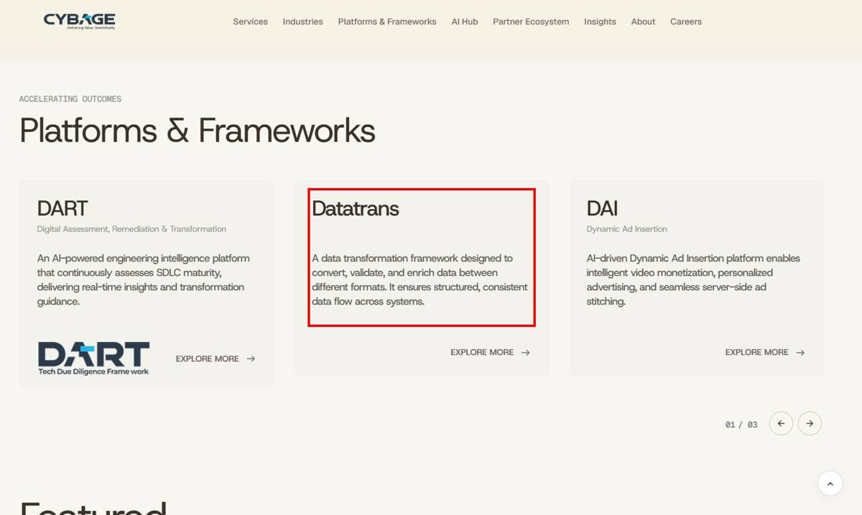
READDY: https://cybage.readdy.co/industries/media-advertising
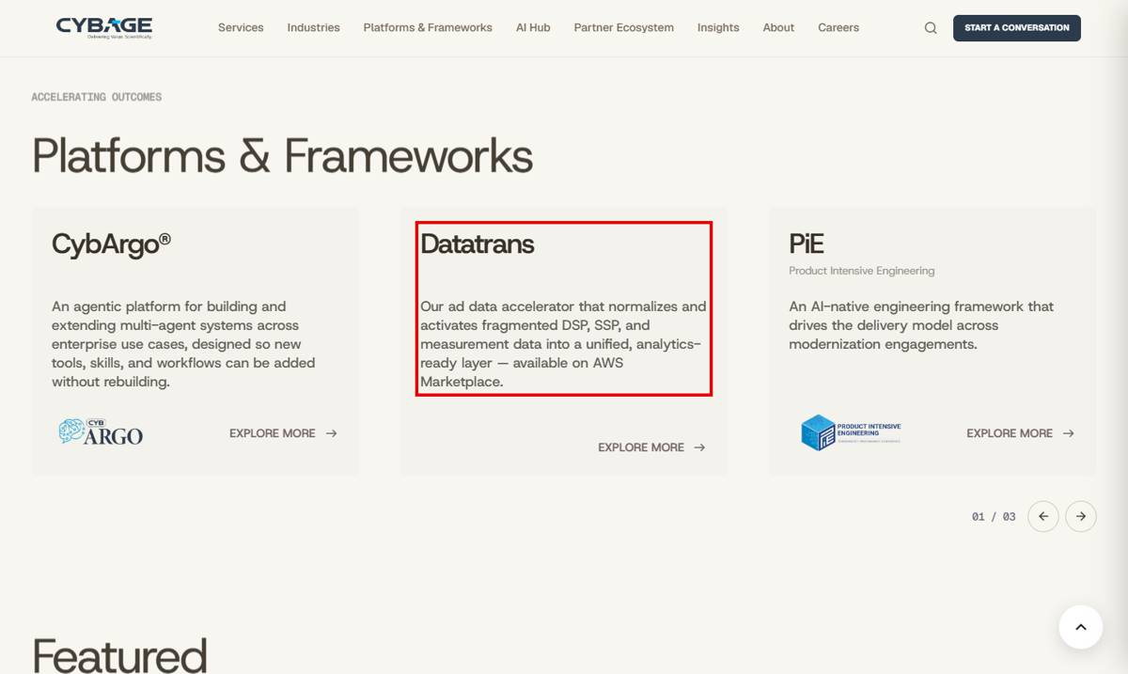

12. Cybage Foundation
Page | Cybage Foundation
Section | CybageAsha / CybageKhushboo - VISIT THE WEBSITE
Readdy URL | https://cybage.readdy.co/about/cybage-foundation
Test URL | https://test-cybage-corporate.pantheonsite.io/about/cybage-foundation
Issue | VISIT THE WEBSITE buttons go to Home.
Readdy has | https://cybageasha.org and https://www.cybagekhushboo.org
Test has | href = / (x2)
Fix | Set the external URLs (open in new tab).

TEST: https://test-cybage-corporate.pantheonsite.io/about/cybage-foundation
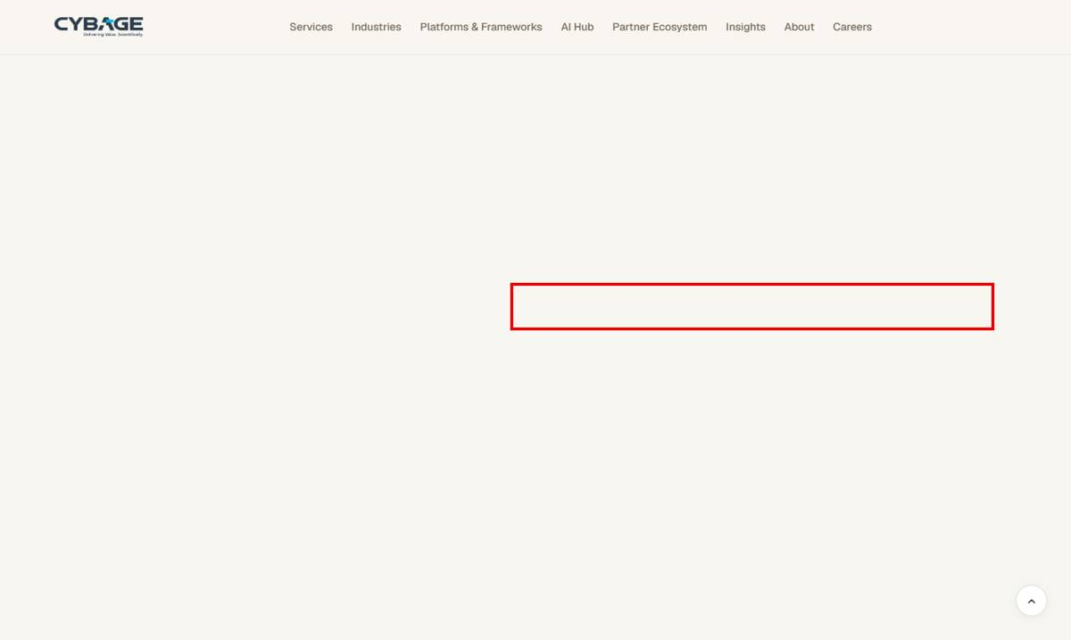
READDY: https://cybage.readdy.co/about/cybage-foundation
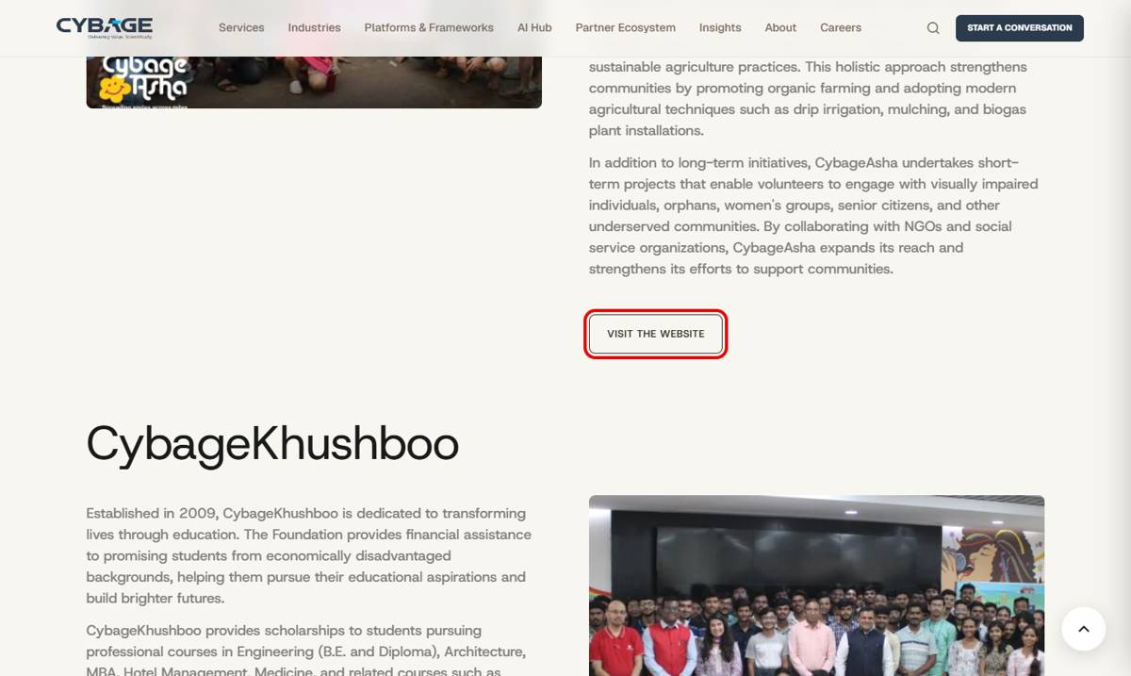

13. Partner Ecosystem + Service pages
Page | Partner Ecosystem + Service pages
Section | Our Partner Ecosystem / Partners Ecosystem logos
Readdy URL | https://cybage.readdy.co/partner-ecosystem
Test URL | https://test-cybage-corporate.pantheonsite.io/partner-ecosystem
Issue | 7 partner logos have no link (empty href); also 1 logo each on AI-Native, Data AI & Agentic, Intelligent Operations.
Readdy has | AWS, Google Cloud, ServiceNow logos link to their sections / pages.
Test has | 7 logos with href = "" (ServiceNow and others), 8 logo links total unlabeled ("Image")
Fix | Add the partner page URL to each logo (e.g. /partner-ecosystem/servicenow).

TEST: https://test-cybage-corporate.pantheonsite.io/partner-ecosystem
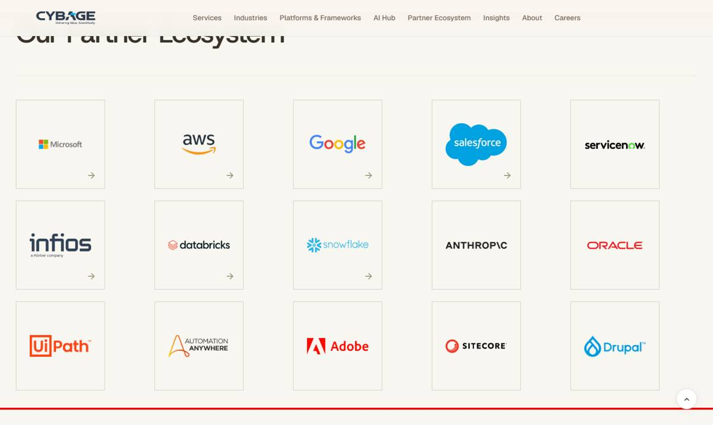
READDY: https://cybage.readdy.co/partner-ecosystem
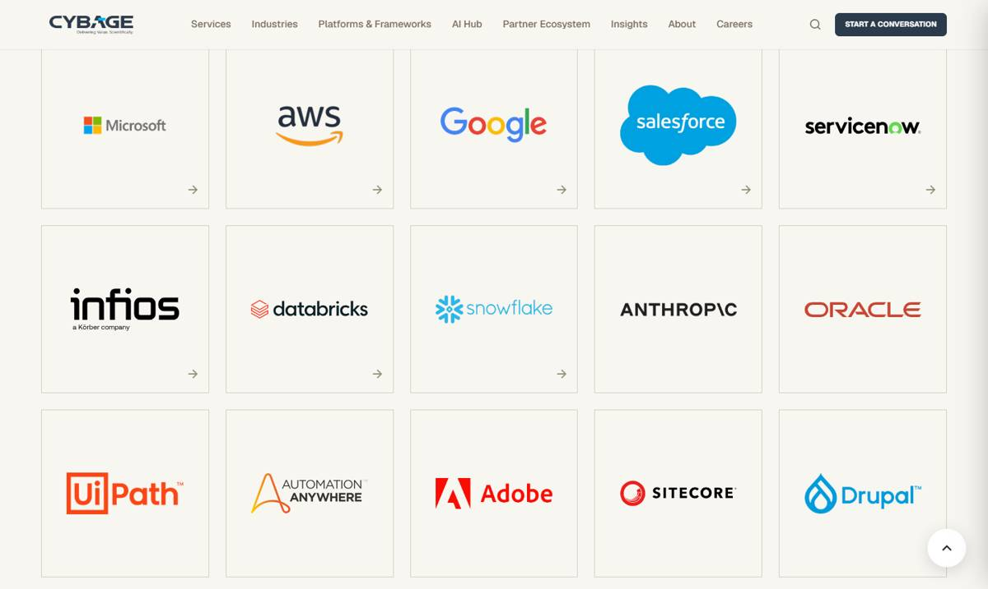

C. URL / alias mismatch and missing pages

14. Our Leadership
Page | Our Leadership
Section | Page URL
Readdy URL | https://cybage.readdy.co/our-leadership
Test URL | https://test-cybage-corporate.pantheonsite.io/about/our-leadership
Issue | Readdy URL /our-leadership gives 404 on test (page lives at /about/our-leadership).
Readdy has | https://cybage.readdy.co/our-leadership
Test has | https://test-cybage-corporate.pantheonsite.io/our-leadership -> 404
Fix | Add alias /our-leadership or a redirect to /about/our-leadership.

TEST: https://test-cybage-corporate.pantheonsite.io/our-leadership
READDY: https://cybage.readdy.co/our-leadership
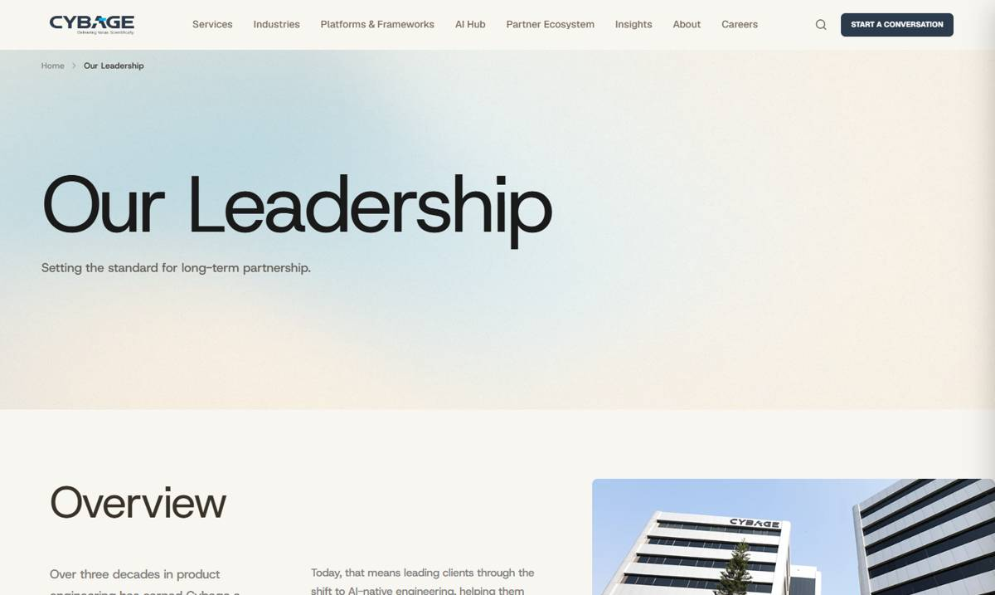

15. Glossary
Page | Glossary
Section | Page URL
Readdy URL | https://cybage.readdy.co/glossary
Test URL | https://test-cybage-corporate.pantheonsite.io/insights/glossary
Issue | Readdy URL /glossary gives 404 on test (page lives at /insights/glossary).
Readdy has | https://cybage.readdy.co/glossary
Test has | https://test-cybage-corporate.pantheonsite.io/glossary -> 404
Fix | Add alias /glossary or a redirect.

TEST: https://test-cybage-corporate.pantheonsite.io/glossary

16. Cybage Times
Page | Cybage Times
Section | Page URL
Readdy URL | https://cybage.readdy.co/insights/cybage-times
Test URL | https://test-cybage-corporate.pantheonsite.io/insights/cybage_times
Issue | Readdy URL /insights/cybage-times gives 404 on test (test uses an underscore).
Readdy has | https://cybage.readdy.co/insights/cybage-times
Test has | https://test-cybage-corporate.pantheonsite.io/insights/cybage-times -> 404
Fix | Change alias to /insights/cybage-times (redirect the old one).

TEST: https://test-cybage-corporate.pantheonsite.io/insights/cybage-times

17. Success Stories
Page | Success Stories
Section | Listing cards - READ SUCCESS STORY (all 9 pages / LOAD MORE)
Readdy URL | https://cybage.readdy.co/insights/success-stories
Test URL | https://test-cybage-corporate.pantheonsite.io/insights/success-stories
Issue | All 65 story links work (HTTP 200), but 57 of them use raw /node/ID URLs (no URL alias).
Readdy has | Readable URLs.
Test has | e.g. /node/445, /node/261, /node/185
Fix | Generate URL aliases (Pathauto) for success-story content.

TEST: https://test-cybage-corporate.pantheonsite.io/insights/success-stories
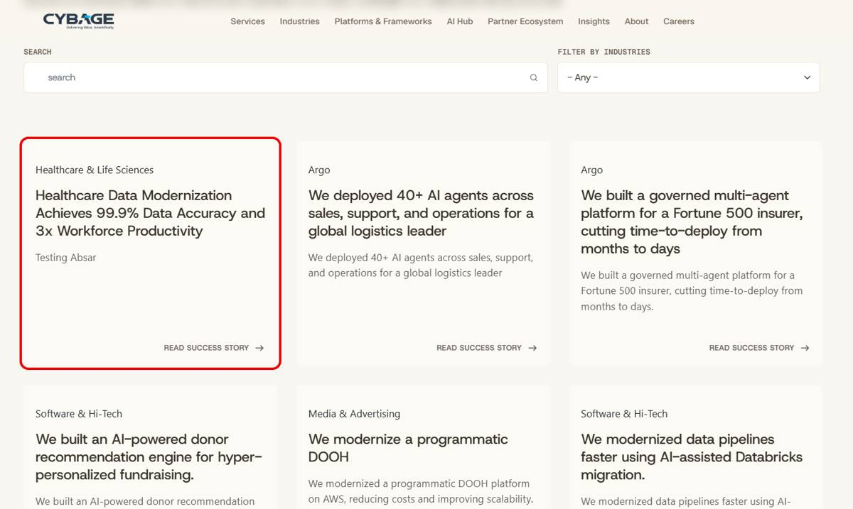

18. 404 page (site-wide)
Page | 404 page (site-wide)
Section | Page not found
Readdy URL | https://cybage.readdy.co/this-page-does-not-exist-qa
Test URL | https://test-cybage-corporate.pantheonsite.io/this-page-does-not-exist-qa
Issue | Custom 404 page is missing; test shows the default Drupal "Page Not Found".
Readdy has | Custom page "Let's Find Your Way Back" with links.
Test has | Plain "The requested page could not be found."
Fix | Build the custom 404 page and set it in Basic site settings.

READDY: https://cybage.readdy.co/this-page-does-not-exist-qa
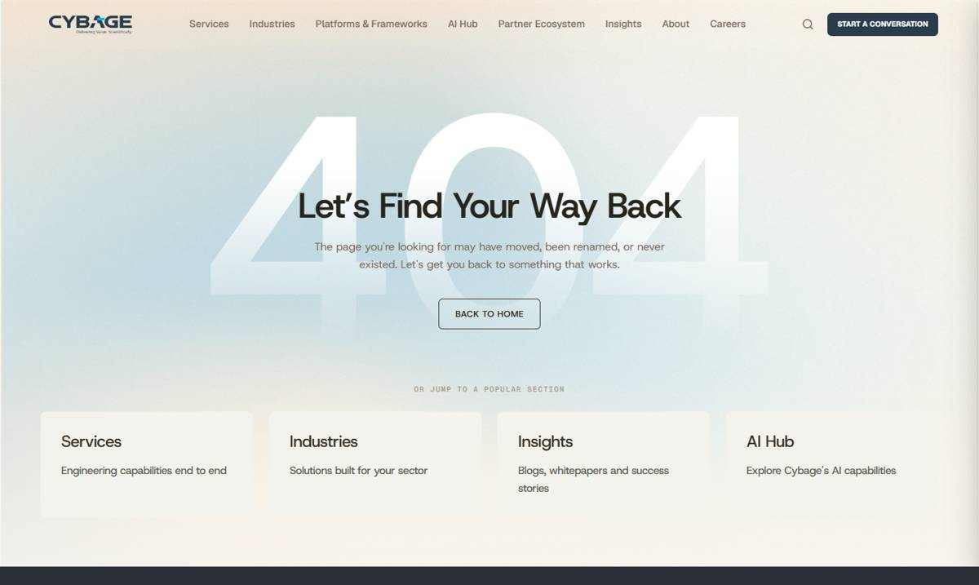
TEST: https://test-cybage-corporate.pantheonsite.io/this-page-does-not-exist-qa

D. Missing sections / missing content

19. Home
Page | Home
Section | Culture In Motion / Move Forward with Us / Locations
Readdy URL | https://cybage.readdy.co/
Test URL | https://test-cybage-corporate.pantheonsite.io/
Issue | Text missing on the Home page.
Readdy has | Culture In Motion: 3 descriptions (people / customers / sustainability).  "Move Forward with Us" heading.  Locations - India: "10 offices across 3 cities".
Test has | Culture In Motion shows different text ("Nurturing People, Shaping Values...") instead of readdy's 3 descriptions; "Move Forward with Us" and "10 offices across 3 cities" are missing.
Fix | Add the missing text from readdy.

READDY: https://cybage.readdy.co/
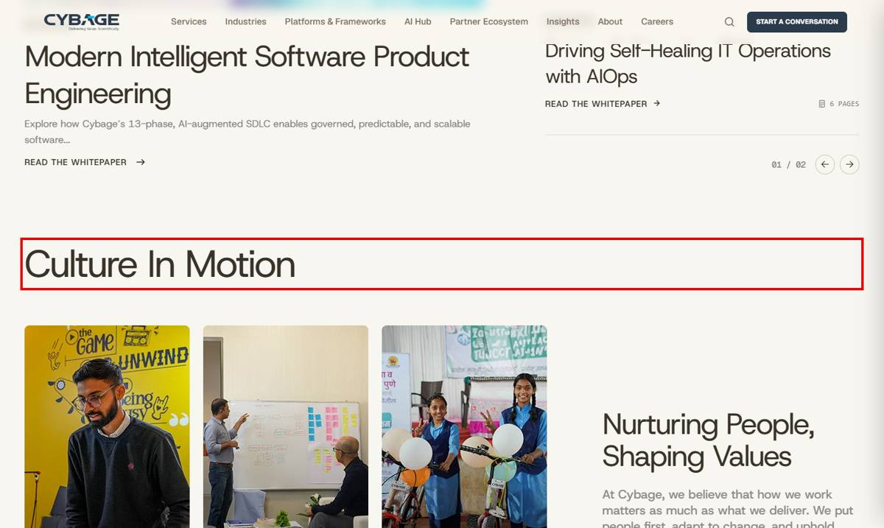
TEST: https://test-cybage-corporate.pantheonsite.io/
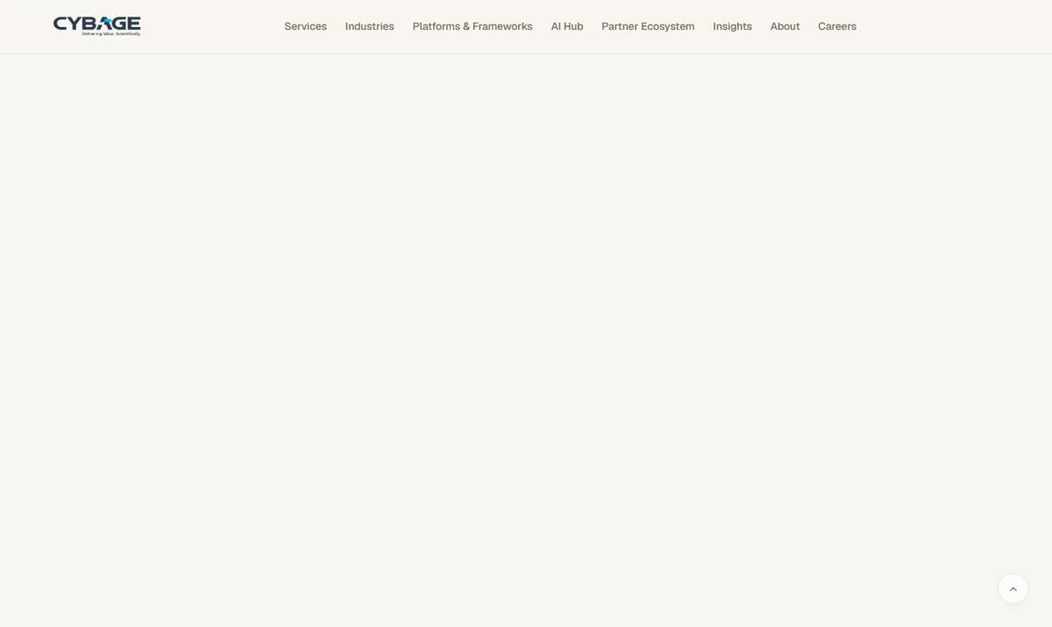

20. Global Capability Centers
Page | Global Capability Centers
Section | Intro / Case study / LinkedIn posts / Closing
Readdy URL | https://cybage.readdy.co/services/global-capability-centers
Test URL | https://test-cybage-corporate.pantheonsite.io/services/global-capability-centers
Issue | Several content blocks are missing.
Readdy has | Intro: "Establish, operate, and evolve Global Capability Centers..."  Case study "Leading European Travel & Hospitality Enterprise": Engagement Model, Specializations Provided, 3 partnership bullets.  2 LinkedIn post cards with READ ON LINKEDIN.  Closing: "Let's drive Global Capability Center (GCC) success..."
Test has | All of the above missing on test.
Fix | Add the missing blocks.

READDY: https://cybage.readdy.co/services/global-capability-centers
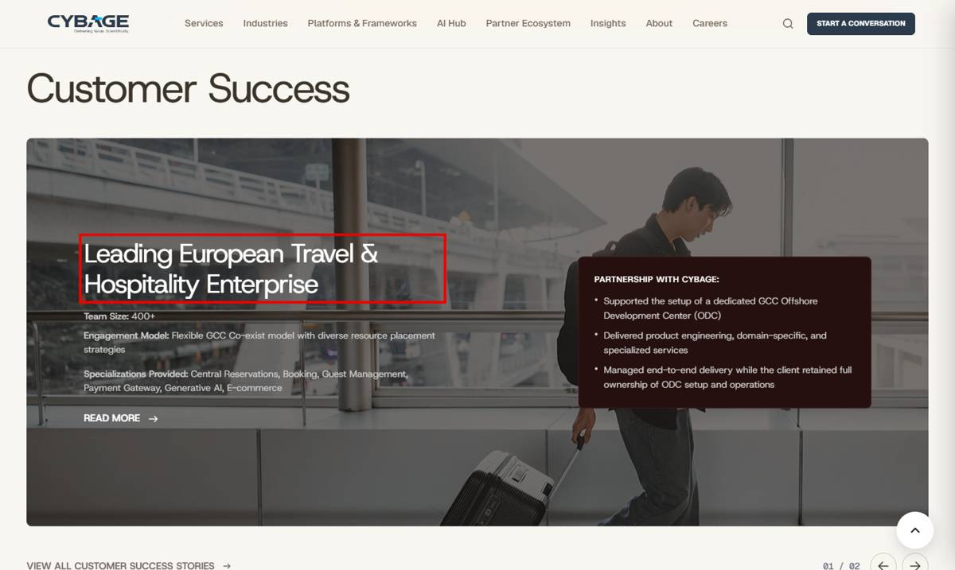
TEST: https://test-cybage-corporate.pantheonsite.io/services/global-capability-centers
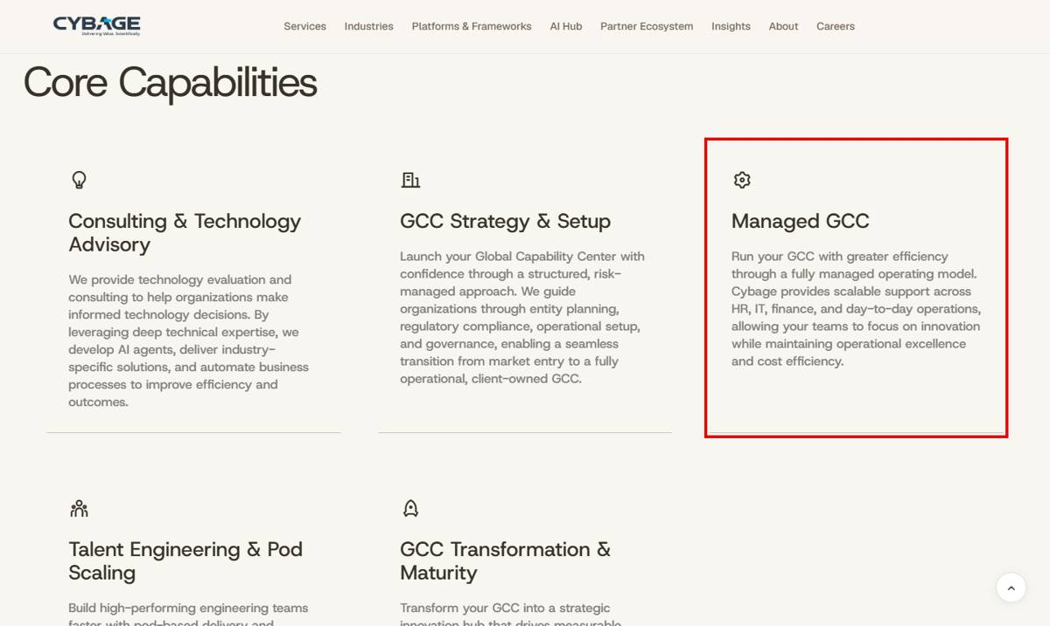

21. Enterprise Modernization
Page | Enterprise Modernization
Section | Closing CTA / CybArgo card
Readdy URL | https://cybage.readdy.co/services/enterprise-modernization
Test URL | https://test-cybage-corporate.pantheonsite.io/services/Enterprise-Modernization
Issue | Closing heading and a card label are missing.
Readdy has | Closing: "Assess Your Modernization Readiness"; CybArgo card label "Agentic Enterprise Platform".
Test has | Closing shows "Operations that improve with every cycle" (from another page); CybArgo label missing.
Fix | Use readdy's closing heading and add the label.

READDY: https://cybage.readdy.co/services/enterprise-modernization
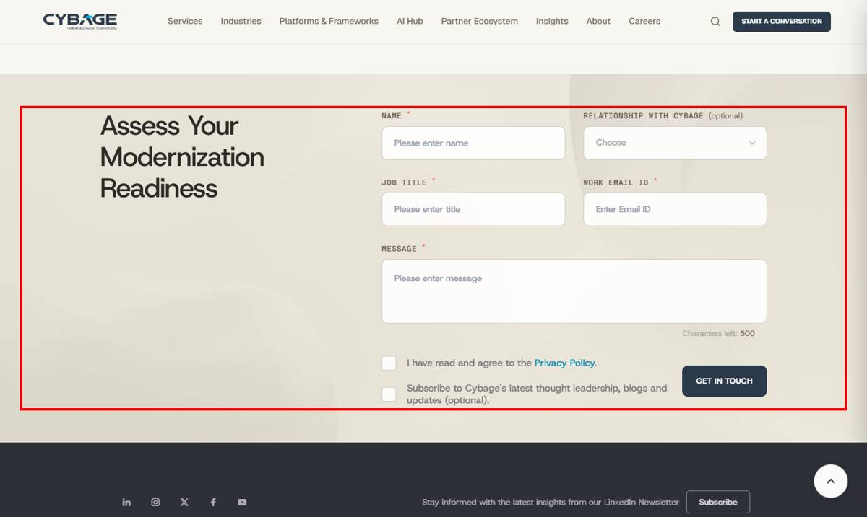
TEST: https://test-cybage-corporate.pantheonsite.io/services/Enterprise-Modernization
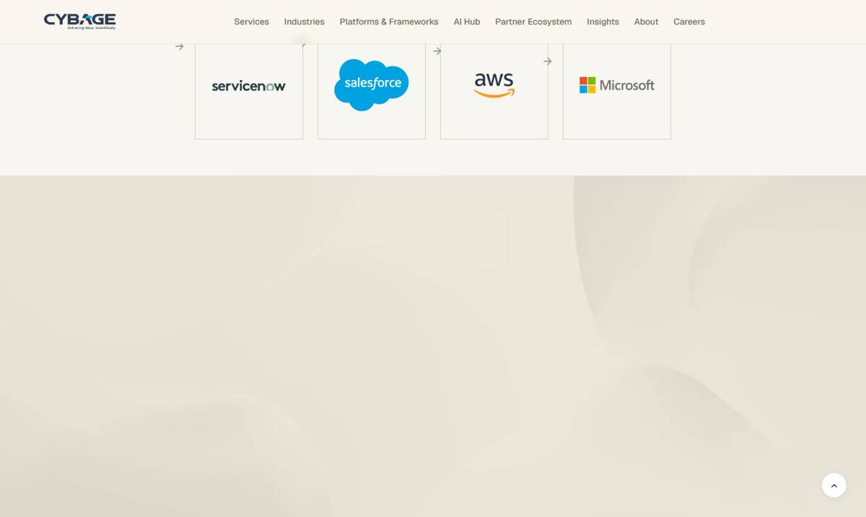

22. Travel & Hospitality
Page | Travel & Hospitality
Section | Capabilities / Closing CTA
Readdy URL | https://cybage.readdy.co/industries/travel-hospitality
Test URL | https://test-cybage-corporate.pantheonsite.io/industries/travel-hospitality
Issue | Two capability descriptions and the closing text are missing.
Readdy has | Booking Engine Architecture & Engineering: "Building high availability booking..."  Revenue Management System Engineering: "Developing intelligent revenue management..."  Closing: "Partner with Cybage to rebuild your CRS, modernize distribution..."
Test has | Descriptions missing; closing shows Media & Advertising text ("...modernize your media platforms...").
Fix | Copy the 3 texts from readdy.

READDY: https://cybage.readdy.co/industries/travel-hospitality
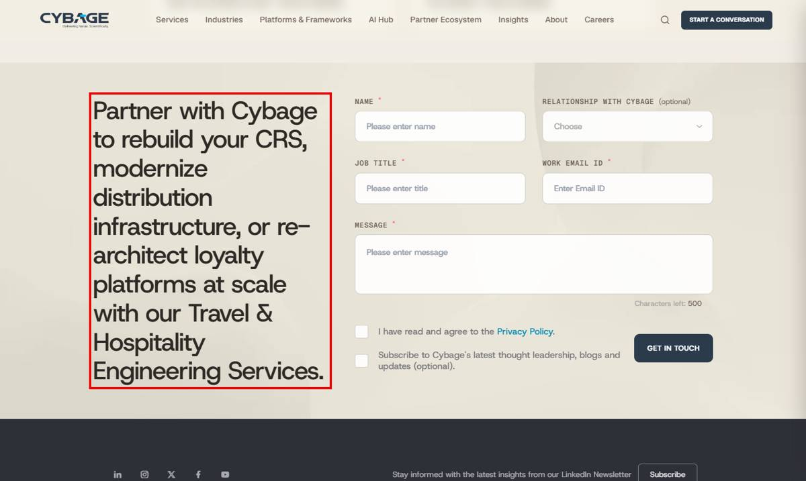
TEST: https://test-cybage-corporate.pantheonsite.io/industries/travel-hospitality
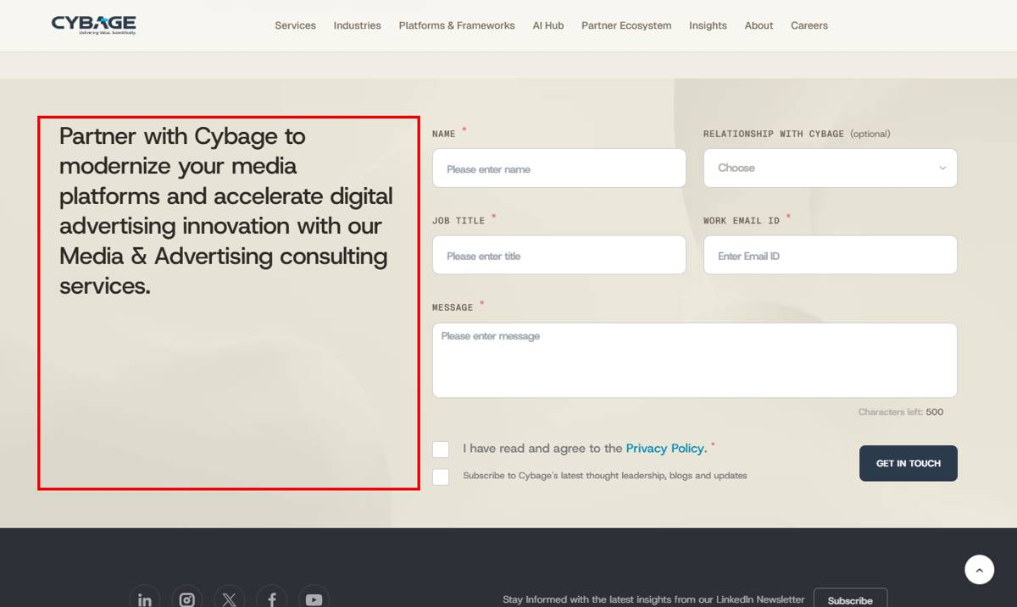

23. Software & Hi-Tech
Page | Software & Hi-Tech
Section | Stats / Experts
Readdy URL | https://cybage.readdy.co/industries/software-hi-tech
Test URL | https://test-cybage-corporate.pantheonsite.io/industries/software-hi-tech
Issue | Stats section and one expert title missing.
Readdy has | 2X productivity (Vector), 40% higher throughput (Togetherwork), 20-35% in-flight uplift (legal tech)  Debasis Ray: "Executive Vice President & Head - Product Engineering Services"
Test has | Missing.
Fix | Add stats and title.

READDY: https://cybage.readdy.co/industries/software-hi-tech
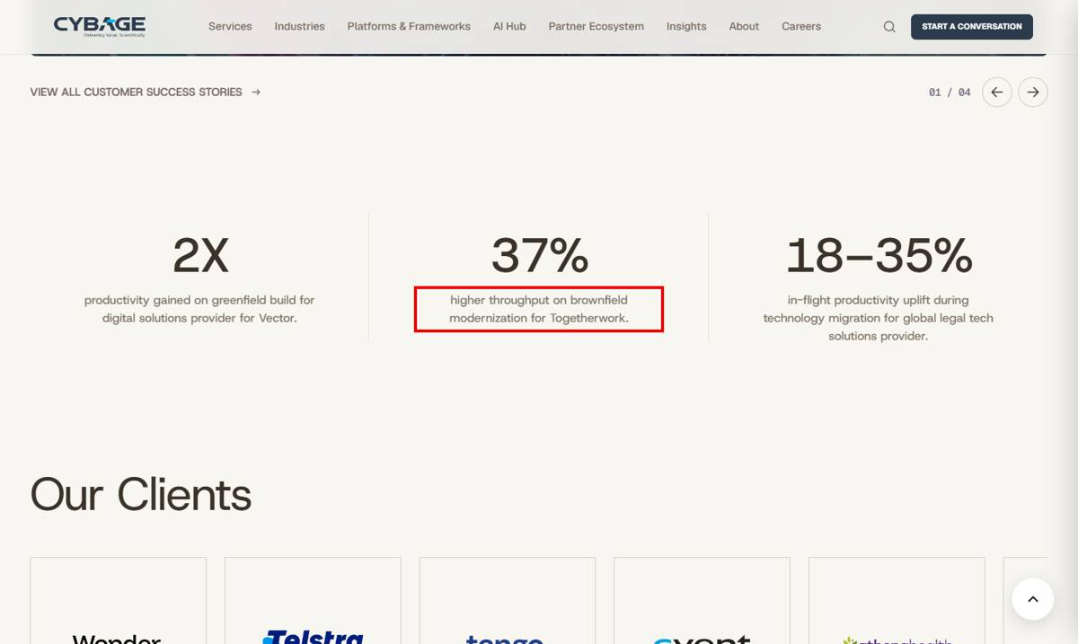
TEST: https://test-cybage-corporate.pantheonsite.io/industries/software-hi-tech
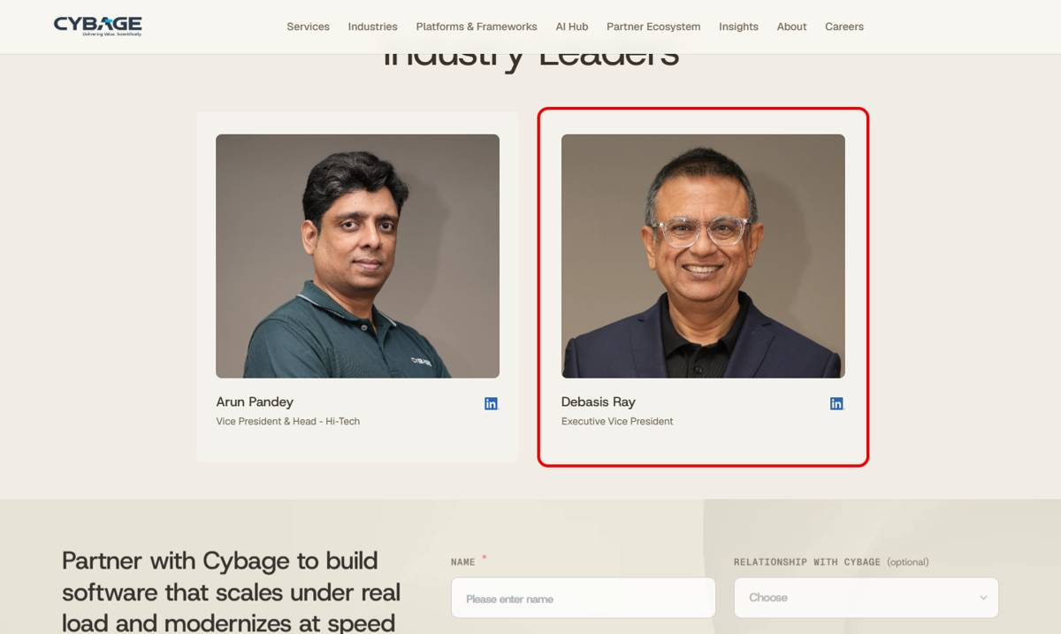

24. Supply Chain & Logistics
Page | Supply Chain & Logistics
Section | Stats / ISV section
Readdy URL | https://cybage.readdy.co/industries/supply-chain-logistics
Test URL | https://test-cybage-corporate.pantheonsite.io/industries/supply-chain-logistics
Issue | Stats section (5 numbers) and a button are missing.
Readdy has | Warehouse throughput, picking productivity (25 to 75 lines/hr), customer onboarding, faster freight booking, inventory visibility / 100% 3PL billing accuracy; button "ACCELERATE SUPPLY CHAIN MODERNIZATION".
Test has | Missing.
Fix | Add the stats section and the button.

READDY: https://cybage.readdy.co/industries/supply-chain-logistics
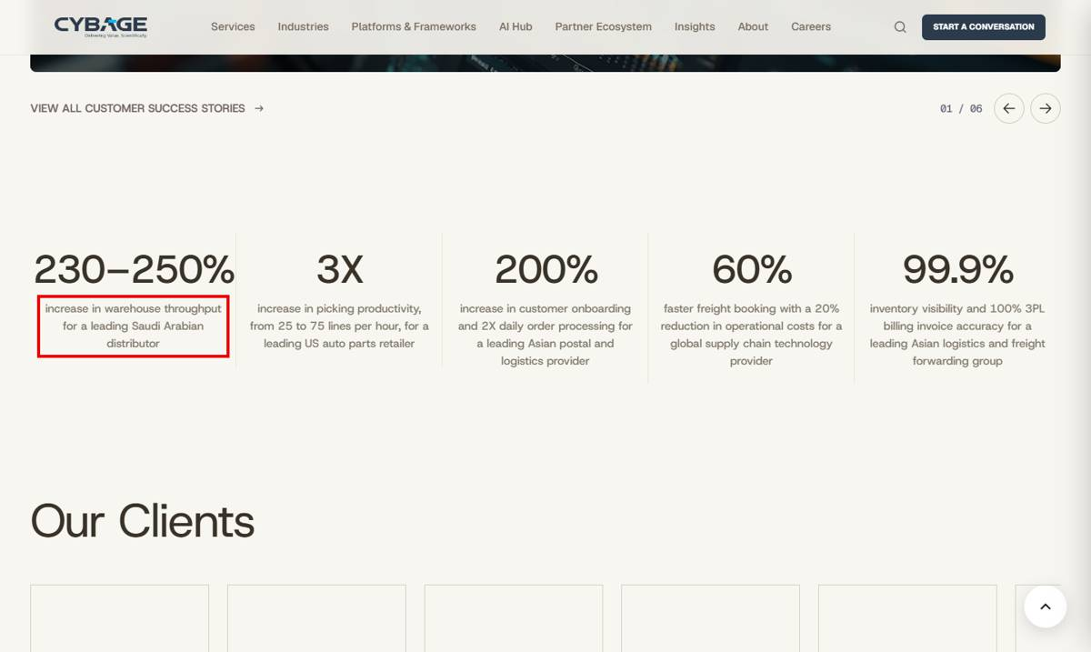
TEST: https://test-cybage-corporate.pantheonsite.io/industries/supply-chain-logistics
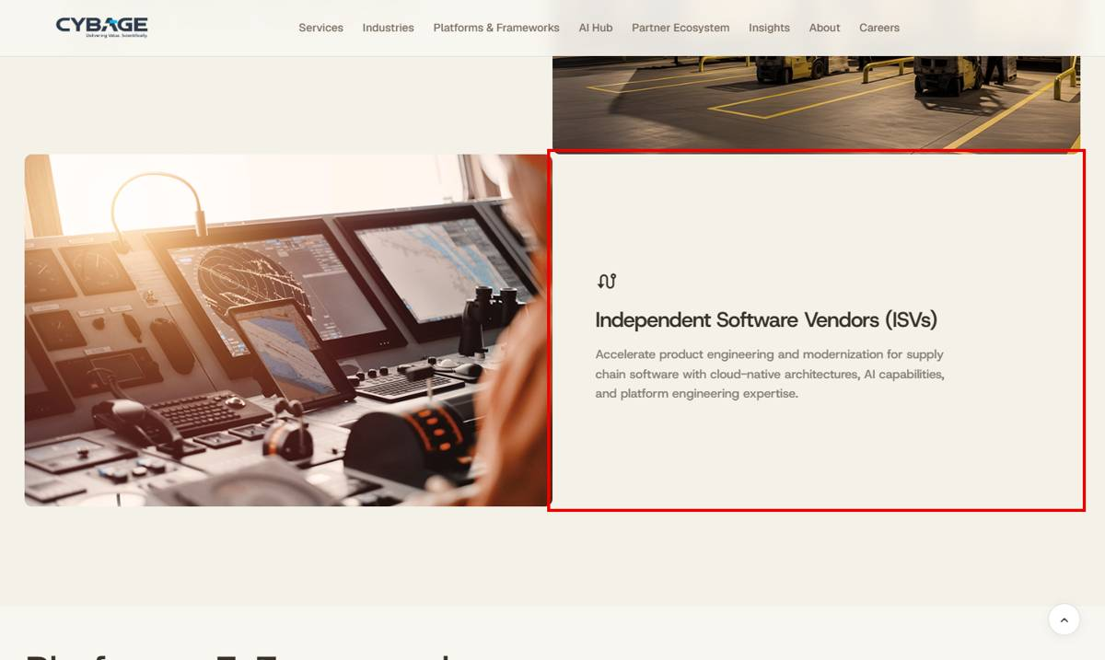

25. Healthcare & Life Sciences
Page | Healthcare & Life Sciences
Section | Capabilities
Readdy URL | https://cybage.readdy.co/industries/healthcare-life-sciences
Test URL | https://test-cybage-corporate.pantheonsite.io/industries/healthcare-life-sciences
Issue | One capability description missing.
Readdy has | Healthcare Compliance, Regulatory & ...: "Engineering secure, compliant healthcare platforms that support HIPAA, CMS..."
Test has | Missing.
Fix | Add the description.

READDY: https://cybage.readdy.co/industries/healthcare-life-sciences
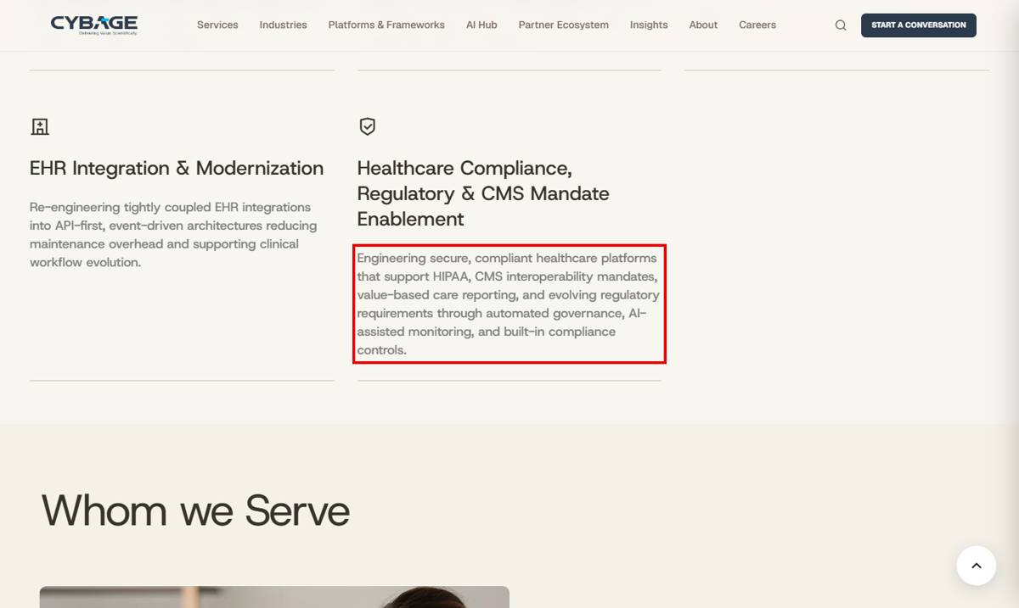

26. TAPAS
Page | TAPAS
Section | Case study stats
Readdy URL | https://cybage.readdy.co/platforms-frameworks/tapas
Test URL | https://test-cybage-corporate.pantheonsite.io/platforms-frameworks/tapas
Issue | Case study results missing.
Readdy has | 21+ vendors consolidated within 8 months; 40% savings in transition costs; Transition across 8 products, 9 countries, 40+ agile pods; "For a Global Facilities Management Technology Provider"
Test has | Missing.
Fix | Add the case-study results.

READDY: https://cybage.readdy.co/platforms-frameworks/tapas
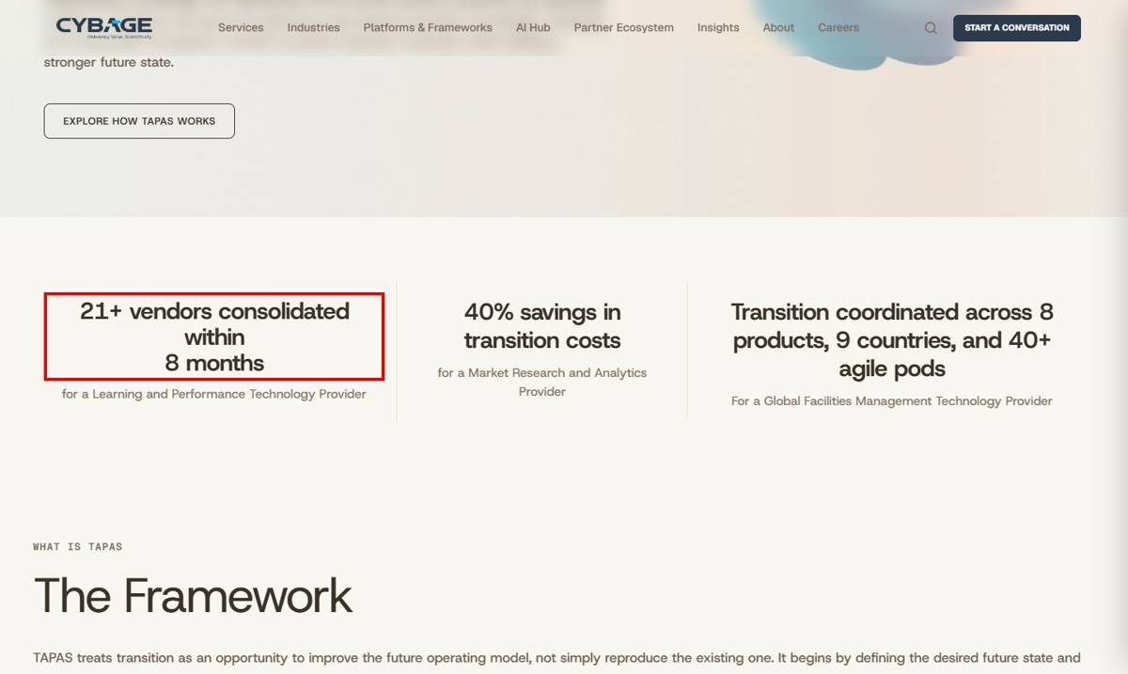

27. AWS
Page | AWS
Section | Platforms (CybArgo, Datatrans, CAM, DAI) / Intro link
Readdy URL | https://cybage.readdy.co/partner-ecosystem/aws
Test URL | https://test-cybage-corporate.pantheonsite.io/partner-ecosystem/aws
Issue | Platforms section and a linked phrase are missing.
Readdy has | 4 platform cards: CybArgo, Datatrans, CAM (Digital Asset Management), DAI (Dynamic Ad Insertion) with descriptions and links; intro text "As an AWS Transform Continuous Modernization Launch Partner..." with link.
Test has | Missing.
Fix | Add the section and the linked intro text.

READDY: https://cybage.readdy.co/partner-ecosystem/aws
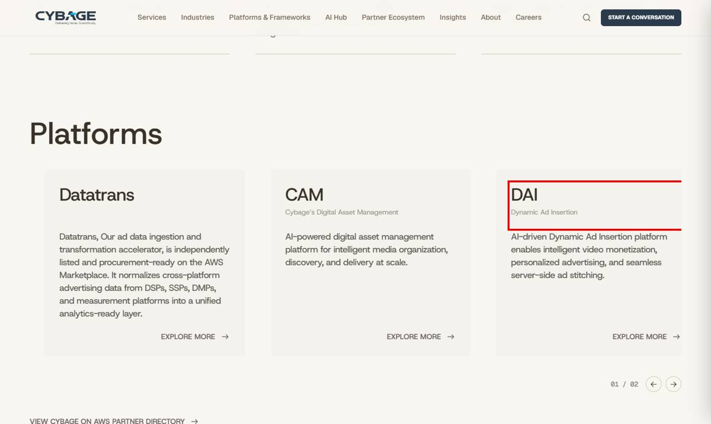
TEST: https://test-cybage-corporate.pantheonsite.io/partner-ecosystem/aws
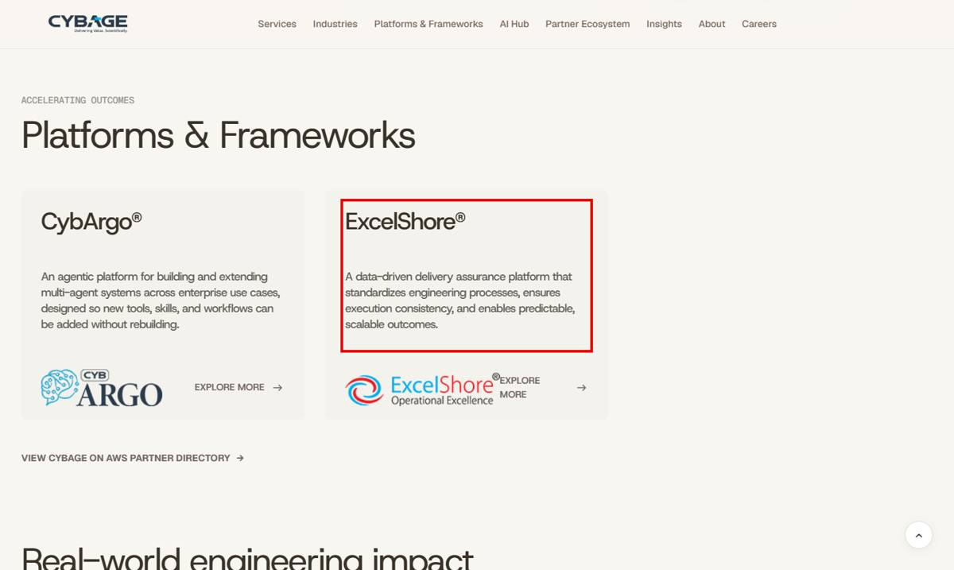

28. Newsroom
Page | Newsroom
Section | Analyst Recognitions / Industry Excellence Awards
Readdy URL | https://cybage.readdy.co/about/newsroom
Test URL | https://test-cybage-corporate.pantheonsite.io/about/newsroom
Issue | Award / recognition items missing.
Readdy has | Analyst: Leader in Media and Technology (2019), Rising Star in Software Product Engineering.  Awards: Best Organization Culture Transformation, LinkedIn Talent Awards 2024, NASSCOM 20 Year Association, ET Future Ready Organization 2022.
Test has | Missing.
Fix | Add the items.

READDY: https://cybage.readdy.co/about/newsroom
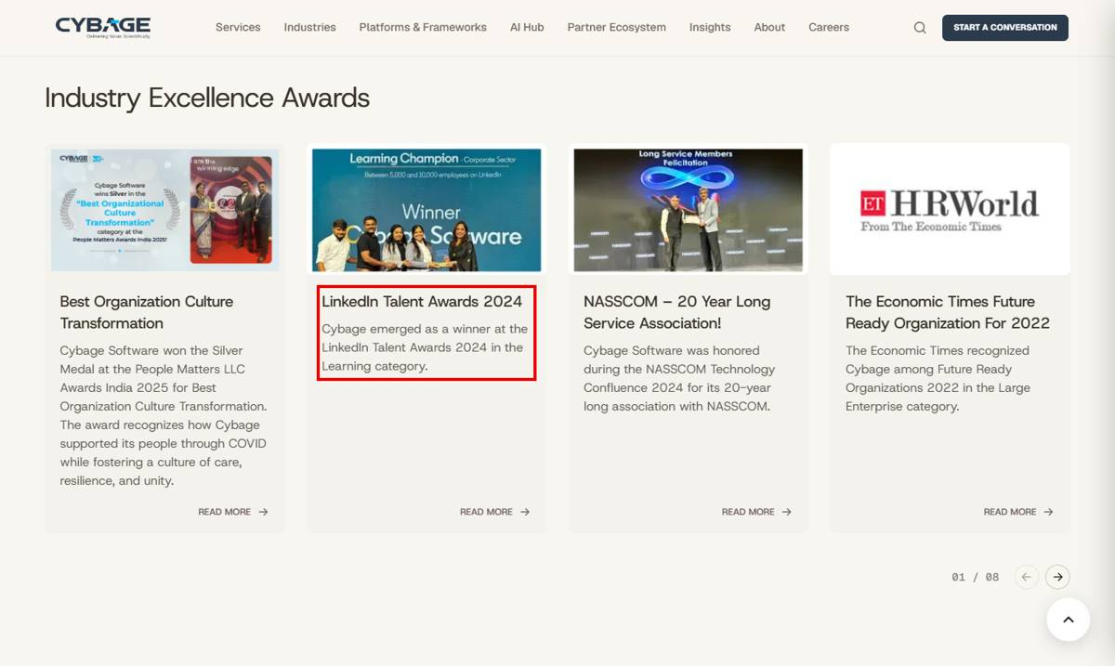
TEST: https://test-cybage-corporate.pantheonsite.io/about/newsroom
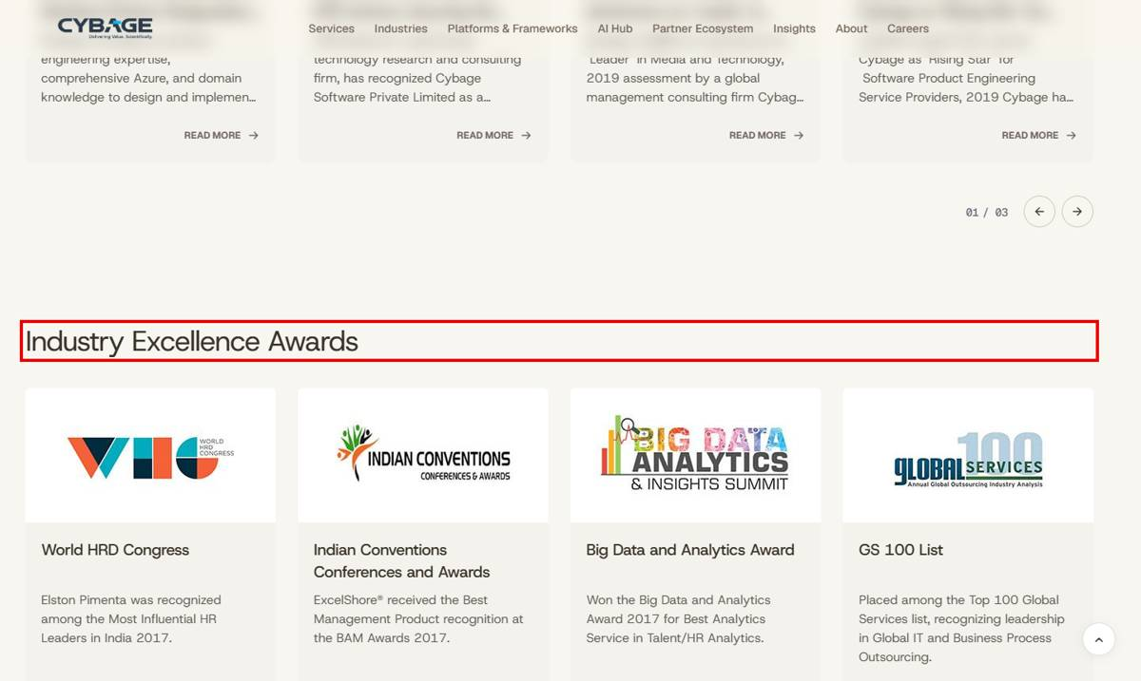

29. Cybage Foundation
Page | Cybage Foundation
Section | CybageKhushboo
Readdy URL | https://cybage.readdy.co/about/cybage-foundation
Test URL | https://test-cybage-corporate.pantheonsite.io/about/cybage-foundation
Issue | CybageKhushboo description missing.
Readdy has | "Established in 2009, CybageKhushboo is dedicated to transforming lives through education..."
Test has | Missing.
Fix | Add the description.

READDY: https://cybage.readdy.co/about/cybage-foundation
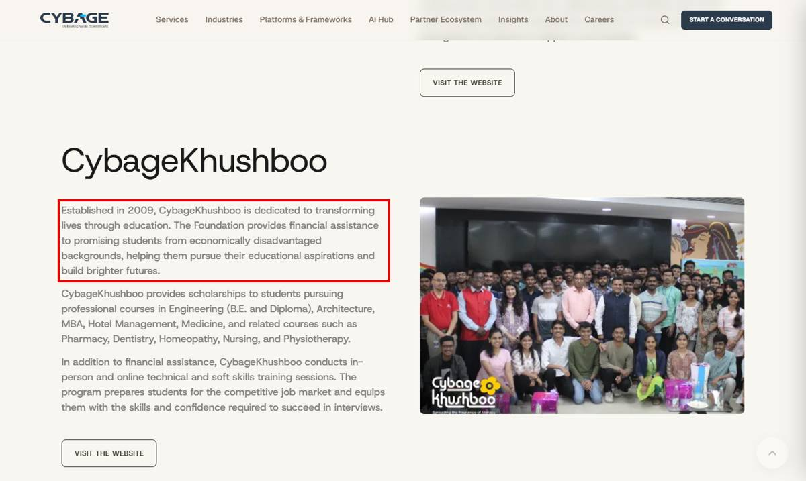
TEST: https://test-cybage-corporate.pantheonsite.io/about/cybage-foundation
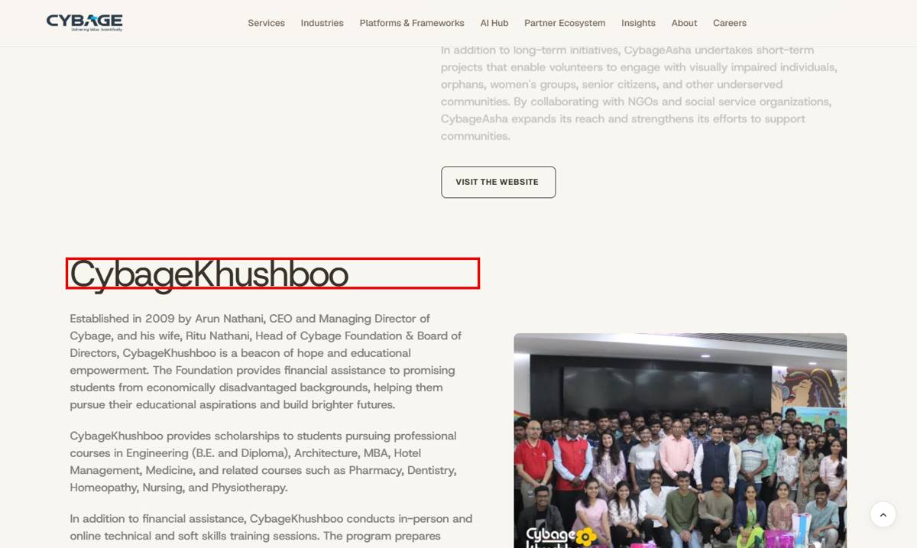

30. Why Join Cybage
Page | Why Join Cybage
Section | Flexibility / Employee Engagement / Life and Wellness / Staying Ahead
Readdy URL | https://cybage.readdy.co/careers/why-join-cybage
Test URL | https://test-cybage-corporate.pantheonsite.io/careers/why-join-cybage
Issue | Bullet points missing or different.
Readdy has | Fair and transparent workplace practices; Recognition that celebrates contributions; Events and experiences...; Open conversations with leaders; A culture of continuous learning; Comprehensive insurance coverage; Opportunities for talent development and career growth; "Flexible work options and working hours"; "The liberty to explore, innovate, and drive change"
Test has | 7 bullets missing; "Flexible work mode options"; "The liberty to explore, create, and bring change".
Fix | Update the bullets to readdy.

READDY: https://cybage.readdy.co/careers/why-join-cybage
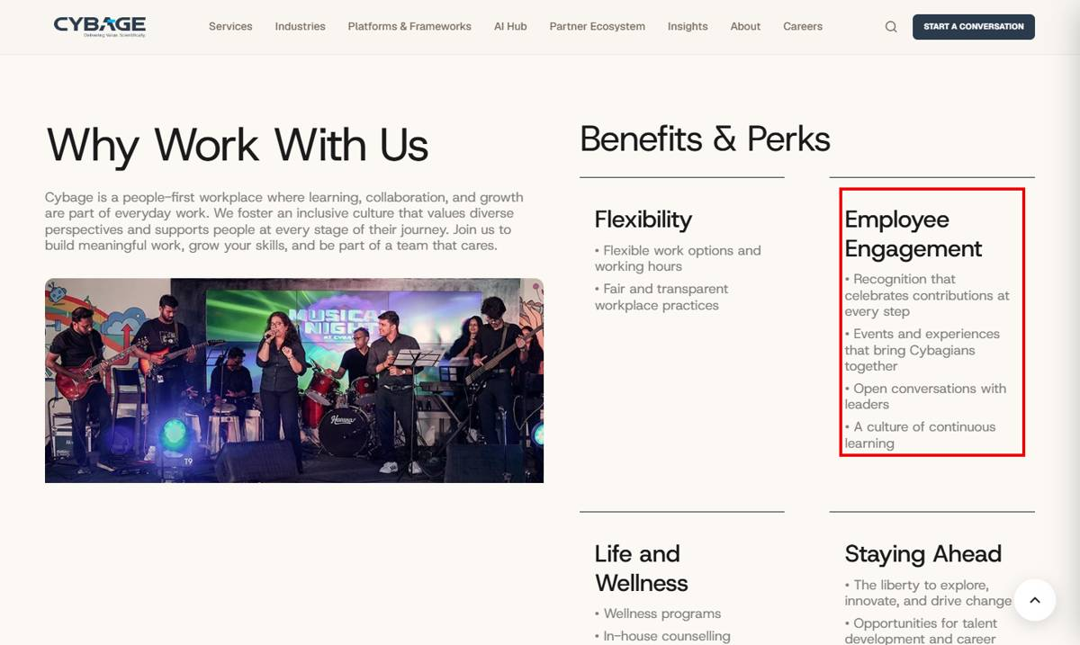
TEST: https://test-cybage-corporate.pantheonsite.io/careers/why-join-cybage
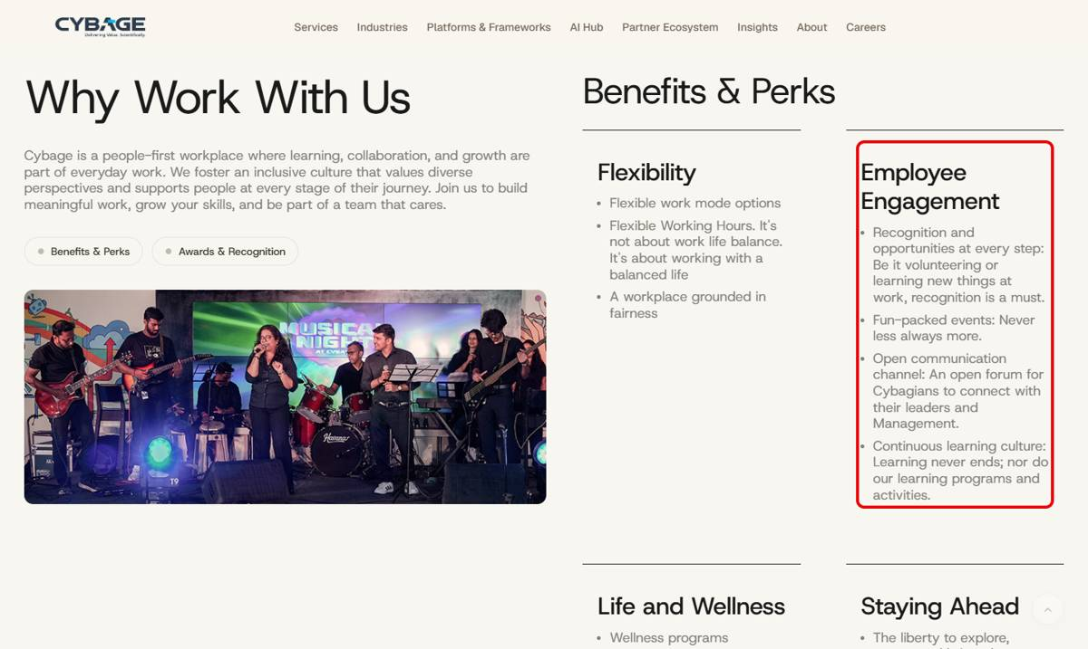

31. Diversity & Inclusion + Contact Us
Page | Diversity & Inclusion + Contact Us
Section | Track record / Policies / Locations
Readdy URL | https://cybage.readdy.co/careers/diversity-inclusion
Test URL | https://test-cybage-corporate.pantheonsite.io/careers/diversity-inclusion
Issue | Text missing / changed.
Readdy has | "16% of our workforce comprises long-tenured employees"; heading "Policies That Support Our Women Employees"; Contact Us India: "10 offices across 3 cities"
Test has | 16% line missing; heading says "...Our Employees"; "10 offices across 3 cities" missing on Contact Us.
Fix | Update text.

READDY: https://cybage.readdy.co/careers/diversity-inclusion
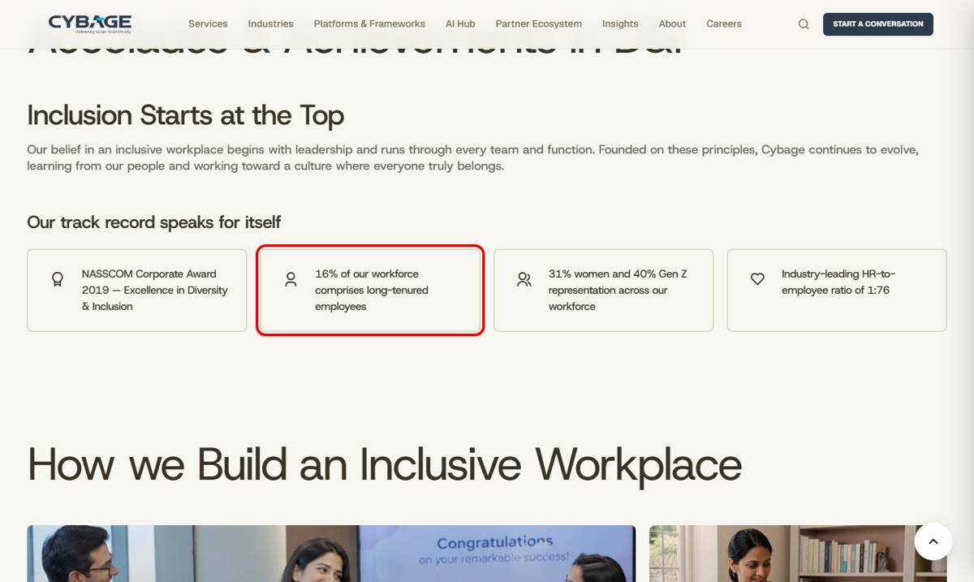
TEST: https://test-cybage-corporate.pantheonsite.io/careers/diversity-inclusion
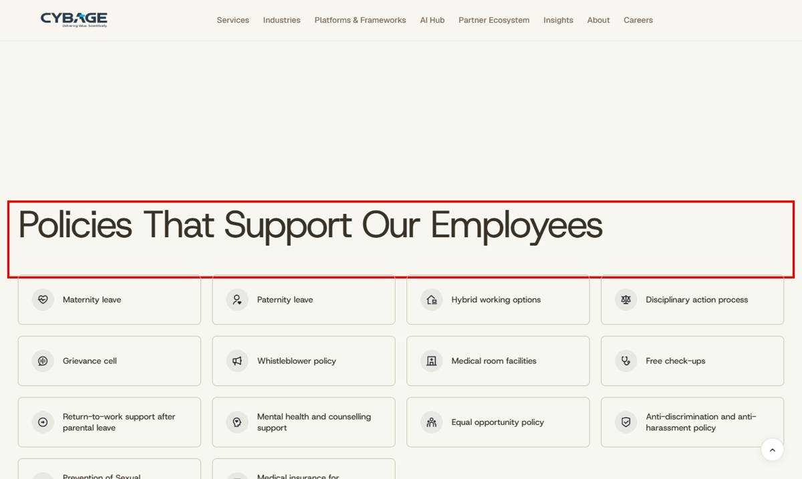

E. Content that differs from readdy

32. Media & Advertising
Page | Media & Advertising
Section | Platforms - Datatrans
Readdy URL | https://cybage.readdy.co/industries/media-advertising
Test URL | https://test-cybage-corporate.pantheonsite.io/industries/media-advertising
Issue | Datatrans description is different.
Readdy has | "Our ad data accelerator that normalizes and activates fragmented DSP, SSP, and measurement data..."
Test has | "A data transformation framework designed to convert, validate, and enrich data between different formats..."
Fix | Replace with readdy text.

READDY: https://cybage.readdy.co/industries/media-advertising
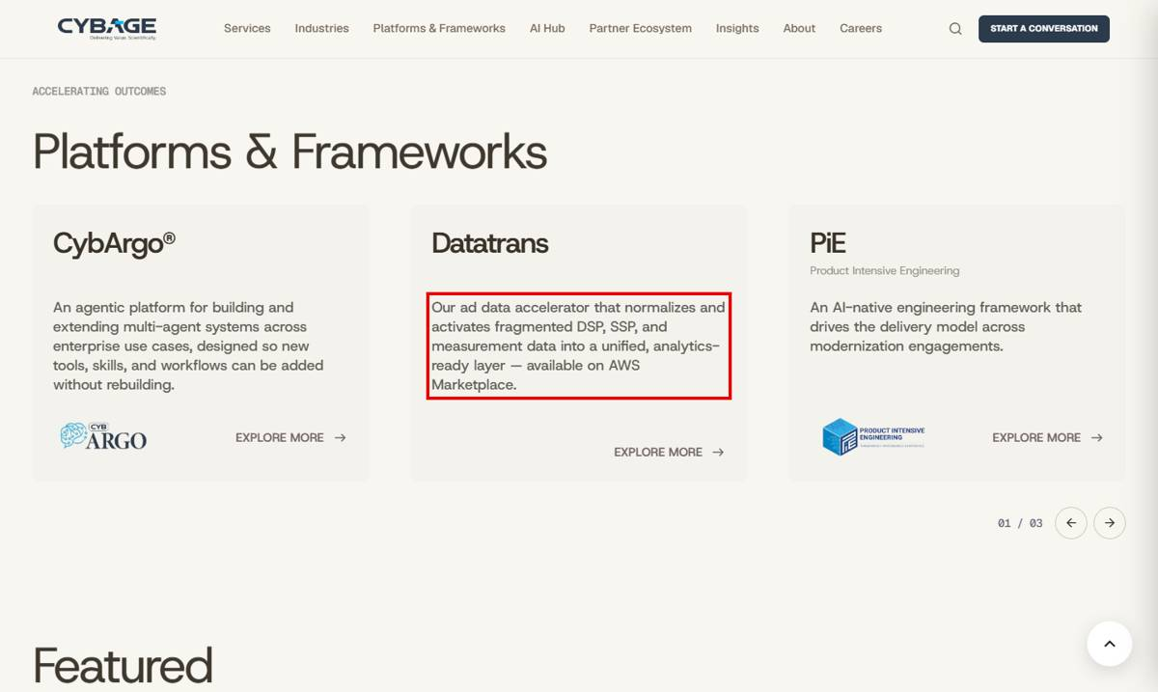
TEST: https://test-cybage-corporate.pantheonsite.io/industries/media-advertising
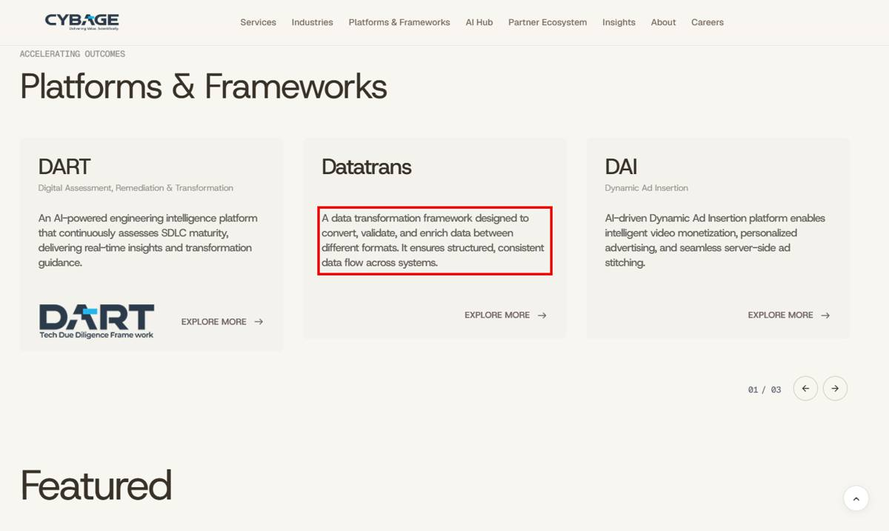

33. Industries
Page | Industries
Section | Financial Services card
Readdy URL | https://cybage.readdy.co/industries
Test URL | https://test-cybage-corporate.pantheonsite.io/industries
Issue | Financial Services card: one bullet missing and the button label differs.
Readdy has | Bullets end with "Wealth & Crypto Platform Engineering"; button EXPLORE FINANCIAL SERVICES
Test has | "Wealth & Crypto Platform Engineering" missing; button EXPLORE FINTECH
Fix | Add the bullet and use the readdy button label.

READDY: https://cybage.readdy.co/industries
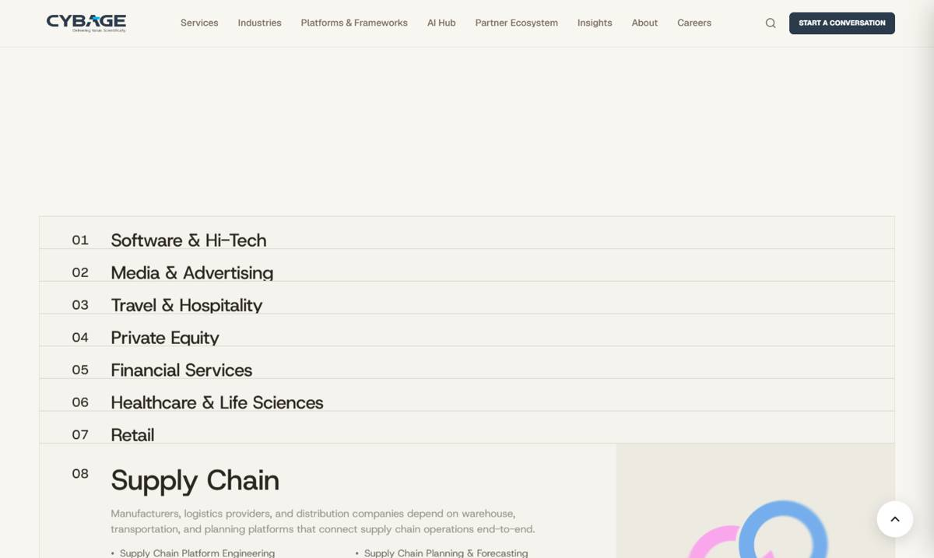
TEST: https://test-cybage-corporate.pantheonsite.io/industries
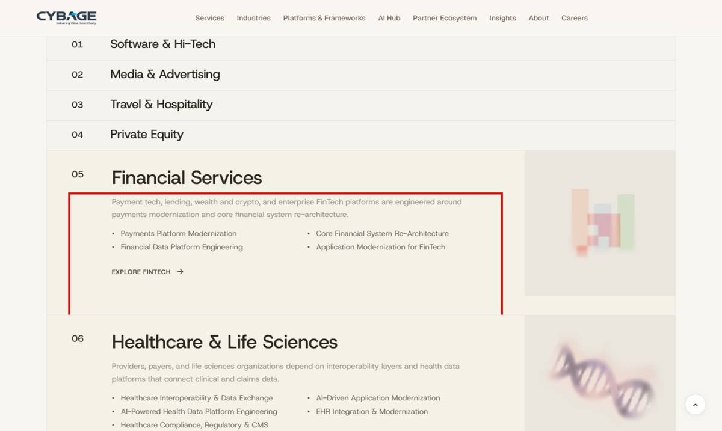

34. Services
Page | Services
Section | Service cards - buttons
Readdy URL | https://cybage.readdy.co/services
Test URL | https://test-cybage-corporate.pantheonsite.io/services
Issue | First button label is shortened.
Readdy has | EXPLORE AI-NATIVE PRODUCT & PLATFORM ENGINEERING
Test has | EXPLORE AI-NATIVE ENGINEERING
Fix | Use the full label.

TEST: https://test-cybage-corporate.pantheonsite.io/services
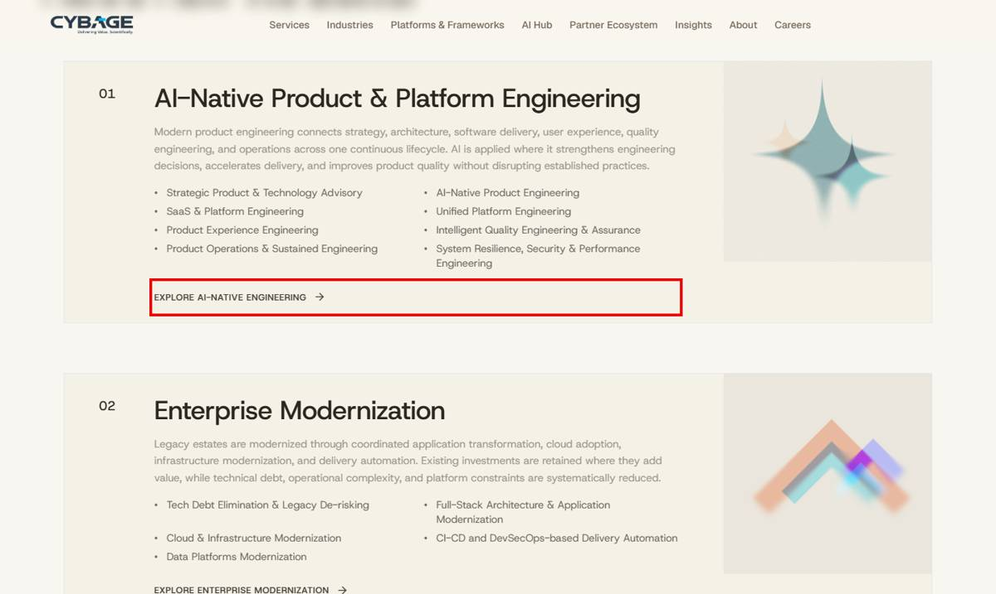

35. Platforms & Frameworks
Page | Platforms & Frameworks
Section | Platforms / Frameworks cards
Readdy URL | https://cybage.readdy.co/platforms-frameworks
Test URL | https://test-cybage-corporate.pantheonsite.io/platforms-frameworks
Issue | Card descriptions differ from readdy (5 cards).
Readdy has | CybArgo: "...built on AWS AgentCore..."; PiE: "The engineering discipline that ties every technical decision back to business value..."; DART: "framework for AI tool adoption and measurement..."; OneTruth: "spec-led operating model..."; TAPAS: "transition excellence framework..."
Test has | Older / generic texts; TAPAS describes "low-code, event-driven processing pipelines".
Fix | Replace the 5 descriptions.

READDY: https://cybage.readdy.co/platforms-frameworks
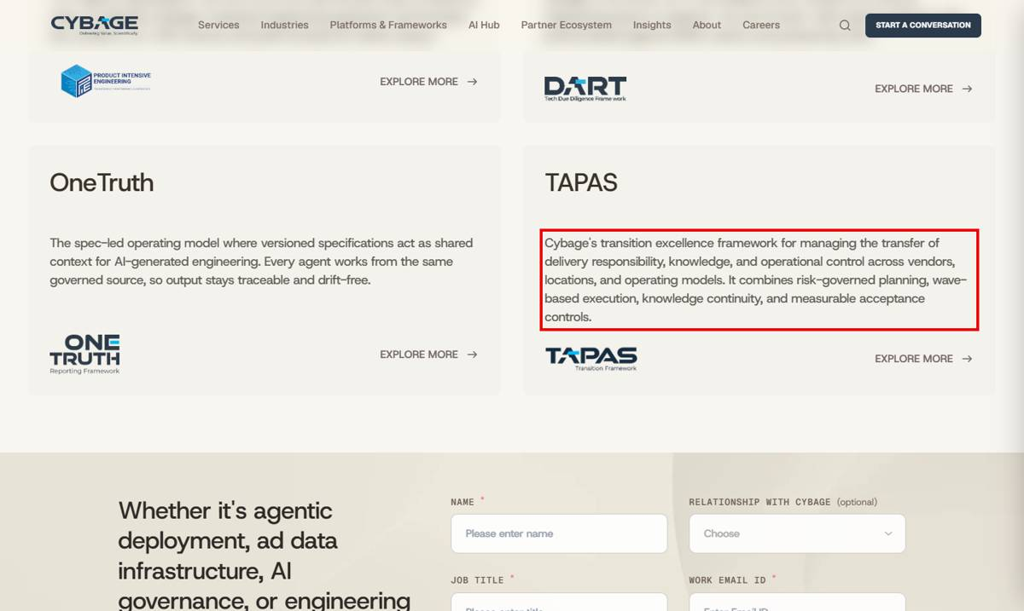
TEST: https://test-cybage-corporate.pantheonsite.io/platforms-frameworks
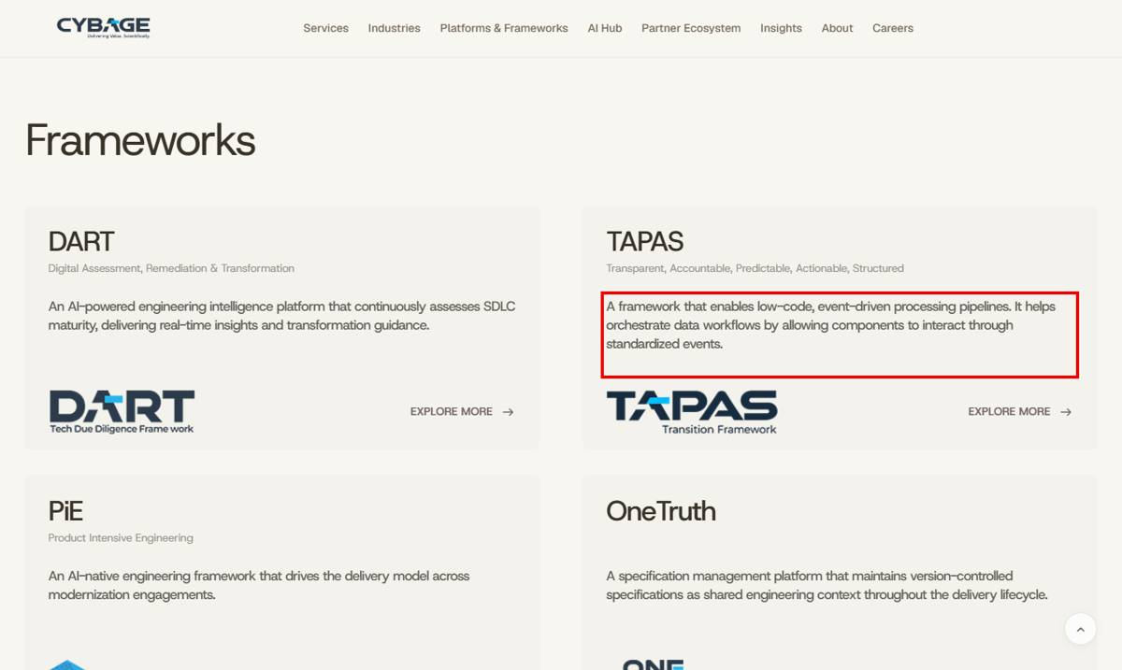

36. Financial Services
Page | Financial Services
Section | Stats / Capabilities / Closing
Readdy URL | https://cybage.readdy.co/industries/financial-services
Test URL | https://test-cybage-corporate.pantheonsite.io/industries/financial-services
Issue | Stats and a card title differ; closing text missing.
Readdy has | Stats: contactless payments (Worldline), operational cost reduction via vendor consolidation (IRIS), e-commerce payment growth (Worldline), faster loan approvals (Banco); card "Payments Platform Engineering"; closing "Talk to Cybage about modernizing your payment infrastructure..."
Test has | Different stats ("...during offshore infrastructure transition"); "Payments Platform Modernization"; closing missing.
Fix | Update to readdy.

READDY: https://cybage.readdy.co/industries/financial-services
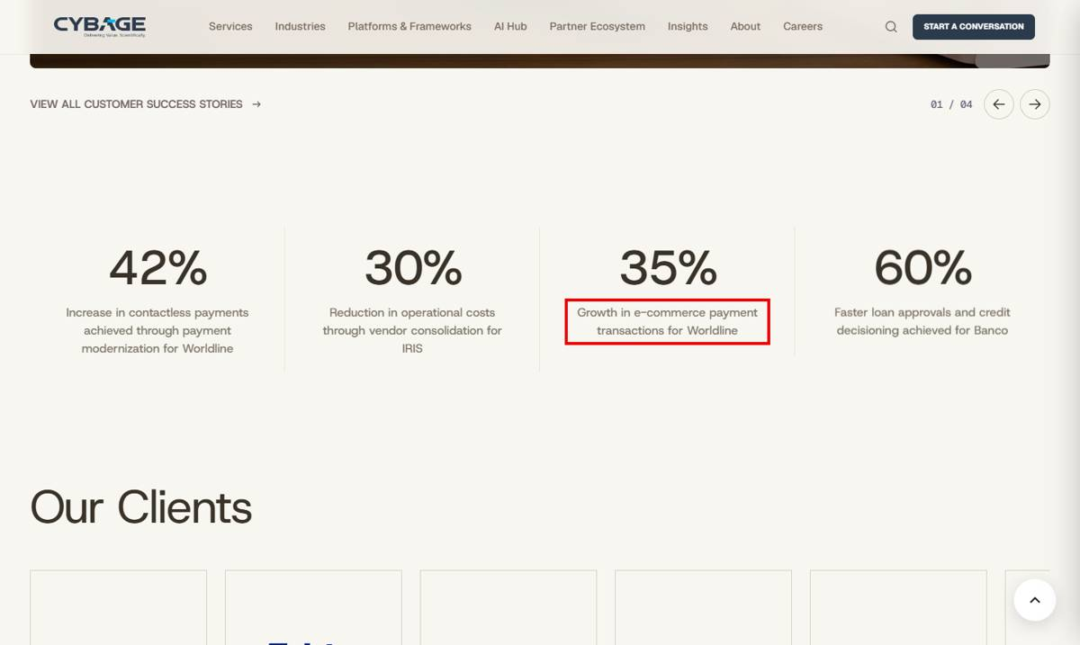
TEST: https://test-cybage-corporate.pantheonsite.io/industries/financial-services
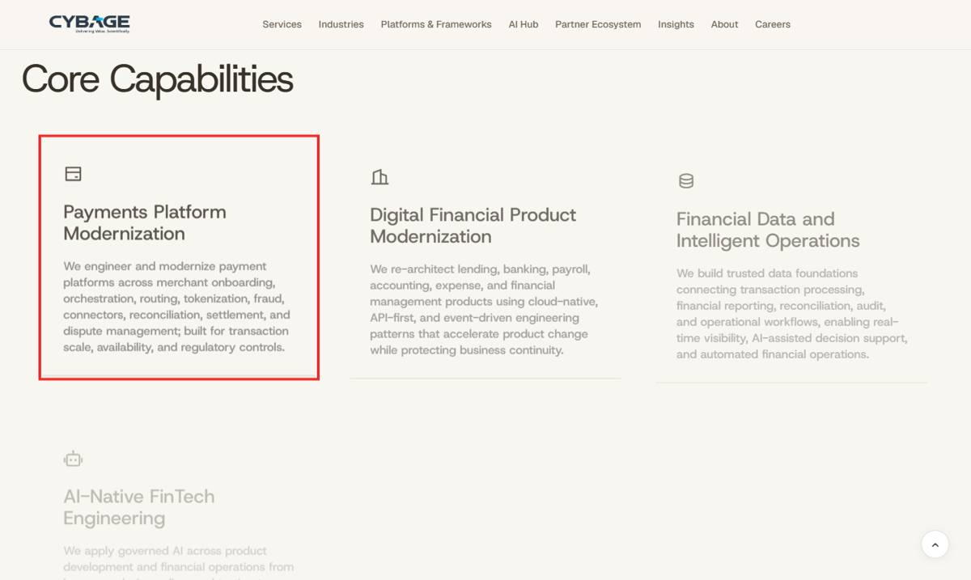

37. ServiceNow
Page | ServiceNow
Section | Stats
Readdy URL | https://cybage.readdy.co/partner-ecosystem/servicenow
Test URL | https://test-cybage-corporate.pantheonsite.io/partner-ecosystem/ServiceNow
Issue | Stats text differs; 2 stats missing.
Readdy has | 60% of Service Requests Automated for a Hi-Tech client...; 35% Reduction in Agent Effort...; 75% First Call Resolution...; 82% CMDB Data Accuracy...; 30% Reduction in IT Support Costs...
Test has | Different wording for 60/35/75%; 82% and 30% missing.
Fix | Update the stats.

READDY: https://cybage.readdy.co/partner-ecosystem/servicenow
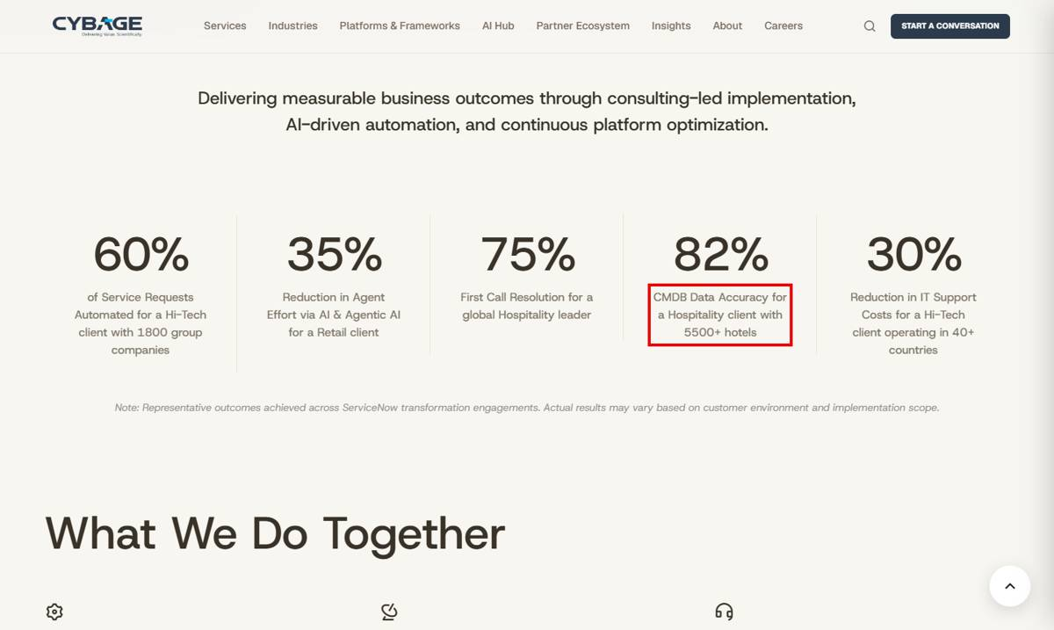
TEST: https://test-cybage-corporate.pantheonsite.io/partner-ecosystem/ServiceNow
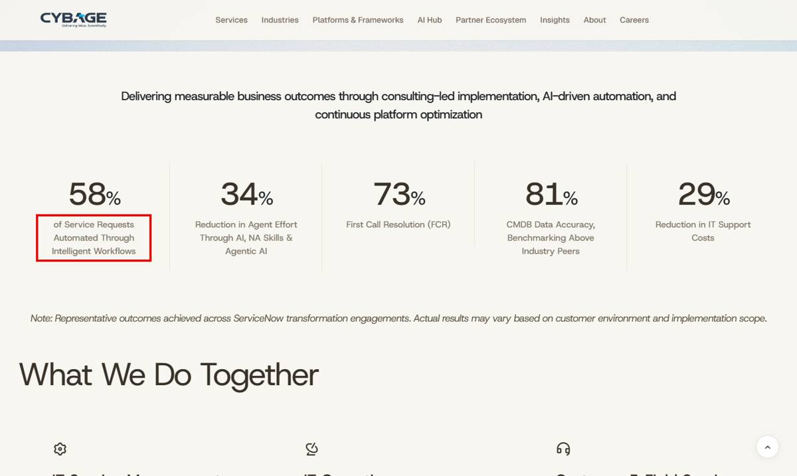

38. Microsoft / Sustainability / Corporate Governance
Page | Microsoft / Sustainability / Corporate Governance
Section | What We Do Together / Scope emissions / Legal & Privacy
Readdy URL | https://cybage.readdy.co/about/sustainability
Test URL | https://test-cybage-corporate.pantheonsite.io/about/sustainability
Issue | Small wording errors.
Readdy has | "...across the Microsoft ecosystem"; "Scope 1 & 2 Emissions"; Corporate Governance legal/privacy wording per readdy
Test has | "...across the ecosystem" (Microsoft missing); "Scope 1 & Emissions 2" (order broken); older wording on Corporate Governance
Fix | Correct the text.

TEST: https://test-cybage-corporate.pantheonsite.io/about/sustainability
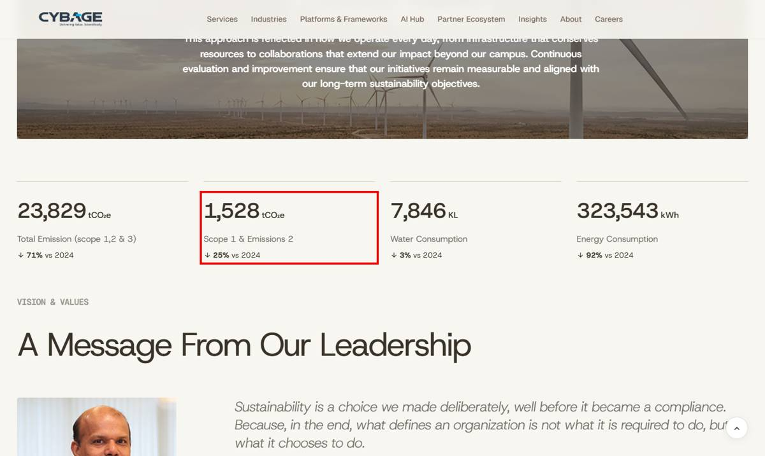
READDY: https://cybage.readdy.co/about/sustainability
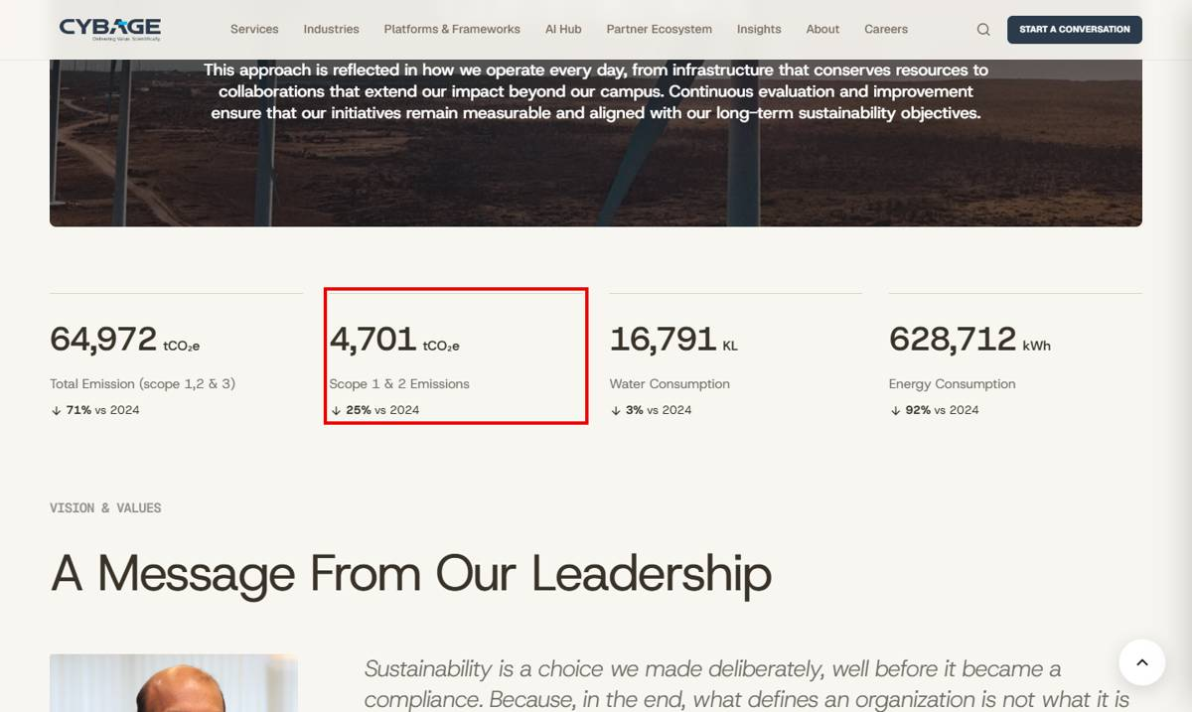

Checked and working (no action)
- Success Stories: all 65 cards across 9 LOAD MORE pages open correctly (HTTP 200).
- Our Leadership: each KNOW MORE opens the correct person's page.
- Glossary and Cybage Times: READ THE GLOSSARY / READ ISSUE links open correctly.
- Industry expert LinkedIn icons are present and linked.
- Header menu links all open correctly; partner and Enterprise Modernization URLs work in both lower and upper case.
- Cybage Foundation page now exists at /about/cybage-foundation.
- Blogs, Whitepapers, Success Stories, Open Positions and Newsroom listings show real CMS content; readdy shows sample cards there, so card-by-card differences are not reported.

Summary
Category | Issues
A. Broken links (404) on test | 5
B. Links that go to Home (/) or have no URL | 8
C. URL / alias mismatch and missing pages | 5
D. Missing sections / missing content | 13
E. Content that differs from readdy | 7
Total | 38

