**Answers to the questions:**

What were your expectations coming into this class?

* When I first came into this class, I expected it to be really hard. However, I was motivated to start and try something new. I thought it would be my favorite class because I have wanted to take a class to learn how to code for about a year now.
* I wasn’t sure what to expect. I have so many people in my life that have done some sort of coding and they have all had different experiences and opinions on it.
  + My brother is a computer scientist and has been trying to convince me to change my degree. He loves coding and wants to share it with others. He also told me that I can make a lot of money if I did something with programming in the future.
  + My dad used to code in his past schooling. However, his coding was all 1’s and 0’s. He loved coding too. He used to make video games in an after-school club.
  + Most of my high school friends are computer science majors. Unfortunately, I don’t talk to them anymore, so I am not sure how they feel about it.
  + My best friend and roommate used to minor in computer science. But, in her first computer science class last semester, she struggled. She had a panic attack every day for a straight week (out of confusion and frustration). It got to the point where she dropped out of the class.
  + One of my ISAT buddies loves coding and shows me all the cool things he makes all the time.
* There were only three things I expected coming into this class:
  + 1) The class would be just like any other class I have taken at JMU.
  + 2) By the end of the year, I would understand how to code.
  + 3) It would be a fun class that I really enjoyed.

What learning goals did you set for yourself?

* The learning goals I set for myself were:
  + To expand my knowledge and learn how to code.
  + To fulfil my requirement for my major.
  + To figure out if I like coding and if I want to pursue it in the future.
  + To make more friends in my major.
  + To pass the class with an A (if possible) and actually learn something.
  + To be able to learn enough to have programming conversations with my brother.
  + To learn enough that I can impress myself with my skill.

What did you actually do? List the tutorials and websites you used/visited. Estimate the amount of time you spent outside of class.

* What I actually did?
  + I have gone to every one of your classes, followed along with your lessons, and tried to understand what was happening. I took notes at every class and asked questions when I was confused. I made our class codes with you and posted them on GitHub.
  + I was very confused on what to do and was only able to code with my friends help for most of the year. But, after everything went online, I got up the courage to ask you for help. After I asked for your help, something clicked, and I was able to code by myself. It wasn’t until then that I realized coding was actually fun. Before that, it was confusing, frustrating, and nothing ever worked.
  + After I got a small idea of what I was doing, I tried a new code of my own (html). I went on many websites and learned some functions on how to use the language html. After that, I posted some of the code I wrote on GitHub.
* Tutorials and websites I used/visited?
  + Used…
    - Canvas/WebEx (Your tutorial)
    - Slack (your tutorials and other classmate stuff)
    - Code4Your.life (everything we did before online classes)
    - Freecodecamp (for html)
    - W3schools (for html)
  + Visited…
    - Exercism (I realized I liked freecodecamp better)
    - Codeacademy (I didn’t like how you had to pay)
* Estimated amount of time I spend outside of class?
  + Probably about 70 hours throughout the entire semester, give or take.
    - Before I knew what I was doing, I wasn’t coding often. Once I was no longer confused, I coded more frequently.
    - I probably spent about 38 hours in the past 2 weeks coding. Also, I have coded for a couple hours in my free time on websites, before I knew how to use visual studio. Back at school, it took longer to succeed at coding. Most of the coding I did was 4-5 hours of my friend explaining things to me. My friend explained things to be about 4 times back at school. So, with that knowledge and the long break of confusion in between those dates, I can assume I spent about 70 hours coding throughout the semester.

How did your goals evolve over the course of the semester?

* At the beginning of the course, I was very hopeful and motivated to learn. I knew it would be difficult, but I was planning to:
  + Expand my knowledge and learn how to code.
  + Fulfil my requirement for my major.
  + Figure out if I like coding and if I wanted to pursue it in the future.
  + Make more friends in my major.
  + Pass the class with an A (if possible) and actually learn something.
  + Be able to learn enough to have programming conversations with my brother.
  + Learn enough that I can impress myself with my skill.
* About midway, I was very confused. I kind of lost motivation in the class a little. I couldn’t stay after class and ask questions because I had a class immediately after your class. Also, it took a while for me to get up the courage to ask you questions. I had convinced myself I didn’t like coding unless I could see what was happening. At this time, my goals changed to:
  + Fulfil my requirement for my major.
  + Pass the class.
* After we went home, programming became easier. I was able to re-watch your online videos and take things at my own speed. I could ask questions because you had office hours that fit my schedule. I found a language I actually liked. I actually became motivated again in your class and was no longer confused. At this time, my goals went back to my original goals.

In what ways did you feel you were successful?  Please refer to specific, concrete artifacts that would serve as evidence of your successes.

* The day I felt like I succeeded in something was when I learned how to use git bash, visual studio, and GitHub by myself. It was nice to actually understand what I was doing.
* Other than that, I do believe I achieved all of my goals at least at their lowest potential. I am succeeding at these goals a little more every day I code.
* Evidence:

Barge@DESKTOP-OFGLVV9 MINGW64 ~/dev (master)

Change directory and going back to the original directory.

$

Barge@DESKTOP-OFGLVV9 MINGW64 ~/dev (master)

$ cd ..

Barge@DESKTOP-OFGLVV9 MINGW64 ~ (master)

Setting up Git Bash

$ git config --global user.name "BargerVA"

Barge@DESKTOP-OFGLVV9 MINGW64 ~ (master)

$ git config --global user.email BargerVA@dukes.jmu.edu

Barge@DESKTOP-OFGLVV9 MINGW64 ~ (master)

$ cd dev

Barge@DESKTOP-OFGLVV9 MINGW64 ~/dev (master)

$ ls -la

total 44

drwxr-xr-x 1 Barge 197609 0 May 8 00:02 ./

drwxr-xr-x 1 Barge 197609 0 May 8 13:45 ../

drwxr-xr-x 1 Barge 197609 0 May 7 17:08 arabic2roman/

drwxr-xr-x 1 Barge 197609 0 Apr 29 15:53 fizzbuzz/

drwxr-xr-x 1 Barge 197609 0 Apr 29 15:54 GitHub/

drwxr-xr-x 1 Barge 197609 0 Apr 29 16:38 Hello-World-Test-scripts/

drwxr-xr-x 1 Barge 197609 0 Apr 29 15:18 isat252s20_02/

drwxr-xr-x 1 Barge 197609 0 May 7 23:48 my_website/

drwxr-xr-x 1 Barge 197609 0 Apr 8 17:38 python-test/

drwxr-xr-x 1 Barge 197609 0 Apr 10 10:43 UsersBargedevmy_websiteindex.html/

Changing directories and see what is in each directory

Barge@DESKTOP-OFGLVV9 MINGW64 ~/dev (master)

$ cd arabic2roman

Barge@DESKTOP-OFGLVV9 MINGW64 ~/dev/arabic2roman (master)

$ ls -la

total 43

drwxr-xr-x 1 Barge 197609 0 May 7 17:08 ./

drwxr-xr-x 1 Barge 197609 0 May 8 00:02 ../

drwxr-xr-x 1 Barge 197609 0 May 7 17:53 .git/

-rw-r--r-- 1 Barge 197609 1928 Apr 10 11:08 .gitignore

drwxr-xr-x 1 Barge 197609 0 May 7 17:08 .vscode/

-rw-r--r-- 1 Barge 197609 3376 Apr 29 16:10 arabic2roman.py

-rw-r--r-- 1 Barge 197609 4258 May 7 17:20 arabic2roman_test.py

-rw-r--r-- 1 Barge 197609 1098 Apr 10 11:08 LICENSE

-rw-r--r-- 1 Barge 197609 548 May 7 17:29 package.json

-rw-r--r-- 1 Barge 197609 251 May 7 17:47 pytest.ini

-rw-r--r-- 1 Barge 197609 103 Apr 10 11:08 README.md

-rw-r--r-- 1 Barge 197609 400 May 7 17:45 requirements.txt

-rw-r--r-- 1 Barge 197609 1010 May 7 17:44 scratchpad.txt

drwxr-xr-x 1 Barge 197609 0 Apr 10 11:10 venv/

Barge@DESKTOP-OFGLVV9 MINGW64 ~/dev/arabic2roman (master)

$ code .

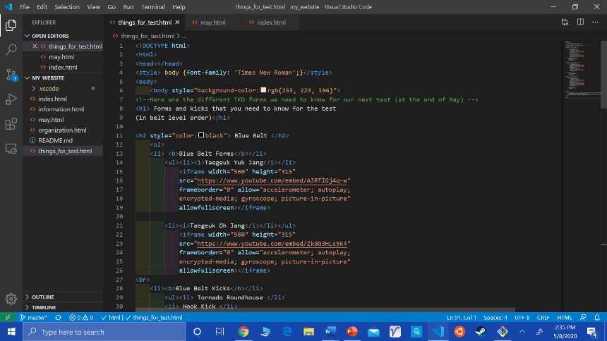

Visual studio time

Barge@DESKTOP-OFGLVV9 MINGW64 ~/dev/my_website (master)

$ git status

Checking the status of my code written.

On branch master

Your branch is up to date with 'origin/master'.

Changes not staged for commit:

(use "git add <file>..." to update what will be committed)

(use "git restore <file>..." to discard changes in working directory)

modified: .vscode/settings.json

modified: things_for_test.html

no changes added to commit (use "git add" and/or "git commit -a")

Barge@DESKTOP-OFGLVV9 MINGW64 ~/dev/my_website (master)

$ git add things_for_test.html

Barge@DESKTOP-OFGLVV9 MINGW64 ~/dev/my_website (master)

$ git commit things_for_test.html -m "updated but still missing kick videos"

[master 9580828] updated but still missing kick videos

Posting things on to GitHub.

1 file changed, 1 insertion(+), 1 deletion(-)

Barge@DESKTOP-OFGLVV9 MINGW64 ~/dev/my_website (master)

$ git push

Enumerating objects: 5, done.

Counting objects: 100% (5/5), done.

Delta compression using up to 8 threads

Compressing objects: 100% (3/3), done.

Writing objects: 100% (3/3), 301 bytes | 150.00 KiB/s, done.

Total 3 (delta 2), reused 0 (delta 0)

remote: Resolving deltas: 100% (2/2), completed with 2 local objects.

To https://github.com/bargerva/my_website.git

0bd391f..9580828 master -> master

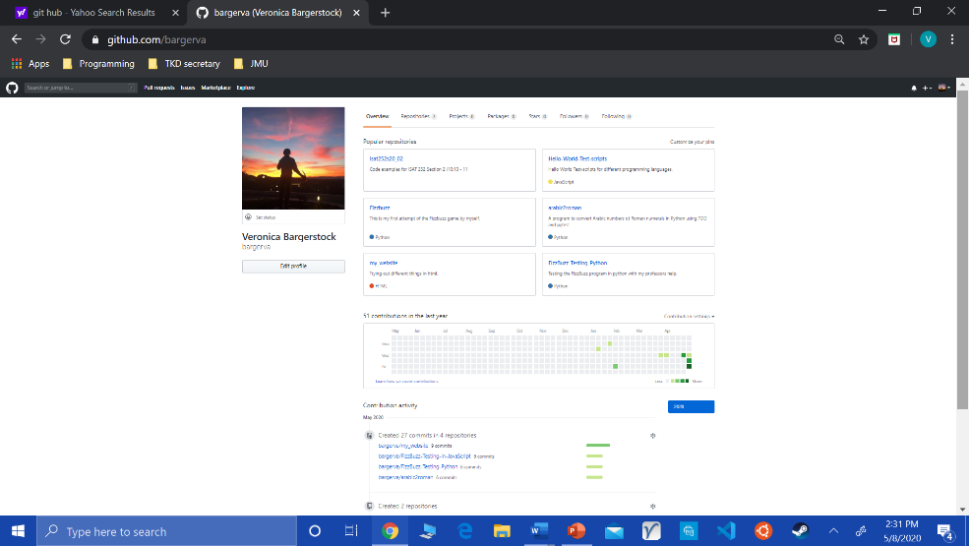

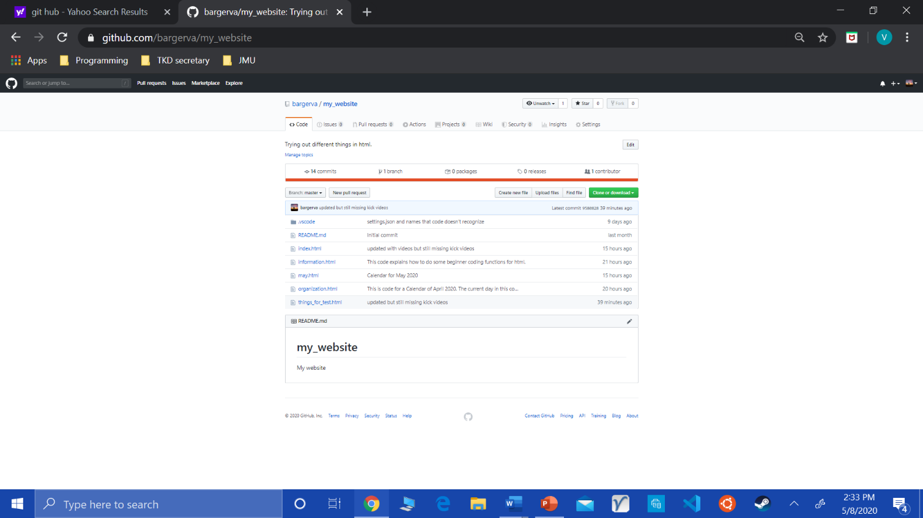

In what areas do you feel you failed to achieve your goals?

* Failing is a matter of perspective. In most circumstances, you can’t really fail unless you stop trying. I think there are areas that I could have worked on more, but I don’t think I have failed. I think I have achieved most if not all of my goals. Although I am not sure if I know enough information to be able to have a conversation with my brother on the topic, yet. Also, I have very high standards for myself, so I haven’t impressed myself yet.
* I do feel that I should have gone to you sooner for help. If I got help sooner, I would have been able to write more code and have more experience coding.

Please reflect on what you think you've learned from your failures, and what, if any, plans you have to address those issues in the future.

* I have learned that when I am struggling in a class, it is better to get help earlier than later. I plan to ask more questions and get help right away if I am struggling in the future.

JMU's Mission Statement is to produce "educated and enlightened citizens who lead meaningful and productive lives." Do you feel more educated? More enlightened? Less so?

* I feel more educated, but I do not feel enlightened. I feel more educated because I now know a new activity that I like to do. I have learned a new skill that allows me to continue learning every day. However, I do not feel more enlightened because I believe enlightenment is when you have a full understanding on a subject. This means you have learned everything that there is, and you can’t expand your knowledge. I think college is a place for growth, not a place to learn everything so you can stop learning in the future.

How have your activities this semester contributed or detracted from your knowing yourself better and having a better grasp on what you want to do in the near or distant future?

* My activities this semester contributed to a greater understanding of myself by :
  + Allowing me to figure out I don’t want to spend all my time on a computer.
  + Allowing me to figure out that I want to learn how to make things like websites, signs that light up, etc..
  + Helping me learn that I want to be able to make products faster, more efficient, more sustainable, and better for the environment.
  + Helping me realize how much I actually like designing, making things, and helping others.
  + I’m not sure what I want to do with this information. I am not sure what I want to do in the future. At the moment, I just have a greater understanding of myself.

What grade would you like for me to report to the registrar for you, and why?

* I would like for you to report an A for me for your class. However, I think that everyone is going to want an A because the thing people care the most about now-a-days is keeping their GPA’s high.
  + I am one of the people that like having a high GPA, but I also like learning new things and want to expand my knowledge.
* I would like an A in this class because of two reasons.
  + 1) I achieved my goal for this class. I was able to learn how to code. Well, I was able to learn enough code to look up how to do it, figure out which language is my favorite, and figure out if I like it. I found out; I really like coding with html. My second favorite is python. I personally don’t like coding in JavaScript as much, but that might change if I put more time into using it.
  + 2) I am able to answer your two questions that you wanted us to be able to answer at the end of the semester.
    - Do you like coding?
      * I do like coding. I think it is really fun but really challenging. I can definitely see myself doing it in my free time (if I had a reason to do so or if I had a creative spark day where I wanted to make things).
        + I can prove this because I have gone to every one of your classes, followed along with your lessons, and tried to understand what was happening. I took notes at every class and asked questions when I was confused. Also, I made our class codes with you and posted them on GitHub. Lastly, I tried a new code of my own (html), learned many of the functions, and posted some of my code on GitHub as well.
    - Do you think you could be good at it?
      * Currently, I don’t think that I am very good at it. But, I am a perfectionist and have very high standards on my abilities. However, I do think that if I continue to put time and effort into coding, I will become very good at it.