Universitatea "Dunărea de Jos" din Galați

Facultatea de Automatică, Calculatoare, Inginerie Electrică și Electronică

**PROIECT REȚELE DE CALCULATOARE II**

***Realizat de:*** George – Marius BARANGA Îndrumător: Asist. drd. ing. GRUPA 22C31A Cristian NICULIȚĂ

***Galati 2021***

Conţinut proiect:

- Harta logică a reţelei

o Visio

- Harta fizică a reţelei

o Visio

- Harta logică a serviciilor

o Visio

- Lista echipamentelor de reţea (switchuri, rutere, modem-uri, convertoare, etc.)

o model, nr. porturi, descriere a funcţionării în cadrul reţelei

- Configuraţiile pentru echipamentele de reţea

o Fişiere text cu configuraţiile sau fişiere text explicative asupra configuraţiei

- Lista serverelor o Model, caracteristici tehnice

o Serverele se află în NOC

- Configuraţiile serverelor

o Fişiere text descriptive sau fişiere text explicative

- Tabel cu calculul de preţ

o Subtotaluri pentru fiecare categorie în parte (cablare, comutare, rutare, servicii)

- Servicii care sunt necesare în reţea

o Partajare de resurse disc ( câte 2 share-uri pentru reţelele „1” şi „2”)

GENERATOR DATE PROIECT:





10.222.128.0/21 -> 2048

10.222.130.160/27

10.222.131.0/24 X

10.222.132.0/25 X

10.222.134.192/26

10.222.135.0/24 X

R1: 60+37+33+17+28=175 +2=177 calculatoare -> 256

R2: 57+32+38+63=190 +2=192 calculatoare -> 256

A1: 22+2 -> 32 calculatoare

A2: 52+2 -> 64 calculatoare

A3: 33+2 -> 64 calculatoare

B1: 24+2 -> 32 calculatoare

B2: 62+2 -> 64 calculatoare

C1: 18+2 -> 32 calculatoare

C2: 66+2 -> 128 calculatoare

D1: 27+2 -> 32 calculatoare

D2: 71+2 -> 128 calculatoare

D3: 22+2 -> 32 calculatoare

E1: 56+2 -> 64 calculatoare

E2: 69+2 -> 128 calculatoare

IP-URI DISPONIBILE:

R1: 10.222.128.1 - 10.222.128.255 255.255.255.0

R2: 10.222.129.1 - 10.222.129.255 255.255.255.0

C2: 10.222.130.1 - 10.222.130.127 255.255.255.128

A1: 10.222.130.129 - 10.222.130.159 255.255.255.224

A2: 10.222.130.193 - 10.222.130.255 255.255.255.192

D2: 10.222.132.129 - 10.222.132.255 255.255.255.128

A3: 10.222.133.1 - 10.222.133.63 255.255.255.192

B2: 10.222.133.65 - 10.222.133.127 255.255.255.192

E1: 10.222.133.129 - 10.222.133.191 255.255.255.192

B1: 10.222.133.193 - 10.222.133.223 255.255.255.224

C1: 10.222.133.225 - 10.222.133.255 255.255.255.224

D1: 10.222.134.1 - 10.222.134.31 255.255.255.224

D3: 10.222.134.33 - 10.222.134.63 255.255.255.224

E2: 10.222.134.65 - 10.222.134.191 255.255.255.128

VLANURI

A1 vlan11

A2 vlan12

A3 vlan13

B1 vlan21

B2 vlan22

C1 vlan31

C2 vlan32

D1 vlan41

D2 vlan42

D3 vlan43

E2 vlan52

R1 vlan61

R2 vlan62

DHCP:

|  |  |  |  |  |  |
| --- | --- | --- | --- | --- | --- |
| POOL NAME | DEFAULT GATEWAY | DNS SERVER | START IP ADDRESS | SUBNET MASK | MAX USER |
| A1 | 10.222.130.157 | 10.222.133.130 | 10.222.130.129 | 255.255.255.224 | 22 |
| A2 | 10.222.130.253 | 10.222.133.130 | 10.222.130.193 | 255.255.255.192 | 52 |
| A3 | 10.222.133.61 | 10.222.133.130 | 10.222.133.1 | 255.255.255.192 | 33 |
| B1 | 10.222.133.221 | 10.222.133.130 | 10.222.133.193 | 255.255.255.224 | 24 |
| B2 | 10.222.133.125 | 10.222.133.130 | 10.222.133.65 | 255.255.255.192 | 62 |
| C1 | 10.222.133.253 | 10.222.133.130 | 10.222.133.225 | 255.255.255.224 | 18 |
| C2 | 10.222.130.125 | 10.222.133.130 | 10.222.130.1 | 255.255.255.128 | 66 |
| D1 | 10.222.134.29 | 10.222.133.130 | 10.222.134.1 | 255.255.255.224 | 27 |
| D2 | 10.222.132.253 | 10.222.133.130 | 10.222.132.129 | 255.255.255.128 | 71 |
| D3 | 10.222.134.61 | 10.222.133.130 | 10.222.134.33 | 255.255.255.224 | 22 |
| R1 | 10.222.128.253 | 10.222.133.130 | 10.222.128.1 | 255.255.255.0 | 175 |
| R2 | 10.222.129.253 | 10.222.133.130 | 10.222.129.1 | 255.255.255.0 | 190 |
| E2 | 10.222.134.189 | 10.222.133.130 | 10.222.134.65 | 255.255.255.128 | 69 |

HARTA FIZICĂ A REȚELEI:

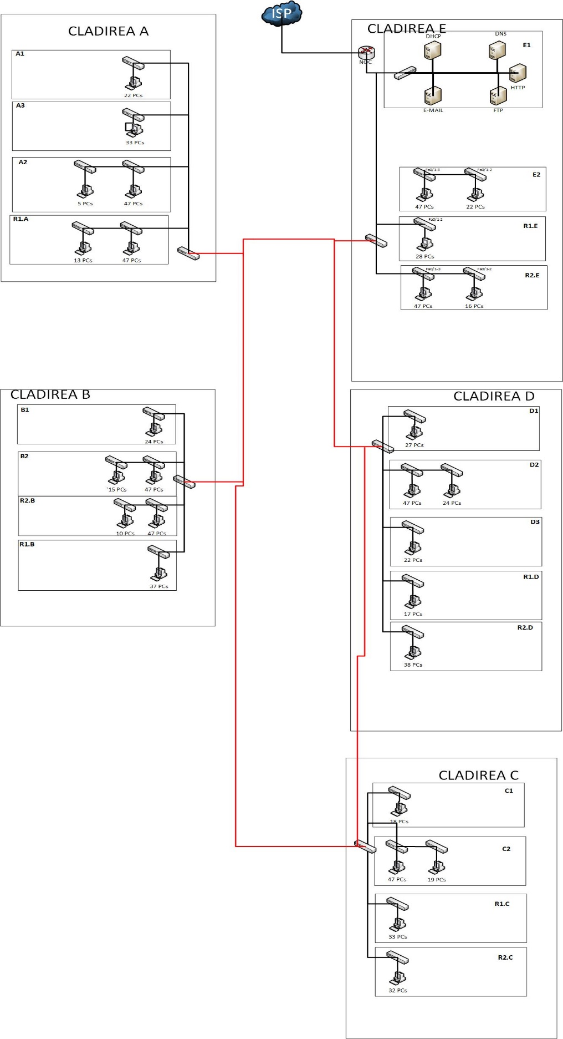

HARTA LOGICĂ A REȚELEI:

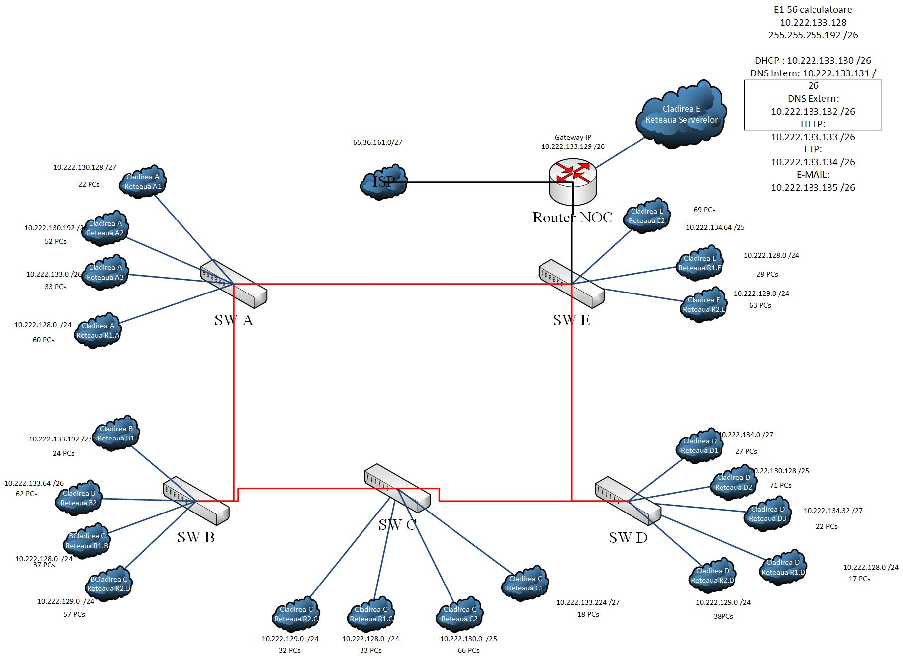

HARTA LOGICĂ A SERVICIILOR:

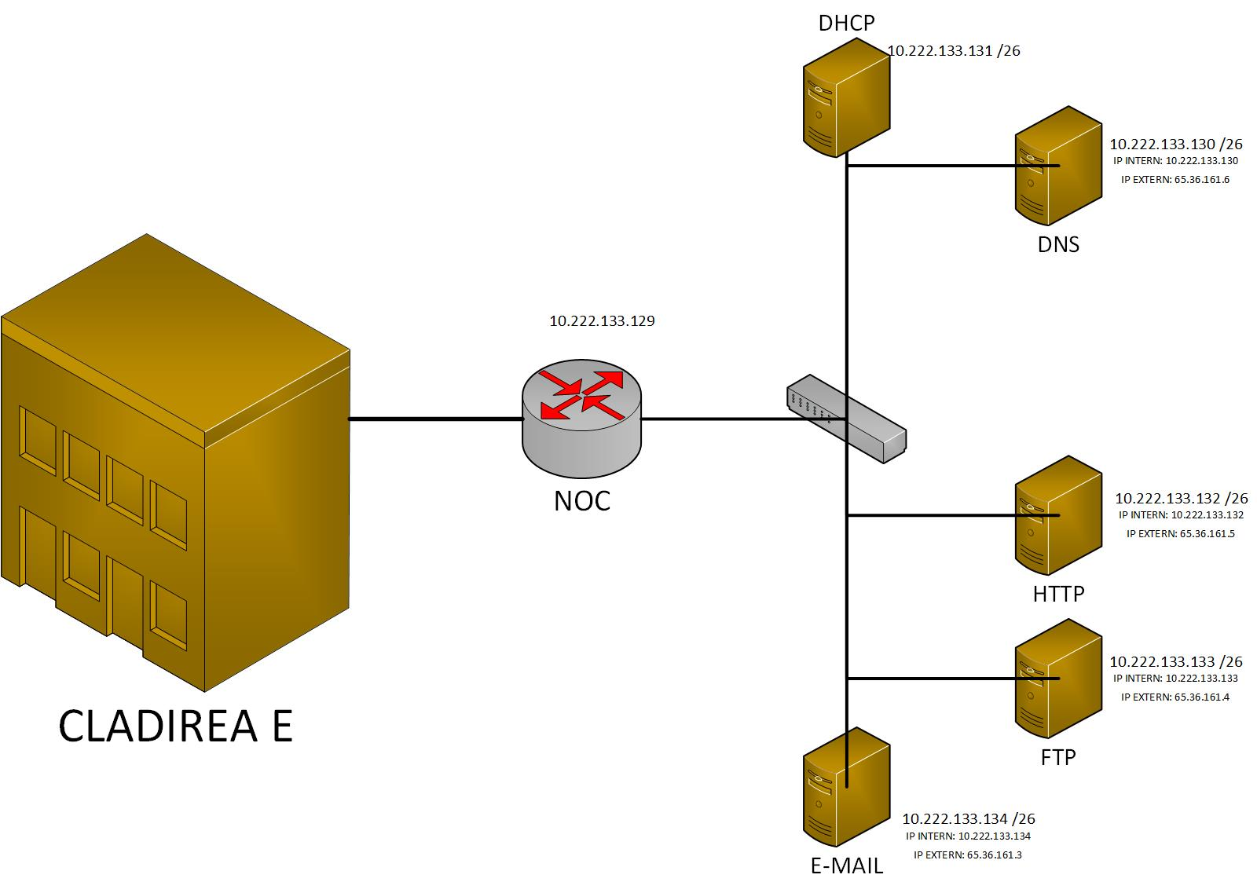

CONFIGURAREA ROUTER-ULUI ISP:

interface FastEthernet0/0

ip address 65.36.161.2 255.255.255.224

ip access-group 130 in

ip access-group 30 out

ip nat outside

duplex auto

speed auto

!

interface FastEthernet1/0

ip address 10.222.133.129 255.255.255.192

ip helper-address 10.222.133.131

ip nat inside

duplex auto

speed auto

!

interface FastEthernet2/0

no ip address

duplex auto

speed auto

!

interface FastEthernet2/0.11

encapsulation dot1Q 11

ip address 10.222.130.157 255.255.255.224

ip helper-address 10.222.133.131

ip nat inside

!

interface FastEthernet2/0.12

encapsulation dot1Q 12

ip address 10.222.130.253 255.255.255.192

ip helper-address 10.222.133.131

ip nat inside

!

interface FastEthernet2/0.13

encapsulation dot1Q 13

ip address 10.222.133.61 255.255.255.192

ip helper-address 10.222.133.131

ip nat inside

!

interface FastEthernet2/0.21

encapsulation dot1Q 21

ip address 10.222.133.221 255.255.255.224

ip helper-address 10.222.133.131

ip nat inside

!

interface FastEthernet2/0.22

encapsulation dot1Q 22

ip address 10.222.133.125 255.255.255.192

ip helper-address 10.222.133.131

ip nat inside

!

interface FastEthernet2/0.31

encapsulation dot1Q 31

ip address 10.222.133.253 255.255.255.224

ip helper-address 10.222.133.131

!

interface FastEthernet2/0.32

encapsulation dot1Q 32

ip address 10.222.130.125 255.255.255.128

ip helper-address 10.222.133.131

ip nat inside

!

interface FastEthernet2/0.41

encapsulation dot1Q 41

ip address 10.222.134.29 255.255.255.224

ip helper-address 10.222.133.131

ip nat inside

!

interface FastEthernet2/0.42

encapsulation dot1Q 42

ip address 10.222.132.253 255.255.255.128

ip helper-address 10.222.133.131

ip nat inside

!

interface FastEthernet2/0.43

encapsulation dot1Q 43

ip address 10.222.134.61 255.255.255.224

ip helper-address 10.222.133.131

ip nat inside

!

interface FastEthernet2/0.52

encapsulation dot1Q 52

ip address 10.222.134.189 255.255.255.128

ip helper-address 10.222.133.131

ip nat inside

!

interface FastEthernet2/0.61

encapsulation dot1Q 61

ip address 10.222.128.253 255.255.255.0

ip helper-address 10.222.133.131

ip nat inside

!

interface FastEthernet2/0.62

encapsulation dot1Q 62

ip address 10.222.129.253 255.255.255.0

ip helper-address 10.222.133.131

ip nat inside

!

ip nat inside source list 10 interface FastEthernet0/0 overload

ip nat inside source static 10.222.133.134 65.36.161.3

ip nat inside source static 10.222.133.133 65.36.161.4

ip nat inside source static 10.222.133.132 65.36.161.5

ip nat inside source static 10.222.133.130 65.36.161.6

ip classless

!

ip flow-export version 9

!

!

access-list 130 deny ip any 10.0.0.0 0.255.255.255

access-list 130 permit ip any any

access-list 10 permit 10.222.0.0 0.0.255.255

access-list 30 deny 10.0.0.0 0.255.255.255

access-list 30 permit any

!

!

!

!

!

line con 0

!

line aux 0

!

line vty 0 4

login

!

!

!

end

CONFIGURARE SWITCH PRINCIPAL:

spanning-tree mode pvst

!

interface FastEthernet0/1

switchport access vlan 11

switchport mode access

!

interface FastEthernet0/2

switchport access vlan 12

switchport mode access

!

interface FastEthernet0/3

switchport access vlan 12

switchport mode access

!

interface FastEthernet0/4

switchport access vlan 61

switchport mode access

!

interface FastEthernet0/5

switchport access vlan 61

switchport mode access

!

interface FastEthernet0/6

switchport access vlan 13

switchport mode access

!

interface FastEthernet0/7

switchport trunk allowed vlan 1,11-13,21-22,31-32,41-43,52,61-62

switchport mode trunk

!

interface FastEthernet0/8

switchport trunk allowed vlan 1,11-13,21-22,31-32,41-43,52,61-62

switchport mode trunk

!

interface FastEthernet0/9

!

interface FastEthernet0/10

!

interface FastEthernet0/11

!

interface FastEthernet0/12

!

interface FastEthernet0/13

!

interface FastEthernet0/14

!

interface FastEthernet0/15

!

interface FastEthernet0/16

!

interface FastEthernet0/17

!

interface FastEthernet0/18

!

interface FastEthernet0/19

!

interface FastEthernet0/20

!

interface FastEthernet0/21

!

interface FastEthernet0/22

!

interface FastEthernet0/23

!

interface FastEthernet0/24

!

interface Vlan1

no ip address

shutdown

!

!

!

!

line con 0

!

line vty 0 4

login

line vty 5 15

login

!

!

End

Configurările switch -urilor principale și configurarea router -ului ISP:



SERVER DNS:

SCHEMA CISCO PACKET TRACER:

ECHIPAMENTE UTILIZATE:

|  |  |  |  |  |  |  |
| --- | --- | --- | --- | --- | --- | --- |
| TIP ECHIPAMENT | OFERTANT | DENUMIRE | BUC. | AMPLASARE | Pret/BUC  (LEI) | TOTAL  (LEI) |
| Switch Cisco SG 200-08 | http://www.pcgarage.ro/switch-uri/cisco/sg-200-08/ | SG 200-08 | 1 | Servere | 519,20 | 519,20 |
| Server Cisco UCS C220 M3 Procesor Intel® Xeon® E5-2609 2.4GHz Sandy | http://www.pcgarage.ro/servere/cisco/ucs-c220-m3-procesor-intel-xeon-e5-2609-24ghz-sandy-bridge-ep-1x-8gb-ddr3-1600mhz-fara-hdd-sff-25-inch/ | UCS C220 M3 | 5 | Servere | 8.093,47 | 40.467,35 |
| Hard disk server Seagate Enterprise Capacity 3.5 HDD 1TB 7200RPM 128MB NL-SAS v3 | http://www.pcgarage.ro/hard-disk-uri-servere/seagate/1tb-sas-7200-rpm-128mb-constellation-es3/ | NL-SAS v3 | 5 | Servere: DHCP, DNS, HTTP, E-MAIL | 560,20 | 2801 |
| Router TP-Link TL-ER6020 | http://www.pcgarage.ro/routere/tp-link/tl-er6020/ | TL-ER6020 | 1 | Router: NOC | 613,54 | 613,54 |
| Switch TP-Link TL-SG3424P | http://www.pcgarage.ro/switch-uri/tp-link/tl-sg3424p-1/ | TL-SG3424P | 5 | SW A, SW B,  SW C, SW D,  SW E | 2.053,30 | 10.266,5 |
| Switch Cisco Smart Switch SLM2024T-EU | http://www.pcgarage.ro/switch-uri/cisco/smart-switch-slm2024t-eu/ | SLM2024T-EU | 28 | Switchuri pentru retele | 1.444,92 | 40.457,76 |
| Cablu UTP Cat.6, solid, AWG24 300m, Value 21.99.0995 | http://www.conectica.ro/retelistica/role-cablu-retea/cablu-utp-value-cat6-solid-awg24-300m-value-21990995 | Cablu UTP | 10 | Cabluri interior | 580 | 5.800 |
| Mufe RJ-45 UTP Roline Cat.6 ecranate, set 10 buc, 21.17.3061 | http://www.conectica.ro/retelistica/accesorii-pentru-retelistica/mufe-rj-45-utp-roline-cat6-ecranate-set-10-buc-21173061 | Mufe RJ-45 | 300 | La capetele cablurilor UTP | 19 | 5700 |
| Bobina de lansare FC/UPC - LC/APC SM(G.652D) 1000m | http://www.accesoriifibraoptica.ro/shop/ro_RO/product/124-LR-AF-1000-AL$002fFC.html | Cablu fibra optica | 10 | Cabluri exterior | 1.367,04 | 13.670,4 |
| Conector patch cord fibra optica LC/PC SM duplex albastru | http://www.accesoriifibraoptica.ro/shop/ro_RO/product/T70-0153.html | Conector fibra optica | 30 | Cablu fibra optic | 22,86 | 685,8 |
| Trusa de scule pentru retea 31 piese, Gembird TK-NETWORK | http://www.conectica.ro/retelistica/scule-si-truse-pentru-retelistica/trusa-de-scule-pentru-retea-31-piese-gembird-tk-network | Trusa de scule | 1 | Montare | 360 | 360 |
|  |  |  |  |  | TOTAL(fara pc – uri) | 121.341,55 |